UNITED STATES

SECURITIES AND EXCHANGE COMMISSION

Washington, D.C. 20549

FORM 6-K

REPORT OF FOREIGN PRIVATE ISSUER PURSUANT TO RULE 13a-16 OR 15d-16 UNDER THE SECURITIES EXCHANGE ACT OF 1934

For the month of June, 2021

Commission File Number: 001-37891

AC IMMUNE SA

(Exact name of registrant as specified in its charter)

EPFL Innovation Park

Building B

1015 Lausanne, Switzerland
(Address of principal executive office)

Indicate by check mark whether the registrant files or will file annual reports under cover of Form 20-F or Form 40-F:
Form 20-F | X | Form 40-F
Indicate by check mark if the registrant is submitting the Form 6-K in paper as permitted by Regulation S-T Rule 101(b)(1):
Yes |  | No |  | X
Indicate by check mark if the registrant is submitting the Form 6-K in paper as permitted by Regulation S-T Rule 101(b)(7):
Yes |  | No |  | X

Annual General Meeting Results

On June 25, 2021, AC Immune SA (“AC Immune”) held its Annual General Meeting of Shareholders. The Management presentation to shareholders is attached hereto as Exhibit 99.1 and the press release relating to the results of the Annual General Meeting is attached hereto as Exhibit 99.2. The amended Articles of Association are attached hereto as Exhibit 99.3, the notarized version of which will be published on AC Immune's website (https://ir.acimmune.com/governance) after the filing of the document with the Swiss Register of Commerce. The Board withdrew Agenda Items 6.2 ("Authorized Share Capital") and 6.3 ("Conditional Capital Increase for Employee Benefit Plans") prior to the Annual General Meeting. The final results of the remaining agenda items submitted to a vote of the shareholders are as follows:

Agenda Item 1: Approval of Annual Report and Other Reports for the year 2020

Agenda Item 1.1: Approval of the Annual Report 2020, Statutory Financial Statements 2020, and IFRS Financial Statements for the year 2020

AC Immune shareholders approved the Annual Report 2020, the Statutory Financial Statements 2020 and the IFRS Financial Statements of AC Immune SA for the year 2020, and took note of the Reports of the Auditors.

Agenda Item 1.2: Advisory Vote on the Compensation Report for the year 2020

AC Immune shareholders endorsed the Compensation Report for the year 2020.

Agenda Item 2: Appropriation of Loss

AC Immune shareholders approved that the loss for the year 2020 in the amount of KCHF 57,824 increases the “accumulated losses brought forward” of KCHF 62,151, resulting in a new balance of “accumulated losses brought forward” of KCHF 119,975.

Agenda Item 3: Discharge of the Board of Directors and of the Executive Committee

AC Immune shareholders approved the discharge the members of the Board of Directors and of the Executive Committee of their liabilities for their activities in the 2020 financial year.

Agenda Item 4: Compensation for the Members of the Board of Directors and the Executive Committee

AC Immune shareholders approved:

- The total maximum amount of non-performance-related compensation for the members of the Board of Directors covering the period from 1 July 2021 to 30 June 2022, i.e., CHF 689,000 (cash-based compensation plus pensionable social security costs);

- The maximum grant of equity or equity linked instruments for the members of the Board of Directors from 1 July 2021 to 30 June 2022 with maximum value of CHF 863,000 (equity or equity linked instruments at grant value plus pensionable social security costs);

- The total maximum amount of non-performance-related cash compensation for the members of the Executive Committee from 1 July 2021 to 30 June 2022, i.e., CHF 3,269,000 (cash-based compensation plus pensionable social security costs);

- The total maximum amount of variable compensation for the members of the Executive Committee for the current year 2021, i.e., CHF 1,378,000 (cash-based compensation plus pensionable social security

costs); and

- The maximum grant of equity or equity linked instruments for the members of the Executive Committee from 1 July 2021 to 30 June 2022 with maximum value of CHF 4,287,000 (equity or equity linked instruments at grant value plus pensionable social security costs).

Agenda Item 5: Re-elections

Agenda Item 5.1: Re-elections of Members of the Board

AC Immune shareholders approved the re-election of Douglas Williams as member and as Chairman of the Board, the re-election of Martin Velasco as member and as Vice-Chairman of the Board, and the re-election of Peter Bollmann, Alan Colowick, Tom Graney, Carl June, Werner Lanthaler, Andrew Pfeifer and Roy Twyman as members of the Board of Directors, each until the end of the Annual General Meeting 2022.

Agenda Item 5.2: Re-elections of Members of the Compensation, Nomination & Corporate Governance Committee

AC Immune shareholders approved the re-election of Tom Graney, Martin Velasco and Douglas Williams as members of the Compensation, Nomination & Corporate Governance Committee, each until the end of the Annual General Meeting 2022.

Agenda Item 5.3: Re-election of the Statutory Auditors

AC Immune shareholders approved the re-election of PricewaterhouseCoopers SA, in Pully, for a term of office of one year.

Agenda Item 5.4: Re-election of the Independent Proxy

AC Immune shareholders approved the re-election of Reymond & Associés, represented by Denis Cherpillod; as AC Immune’s independent proxy until the end of the Annual General Meeting 2022.

Agenda Item 6: Amendments of the Articles of Association

Agenda Item 6.1: Limit on Number of Directors

AC Immune shareholders approved an amendment to the existing first paragraph of article 20 (Number of Members, Term of Office) of the articles of association to give AC Immune flexibility to comply with nationality, residency and/or gender requirements under Swiss or foreign laws.

Agenda Item 6.4: Remuneration Amendments to the Articles of Association

AC Immune shareholders approved certain amendments in the articles of association to adjust the compensation system of AC Immune to a more common framework in line with many Swiss-listed companies and which aligns the compensation architecture to that of the calendar year.

SIGNATURE

Pursuant to the requirements of the Securities Exchange Act of 1934, the registrant has duly caused this report to be signed on its behalf by the undersigned, thereunto duly authorized.

AC IMMUNE SA
By: | /s/ Andrea Pfeifer
 | Name: | Andrea Pfeifer
 | Title: | Chief Executive Officer
By: | /s/ Joerg Hornstein
 | Name: | Joerg Hornstein
 | Title: | Chief Financial Officer
Date: June 25, 2021

 | EXHIBIT INDEX
Exhibit Number | Description
99.1 | Annual General Meeting presentation
99.2 | Press Release dated June 25, 2021
99.3 | Articles of Association as of June 25, 2021

Exhibit 99.1


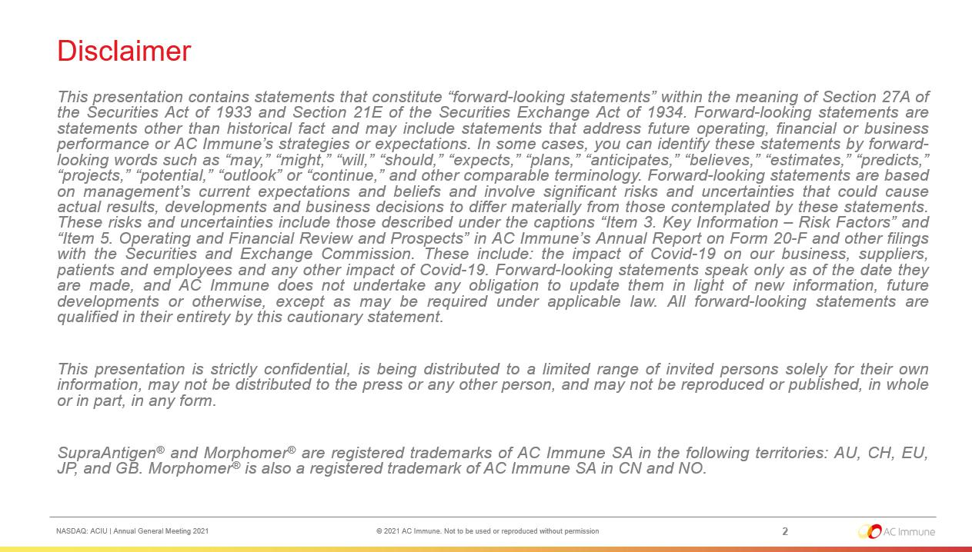

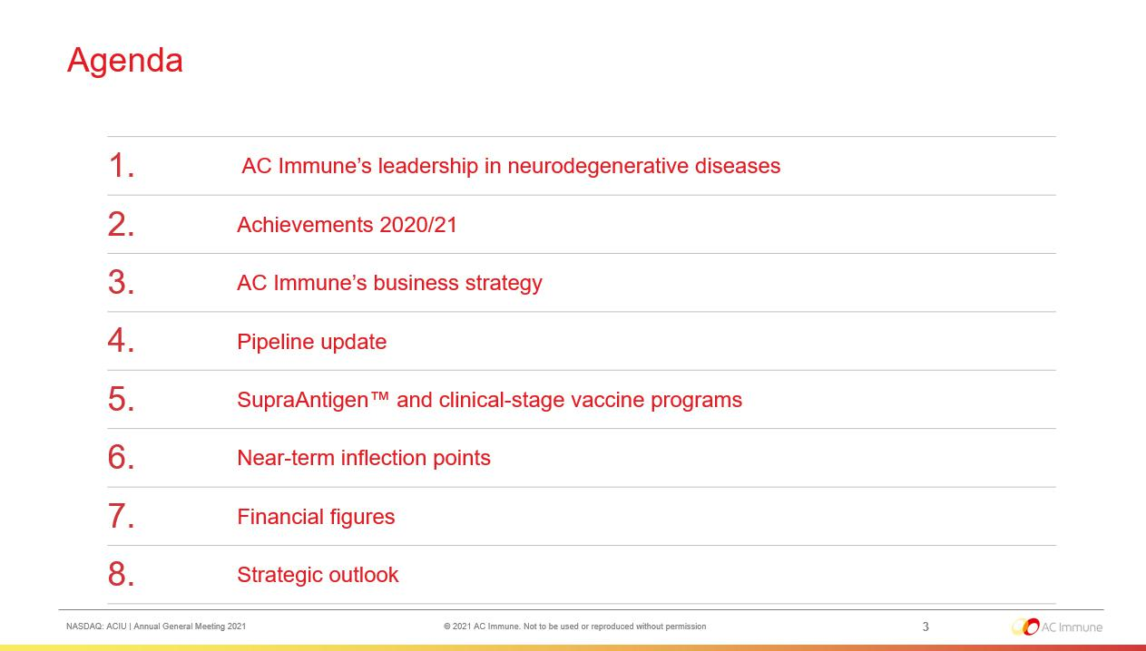

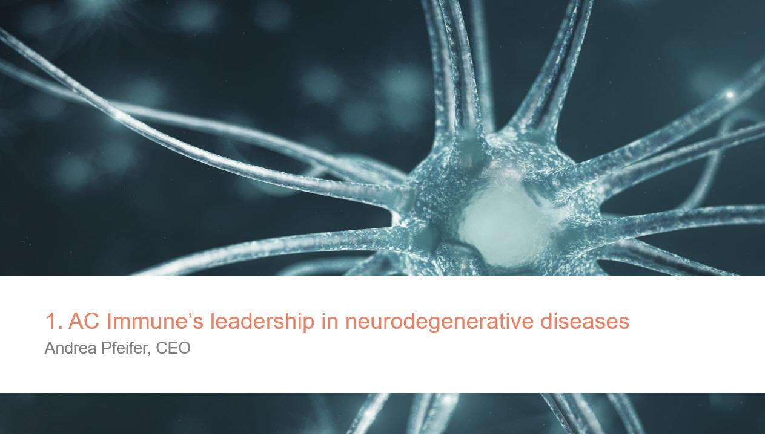

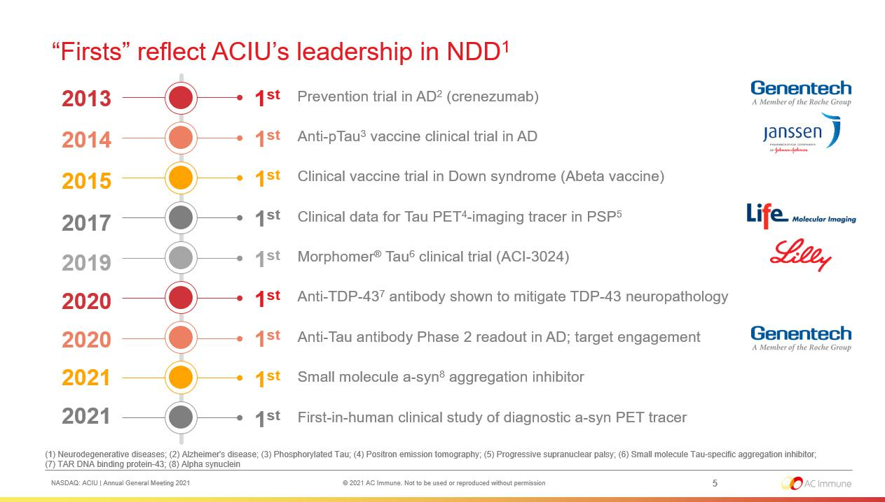

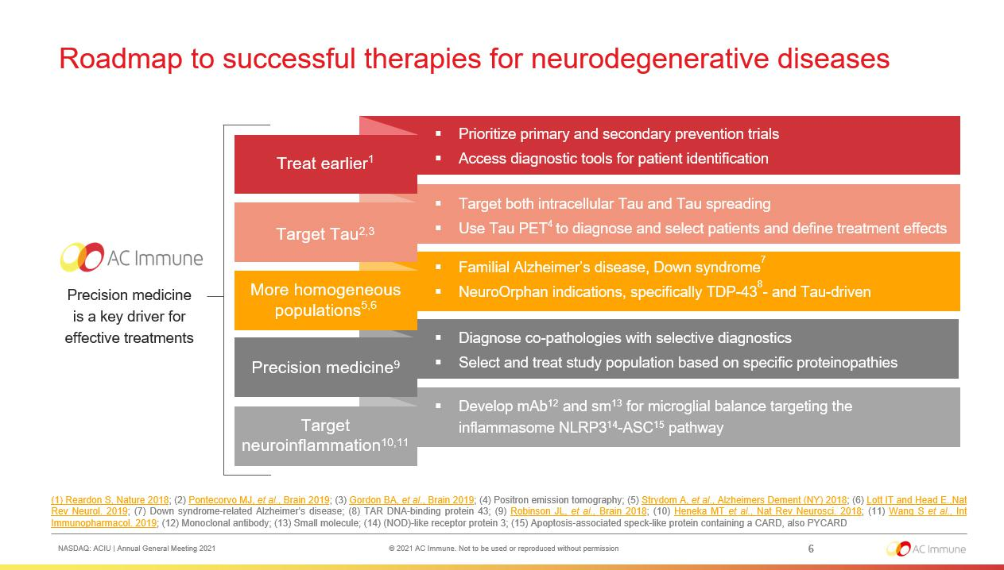

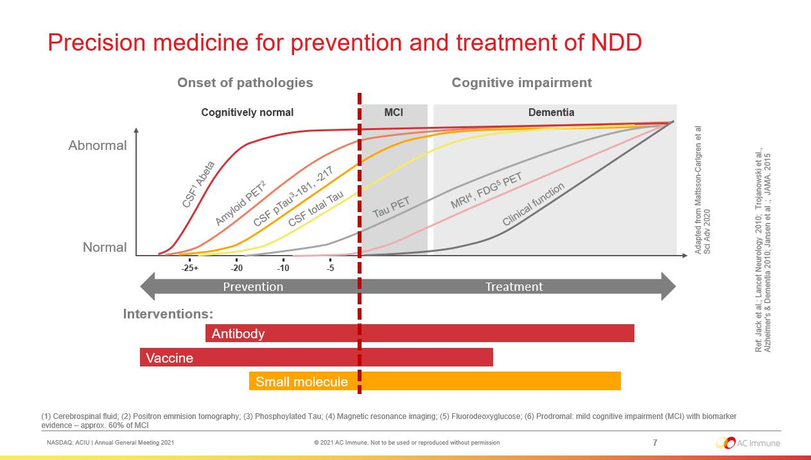

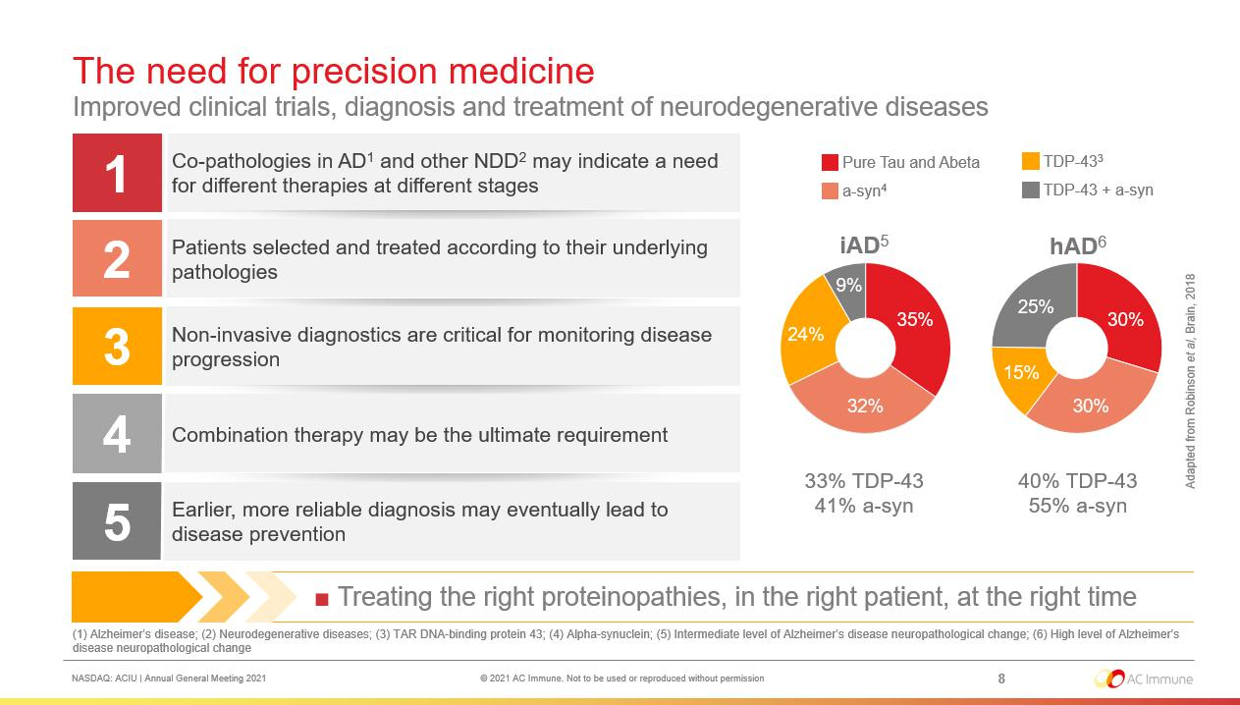



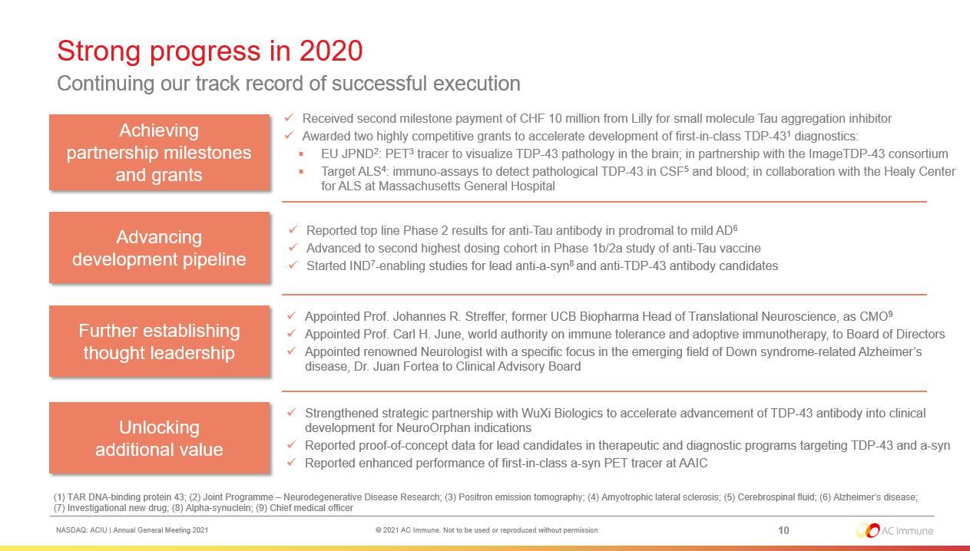



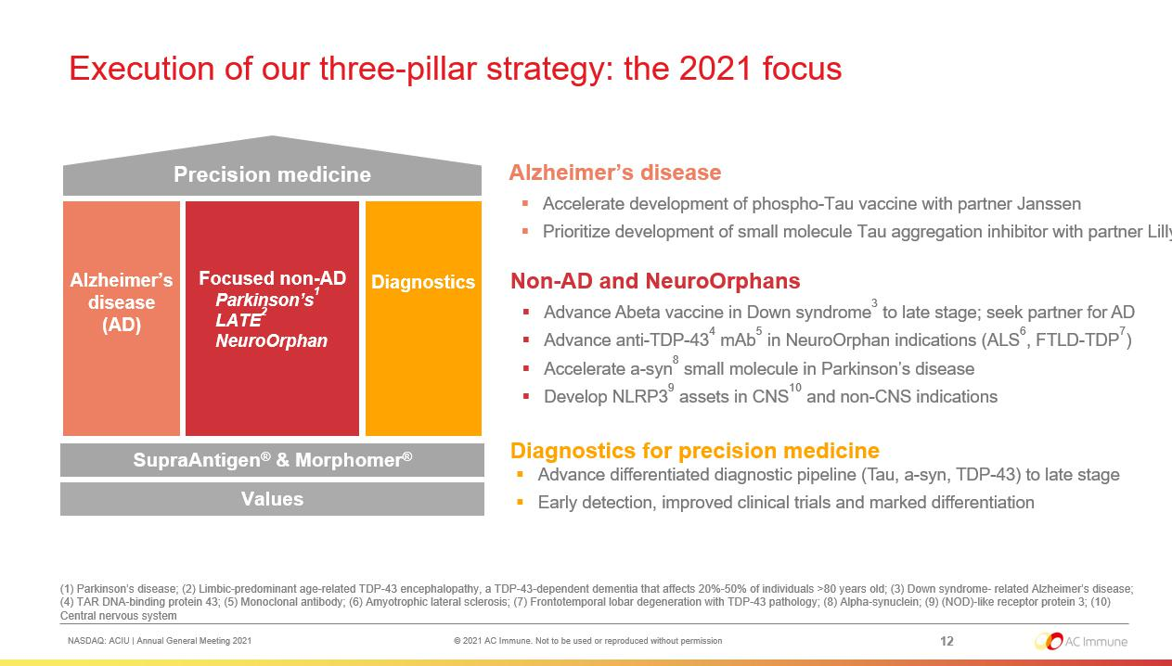

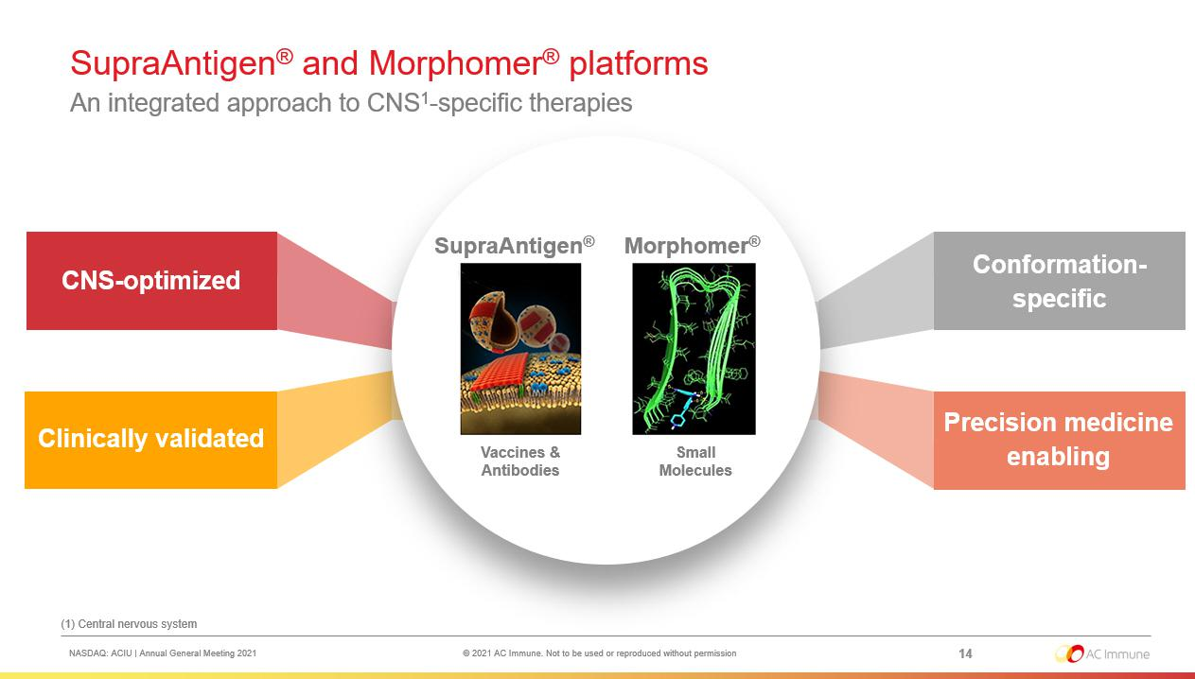



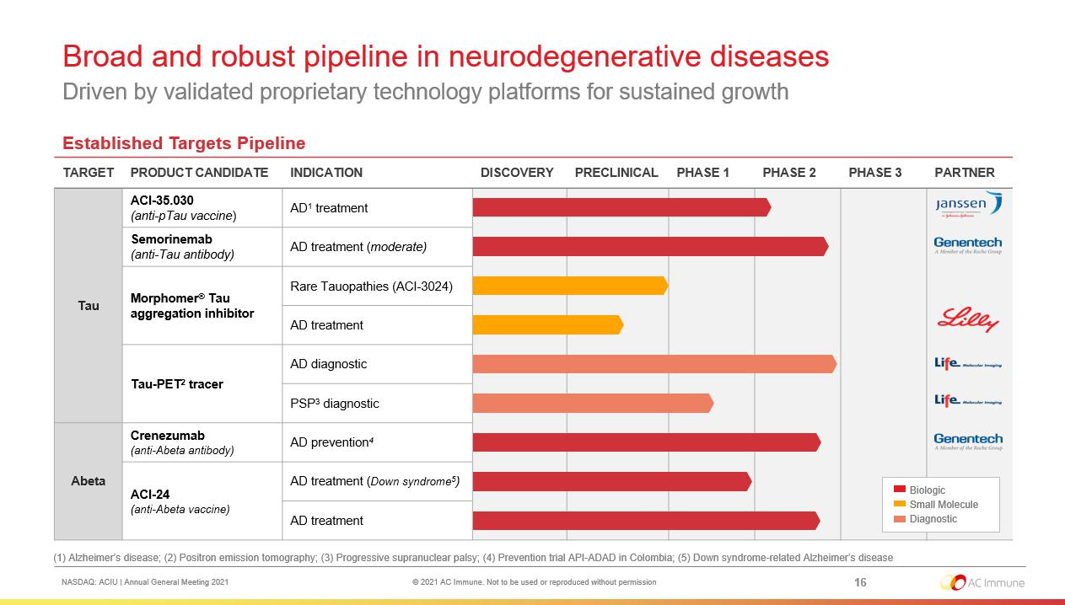

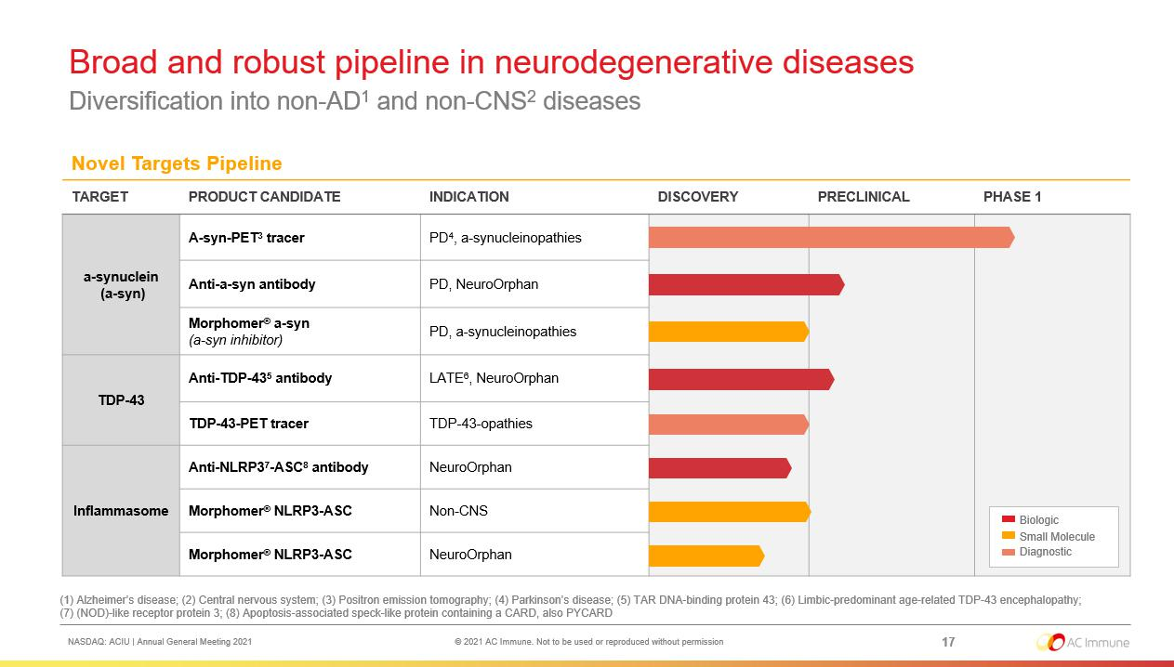



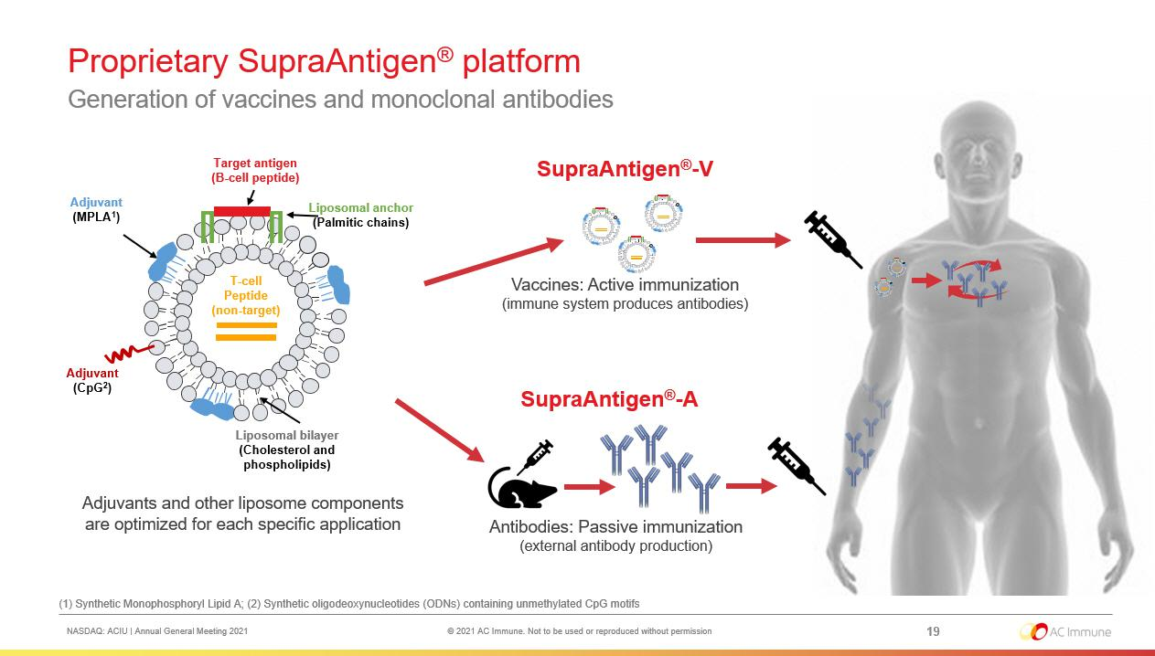

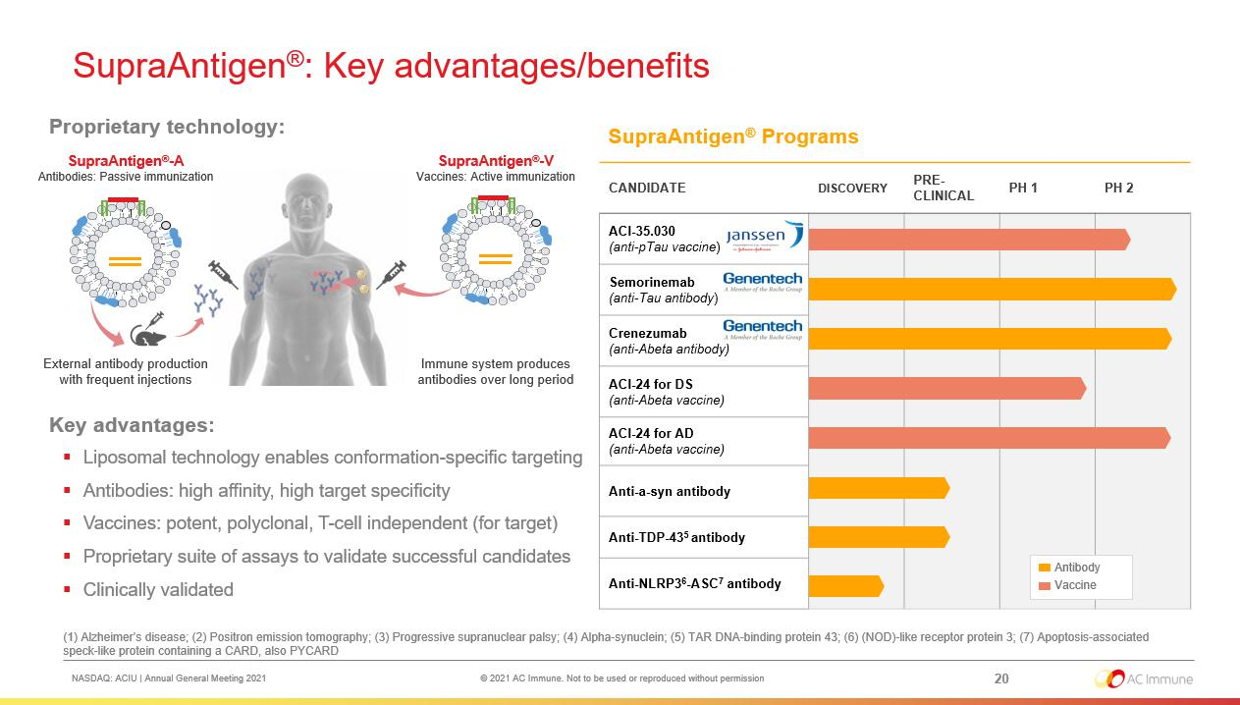

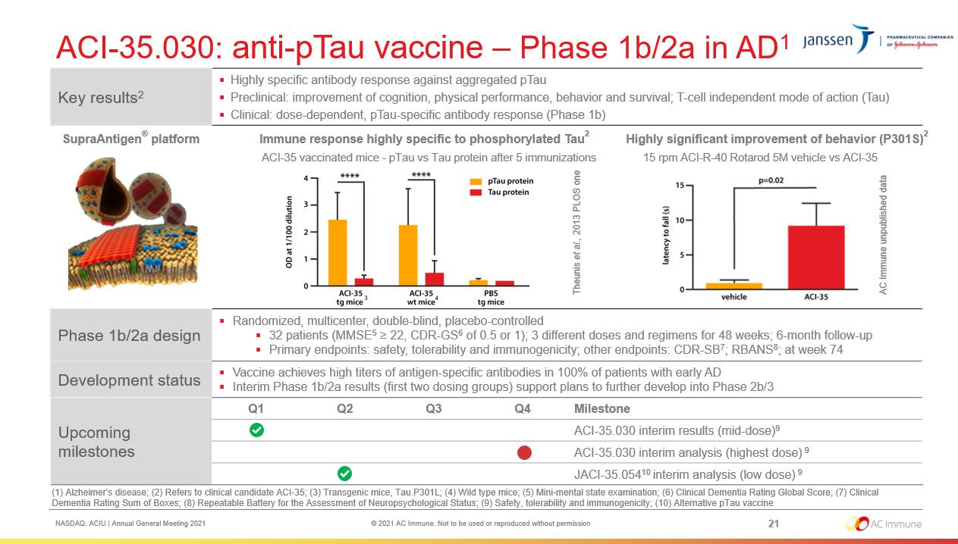

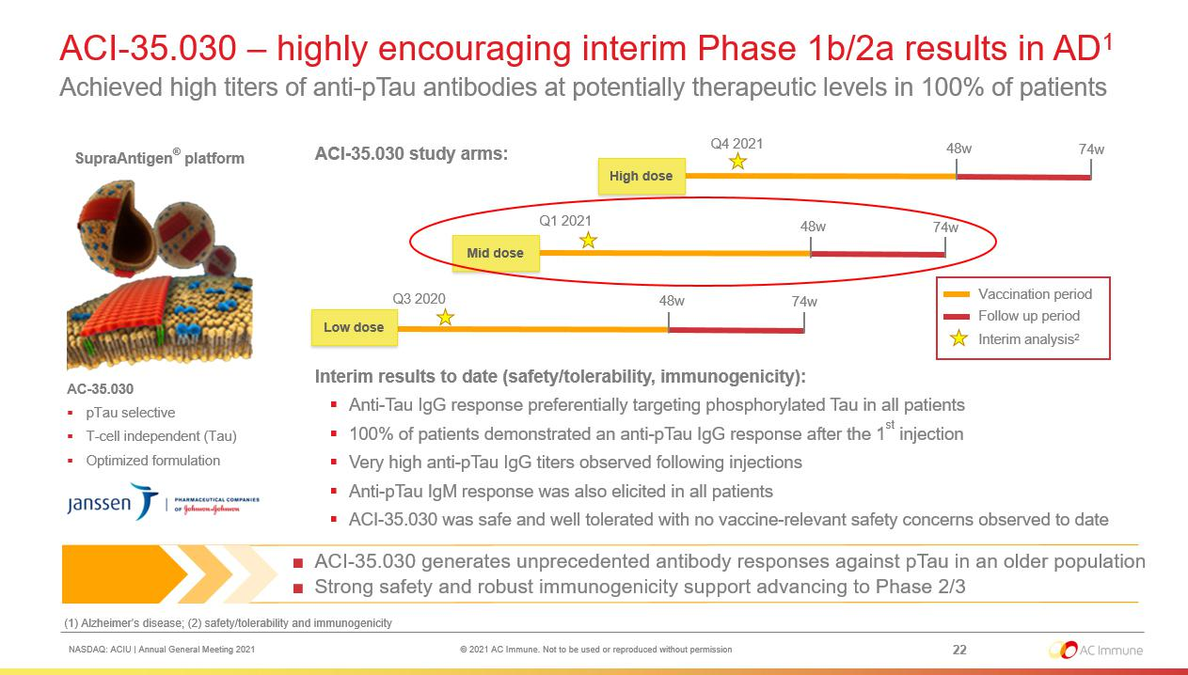

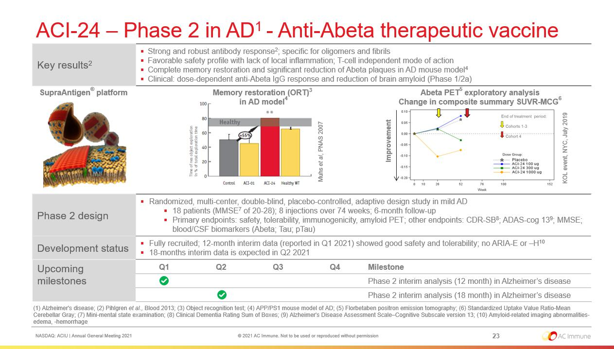

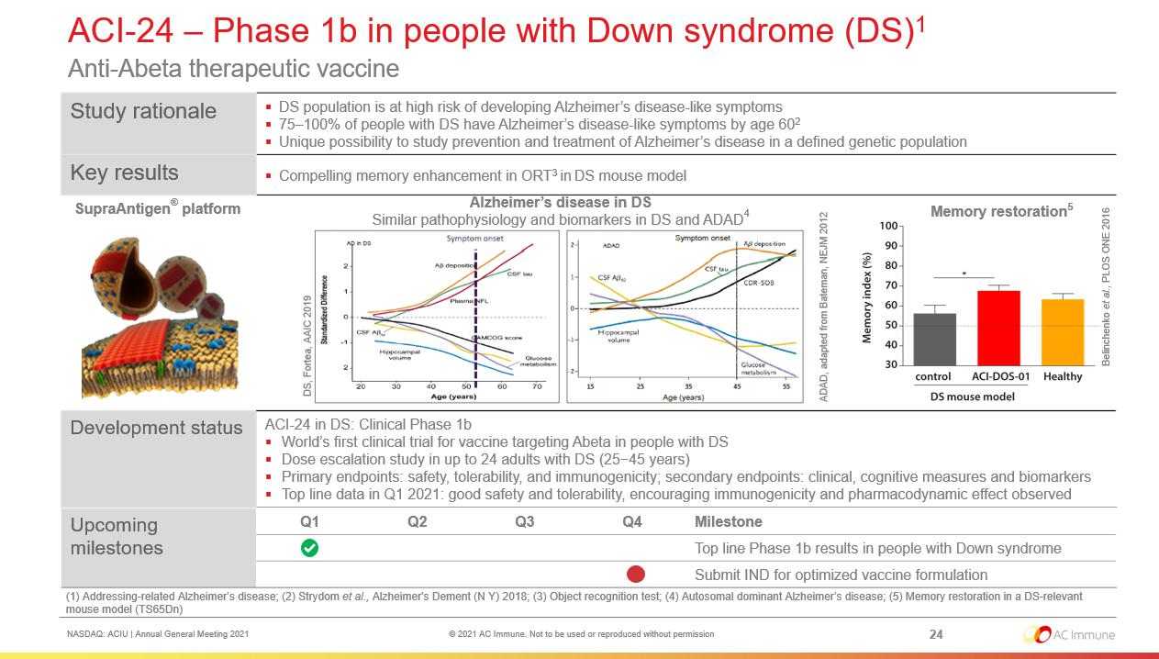

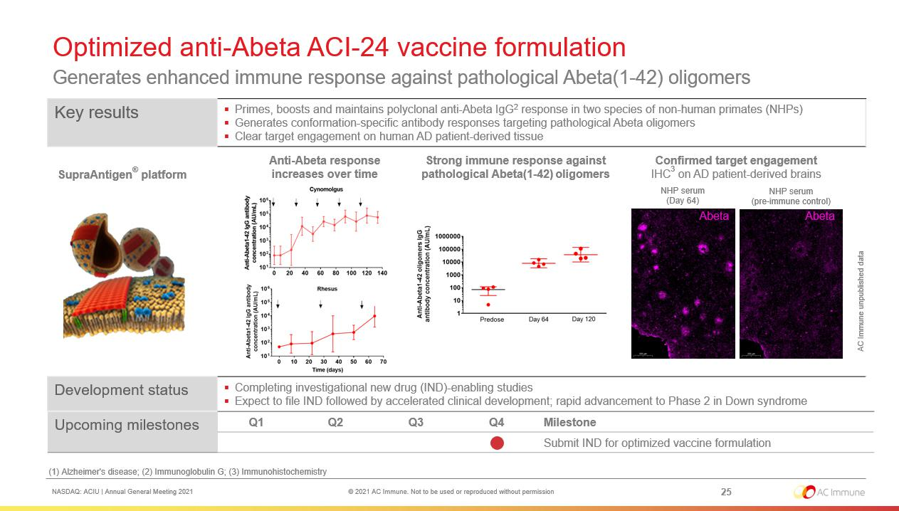

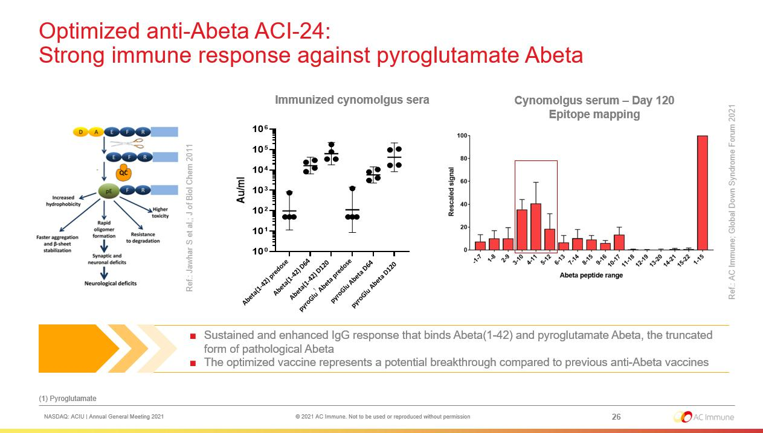

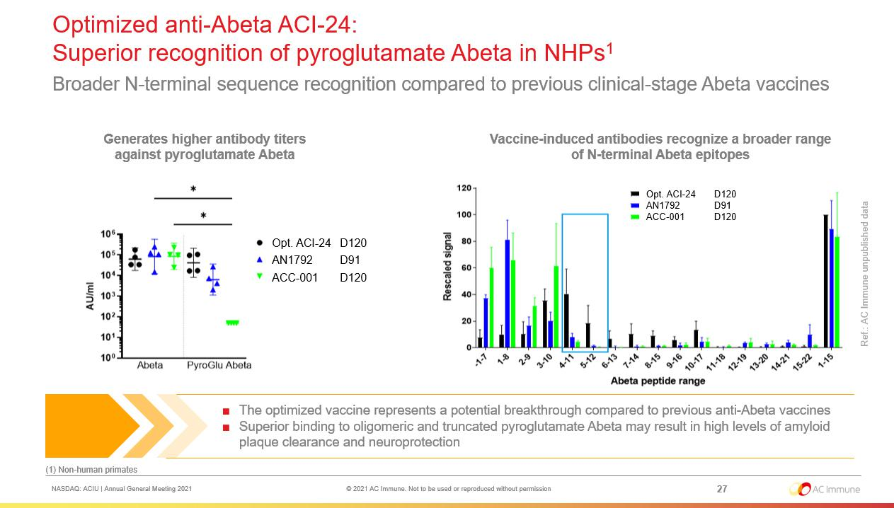

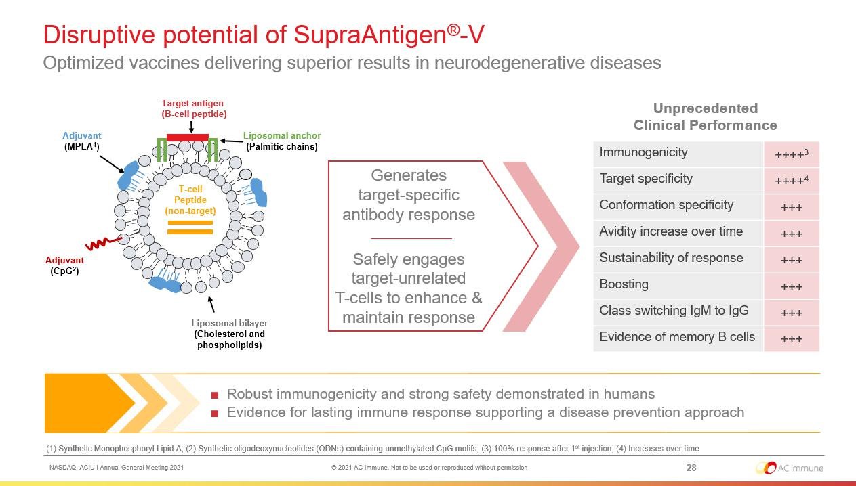



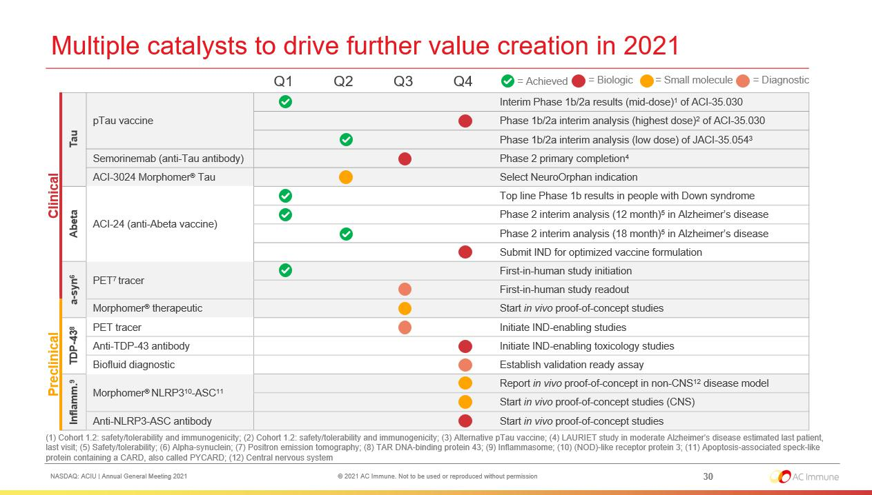



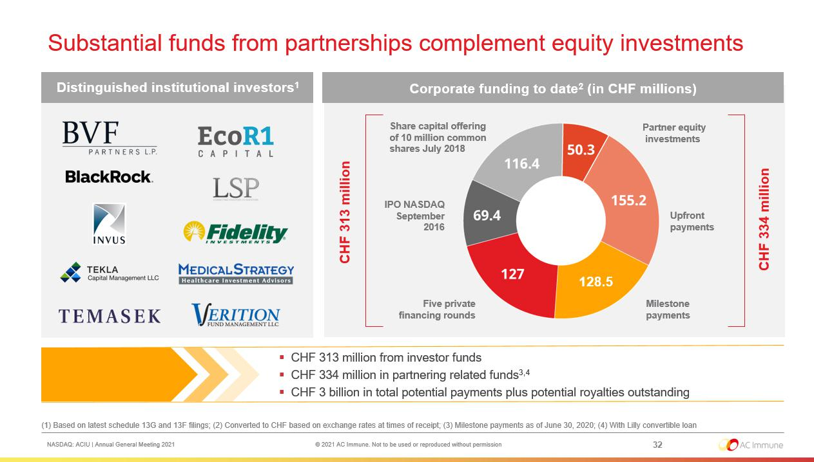

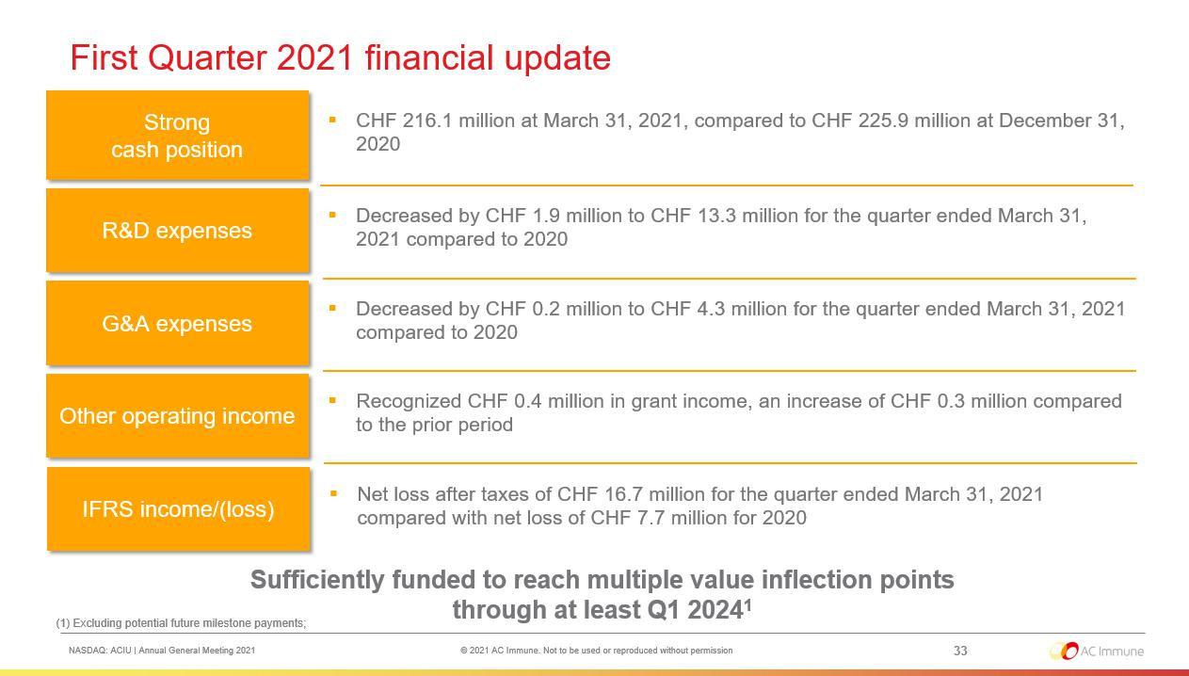



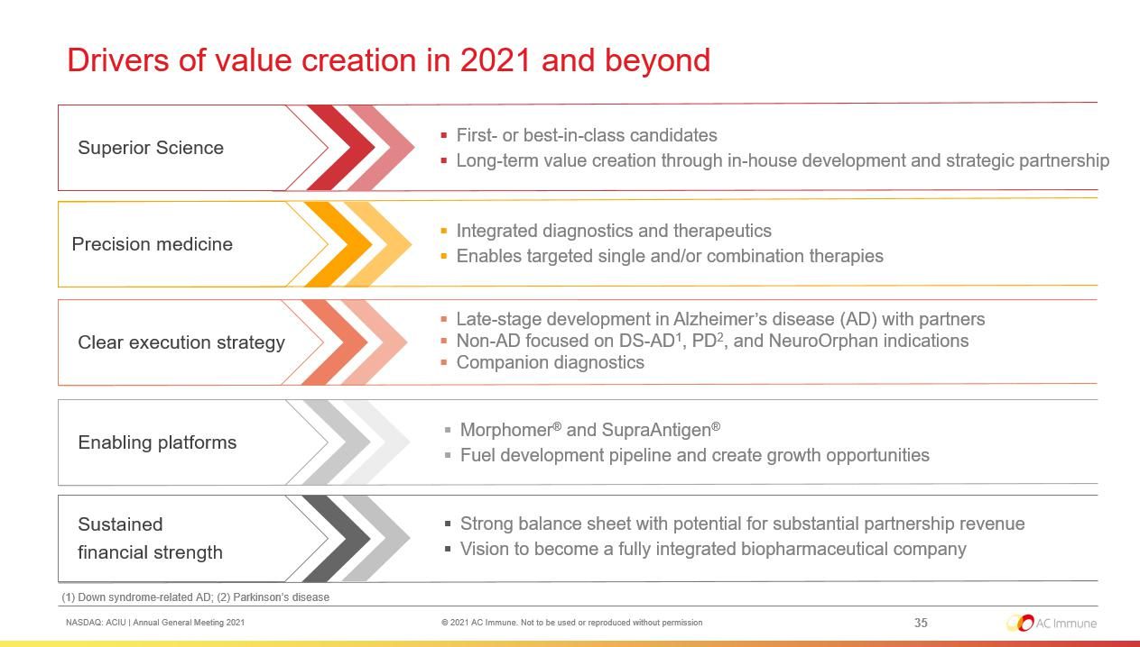

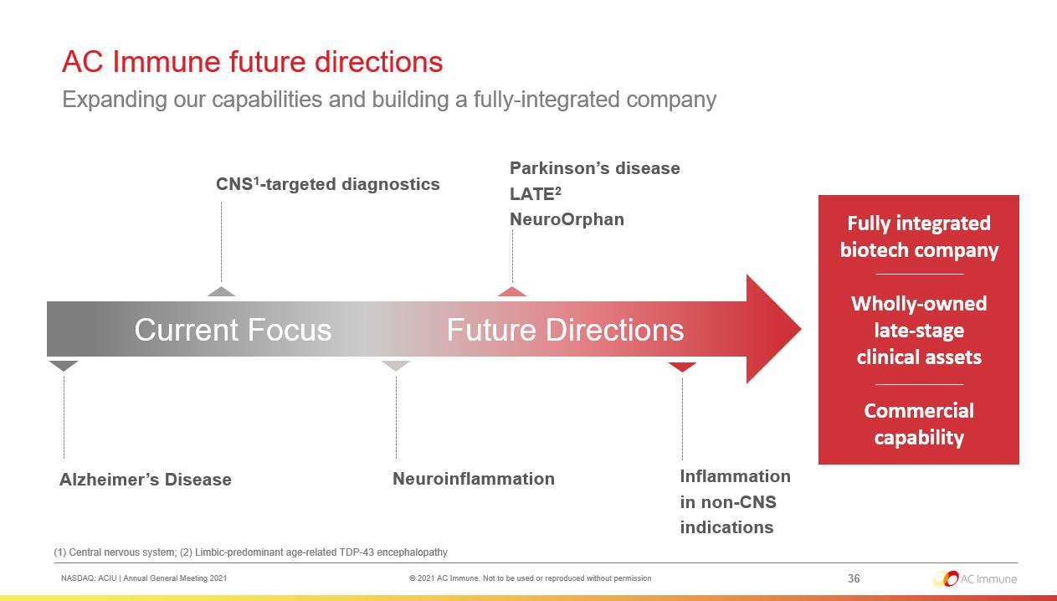



Exhibit 99.2

PRESS RELEASE

AC Immune Holds its Annual General Meeting of Shareholders

Lausanne, Switzerland, June 25, 2021 – AC Immune SA (NASDAQ: ACIU), a clinical-stage biopharmaceutical company pioneering precision medicine for neurodegenerative diseases, today announced that AC Immune held its Annual General Meeting per Swiss law. Shareholders cast their votes through the independent proxy appointed by the shareholders.

Shareholders re-elected Douglas Williams, Martin Velasco, Peter Bollmann, Alan Colowick, Tom Graney, Carl June, Werner Lanthaler, Andrea Pfeifer and Roy Twyman to their positions on the Board of Directors.
Douglas Williams and Martin Velasco will continue to serve as Chairman and Vice-Chairman of the Board, respectively.

Douglas Williams, Chairman of the Board of Directors of AC Immune, commented: “Despite impact from COVID-19, AC Immune has maintained its business on track. In fact, the Company is emerging from the pandemic with plans to accelerate development of key clinical programs, in particular its Alzheimer’s disease vaccines targeting Tau and Abeta. These industry-leading programs continue to demonstrate good safety and robust, lasting immunization against key pathological proteins, including phospho-Tau and both oligomeric and pyroglutamate Abeta, respectively. As the treatment focus for AD shifts earlier and potentially into the prevention setting, pioneering active vaccination positions AC Immune to become a global leader with a highly differentiated approach and clinically validated candidates. I am thankful to our Shareholders for their trust in the Board to lead AC Immune in its next phase of development.”

Shareholders also approved all resolutions at the AGM as proposed by the Board of Directors. Prior to the meeting, the Board withdrew agenda items 6.2 and 6.3. The meeting was held in accordance with the requirements of the COVID-19 Ordinance 3, issued by the Swiss Federal Council. About AC Immune SA

AC Immune SA is clinical-stage biopharmaceutical company that aims to become a global leader in precision medicine for neurodegenerative diseases, including Alzheimer’s disease, Parkinson’s disease, and NeuroOrphan indications driven by misfolded proteins. The Company’s two clinically validated technology platforms, SupraAntigen® and Morphomer®, fuel its broad and diversified pipeline of first- and best-in-class assets, which currently features nine therapeutic and three diagnostic candidates, six of which are currently in clinical trials. AC Immune has a strong track record of securing strategic partnerships with leading global pharmaceutical companies including Genentech, a member of the Roche Group, Eli Lilly and Company, and Janssen Pharmaceuticals, Inc., resulting in substantial non-dilutive funding to advance its proprietary programs and >$3 billion in potential milestone payments.

SupraAntigen® and Morphomer® are registered trademarks of AC Immune SA in the following territories: AU, CH, EU, JP, and GB. Morphomer® is also a registered trademark of AC Immune SA in CN and NO.

1/2

For further information, please contact:
Head of Investor Relations and |  |  | U.S. Media
Corporate Communications |  |  | Katie Gallagher
Joshua Drumm, Ph.D. |  |  | LaVoie Health Science
AC Immune |  |  | Phone: +1 617 792 3937
Phone : +1 917 809 0814 |  |  | Email: kgallagher@lavoiehealthscience.com
Email: joshua.drumm@acimmune.com

European Investors & Media

Chris Maggos
LifeSci Advisors
Phone : +41 79 367 6254
Email : chris@lifesciadvisors.com

Forward-looking statements

This press release contains statements that constitute “forward-looking statements” within the meaning of Section 27A of the Securities Act of 1933 and Section 21E of the Securities Exchange Act of 1934. Forward-looking statements are statements other than historical fact and may include statements that address future operating, financial or business performance or AC Immune’s strategies or expectations. In some cases, you can identify these statements by forward-looking words such as “may,” “might,” “will,” “should,” “expects,” “plans,” “anticipates,” “believes,” “estimates,” “predicts,” “projects,” “potential,” “outlook” or “continue,” and other comparable terminology. Forward-looking statements are based on management’s current expectations and beliefs and involve significant risks and uncertainties that could cause actual results, developments and business decisions to differ materially from those contemplated by these statements. These risks and uncertainties include those described under the captions “Item 3. Key Information – Risk Factors” and “Item 5. Operating and Financial Review and Prospects” in AC Immune’s Annual Report on Form 20-F and other filings with the Securities and Exchange Commission. These include: the impact of Covid-19 on our business, suppliers, patients and employees and any other impact of Covid-19. Forward-looking statements speak only as of the date they are made, and AC Immune does not undertake any obligation to update them in light of new information, future developments or otherwise, except as may be required under applicable law. All forward-looking statements are qualified in their entirety by this cautionary statement.

2/2

Exhibit 99.3

Version of 25 June 2021, as voted by AGM

 | ARTICLES OF ASSOCIATION |  |  | STATUTS
 | of |  |  | DE
 | AC Immune SA |  |  | AC IMMUNE SA
 | (AC Immune AG) |  |  | (AC IMMUNE AG)
 | (AC Immune Ltd) |  |  | (AC IMMUNE LTD)
 | with registered office in |  |  | AVEC SIÈGE À
 | Ecublens (VD) |  |  | ECUBLENS (VD)
The French version of these articles of association shall prevail. |  |  |  | LA VERSION FRANÇAISE DE CES STATUTS FAIT FOI.
 |  |  | I. | RAISON SOCIALE, SIÈGE,
I. | CORPORATE NAME, PRINCIPAL OFFICE, DURATION AND PURPOSE OF THE COMPANY |  |  | DURÉE ET BUT DE LA SOCIÉTÉ
Art. 1 Corporate Name and Duration |  |  | Art. 1 Raison sociale et durée
Under the name |  |  | Sous la raison sociale
 | AC Immune SA |  |  | AC Immune SA
 | (AC Immune AG) |  |  | (AC Immune AG)
 | (AC Immune Ltd) |  |  | (AC Immune Ltd)
there exists a Company pursuant to the provisions of Articles 620 et seq. of the Swiss Code of |  |  | il existe une société conformément aux articles 620 ss. du Code des Obligations suisse (CO) ayant
Obligations (CO) with registered office in Ecublens (VD). The duration of the Company is unlimited. |  |  | son siège à Ecublens (VD). La durée de la société est illimitée.
Art. 2 Purpose |  |  | Art. 2 | But
The purpose of the Company is the research, study, development, manufacture, promotion, sale and |  |  | Le but de la société est la recherche, les études, le développement, la fabrication, la promotion, la
marketing of products and substances within the pharmaceutical and nutrition industry as well as the |  |  | vente et le marketing des produits et des substances au sein de l'industrie pharmaceutique et de la
purchase, sale and exploitation of patents and licenses in this field. |  |  | nutrition ainsi que l'achat, la vente et l'exploitation de brevets et de licences dans ce domaine.
The Company may engage in any activities which are apt to favor the purpose of the Company directly |  |  | La société peut se livrer à des activités qui sont de nature à favoriser directement ou indirectement le
or indirectly. The Company may also acquire and sell real estate. |  |  | but de la société. La société peut également acquérir et vendre des biens immobiliers.
The Company may open branch offices in Switzerland and abroad and may also acquire participations |  |  | La société peut ouvrir des succursales en Suisse et à l'étranger et peut également acquérir des
in other companies. |  |  | participations dans d'autres sociétés.
The Company may provide securities to its subsidiaries and supply guarantees. |  |  | La société peut fournir des titres à ses filiales et des garanties d'approvisionnement.

 |  |  |  | 2
II. | SHARE CAPITAL AND SHARES |  | II. | CAPITAL-ACTIONS ET ACTIONS
Art. 3 Share Capital and Shares |  |  | Art. 3 Capital-actions et actions
The Share Capital of the Company is CHF 1'537'748.98. It is divided into 76'887'449 registered shares |  |  | Le capital-actions de la société se monte à CHF 1'537'748.98. Il est divisé en 76'887'449 actions
with a nominal value of CHF 0.02 each, fully paid-in. |  |  | nominatives d'une valeur nominale de CHF 0.02 chacune, entièrement libérées.
 |  |  | Art. 3a Augmentation autorisée du
Art. 3a Authorized Capital Increase of Share Capital |  |  |  | capital-actions
The Board of Directors is authorized to increase the share capital, in one or several steps until 27 |  |  | Le conseil d'administration est autorisé à augmenter le capital-actions, en une ou plusieurs étapes
June 2022, by a maximum amount of CHF 190'000 by issuing a maximum of 9'500'000 registered |  |  | jusqu'au 27 juin 2022, d'un montant maximum de CHF 190'000 par l'émission d'un nombre maximum
shares with a par value of CHF 0.02 each, to be fully paid up. An increase of the share capital (i) by |  |  | de 9'500'000 actions nominatives d'une valeur nominale de CHF 0.02 chacune, à libérer entièrement.
means of an offering underwritten by a financial institution, a syndicate or another third party or third |  |  | Une augmentation de capital (i) par souscription d'actions par une institution financière, un syndicat ou
parties, followed by an offer to the then-existing shareholders of the Company and (ii) in partial |  |  | un tiers ou des tiers, suivie par une souscription d'actions par les actionnaires de la société alors
amounts shall also be permissible. |  |  | existants et (ii) par montants partiels, est également autorisée.
The Board of Directors shall determine the time of the issuance, the issue price, the manner in which |  |  | Le conseil d'administration fixe la date d'émission, le prix d'émission, la manière de libérer les
the new registered shares have to be paid up, the date from which the registered shares carry the |  |  | nouvelles actions nominatives, la date à partir de laquelle les actions nominatives donnent droit à un
right to dividends, the conditions for the exercise of the preemptive rights and the allotment of |  |  | dividende, les conditions pour l'exercice des droits de souscription préférentiels et l'attribution des
preemptive rights that have not been exercised. The Board of Directors may allow the preemptive |  |  | droits de souscription préférentiels qui n'ont pas été exercés. Le conseil d'administration peut
rights that have not been exercised to expire, or it may place with third parties such rights or registered |  |  | autoriser que des droits de souscription préférentiels qui n'ont pas été exercés expirent ou attribuer à
shares, the preemptive rights of which have not been exercised, at market conditions or use them |  |  | des tiers ces droits ou actions nominatives, dont les droits de souscription préférentiels n'ont pas été
otherwise in the interest of the Company. |  |  | exercés, aux conditions du marché ou les utiliser autrement dans l'intérêt de la société.

3


The Board of Directors is authorized to withdraw or limit the preemptive rights of the shareholders and to allot them to third parties:

- if the issue price of the new registered shares is determined by reference to the market price; or

- for the acquisition of an enterprise, part of an enterprise or participations, or for the financing or refinancing of any of such acquisition, or in the event of share placement for the financing or refinancing of such placement; or

- for purposes of broadening the shareholder constituency of the Company in certain financial or investor markets, for purposes of the participation of strategic partners, or in connection with the listing or registration of new registered shares on domestic or foreign stock exchanges; or

- for purposes of granting an over-allotment option (Greenshoe) of up to 20% of the total number of registered shares in a placement or sale of registered shares to the respective initial purchaser(s) or underwriter(s); or

- for raising of capital (including private placements) in a fast and flexible which probably could not be reached without the exclusion of the statutory pre-emptive right of the existing shareholders; or

- for other valid grounds in the sense of Article 652b para. 2 CO; or

- following a shareholder or a group of shareholders acting in concert having accumulated shareholdings in excess of 33 ¹/₃ % of the share capital registered in the commercial register without having submitted to the other shareholders a takeover offer recommended by the Board of Directors, or for the defense of an actual, threatened or potential takeover bid, in relation to which the Board of Directors, upon consultation with an independent financial adviser retained by it, has not recommended to the shareholders acceptance on the basis that the Board of Directors has not found the takeover bid to be financially fair to the shareholders.

Le conseil d'administration est autorisé à retirer ou de limiter les droits de souscription préférentiels des actionnaires et de les attribuer à des tiers:

- si le prix d'émission des nouvelles actions nominatives est déterminé avec une référence au prix de marché; ou

- pour l'acquisition d'une entreprise, part d'entreprise ou participation, ou pour le financement ou le refinancement de ladite acquisition, ou en cas de placement d'actions pour le financement ou le refinancement dudit placement; ou

- pour l'élargissement de la base des actionnaires de la société dans certains marchés financiers ou d'investissement, afin de permettre une participation de partenaires stratégiques, ou dans le cas de cotation ou d'enregistrement de nouvelles actions nominatives aux bourses nationales ou étrangères; ou

- pour octroyer une option de surallocation (Greenshoe) d'un maximum de 20% du nombre total d'actions nominatives dans un placement ou une vente d'actions nominatives à l'/des acheteur(s) initial(s) ou du/des souscripteur(s) respectif(s); ou

- pour lever des capitaux (y compris des placements privés) dans un délai rapide et flexible, ce qui ne pourrait probablement pas être réalisé sans l'exclusion du droit préférentiel de souscription statuaire des actionnaires existants; ou

- pour d'autres motifs valables au sens de l'article 652b al. 2 CO; ou

- suite à l'accumulation par un actionnaire ou un groupe d'actionnaires agissant de concert de participations supérieures à 33 ¹/₃ % du capital-actions inscrit au registre du commerce sans avoir soumis aux autres actionnaires une offre publique d'achat recommandée par le conseil d'administration, ou pour la défense d'une offre publique d'achat réelle, imminente ou potentielle, pour laquelle le conseil d'administration, après consultation avec un conseiller financier indépendant retenu par lui, n'a pas recommandé l'acceptation aux actionnaires car il a estimé que l'offre publique d'achat n'était pas financièrement équitable pour les actionnaires.

 |  |  | 4
The acquisition of registered shares out of authorized capital increase of share capital for general |  |  | L'acquisition d'actions nominatives dans le cadre d'une augmentation autorisée du capital-actions à
purposes and any transfers of registered shares shall be subject to the restrictions specified in Article |  |  | des fins générales et les transferts d'actions nominatives sont soumis aux restrictions prévues à
4 of the Articles of Association. |  |  | l'article 4 des statuts.
Art. 3b | Conditional Capital Increase for Bonds and Similar Debt Instruments |  | Art. 3b Augmentation conditionnelle du capital-actions pour les obligations et instruments de
 |  |  | dettes similaire
The share capital of the Company shall be increased by a maximum amount of |  |  | Le capital-actions de la société peut être augmenté d'un montant maximum de CHF 91'560.94 par
CHF 91'560.94 through the issue of a maximum of 4'578'047 registered shares, payable in full, each |  |  | l'émission d'un maximum de 4'578'047 actions nominatives, d'une valeur nominale de CHF 0.02
with a nominal value of CHF 0.02 through the exercise of conversion and/or option or warrant rights |  |  | chacune, à libérer entièrement, suite à l'exercice de droits de conversion et/ou d'option ou de bons de
granted in connection with bonds or similar instruments, issued or to be issued by the Company or by |  |  | souscription accordés en relation avec des obligations ou d'instruments similaires, émis ou devant
subsidiaries of the Company, including convertible debt instruments. |  |  | être émis par la société ou par des filiales de la société, y compris les instruments d'emprunt
 |  |  | convertibles.
Shareholders' subscription rights are excluded. Shareholders' advance subscription rights with regard |  |  | Le droit de souscription préférentiel des actionnaires est exclu. Les droits de souscription préférentiels
to the new bonds or similar instruments may be restricted or excluded by decision of the Board of |  |  | préalables des actionnaires à l'égard des nouvelles obligations ou instruments similaires peuvent être
Directors in order to finance or re-finance the acquisition of companies, parts of companies or |  |  | limités ou exclus par décision du conseil d'administration afin de financer ou de refinancer l'acquisition
holdings, or new investments planned by the Company, or in order to issue convertible bonds and |  |  | d'entreprises, parts d'entreprises ou de holdings, ou de nouveaux investissements prévus par la
warrants on the international capital markets or through private placement. If advance subscription |  |  | société, ou en vue d'émettre des obligations convertibles et des bons de souscription sur les marchés
rights are excluded, then (1) the instruments are to be placed at market conditions, (2) the exercise |  |  | internationaux de capitaux ou par placement privé. Si les droits de souscription préférentiels
period is not to exceed ten years from the date of issue for warrants and twenty years for conversion |  |  | préalables sont exclus, (1) les instruments doivent être attribués aux conditions du marché, (2) la
rights and (3) the conversion or exercise price for the new shares is to be set at least in line with the |  |  | période d'exercice ne doit pas dépasser dix ans à partir de la date d'émission des bons de
market conditions prevailing at the date on which the instruments are issued. The respective holders |  |  | souscription et vingt ans pour les droits de conversion et (3) le prix de conversion ou d'exercice des
of conversion and/or option or warrant rights are entitled to subscribe the new shares. |  |  | actions nouvelles doit être fixé au moins aux conditions du marché prévalant à la date à laquelle les
 |  |  | instruments sont émis. Les détenteurs respectifs de droits de conversion et/ou option ou de bons de
 |  |  | souscription ont le droit de souscrire les nouvelles actions.

 |  |  |  | 5
The acquisition of registered shares through the exercise of conversion rights or warrants and any |  |  | L'acquisition d'actions nominatives par l'exercice de droits ou de bons de conversion et les transferts
transfers of registered shares shall be subject to the restrictions specified in Article 4 of the Articles of |  |  | d'actions nominatives sont assujetties aux restrictions prévues par l'article 4 des statuts.
Association.
Art. 3c | Conditional Share Capital Increase for Employee Benefit Plans |  | Art. 3c | Augmentation conditionnelle du capital-actions pour les plans d'avantages
 |  |  |  | sociaux
The share capital of the Company shall be increased by an amount not exceeding CHF 65'954.32 |  |  | Le capital social de la société sera augmenté d'un montant ne dépassant pas CHF 65'954.32 par
through the issue of a maximum of 3'297'716 registered shares, payable in full, each with a nominal |  |  | l'émission d'un maximum de 3'297'716 actions nominatives, entièrement libérées, chacune avec une
value of CHF 0.02, in connection with the exercise of option rights granted to any employee of the |  |  | valeur nominale de CHF 0.02, dans le cadre de l'exercice de droits d'option accordés à tout employé
Company or a subsidiary, and any consultant, members of the Board of Directors, or other person |  |  | de la Société ou d'une succursale, et à tout consultant, aux membres du conseil d'administration, ou à
providing services to the Company or a subsidiary. |  |  | d'autres personnes fournissant des services en faveur de la Société ou d'une filiale.
Shareholders' subscription rights shall be excluded with regard to these shares. These new registered |  |  | Le droit de souscription préférentiel des actionnaires est exclu à l'égard de ces actions. Ces nouvelles
shares may be issued at a price below the current market price. The Board of Directors shall specify |  |  | actions nominatives peuvent être émises à un prix inférieur au prix du marché actuel. Le conseil
the precise conditions of issue including the issue price of the shares. |  |  | d'administration doit préciser les conditions précises d'émission, y compris le prix d'émission des
 |  |  | actions.
The acquisition of registered shares in connection with employee participation and any further |  |  | L'acquisition d'actions nominatives dans le cadre de la participation des employés et d'autres
transfers of registered shares shall be subject to the restrictions specified in Article 4 of the Articles of |  |  | transferts d'actions nominatives sont soumis aux restrictions prévues à l'article 4 des statuts.
Association.

 |  |  |  | 6
Art. 4 | Share Register |  | Art. 4 | Registre des actions
The Company shall maintain a share register in which it shall register the name, first name and place |  |  | La société tient un registre des actions nominatives, dans lequel sont inscrits le nom, le prénom et
of residence (in case of legal persons the place of incorporation) of the owners and usufructuaries of |  |  | l'adresse (dans le cas d'une personne morale, le siège) des propriétaires et des usufruitiers des
its registered shares. Natural and legal persons as well as legal representatives of minors etc. entitled |  |  | actions. Les personnes physiques et morales ainsi que les représentants légaux des mineurs etc.
by law to the voting rights of a share which they do not own will be noted in the share register upon |  |  | autorisés par la loi à voter alors qu'ils ne sont pas propriétaires des actions seront, sur demande,
request. |  |  | inscrits dans le registre des actions.
Upon request, acquirers of shares will be registered in the share register without limitation as |  |  | Sur demande, les acquéreurs d'actions seront inscrits dans le registre des actions sans limitation
shareholders if they expressly certify that they acquired the shares in their own name and for their own |  |  | comme actionnaires s'ils attestent expressément qu'ils ont acquis les actions en leur propre nom et
account. |  |  | pour leur propre compte.
Persons who do not expressly declare in the registration application that they are holding the shares |  |  | Les personnes qui ne déclarent pas expressément dans la demande d'inscription qu'ils détiennent les
on their own account (thereafter: nominees) shall forthwith be entered on the share register as |  |  | actions pour leur propre compte (par la suite: les candidats) doivent immédiatement être inscrits dans
shareholders with voting rights up to a maximum of 3 percent of the share capital. Beyond that limit, |  |  | le registre des actions comme actionnaires avec droit de vote pour un maximum de 3 pour cent du
registered shares of nominees shall only be entered as voting if the nominees in question confirm in |  |  | capital-actions. Au-delà de cette limite, les actions nominatives des candidats ne sont inscrites avec
writing that they are willing to disclose the names, addresses and shareholdings of the persons on |  |  | droit de vote que si les candidats en question confirment par écrit qu'ils sont prêts à divulguer les
whose account they hold 0.5 percent or more of the share capital. The Board of Directors concludes |  |  | noms, adresses et participations des personnes pour le compte desquelles ils détiennent 0,5 pour
agreements with nominees that among other things govern the representation of shareholders and the |  |  | cent ou plus du capital-actions. Le conseil d'administration conclut des accords avec les candidats
voting rights. |  |  | qui, entre autres choses, régissent la représentation des actionnaires et des droits de vote.
After hearing the registered shareholder or nominee, the Board of Directors may remove entries in the |  |  | Après avoir entendu l'actionnaire enregistré ou le candidat, le conseil d'administration peut supprimer
share register with retroactive effect as per the date of entry, if such entry was based on false |  |  | des inscriptions dans le registre des actions avec effet rétroactif à la date d'inscription, si cette
information. The party affected must be informed of such removal immediately. |  |  | inscription était basée sur de fausses informations. La partie touchée doit être immédiatement
 |  |  | informée de cette suppression.

 |  |  |  | 7
No individual or legal entity may, directly or indirectly, formally, constructively or beneficially own (as |  |  | Aucune personne physique ou morale ne peut, directement ou indirectement, formellement ou
defined in the next paragraph below) or otherwise control voting rights ("Controlled Shares") with |  |  | implicitement détenir à son profit (comme défini dans le paragraphe ci-dessous) ou, d'une autre
respect to 33 ¹/₃ % or more of the registered share capital recorded in the Commercial Register |  |  | manière, contrôler le droit de vote (les "Actions Contrôlées") de 33 ¹/₃ % ou plus du capital-actions
except if such individual or legal entity has submitted prior to the acquisition of such Controlled Shares |  |  | nominatif tel qu'inscrit au registre du commerce sauf si cette personne physique ou morale a présenté
an orderly tender offer to all shareholders with a minimum price of the higher of (i) the volume |  |  | avant l'acquisition de ces Actions Contrôlée une offre publique d'achat en bonne et due forme à tous
weighted average price of the last 60 trading days prior to the publication of the tender offer or (ii) the |  |  | les actionnaires à un prix minimum équivalent au montant le plus élevé entre (i) le cours moyen
highest price paid by such individual or legal entity in the 12 months preceding to the publication of the |  |  | pondéré en fonction du volume des 60 derniers jours de bourse précédant la publication de l'offre
tender offer. Those associated through capital, voting power, joint management or in any other way, or |  |  | publique d'achat et (ii) le plus haut prix payé par cette personne physique ou morale dans les 12 mois
joining for the acquisition of shares, shall be regarded as one person. The registered shares |  |  | précédant la publication de l'offre publique d'achat. Les personnes associées par le capital, les droits
exceeding the limit of 33 ¹/₃ % and not benefiting from the exemption regarding a tender offer shall be |  |  | de vote, une gestion commune ou de toute autre manière, ou qui se joignent pour une acquisition
entered in the share register as shares without voting rights. |  |  | d'actions, sont considérées comme une personne. Les actions nominatives dépassant la limite de 33
 |  |  | ¹/₃ % et ne bénéficiant pas de l'exemption relative à une offre publique d'achat sont inscrites dans le
 |  |  | registre des actions comme des actions sans droit de vote.
For the purposes of this Article 4, "Controlled Shares" in reference to any individual or entity means: |  |  | Aux fins du présent article 4, Actions Contrôlées signifie en référence à toute personne physique ou
(a) all shares of the Company directly, indirectly or constructively owned by such individual or entity; |  |  | morale:
provided that |  |  | (a) toutes actions directement, indirectement ou implicitement détenues par cette personne physique
 |  |  | ou morale, à condition que
(i) shares owned, directly or indirectly, by or for a partnership, or trust or estate will be |  |  | (i) les actions détenues, directement ou indirectement, par ou pour un partenariat, une fiducie
 | considered as being owned proportionately by its partners, or beneficiaries; and |  |  | ou une communauté d'héritiers sont considérées comme étant détenues
 |  |  |  | proportionnellement par leurs partenaires ou bénéficiaires; et
 |  |  | (ii) | les actions détenues, directement ou indirectement, par ou pour une société seront
(ii) | shares owned, directly or indirectly, by or for a corporation will be considered as being |  |  | considérées comme étant détenues proportionnellement par tout actionnaire détenant 50%
 | owned proportionately by any shareholder owning 50% or more of the outstanding voting |  |  | ou plus des actions avec droit de vote en circulation de cette société; et
 | shares of such corporation; and

8


  - shares subject to options, warrants or other similar rights shall be deemed to be owned; and

- all shares of the Company directly, indirectly beneficially owned by such individual or entity; provided that

  - a beneficial owner of a security includes any person who, directly or indirectly, through any contract, arrangement, understanding, relationship, or otherwise alone or together with other such persons has or shares:

    - voting power which includes the power to vote, or to direct the voting of, such security; and/or

    - investment power which includes the power to dispose, or to direct the disposition of, such security.

- Any person who, directly or indirectly, creates or uses a trust, proxy, power of attorney, pooling arrangement or any other contract, arrangement, or device with the purpose or effect of divesting such person of beneficial ownership of shares of the Company or preventing the vesting of such beneficial ownership as part of a plan or scheme to evade the provisions of these articles of association shall be deemed to be the beneficial owner of such shares.

- A person shall be deemed to be the beneficial owner of shares if that person has the right to acquire beneficial ownership of such shares within 60 days, including but not limited to any right acquired: (A) through the exercise of any option, warrant or right; (B) through the conversion of a security; (C) pursuant to the power to revoke a trust, discretionary account, or similar arrangement; or (D) pursuant to the automatic termination of a trust, discretionary account or similar arrangement.

  - les actions sujettes à des options, des bons de souscription ou autres droits semblables sont réputées être détenues; et

- toutes actions de la société détenues directement, indirectement ou à son profit par cette personne physique ou morale, à condition que

  - un bénéficiaire effectif d'un titre comprend toute personne qui, directement ou indirectement, par le biais d'un contrat, d'un accord, d'une entente, d'une relation, ou autrement, seul ou avec d'autres personnes a ou partage:

    - le pouvoir de voter, y compris le pouvoir de voter ou de diriger le vote d'un tel titre; et/ou

    - le pouvoir d'investir, y compris le pouvoir de disposer ou de diriger la disposition d'un tel titre.

- Toute personne qui, directement ou indirectement, crée ou utilise une fiducie, une procuration, un pooling ou tout autre contrat, accord, ou un dispositif ayant pour objet ou pour effet de priver cette personne de la propriété effective des actions de la société ou d'en empêcher l'acquisition effective au moyen d'un plan ou programme visant à se soustraire aux dispositions de ces statuts est réputée être le propriétaire effectif de ces actions.

- Une personne est réputée être propriétaire effective d'actions si cette personne a le droit d'acquérir la propriété effective de ces actions dans les 60 jours, y compris, mais pas limité à un droit acquis: (A) au moyen de l'exercice d'une option, d'un bon ou d'un droit de souscription; (B) par la conversion d'un titre; (C) en vertu du pouvoir de révoquer une fiducie, compte discrétionnaire ou accord semblable; ou (D) conformément à la résiliation automatique d'une fiducie, compte discrétionnaire ou accord semblable.

 |  |  |  |  |  | 9
The limit of 33 ¹/ % of the registered share capital also applies to the subscription for, or acquisition |  |  | La limite | de 33 ¹/ | 3 | % du capital-actions nominatif s'applique également à la souscription ou
 | 3 |  |  |  | 3
of, registered shares by exercising option or convertible rights arising from registered or bearer |  |  | l'acquisition d'actions nominatives par l'exercice d'options ou de droits convertibles découlant de titres
securities or any other securities issued by the Company or third parties, as well as by means of |  |  | nominatifs ou au porteur ou d'autres titres émis par la société ou par des tiers, ainsi que par le biais
exercising purchased preemptive rights arising from either registered or bearer shares. The registered |  |  | de l'exercice de droits de souscription préférentiels achetés découlant d'actions nominatives ou au
shares exceeding the limit of 33 ¹/₃ % shall be entered in the share register as shares without voting |  |  | porteur. Les actions nominatives dépassant la limite de 33 ¹/₃ % sont inscrites dans le registre des
rights. |  |  | actions comme des actions sans droit de vote.
 |  |  | Le conseil d'administration peut dans des cas particuliers approuver des exceptions aux règles
The Board of Directors may in special cases approve exceptions to the above regulations. The Board |  |  | précitées. Il est en outre autorisé, après consultation avec la personne concernée, de supprimer avec
of Directors is in addition authorized, after due consultation with the person concerned, to delete with |  |  | effet rétroactif des inscriptions du registre des actions qui ont été effectuées sur la base de fausses
retroactive effect entries in the share register which were effected on the basis of false information. |  |  | informations.
Art. 5 | Share Certificates and Intermediated Securities |  | Art. 5 | Certificats d'actions et titres intermédiés
The Company may issue registered shares in the form of single certificates, global certificates and |  |  | La société peut émettre des actions nominatives sous forme de certificats individuels, de certificats
uncertificated securities. Under the conditions set forth by statutory law, the Company may convert its |  |  | globaux et de titres dématérialisés. Dans les conditions prévues par la loi, la société peut convertir
registered shares from one form into another form at any time and without the approval of the |  |  | ses actions nominatives d'une forme en une autre forme, à tout moment et sans l'approbation des
shareholders. |  |  | actionnaires.
The shareholder has no right to demand a conversion of the registered shares. Each shareholder may, |  |  | L'actionnaire n'a pas le droit d'exiger une conversion d'actions nominatives. Chaque actionnaire peut
however, at any time request a written confirmation from the Company of the registered shares held |  |  | toutefois, à tout moment, demander une confirmation écrite de la société du nombres d'actions
by such shareholder, as reflected in the share register. |  |  | nominatives détenues par cet actionnaire telles qu'inscrites au registre du commerce.

 |  |  |  | 10
The transfer of intermediated securities and the pledging of these intermediated securities shall be |  |  | Le transfert des titres intermédiés et la mise en gage de ces titres intermédiés suivent les dispositions
based on the provisions of the Swiss Federal Intermediated Securities Act. Transfer of propriety as |  |  | de la Loi fédérale sur les titres intermédiés. Le transfert de propriété à titre de sûreté par cession
collateral by means of written assignment are not permitted. |  |  | écrite n'est pas autorisé.
Art. 6 Exercise of Shareholders Rights |  |  | Art. 6 | Exercice des droits des actionnaires
The shares are indivisible and the Company recognizes only one single representative per share. |  |  | Les actions sont indivisibles et la société ne reconnaît qu'un seul représentant par action.
The right to vote and the other rights pertaining to a registered share may only be exercised by a |  |  | Le droit de vote et les autres droits relatifs à une action nominative ne peut être exercé que par un
shareholder, a usufructuary or a nominee who is registered with the right to vote in the share register |  |  | actionnaire, un usufruitier ou un candidat qui est inscrit avec le droit de vote dans le registre des
and by persons who are entitled by law to the voting rights of a share. |  |  | actions et par des personnes autorisées par la loi à exercer les droits de vote d'une action.
III. | CORPORATE STRUCTURE |  | III. | STRUCTURE DE LA SOCIÉTÉ
Art. 7 | Organization |  | Art. 7 | Organisation
The corporate bodies are: |  |  | Les organes de la société sont:
A. | the General Meeting; |  | A. | L'assemblé générale;
B. | the Board of Directors; |  | B. | Le conseil d'administration;
C. | the Auditors. |  | C. | l'organe de révision.
IV. | THE GENERAL MEETING |  | IV. | L'ASSEMBLÉE GÉNÉRALE
Art. 8 | Powers |  | Art. 8 | Pouvoirs
The General Meeting is the supreme body of the Company. It has the following non delegable |  |  | L'assemblée générale des actionnaires est le pouvoir suprême de la société. Elle a les droits
powers: |  |  | intransmissibles suivants:
a) to adopt and amend the Articles of Association (Articles 651a, 652g, 653g und 653i CO remain
reserved); |  |  | a) adapter et modifier les statuts (articles 651a, 652g, 653g et 653i CO sont réservés);

 |  |  |  |  |  | 11
b) to elect and remove the members of the Board of Directors, the Chairman of the Board of |  |  |  | b) |  | nommer et révoquer les membres du conseil d'administration, le président du conseil
 | Directors, the members of the Compensation Committee, the Auditors and the Independent Proxy; |  |  |  | d'administration, les membres du comité de rémunération, l'organe de révision et le mandataire
 |  |  |  |  | indépendant;
c) to approve the management report and the annual accounts and to determine the allocation of |  |  |  | c) approuver le rapport de gestion et les comptes annuels et déterminer la répartition des bénéfices,
 | profits, in particular with regard to dividends and bonus payments; |  |  |  | en particulier en ce qui concerne les dividendes et les bonus;
d) to discharge the members of the Board of Directors and of the Executive Committee; |  |  |  | d) donner décharge aux membres du conseil d'administration et au comité exécutif;
e) to approve the aggregate amounts of compensation of the Board of Directors and the Executive |  |  |  | e) | approuver les montants globaux des rémunérations du conseil d'administration et du comité
 | Committee in accordance with Article 18 of the Articles of Association; |  |  |  | exécutif conformément à l'article 18 des statuts;
f) | to pass resolutions concerning all matters which are reserved to the authority of the General |  |  | f) | prendre les décisions sur toutes les affaires qui sont attribuées à l'assemblée générale par la loi
 | Meeting by law or by the Articles of Association. |  |  |  | ou les statuts.
Art. 9 |  | Ordinary General Meeting |  | Art. 9 |  | Assemblée générale ordinaire
The Ordinary General Meeting shall be held annually within six months after the close of the business |  |  |  | L'assemblée générale ordinaire aura lieu chaque année dans les six mois qui suivent la clôture de
year at such time and at such location, which may be within or outside Switzerland, as determined by |  |  |  | l'exercice à la date et à l'endroit, qui peut être en ou hors de la Suisse, tel que déterminé par le conseil
the Board of Directors. |  |  |  | d'administration.
Art. 10 Extraordinary General Meeting |  |  |  | Art. 10 |  | Assemblée générale extraordinaire
 |  |  |  | Les assemblées générales extraordinaires peuvent être convoquées par décision de l'assemblée
Extraordinary General Meetings may be called by resolution of the General Meeting, the Auditors or |  |  |  | générale, l'organe de révision ou le conseil d'administration, ou par des actionnaires avec droit de
the Board of Directors, or by shareholders with voting powers, provided they represent at least 10% of |  |  |  | vote, à condition qu'ils représentent au moins 10% du capital-actions et qu'ils soumettent (a) (1) une
the share capital and who submit (a)(1) a request signed by such shareholder(s) that specifies the |  |  |  | demande signée par le(s)dit(s) actionnaire(s) qui spécifie les objets à faire figurer sur l'ordre du jour,
item(s) to be included on the agenda, (2) the respective proposals of the shareholders and (3) |  |  |  | (2) les propositions respectives de ces actionnaires et (3) la preuve des participations requises
evidence of the required shareholdings recorded in the share register and (b) such other information |  |  |  | inscrites dans le registre des actions et (b) les autres informations qui doivent être mentionnées dans
as would be required to be included in a proxy statement pursuant to the rules of the country where |  |  |  | une déclaration (proxy statement) conformément aux règles du pays où les actions de la société sont
the Company's shares are primarily listed. |  |  |  | principalement cotées.

 |  |  | 12
Art. 11 Notice and Agenda of Shareholders' Meetings |  | Art. 11 | Convocations et ordres du jour des assemblées générales
Notice of a General Meeting of Shareholders shall be given by the Board of Directors or, if necessary, |  | L'assemblée générale est convoquée par le conseil d'administration ou, si nécessaire, par l'organe de
by the Auditor, not later than twenty calendar days prior to the date of the General Meeting of |  | révision, au moins 20 jours avant la tenue de l'assemblée générale des actionnaires. La convocation à
Shareholders. Notice of the General Meeting of Shareholders shall be given by way of a one-time |  | l'assemblée générale des actionnaires doit être faite au moyen d'une seule publication conformément
announcement in the official means of publication of the Company pursuant to Article 46 of these |  | à l'article 46 de ces statuts. La période de préavis sera réputée avoir été respectée si la convocation à
Articles of Association. The notice period shall be deemed to have been observed if notice of the |  | l'assemblée générale des actionnaires est publiée conformément à l'article 46 de ces statuts, étant
General Meeting of Shareholders is published in such official means of publication, it being |  | entendu que la date de publication ne doit pas être calculée dans la période de préavis. Les
understood that the date of publication shall not be computed in the notice period. Shareholders of |  | actionnaires inscrits peuvent en outre être informés de l'assemblée générale des actionnaires par
record may in addition be informed of the General Meeting of Shareholders by ordinary mail or e-mail. |  | courrier ordinaire ou par e-mail.
The notice of a General Meeting of Shareholders shall specify the items on the agenda and the |  | La convocation à l'assemblée générale des actionnaires doit préciser les objets de l'ordre du jour et
proposals of the Board of Directors and the shareholder(s) who requested that a General Meeting of |  | les propositions du conseil d'administration et l'/les actionnaire(s) qui a/ont demandé que l'assemblée
Shareholders be held or an item be included on the agenda, and, in the event of elections, the |  | générale des actionnaires ait lieu ou qu'un objet soit inscrit à l'ordre du jour, et, dans le cas
name(s) of the candidate(s) that has or have been put on the ballot for election. |  | d'élections, le/les nom(s) du/des candidat(s) qui a ou ont été mis sur le bulletin de vote pour l'élection.
The Board of Directors shall state the matters on the agenda. |  | Le conseil d'administration doit indiquer les objets de l'ordre du jour.

 |  | 13
Shareholders who represent an aggregate of at least 10 percent of the share capital or together |  | Les actionnaires qui représentent un total d'au moins 10 pour cent du capital-actions ou qui
representing shares with a nominal value of 1 million Swiss francs may demand that an item be placed |  | représentent ensemble une valeur nominale de CHF 1 million d'actions peuvent exiger qu'un objet soit
on the agenda of a General Meeting of Shareholders. A request for inclusion of an item on the agenda |  | inscrit à l'ordre du jour d'une assemblée générale des actionnaires. Une demande d'inscription d'un
must be requested in writing delivered to or mailed and received at the registered office of the |  | objet à l'ordre du jour doit être faite par écrit et remise ou envoyée et reçue au siège de la société au
Company at least 120 calendar days before the first anniversary of the date that the Company's proxy |  | moins 120 jours avant le premier anniversaire de la date à laquelle la déclaration (proxy statement) de
statement was released to shareholders in connection with the previous year's ordinary General |  | la Société a été communiquée aux actionnaires lors de l'assemblée générale ordinaire des
Meeting of Shareholders. However, if no ordinary General Meeting of Shareholders was held in the |  | actionnaires de l'année précédente. Toutefois, si aucune assemblée générale ordinaire des
previous year or if the date of the ordinary General Meeting of Shareholders has been changed by |  | actionnaires n'a eu lieu l'année précédente ou si la date de l'assemblée générale ordinaire des
more than 30 calendar days from the date contemplated at the time of the previous year's proxy |  | actionnaires a été modifiée de plus de 30 jours calendaires à compter de la date prévue au moment
statement, request for inclusion of an item on the agenda must be requested not fewer than the later |  | de la déclaration (proxy statement) de l'année précédente, une demande d'inscription d'un objet à
of (i) 150 calendar days prior to the date of the contemplated annual General Meeting or (ii) the date |  | l'ordre du jour doit être demandée au moins à la date la plus tardive entre (i) 150 jours calendaires
which is ten calendar days after the date of the first public announcement or other notification to the |  | avant la date de l'assemblée générale ordinaire envisagée ou (ii) la date qui est dix jours calendaires
shareholders of the date of the contemplated annual General Meeting. To be timely for an |  | plus tard que la date de la première annonce publique ou autre notification aux actionnaires de la date
extraordinary General Meeting, a shareholder's notice to the Secretary must be delivered to or mailed |  | envisagée de l'assemblée générale ordinaire. Pour être dans les délais pour une assemblée générale
and received at the registered office of the Company not fewer than the later of (i) 120 calendar days |  | extraordinaire, l'avis d'un actionnaire au secrétaire doit être livré ou envoyé et reçu au siège de la
before the date of the extraordinary General Meeting of Shareholders or (ii) the date which is ten |  | société au moins à la date la plus tardive entre (i) 120 jours calendaires avant la date de l'assemblée
calendar days after the date of the first public announcement or other notification to the shareholders |  | générale extraordinaire des actionnaires ou (ii) la date qui est dix jours calendaires plus tard que la
of the date of the contemplated extraordinary General Meeting of Shareholders. |  | date de la première annonce publique ou autre notification aux actionnaires de la date envisagée de
 |  | l'assemblée générale extraordinaire des actionnaires.
Each request for inclusion of an item on the agenda must include (i) a brief description of the business |  | Chaque demande d'inscription d'un objet à l'ordre du jour doit inclure (i) une brève description de
desired to be brought before the meeting and the reasons for conducting such business at the |  | l'affaire qui sera soumise à l'assemblée et les raisons pour lesquelles cette affaire est soumise à
meeting; (ii) the name and address, as they appear on the Company's register of shareholders, of the |  | l'assemblée; (ii) le nom et l'adresse, tels qu'ils apparaissent dans le registre des actionnaires de la
shareholder proposing such business; (iii) the number of shares of the Company which are beneficially |  | société, de l'/des actionnaire(s) proposant un tel objet; (iii) le nombre d'actions de la société
owned by such shareholder; (iv) the dates upon which the shareholder acquired such shares; (v) |  | effectivement détenues par (un) tel(s) actionnaire(s); (iv) les dates auxquelles l'/les actionnaire(s)
documentary support for any claim of beneficial ownership; (vi) any material interest of such |  | a/ont acquis ces actions; (v) l'appui documentaire pour toute revendication de propriété effective; (vi)
shareholder in such business; and (vii) a statement in support of the matter and, for proposals sought |  | un intérêt important de cet/ces actionnaire(s) par rapport à cet objet; et (vii) une déclaration à l'appui
to be included in the Company's proxy statement, any other information required by Securities and |  | de cet objet et, pour les propositions devant être incluses dans la déclaration (proxy statement) de la
Exchange Commission Rule "14a-8". |  | société, toute autre information requise par la Securities and Exchange Commission règle "14a-8".

 |  | 14
In addition, if the shareholder intends to solicit proxies from the shareholders of the Company, such |  | En outre, si un actionnaire a l'intention de solliciter des procurations des actionnaires de la société, cet
shareholder shall notify the Company of this intent in accordance with Securities and Exchange |  | actionnaire doit en informer la société conformément aux dispositions de la Securities and Exchange
Commission Rule "14a-4" and/or Rule "14a-8". |  | Commission règle "14a-4" et "14a-8".
No resolution may be passed at a General Meeting of Shareholders concerning an item in relation to |  | Aucune décision ne peut être adoptée lors d'une assemblée générale des actionnaires si un objet n'a
which due notice was not given. Proposals made during a General Meeting of Shareholders to (i) |  | pas été inscrit à l'ordre du jour dans le délai de préavis. Les propositions faites au cours d'une
convene a extraordinary General Meeting or (ii) initiate a special investigation in accordance with |  | assemblée générale des actionnaires pour (i) convoquer une assemblée générale extraordinaire ou
article 697a of the Swiss Code of Obligations are not subject to the due notice requirement set forth |  | (ii) instituer un contrôle spécial au sens de l'article 697a CO ne sont pas soumises à l'obligation
herein. |  | d'inscription prévue dans ces statuts.
No advance notice is required to propose motions on duly notified agenda items and to debate items |  | Aucun préavis n'est nécessaire pour proposer des motions sur les objets inscrits à l'ordre du jour ou
without passing resolutions. |  | débattre desdits objets sans prendre de décisions.
Art. 12 Documentation |  | Art. 12 Documents
The annual business report, the compensation report and the Auditor's report must be submitted for |  | Le rapport de gestion annuel, le rapport de rémunération et le rapport du réviseur doivent être
examination by the shareholders at the registered office of the Company at least 20 days prior to the |  | présentés aux actionnaires pour examen au siège de la société au moins 20 jours avant la date de
date of the Ordinary General Meeting. Each shareholder may request that a copy of this |  | l'assemblée générale ordinaire. Chaque actionnaire peut demander une copie de ces documents qui
documentation be sent to him promptly by e-mail. Such right shall be included in the invitation to the |  | doivent lui être envoyés promptement par e-mail. Ce droit doit être mentionné dans l'invitation à
General Meeting. |  | l'assemblée générale.

 |  |  |  | 15
Art. 13 | Meeting of All Shareholders |  | Art. 13 | Assemblée universelle
Shareholders or their proxies representing all shares issued may hold a General Meeting without |  |  | Les propriétaires ou les représentants de la totalité des actions peuvent, s'il n'y a pas d'opposition,
observing the formalities required for calling a meeting, unless objection is raised. At such a meeting, |  |  | tenir une assemblée générale sans observer les formes prévues pour sa convocation. Aussi
discussions may be held and resolutions passed on all matters within the scope of the powers of a |  |  | longtemps que les propriétaires ou les représentants de la totalité des actions sont présents, cette
General Meeting for so long as the shareholders or proxies representing all shares issued are present. |  |  | assemblée a le droit de délibérer et de statuer valablement sur tous les objets qui sont du ressort de
 |  |  | l'assemblée générale.
Art. 14 | Chairman and Scrutineers |  | Art. 14 | Président et scrutateurs
The Chairman of the Board of Directors shall preside over the General Meeting. In his absence, a |  |  | L'assemblée générale est présidée par le président du conseil d'administration. En cas
member of the Board of Directors or another Chairman of the Meeting designated by the General |  |  | d'empêchement, un autre membre du conseil d'administration ou un président ad hoc nommé par
Meeting shall preside. |  |  | l'assemblée générale préside celle-ci.
The Chairman of the Meeting shall designate a Secretary and the scrutineers who need not be |  |  | Le président de l'assemblée générale désigne un secrétaire et les scrutateurs qui ne doivent pas
shareholders. |  |  | nécessairement être actionnaires.
Art. 15 | Minutes |  | Art. 15 | Procès-verbal
The Board of Directors is responsible for the keeping of the minutes of the Meeting, which shall state the |  |  | Le conseil d'administration est responsable de la tenue du procès-verbal de l'assemblée, qui doit
number, kind, nominal value of shares represented by the shareholders, by the corporate bodies and by |  |  | indiquer le nombre, le type, la valeur nominale des actions représentées par les actionnaires, par
the independent proxy and gives information on resolutions passed, elections, requests for information |  |  | les organes sociaux et par le représentant indépendant et donne des informations sur les décisions
and information as well as declarations given by the shareholders. The minutes shall be signed by the |  |  | adoptées, les élections, les demandes de renseignements et les informations ainsi que les
Chairman and the Secretary. |  |  | déclarations faites par les actionnaires. Le procès-verbal est signé par le président et le secrétaire.
The shareholders are entitled to inspect the minutes. |  |  | Les actionnaires ont le droit d'examiner le procès-verbal.
Art. 16 | Right to Vote |  | Art. 16 | Droit de vote
Each share entitles to one vote. |  |  | Chaque action donne droit à une voix.
Each shareholder may be represented at a General Meeting by any person who is so authorized by a |  |  | Chaque actionnaire peut se faire représenter à l'assemblée générale par toute personne qui est
written proxy. A proxy need not be a shareholder. |  |  | autorisée par une procuration écrite. Le représentant ne doit pas nécessairement être un
 |  |  | actionnaire.

 |  |  |  |  |  | 16
Each shareholder may be represented by the Independent Proxy. The requirements regarding proxies |  |  |  | Chaque actionnaire peut se faire représenter par le représentant indépendant. Les exigences en
and instructions are determined by the Board of Directors. |  |  |  | matière de procurations et les instructions sont déterminées par le conseil d'administration.
Art. 17 Resolutions and Elections |  |  |  | Art. 17 |  | Décisions and élections
All voting and elections are held openly or electronically. A written voting or election shall be held if |  |  |  | Tous votes et élections sont tenus ouvertement ou par voie électronique. Sur instruction du
instructed so by the Chairman or if decided by the General Meeting. |  |  |  | président ou de l'assemblée générale, un vote ou une élection doit être tenu par écrit.
The General Meeting shall pass its resolutions and carry out its elections with the simple majority of the |  |  |  | Sous réserve des dispositions impératives de la loi ou des statuts, l'assemblée générale prend ses
votes cast regardless of abstentions and empty or invalid votes, unless statutory law or articles of |  |  |  | décisions et procède aux élections à la majorité simple des voix émises. En cas de partage égal des
association state otherwise. In the event of tie votes, the request shall be refused. The Chairman shall |  |  |  | voix, la requête sera refusée. Le président n'a pas voix prépondérante.
not have a casting vote.
A resolution of the General Meeting passed by at least two thirds of the represented share votes and the |  |  |  | Une décision de l'assemblée générale recueillant au moins les deux tiers des voix attribuées aux
absolute majority of the represented shares par value is required for: |  |  |  | actions représentées et la majorité absolue des valeurs nominales représentées est nécessaire
 |  |  |  | pour:
a) The cases listed in art. 704 para. 1 CO, i.e.: |  |  |  | a) les cas énumérés dans l'art. 704 al. 1 CO, i.e.:
 | (i) the change of the company purpose; |  |  |  | (i) la modification du but social;
 | (ii) the creation of shares with privileged voting rights; |  |  |  | (ii) l'introduction d'actions à droit de vote privilégié;
 | (iii) the restriction of the transferability of registered shares; |  |  |  | (iii) la restriction de la transmissibilité des actions nominatives;
 | (iv) an increase of capital, authorized or subject to a condition; |  |  |  | (iv) l'augmentation autorisée ou conditionnelle du capital-actions;
 | (v) | an increase of capital out of equity, against contribution in kind, or for the purpose of |  |  | (v) l'augmentation du capital-actions au moyen des fonds propres, contre apport en nature
 |  | acquisition of assets and the granting of special benefits; |  |  |  | ou en vue d'une reprise de biens et l'octroi d'avantages particuliers;
 | (vi) the limitation or withdrawal of subscription rights; |  |  |  | (vi) la limitation ou la suppression du droit de souscription préférentiel;
 | (vii) | the change of the domicile of the Company; and |  |  | (vii) | le transfert du siège de la société; et
 | (viii) | the liquidation of the Company; |  |  | (viii) la dissolution de la société;
b) | the merger, de-merger or conversion of the Company (subject to mandatory law); |  |  | b) |  | la fusion, la scission ou la conversion de la société (sous réserve des dispositions
c) the alleviating or withdrawal of restrictions upon the transfer of registered shares; |  |  |  |  | impératives);
d) the conversion of registered shares into bearer shares and vice versa; and |  |  |  | c) | l'atténuation ou la suppression des restrictions sur le transfert des actions nominatives;
e) the amendment or elimination of the provisions of Article 4 and 29 of the Articles of Association as |  |  |  | d) | la conversion d'actions nominatives en actions au porteur et vice versa; et
 | well as those contained in this Article 17. |  |  | e) | la modification ou la suppression des dispositions des articles 4 et 29 des statuts ainsi que
 |  |  |  |  | ceux contenues dans le présent article 17.

 |  |  |  | 17
Art.18 | Votes on Compensation |  | Art. 18 | Votes sur la rémunération
The General Meeting shall approve annually and separately the proposals of the Board of Directors in |  |  | L'assemblée générale approuve annuellement et séparément les propositions du conseil
relation to the maximum aggregate amount of: |  |  | d’administration relatives au montant global maximal de:
a) compensation of the Board of Directors for the period until the next Ordinary General Meeting; |  |  | a) la rémunération du conseil d'administration pour la période allant jusqu'à l'assemblée générale
b) compensation of the Executive Committee for the following financial year. |  |  | ordinaire suivante;
 |  |  | b) la rémunération du comité exécutif pour l’exercice annuel suivant.
The respective total compensation amounts include social security and occupational pension |  |  | Les montants totaux de rémunération respectifs comprennent la sécurité sociale et les cotisations
contributions for the benefit of the members of the Board of Directors, the Executive Committee and the |  |  | de retraite professionnelle au profit des membres du conseil d'administration, du comité exécutif et
Company. |  |  | de la société.
If the General Meeting refuses to approve a respective motion by the Board of Directors, the Board of |  |  | Si l'assemblée générale refuse d'approuver une motion soumise par le conseil d'administration, le
Directors may either submit a new motion at the same meeting or determine a maximum total |  |  | conseil d'administration peut, soit présenter une nouvelle motion à la même séance ou déterminer
remuneration or several maximum partial remunerations, subject to the relevant principles of the |  |  | une rémunération maximale totale ou plusieurs rémunérations maximales partielles, sous réserve
compensation, or submit a new motion to the next General Meeting for approval. The Company may pay |  |  | des principes concernant la rémunération, soit soumettre une nouvelle motion à la prochaine
remunerations within the framework of the maximum total or partial remuneration and subject to the |  |  | assemblée générale pour approbation. La société peut verser des rémunérations dans le cadre de
approval by the General Meeting. |  |  | la rémunération maximale totale ou partielle et sous réserve de l'approbation par l'assemblée
 |  |  | générale.

18

 |  |  | Le conseil d'administration soumet le rapport de rémunération à un vote consultatif de l'assemblée
The Board of Directors shall submit the compensation report to an advisory vote of the General Meeting. |  |  | générale.
Art. 19 Independent Proxy |  |  | Art. 19 Représentant indépendant
 |  |  | Le représentant indépendant est élu par l'assemblée générale ordinaire pour une durée d'un an
The Independent Proxy shall be elected by the Ordinary General Meeting for a term of one year until the |  |  | jusqu'à la fin de la prochaine assemblée générale ordinaire. Une réélection est possible. Le
end of the next Ordinary General Meeting. Re-election is permitted. The Independent Proxy informs the |  |  | représentant indépendant informe la société sur le nombre, le type, la valeur nominale et la
Company about number, type, par value and category of the represented shares. The Chairman of the |  |  | catégorie des actions représentées. Le président du conseil d'administration communique ces
Board discloses the information to the General Meeting. The other duties of the Independent Proxy are |  |  | informations à l'assemblée générale. Les autres fonctions du représentant indépendant sont
determined by the applicable statutory provisions. |  |  | déterminées par les dispositions statutaires applicables.
V. | BOARD OF DIRECTORS |  | V. | CONSEIL D'ADMINISTRATION
Art. 20 Number of Members, Term of Office |  |  | Art. 20 Nombre de membres, durée de la fonction
 |  |  | Le conseil d'administration se compose d'au minimum 3 et au maximum 9 membres. Ce nombre
The Board of Directors shall consist of at least 3 and not more than 9 members. This maximum number |  |  | maximum pourra être dépassé s’il est nécessaire de satisfaire à des conditions de nationalités, de
may be exceeded if it is necessary to satisfy nationality, residency and / or gender requirements under |  |  | résidences ou de genres selon le droit suisse ou étranger. Le président et les membres du conseil
Swiss or foreign laws. The chairman and the members of the Board of Directors are individually elected |  |  | d'administration sont élus individuellement par l'assemblée générale pour un mandat d'un an
by the General Meeting for a term of one year until the end of the next Ordinary General Meeting, |  |  | jusqu'à la fin de la prochaine assemblée générale ordinaire, à condition qu'il/elle ne démissionne
provided that he/she does not resign or is not replaced during his/her term. |  |  | pas ou ne soit pas remplacé(e) durant son mandat.
 |  |  | Les membres du conseil d'administration peuvent être réélus sans limitation. La limite d’âge des
The members of the Board of Directors may be re-elected without limitation. The maximum age limit of |  |  | membres du conseil d'administration est fixée à 75 ans. Lorsqu'un membre du conseil
members of the Board shall be 75 years. When a member of the Board of Directors reaches this age |  |  | d'administration atteint cette limite d'âge durant son mandat, ledit mandat sera automatiquement
limit during his term of office, such term shall automatically extend to the next ordinary shareholders' |  |  | prolongé jusqu'à la prochaine assemblée générale ordinaire. L'assemblée générale des
meeting. The shareholders' meeting may resolve to grant an exception to the age limit. |  |  | actionnaires peut décider d'accorder une dérogation à la limite d'âge.

 |  |  |  |  |  |  | 19
Art. 21 |  | Constitution |  | Art. 21 |  |  | Constitution
Subject to the powers of the General Meeting, the Board of Directors determines its own organization. It |  |  |  | Sous réserve des pouvoirs de l'assemblée générale, le conseil d'administration détermine sa propre
appoints a Secretary who needs not be a member of the Board of Directors. |  |  |  | organisation. Il nomme un secrétaire qui ne doit pas nécessairement être un membre du conseil
 |  |  |  | d'administration.
Art. 22 |  | Function, Organization |  | Art. 22 |  |  | Fonction, organisation
It is the Board of Director's duty to lead the Company and to supervise the management. The Board of |  |  |  | Le conseil d'administration exerce la direction de la société et en supervise la gestion. Le conseil
Director represents the Company and may take decisions on all affairs which are not assigned to any |  |  |  | d'administration représente la société et peut prendre les décisions sur toutes les affaires qui ne
other body of the Company by law, the Articles of Association or the organizational regulations. |  |  |  | sont pas attribuées à un autre organe de la société par la loi, les statuts ou le règlement
 |  |  |  | d'organisation.
The Board of Directors shall enact the organizational regulations and arrange for the appropriate |  |  |  | Le conseil d'administration édicte le règlement d'organisation et s'occupe des relations
contractual relationships. |  |  |  | contractuelles appropriées.
Art. 23 |  | Powers |  | Art. 23 |  |  | Pouvoirs
The Board of Directors has the following non-delegable and inalienable duties: |  |  |  | Le conseil d'administration a les attributions intransmissibles et inaliénables suivantes:
a) the overall management of the company and the issuing of all necessary directives; |  |  |  | a) exercer la haute direction de la société et établir les instructions nécessaires;
b) determination of the company's organisation; |  |  |  | b) | fixer l'organisation;
c) the organisation of the accounting, financial control and financial planning systems as required for |  |  |  | b)
 | management of the company; |  |  | c) |  | fixer les principes de la comptabilité et du contrôle financier ainsi que le plan financier pour
d) the appointment and dismissal of persons entrusted with managing and representing the company; |  |  |  |  | autant que celui-ci soit nécessaire à la gestion de la société;
e) overall supervision of the persons entrusted with managing the company, in particular with regard to |  |  |  | d) nommer et révoquer les personnes chargées de la gestion et de la représentation;
 | compliance with the law, articles of association, operational regulations and directives; |  |  | e) |  | exercer la haute surveillance sur les personnes chargées de la gestion pour s'assurer
f) | compilation of the annual report, preparation for the general meeting and implementation of its |  |  |  | notamment qu'elles observent la loi, les statuts, les règlements et les instructions données;
 | resolutions; |  |  | f) établir le rapport de gestion, préparer l'assemblée générale et exécuter ses décisions;
g) | the preparation of the compensation report and to request approval by the General Meeting
 | regarding compensation of the Board of Directors and the Executive Committee; and |  |  | g) |  | la préparation du rapport de rémunération et de demander l'approbation par l'assemblée
 |  |  |  |  | générale en ce qui concerne la rémunération du conseil d'administration et du comité exécutif;
h) notification of the court in the event that the company is overindebted. |  |  |  |  | et
 |  |  |  | h) informer le juge en cas de surendettement.
The board of directors may assign responsibility for preparing and implementing its resolutions or |  |  |  | Le conseil d'administration peut déléguer à un ou plusieurs membres, regroupés en comités, la
monitoring transactions to committees or individual members. It must ensure appropriate reporting to its |  |  |  | charge de préparer et d'exécuter ses décisions ou de surveiller certaines affaires. Il veille à ce que
members. |  |  |  | ses membres soient convenablement informés.
Art. 24 Representation of the Company |  |  |  | Art. 24 Représentation de la société
The Board of Directors shall assign the persons with signatory power for the company and the kind of |  |  |  | Le conseil d'administration nomme les personnes pouvant représenter la société ainsi que le mode
signatory power. |  |  |  | de signature.

 |  | 20
Art. 25 Delegation |  | Art. 25 Délégation
Moreover, the Board of Directors is authorized to delegate, in part or entirely, the management and the |  | En outre, le conseil d'administration peut, dans les limites de la loi, déléguer, en partie ou
representation of the Company, within the limits of the law, to one or more individual directors |  | entièrement, la gestion et la représentation de la société à un ou plusieurs administrateurs
(Delegates) or to third parties pursuant to organizational regulations. |  | (délégués) ou à des tiers conformément au règlement d'organisation.
Art. 26 Meetings, Resolutions and Minutes |  | Art. 26 Réunions, décisions et procès-verbal
The organization of the meetings, the presence quorum and the passing of resolutions of the Board of |  | L'organisation des réunions, le quorum de présence et l'adoption de décisions du conseil
Directors is determined by the organizational regulations. No presence quorum is required for the |  | d'administration sont prévus dans le règlement d'organisation. Aucun quorum de présence n'est
approval of the capital increase. |  | nécessaire pour l'approbation d'un rapport d'augmentation de capital.
Resolutions may be passed via telephone or videoconference. Resolutions may also be passed by way |  | Les décisions peuvent être prises par téléphone ou par vidéoconférence. Les décisions peuvent
of circulation, provided that no member requests oral deliberation. |  | également être prises par voie de circulation, à condition qu'aucun membre ne demande une
 |  | délibération orale.
Minutes are kept of the board's discussions and resolutions and signed by the chairman and the minute- |  | Les délibérations et les décisions du conseil d'administration sont consignées dans un procès-
taker. |  | verbal signé par le président et le rédacteur du procès-verbal.
Art. 27 Right to information and inspection |  | Art. 27 Droit aux renseignements et à la consultation
Any member of the board of directors may request information on any company business. |  | Chaque membre du conseil d'administration a le droit d'obtenir des renseignements sur toutes les
 |  | affaires de la société.
Outside meetings, any member may request information from the persons entrusted with managing the |  | En dehors des séances, chaque membre du conseil d'administration peut exiger des personnes
company's business concerning the company's business performance and, with the chairman's |  | chargées de la gestion des renseignements sur la marche de l'entreprise et, avec l'autorisation du
authorisation, specific transactions. |  | président, sur des affaires déterminées.
Where required for the performance of his duties, any member may request the chairman to have books |  | Dans la mesure où cela est nécessaire à l'accomplissement de ses tâches, chaque membre du
of account and documents made available to him for inspection. |  | conseil d'administration peut demander au président la production des livres ou des dossiers.

 |  | 21
If the chairman refuses a request for information, a request to be heard or an application to inspect |  | Si le président rejette une demande de renseignement, d'audition ou de consultation, le conseil
documents, the board of directors rules on the matter. |  | d'administration tranche.
Art. 28 Compensation Committee |  | Art. 28 Comité de rémunération
The Compensation Committee shall comprise at least 2 members. The members of the Compensation |  | Le comité de rémunération se compose d'au moins 2 membres. Les membres du comité de
Committee shall be individually elected by the Ordinary General Meeting from among the members of |  | rémunération sont élus par l'assemblée générale ordinaire parmi les membres du conseil
the Board of Directors for a term of one year until the next Ordinary General Meeting. Re-election is |  | d'administration pour un mandat d'un an jusqu'à la prochaine assemblée générale ordinaire. Une
permitted. The Compensation Committee has the following duties: |  | réélection est possible. Le comité de rémunération a les fonctions suivantes:
a) | to draw up principles for compensation of members of the Board of Directors and the Executive | a) élaborer des principes de rémunération des membres du conseil d'administration et du comité
 | Committee and to submit them to the Board of Directors for approval; | exécutif et de les soumettre au conseil d'administration pour approbation;
b) to propose to the Board of Directors the resolution to be submitted to the Ordinary General Meeting |  | b) proposer au conseil d'administration la décision sera soumise à l'assemblée générale ordinaire
 | for the maximum total compensation of the Board of Directors and Executive Committee; | pour la rémunération totale maximale du conseil d'administration et du comité exécutif;


- subject to and within the bounds of the maximum compensation approved by the Ordinary General
Meeting, to request approval by the Board of Directors of the individual remuneration packages to | c) | sous réserve et dans les limites de la rémunération maximale approuvée par l'assemblée
be paid to members of the Board of Directors and members of the Executive Committee; |  | générale ordinaire, demander l'approbation du conseil d'administration quant aux paquets de
 |  | rémunération individuels devant être versés aux membres du conseil d'administration et aux
 |  | membres du comité exécutif;
- to request approval by the Board of Directors regarding the determination of the compensation-
related targets for the Executive Committee; | d) | requérir l'approbation du conseil d'administration sur la fixation d'objectifs liés à la
 |  | rémunération pour le comité exécutif;
- to request approval by the Board of Directors regarding the adjustments to the Articles of
Association relating to remuneration; and | e) | requérir l'approbation du conseil d'administration sur les adaptations des statuts relatives à la
 |  | rémunération; et
- to prepare the Compensation Report and submit it to the Board of Directors.

f) préparer le rapport de rémunération et de le soumettre au conseil d'administration.
The Board of Directors shall set out any further duties and responsibilities vested on the Compensation
Committee in the Company's Organizational Rules. Le conseil d'administration fixe toutes les autres fonctions et responsabilités dévolues au comité de rémunération dans le règlement d'organisation de la société.

 |  | 22
If there are vacancies on the Compensation Committee, the Board of Directors may appoint substitutes |  | S'il y a des postes vacants au sein du comité de rémunération, le conseil d'administration peut
from amongst its members for the remaining term of office. |  | désigner des substituts parmi ses membres pour la durée restante du terme de fonction.
The Board of Directors shall elect a chairman of the Compensation Committee. |  | Le conseil d'administration élit un président du comité de rémunération.
Art. 29 Indemnification |  | Art. 29 Indemnisation
As far as is permissible under applicable law, the Company shall indemnify any current or former |  | Dans la mesure permise par la loi applicable, la société indemnisera tout membre actuel ou ancien
member of the Board of Directors, former members of the Executive Committee, or any person who is |  | du conseil d'administration, les anciens membres du comité exécutif, ou toute personne qui sert ou
serving or has served at the request of the Company as a member of the Board of Directors or member |  | a servi à la demande de la société en tant que membre du conseil d'administration ou membre du
of the Executive Committee (each individually, a "Covered Person"), against any expenses, including |  | comité exécutif (chacun individuellement, une "Personne Couverte"), pour toutes les dépenses, y
attorneys' fees, judgments, fines, and amounts paid in settlement actually and reasonably incurred by |  | compris les honoraires d'avocat, jugements, amendes, et montants versés effectivement et
him or her in connection with any threatened, pending, or completed action, suit or proceeding, whether |  | raisonnablement à titre de règlement dans le cadre de toute action, poursuite ou procédure
civil, criminal or administrative, to which he or she was, is, or is threatened to be made a party, or is |  | imminente, pendante ou terminée, qu'elle soit civile, pénale ou administrative, à laquelle il ou elle a
otherwise involved (a "Proceeding"). This provision shall not indemnify any Covered Person against any |  | été, est, ou est menacé d'être partie, ou est impliqué de toute autre manière (une "Procédure").
liability arising out of (a) any fraud or dishonesty in the performance of such Covered Person's duty to |  | Cette disposition ne doit pas indemniser une Personne Couverte contre une responsabilité
the Company, or (b) such Covered Party's conscious, intentional or willful or grossly negligent breach of |  | découlant de (a) une fraude ou une malhonnêteté de cette Personne Couverte dans l'exercice de
the obligation to act honestly and in good faith with a view to the best interests of the Company. |  | ses fonctions vis-à-vis de la société, ou (b) une violation consciente, intentionnelle ou volontaire ou
Notwithstanding the preceding sentence, this section shall not extend to any person holding the office of |  | gravement négligente de l'obligation de cette Personne Couverte d'agir avec honnêteté en tenant
auditor or special auditor of the Company. |  | compte du meilleur intérêt de la société. Nonobstant ce qui précède, cette disposition ne s'étend
 |  | pas aux personnes qui occupent le poste de réviseur ou de réviseur spécial de la société.

 |  | 23
In the case of any Proceeding by or in the name of the Company, the Company shall indemnify each |  | Dans le cas de toute Procédure intentée par ou au nom de la société, la société doit indemniser
Covered Person against expenses, including attorneys' fees, actually and reasonably incurred in |  | chaque Personne Couverte pour les dépenses, y compris les honoraires d'avocat, effectivement et
connection with the defense or settlement thereof, except no indemnification shall be made in respect of |  | raisonnablement encourus dans le cadre de la défense ou du règlement dans le cadre de la
any claim, issue or matter as to which a Covered Person shall have been adjudged to be liable for fraud |  | Procédure. Aucune indemnisation ne sera octroyée pour une réclamation, problème ou affaire pour
or dishonesty in the performance of his or her duty to the Company, or for conscious, intentional or willful |  | laquelle une Personne Couverte est tenue responsable à la suite de fraude ou de malhonnêteté
or grossly negligent breach of his or her obligation to act honestly and in good faith with a view to the |  | dans l'exercice de ses fonctions vis-à-vis de la société, ou à cause d'une violation consciente,
best interests of the Company, unless and only to the extent that a court in which such action or suit was |  | intentionnelle ou volontaire ou gravement négligente de l'obligation de la Personne Couverte d'agir
brought shall determine upon application that despite the adjudication of liability, but in view of all the |  | avec honnêteté en tenant compte du meilleur intérêt de la société, sauf et uniquement si un tribunal
circumstances of the case, such Covered Person is fairly and reasonably entitled to indemnity for such |  | auquel une telle action ou poursuite a été porté détermine que, malgré la reconnaissance de la
expenses as the court shall deem proper. Notwithstanding the preceding sentence, this section shall not |  | responsabilité, mais compte tenu de toutes les circonstances du cas d'espèce, cette Personne
extend to any person holding the office of auditor or special auditor of the Company. |  | Couverte a équitablement et raisonnablement droit à une indemnisation de ces dépenses, mais
 |  | uniquement à hauteur du montant que le tribunal jugera convenable. Nonobstant la phrase
 |  | précédente, cette disposition ne s'étend pas aux personnes qui occupent le poste de réviseur ou de
 |  | réviseur spécial de la société.
Any indemnification under this Article 29 (unless ordered by a court) shall be made by the Company only |  | Toute indemnisation en vertu du présent article 29 (sauf si ordonnée par un tribunal) doit être
as authorized in the specific case upon a determination that indemnification of the Covered Person is |  | octroyée par la société dans chaque cas dans les limites de l'autorisation sur la base d'une
proper in the circumstances because such person has met the applicable Standard of conduct set forth |  | détermination que l'indemnisation de la Personne Couverte est appropriée dans les circonstances
in this Article 29. Such determination shall be made, with respect to a Covered Person (a) by a majority |  | parce que cette personne a satisfait au standard de conduite applicable énoncé dans le présent
vote of the members of the Board of Directors who are not parties to such proceeding, even though less |  | article 29. Une telle décision concernant une Personne Couverte doit être prise (a) par la majorité
than a quorum; (b) by a committee of such members of the Board of Directors designated by a majority |  | des votes des membres du conseil d'administration qui ne sont pas parties à cette procédure,
vote of such the Board of Directors, even though less than a quorum; (c) if there are no such member of |  | même si le quorum requis n'est pas réuni; (b) par un comité de membres du conseil d'administration
the Board of Directors, or if such member of the Board of Directors so direct, by independent legal |  | désignés par une majorité des votes du conseil d'administration, même si le quorum requis n'est
counsel in a written opinion; or (d) by the General Meeting of Shareholders. Such determination shall be |  | pas réuni; (c) s'il n'y a pas de tel membre du conseil d'administration, ou si ce membre du conseil
made, with respect to any other Covered Person, by any person or persons having the authority to act |  | d'administration l'ordonne, par un conseiller juridique indépendant dans un avis écrit; ou (d) par
on the matter on behalf of the Company. To the extent, however, that any Covered Person has been |  | l'assemblée générale des actionnaires. Une telle décision concernant une Personne Couverte doit
successful on the merits or otherwise in defense of any proceeding, or in defense of any claim, issue or |  | être prise par une personne ou des personnes ayant le pouvoir d'agir dans cet affaire au nom de la
matter therein, such Covered Person shall be indemnified against expenses (including attorneys' fees) |  | société. Dans la mesure, cependant, où une Personne Couverte a gagné sur le fond ou autrement
actually and reasonably incurred by such person in connection therewith, without the necessity of |  | dans la défense d'une procédure, ou dans la défense de toute réclamation, problème ou affaire
authorization in the specific case. |  | dans cette procédure, cette Personne Couverte doit être indemnisée pour les dépenses (y compris
 |  | les honoraires d'avocat) effectivement et raisonnablement encourus dans le cadre de l'affaire en
 |  | question sans qu'il soit nécessaire d'avoir une autorisation dans le cas spécifique.

 |  | 24
As far as is permissible under applicable law, expenses, including attorneys' fees, incurred in defending |  | Dans la mesure permise par la loi applicable, les dépenses, y compris les honoraires d'avocats,
any proceeding for which indemnification is permitted pursuant to this Article 29 shall be paid by the |  | encourus dans la défense de toute procédure pour laquelle l'indemnisation est permise en vertu du
Company in advance of the final disposition of such proceeding upon receipt by the Board of Directors of |  | présent article 29, doivent être payées par la société avant la décision finale dans cette procédure à
an undertaking by or on behalf of the Covered Person to repay such amount if it shall ultimately be |  | réception par le conseil d'administration d'une promesse faite par ou au nom de la Personne
determined that he or she is not entitled to be indemnified by the Company under these Articles of |  | Couverte de rembourser ce montant s'il s'avère finalement que cette Personne Couverte n'a pas
Association. |  | droit à l'indemnisation par la société en vertu de ces statuts.
It being the policy of the Company that indemnification of the persons specified in this Article 29 shall be |  | La politique de la société prévoit que l'indemnisation des personnes visées au présent article 29 doit
made to the fullest extent permitted by law and the indemnification provided by this Article 29 shall not |  | être payée dans toute la mesure autorisée par la loi et l'indemnisation prévue par cet article 29 ne
be deemed exclusive (a) of any other rights to which those seeking indemnification or advancement of |  | sera pas considérée comme exclusive (a) d'autres droits auxquels les personnes demandant une
expenses may be entitled under these Articles of Association, any agreement, any insurance purchased |  | indemnisation ou une avance des dépenses ont droit en vertu de ces statuts, d'un accord, d'une
by the Company, vote of shareholders or disinterested members of the Board of Directors, or pursuant to |  | assurance souscrite par la société, d'un vote d'actionnaires ou de membres du conseil
the decision of any court of competent jurisdiction, or otherwise, both as to action in his or her official |  | d'administration n'ayant pas d'intérêt direct, ou en vertu d'une décision d'un tribunal compétent, ou
capacity and as to action in another capacity while holding such office, or (b) of the power of the |  | autrement, soit à l'égard d'actions faites en sa capacité officielle, soit à l'égard d'actions faites à un
Company to indemnify any person who is or was an employee or agent of the Company or of another |  | autre titre tout en ayant une telle fonction, ou (b) du pouvoir de la société d'indemniser toute
corporation, joint venture, trust or other enterprise which he or she is serving or has served at the |  | personne qui est ou était un employé ou un mandataire de la société ou d'une autre société, d'une
request of the Company, to the same extent and in the same situations and subject to the same |  | joint venture, d'une fiducie ou d'une autre entreprise pour laquelle il ou elle travaille ou a travaillé à
determinations as are hereinabove set forth with respect to a Covered Person. |  | la demande de la société, dans la même mesure et dans les mêmes situations et sous réserve des
 |  | mêmes principes concernant une Personne Couverte évoquées ci-dessus.

 |  |  |  | 25
As used in this Article 29, references to the "Company" include all constituent corporations in a |  |  | Tel qu'utilisé dans le présent article 29, les références à la "société" comprennent toutes les sociétés
consolidation or merger in which the Company or a predecessor to the Company by consolidation or |  |  | ayant fait l'objet d'un regroupement ou d'une fusion dans laquelle la société ou un prédécesseur à la
merger was involved. |  |  | société a été impliqué.
The indemnification provided by this Article 29 shall continue as to a person who has ceased to be a |  |  | L'indemnisation prévue par cet article 29 est maintenue à l'égard d'une personne qui a cessé d'être un
member of the Board of Directors or the Executive Committee and shall inure to the benefit of their |  |  | membre du conseil d'administration ou le comité exécutif et sera en vigueur au bénéfice de ses
heirs, executors, and administrators. |  |  | héritiers, exécuteurs et administrateurs.
VI. | AUDITORS |  | VI. | ORGANE DE RÉVISION
Art. 30 | Election, Term |  | Art. 30 | Élection, durée
The General Meeting shall elect one or more accountants as its Auditors in terms of Articles 727 et |  |  | L'assemblée générale nomme chaque année un ou plusieurs réviseurs comme organe de révision
seq. CO every year with the rights and duties determined by law. |  |  | selon les articles 727 ss. CO avec les droits et les devoirs déterminés par la loi.
The General Meeting may appoint Special Auditors for a term of up to three years who provide the |  |  | L'assemblée générale peut nommer des réviseurs spéciaux pour une durée de trois ans au maximum
attestations required for capital increases. |  |  | qui fournissent les attestations requises pour les augmentations de capital.
Art. 31 | Duties |  | Art. 31 | Fonctions
The Auditors shall perform their duties to audit and report whether the accounting, the annual |  |  | Art. 31 | Fonctions
accounts and the proposal regarding allocation of profits are in accordance with law and the Articles of |  |  | L'organe de révision vérifie et rapporte si la comptabilité, les comptes annuels et la proposition relative
Association. |  |  | à la répartition des bénéfices sont en conformité avec la loi et les statuts.

 |  |  |  | 26
VII. | COMPENSATION AND RELATED PROVISIONS |  | VII. | RÉMUNÉRATION ET DISPOSITIONS ANALOGUES
Art. 32 Principles of the Compensation of the Board of Directors |  |  | Art. 32 Principes de rémunération du conseil d'administration
The compensation payable to the members of the Board of Directors comprises, subject to and within |  |  | La rémunération des membres du conseil d'administration comprend, sous réserve et dans les limites
the bounds of the approval by the General Meeting of the total compensation, the following elements: |  |  | de l'approbation de la rémunération totale par l'assemblée générale, les éléments suivants:
a) a fixed basic remuneration; |  |  | a) une rémunération fixe de base;
b) a fixed committee fee for work in a committee of the Board of Directors; |  |  | b) des frais de commission fixes pour le travail dans un comité du conseil d'administration;
c) a lump sum compensation for expenses; |  |  | c) une compensation forfaitaire pour les dépenses;
d) a number of options or shares in the Company, as further outlined in Art. 41. |  |  | d) un nombre d'actions ou d'options dans la société, comme détaillée à l'art. 41.
The compensation is paid in cash and in form of options or shares in the Company. The board of |  |  | La rémunération est versée en espèces et sous forme d'options ou d'actions de la société. Le conseil
directors or, to the extent delegated to it, the compensation committee shall determine grant, exercise |  |  | d'administration ou, en cas de délégation des fonctions, le comité de rémunération doit fixer les
and forfeiture conditions. In particular, they may provide for continuation, acceleration or removal of |  |  | conditions de l'octroi, de l'exercice et de la péremption. En particulier, il peut prévoir la poursuite,
vesting, exercise and forfeiture conditions, for payment or grant of compensation based upon |  |  | l'accélération ou la suppression des conditions d'acquisition, d'exercice et de péremption, pour le
assumed target achievement, or for forfeiture, in each case in the event of pre-determined events |  |  | paiement ou l'octroi d'une rémunération basée sur la réalisation des objectifs supposés, ou pour la
such as a change-of-control or termination of an employment or mandate agreement. The Company |  |  | péremption, dans chaque cas, dans le cas d'événements prédéterminés tels qu'un changement de
may procure the required shares through purchases in the market, from treasury shares or by using |  |  | contrôle ou la résiliation d'un contrat de travail ou d'un mandat. La société peut fournir les actions
contingent or authorized share capital. |  |  | nécessaires par des achats sur le marché, par ses actions propres ou en utilisant du capital
 |  |  | conditionnel ou autorisé.
Subject to the approval by the General Meeting, the members of the Board of Directors may receive |  |  | Sous réserve de l'approbation par l'assemblée générale, les membres du conseil d'administration
remuneration in cash at customary conditions for advisory services rendered outside their capacity as |  |  | peuvent recevoir une rémunération en espèces dans les conditions habituelles pour des services
Board member for the benefit of the Company or companies under its control. The General Meeting |  |  | consultatifs rendus en-dehors de leur qualité de membre du conseil pour le bénéfice de la société ou
may approve an additional bonus for the members of the Board of Directors in exceptional cases. |  |  | des sociétés sous son contrôle. L'assemblée générale peut approuver un bonus supplémentaire pour
 |  |  | les membres du conseil d'administration dans des cas exceptionnels.
The compensation may also be paid for activities in companies that are directly or indirectly controlled |  |  | La rémunération peut également être accordée pour des activités dans des entreprises qui sont
by the Company and may be paid by the Company or by a company controlled by it. |  |  | contrôlées directement ou indirectement par la société et peuvent être versées par la société ou par
 |  |  | une société contrôlée par elle.

 |  | 27
Art. 33 Principles of the Compensation of the Executive Committee |  | Art. 33 Principe de rémunération du comité exécutif
The compensation payable to the members of the Executive Committee is subject to the approval by |  | La rémunération des membres du comité exécutif est soumis à l'approbation l'assemblée générale et
the General Meeting and comprises the following elements: |  | comprend les éléments suivants
a) a fixed remuneration payable in cash; |  | a) une rémunération fixe payable en espèces;
b) a performance-related remuneration payable in cash (variable); |  | b) une rémunération liée à la performance payable en espèces (variable);
c) a number of options or shares in the Company, as further outlined in Art. 41. |  | c) un nombre d'actions ou d'options dans la société, comme détaillée à l'art. 41.
The performance-related remuneration depends on the Company's business success and the |  | La rémunération liée à la performance dépend de la réussite économique de la société et de la
individual performance of the member of the Executive Committee based on the achievement of pre- |  | performance individuelle du membre du comité exécutif sur la base de la réalisation des objectifs
determined targets during a business year. The Board of Directors determines annually at the |  | prédéterminés au cours d'une année d'activité. Le conseil d'administration détermine au début de
beginning of each relevant business year the decisive targets and their weighting upon proposal by |  | chaque exercice les objectifs décisifs et leur pondération sur proposition du comité de rémunération.
the Compensation Committee. The amount of the performance-related remuneration for each member |  | Le montant de la rémunération liée à la performance pour chaque membre du comité exécutif est
of the Executive Committee is determined by the Board of Directors and may not exceed 100 percent |  | déterminé par le conseil d'administration et ne peut dépasser 100 pour cent de la rémunération fixe
of the respective individual fixed remuneration for the same year. |  | individuelle respective pour la même année.
The compensation may also be paid for activities in companies that are directly or indirectly controlled |  | La rémunération peut également être versée pour activités dans des entreprises qui sont contrôlées
by the Company and may be paid by the Company or by a company controlled by it. |  | directement ou indirectement par la société et peut être versée par la société ou par une société
 |  | contrôlée par elle.

 |  |  |  | 28
Art. 34 Compensation for new Members of the Executive Committee |  |  | Art. 34 Rémunération pour les nouveaux membres du comité exécutif
If new members of the Executive Committee are appointed and take up their position in the Company after |  |  | Si de nouveaux membres du comité exécutif sont nommés et prennent leur position dans la
the General Meeting has approved the maximum total compensation for members of the Executive |  |  | société après que l'assemblée générale a approuvé la rémunération totale maximale pour les
Committee for the year in question, the new members may be paid an additional amount for the period |  |  | membres du comité exécutif pour l'année en question, les nouveaux membres peuvent être
until the next Ordinary Meeting of Shareholder. The additional amount payable to all new members of the |  |  | payés au moyen d'un montant additionnel pour la période allant jusqu'à la prochaine assemblée
Executive Committee may not exceed 50 percent of the respective total compensation already approved |  |  | ordinaire des actionnaires. Le montant additionnel payable à tous les nouveaux membres du
by the General Meeting. The additional compensation may only be paid if the total compensation amount |  |  | comité exécutif ne peut pas dépasser 50 pour cent de la rémunération totale respective déjà
that has been approved by the General Meeting for the compensation of the members of the Executive |  |  | approuvé par l'assemblée générale. La rémunération additionnelle ne peut être versée que si le
Committee is insufficient to compensate the newly appointed members. The General Meeting is not |  |  | montant total de la rémunération qui a été approuvé par l'assemblée générale pour la
required to vote on this additional amount. |  |  | rémunération des membres du comité exécutif est insuffisant pour rémunérer les membres
 |  |  | nouvellement nommés. L'assemblée générale n'a pas à se prononcer sur ce montant
 |  |  | supplémentaire.
This additional overall compensation is understood to include any settlements for any disadvantage |  |  | Cette rémunération additionnelle globale est sensée comprendre tous les règlements pour tout
suffered as a result of the change of job. |  |  | inconvénient subi à la suite du changement de travail.
Art. 35 | Expenses |  | Art. 35 | Dépenses
Expenses which are not covered by the lump sum compensation pursuant to the Company's expense |  |  | Les dépenses qui ne sont pas couvertes par l'indemnité forfaitaire conformément aux règlements
regulations shall be reimbursed following presentation of the supporting receipts. This additional |  |  | de frais de la société sont remboursées à la suite de la présentation des reçus correspondants.
remuneration is not subject to a separate vote by the General Meeting. |  |  | Cette rémunération additionnelle n'est pas soumise à un vote séparé par l'assemblée générale.
Art. 36 | Compensation Agreements |  | Art. 36 | Accords sur la rémunération
Agreements on compensation with members of the Board of Directors may not exceed the term of |  |  | Les accords sur la rémunération des membres du conseil d'administration ne peuvent pas
maximal one year. |  |  | excéder la durée maximale d'une année.
Employment agreements of the members of the Executive Committee are principally concluded for an |  |  | Les contrats de travail des membres du comité exécutif sont principalement conclus pour une
indefinite period of time whereas a notice period may not exceed 12 months. If an employment agreement |  |  | durée indéterminée. Un délai de préavis ne peut pas excéder 12 mois. Si un accord de travail est
is concluded for a fixed term such term may not exceed one year. |  |  | conclu pour une durée déterminée, telle durée ne peut pas excéder un an.

 |  |  | 29
Art. 37 Mandates of a Member of the Board of Directors outside the Company |  | Art. 37 Mandats d'un membre du conseil d'administration de la société
A member of the Board of Directors may cumulatively assume not more than the following number of |  | Un membre du conseil d'administration ne peut pas cumuler plus que le nombre suivant de
mandates in the board of directors, the superior management or an administrative body of a legal entity |  | mandats dans un conseil d'administration, une direction supérieure ou un organisme administratif
which is obliged to be registered in the Swiss commercial register or an equivalent foreign register: |  | d'une personne morale qui est obligée d'être inscrite au registre du commerce suisse ou un
a) 7 mandates for publicly traded companies pursuant to art. 727 para. 1 number 1 CO; and |  | registre étranger équivalent:
 |  | a) 7 mandats pour les entreprises cotées en bourse selon l'art. 727 al. 1 chiffre 1 CO; et
b) 8 mandates for companies pursuant to art. 727 para. 1 number 2 CO; and
 |  | b) 8 mandats pour des entreprises selon l'art. 727 al. 1 chiffre 2 CO; et
c) 5 mandates for companies which do not fulfil the criteria under a) and b) above.
 |  | c) 5 mandats pour les entreprises qui ne remplissent pas les critères sous a) et b) ci-dessus.
Mandates held in several legal entities each operating under the same management or same beneficial |  | Les mandats exercés dans plusieurs entités juridiques opérant chacune sous la même direction
owner (group) are deemed to be a single mandate. |  | ou le même bénéficiaire effectif (groupe) sont réputés être un seul mandat.
If a legal entity fulfills several of the above mentioned criteria, it can be freely counted towards any |  | Si une entité juridique remplit plusieurs des critères mentionnés ci-dessus, elle peut être librement
category. The following mandates are excepted from these restrictions: |  | placée dans une catégorie. Les mandats suivants sont exceptés de ces restrictions:
a) mandates in legal entities which are controlled by the Company or which control the Company; |  | a) | les mandats dans des entités juridiques qui sont contrôlées par la société ou qui contrôlent
b) honorary mandates in charitable legal entities. |  |  | la société;
b) honorary mandates in charitable legal entities. |  | b) des mandats d'honneur à des personnes morales de bienfaisance.

 |  |  |  |  | 30
Art. | 38 Mandates of a Member of the Executive Committee outside the Company |  |  | Art. 38 Mandats d'un membre du comité exécutif en-dehors de la société
Each member of the Executive Committee may, with approval of the Board of Directors, cumulatively |  |  |  | Chaque membre du comité exécutif peut, avec l'approbation du conseil d'administration, cumuler
assume not more than the following number of mandates in the board of directors, the superior |  |  |  | pas plus que le nombre suivant de mandats dans un conseil d'administration, une direction
management or an administrative body of a legal entity which is obliged to be registered in the Swiss |  |  |  | supérieure ou un organisme administratif d'une personne morale qui est obligée d'être inscrite
commercial register or an equivalent foreign register: |  |  |  | dans le registre du commerce suisse ou un registre étranger équivalent:
a) | 2 mandates for publicly traded companies pursuant to Art. 727 para. 1 number 1 CO; and |  |  | a) 2 mandats pour les entreprises cotées en bourse selon l'art. 727 al. 1 chiffre 1 CO; et
b) | 3 mandates for companies pursuant to Art. 727 para. 1 number 2 CO; and |  |  | b) 3 mandats pour des entreprises selon l'art. 727 al. 1 chiffre 2 CO; et
c) 5 mandates for companies which do not fulfil the criteria under litera a) and b) above. |  |  |  | c) 5 mandats pour les entreprises qui ne remplissent pas les critères sous a) et b) ci-dessus.
Mandates held in several legal entities each operating under the same management or same beneficial |  |  |  | Les mandats exercés dans plusieurs entités juridiques opérant chacun sous la même direction ou
owner (group) are deemed to be a single mandate. |  |  |  | même bénéficiaire effectif (groupe) sont réputés être un seul mandat.
If a legal entity fulfills several of the above mentioned criteria, it can be freely counted towards any |  |  |  | Si une entité juridique remplit plusieurs des critères mentionnés ci-dessus, elle peut être librement
category. The following mandates are excepted from this restrictions: |  |  |  | placée dans une catégorie. Les mandats suivants sont exceptés de ces restrictions:
a) mandates in legal entities which are controlled by the Company or which control the Company; |  |  |  | a) | les mandats dans des entités juridiques qui sont contrôlées par la société ou qui contrôlent
b) | honorary mandates in charitable legal entities. |  |  |  | la société;
b) |  |  |  | b) mandats d'honneur dans des entités juridiques de bienfaisance.
Art. | 39 | Loans and Credits |  | Art. 39 Prêts et crédits
The members of the Board of Directors and the Executive Committee may not be granted any loans, |  |  |  | Les membres du conseil d'administration et du comité exécutif ne peuvent pas souscrire des
credits or securities. Excepted from the above are advances in the maximum amount of CHF 500'000 per |  |  |  | prêts, des crédits ou des titres. Sont exceptées les avances d'un montant maximum de CHF
person for attorneys' fees, court and other similar costs required for the defence of third-party liability |  |  |  | 500'000 par personne pour les frais d'avocat, des coûts de tribunaux et d'autres coûts similaires
claims permitted by Article 29. |  |  |  | nécessaires à la défense contre des actions en responsabilité civile autorisés par l'article 29.
Art. | 40 | Pension Funds |  | Art. 40 Fonds de pension
The Company shall remunerate members of the Board of Directors only in respect of the employer's |  |  |  | La société ne doit rémunérer les membres du conseil d'administration que du montant dû au titre
mandatory contributions to social insurance. Above and beyond this, the Company shall not make any |  |  |  | de contributions obligatoire de l'employeur à l'assurance sociale. Au-delà de ce montant, la
contributions to pension funds or other such pension plans. In exceptional cases, contributions such as |  |  |  | société ne doit pas verser de cotisations à des institutions de prévoyance ou à d'autres régimes
these may be made subject to a request by the Compensation Committee and the approval of the General |  |  |  | de retraite. Dans des cas exceptionnels, des contributions comme celles-ci peuvent être faites sur
Meeting. |  |  |  | demande au comité de rémunération et sous réserve de l'approbation de l'assemblée générale.

 |  | 31
Members of the Executive Committee participate in the Company's pension plans (the Company's |  | Les membres du comité exécutif participent aux régimes de retraite de la société (le fond de pension
pension fund and the management pension plan). The pension plans conform to the legal |  | de la société et le régime de retraite du management). Les régimes de retraite sont conformes aux
requirements. For members of the Executive Committee, the insured income is defined as the fixed |  | exigences légales (LPP). Pour les membres du comité exécutif, le revenu assuré est défini comme la
remuneration plus 50 percent of the target performance-related remuneration, up to the legal |  | rémunération fixe plus les 50 pour cent de la rémunération liée à la performance, jusqu'au maximum
maximum. Equity-linked income components are not included. |  | légal. Les composantes du revenu liées au capital propre ne sont pas inclus.
 |  | Dans la rémunération globale approuvée par l'assemblée générale, la société pourra effectuer des
Within the overall compensation approved by the General Meeting, the Company may make additional |  | paiements supplémentaires dans les caisses de retraite de la société pour le bénéfice des membres
payments into the Company's pension funds for the benefit of members of the Executive Committee in |  | du comité exécutif afin de couvrir tout désavantage subi par suite de la modification de l'emploi ou
order to cover any disadvantage suffered as a result of the change of jobs or to purchase additional |  | pour acheter des droits de pension supplémentaires. Dans ce contexte, la société peut conclure des
pension entitlements. In this context the Company may conclude life insurance policies on behalf of |  | contrats d'assurance-vie au nom des membres du comité exécutif et payer en totalité ou en partie les
members of the Executive Committee and pay the insurance premiums either fully or in part. |  | primes d'assurance.
Upon retirement, the Company may also grant members of the Executive Committee a bridging |  | À la retraite, la société peut également accorder aux membres du comité exécutif, une pension de
pension to cover the period between early retirement at 62 and the ordinary age of retirement, if such |  | transition pour couvrir la période entre la retraite anticipée à 62 ans et l'âge ordinaire de la retraite, si
bridging pension does not exceed 100 percent of the total annual compensation of the respective |  | cette rente transitoire ne dépasse pas 100 pour cent du dernier montant de la rémunération annuelle
member last paid. |  | totale payée au membre respectif.
Art. 41 Option and Share Plans |  | Art. 41 Options et plan d'actions
Under the Company's Long Term Incentive Plan, the Board of Directors, upon proposal of the |  | En vertu du plan d’intéressement à long terme de la société, le conseil d'administration, sur
Compensation Committee, allocates the participating members of the Executive Committee and the |  | proposition du comité de rémunération, attribue aux membres participants du comité exécutif et du
Board of Directors a fixed number of options or shares with a vesting or a blocking period (the vesting |  | conseil d'administration un nombre fixe d'options ou d'actions avec une période de vesting ou de
period). At the end of the vesting period, participants in the Long Term Incentive Plan are entitled to |  | blocage (la "Période de Vesting "). À la fin de la Période de Vesting, les participants au plan
exercise the options granted against payment of the strike price. These options to acquire shares in |  | d’intéressement à long terme sont habilités à exercer les options attribuées contre paiement du prix
the Company or allocated shares are subject to the basic principles set out in the following: |  | d'exercice. Ces options d'achat d'actions de la société ou d'actions attribuées sont soumises aux
 |  | principes de base suivants:

32


- it is the sole discretion of the Board of Directors to decide whether to allocate options or shares and to whom and to determine the valuation of each compensation element on the basis of the principles that apply to the establishment of the compensation report;

- each year, the Board of Directors, upon proposal of the Compensation Committee, stipulates the number of options and shares to be allocated, the date of allocation and the strike price;

- each option incorporates a non-transferable, pre-emptive, and contingent right to acquire a certain number of Company's shares;

- in the case of a change of control (as defined in the Long Term Incentive Plan) or delisting of the Company's shares, the vesting period shall end (accelerated vesting) and the participant shall be entitled to exercise the options on a pro rata basis on the day the transaction that led to the change of control or delisting was executed. It is at the sole discretion of the Board of Directors to decide upon proposal of the Compensation Committee whether the financial objectives have been met;

- the individual members of the Executive Committee or the Board of Directors participating in the Long Term Incentive Plan are responsible for paying any taxes or social security contributions and for declaring income correctly to the authorities;

- it is at the sole discretion of the Board of Directors to decide whether to supplement the Long Term Incentive Plan within the bounds of the principles set out above or to discontinue it.

- il relève de la libre appréciation du conseil d'administration de décider si des options ou actions sont attribuées et à qui et de déterminer l'évaluation de chaque élément de rémunération sur la base des principes qui s'appliquent à l'établissement du rapport de rémunération;

- chaque année, le conseil d'administration, sur proposition du comité de rémunération, fixe le nombre d'options et d'actions à attribuer, la date d'attribution et le prix d'exercice;

- chaque option comporte un droit non transférable, de souscription préférentielle et optionnel d'acquérir un certain nombre d'actions de la société;

- dans le cas d'un changement de contrôle (tel que défini dans le plan d’intéressement à long terme) ou la radiation des actions de la société, la Période de Vesting prend fin (vesting accéléré) et le participant est en droit d'exercer les options sur une base pro rata, le jour de la transaction qui a conduit à un changement de contrôle ou le jour où la radiation a été exécutée. Il relève de la libre appréciation du conseil d'administration de décider, sur proposition du comité de rémunération, si les objectifs financiers ont été atteints;

- les membres individuels du comité exécutif ou du conseil d'administration qui participent au plan d’intéressement à long terme sont responsables du paiement de tous les impôts ou cotisations de sécurité sociale et de déclarer correctement le revenu aux autorités;

- il relève de la libre appréciation du conseil d'administration de compléter le plan d’intéressement
  - long terme dans les limites des principes énoncés ci-dessus ou de l'interrompre.

 |  |  |  | 33
 |  |  | La société peut périodiquement offrir des actions de la société aux salariés importants et à long terme
The Company may periodically offer shares in the Company to important and long-term employees for |  |  | pour un prix étant au maximum dix pour cent au-dessous du prix moyen pondéré par les volumes des
a price being at maximum ten percent below the average volume-weighted price of the last 30 trading |  |  | 30 derniers jours à la bourse. Les membres du conseil d'administration et du comité exécutif peuvent
days at the stock exchange. Members of the Board of Directors and the Executive Committee may be |  |  | être inclus dans ce programme. Les actions ainsi acquises seront bloquées pour une période d'au
included in this program. The shares acquired thereby shall be blocked for a period of at least 3 years. |  |  | moins 3 ans.
VIII. | BUSINESS YEAR, ACCOUNTING, ALLOCATION OF PROFITS |  | VIII. | EXERCICE, COMPTABILITÉ, RÉPARTITION DES BÉNÉFICES
Art. 42 | Business Year |  | Art. 42 | Exercice
The Board of Directors shall determine the start and the end of the Company's business year. |  |  | Le conseil d'administration détermine le début et la fin de l'exercice de la société.
Art. 43 | Accounting |  | Art. 43 | Comptabilité
The annual accounts consist of the profit and loss statement, the balance sheet, the cash flow |  |  | Les comptes annuels se composent du compte de profits et pertes, du bilan, du tableau des flux de
statement, the annex and the management report, and shall be drawn up pursuant to the provisions of |  |  | trésorerie, de l'annexe et du rapport de gestion, et sont établis conformément aux dispositions du CO,
the CO, particularly of Articles 958 et seq. CO, and the generally accepted commercial principles and |  |  | en particulier des articles 958 ss. CO, et aux principes commerciaux généralement reconnus et aux
customary rules in that business area. |  |  | règles coutumières dans ce secteur d'activité.
If required by law, the consolidated financial statements shall be drawn in accordance with the |  |  | Si requis par la loi, les états financiers consolidés sont établis en conformité avec les dispositions de
provisions of Article 962 CO. |  |  | l'article 962 CO.
Art. 44 Allocation of Profits |  |  | Art. 44 | Répartition des bénéfices
Subject to the legal provisions regarding distribution of profits, the profit as shown on the balance |  |  | Sous réserve des dispositions légales en matière de répartition des bénéfices, le bénéfice comme
sheet shall be allocated by the General Meeting at its discretion after receipt of the proposals of the |  |  | indiqué sur le bilan doit être alloué à la libre appréciation de l'assemblée générale après réception des
Board of Directors and the Auditors. |  |  | propositions du conseil d'administration et de l'organe de révision.
In addition to the legal reserves, the General Meeting may create supplemental reserves. |  |  | En plus des réserves légales, l'assemblée générale peut créer des réserves supplémentaires.
Dividends not claimed within five years after the due date shall remain with the Company and be |  |  | Les dividendes non réclamés dans les cinq ans après la date d'échéance restent avec la société et
allocated to the general reserves. |  |  | sont attribués aux réserves générales.

34

IX. | DISSOLUTION AND LIQUIDATION |  | IX. | DISSOLUTION ET LIQUIDATION
Art. 45 Dissolution and Liquidation |  |  | Art. 45 | Dissolution et Liquidation
The dissolution and liquidation of the Company shall take place in accordance with the provisions of |  |  | Art. 45 | Dissolution et Liquidation
the CO. |  |  | La dissolution et la liquidation de la société ont lieu en conformité avec les dispositions du CO.
X. | NOTICES AND PUBLICATIONS |  | X. | AVIS ET PUBLICATIONS
Art. 46 | Notices and Publications |  | Art. 46 | Avis et Publications
The Swiss Official Gazette of Commerce is the official publication medium. |  |  | L'organe de publication légal est la Feuille officielle suisse du commerce.
Shareholder communications and notices to the shareholders shall be made by publication in the |  |  | Les communications et avis aux actionnaires sont effectués par publication dans la Feuille officielle
Swiss Official Gazette of Commerce or sent by mail or e-mail to the addresses registered in the share |  |  | suisse du commerce ou envoyés par courrier ou e-mail aux adresses enregistrées dans le registre
register. |  |  | des actions.
 |  |  | Sauf si la loi en dispose autrement, les avis seront envoyés aux créanciers par publication dans la
Unless the law provides otherwise, notices shall be given to creditors by publication in the Swiss |  |  | Feuille officielle suisse du commerce. Le conseil d'administration peut prévoir d'autres moyens de
Official Gazette of Commerce. The Board of Directors may assign further means of communication. |  |  | communication.
XI. | TRANSITIONAL PROVISIONS |  | XI. | DISPOSITIONS TRANSITOIRES
Art. 47 | Transitional Provisions concerning the Compensation of the Executive Committee |  | Art. 47 | Dispositions transitoires concernant la rémunération du comité exécutif
In the event that no vote was taken prior to the Ordinary General Meeting 2022 with respect to i) and |  |  | Dans l’hypothèse où aucun vote n’a eu lieu avant l'assemblée générale ordinaire 2022 sur les objets
ii) below, the shareholders shall vote, at the Ordinary General Meeting 2022, among other things, |  |  | (i) et (ii) ci-dessous, les actionnaires voteront lors de l'assemblée générale ordinaire 2022, entre
separately on the approval of the proposals of the Board of Directors in relation to (i) the maximum |  |  | autres, séparément sur l'approbation des propositions du conseil d'administration concernant (i) le
aggregate amount of compensation of the Executive Committee for the following financial year 2023 in |  |  | montant global maximum de la rémunération du comité exécutif pour l'exercice suivant 2023
accordance with the amended Articles 8 para. 1 lit. e) and 18 of the Articles of Association approved |  |  | conformément aux articles 8, al. 1 let. e) et 18 des statuts approuvés par l'assemblée générale
by the Ordinary General Meeting held on 25 June 2021 and the Articles 33 and 35 of the Articles of |  |  | ordinaire du 25 juin 2021 et les articles 33 and 35 des statuts, et (ii) le montant total maximum de la
Association, and (ii) the total maximum amount of compensation of the Executive Committee for |  |  | rémunération du comité exécutif pour

35


- the non-performance-related compensation of the Executive Committee for the 6-month period starting on 1 July 2022 to 31 December 2022;

- the variable compensation for the Executive Committee for the 12-month period starting on 1 January 2022 to 31 December 2022; and

- the grant of Equity in the Company to the Executive Committee for the 6-month period starting on 1 July 2022 to 31 December 2022,

in accordance with Articles 18 para. 2 and 3, 33 as well as 35 of the Articles of Association.

- la rémunération non liée à la performance du comité exécutif pour la période de 6 mois du 1er juillet 2022 au 31 décembre 2022;

- la rémunération variable pour le comité exécutif pour la période de 12 mois du 1er janvier 2022 au 31 décembre 2022;

- l'octroi de participations dans la société au comité exécutif pour la période de 6 mois du 1er juillet 2022 au 31 décembre 2022,

conformément à l'article 18 al. 2 et 3, ainsi que 33 et 35 des statuts.

Statuts modifiés lors de la séance de l’assemblée générale ordinaire du 25 juin 2021.

L'atteste :

