UNITED STATES

SECURITIES AND EXCHANGE COMMISSION

Washington, D.C. 20549

FORM 6-K

REPORT OF FOREIGN PRIVATE ISSUER PURSUANT TO RULE 13a-16 OR 15d-16 UNDER THE SECURITIES EXCHANGE ACT OF 1934

For the month of June, 2017

Commission File Number: 001-37891

AC IMMUNE SA

(Exact name of registrant as specified in its charter)

EPFL Innovation Park

Building B

1015 Lausanne, Switzerland

(Address of principal executive office)

Indicate by check mark whether the registrant files or will file annual reports under cover of Form 20-F or Form 40-F:

Form 20-F X Form 40-F

Indicate by check mark if the registrant is submitting the Form 6-K in paper as permitted by Regulation S-T Rule 101(b)(1):

Yes No X

Indicate by check mark if the registrant is submitting the Form 6-K in paper as permitted by Regulation S-T Rule 101(b)(7):

Yes No X

SIGNATURE

Pursuant to the requirements of the Securities Exchange Act of 1934, the registrant has duly caused this report to be signed on its behalf by the undersigned, thereunto duly authorized.

AC IMMUNE SA

By: /s/ Andrea Pfeifer

Name: Andrea Pfeifer

Title: Chief Executive Officer

By: /s/ Joerg Hornstein

Name: Joerg Hornstein

Title: Chief Financial Officer

Date: June 1, 2017

EXHIBIT INDEX

Exhibit

Number

Description

99.1* Invitation to the Ordinary Shareholders’ Meeting

99.2* 2017 Annual General Meeting Proxy Card

99.3 2016 Statutory Annual Report (incorporated by reference to Exhibit 99.2 to the AC Immune Report of Foreign Private Issuer on Form 6-K filed on March 17, 2017)
99.4 Financial Statements (IFRS) as at and for the years ended December 31, 2016, 2015 and 2014 (incorporated by reference to Item 18 of Part III of AC Immune’s Annual Report on Form 20-F for the fiscal year ended December 31, 2016 filed on March 17, 2017)

99.5 2016 Compensation Report (incorporated by reference to Exhibit 99.3 to the AC Immune Report of Foreign Private Issuer on Form 6-K filed on March 17, 2017)
99.6* Instructions on How to Become a Holder of Record

* Filed herewith.

Exhibit 99.1


Lausanne, 30 May 2017

Invitation to the Ordinary Shareholders' Meeting

Date:

28 June 2017, at 11.00 am Swiss time

Place:

EPFL Innovation Park Building D, ground floor, Uranus Meeting room, 1015 Lausanne

Dear Shareholder,

2016 was an exciting landmark year for AC Immune. Through our successful IPO on the US NASDAQ stock exchange we have strengthened the Company’s capabilities as a global leader in personalized treatments for neurodegenerative diseases. The IPO provides us with the financial resources and a broad shareholder base to support the dynamic next growth phase. In 2016 we continued to make substantial progress in our promising product pipeline of seven therapeutics and three diagnostics candidates, entered into a new collaboration with another major partner and strengthened our organization with new talents.

Innovation creates value in a challenging field

Despite many ongoing global research endeavors, neurodegenerative diseases continue to represent a significant unmet medical need and have proven to be a challenging field for drug development. Current research clearly demonstrates that Abeta and Tau are the most promising targets for Alzheimer’s disease and much knowledge is now available about how to conduct clinical trials and the importance of early intervention with disease modifying drugs. We believe that a multipronged approach is needed to deliver meaningful therapeutic benefit to patients and that this benefit is best delivered in a preventive phase of the disease.

AC Immune’s therapeutic pipeline is well positioned with four clinical product candidates to tackle the two hallmarks of Alzheimer’s disease, notably the anti-Abeta antibody, crenezumab, now in two pivotal phase 3 clinical trials, an anti-Tau antibody in late phase 1 clinical development and the anti-Abeta ACI-24 and the anti-Tau ACI-35 therapeutic vaccines in early clinical development. We aim at advancing this portfolio as quickly as possible, in partnership or alone.

The measurable progress of our diagnostic portfolio has become an important value driver. The scientific community has established that better diagnostics will be essential to get new disease-modifying therapies to patients. Highly sensitive tools are needed to achieve not only early diagnosis, but also to stage Alzheimer’s disease and stratify the risk throughout clinical trials and to develop companion diagnostics and surrogate markers. Lately, there has been a high demand for Tau diagnostics, as the severity of cognitive impairment of patients correlates with the presence of Tau. The knowledge about Tau pathology for baseline selection of patients could dramatically improve the power of clinical trials and counselling of patients regarding disease progression. AC Immune is developing a highly sensitive tau-PET tracer, in collaboration with Piramal, which has shown promising first data in a phase 1 clinical trial.

1

Investing beyond Alzheimer’s

An important use of the funds raised at our IPO is to leverage our in-depth knowledge of protein misfolding beyond Alzheimer’s disease, namely to:

- Expand our existing product candidates into neuro-orphan diseases which represent a high value area characterized by small clinical trials and low commercialization costs

- Invest in the exploration of new targets to strengthen our leadership in neurodegenerative diseases and complement the existing technology leads.

We are currently exploring other disease areas such as Down syndrome (ACI-24 anti-Abeta vaccine), Glaucoma (Morphomer Abeta inhibitor) and Parkinson’s disease (alpha-synuclein inhibitor and alpha-synuclein diagnostic) and expect that this portfolio will grow in importance.

A strong culture to drive sustainable growth

A key element of our success is a strong company culture based on a highly talented and growing team. While we advance our Company to the next stage of development it is vital that we continue to focus on our commitment to innovation and our entrepreneurial attitude. Over the last 12 months we increased our team by more than 25%, engaging global experts in Finance and R&D. We continue to aim for the highest standards and excellence across everything we do.

We would like to take this opportunity to express our gratitude to all our employees for their dedication and hard work. We are equally very appreciative of our shareholders and thank you for your continued confidence and support.

Our world-leading science, strong partnerships and new financial backing, puts AC Immune in the fore-front of life science companies tackling neurodegenerative diseases.

We look ahead with great optimism to a successful 2017 and beyond.

/s/ Martin Velasco
Martin Velasco

Chairman of the Board

/s/ Andrea Pfeifer
Prof. Andrea Pfeifer

CEO

2

Kindly find hereafter the agenda items and proposals of the Board of Directors in connection with the second ordinary annual meeting of AC Immune SA as a public company:

Agenda Items and Proposals of the Board of Directors

- Approval of the Annual Report, Annual Statutory Financial Statements and Financial Statements under IFRS of AC Immune SA for the year 2016

The Board proposes to approve the Annual Report, the Annual Statutory Financial Statements and the Financial Statements under IFRS of AC Immune SA for the year 2016, and to take note of the Reports of the Auditors. Copies of these documents are available for download in the "Investors" section of our website (www.acimmune.com).

- Appropriation of Loss

The Board of Directors proposes that the net loss of the year 2016 in the amount of KCHF 7’628 is added to the loss brought forward of KCHF 24’930 resulting in a reduced new balance of loss brought forward of KCHF 32’558. Under IFRS accounting principles, the net loss for the business year 2016 amounted to KCHF 7’096.

- Discharge of the Members of the Board of Directors and the Executive Committee

The Board proposes that the members of the Board and the Executive Committee are discharged from their liabilities for their activities in the financial year 2016.

- Compensation for the Members of the Board of Directors and the Executive Committee

The Board of Directors proposes to hold the following separate votes on the non-performance-related and the variable compensation of the Board of Directors and the Executive Committee:

4.a Vote on Total Non-Performance-Related Compensation for Members of the Board of Directors from 1 July 2017 to 30 June

2018

The Board of Directors proposes that shareholders approve the total maximum amount of non-performance-related compensation for the members of the Board of Directors covering the period from 1 July 2017 to 30 June 2018, i.e., CHF 428'000 (cash base compensation plus social security costs).

4.b Vote on Equity for Members of the Board of Directors

The Board of Directors proposes that shareholders approve the maximum grant of equity or equity linked instruments for the members of the Board of Directors from 1 July 2017 to 30 June 2018 with maximum value of CHF 451’000 (equity or equity linked instruments value plus social security costs).

3

4.c Vote on Total Non-Performance-Related Compensation for Members of the Executive Committee from 1 July 2017 to 30 June 2018

The Board of Directors proposes that shareholders approve the total maximum amount of non-performance-related cash compensation for the members of the Executive Committee from 1 July 2017 to 30 June 2018, i.e., CHF 1'554'000 (cash base compensation plus social security costs).

4.d Vote on Total Variable Compensation for Members of the Executive Committee for the current year 2017

The Board of Directors proposes that shareholders approve the total maximum amount of variable compensation for the members of the Executive Committee for the current year 2017, i.e., CHF 782'000 (cash compensation plus social security costs).

4.e Vote on Equity for Members of the Executive Committee

The Board of Directors proposes that shareholders approve the maximum grant of equity or equity linked instruments for the members of the Executive Committee from 1 July 2017 to 30 June 2018 with maximum value of CHF 3’472’000 (equity or equity linked instruments value plus social security costs).

- Election of the Members of the Board

The Board of Directors proposes the re-election of Martin Velasco as member and as Chairman of the Board, Peter Bollmann, Friedrich von Bohlen, Andrea Pfeifer, Detlev Riesner and Thomas Graney as members of the Board of Directors, each until the end of the next ordinary General Meeting. As Detlev Riesner has exceeded the general age limit of 75 years foreseen in the Articles of Association, his election therefore requires an exception by the Shareholders' Meeting.

5.a Re-election of Martin Velasco as member and Chairman of the Board of Directors

5.b Re-election of Peter Bollmann

5.c Re-election of Friedrich von Bohlen

5.d Re-election of Andrea Pfeifer

5.e Re-election of Detlev Riesner including granting an exception to the age limit

5.f Re-election of Tom Graney

4

- Election to the Compensation, Nomination & Corporate Governance Committee

The Board of Directors proposes the re-election of Detlev Riesner, Martin Velasco and Tom Graney as members of the Compensation, Nomination & Corporate Governance Committee, each until the end of the next ordinary General Meeting.

6.a Re-election of Detlev Riesner

6.b Re-election of Martin Velasco

6.c Re-election of Tom Graney

- Re-election of the independent proxy

The Board of Directors proposes that Bugnion Ballansat Ehrler, represented by Gérald Virieux, avocat, rue de Rive 6, case postale 3143, CH-1211 Geneva 3 shall be re-elected as the independent proxy of the Company until the end of the next ordinary General Meeting.

- Re-election of the Auditors

The Board of Directors proposes to re-elect Ernst & Young SA, in Lancy, for a term of office of one year.

For the Board of Directors:
/s/ Martin Velasco |  |  | /s/ Andrea Pfeifer
 | Martin Velasco, Chairman |  | Andrea Pfeifer, CEO

5

Organizational Matters

1 Financial Statements

The Annual Statutory Financial Statements and the Financial Statements under IFRS of AC Immune SA for the year 2016 as well as the corresponding Auditor's reports are available for download in the "Investors" section of our website (www.acimmune.com).

2 Invitation and Attendance

Shareholders registered in the share register maintained by our transfer agent, Computershare Trust Company N.A. at 5:00 pm Eastern Standard Time ("EST") / 11:00 pm Swiss time on 26 May 2017 are entitled to participate in and vote at the Annual General Meeting. On 30 May 2017, the invitation and proxy form will be mailed to all holders of record as at 26 May 2017 at 5:00 pm EST / 11:00 pm Swiss time. The invitation is available for download in the "Investors" section of our website (www.acimmune.com).

If you wish to attend the Annual General Meeting in person, you will be required to present the enclosed proxy form and a valid government issued proof of identification.

3 Representation

Shareholders of record, who do not attend the Annual General Meeting in person, may:

- grant a proxy to the independent proxy, Bugnion Ballansat Ehrler, represented by Gérald Virieux, avocat, rue de Rive 6, case postale 3143, CH-1211 Geneva 3 in writing or electronically as described below; or

- grant a proxy in writing to another shareholder or other third party.

Proxies to the independent proxy must be mailed to and received by our transfer agent, Computershare Trust Company N.A. by 12:00 pm EST
- 6:00 pm Swiss time on 23 June 2017. Proxies received after such time will not be considered. Please do not send your proxy card directly to the independent proxy.

The login information for electronic instructions is set forth on the proxy form. Electronic instructions must be received no later than 11:59 pm EST on 23 June 2017 / 5:59 am Swiss time on 24 June 2017.

Shareholders that have granted a proxy to the independent proxy, in writing or electronically, may not vote their shares at the Annual General Meeting.

4 Registration as Shareholder with Voting Rights

Instructions on how a "street name" holder may become a holder of record are available in the "Investors" section of our website (www.acimmune.com). Between 5:00 pm EST / 11:00 pm Swiss time on 26 May 2017 and 12:00 pm EST / 6:00 pm Swiss time on 28 June 2017, no new shareholder will be registered for voting purposes. Computershare Trust Company N.A. will continue to register transfers of shares in the share register in its capacity as transfer agent.

5 Trading Restrictions

The registration of shareholders for voting purposes does not impact trading of AC Immune shares held by registered shareholders before, during or after the Annual General Meeting. Shareholders selling their shares in AC Immune prior to the meeting are excluded from voting.

6

Exhibit 99.2
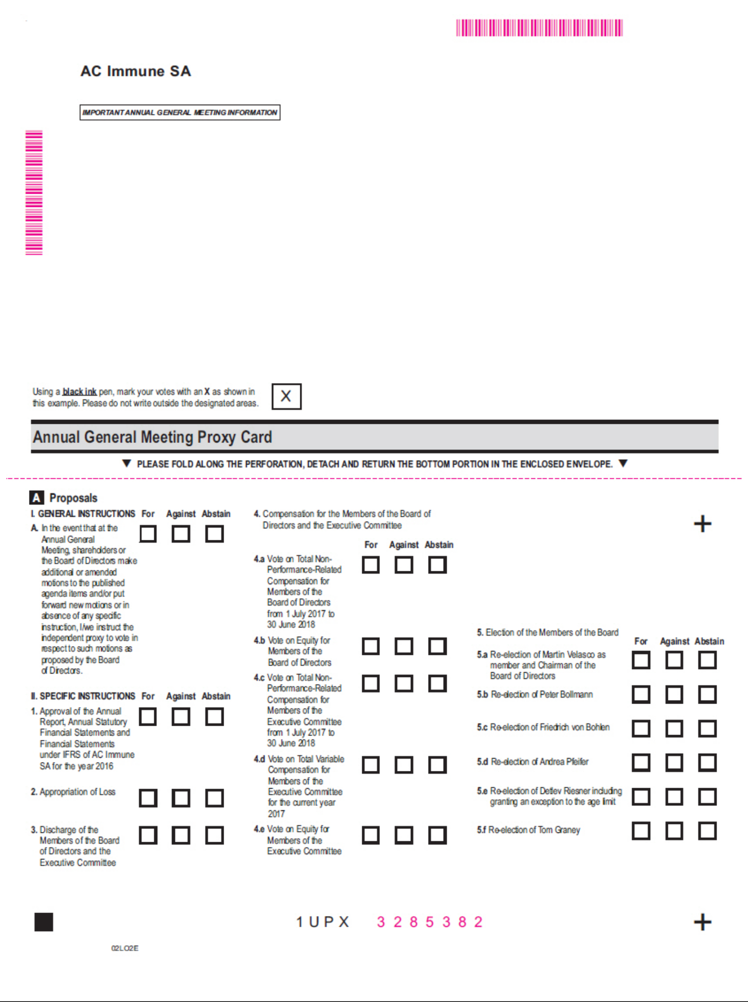

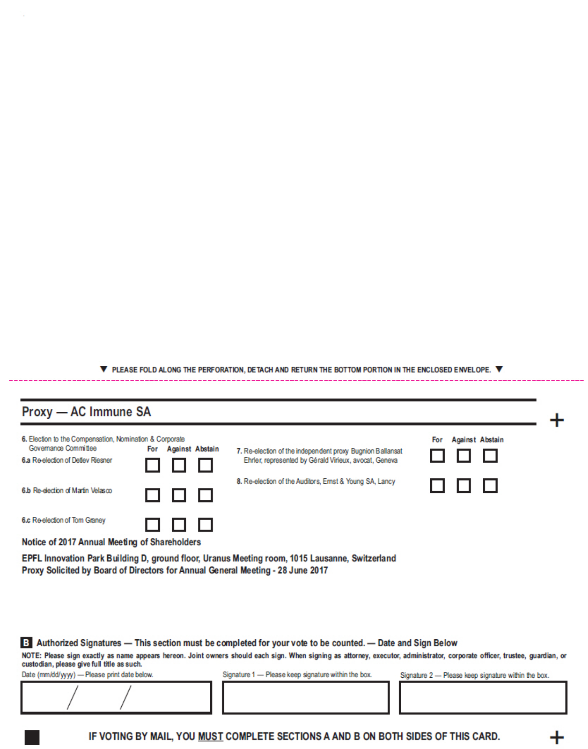

Exhibit 99.6

Lausanne, 30 May 2017

Instructions on how to become a holder of record

These instructions do not apply to existing holders of record as of 26 May 2017

You already qualify as a holder of record as of 26 May 2017 with respect to all your shareholding in AC Immune SA if:

- you were shareholder of AC Immune SA prior to our initial public offering; and
- you did not purchase any additional shares in AC Immune SA during our initial public offering or subsequently.

If you purchased shares in AC Immune SA during our initial public offering or subsequently and that you have already become a registered holder as at the record date of 26 May 2017 with respect to such shares, these instructions do not apply to you.

As an individual holder of record, you may attend and vote at our annual general meeting in person or by proxy.

As a corporate holder of record (corporations or other entities), you may have your duly authorized representatives attend and vote at our annual general meeting in person or by proxy.

For additional information, please review the "Invitation to the ordinary shareholders' meeting" and the "Annual General Meeting Proxy Card". Instructions for shareholders who want to become holders of record
If you purchased shares in AC Immune SA during our initial public offering or subsequently, your shares are currently registered in the name of a bank or brokerage firm (acting as your record holder). You will receive instructions from your record holder in order for your record holder to vote your shares per your instructions.

We encourage you to contact your record holder to commence the process to become a registered holder as at the record date of 26 May 2017. Alternatively, you may directly contact AC Immune SA to request a guest card to attend our annual general meeting. You will need to provide us with evidence of ownership of your shares in AC Immune SA to be entitled to vote your shares at our annual general meeting.

Please send your written request along with evidence of ownership of your shares in AC Immune SA by regular mail or email at the following address:

AC Immune SA
Attn. Jean-Fabien Monin, Chief Administrative Officer
EPFL Innovation Park
Building B
CH-1015 Lausanne
Switzerland
E-mail: jean-fabien.monin@acimmune.com

* * *

1

