UNITED STATES

SECURITIES AND EXCHANGE COMMISSION

Washington, D.C. 20549

FORM 6-K

REPORT OF FOREIGN PRIVATE ISSUER PURSUANT TO RULE 13a-16 OR 15d-16 UNDER THE SECURITIES EXCHANGE ACT OF 1934

For the month of July, 2018

Commission File Number: 001-37891

AC IMMUNE SA

(Exact name of registrant as specified in its charter)

EPFL Innovation Park

Building B
1015 Lausanne, Switzerland

(Address of principal executive office)

Indicate by check mark whether the registrant files or will file annual reports under cover of Form 20-F or Form 40-F:

Form 20-F X Form 40-F

Indicate by check mark if the registrant is submitting the Form 6-K in paper as permitted by Regulation S-T Rule 101(b)(1):

Yes No X

Indicate by check mark if the registrant is submitting the Form 6-K in paper as permitted by Regulation S-T Rule 101(b)(7):

Yes No X

Annual Ordinary Shareholders’ Meeting Results

On July 6, 2018, AC Immune SA (“AC Immune”) held its annual Ordinary Shareholders’ Meeting. The presentation that was given at the Ordinary Shareholders’ Meeting is attached hereto as Exhibit 99.1 and the press release relating to the results of the Ordinary Shareholders’ Meeting is attached hereto as Exhibit 99.2. The final results of each of the agenda items submitted to a vote of the shareholders are as follows:

Agenda Item 1: Approval of the Annual Report, Annual Statutory Financial Statements and Financial Statements under IFRS of AC Immune SA for the year 2017

AC Immune shareholders approved the Annual Report, the Annual Statutory Financial Statements and the Financial Statements under IFRS of AC Immune SA for the year 2017, and took note of the Reports of the Auditors.

Agenda Item 2: Appropriation of Loss

AC Immune shareholders approved the addition of the net loss for the year 2017 in the amount of KCHF 25,868 to the loss brought forward of KCHF 32,558, resulting in a reduced new balance of loss brought forward of KCHF 58,426.

Agenda Item 3: Discharge of the Members of the Board of Directors and the Executive Committee

AC Immune shareholders approved the discharge the Board and the Executive Committee of their liabilities for their activities in the financial year 2017.

Agenda Item 4: Compensation for the Members of the Board of Directors and the Executive Committee

AC Immune shareholders approved:

- The total maximum amount of non-performance-related compensation for the members of the Board of Directors covering the period from 1 July 2018 to 30 June 2019, i.e., CHF 547,000 (cash base compensation plus social security costs);

- The maximum grant of equity or equity linked instruments for the members of the Board of Directors from 1 July 2018 to 30 June 2019 with maximum value of CHF 515,000 (equity or equity linked instruments value plus social security costs);

- The total maximum amount of non-performance-related cash compensation for the members of the Executive Committee from 1 July 2018 to 30 June 2019, i.e., CHF 1,807,000 (cash base compensation plus social security costs);

- The total maximum amount of variable compensation for the members of the Executive Committee for the current year 2018, i.e., CHF 799,000 (cash compensation plus social security costs); and

- The maximum grant of equity or equity linked instruments for the members of the Executive Committee from 1 July 2018 to 30 June 2019 with maximum value of CHF 2,527,000 (equity or equity linked instruments value plus social security costs).

Agenda Item 5: Election of the Members of the Board

AC Immune shareholders approved the re-election of Martin Velasco as member and as Chairman of the Board, Peter Bollmann, Friedrich von Bohlen, Andrea Pfeifer, Detlev Riesner (including granting an exception to the age limit of 75 years foreseen in the Articles of Association), Thomas Graney and Douglas E. Williams, as well as the election of Werner Lanthaler as members of the Board of Directors, each until the end of the next Ordinary General Meeting.

Agenda Item 6: Election to the Compensation, Nomination & Corporate Governance Committee

AC Immune shareholders approved the re-election of Martin Velasco, Tom Graney and Douglas E. Williams as members of the Compensation, Nomination & Corporate Governance Committee, each until the end of the next Ordinary General Meeting.

Agenda Item 7: Re-Election of the independent proxy

AC Immune shareholders approved the re-election of Bugnion Ballansat Ehrler, represented by Gérald Virieux, as AC Immune’s independent proxy until the end of the next Ordinary General Meeting.

Agenda Item 8: Election of the Auditors

AC Immune shareholders approved the election of PricewaterhouseCoopers SA, in Pully, for a term of office of one year.

Agenda Item 9: Extension of Authorization for Share Capital Increase

AC Immune shareholders approved the extension by three months of the authorization to increase the share capital of AC Immune, which initial authorization was granted to the Board of Directors at AC Immune’s Extraordinary Shareholders’ Meeting held on 27 April 2018. This extension will replace the previous authorization resolution granted at the Extraordinary Shareholders' Meeting of 27 April 2018 and will become effective upon expiration of the three-month period to implement the initial resolution regarding the previous authorization if and to the extent such initial resolution has not been implemented.

SIGNATURE

Pursuant to the requirements of the Securities Exchange Act of 1934, the registrant has duly caused this report to be signed on its behalf by the undersigned, thereunto duly authorized.

AC IMMUNE SA
By: | /s/ Andrea Pfeifer
 | Name: | Andrea Pfeifer
 | Title: | Chief Executive Officer
By: | /s/ Joerg Hornstein
 | Name: | Joerg Hornstein
 | Title: | Chief Financial Officer
Date: July 6, 2018

 | EXHIBIT INDEX
Exhibit Number | Description
99.1 | Annual Ordinary Shareholders’ Meeting presentation
99.2 | Press Release dated July 6, 2018

Exhibit 99.1


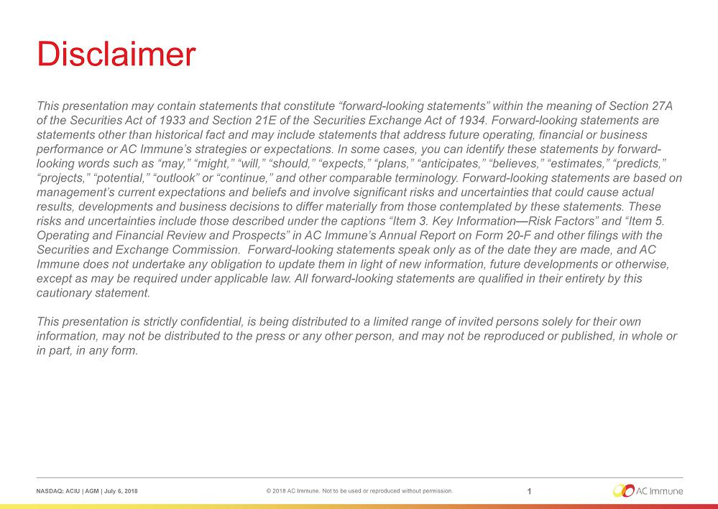

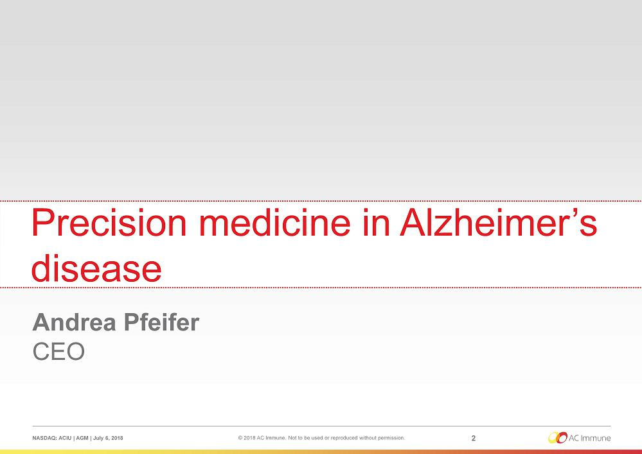

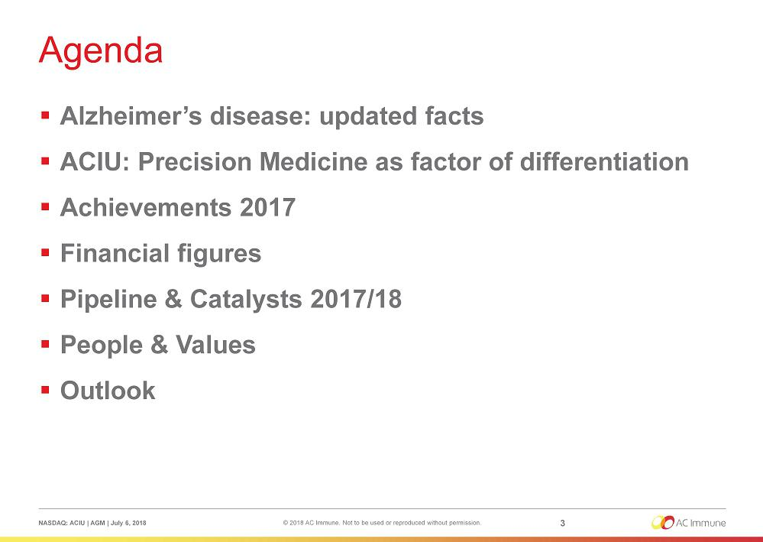

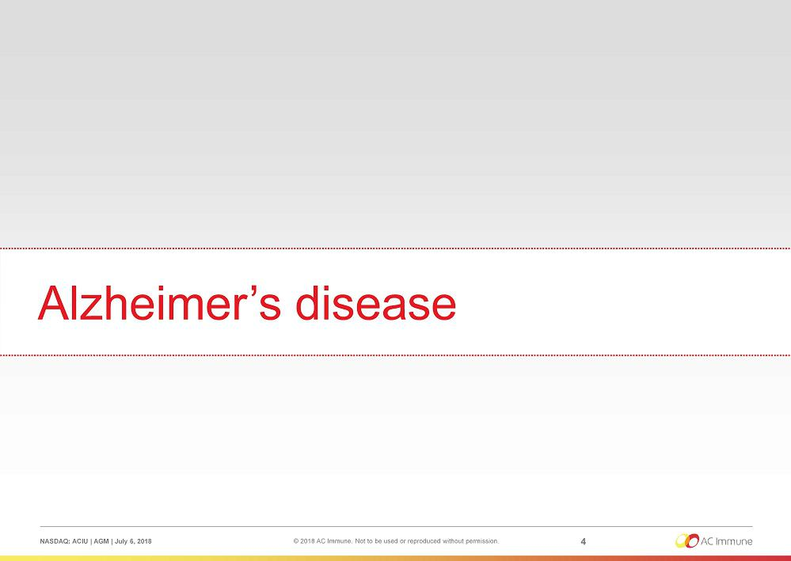

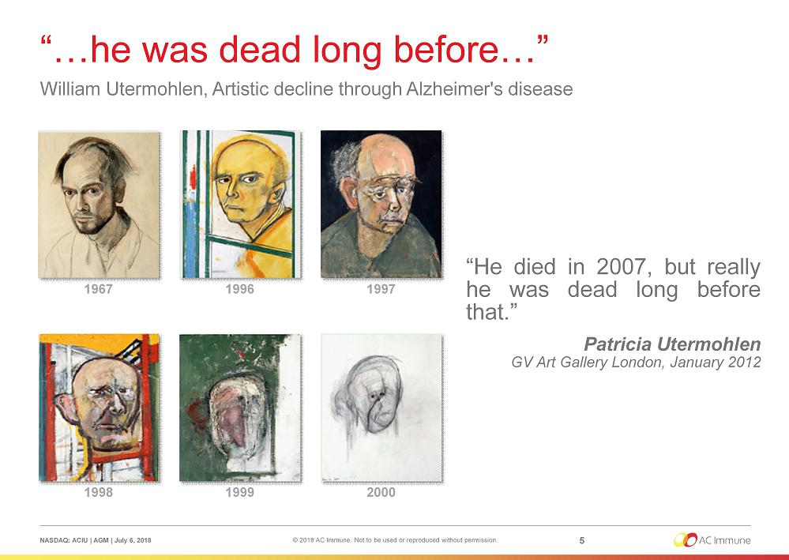

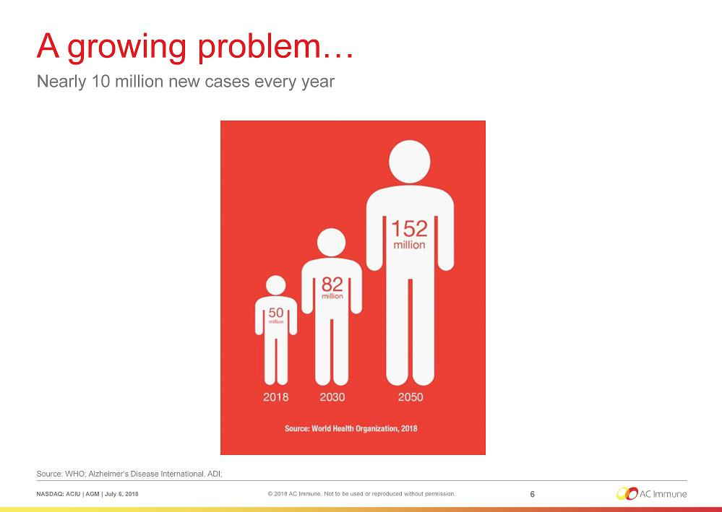

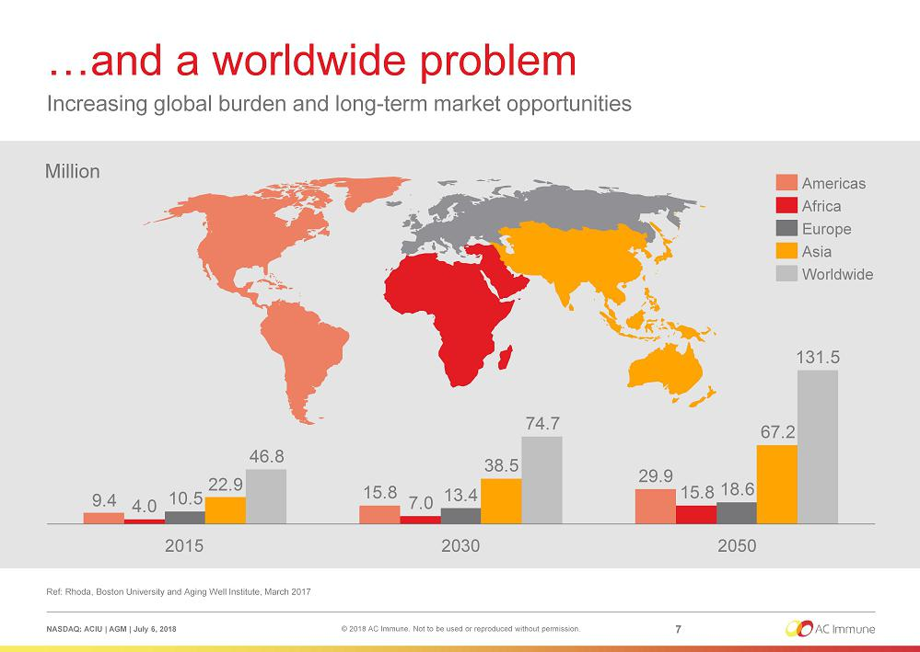

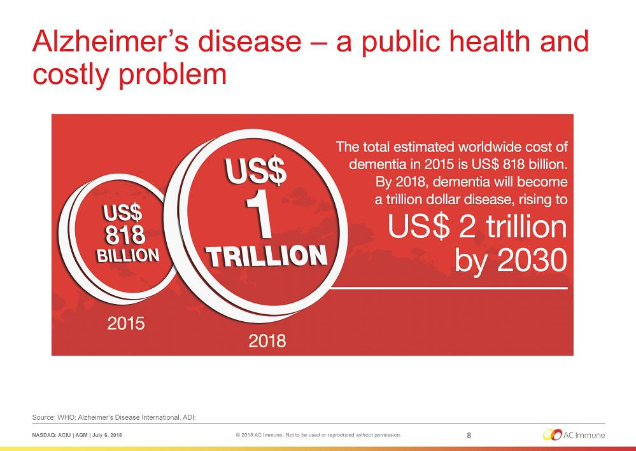

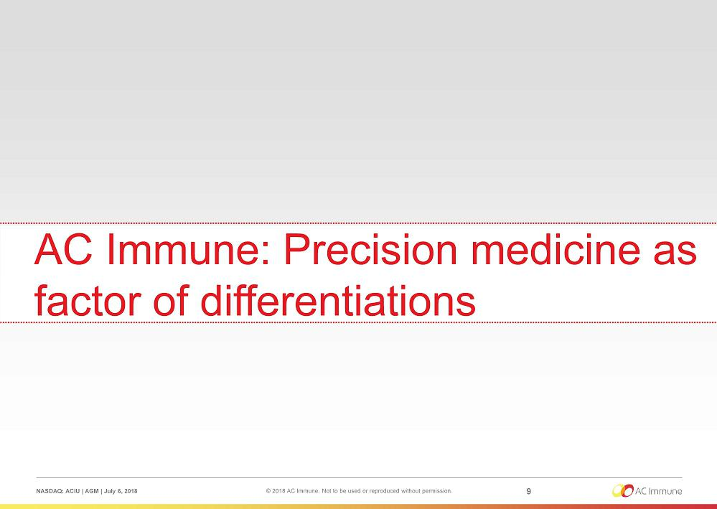

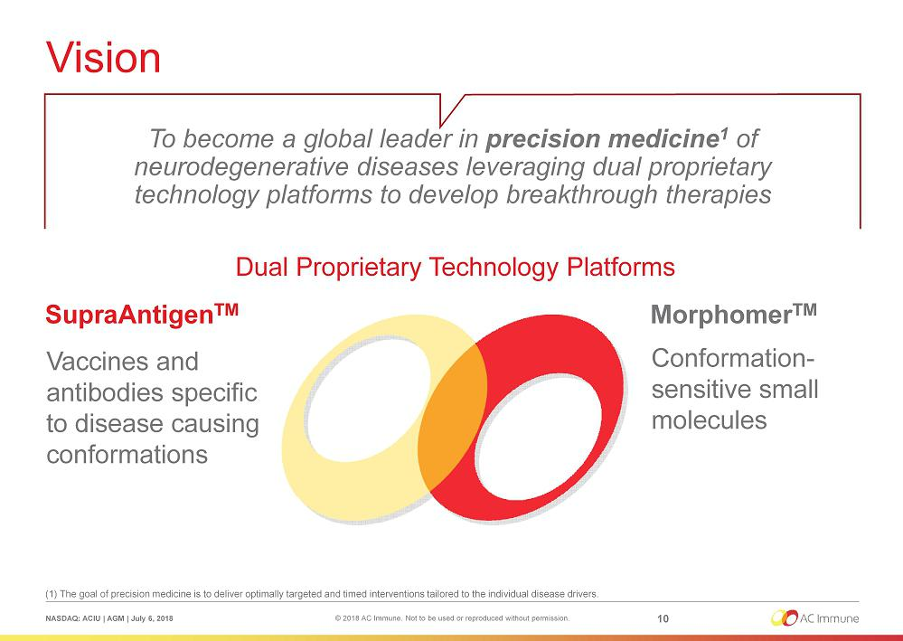

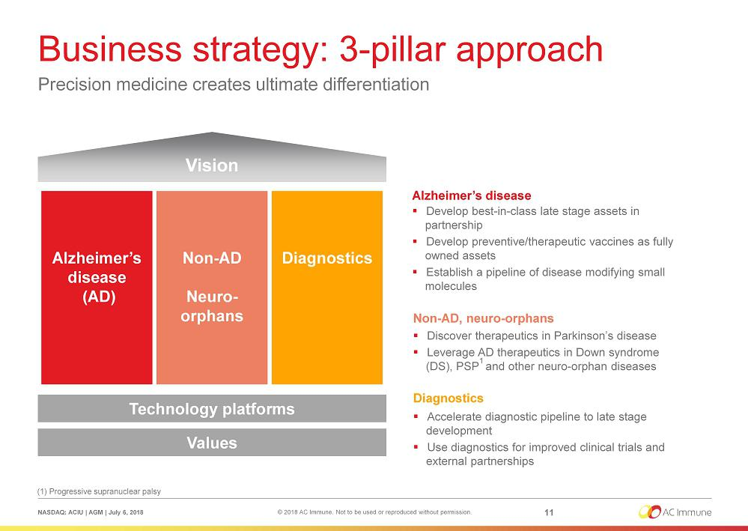

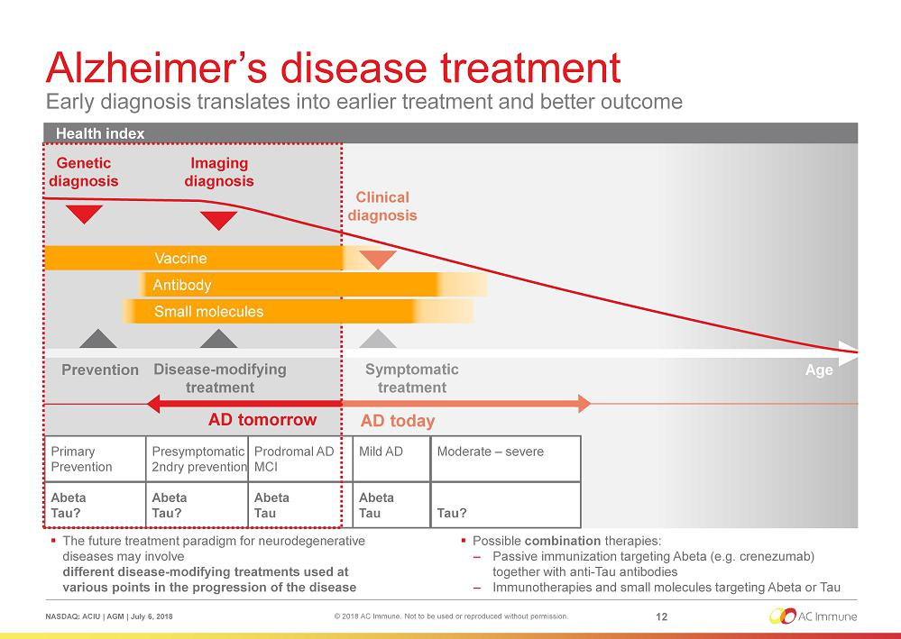

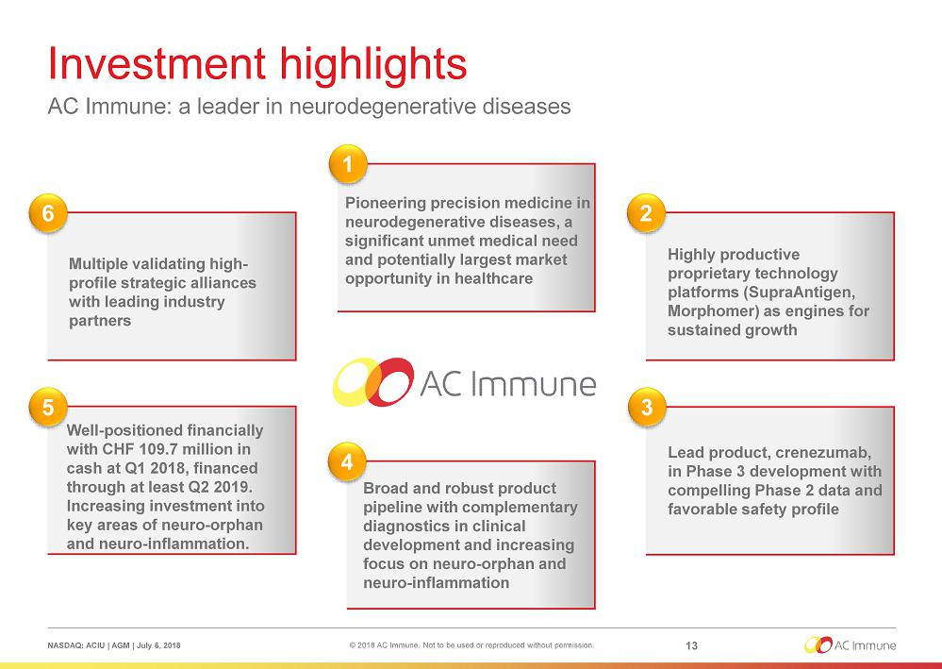

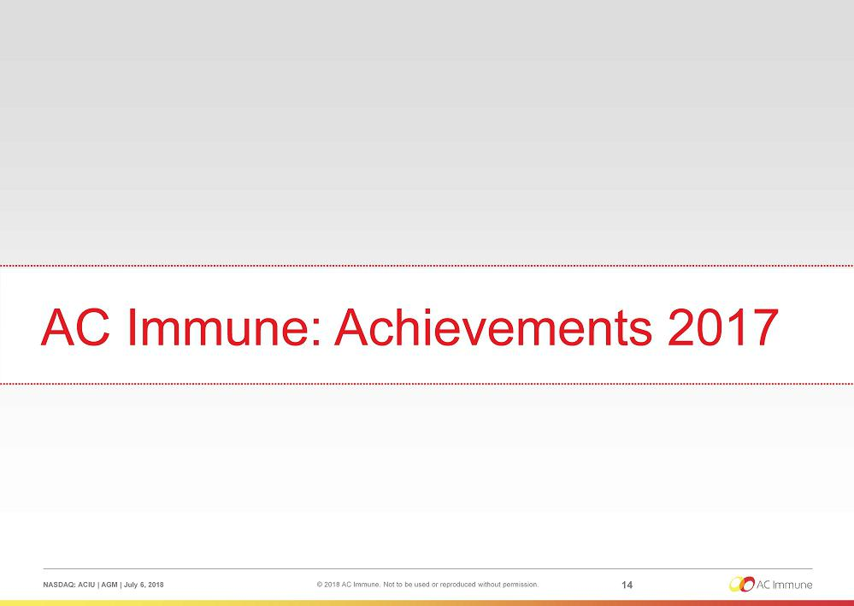

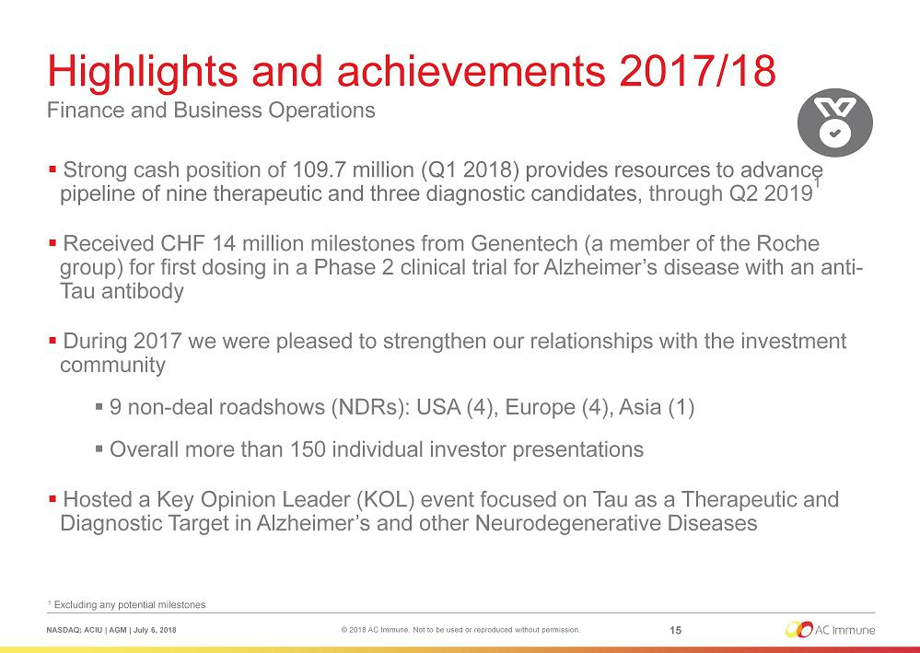

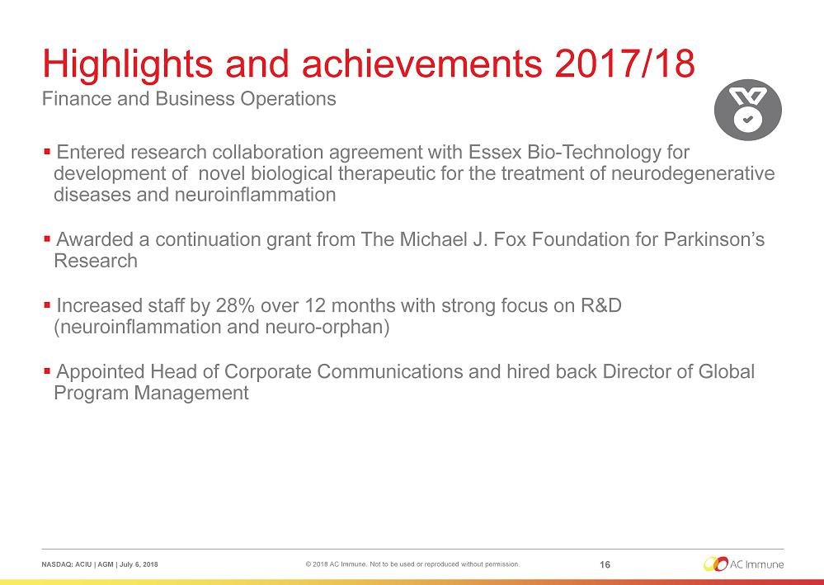

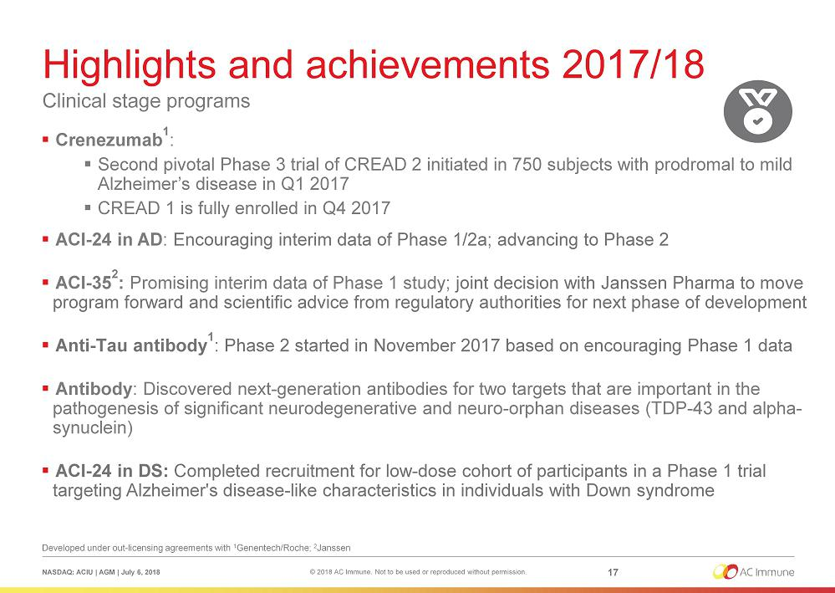

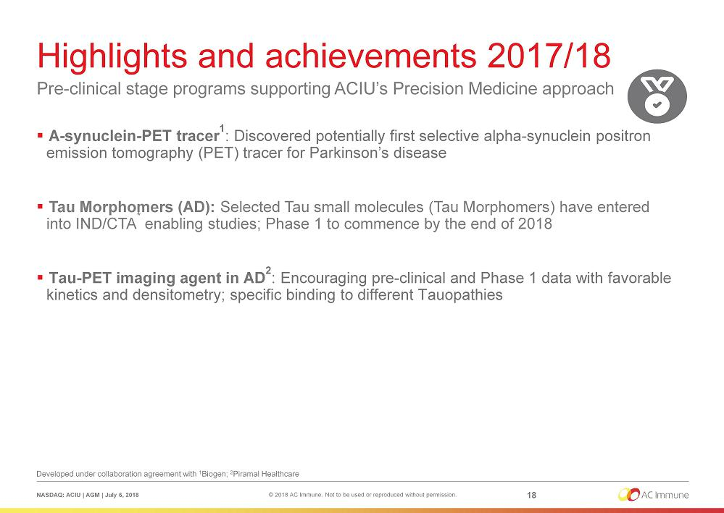

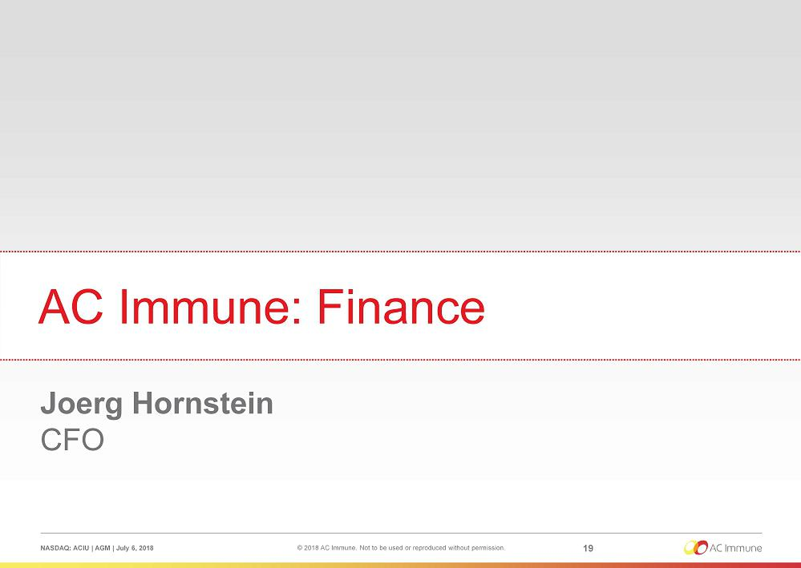

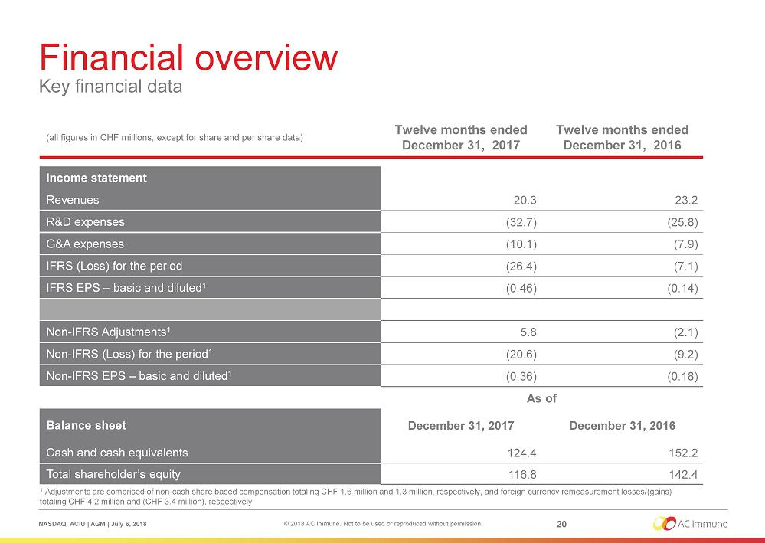

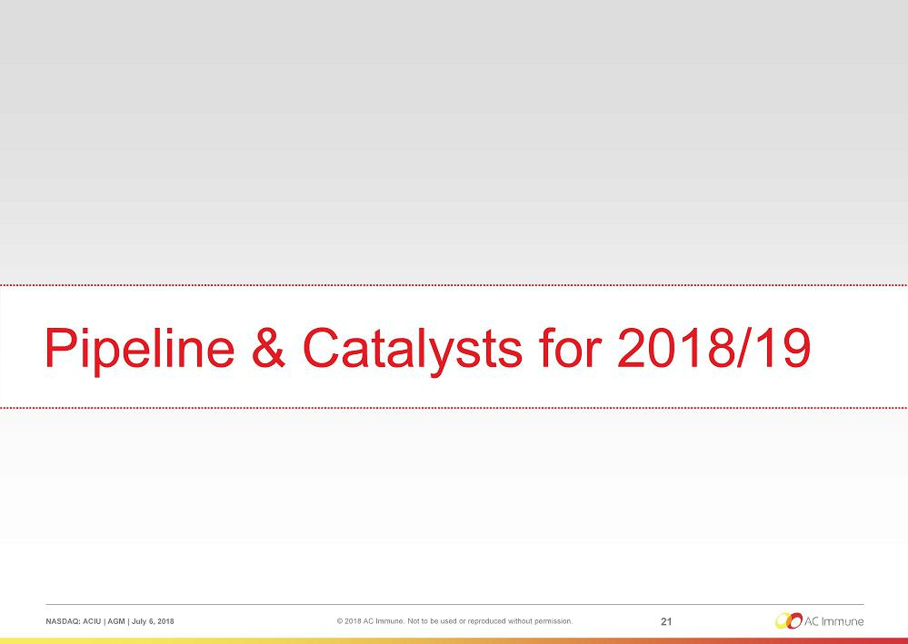

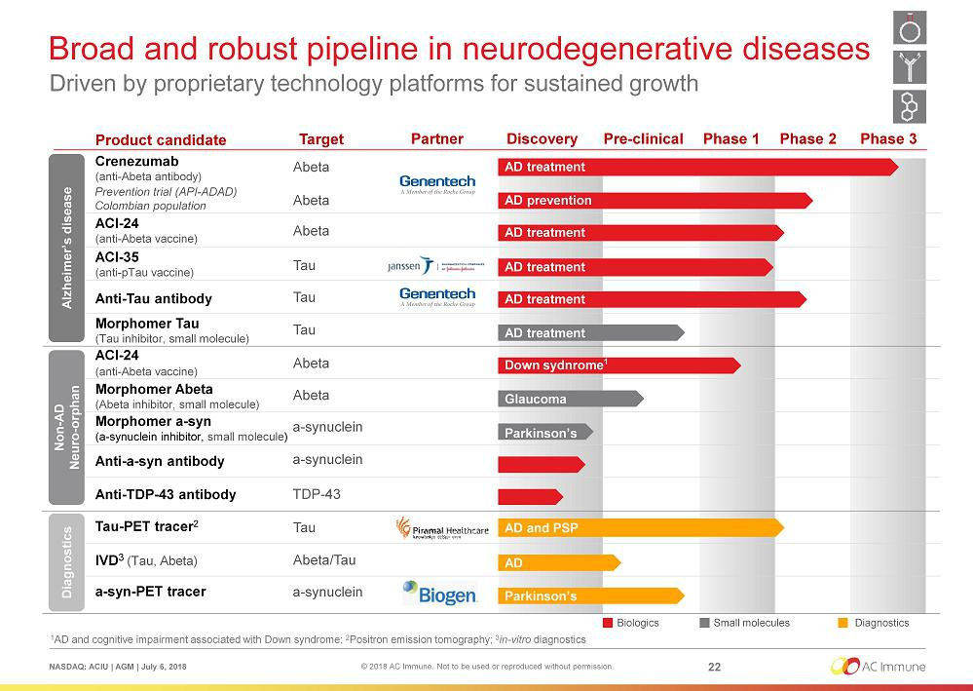

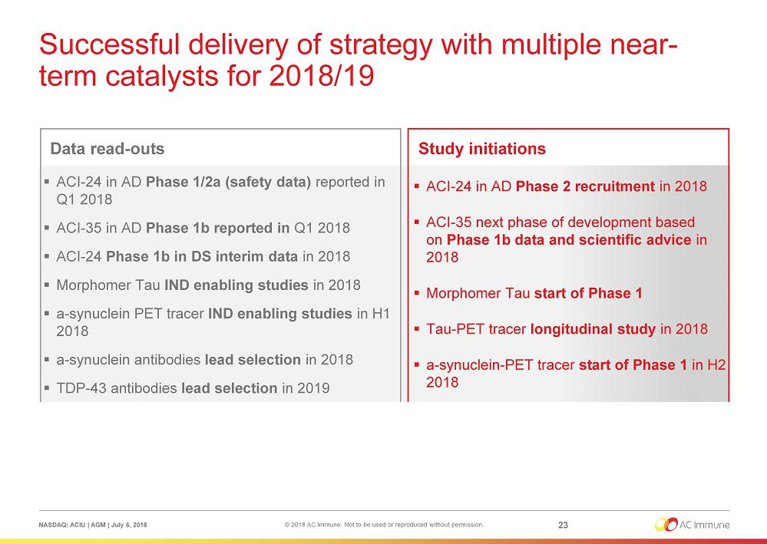

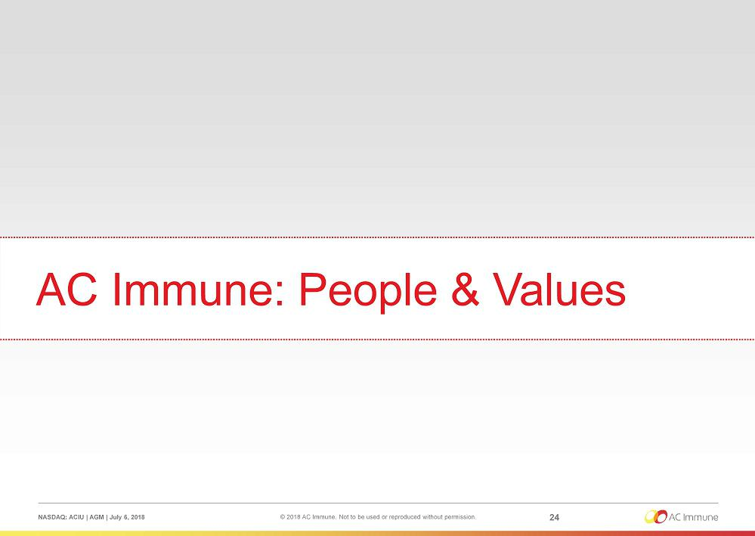

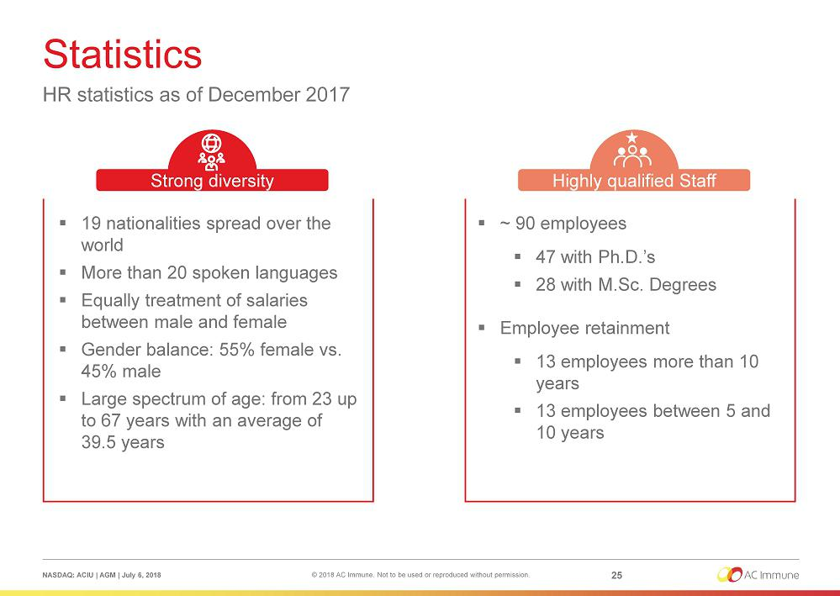

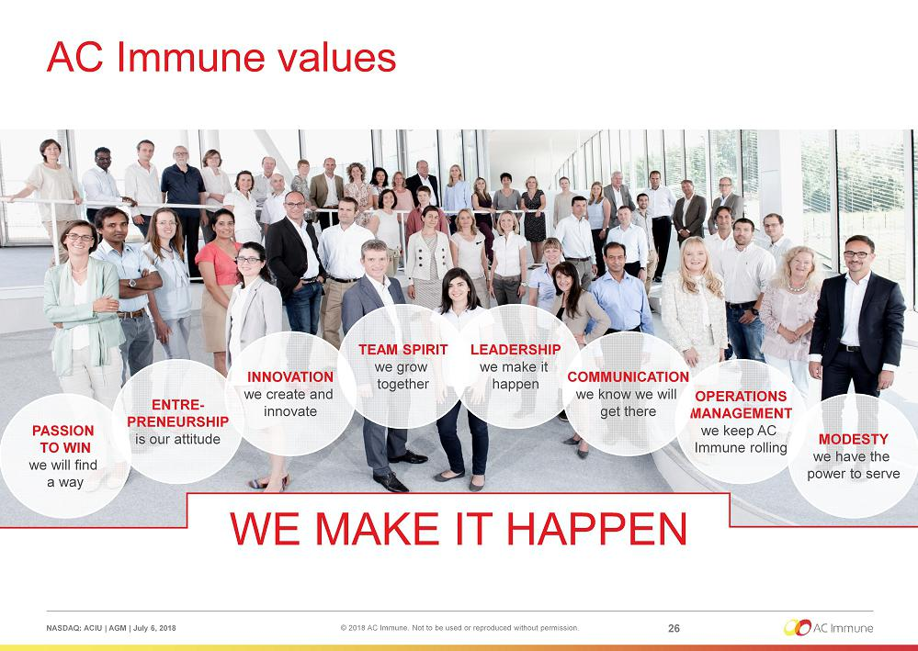

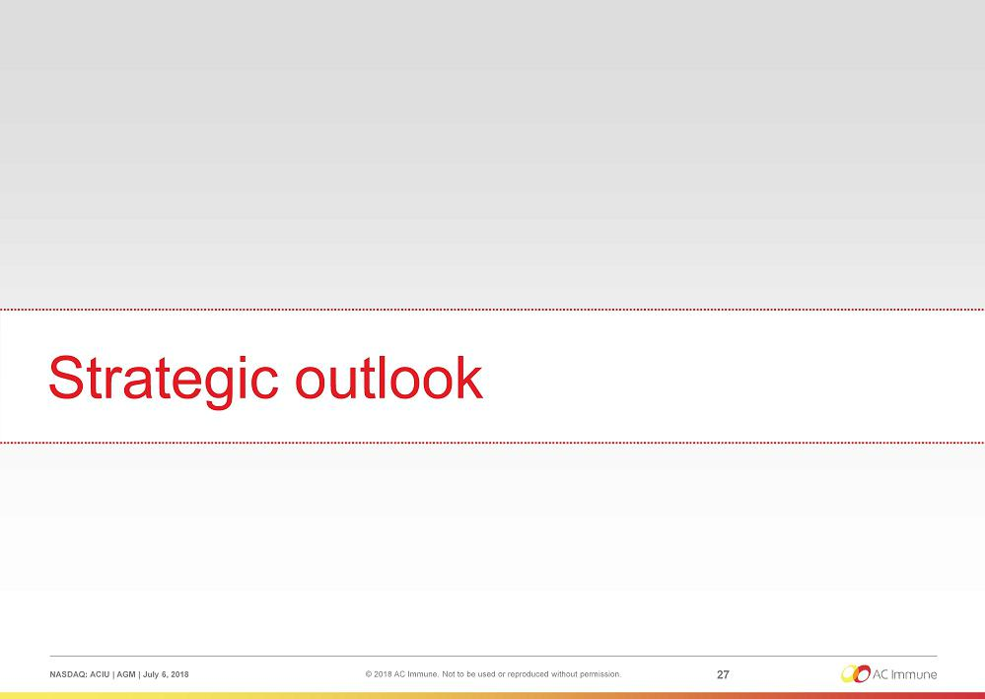

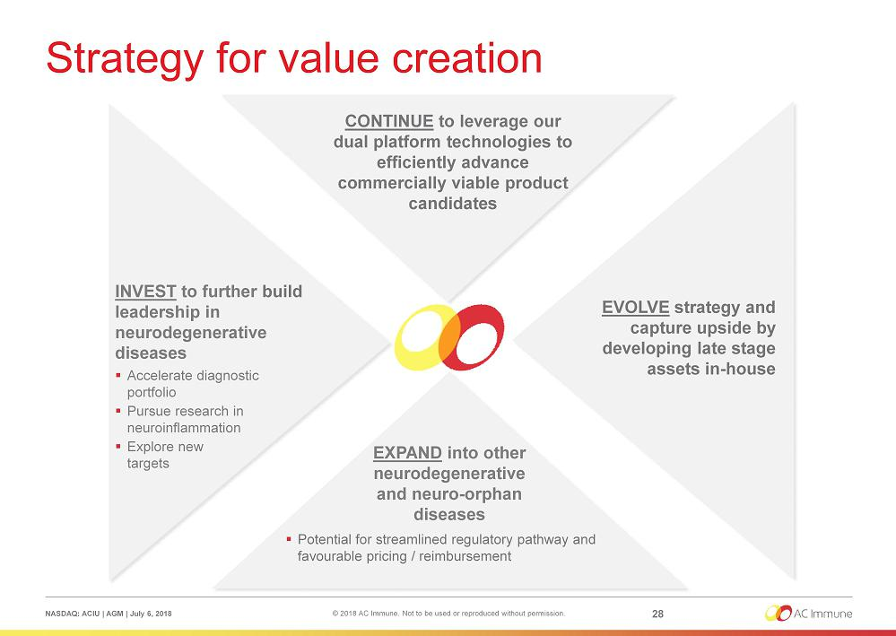

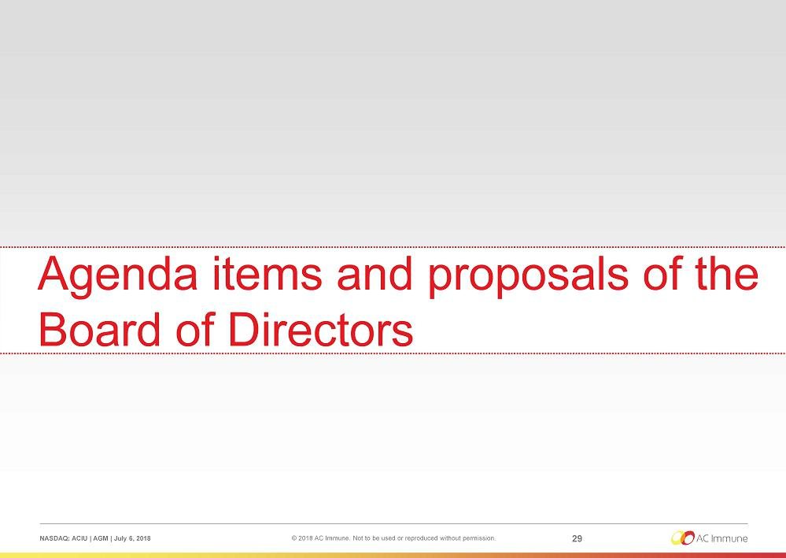

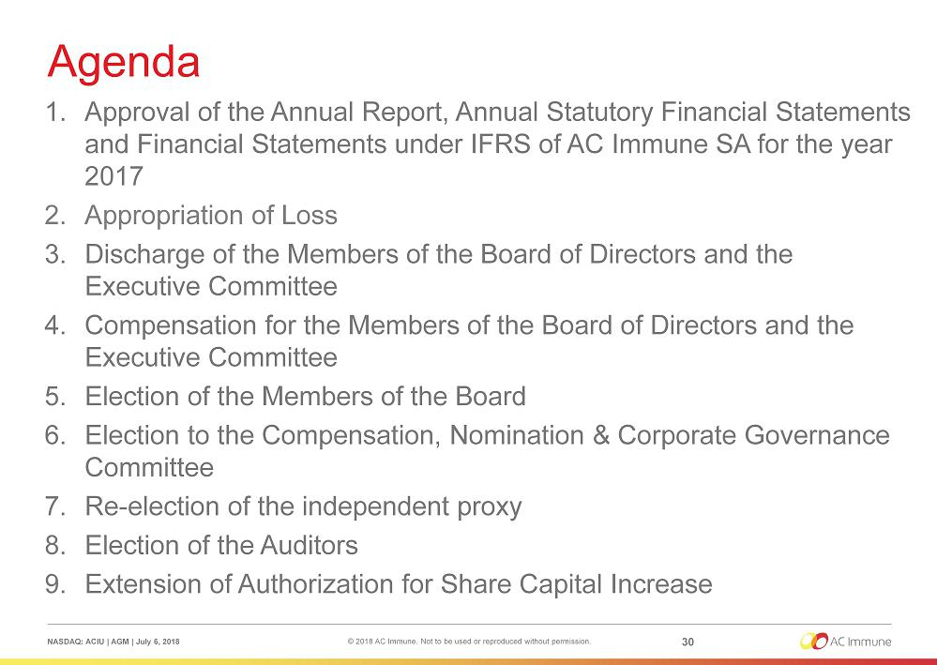

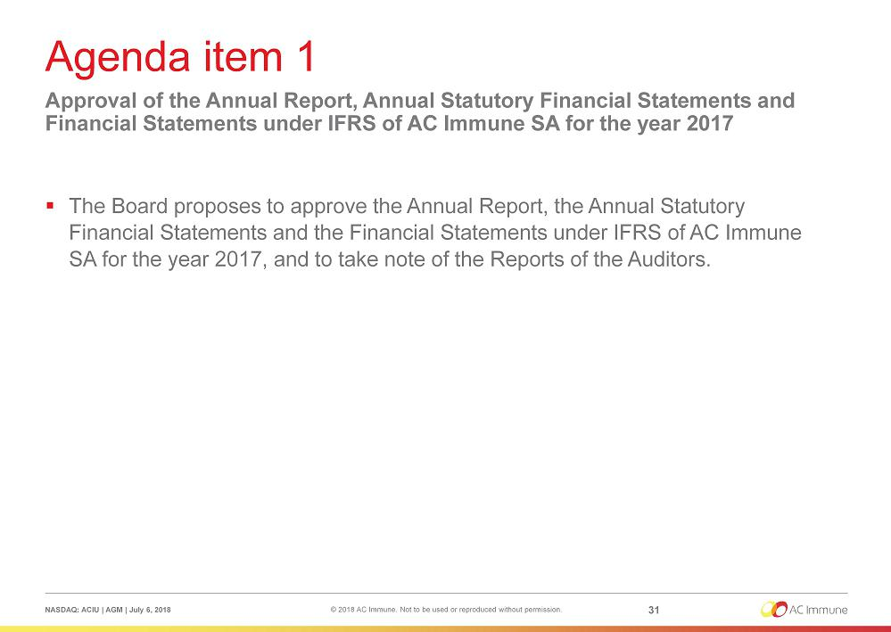

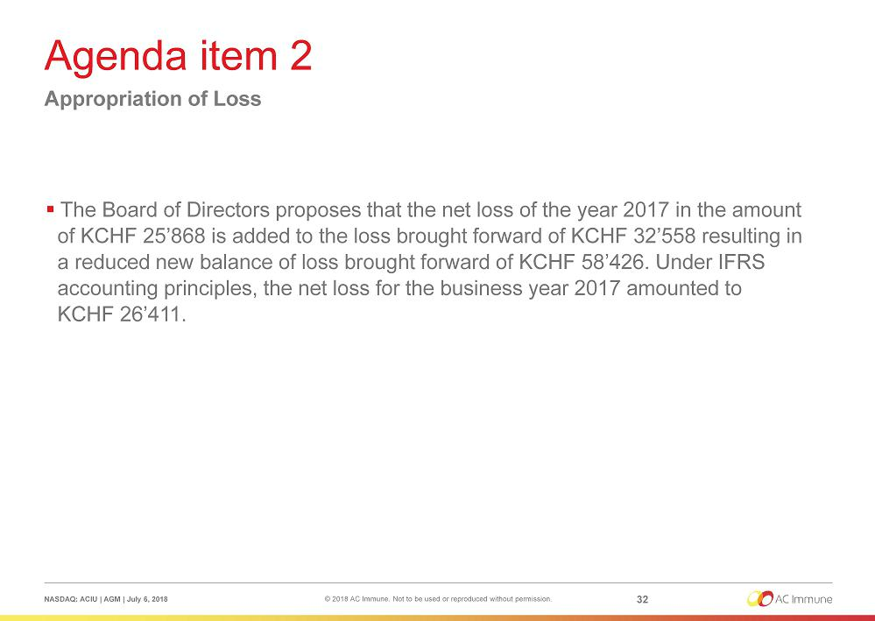

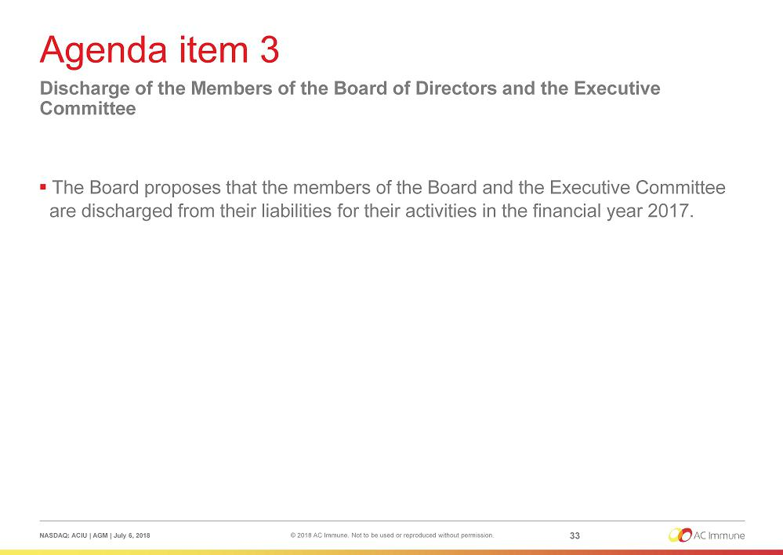

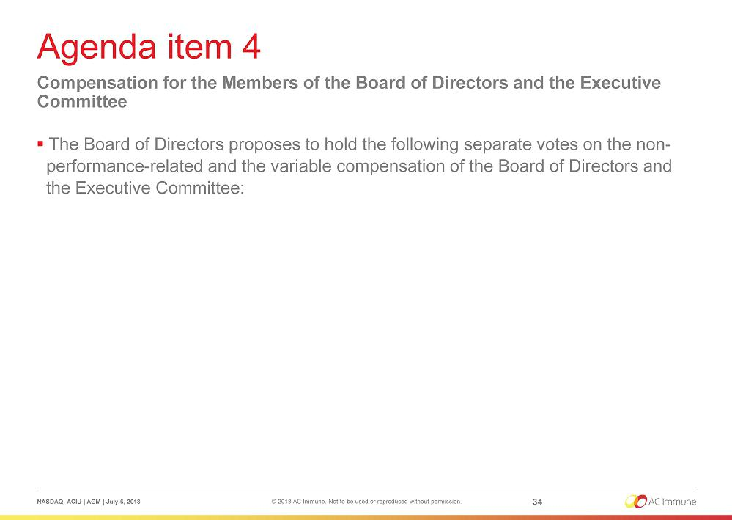

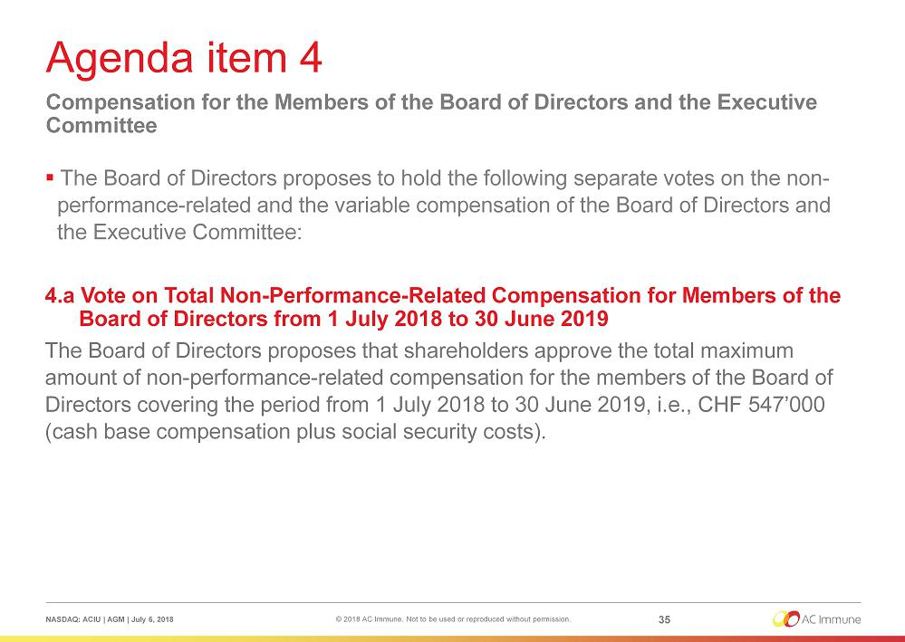

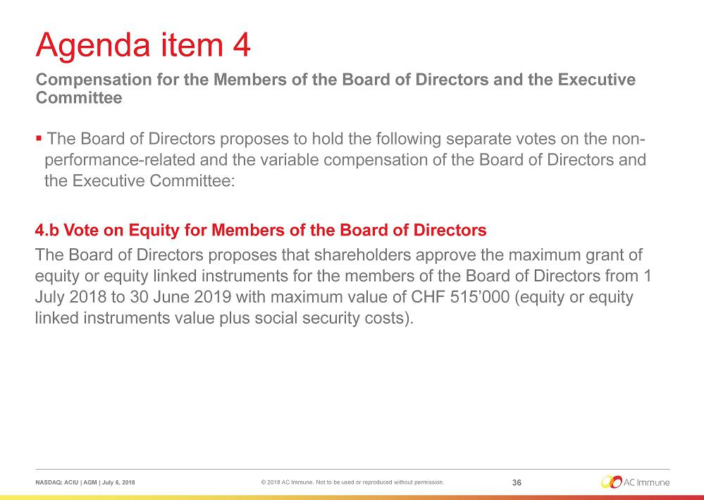

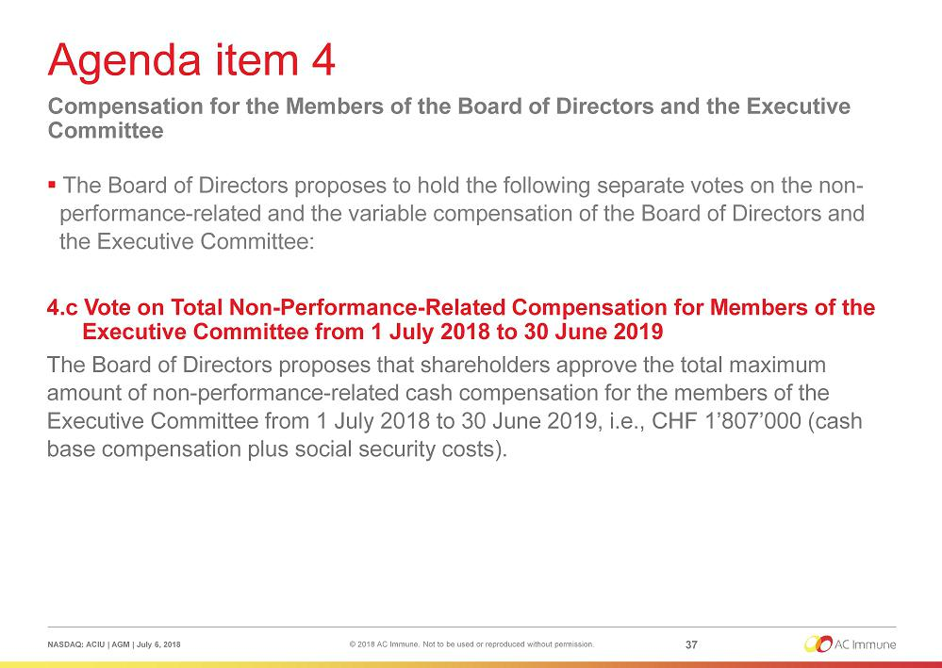

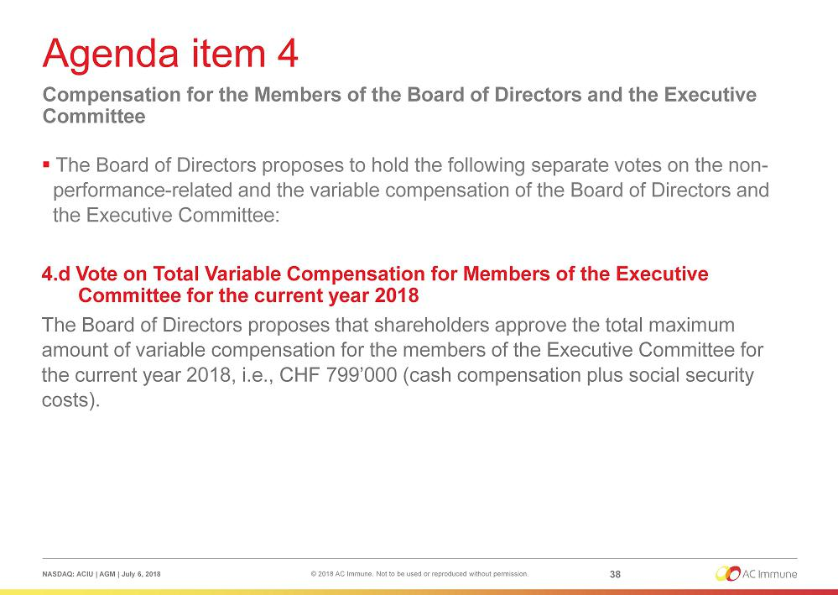

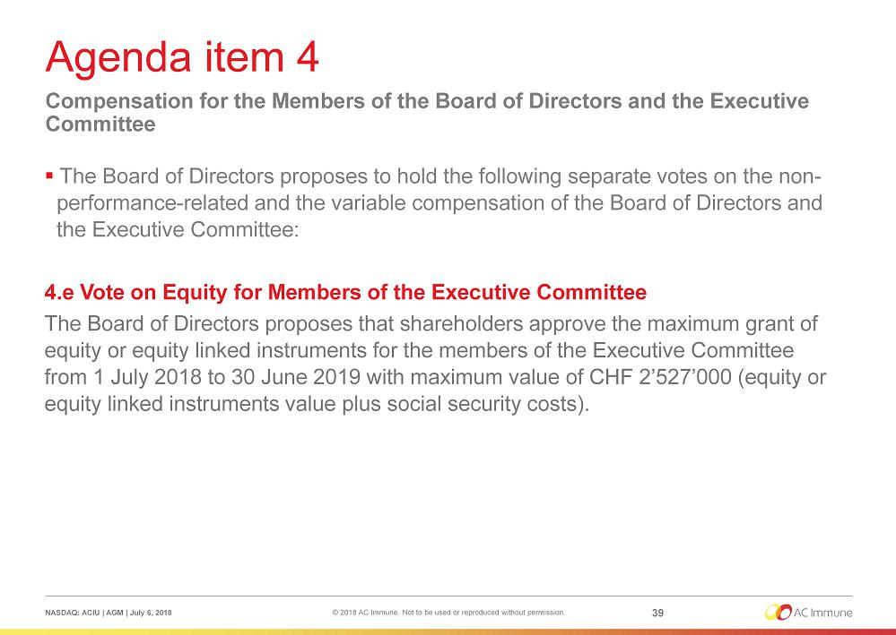

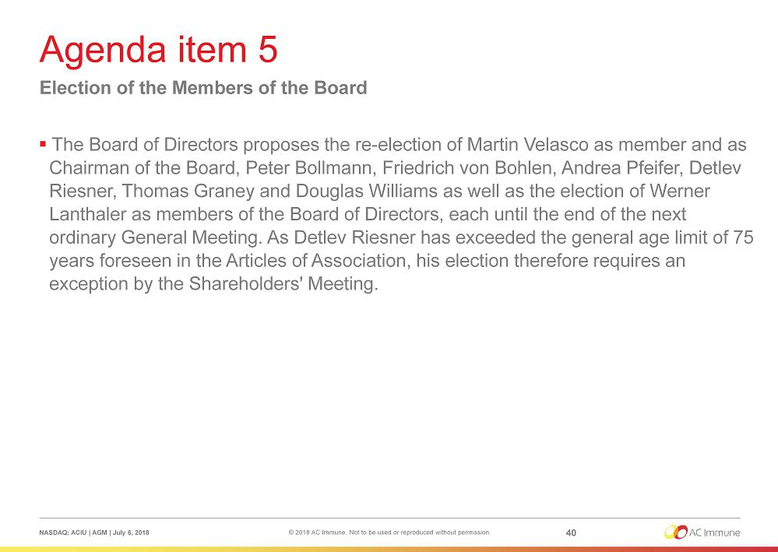

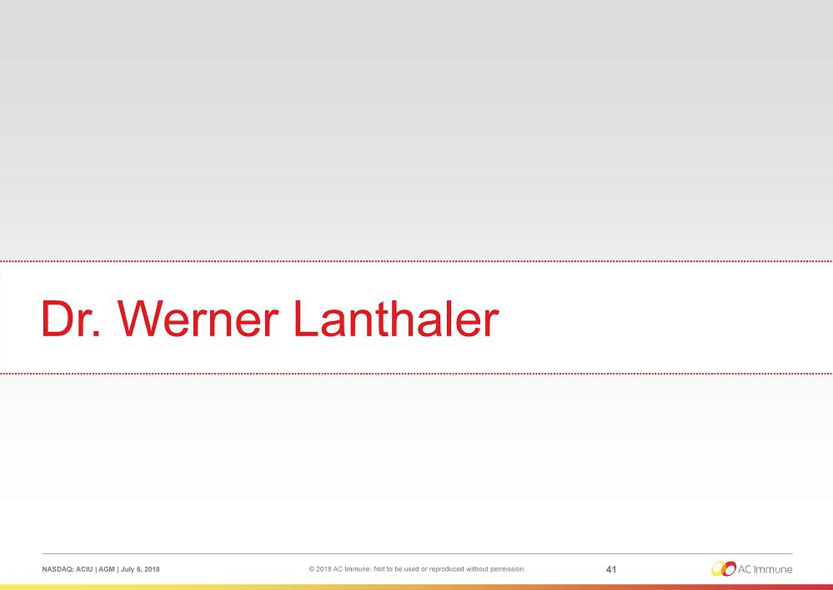

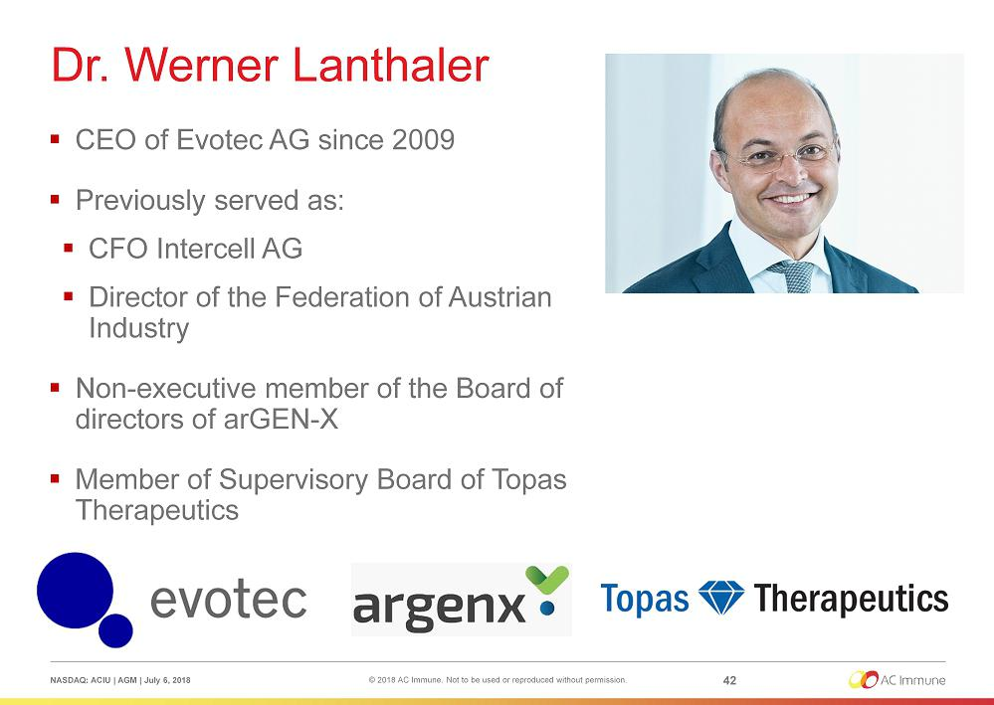

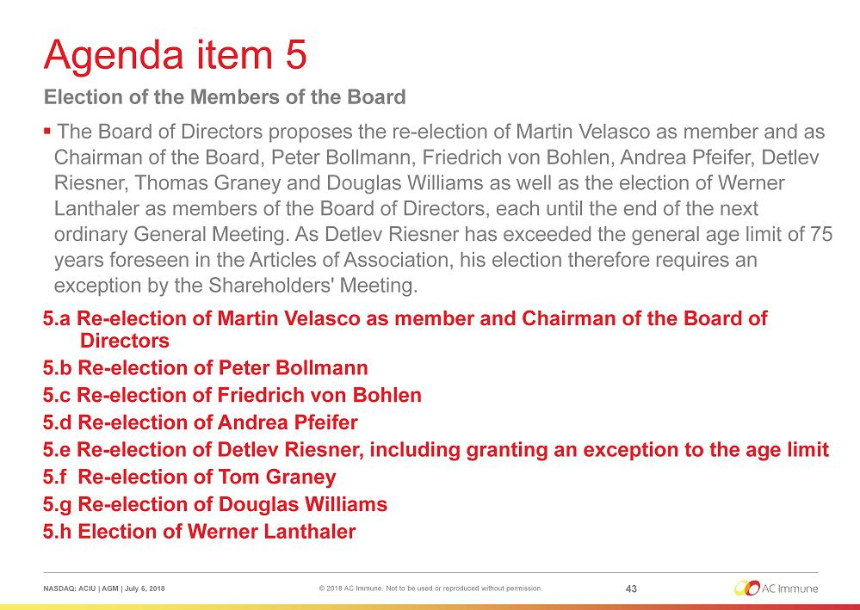

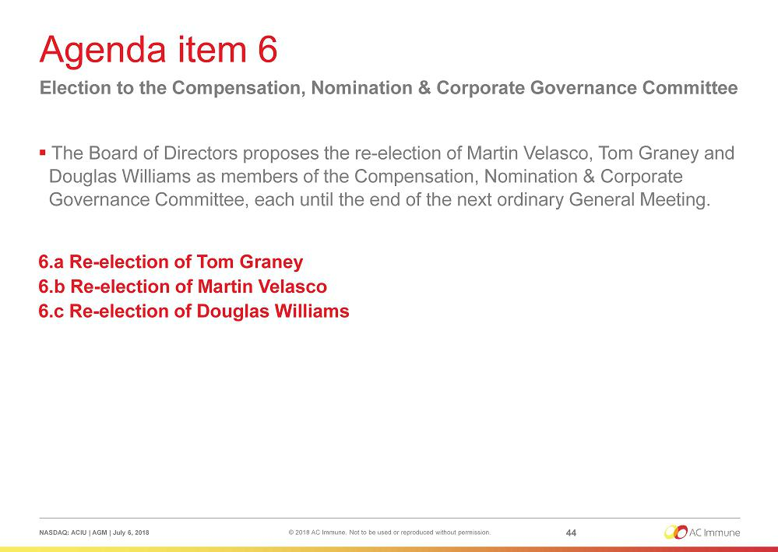

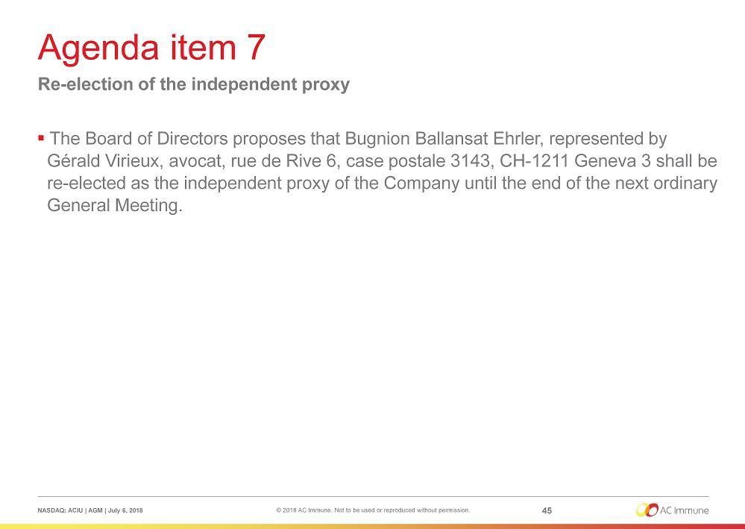

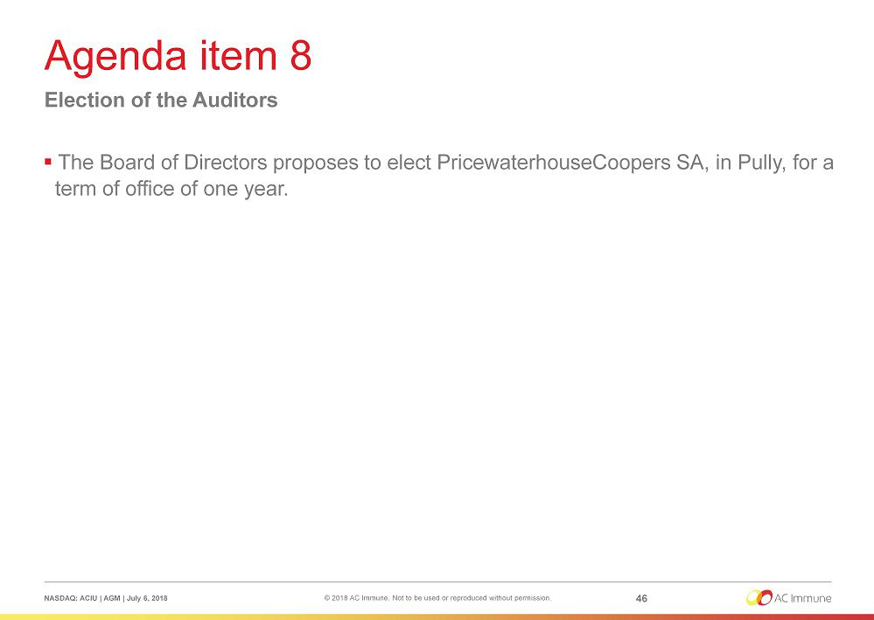

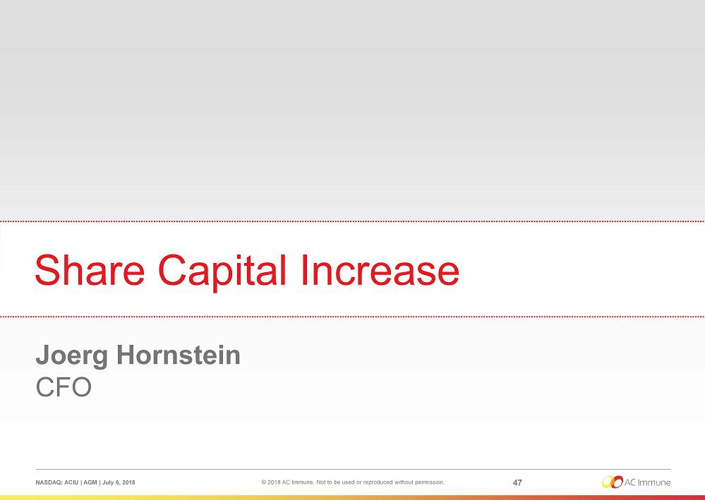

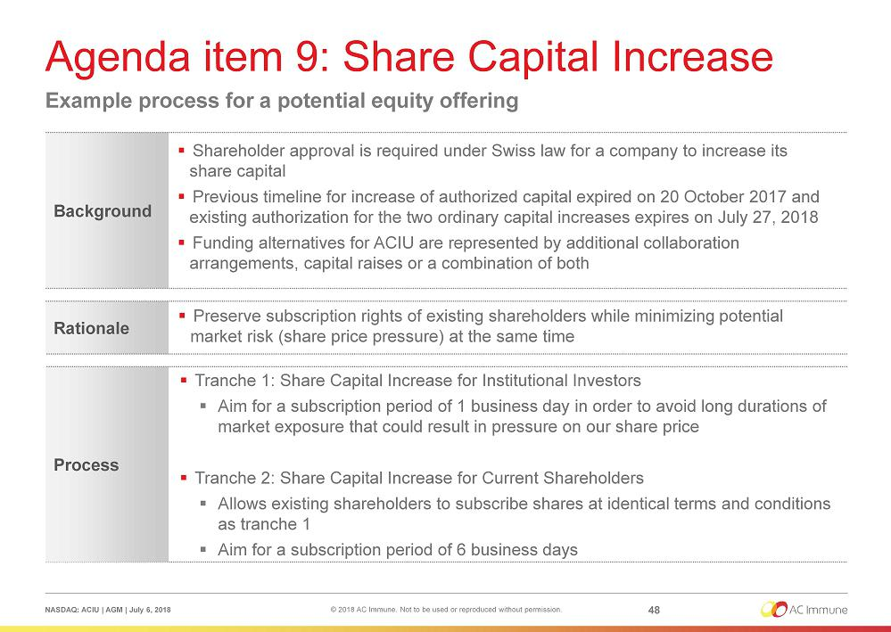

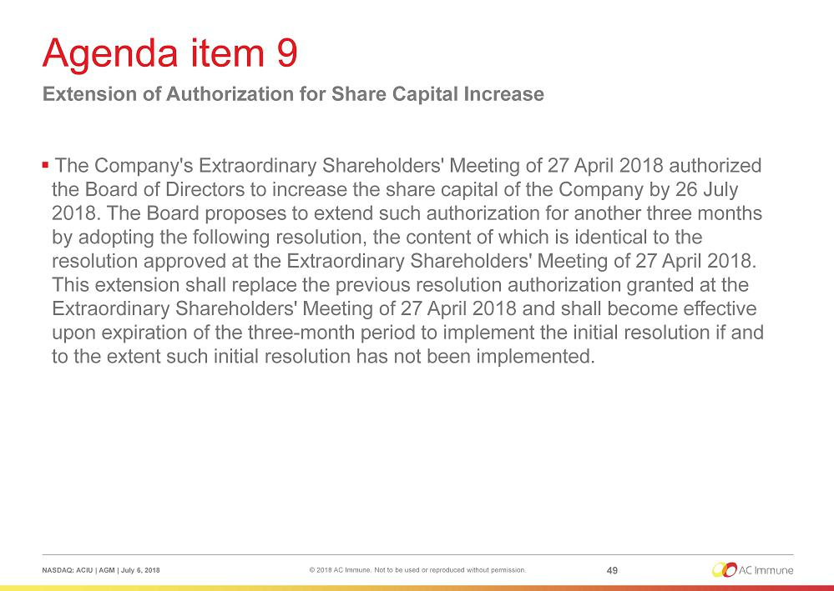

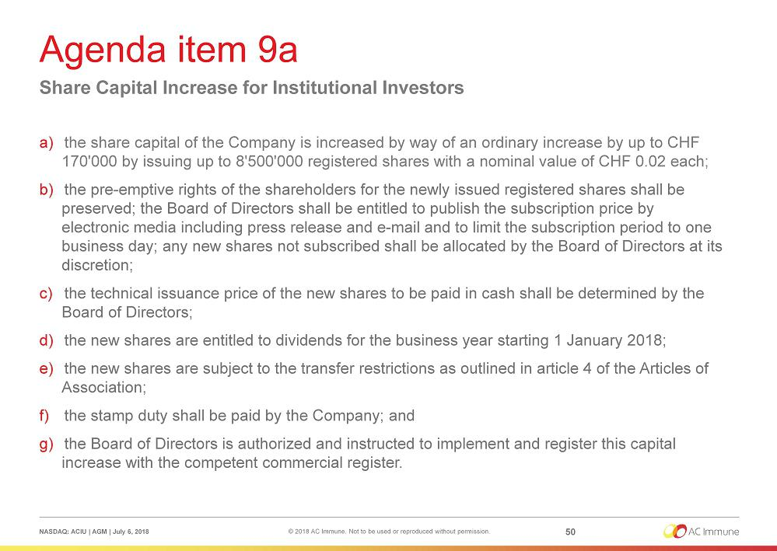

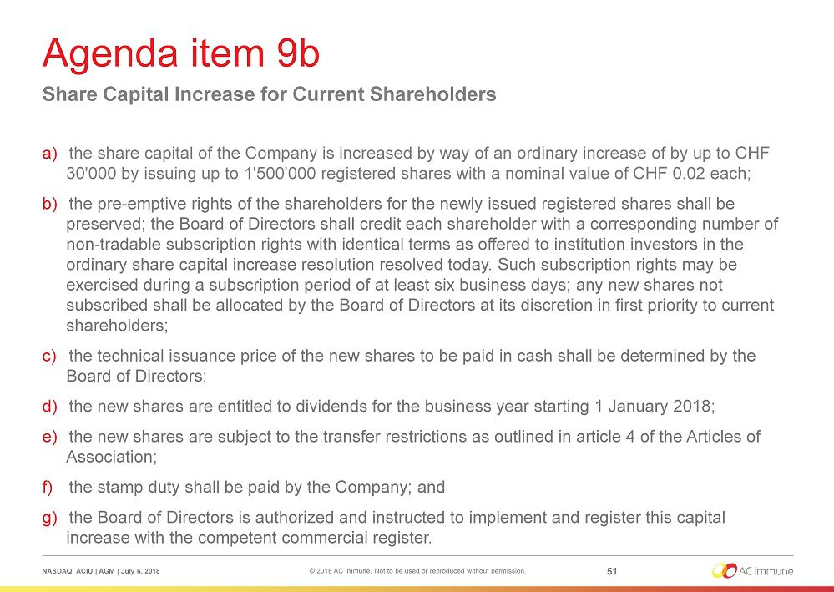

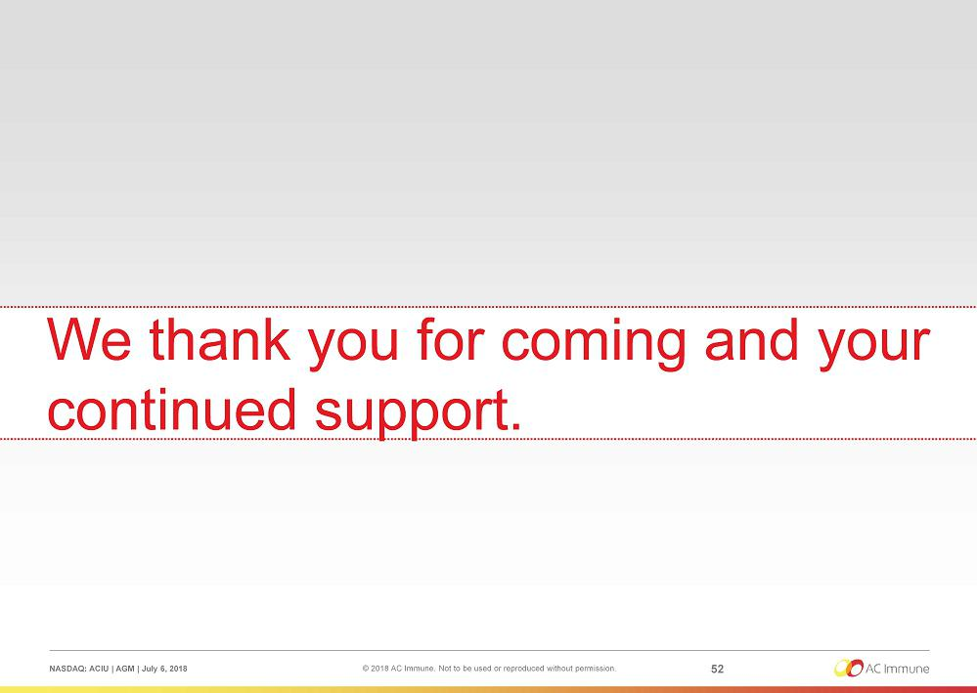

Exhibit 99.2


PRESS RELEASE

AC Immune Announces Results of Annual General Meeting

Lausanne, Switzerland, July 6, 2018 – AC Immune SA (NASDAQ: ACIU), a Swiss-based, clinical stage biopharmaceutical company focused on neurodegenerative diseases, today announced that the shareholders of the Company have approved all resolutions as proposed by the Board of Directors at the Company’s Annual General Meeting which took place today in Lausanne, including:

- The annual report and the financial statements for the year 2017

- The appropriation of loss

- The discharge of the members of the Board of Directors and the Executive Committee

- The compensation for the members of the Board of Directors and the Executive Committee

- Re-election of the Members of the Board of Directors and the Members of the Compensation, Nomination and Corporate Governance Committee

- Election of Dr. Werner Lanthaler to the Board of Directors

- Re-election of the independent proxy of the company

- Election of the Auditors

- Extension of authorization for share capital increase

Martin Velasco, Chairman of the Board of Directors, commented: “We are very pleased to welcome Dr. Werner Lanthaler to our Board. He has considerable international experience in the life sciences sector and corporate leadership positions, and his appointment will greatly benefit AC Immune.”

He added: “This year marks 15 years since the founding of AC Immune and the company continues to make significant progress in 2018. I want to thank our shareholders for their continued trust and support as we continue to pursue our mission of being a leader in precision medicine for neurodegenerative diseases.”

More information on the Annual General Meeting is available on the Company’s website.

About Dr. Werner Lanthaler

Dr. Werner Lanthaler is the CEO of Evotec AG, a drug discovery alliance and development partnership company focused on rapidly progressing innovative product approaches with leading pharmaceutical and biotechnology companies, academics, patient advocacy groups and venture capitalists. Since joining Evotec in 2009, Dr. °Lanthaler has focused the company on collaborating with biotech and pharma companies and academia – supporting biotech innovation. He previously served as Chief Financial Officer at Intercell AG where he played a key role in many of the company’s major milestones. During his tenure, Intercell undertook an Initial Public Offering and developed from a venture-backed biotechnology company into a global vaccine player. Dr. Lanthaler has also served as Director of the Federation of Austrian Industry, and from 1995 to 1998 was a Senior Management Consultant at McKinsey & Company. Dr. Lanthaler is a Non-Executive Member of the Board of Directors of arGEN-X and is a member of the Supervisory Board of Topas Therapeutics GmbH. He holds a Doctorate in Economics from Vienna University, a Master’s degree in Business Administration from Harvard University, and a degree in Psychology.

About AC Immune

AC Immune is a clinical stage Swiss-based biopharmaceutical company, listed on Nasdaq, which aims to become a global leader in precision medicine for neurodegenerative diseases. The Company designs, discovers and develops therapeutic as well as diagnostic products intended to prevent and modify diseases caused by misfolding proteins. AC Immune’s two proprietary technology platforms create antibodies, small molecules and vaccines designed to address a broad spectrum of neurodegenerative indications, such as Alzheimer’s disease (AD). The Company’s pipeline features nine therapeutic and three diagnostic product candidates – with five product candidates currently in clinical trials. The most advanced of these is crenezumab, a humanized anti-amyloid-β monoclonal IgG4 antibody that targets monomeric and aggregated forms of amyloid-β, with highest affinity for neurotoxic oligomers. Crenezumab is currently in Phase 3 clinical studies for AD, under a global program conducted by the collaboration partner Genentech (a member of the Roche group). Other collaborations include Biogen, Janssen Pharmaceuticals, Nestlé Institute of Health Sciences, Piramal Imaging and Essex Bio-Technology.

For further information, please contact:

In Europe |  |  |  |  | In the US
Beatrix Benz |  |  |  |  | Lisa Sher
AC Immune Corporate Communications |  |  |  |  | AC Immune Investor Relations
Phone: +41 21 345 91 34 |  |  |  |  | Phone: +1 970 987 26 54
E-mail: beatrix.benz@acimmune.com |  |  |  |  | E-mail: lisa.sher@acimmune.com
Nick Miles/Toomas Kull |  |  |  |  | Ted Agne
Cabinet Privé de Conseils s.a. |  |  |  |  | The Communications Strategy Group Inc.
Phone: +41 22 552 46 46 |  |  |  |  | Phone: +1 781 631 3117
E-mail: miles@cpc-pr.com |  |  |  |  | E-mail: edagne@comstratgroup.com
 | kull@cpc-pr.com


