UNITED STATES

SECURITIES AND EXCHANGE COMMISSION

Washington, D.C. 20549

FORM 6-K

REPORT OF FOREIGN PRIVATE ISSUER PURSUANT TO RULE 13a-16 OR 15d-16 UNDER THE SECURITIES EXCHANGE ACT OF 1934

For the month of June, 2018

_________________

Commission File Number: 001-37891

AC IMMUNE SA

(Exact name of registrant as specified in its charter)

EPFL Innovation Park

Building B

1015 Lausanne, Switzerland

(Address of principal executive office)

Indicate by check mark whether the registrant files or will file annual reports under cover of Form 20-F or Form 40-F:

Form 20-F X Form 40-F

Indicate by check mark if the registrant is submitting the Form 6-K in paper as permitted by Regulation S-T Rule 101(b)(1):

Yes No X

Indicate by check mark if the registrant is submitting the Form 6-K in paper as permitted by Regulation S-T Rule 101(b)(7):

Yes No X

Submission of Matters to a Vote of Security Holders

On June 6, 2018, AC Immune SA (the “Company”) mailed to all of its shareholders of record as of May 23, 2018 an invitation and proxy form to participate in the Company's annual general meeting of shareholders to be held on July 6, 2018. The invitation to the annual general meeting (including the agenda items and proposals that are being voted upon) as well as other materials provided to the Company's shareholders are included as exhibits to this Report of Foreign Private Issuer on Form 6-K. In addition to matters resolved by shareholders on an annual basis (such as elections of directors and compensation proposals), the Board of Directors of the Company proposes that the previous authorizations to raise capital as granted by the Extraordinary Shareholders' Meeting of April 27, 2018 shall, upon the expiry of the authorizations on July 27, 2018, be extended until October 6, 2018.

SIGNATURE

Pursuant to the requirements of the Securities Exchange Act of 1934, the registrant has duly caused this report to be signed on its behalf by the undersigned, thereunto duly authorized.

AC IMMUNE SA

By: | /s/ Andrea Pfeifer
 | Name: Andrea Pfeifer
 | Title: | Chief Executive Officer
By: | /s/ Joerg Hornstein
 | Name: Joerg Hornstein
 | Title: | Chief Financial Officer

Date: June 7, 2018

EXHIBIT INDEX

Exhibit

Number

Description

99.1* Invitation to the Ordinary Shareholders’ Meeting

99.2* 2018 Annual General Meeting Proxy Card

99.3* Letter to Shareholders

99.4 2017 Statutory Financial Statements (incorporated by reference to Exhibit 99.2 to the AC Immune Report of Foreign Private Issuer on Form

6-K filed on March 20, 2018)

99.5 Financial Statements (IFRS) as at and for the years ended December 31, 2017, 2016 and 2015 (incorporated by reference to Item 18 of Part III of AC Immune’s Annual Report on Form 20-F for the fiscal year ended December 31, 2017 filed on March 20, 2018)

99.6 2017 Compensation Report (incorporated by reference to Exhibit 99.3 to the AC Immune Report of Foreign Private Issuer on Form 6-K filed on March 20, 2018)

99.7* Instructions on How to Become a Holder of Record

* Filed herewith.

Exhibit 99.1

Lausanne, 6 June 2018

Invitation to the Ordinary Shareholders' Meeting

Date: 6 July 2018, at 10.30 am Swiss time

Place: EPFL Innovation Park Building D, ground floor, Uranus Meeting room, 1015 Lausanne

Dear Shareholder,

We are pleased to report that AC Immune has continued to make significant progress in 2017 – our first full year as a public company. Notably, our lead asset, crenezumab, entered a second pivotal Phase 3 trial in Alzheimer’s disease with our partner Genentech, a member of the Roche group. And there were also positive important developments and progress with our other assets, along with an exciting new collaboration with Essex Biotechnology in Asia, our first endeavor in this region.

Two noteworthy examples of pipeline progress occurred in the first quarter 2018 when we announced plans to start the first-in-human study for an alpha-synuclein positron emission tomography (PET) tracer for earlier and more accurate diagnosis of Parkinson’s disease. In addition, our Tau small molecules (Tau Morphomers) demonstrated target-specific reduction of pathological Tau and related neuro-inflammation as well as functional improvement.

Today AC Immune is built on three strong strategic pillars – Alzheimer’s disease, neuro-orphan indications and diagnostics. Further, we believe that precision medicine, a rapidly advancing science, which provides highly accurate matching of therapeutics and disease, will significantly improve patients’ lives. As we continue to advance and grow, we are investing time and talent in this game-changing factor in human health.

Leading expertise in the pathology of misfolded proteins

We continued to invest in our core highly-valued R&D resources and we aim at advancing our portfolio as rapidly as possible – in partnerships or alone – as we pursue our mission of being a leader in precision medicine for neurodegenerative diseases.

AC Immune’s deep pipeline features nine therapeutic and three diagnostic product candidates – with five product candidates currently in clinical trials. Notably, the anti-Tau antibody – also partnered with Genentech – moved into a Phase 2 trial for Alzheimer's disease.

The pipeline expansion with new antibodies active against alpha-synuclein and TDP-43 marks the advancement of our business strategy by targeting pathological proteins involved in Alzheimer’s disease and Parkinson’s disease, beyond Abeta and Tau. These two antibodies may potentially also address significant neurodegenerative and orphan indications.

Based on the promising safety profile and potential dose dependent reduction of amyloid plaques, we plan to move ACI-24, the anti-Abeta vaccine program for Alzheimer’s disease, forward into a Phase 2 clinical trial. Also we completed recruitment for a Phase 1b trial targeting Alzheimer’s disease-like characteristics in individuals with Down syndrome.

Encouraged by the latest data, AC Immune and our partner Janssen Pharmaceuticals jointly decided to advance the ACI-35 anti-Tau vaccine program for Alzheimer’s disease into the next stage of development.

1

The measurable progress of our diagnostic portfolio has become an important value driver for the Company. We will commence in the second half 2018 a first in human study for the potentially first alpha-synuclein positron emission tomography (PET) tracer for Parkinson’s disease. This new compound is highly selective for alpha-synuclein aggregates, a recognized and known target for Parkinson’s disease.

During 2017, we were also honored to have been awarded a continuation of a 2015 research grant from the Michael J. Fox Foundation for Parkinson’s Research (MJFF) for this important diagnostic program.

AC Immune has one of the largest Tau pipelines in the industry. Several Tau small molecule candidates, derived from the Company’s proprietary MorphomerTM platform and designed to cross the blood brain barrier, have demonstrated target-specific reduction of pathological Tau and related neuroinflammation as well as functional improvement in proof-of-concept studies in Alzheimer’s disease. The IND/CTA enabling studies have started and a Phase 1 study will commence by the end of 2018.

15 years anniversary: from a start-up to a clinical stage biopharmaceutical company

2018 is a landmark year as we are celebrating 15 years of AC Immune. We started in 2003 with fundamental new insights into the pathology of misfolding proteins and how they might be a root cause of Alzheimer’s disease. That core expertise will also continue to drive our future success as we leverage it in related diseases such as Parkinson’s disease and Down syndrome.

A key element of our success is a strong company culture based on a highly talented and rapidly growing team. While we advance our company to the next exciting stage of development it is vital that we continue to focus on our commitment to innovation and maintain our core entrepreneurial attitude.

So where do we go from here? Our strategy is clear: we will continue to invest and create value across the three pillars of our business – Alzheimer’s disease, neuro-orphan indications and diagnostics.

We are celebrating 15 years of AC Immune – 15 years of extraordinary achievements by outstanding people. In closing, we would like to thank all our employees for their passion, team spirit and commitment.

Moreover, the achievements of the past 15 years would not have been possible without the long-term commitment and belief of many of you, our highly valued shareholders. We greatly appreciate the insights and feedback you give us whenever we have the opportunity to meet face to face, and we look forward to sharing with you the important milestones planned over the coming 12 months.

Together, we are justified in looking ahead with great optimism to another 15 years of excellence and innovation.



Martin Velasco

Prof. Andrea Pfeifer

Chairman of the Board

CEO

2

Kindly find hereafter the agenda items and proposals of the Board of Directors in connection with the second ordinary annual meeting of AC Immune SA as a public company:

Agenda Items and Proposals of the Board of Directors

- Approval of the Annual Report, Annual Statutory Financial Statements and Financial Statements under IFRS of AC Immune SA for the year 2017

The Board proposes to approve the Annual Report, the Annual Statutory Financial Statements and the Financial Statements under IFRS of AC Immune SA for the year 2017, and to take note of the Reports of the Auditors. Copies of these documents are available for download in the "Investors" section of our website (www.acimmune.com).

- Appropriation of Loss

The Board of Directors proposes that the net loss of the year 2017 in the amount of KCHF 25’868 is added to the loss brought forward of KCHF 32’558 resulting in a reduced new balance of loss brought forward of KCHF 58’426. Under IFRS accounting principles, the net loss for the business year 2017 amounted to KCHF 26’411.

- Discharge of the Members of the Board of Directors and the Executive Committee

The Board proposes that the members of the Board and the Executive Committee are discharged from their liabilities for their activities in the financial year 2017.

- Compensation for the Members of the Board of Directors and the Executive Committee

The Board of Directors proposes to hold the following separate votes on the non-performance-related and the variable compensation of the Board of Directors and the Executive Committee:

4.a Vote on Total Non-Performance-Related Compensation for Members of the Board of Directors from 1 July 2018 to 30 June

2019

The Board of Directors proposes that shareholders approve the total maximum amount of non-performance-related compensation for the members of the Board of Directors covering the period from 1 July 2018 to 30 June 2019, i.e., CHF 547’000 (cash base compensation plus social security costs).

3

4.b Vote on Equity for Members of the Board of Directors

The Board of Directors proposes that shareholders approve the maximum grant of equity or equity linked instruments for the members of the Board of Directors from 1 July 2018 to 30 June 2019 with maximum value of CHF 515’000 (equity or equity linked instruments value plus social security costs).

4.c Vote on Total Non-Performance-Related Compensation for Members of the Executive Committee from 1 July 2018 to 30 June 2019

The Board of Directors proposes that shareholders approve the total maximum amount of non-performance-related cash compensation for the members of the Executive Committee from 1 July 2018 to 30 June 2019, i.e., CHF 1’807’000 (cash base compensation plus social security costs).

4.d Vote on Total Variable Compensation for Members of the Executive Committee for the current year 2018

The Board of Directors proposes that shareholders approve the total maximum amount of variable compensation for the members of the Executive Committee for the current year 2018, i.e., CHF 799’000 (cash compensation plus social security costs).

4.e Vote on Equity for Members of the Executive Committee

The Board of Directors proposes that shareholders approve the maximum grant of equity or equity linked instruments for the members of the Executive Committee from 1 July 2018 to 30 June 2019 with maximum value of CHF 2’527’000 (equity or equity linked instruments value plus social security costs).

- Election of the Members of the Board

The Board of Directors proposes the re-election of Martin Velasco as member and as Chairman of the Board, Peter Bollmann, Friedrich von Bohlen, Andrea Pfeifer, Detlev Riesner, Thomas Graney and Douglas Williams as well as the election of Werner Lanthaler as members of the Board of Directors, each until the end of the next ordinary General Meeting. As Detlev Riesner has exceeded the general age limit of 75 years foreseen in the Articles of Association, his election therefore requires an exception by the Shareholders' Meeting.

5.a Re-election of Martin Velasco as member and Chairman of the Board of Directors 5.b Re-election of Peter Bollmann

5.c Re-election of Friedrich von Bohlen

5.d Re-election of Andrea Pfeifer

5.e Re-election of Detlev Riesner including granting an exception to the age limit

5.f Re-election of Tom Graney

5.g Re-election of Douglas Williams

5.h Election of Werner Lanthaler

4

- Election to the Compensation, Nomination & Corporate Governance Committee

The Board of Directors proposes the re-election of Martin Velasco, Tom Graney and Doug Williams as members of the Compensation, Nomination & Corporate Governance Committee, each until the end of the next ordinary General Meeting.

6.a Re-election of Tom Graney

6.b Re-election of Martin Velasco

6.c Re-election of Doug Williams

- Re-election of the independent proxy

The Board of Directors proposes that Bugnion Ballansat Ehrler, represented by Gérald Virieux, avocat, rue de Rive 6, case postale 3143, CH-1211 Geneva 3 shall be re-elected as the independent proxy of the Company until the end of the next ordinary General Meeting.

- Election of the Auditors

The Board of Directors proposes to elect PricewaterhouseCoopers SA, in Pully, for a term of office of one year.

- Extension of Authorization for Share Capital Increase

The Company's Extraordinary Shareholders' Meeting of 27 April 2018 authorized the Board of Directors to increase the share capital of the Company by 26 July 2018. The Board proposes to extend such authorization for another three months by adopting the following resolution, the content of which is identical to the resolution approved at the Extraordinary Shareholders' Meeting of 27 April 2018 and which shall replace the previous authorization granted.

9.a Share Capital Increase for Institutional Investors

  - the share capital of the Company is increased by way of an ordinary increase by up to CHF 170'000 by issuing up to 8'500'000 registered shares with a nominal value of CHF 0.02 each;

  - the pre-emptive rights of the shareholders for the newly issued registered shares shall be preserved; the Board of Directors shall be entitled to publish the subscription price by electronic media including press release and e-mail and to limit the subscription period to one business day; any new shares not subscribed shall be allocated by the Board of Directors at its discretion;

  - the technical issuance price of the new shares to be paid in cash shall be determined by the Board of Directors;

  - the new shares are entitled to dividends for the business year starting 1 January 2018;

5

- the new shares are subject to the transfer restrictions as outlined in article 4 of the Articles of Association;

- the stamp duty shall be paid by the Company; and

- the Board of Directors is authorized and instructed to implement and register this capital increase with the competent commercial register.

9.b Share Capital Increase for Current Shareholders

- the share capital of the Company is increased by way of an ordinary increase of by up to CHF 30'000 by issuing up to 1'500'000 registered shares with a nominal value of CHF 0.02 each;

- the pre-emptive rights of the shareholders for the newly issued registered shares shall be preserved; the Board of Directors shall credit each shareholder with a corresponding number of non-tradable subscription rights with identical terms as offered to institution investors in the ordinary share capital increase resolution resolved today. Such subscription rights may be exercised during a subscription period of at least six business days; any new shares not subscribed shall be allocated by the Board of Directors at its discretion in first priority to current shareholders;

- the technical issuance price of the new shares to be paid in cash shall be determined by the Board of Directors;

- the new shares are entitled to dividends for the business year starting 1 January 2018;

- the new shares are subject to the transfer restrictions as outlined in article 4 of the Articles of Association;

- the stamp duty shall be paid by the Company; and

- the Board of Directors is authorized and instructed to implement and register this capital increase with the competent commercial register.

Please participate electronically or mail as per the Organizational Matters section at the end of this invitation to vote in this Shareholders' Meeting.

For the Board of Directors:

Martin Velasco, Chairman Andrea Pfeifer, CEO

6

Organizational Matters

1 Financial Statements

The Annual Statutory Financial Statements and the Financial Statements under IFRS of AC Immune SA for the year 2017 as well as the corresponding Auditor's reports are available for download in the "Investors" section of our website (www.acimmune.com).

2 Invitation and Attendance

Shareholders registered in the share register maintained by our transfer agent, Computershare Trust Company N.A. at 5:00 pm Eastern Standard Time ("EST") / 11:00 pm Swiss time on 23 May 2018 are entitled to participate in and vote at the Annual General Meeting. On 6 June 2018, the invitation and proxy form will be mailed to all holders of record as at 23 May 2018 at 5:00 pm EST / 11:00 pm Swiss time. The invitation is available for download in the "Investors" section of our website (www.acimmune.com).

If you wish to attend the Annual General Meeting in person, you will be required to present the enclosed proxy form and a valid government issued proof of identification and present yourself at the admission desk at the latest 20 minutes prior to the beginning of the Annual General Meeting

3 Representation

Shareholders of record, who do not attend the Annual General Meeting in person, may:

- grant a proxy to the independent proxy, Bugnion Ballansat Ehrler, represented by Gérald Virieux, avocat, rue de Rive 6, case postale 3143, CH-1211 Geneva 3 in writing or electronically as described below; or

- grant a proxy in writing to another shareholder or other third party who must present him- or herself at the admission desk at the latest 20 minutes prior to the beginning of the Annual General Meeting.

Proxies to the independent proxy must be mailed to and received by our transfer agent, Computershare Trust Company N.A. by 12:00 pm EST / 6:00 pm Swiss time on 3 July 2018. Proxies received after such time will not be considered. Please do not send your proxy card directly to the independent proxy.

The login information for electronic instructions is set forth on the proxy form. Electronic instructions must be received no later than 11:59 pm EST on 3 July 2018 / 5:59 am Swiss time on 4 July 2018.

Shareholders that have granted a proxy to the independent proxy, in writing or electronically, may not vote their shares at the Annual General Meeting.

4 Registration as Shareholder with Voting Rights

Instructions on how a "street name" holder may become a holder of record are available in the "Investors" section of our website (www.acimmune.com). Between 5:00 pm EST / 11:00 pm Swiss time on 23 May 2018 and 12:00 pm EST / 6:00 pm Swiss time on 6 July 2018, no new shareholder will be registered for voting purposes. Computershare Trust Company N.A. will continue to register transfers of shares in the share register in its capacity as transfer agent.

7

5 Trading Restrictions

The registration of shareholders for voting purposes does not impact trading of AC Immune shares held by registered shareholders before, during or after the Annual General Meeting. Shareholders selling their shares in AC Immune prior to the meeting are excluded from voting.

8

Exhibit 99.2
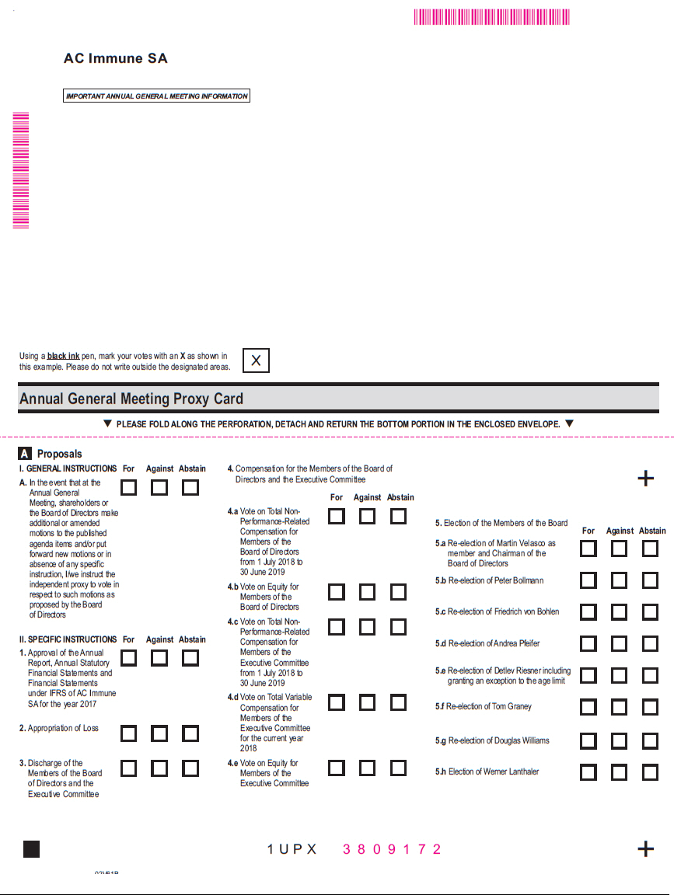

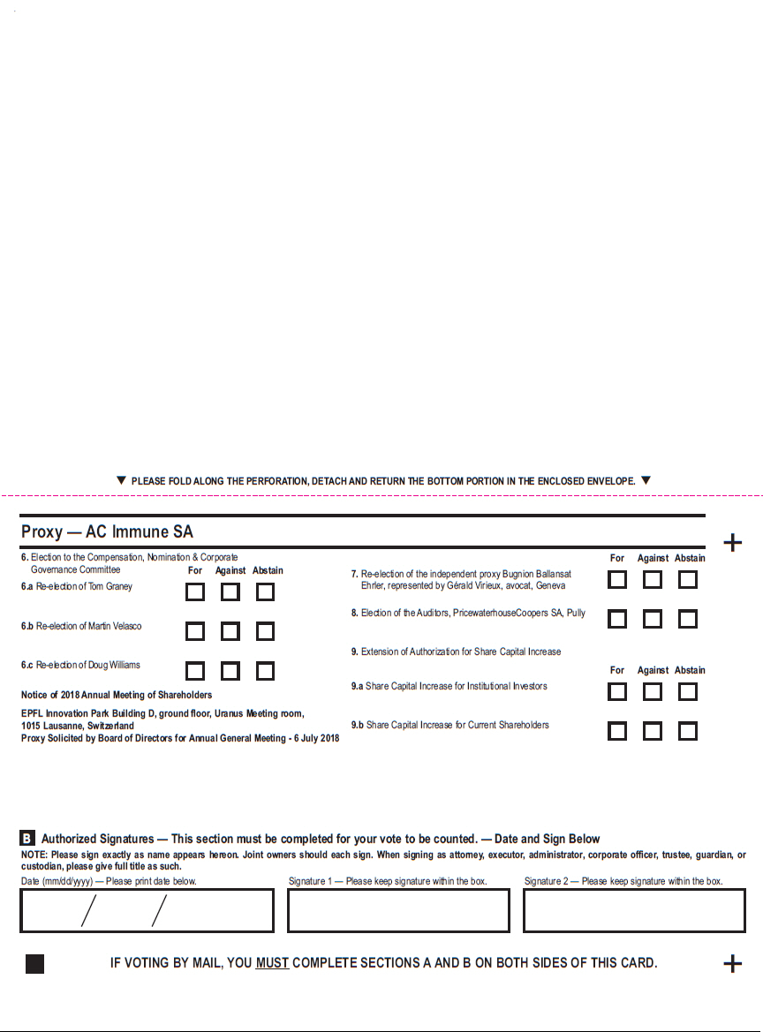

Exhibit 99.3


Lausanne, 6 June 2018

Dear Shareholder,

We are pleased to report that AC Immune has continued to make significant progress in 2017 – our first full year as a public company. Notably, our lead asset, crenezumab, entered a second pivotal Phase 3 trial in Alzheimer’s disease with our partner Genentech, a member of the Roche group. And there were also positive important developments and progress with our other assets, along with an exciting new collaboration with Essex Biotechnology in Asia, our first endeavor in this region.

Two noteworthy examples of pipeline progress occurred in the first quarter 2018 when we announced plans to start the first-in-human study for an alpha-synuclein positron emission tomography (PET) tracer for earlier and more accurate diagnosis of Parkinson’s disease. In addition, our Tau small molecules (Tau Morphomers) demonstrated target-specific reduction of pathological Tau and related neuro-inflammation as well as functional improvement.

Today AC Immune is built on three strong strategic pillars – Alzheimer’s disease, neuro-orphan indications and diagnostics. Further, we believe that precision medicine, a rapidly advancing science, which provides highly accurate matching of therapeutics and disease, will significantly improve patients’ lives. As we continue to advance and grow, we are investing time and talent in this game-changing factor in human health.

Leading expertise in the pathology of misfolded proteins

We continued to invest in our core highly-valued R&D resources and we aim at advancing our portfolio as rapidly as possible – in partnerships or alone – as we pursue our mission of being a leader in precision medicine for neurodegenerative diseases.

AC Immune’s deep pipeline features nine therapeutic and three diagnostic product candidates – with five product candidates currently in clinical trials. Notably, the anti-Tau antibody – also partnered with Genentech – moved into a Phase 2 trial for Alzheimer's disease.

The pipeline expansion with new antibodies active against alpha-synuclein and TDP-43 marks the advancement of our business strategy by targeting pathological proteins involved in Alzheimer’s disease and Parkinson’s disease, beyond Abeta and Tau. These two antibodies may potentially also address significant neurodegenerative and orphan indications.

Based on the promising safety profile and potential dose dependent reduction of amyloid plaques, we plan to move ACI-24, the anti-Abeta vaccine program for Alzheimer’s disease, forward into a Phase 2 clinical trial. Also we completed recruitment for a Phase 1b trial targeting Alzheimer’s disease-like characteristics in individuals with Down syndrome.

Encouraged by the latest data, AC Immune and our partner Janssen Pharmaceuticals jointly decided to advance the ACI-35 anti-Tau vaccine program for Alzheimer’s disease into the next stage of development.


The measurable progress of our diagnostic portfolio has become an important value driver for the Company. We will commence in the second half 2018 a first in human study for the potentially first alpha-synuclein positron emission tomography (PET) tracer for Parkinson’s disease. This new compound is highly selective for alpha-synuclein aggregates, a recognized and known target for Parkinson’s disease.

During 2017, we were also honored to have been awarded a continuation of a 2015 research grant from the Michael J. Fox Foundation for Parkinson’s Research (MJFF) for this important diagnostic program.

AC Immune has one of the largest Tau pipelines in the industry. Several Tau small molecule candidates, derived from the Company’s proprietary MorphomerTM platform and designed to cross the blood brain barrier, have demonstrated target-specific reduction of pathological Tau and related neuroinflammation as well as functional improvement in proof-of-concept studies in Alzheimer’s disease. The IND/CTA enabling studies have started and a Phase 1 study will commence by the end of 2018.

15 years anniversary: from a start-up to a clinical stage biopharmaceutical company

2018 is a landmark year as we are celebrating 15 years of AC Immune. We started in 2003 with fundamental new insights into the pathology of misfolding proteins and how they might be a root cause of Alzheimer’s disease. That core expertise will also continue to drive our future success as we leverage it in related diseases such as Parkinson’s disease and Down syndrome.

A key element of our success is a strong company culture based on a highly talented and rapidly growing team. While we advance our company to the next exciting stage of development it is vital that we continue to focus on our commitment to innovation and maintain our core entrepreneurial attitude.

So where do we go from here? Our strategy is clear: we will continue to invest and create value across the three pillars of our business – Alzheimer’s disease, neuro-orphan indications and diagnostics.

We are celebrating 15 years of AC Immune – 15 years of extraordinary achievements by outstanding people. In closing, we would like to thank all our employees for their passion, team spirit and commitment.

Moreover, the achievements of the past 15 years would not have been possible without the long-term commitment and belief of many of you, our highly valued shareholders. We greatly appreciate the insights and feedback you give us whenever we have the opportunity to meet face to face, and we look forward to sharing with you the important milestones planned over the coming 12 months.

Together, we are justified in looking ahead with great optimism to another 15 years of excellence and innovation.

Martin Velasco | Prof. Andrea Pfeifer
Chairman of the Board | CEO

Exhibit 99.7


Lausanne, 6 June 2018

Instructions on how to become a holder of record

These instructions do not apply to existing holders of record as of 23 May 2018

You already qualify as a holder of record as of 23 May 2018 with respect to all your shareholding in AC Immune SA if:

- you were shareholder of AC Immune SA prior to our initial public offering; and

- you did not purchase any additional shares in AC Immune SA during our initial public offering or subsequently.

If you purchased shares in AC Immune SA during our initial public offering or subsequently and that you have already become a registered holder as at the record date of 23 May 2018 with respect to such shares, these instructions do not apply to you.

As an individual holder of record, you may attend and vote at our annual general meeting in person or by proxy.

As a corporate holder of record (corporations or other entities), you may have your duly authorized representatives attend and vote at our annual general meeting in person or by proxy.

For additional information, please review the "Invitation to the Ordinary Shareholders' meeting" and the "Annual General Meeting Proxy Card".

Instructions for shareholders who want to become holders of record

If you purchased shares in AC Immune SA during our initial public offering or subsequently, your shares are currently registered in the name of a bank or brokerage firm (acting as your record holder). You will receive instructions from your record holder in order for your record holder to vote your shares per your instructions.

We encourage you to contact your record holder to commence the process to become a registered holder as at the record date of 23 May 2018. Alternatively, you may directly contact AC Immune SA to request a guest card to attend our annual general meeting. You will need to provide us with evidence of ownership of your shares in AC Immune SA to be entitled to vote your shares at our annual general meeting.

Please send your written request along with evidence of ownership of your shares in AC Immune SA by regular mail or email at the following address:

AC Immune SA
Attn. Jean-Fabien Monin, Chief Administrative Officer
EPFL Innovation Park
Building B
CH-1015 Lausanne
Switzerland
E-mail: jean-fabien.monin@acimmune.com

