UNITED STATES

SECURITIES AND EXCHANGE COMMISSION

Washington, D.C. 20549

FORM 6-K

REPORT OF FOREIGN PRIVATE ISSUER PURSUANT TO RULE 13a-16 OR 15d-16 UNDER THE SECURITIES EXCHANGE ACT OF 1934

For the month of May, 2020

Commission File Number: 001-37891

AC IMMUNE SA

(Exact name of registrant as specified in its charter)

EPFL Innovation Park

Building B
1015 Lausanne, Switzerland
(Address of principal executive office)

Indicate by check mark whether the registrant files or will file annual reports under cover of Form 20-F or Form 40-F:

Form 20-F X Form 40-F

Indicate by check mark if the registrant is submitting the Form 6-K in paper as permitted by Regulation S-T Rule 101(b)(1):

Yes No X

Indicate by check mark if the registrant is submitting the Form 6-K in paper as permitted by Regulation S-T Rule 101(b)(7):

Yes No X

SIGNATURE

Pursuant to the requirements of the Securities Exchange Act of 1934, the registrant has duly caused this report to be signed on its behalf by the undersigned, thereunto duly authorized.

AC IMMUNE SA
By: | /s/ Andrea Pfeifer
 | Name: | Andrea Pfeifer
 | Title: | Chief Executive Officer
By: | /s/ Joerg Hornstein
 | Name: | Joerg Hornstein
 | Title: | Chief Financial Officer

Date: May 22, 2020

EXHIBIT INDEX

Exhibit Description

Number

99.1*
99.2*

99.3

99.4

99.5

99.6*
* Filed herewith.

Invitation to the Ordinary Shareholders’ Meeting

2020 Annual General Meeting Proxy Card

2019 Statutory Annual Report (incorporated by reference to Exhibit 99.2 to the AC Immune Report of Foreign Private Issuer on Form 6-K filed on March 30, 2020)

Financial Statements (IFRS) as at and for the years ended December 31, 2019, 2018 and 2017 (incorporated by reference to Item 18 of Part III of AC Immune’s Annual Report on Form 20-F for the fiscal year ended December 31, 2019 filed on March 30, 2020)
2019 Compensation Report (incorporated by reference to Exhibit 99.3 to the AC Immune Report of Foreign Private Issuer on Form 6-K filed on March 30, 2020)

Instructions on How to Become a Holder of Record

Exhibit 99.1

Lausanne 19 May 2020

Invitation to the Ordinary Shareholders' Meeting

Date:

Place:

Friday, 26 June 2020 | 11:00 am Swiss time
R. Reagan Room | EPFL Innovation Park, Building B | Ecublens | Switzerland

- Letter to the Shareholders 2

- Agenda 5

  - Approval of the Annual Report, Annual Statutory Financial Statements and Financial Statements under IFRS for the year 2019 5

  - Appropriation of Profit 5

  - Discharge of the Members of the Board of Directors and of the Executive Committee 5

  - Compensation for the Members of the Board of Directors and of the Executive Committee 5

  - Re-elections 6

  - Amendments to the Articles of Association 6

- Organizational Notes (including measures due to Covid-19) 7

  - Coronavirus Restrictions 7

  - Availability of Financial Statements 7

  - Eligibility to Vote 7

  - Invitation and Ancillary Material 7

  - Voting (Instructions to Independent Proxy) 8

IV. Legal Notice 8

- Frequently Asked Questions (FAQ) 9

Contact information: AC Immune SA, Investor Services, EPFL Innovation Park, Building B, 1015 Lausanne, Switzerland,

Tel: +41 21 345 91 22 | Email: agm@acimmune.com | Visit our Webpage: https://ir.acimmune.com/events/agm

2

I. Letter to the Shareholders

Dear Shareholder,

2019 has been an extraordinary year in the field of Alzheimer’s disease and for AC Immune, with multiple clinical, value-creating milestones achieved and continued demonstration of our leadership in the field through the development and communication of our Roadmap to Successful Therapies for Neurodegenerative Diseases.

Our continued strong cash position of CHF 277.9 million, as of 31 March 2020, funds the Company through Q1 2024 without potential milestones, and will ensure we remain a leader in discovering and developing breakthrough therapies. This core financial stability and strength reflects that, as with our research strategy, we have always taken a long-term, informed approach. As a result, we are in the best position possible to manage the extraordinary situation presented by Covid-19 with our transformative industry partnerships an important element in our continuing strong financial outlook.

Transformative collaborations

In 2019, our partnership with Eli Lilly and Company on the small molecule Morphomer™ Tau aggregation inhibitor program has gone from strength to strength, with CHF 110 million received in upfront and development milestone payments and a USD 50 million equity note. This strong financial outlook continues in 2020, with a second CHF 10 million milestone payment received in Q1 and our transformative agreement with Lilly expanded to add a new potential CHF 60 million Phase 2 initiation milestone. Our financial position has been further strengthened with a milestone payment of EUR 2 million (CHF 2.2 million) from Life Molecular Imaging in Q3 2019 in connection with the initiation of a Phase 2 study in our Tau-imaging program.

Pipeline advancement

With increasing recognition that precision medicine is likely to be the best way to address the complexity of neurodegenerative disease pathology, one of AC Immune’s key strengths is our diversified approach. Through 2019, we are pleased to have advanced the nine therapeutic and three diagnostic product candidates in the Company's pipeline. These advances include those on well-established targets like Tau and Abeta, as well as novel targets and mechanisms.

The close correlation between the spread of Tau pathology and the onset and progression of cognitive decline, increasingly underscores the importance of Tau-targeted therapies. The Tau window of therapeutic intervention now seems much broader than Abeta and, as a result, may offer multiple opportunities for mono- or combination therapies to disrupt, slow or prevent disease progression – both at early and later stages of the disease. As such, Tau-targeted approaches are a key element of our Roadmap, and with partners, we are advancing one of the industry’s broadest Tau pipelines. In 2019 significant progress was achieved across our small molecule, antibody, vaccine and diagnostic programs.

Contact information: AC Immune SA, Investor Services, EPFL Innovation Park, Building B, 1015 Lausanne, Switzerland,

Tel: +41 21 345 91 22 | Email: agm@acimmune.com | Visit our Webpage: https://ir.acimmune.com/events/agm

3

- ACI-3024, the small molecule Morphomer™ Tau advanced into clinical development in partnership with Lilly

- A second Phase 2 trial of semorinemab, an anti-Tau antibody, was initiated by our collaboration partner Genentech, a member of the Roche Group

- A Phase 1b/2a clinical trial was initiated in our anti-phospho-Tau vaccine program in early Alzheimer’s disease in collaboration with Janssen Pharmaceuticals, Inc.

- A Phase 2 study of the Tau positron-emission tomography (PET) tracer PI-2620 was initiated in collaboration with Life Molecular Imaging

As we progress through 2020, we are building on these successes with a number of clinical milestones anticipated across these programs including the first Phase 2 readout of an anti-Tau antibody in Alzheimer’s disease, in the semorinemab trial in prodromal to mild Alzheimer’s disease. Phase 1 results are also anticipated in healthy volunteers for the ACI-3024 small molecule Morphomer™ Tau aggregation inhibitor. Both milestones reflect we are at the cutting-edge of research. ACI-3024’s unique mechanism of action targets misfolded Tau proteins both inside and outside cells. While semorinemab offers the potential for a first-in-class immunotherapy designed to intercept the cell-to-cell spread of pathological Tau.

In tandem, Abeta remains an important focus of AC Immune’s pipeline with clinical readouts in H2 2020 on both anti-Abeta vaccine programs in Alzheimer’s disease and Down syndrome-related Alzheimer’s disease. Our Down syndrome program remains the most advanced in the world, with plans being finalized to initiate a Phase 2 trial in H2 2020. This builds on initial interim data from the Phase 1b trial announced in July 2019 that showed ACI-24 has a favorable safety profile at all doses tested, mirroring previous clinical trial results.

Covid-19 update

AC Immune has always maintained a robust business continuity plan. During the Covid-19 outbreak, every provision is being made to protect the health of patients, staff and investigators, as well as the productivity and integrity of our clinical development. Importantly, we currently remain on track to deliver the five clinical readouts expected in 2020, owing largely to the fact that many of the Company’s key trials are already fully enrolled, and patient follow up is continuing virtually. The potential impact of Covid-19 on the Company’s business and operations has been comprehensively assessed, and its status as of May 4, 2020, whilst not directly relevant for this Annual General Meeting 2020 has been disclosed in our 6-K Form filed with the U.S. Security & Exchange Commission, the full details can be read here:

https://www.sec.gov/Archives/edgar/data/1651625/000095010320008879/dp127430_ex9902.htm

There are positive signs that countries, including Switzerland, are beginning to ease restrictions. AC Immune remains in continuous contact with its partners and other important stakeholders, including the Swiss government, trial investigators and contractors. At this stage the Company is not modifying guidance with respect to the multiple clinical and preclinical data readouts anticipated this year. AC Immune will keep the market apprised of any new developments or information that may impact clinical timelines.

Pipeline expansion

The strength of our clinical programs is also mirrored in our preclinical programs. In Q1 2020, we achieved the first of five milestones, with the rest remaining on track. Thanks to work undertaken through 2019, new

Contact information: AC Immune SA, Investor Services, EPFL Innovation Park, Building B, 1015 Lausanne, Switzerland,

Tel: +41 21 345 91 22 | Email: agm@acimmune.com | Visit our Webpage: https://ir.acimmune.com/events/agm

4

proof-of-concept data was presented at this year’s AAT-AD/PDTM on our TDP-43 and alpha-synuclein therapeutic and diagnostic programs. These pathological proteins represent targets of increasing interest for the treatment of neurodegenerative diseases, including NeuroOrphan indications, and AC Immune’s programs are amongst the most advanced in the field. Our leadership in this area was further strengthened in 2019 through a new research collaboration on TDP-43 with leading scientists at the Perelman School of Medicine, University of Pennsylvania, and a new grant from The Michael J. Fox Foundation for our pioneering alpha-synuclein PET tracer program.

Conclusion

Through 2019 we remained steadfast in our leadership and approach as many others seeded doubt about the Abeta hypothesis. Recent developments in the field reflect, our continued belief in Abeta, especially in preventative settings, was correct. Only through the continued commitment of you, our highly valued shareholders, was this possible and we would like to take this opportunity to extend our gratitude for your continued interest and engagement in our work in such an exciting and challenging field, which is one of the greatest unmet medical needs as well as one of the biggest opportunities in healthcare.

This year Covid-19 represents a new challenge – one we have risen to. The depth and breadth of our scientific knowledge and understanding has ensured that we have been able to anticipate, activate and implement a robust business continuity plan. I am proud and humbled that we remain on track to deliver multiple clinical and preclinical data readouts anticipated in 2020, backed by a strong financial position.

Dr. Doug Williams Prof. Andrea Pfeifer

Chairman of the Board CEO

Contact information: AC Immune SA, Investor Services, EPFL Innovation Park, Building B, 1015 Lausanne, Switzerland,

Tel: +41 21 345 91 22 | Email: agm@acimmune.com | Visit our Webpage: https://ir.acimmune.com/events/agm

5

Kindly find hereafter the agenda items and proposals of the Board of Directors in connection with the fourth ordinary annual meeting of AC Immune SA as a public company:

II. Agenda

- Approval of the Annual Report, Annual Statutory Financial Statements and Financial Statements under IFRS for the Year 2019

The Board of Directors proposes to approve the Annual Report, the Annual Statutory Financial Statements and the Financial Statements under IFRS of AC Immune SA for the year 2019, and to take note of the Reports of the Auditors. Copies of these documents are available for download on the “Annual General Meeting 2020” page of the “Investors” section of our website at: https://ir.acimmune.com/events/agm

2. Appropriation of Profit

The Board of Directors proposes that the profit for the year ended 31 December 2019 in the statutory financial statements of the Company of KCHF 45'169 reduces the “accumulated losses brought forward” of KCHF 107'320, resulting in a new balance of “accumulated losses brought forward” of KCHF 62'151. Under IFRS accounting standards, the net income for the business year 2019 amounted to KCHF 45'442.

- Discharge of the Members of the Board of Directors and of the Executive Committee

The Board of Directors proposes that the members of the Board of Directors and of the Executive Committee are discharged from their liabilities for their activities in the financial year 2019 (in a single vote for all members of the Board of Directors and of the Executive Committee).

- Compensation for the Members of the Board of Directors and the Executive Committee

The Board of Directors proposes to hold the following separate votes on the compensation of the Board of Directors and the Executive Committee:

4.1 Binding vote on Total Non-Performance-Related Compensation for Members of the Board of Directors from 1 July 2020 to 30 June 2021

The Board of Directors proposes that shareholders approve the total maximum amount of non-performance-related compensation for the members of the Board of Directors covering the period from 1 July 2020 to 30 June 2021, i.e. CHF 565’000 (cash based compensation plus pensionable social security costs).

4.2 Binding vote on Equity for Members of the Board of Directors from 1 July 2020 to 30 June 2021

The Board of Directors proposes that shareholders approve the maximum grant of equity or equity linked instruments for the members of the Board of Directors from 1 July

2020 to 30 June 2021 with maximum value of CHF 635’000 (equity or equity linked instruments at grant value plus pensionable social security costs).

4.3 Binding vote on Total Non-Performance-Related Compensation for Members of the Executive Committee from 1 July 2020 to 30 June 2021

The Board of Directors proposes that shareholders approve the total maximum amount of non-performance-related cash compensation for the members of the Executive Committee from 1 July 2020 to 30 June 2021, i.e. CHF 2’778’000 (cash based compensation plus pensionable social security costs).

4.4 Binding vote on Total Variable Compensation for Members of the Executive Committee for the current year 2020

The Board of Directors proposes that shareholders approve the total maximum amount of variable compensation for the members of the Executive Committee for the current year 2020, i.e. CHF 1’133’000 (cash based compensation plus pensionable social security costs).

4.5 Binding vote on Equity for Members of the Executive Committee from 1 July 2020 to 30 June 2021

The Board of Directors proposes that shareholders approve the maximum grant of equity or equity linked instruments for the members of the Executive Committee from 1 July 2020 to 30 June 2021 with maximum value of CHF 3’496’000 (equity or equity linked instruments at grant value plus pensionable social security costs).

4.6 Advisory vote on the 2019 Compensation Report

The Board of Directors proposes the endorsement of the 2019 Compensation report as filed with the US Security and Exchange Commission as Annex 99.3 to the Company’s 30 March 2020 6K-Form filing (advisory vote).

Contact information: AC Immune SA, Investor Services, EPFL Innovation Park, Building B, 1015 Lausanne, Switzerland,

Tel: +41 21 345 91 22 | Email: agm@acimmune.com | Visit our Webpage: https://ir.acimmune.com/events/agm

6

5. Re-elections 6. Amendments to the Articles of Association

5.1 Re-elections to the Board of Directors 6.1 Authorized Share Capital

The Board of Directors proposes for a term until the end of the next
Annual General Meeting, the re-election of:

- Douglas Williams as member and as Chairman of the Board of Directors,

- Martin Velasco as member and as Vice-Chairman of the Board of Directors,

- Peter Bollmann, Andrea Pfeifer, Tom Graney, Werner Lanthaler and Roy Twyman as members of the Board of Directors.

5.1.a Re-election of Douglas Williams as member and as Chairman of the Board of Directors.

5.1.b Re-election of Martin Velasco as member and as Vice-Chairman of the Board of Directors.

5.1.c Re-election of Peter Bollmann

5.1.d Re-election of Andrea Pfeifer

5.1.e Re-election of Tom Graney

5.1.f Re-election of Werner Lanthaler

5.1.g Re-election of Roy Twyman

5.2 Re-elections of the Members of the Compensation, Nomination & Corporate Governance Committee

The Board of Directors proposes for a term until the end of the next Annual General Meeting, the re-election of Douglas Williams, Martin Velasco and Tom Graney as members of the Compensation, Nomination & Corporate Governance Committee.

5.2.a Re-election of Douglas Williams

5.2.b Re-election of Martin Velasco

5.2.c Re-election of Tom Graney

5.3 Re-election of the Statutory Auditors

The Board of Directors proposes to re-elect PricewaterhouseCoopers SA, in Pully, Switzerland, as statutory auditors for a term of office of one year.

5.4 Re-election of the Independent Proxy

The Board of Directors proposes the re-election of Reymond & Associés, represented by Denis Cherpillod, Attorney at Law, Avenue de la Gare 1, case postale 7255, 1002 Lausanne, Switzerland, as the independent proxy for a one-year term of office until completion of the next Annual General Meeting.

As the previous window for the increase of authorized share capital expired on 20 October 2017, the Board of Directors proposes to:

- create authorized share capital to allow the Board of Directors to issue up to 14'500'000 new registered common shares of CHF 0.02 nominal value each until 27 June 2022, and

- amend article 3a (Authorized Capital Increase of Share Capital), paragraph 1, of the Articles of Association, as set out below:

“The Board of Directors is authorized to increase the share capital, in one or several steps, until 27 June 2022, by a maximum amount of CHF 290'000 by issuing a maximum of 14'500'000 registered shares with a par value of CHF 0.02 each, to be fully paid up. An increase of the share capital (i) by means of an offering underwritten by a financial institution, a syndicate or another third party or third parties, followed by an offer to the then-existing shareholders of the Company and (ii) in partial amounts, shall also be permissible.”

  - Le conseil d'administration est autorisé à augmenter le capital-actions, en une ou plusieurs étapes jusqu'au 27 juin 2022, d'un montant maximum de CHF 290'000 par l'émission d'un nombre maximum de 14'500'000 actions nominatives d'une valeur nominale de CHF 0.02 chacune, à libérer entièrement. Une augmentation de capital (i) par souscription d'actions par une institution financière, un syndicat ou un tiers ou des tiers, suivie par une souscription d'actions par les actionnaires de la société alors existants et (ii) par montants partiels, est également autorisée. »

- the remaining paragraphs of article 3a of the Articles of Association remain unchanged.

6.2 Conditional Capital Increase for Bonds and Similar Debt Instruments

With a view of resetting the Company's conditional share capital subsequent to the equity issuance related to the license and collaboration agreement entered into with Eli Lilly and Company, in December 2018, the Board of Directors proposes to:

- increase the conditional capital for bonds and similar debt instruments in the maximum amount of CHF 91'560.94 by allowing the issuance of 4'578'047 registered common shares of CHF 0.02 nominal value each; and

- amend article 3b (Conditional Capital Increase for Bonds and Similar Debt

Contact information: AC Immune SA, Investor Services, EPFL Innovation Park, Building B, 1015 Lausanne, Switzerland,

Tel: +41 21 345 91 22 | Email: agm@acimmune.com | Visit our Webpage: https://ir.acimmune.com/events/agm

Instruments), paragraph 1, of the Articles of Association, as set out below:

“The share capital of the Company shall be increased by a maximum amount of CHF 91'560.94 through the issue of a maximum of 4’578'047 registered shares, payable in full, each with a nominal value of CHF 0.02, through the exercise of conversion and/or option or warrant rights granted in connection with bonds or similar instruments, issued or to be issued by the Company or by subsidiaries of the Company, including convertible debt instruments.”

  - Le capital-actions de la société peut être augmenté d'un montant maximum de CHF 91'560.94 par l'émission d'un maximum de 4’578'047 actions nominatives, d'une valeur nominale de CHF 0.02 chacune, à libérer entièrement, suite à l'exercice de droits de conversion et/ou d'option ou de bons de souscription accordés en relation avec des obligations ou d'instruments similaires, émis ou devant être émis par la société ou par des filiales de la société, y compris les instruments d'emprunt convertibles. »

- the remaining paragraphs of article 3b of the Articles of Association remain unchanged.

- Organizational Notes (including on measures due to Covid-19)

1. Coronavirus Restrictions

1.1 No “in-person” Meeting for Shareholders

The current situation surrounding the coronavirus (Covid-19) and the measures prescribed by the Swiss Federal Council to combat this infectious disease have prompted us to take special steps for the Annual General Meeting 2020, which we are legally obliged to take. Our primary goal is to protect the health of our shareholders and employees as far as possible.

Because of the special situation, we have decided to reduce the Annual General Meeting 2020 to the mandatory part as stipulated by Swiss law and by the Company’s Articles of Association. We will hold a meeting with a minimal attendance to which shareholders will not be invited to attend in person, and only hold the necessary speeches, elections and votes and will completely dispense with the usual supporting program after the shareholders’ meeting. In particular, the members of the Board of Directors and of the Executive Committee will not be available for discussion.

1.2. Voting via the Independent Proxy

Based on the measures prescribed by the Swiss Federal Council, the Board of Directors offers that shareholders issue their voting instructions to the

7

independent proxy Reymond & Associés, represented by Mr. Denis Cherpillod, Attorney at Law, Avenue de la Gare 1, case postale 7255, 1002 Lausanne, Switzerland. You can do so following the instructions in Section 5.2 below.

2. Availability of Financial Statements

The Annual Statutory Financial Statements and the Financial Statements under IFRS, the compensation report as well as the Reports of the Auditors may be downloaded from the Company’s website at https://ir.acimmune.com/events/agm or you may order a printed copy via email at agm@acimmune.com indicating your mailing address. Please note that the Annual Report is only available in English.

3. Eligibility to Vote

Shareholders registered in the share register maintained by our transfer agent, Computershare Trust Company N.A. (“Computershare”), up to and including 18 May 2020 at close of NASDAQ (“Record Date”) will be eligible to vote at the Annual General Meeting 2020. Shareholders selling their shares prior to the Annual General Meeting 2020 are excluded from voting.

New shares acquired between 19 May 2020 and 29 June 2020 (at the opening of NASDAQ) will not give any corresponding voting rights for this Annual General Meeting 2020.

These restrictions on voting do not impact trading of AC Immune shares held by registered shareholders before, during or after the Annual General Meeting 2020.

4. Invitation and Ancillary Material

Shareholders who are registered with Computershare receive their Invitation to the Annual General Meeting 2020 directly from Computershare. With their Invitation, these shareholders are receiving the means to vote electronically with the individual shareholder number (“QR Code”) and a personalized Proxy Card enabling them to give their voting instructions to the independent proxy. Section 5 below describes the voting process.

Shareholders who are “Beneficial Owners”, holding their AC Immune SA shares on 18 May 2020 through their broker or bank, are unknown to the Company or to Computershare. Their Invitation and material is issued by Computershare and channeled through their broker or bank. These shareholders should be able to vote on the portal of their bank or broker. If the receipt of the Invitation is delayed or impossible due to deficiencies in the postal delivery services, these shareholders may nevertheless access the Invitation and ancillary material for the Annual General Meeting

Contact information: AC Immune SA, Investor Services, EPFL Innovation Park, Building B, 1015 Lausanne, Switzerland,

Tel: +41 21 345 91 22 | Email: agm@acimmune.com | Visit our Webpage: https://ir.acimmune.com/events/agm

2020 and download a generic proxy card on the Company’s website at

https://ir.acimmune.com/events/agm.

5. Voting (Instructions to Independent Proxy)

Voting is done through the independent proxy prior to the Annual General Meeting 2020 (see Section 1.2 of Chapter III above).

The independent proxy will be physically present at the Annual General Meeting 2020 to vote on behalf of the shareholders who issued instructions to him.

5.1 Electronic-Voting

The Company recommends that shareholders do vote electronically through the Computershare portal with the individual shareholder number (“QR Code”) or, for “Beneficial Owners”, using the portal of their bank or broker. The independent proxy will receive the consolidated electronic instructions from shareholders, banks and brokers via Computershare.

Electronic voting instructions must be given no later than 23 June 2020 at 11:59 PM, US Eastern Standard Time.

5.2 Use of Proxy Card

Shareholders who do not wish to vote electronically may give their written instructions to the independent proxy by sending him their filled and signed Proxy Card at the email address independentproxy@acimmune.com or at the postal address indicated in Section 1.2, no later than 24 June 2020 at 11:59 PM, US Eastern Standard Time.

Shareholders who are “Shareholders of Record” registered with Computershare until 18 May 2020 (“Record Date”) should use their nominal Proxy Card, with the individual shareholder number (“QR Code”). Shareholders who are “Beneficial Owners”, holding their AC Immune SA shares through their broker or bank, should use their nominal Proxy Card received from their bank or broker.

8

If for any reason shareholders have not received an Invitation or their Proxy Card, they may download a generic Proxy Card from the Company’s website at: https://ir.acimmune.com/events/agm

Once received by the independent proxy, voting instructions may not be changed by shareholders.

Shareholders who are “Beneficial Owners” on 18 May 2020 will be requested to attach to their signed Proxy Card (i) a declaration of honor, confirming that they have not instructed the independent proxy electronically, and (ii) a bank statement establishing the number of shares in their nominal ownership.

Should the independent proxy receive voting instructions from shareholders both electronically and in writing, only the electronic instructions will be taken into account.

IV. Legal Notice

Per the Company’s Articles of Association, the official Invitation to the Annual General Meeting 2020 will be published in the Swiss Official Gazette of Commerce (“SOGC”) on or before 5 June 2020. Concurrently with the publication in the SOGC, the Company’s webpage “Investors/Annual General Meeting 2020” on https://ir.acimmune.com/events/agm will display a copy of the publication and provide a link to the publication as soon as it is released in the SOGC.

Ecublens, AC Immune SA

On behalf of the Board of Directors
Dr. Douglas Williams, Chairman of the Board of Directors

Contact information: AC Immune SA, Investor Services, EPFL Innovation Park, Building B, 1015 Lausanne, Switzerland,

Tel: +41 21 345 91 22 | Email: agm@acimmune.com | Visit our Webpage: https://ir.acimmune.com/events/agm

V. Frequently Asked Questions (FAQ)

- Definitions

1.1 What is the “AGM” or “AGM 2020”? It stands for AC Immune’s Annual General Meeting, which is taking place on 26 June 2020, at the Company’s premises in Lausanne, Switzerland.

1.2 What is a “Shareholder of Record”? A shareholder of AC Immune whose shares are currently registered in such shareholder’s name with Computershare.

1.3 What is a “Beneficial Owner”? A shareholder whose shares of AC Immune are currently registered in the name of a bank or brokerage firm (acting as the Beneficial Owner’s record holder).

1.4 What is the “Record Date”? 18 May 2020 at close of NASDAQ.

- Shareholders’ eligibility to vote

2.1 I am a registered shareholder (whether as Shareholder of Record or as Beneficial Owner) on the Record Date: can I vote at the AGM? Yes, if you still hold your AC Immune shares on the date of the AGM.

2.2 I have purchased AC Immune shares between the Record Date and the date of the AGM: can I vote at the AGM? No.

- Invitation to AGM

3.1 How do I receive my personalized Invitation to the AGM? If you are a Shareholder of Record, you should receive your Invitation to the AGM directly from Computershare via email before 31 May 2020. If you are a Beneficial Owner, Computershare will send your Invitation to your bank or broker via email or post (if you opted-out of email correspondence in your bank or broker’s system).

3.2 I have not received a personalized Invitation: how can I procure an Invitation and how can I vote? A non-personalized Invitation and all documentation (including a generic proxy card) may be downloaded from the AC Immune website (https://ir.acimmune.com/events/agm). The official Invitation with the Agenda is published in the Swiss Official Gazette of Commerce on or before 5 June 2020 (https://shab.ch/#!/gazette), a link which will be provided on AC Immune's website.

9

3.3 Where can I obtain the Annual Report and Financial Statements for 2019? You can download the Annual Statutory Financial Statements and the Financial Statements under IFRS, the Compensation Report as well as the Reports of the Auditors

from the Company’s website at https://ir.acimmune.com/events/agm or you may order a printed copy via email at agm@acimmune.com indicating your mailing address.

- Voting

4.1 How can I vote? Each of your shares gives you one vote at the AGM. Due to coronavirus, the AGM will not be an “in-person” meeting among the shareholders. Your votes will have to be expressed via the independent proxy, who will vote at the AGM on the basis of instructions that you have given to him either electronically or by using the Proxy Card.

4.2 How can I vote electronically? We recommend that you give your instructions to the independent proxy electronically:

- If you are a Shareholder of Record you can vote through the Computershare portal using your unique voting code provided to you by Computershare.

- If you are a Beneficial Owner, you will have to follow the instructions of your bank or broker on the use of their portal or other digital means (such as, potentially, phone instructions).

The independent proxy will receive the consolidated electronic instructions from all shareholders and vote accordingly at the AGM.

4.3 Where do I find my individual shareholder number (“QR Code”)? Shareholders of Record receive their individual shareholder number (“QR Code”) from Computershare on their Proxy Card. Beneficial Owners receive their unique identification code from their bank or broker with the Invitation and material.

4.4 What is the use of the Proxy Card? The individualized Proxy Card which is received with the Invitation is an alternative to electronic voting: it needs to be filled, signed and sent to the independent proxy, together with the supporting documentation (if you are a Beneficial Owner) to the email address of the independent proxy independentproxy@acimmune.com or to his postal address: Reymond & Associés,

Contact information: AC Immune SA, Investor Services, EPFL Innovation Park, Building B, 1015 Lausanne, Switzerland,

Tel: +41 21 345 91 22 | Email: agm@acimmune.com | Visit our Webpage: https://ir.acimmune.com/events/agm

represented by Mr. Denis Cherpillod, Attorney at Law, Avenue de la Gare 1, case postale 7255, 1002 Lausanne, Switzerland.

4.5 What is the Supporting Documentation? If you are a Beneficial Owner and are not voting electronically, this documentation has to be provided in support of the Proxy Card to the independent proxy, and consists of:

- A signed declaration of honor by which you confirm that you have not voted electronically. A model can be downloaded from AC Immune's website (https://ir.acimmune.com/events/agm).

- A bank or broker statement confirming the number of AC Immune shares held by you.

The supporting documentation has to be sent to the independent proxy with the Proxy Card as described in the Answer 4.4 above.

4.6 What is my deadline for voting? You have to issue your instructions to the independent proxy:

- if you vote electronically, on or before 23 June 2020 at 11:59 PM US Eastern Standard Time; or

- if you vote by Proxy Card, your Proxy Card and supporting documentation must be received by the independent proxy before 24 June 2020 at 11:59 PM US Eastern Standard Time.

4.7 I have not received a personalized Proxy Card or lost my Proxy Card: how can I vote? If you are a Shareholder of Record you should contact Computershare to obtain your unique voting code and duplicate Proxy Card. If you are a Beneficial Owner, you should contact your bank or broker to enquire on your available means of voting. In any case, you can download a generic proxy card from AC Immune's website at https://ir.acimmune.com/events/agm, fill it out and send it to the independent proxy with the Supporting Documentation as described in Answers 4.4 and 4.5.

10

- The AGM

5.1 Will the AGM take place as a physical meeting? Yes, the AGM will be held as a physical meeting, but in the presence of such minimal number of individuals as permitted according to the Swiss Covid-19 legal restrictions. At minimum, the Chairman of the Board of Directors, the CEO, the independent proxy and the secretary of the AGM will be in physical attendance.

5.2 Can I vote in “real-time” at the AGM? No, instructions may only be given to the independent proxy before the AGM, all as detailed in the Answers in Section 4 above.

5.3 How can I vote on motions which are amended during the AGM or on new motions proposed? On the electronic portal or on the Proxy Card, you may give a general instruction to the independent proxy to vote in favor of the motions as proposed by the Board of Directors, to oppose such motions, or to abstain.

5.4 Will the AGM be recorded or broadcasted? No, due to the technical challenges the Board of Directors has decided that the AGM will not be recorded or broadcast.

*****

Contact information: AC Immune SA, Investor Services, EPFL Innovation Park, Building B, 1015 Lausanne, Switzerland,

Tel: +41 21 345 91 22 | Email: agm@acimmune.com | Visit our Webpage: https://ir.acimmune.com/events/agm

Exhibit 99.2
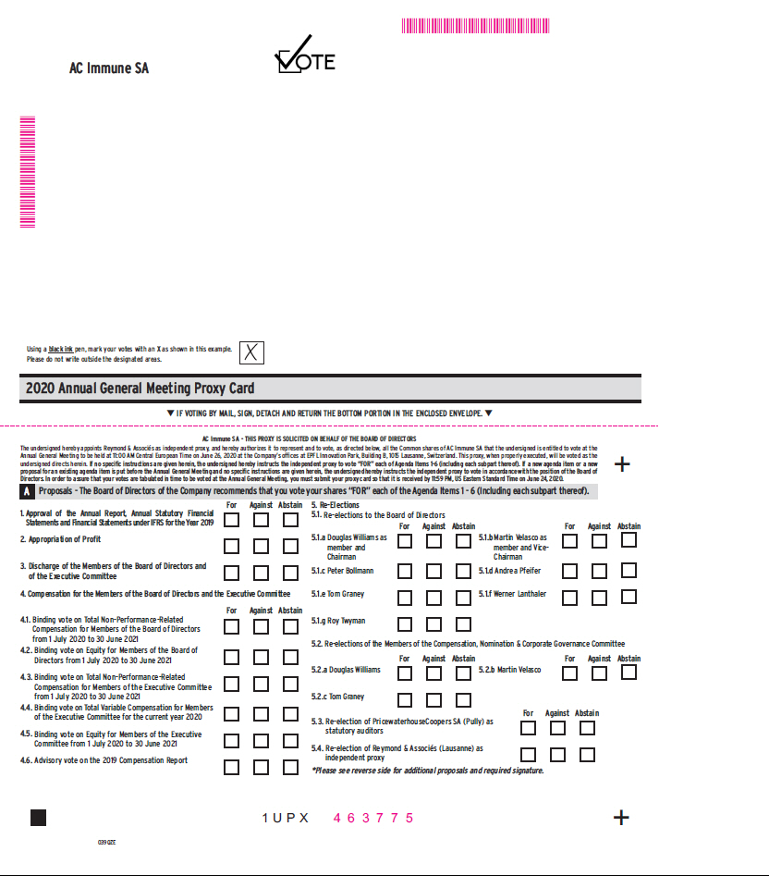

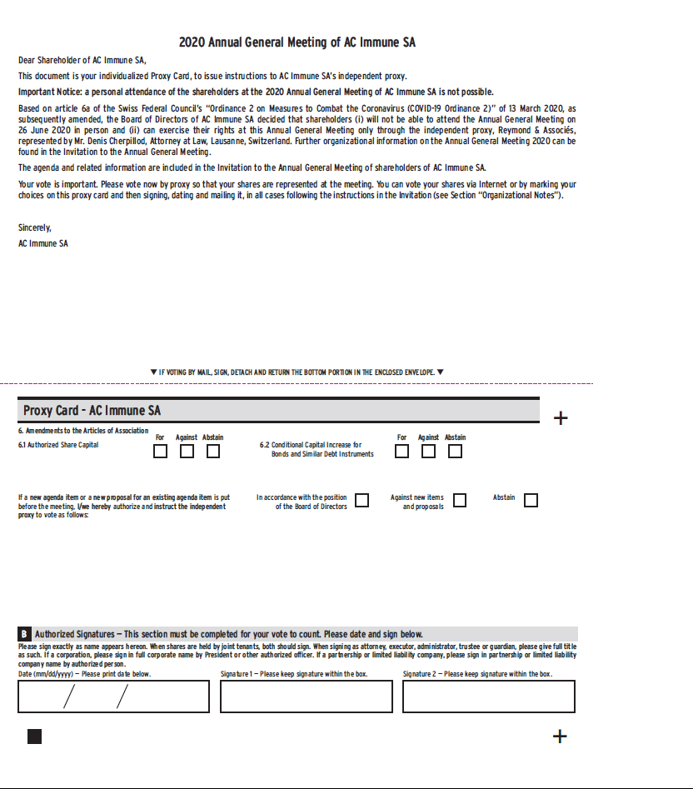

Exhibit 99.6

Lausanne, 20 May 2020

Information to Beneficial Owners regarding the Annual General Meeting 2020 of AC Immune SA, on 26 June 2020

If your shares in AC Immune SA were registered on 18 May 2020 in the name of a bank or brokerage firm (acting as your “Record Holder”), you are a “Beneficial Owner”.

Your Invitation and Voting Material

You will receive from your Record Holder, the Invitation to the Annual General Meeting 2020 (“AGM”), together with the Agenda of the AGM with the proposed motions for voting, your Proxy Card and the voting instructions.

If for any reason you have not received your Invitation from your Record Holder, you may also download the Invitation and additional documentation on our Webpage:

https://ir.acimmune.com/events/agm.

Voting at the AGM

Due to the coronavirus, there will be no “in-person” attendance of shareholders at the AGM, and shareholders will be able to vote via AC Immune SA’s independent proxy, before the AGM.

Your Record Holder will give you instructions on how to vote your shares at the AGM, whether electronically or using your personal Proxy Card.

You may also download a generic Proxy Card from the “Investors” page of our Website https://ir.acimmune.com/events/agm and send it to the independent proxy, together with supporting documentation, as instructed in the Invitation.

Becoming a Shareholder of Record

If you wish to become a “Shareholder of Record” after the AGM, you need to register as a shareholder with our transfer agent, Computershare Trust Company N.A..

Additional Information

All specific information is provided in the Invitation. We are also displaying a FAQ on our webpage https://ir.acimmune.com/events/agm. You may also directly contact us for any additional information at agm@acimmune.com.

Contact information: AC Immune SA, EPFL Innovation Park, Building B, 1015 Lausanne, Switzerland

Tel: +41 21 345 91 22 | Email: agm@acimmune.com | Website : https://ir.acimmune.com/events/agm

