UNITED STATES

SECURITIES AND EXCHANGE COMMISSION

Washington, D.C. 20549

FORM 6-K

REPORT OF FOREIGN PRIVATE ISSUER PURSUANT TO RULE 13a-16 OR 15d-16 UNDER THE SECURITIES EXCHANGE ACT OF 1934

For the month of June, 2023

Commission File Number: 001-37891

AC IMMUNE SA

(Exact name of registrant as specified in its charter)

EPFL Innovation Park

Building B

1015 Lausanne, Switzerland

(Address of principal executive office)

Indicate by check mark whether the registrant files or will file annual reports under cover of Form 20-F or Form 40-F:

Form 20-F X Form 40-F

Annual General Meeting Results

On June 23, 2023, AC Immune SA (“AC Immune”) held its Annual General Meeting of Shareholders. The Management presentation to shareholders is attached hereto as Exhibit 99.1 and the press release relating to the results of the Annual General Meeting is attached hereto as Exhibit 99.2. The amended Articles of Association are attached hereto as Exhibit 99.3, the notarized version of which will be published on AC Immune’s website (https://ir.acimmune.com/governance) after the filing of the document with the Swiss Register of Commerce. The final results of the remaining agenda items submitted to a vote of the shareholders are as below and the detailed results will be provided in the minutes which will be published on AC Immune’s website (https://ir.acimmune.com/governance) within 15 days:

Agenda Item 1: 2022 IFRS Consolidated Financial Statements, 2022 Statutory Financial Statements and 2022 Compensation Report

Agenda Item 1.1: Approval of 2022 IFRS Consolidated Financial Statements and 2022 Statutory Financial Statements

AC Immune shareholders approved the 2022 IFRS Consolidated Financial Statements and the 2022 Statutory Financial Statements, and took note of the Reports of the Auditors.

Agenda Item 1.2: Advisory Vote on the 2022 Compensation Report

AC Immune shareholders endorsed the 2022 Compensation Report.

Agenda Item 2: Appropriation of Loss

AC Immune shareholders approved that the net loss for the year 2022 in the amount of KCHF 66,936 increases the “accumulated losses brought forward” of KCHF 195,179, resulting in a new balance of “accumulated losses brought forward” of KCHF 262,115.

Agenda Item 3: Discharge of the Board of Directors and of the Executive Committee

AC Immune shareholders approved the discharge of the members of the Board of Directors and of the Executive Committee of their liabilities for their activities in the 2022 financial year.

Agenda Item 4: Compensation for the Members of the Board of Directors and the Executive Committee

Agenda Item 4.1: Binding vote on Maximum Aggregate Compensation for Members of the Board of Directors from 1 July 2023 to 30 June 2024

AC Immune shareholders approved the total maximum amount of compensation for the Board of Directors of CHF 862K (cash-based and equity or equity linked instruments at grant value, excluding employer social security contributions) covering the period from 1 July 2023 to 30 June 2024.

Agenda Item 4.2: Binding vote on Maximum Aggregate Compensation for Members of the Executive Committee for the calendar year 2024

AC Immune shareholders approved the total maximum compensation for the Executive Committee with maximum value of CHF 7,581K (cash-based compensation, variable compensation including equity and equity linked instruments at grant value, excluding employer social security and pension contributions) from 1 January 2024 to 31 December 2024.

Agenda Item 5: Election and re-elections

Agenda Item 5.1: Re-election of Members of the Board of Directors

AC Immune shareholders approved the re-election of Douglas Williams as member and as Chair of the Board of Directors and the re-election of Monika Bütler, Carl June, Werner Lanthaler, Andrea Pfeifer, Monica Shaw and Roy Twyman as members of the Board of Directors, each until the end of the Annual General Meeting 2024.

Agenda Item 5.2: Election and re-elections of Members of the Compensation, Nomination and Corporate Governance Committee

AC Immune shareholders approved the election of Monika Bütler and the re-election of Roy Twyman and Douglas Williams as members of the Compensation, Nomination and Corporate Governance Committee, each until the end of the Annual General Meeting 2024.

Agenda Item 5.3: Re-election of the Statutory Auditors

AC Immune shareholders approved the re-election of PricewaterhouseCoopers SA, in Pully, Switzerland, as AC Immune’s statutory auditors for a term of office of one year.

Agenda Item 5.4: Re-election of the Independent Proxy

AC Immune shareholders approved the re-election of Reymond & Associés, Lausanne, as AC Immune’s independent proxy until the end of the Annual General Meeting 2024.

Agenda Item 6: Changes in the Articles of Association

AC Immune shareholders approved certain changes to Article 3b of AC Immune’s Articles of Association relating to conditional capital for bonds and similar debt instruments, enabling the Company to use conditional capital for the issuance of standalone warrants and similar instruments.

SIGNATURE

Pursuant to the requirements of the Securities Exchange Act of 1934, the registrant has duly caused this report to be signed on its behalf by the undersigned, thereunto duly authorized.

AC IMMUNE SA
By: | /s/ Andrea Pfeifer
 | Name: | Andrea Pfeifer
 | Title: | Chief Executive Officer
By: | /s/ Christopher Roberts
 | Name: | Christopher Roberts
 | Title: | Vice President, Finance and Interim Chief Financial Officer

Date: June 26, 2023

 | EXHIBIT INDEX
Exhibit Number | Description
99.1 | Annual General Meeting presentation
99.2 | Press Release dated June 23, 2023
99.3 | Articles of Association as of June 23, 2023

Exhibit 99.1


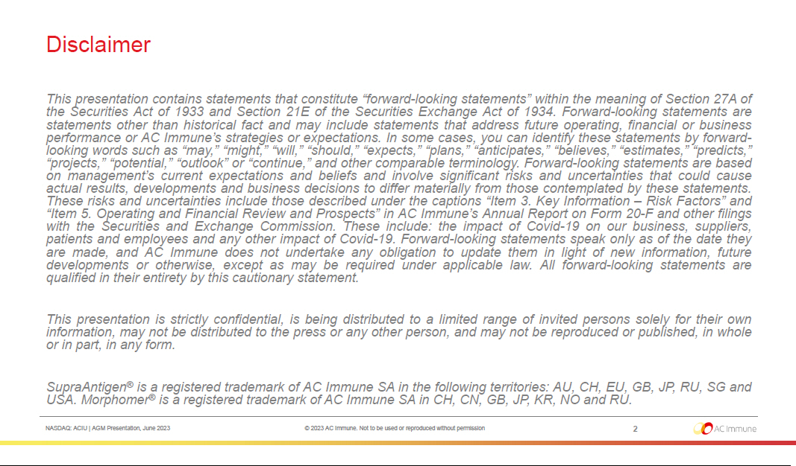

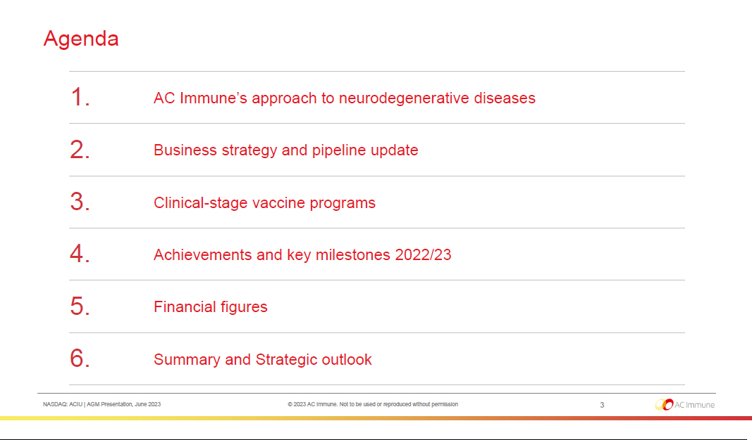

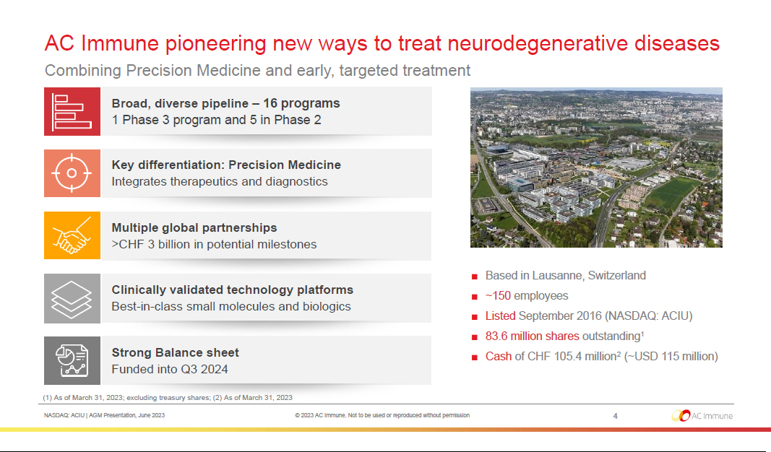

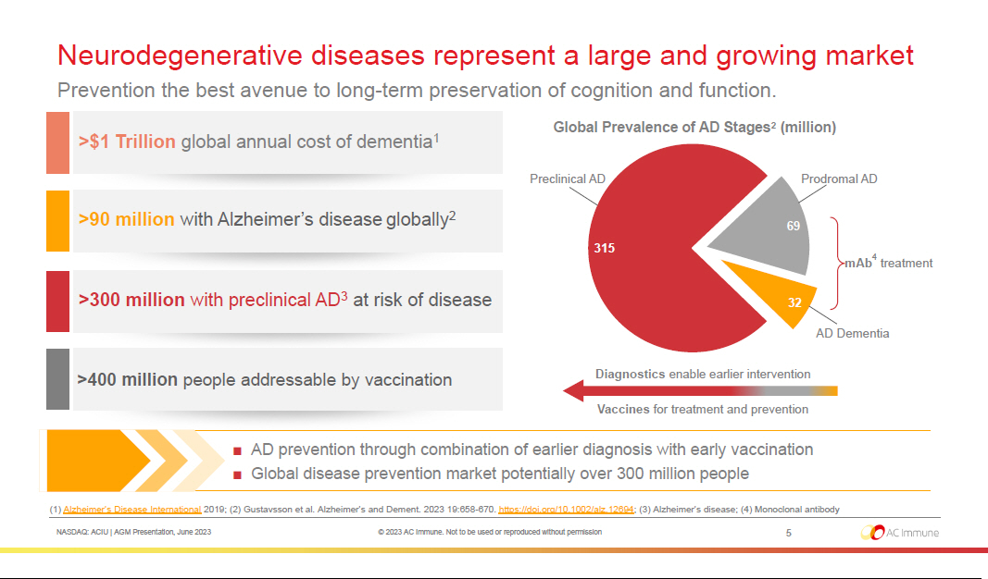

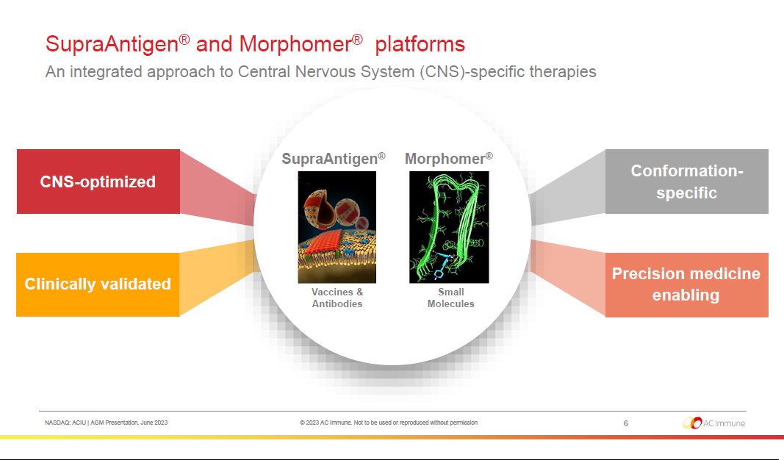



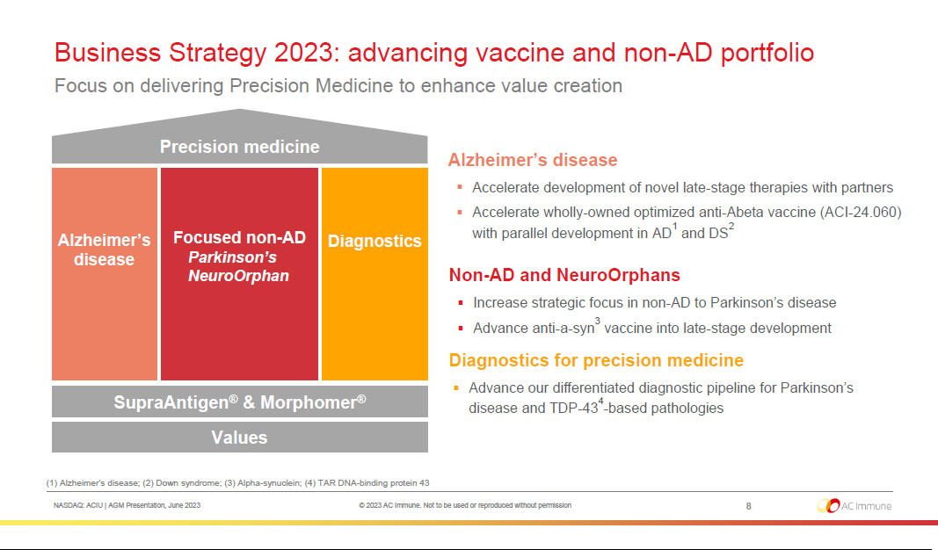

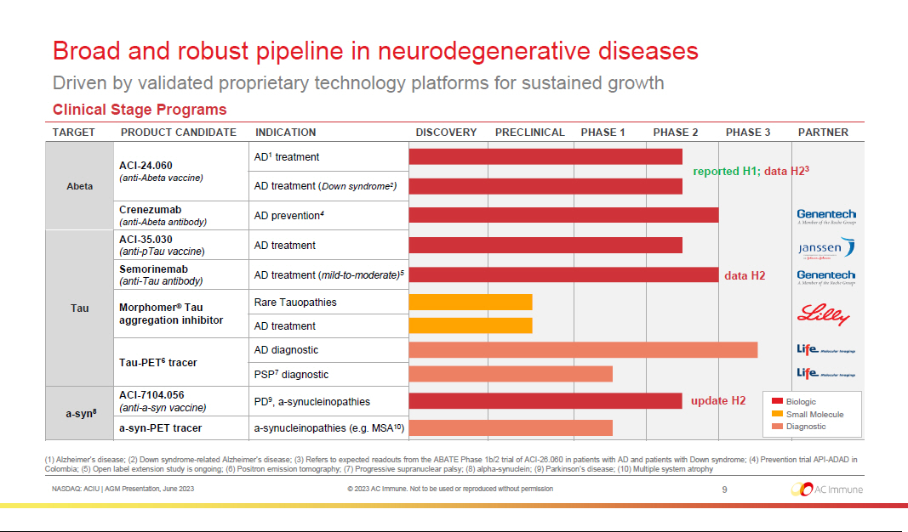



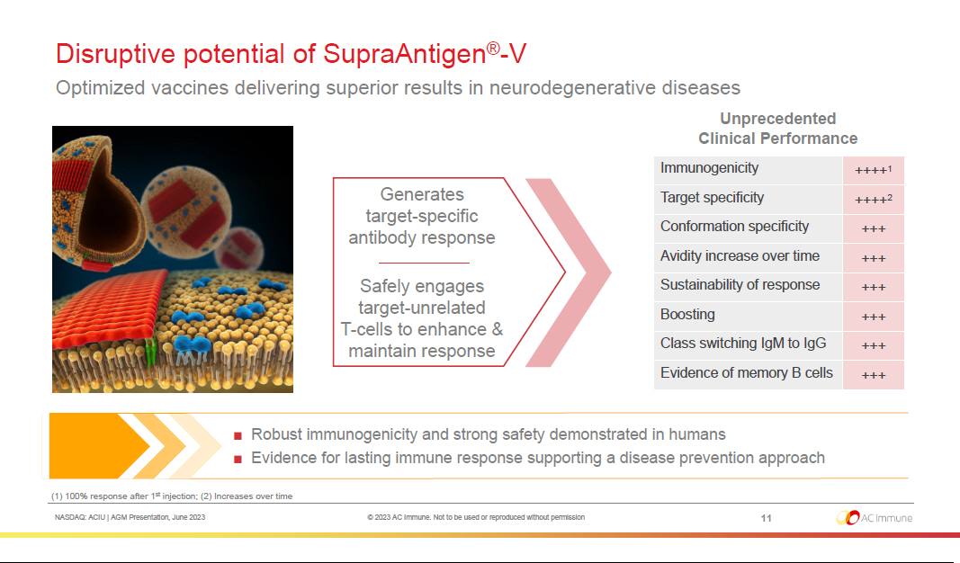

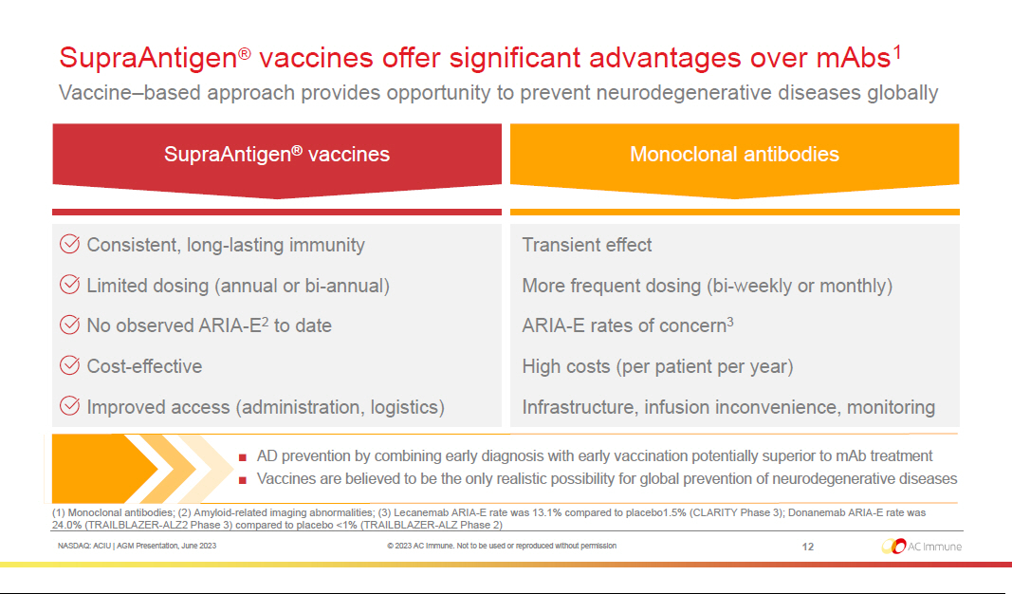

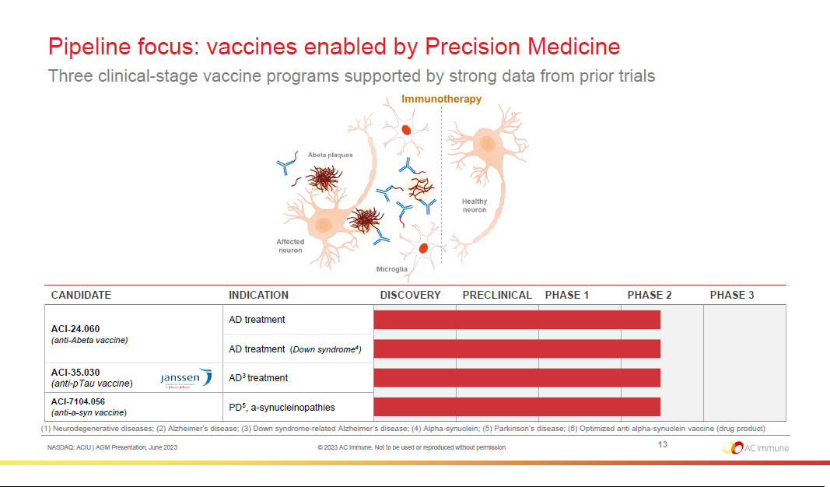

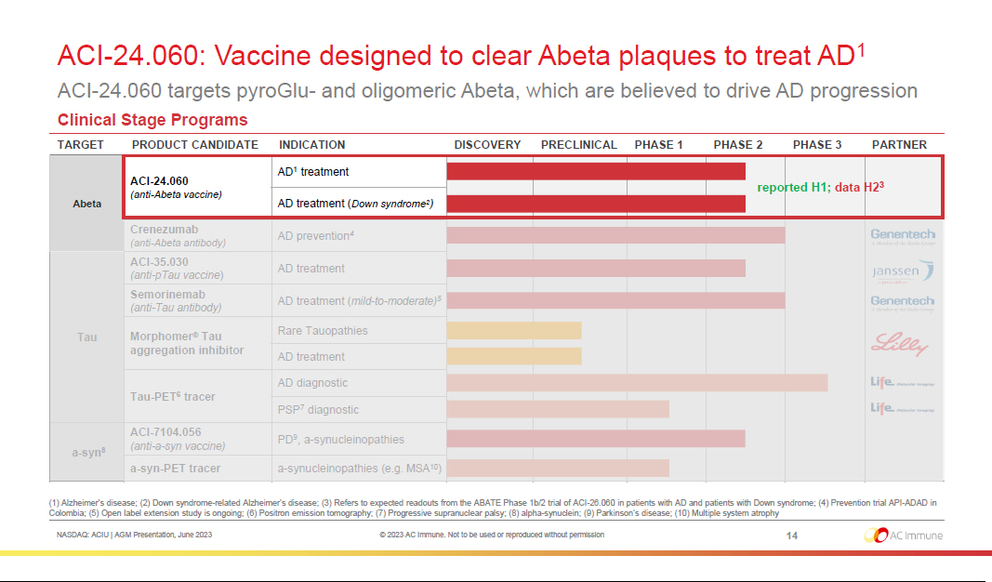

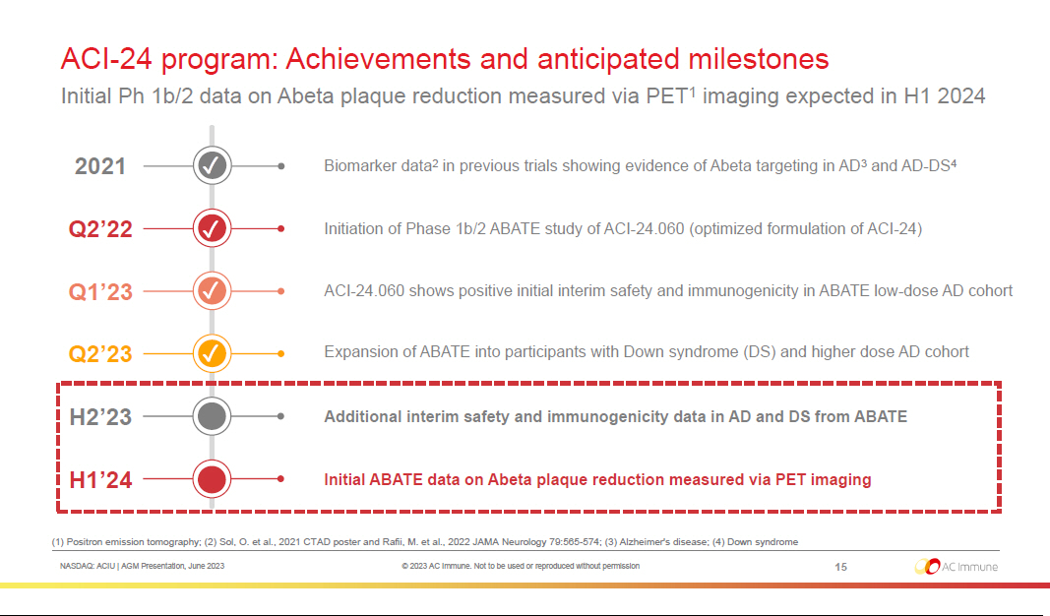

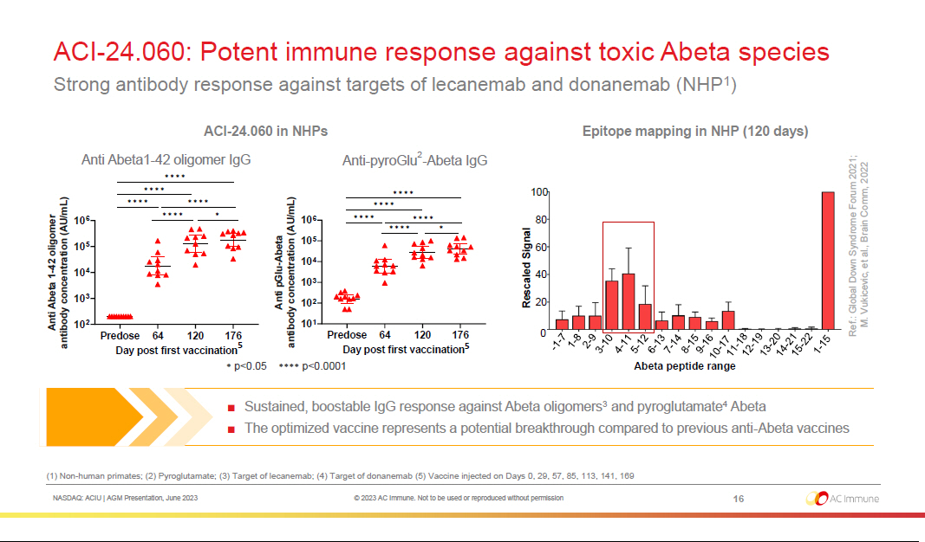

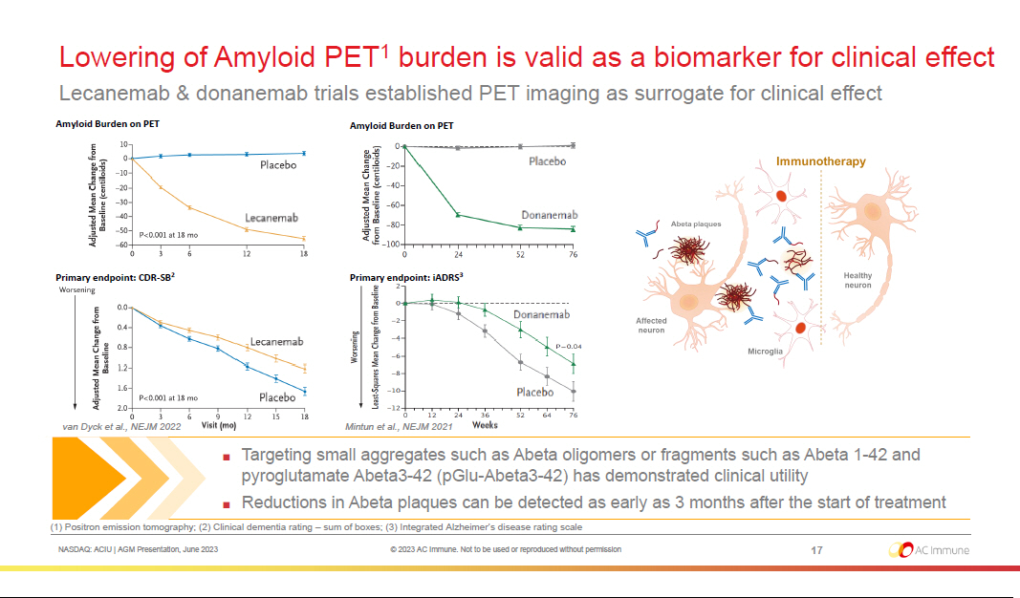

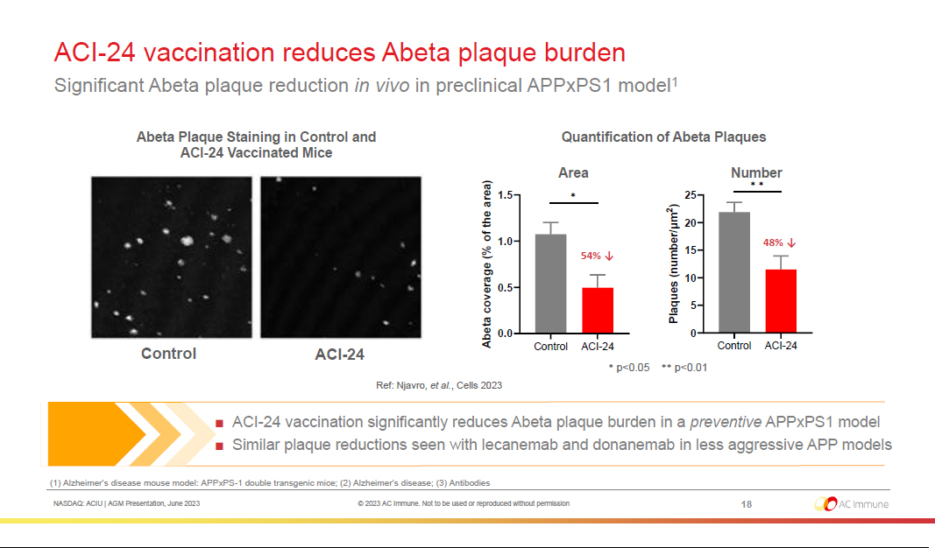

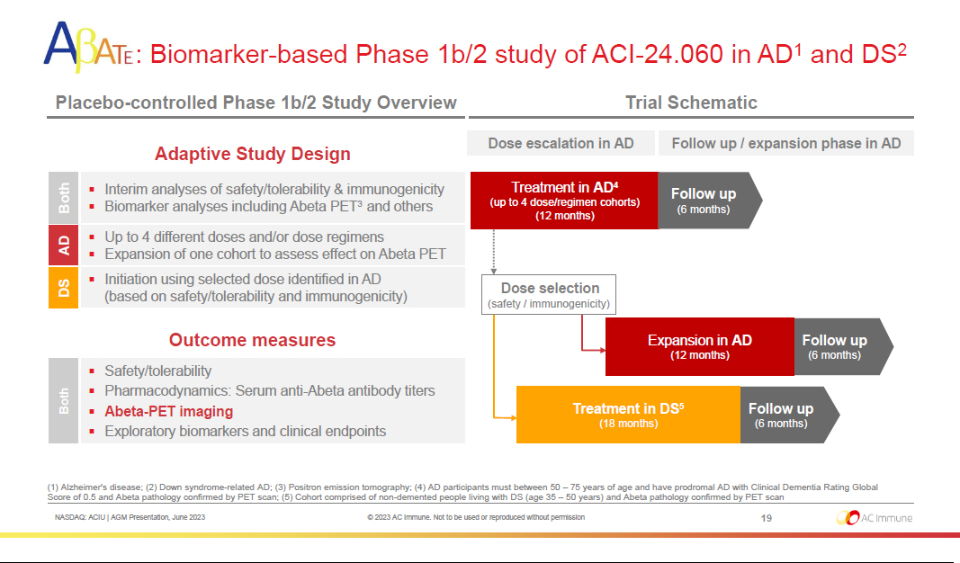

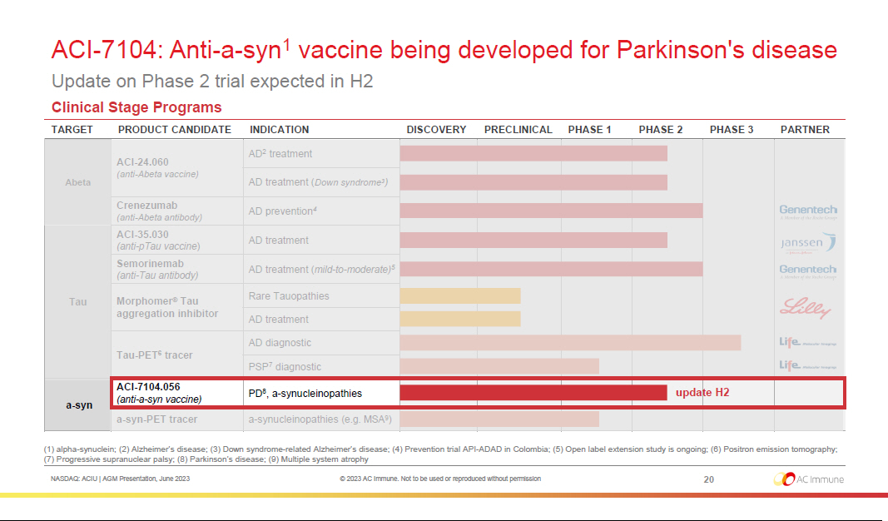

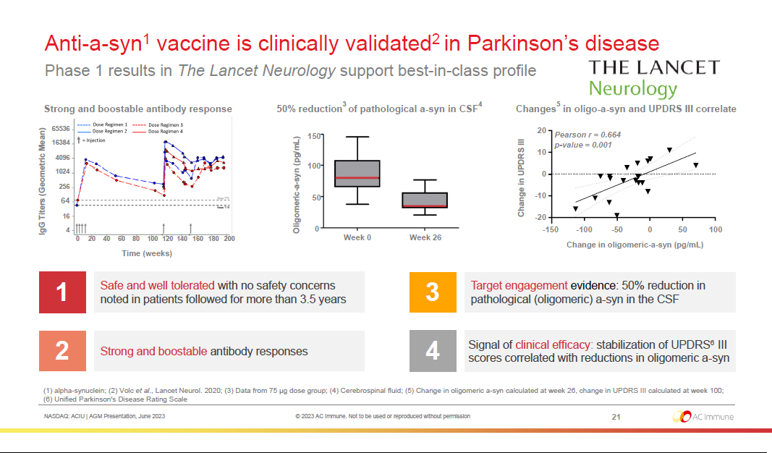

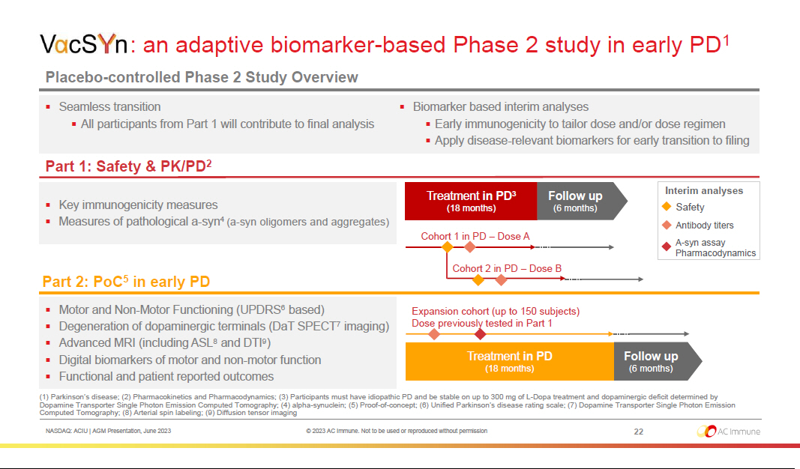

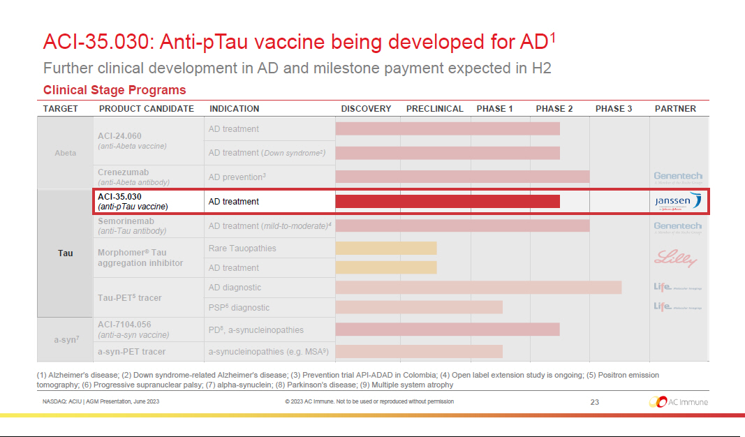

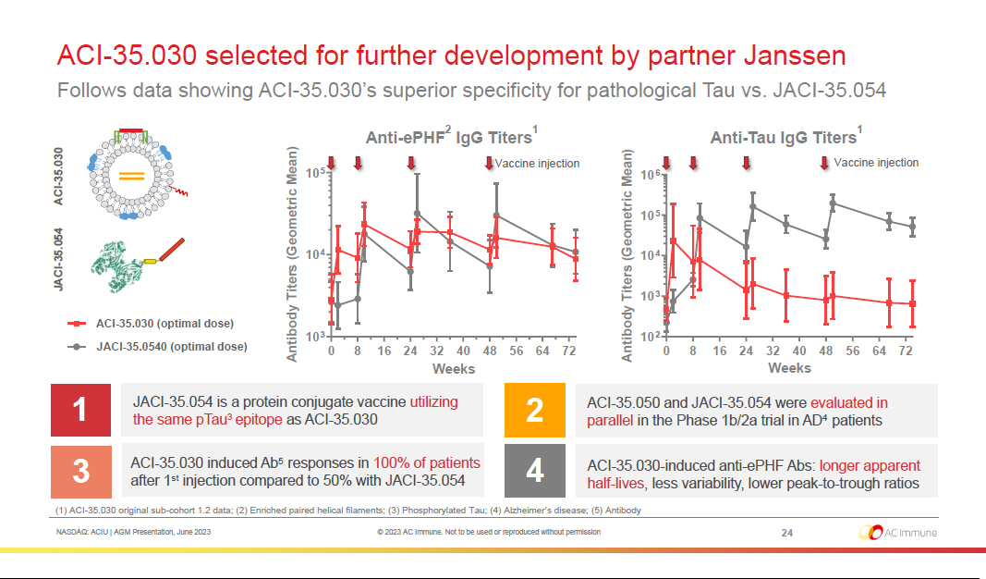

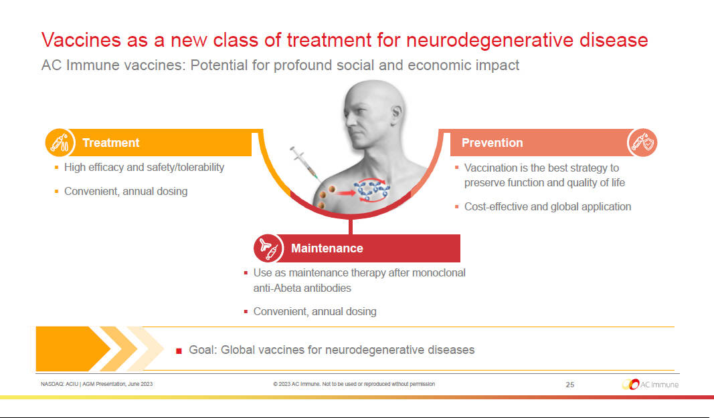

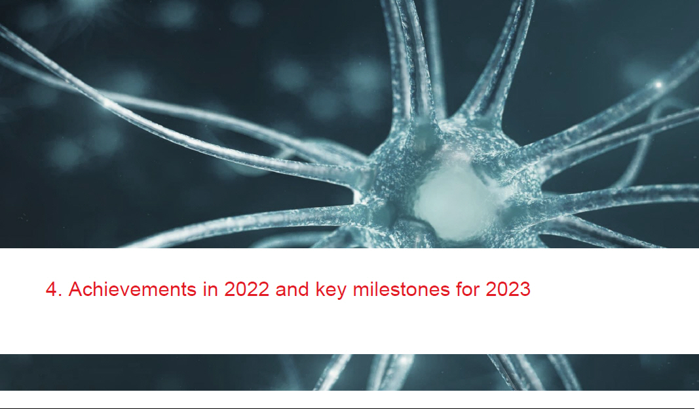

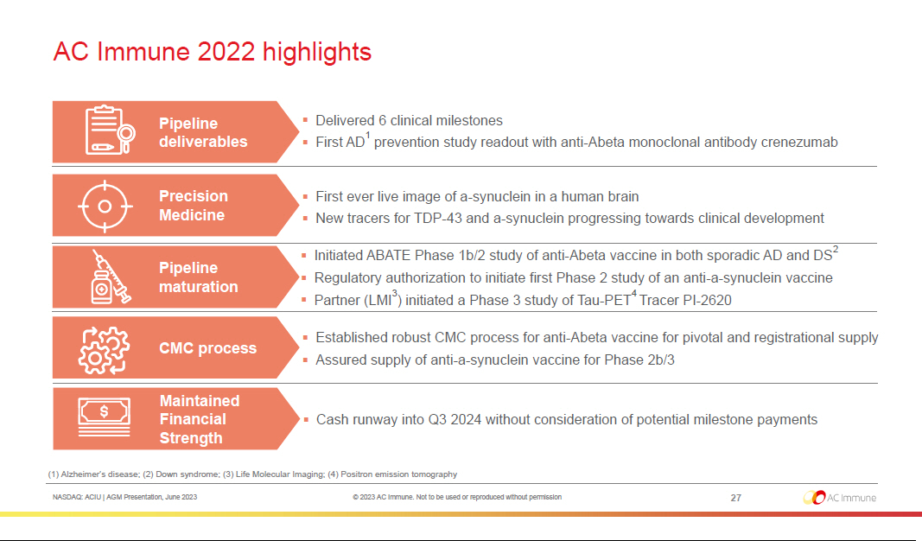

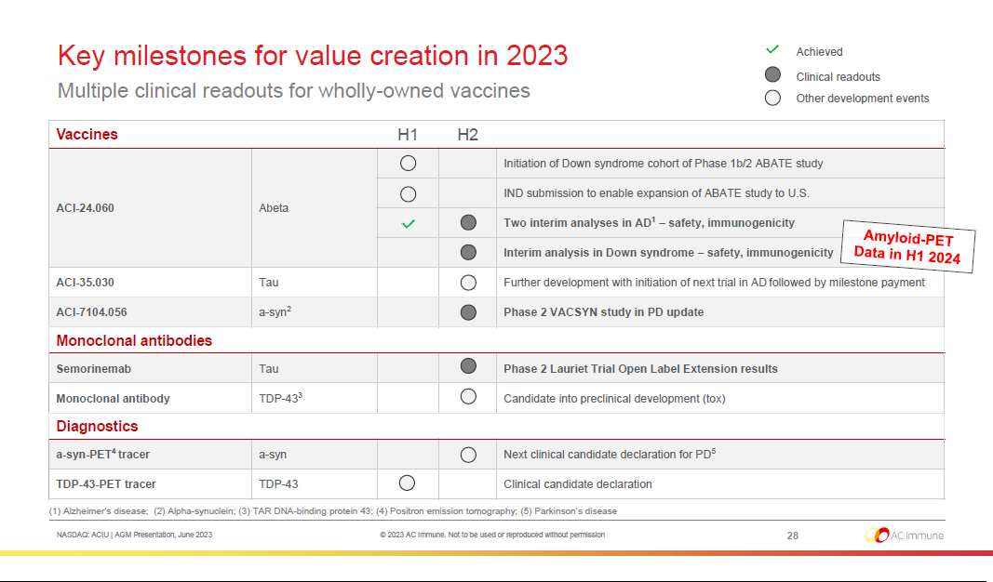



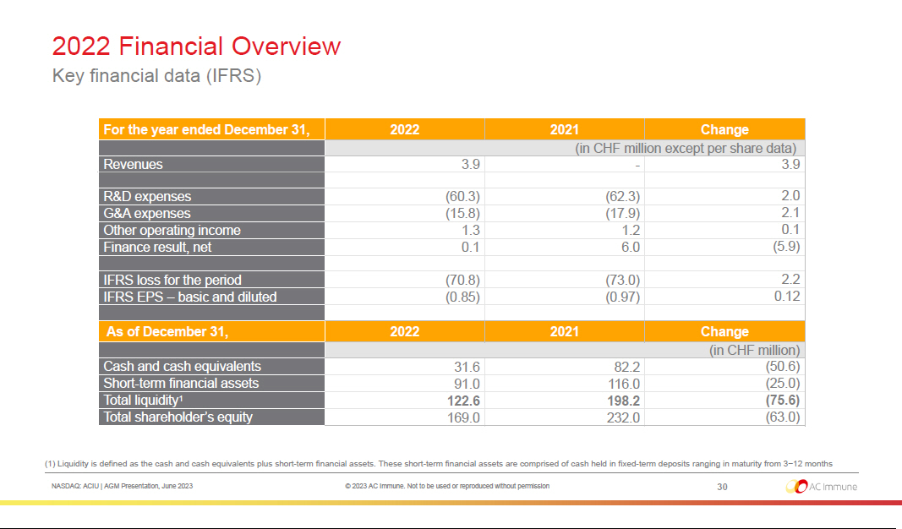



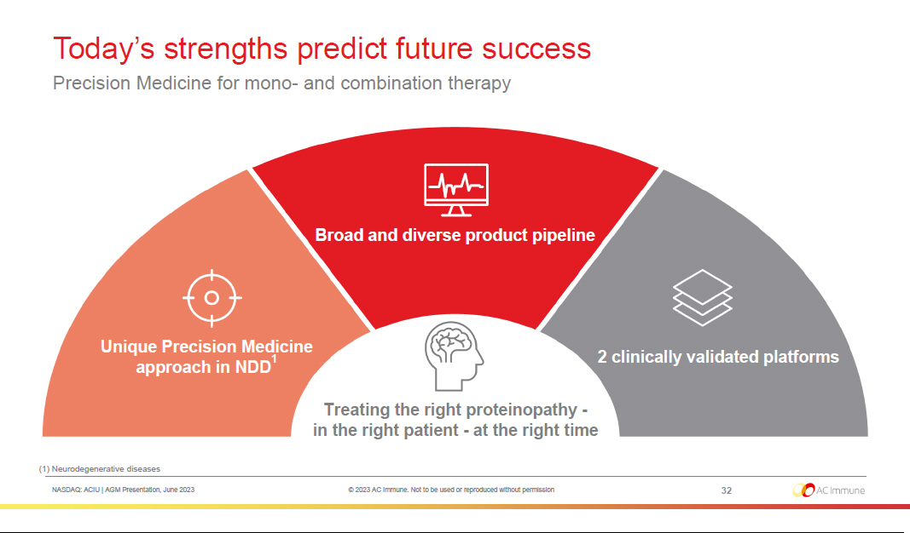

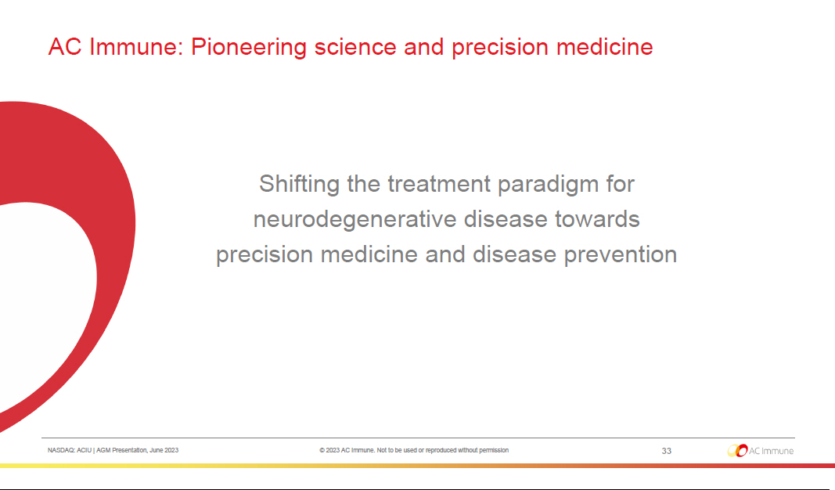

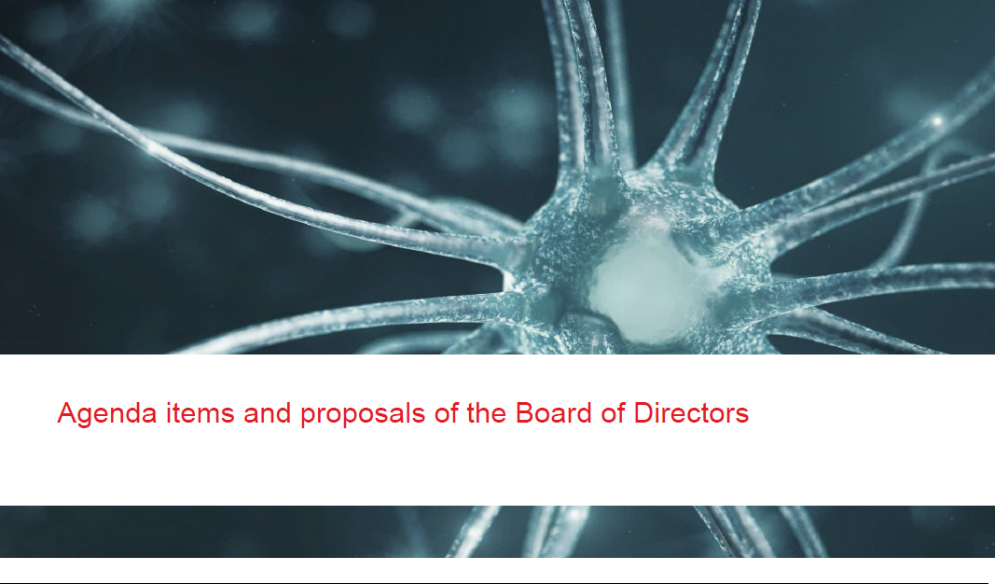

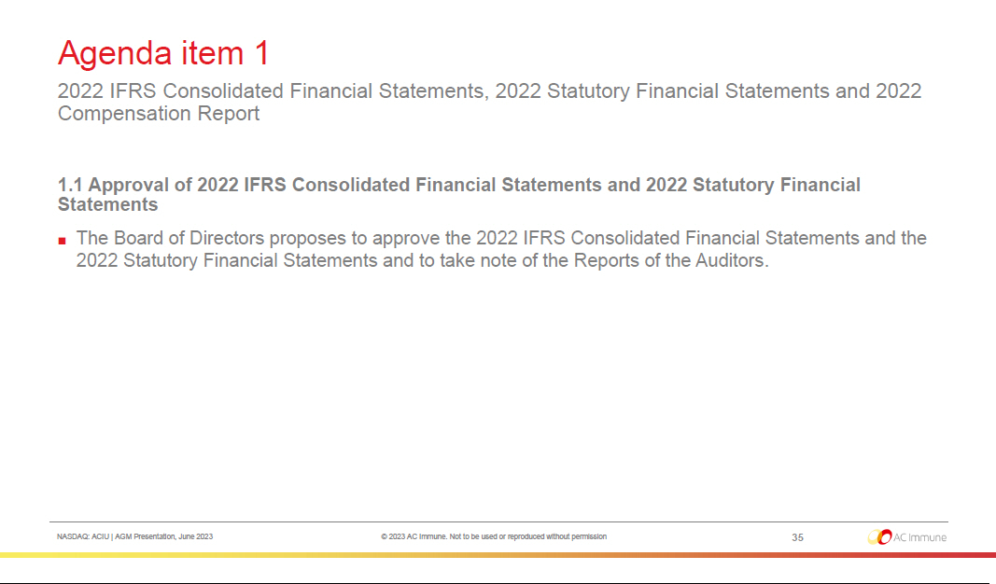

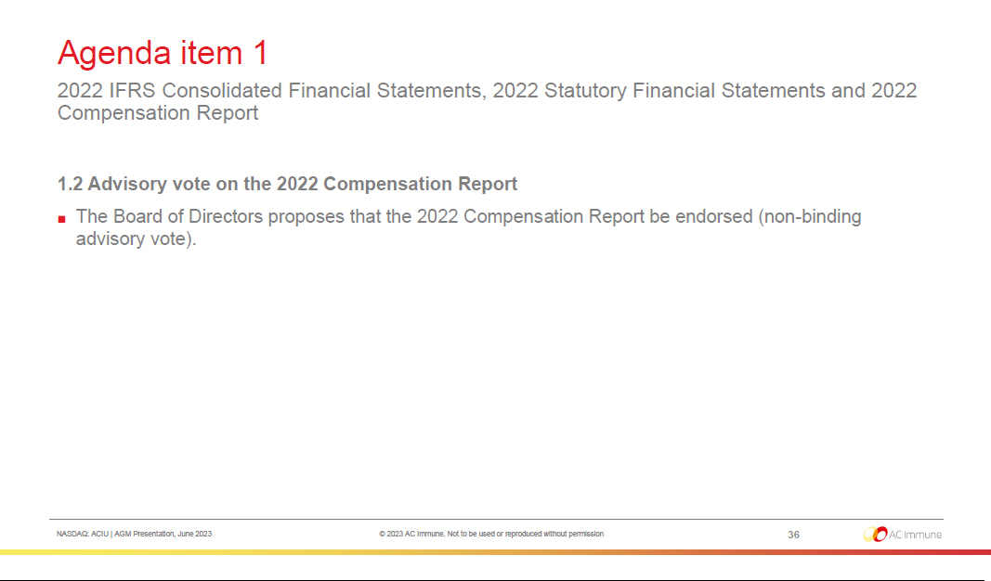

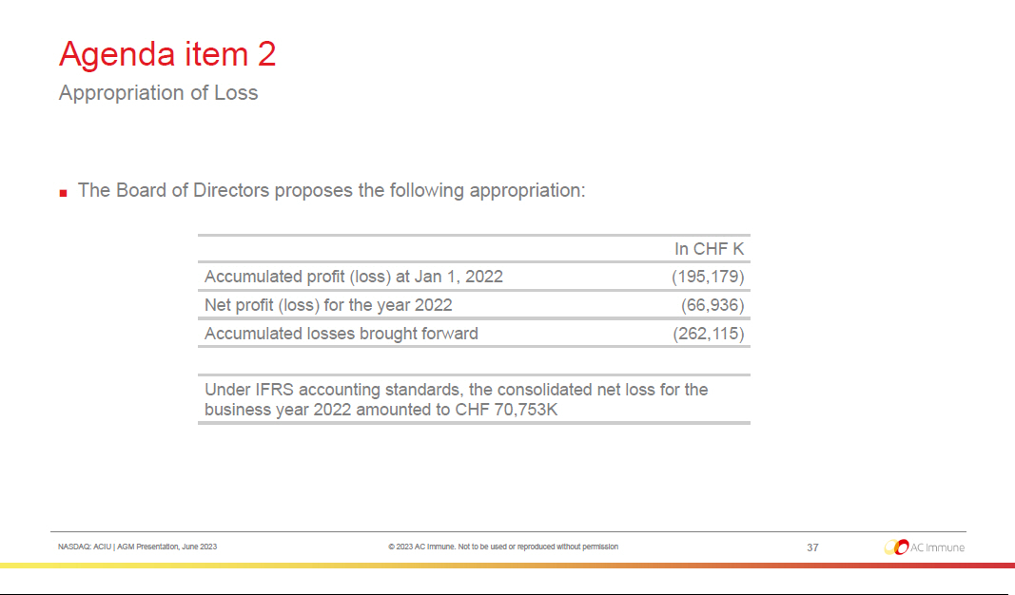

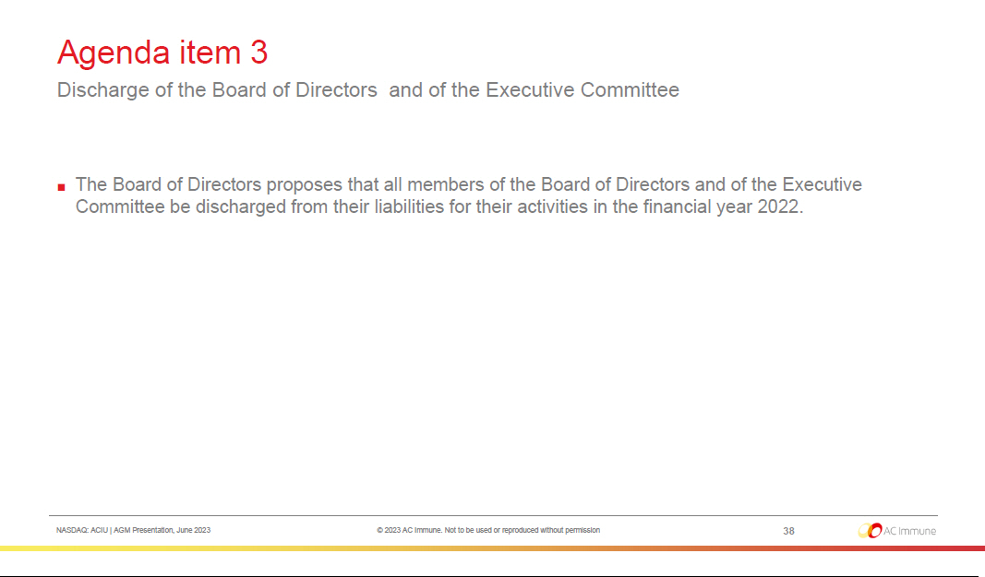

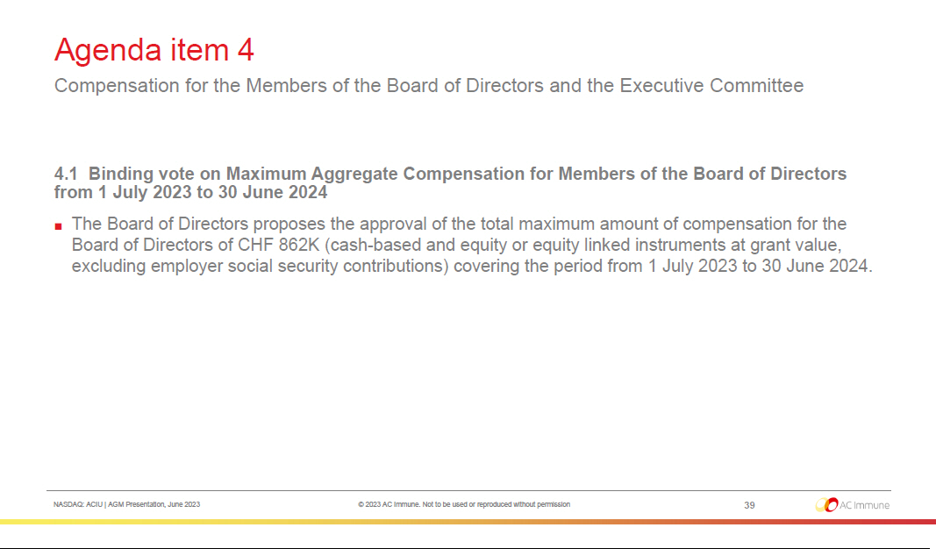

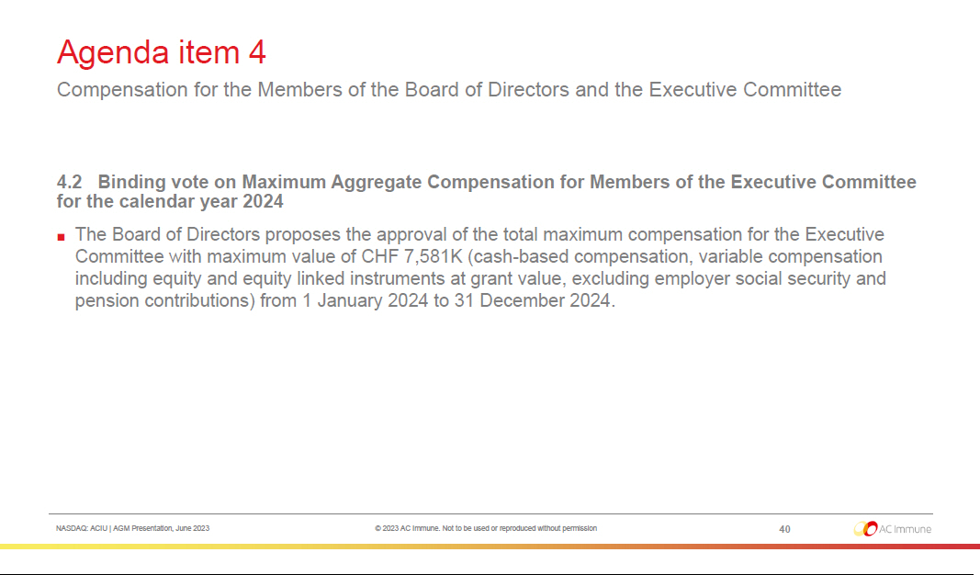

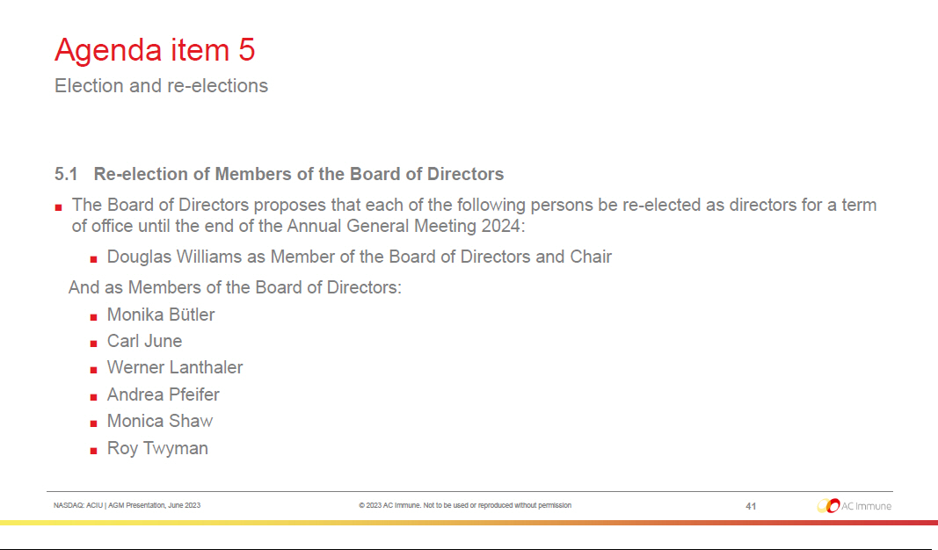

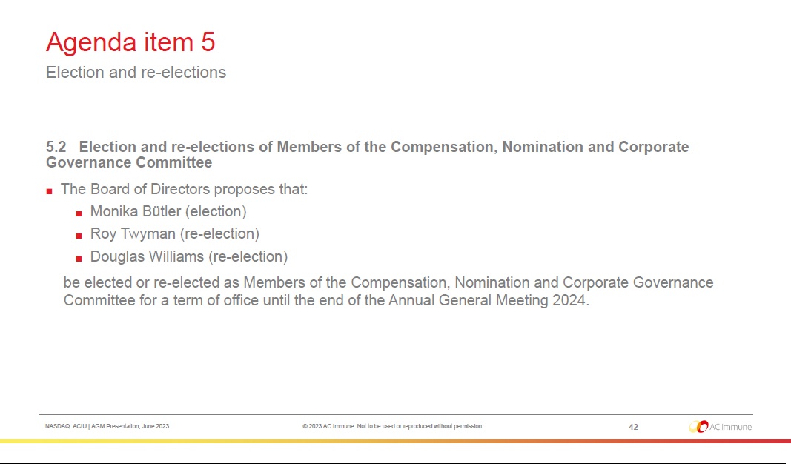

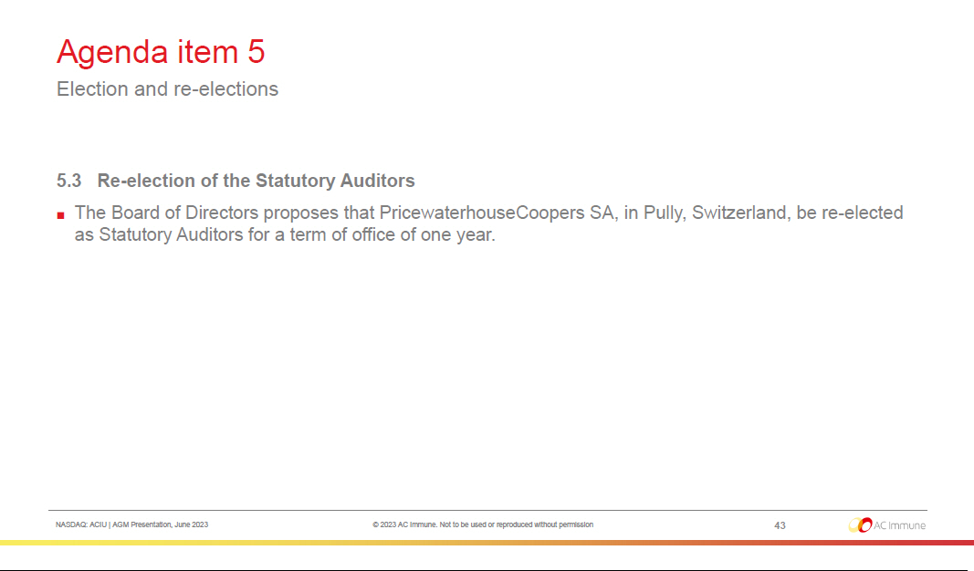

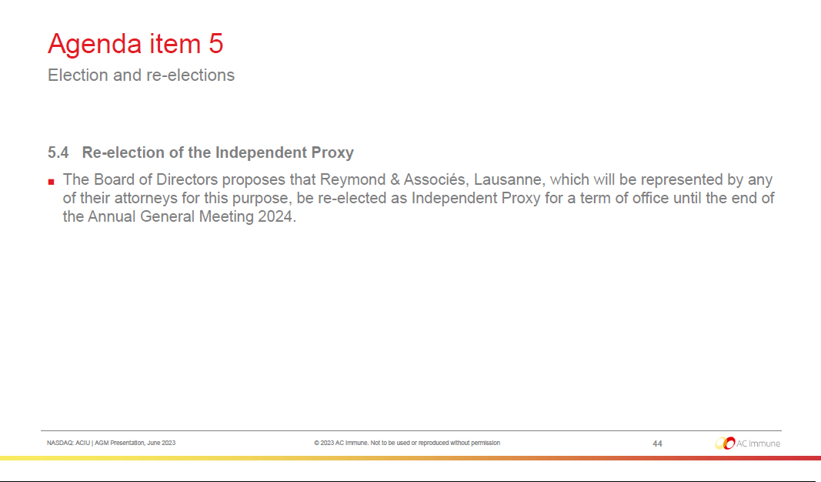

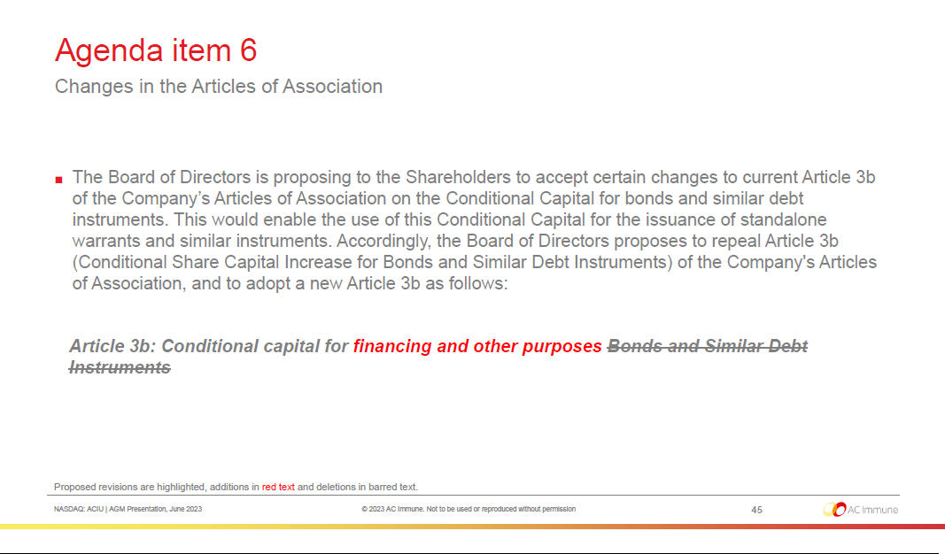

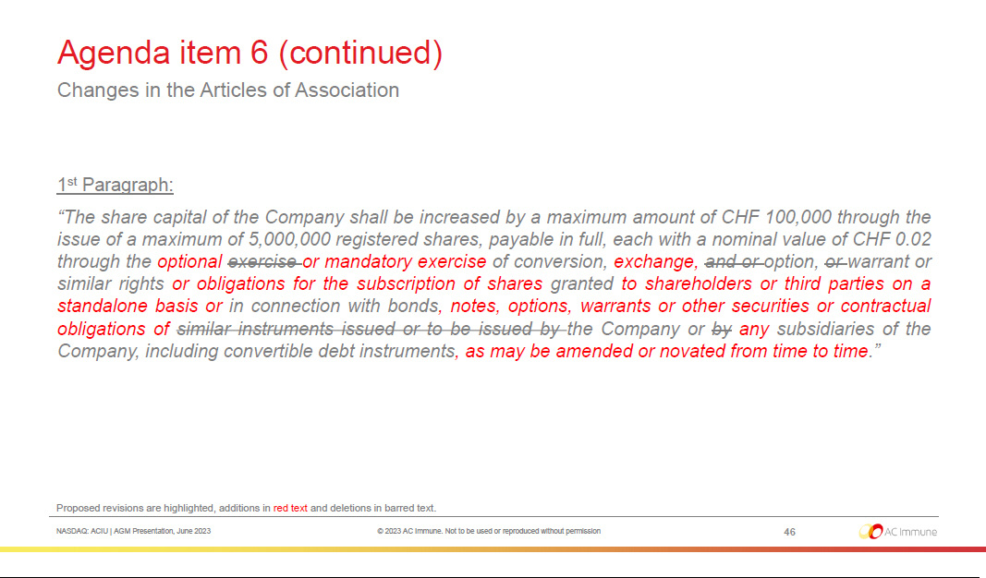

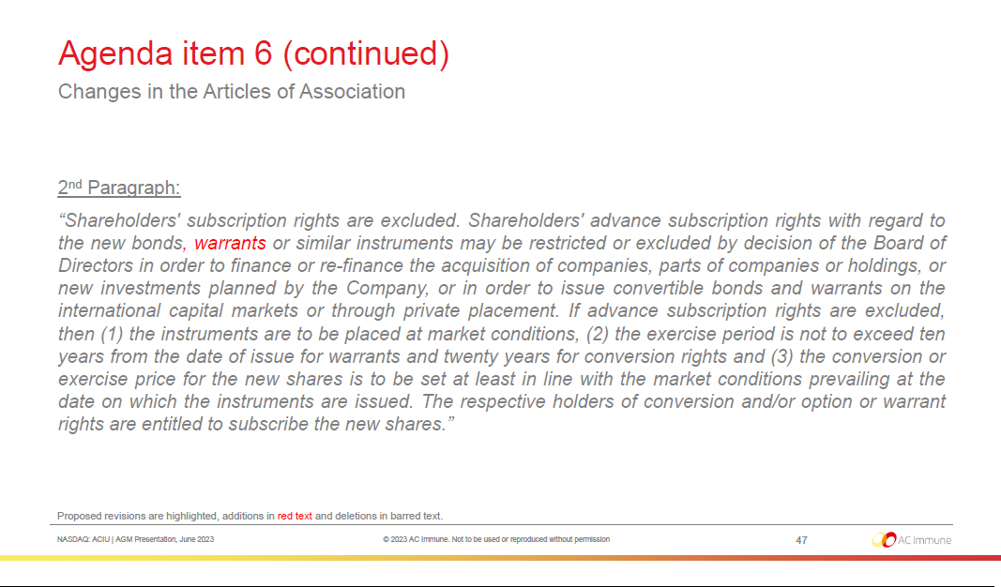

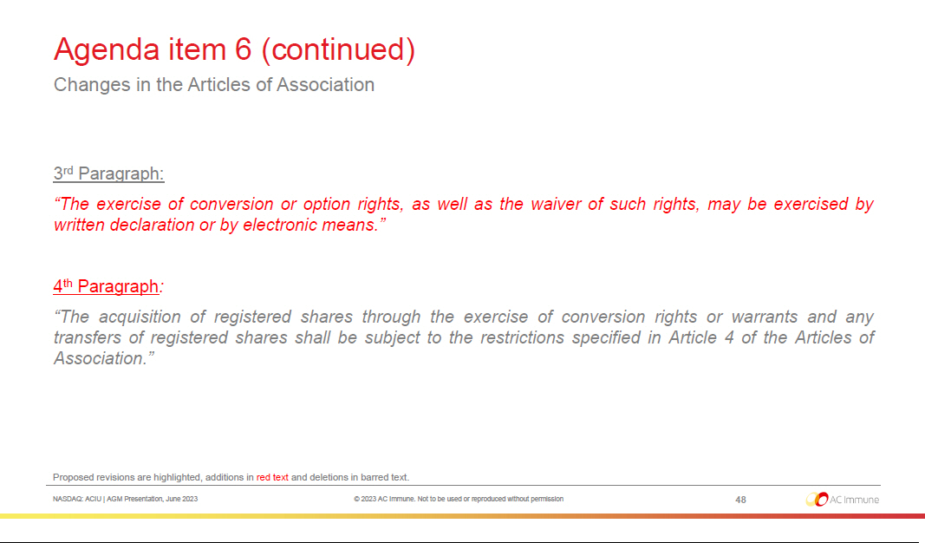

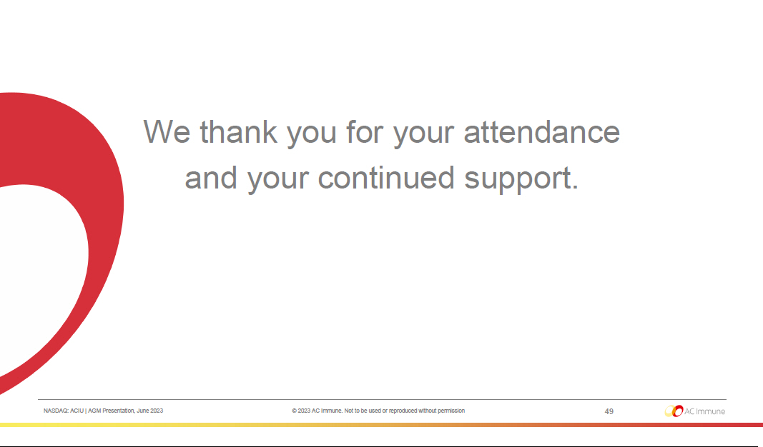

Exhibit 99.2


PRESS RELEASE

AC Immune Holds Annual General Meeting of Shareholders

- Shareholders approved all resolutions as proposed by the Board of Directors

Lausanne, Switzerland, June 23, 2023 – AC Immune SA (NASDAQ: ACIU), a clinical-stage biopharmaceutical company pioneering precision medicine for neurodegenerative diseases, today announced that the Company held its Annual General Meeting per Swiss law. Shareholders cast their votes in person at the Annual General Meeting or through the Independent Proxy appointed by the shareholders.

Shareholders re-elected Douglas Williams, Monika Bütler, Carl June, Werner Lanthaler, Andrea Pfeifer, Monica Shaw and Roy Twyman to their positions on the Board of Directors.

Alan Colowick and Tom Graney did not stand for re-election and we thank them for their contributions. Douglas Williams will continue to serve as Chair of the Board.

Douglas Williams, Chair of the Board of Directors of AC Immune, commented: “In 2022, AC Immune continued to deliver exciting developments in its broad and diverse pipeline of innovative product candidates, from the first ever live images of alpha-synuclein in patients’ brains to the initiation of the ABATE Phase 1b/2 clinical trial of ACI-24.060 in Alzheimer’s disease (AD) and AD in Down syndrome, and the selection of ACI-35.030 for continued development in AD. In the coming period we will be reporting further progress with key amyloid-PET data from the ABATE trial of ACI-24.060 expected in the first half of 2024. With our unwavering focus on rigorous science and with the strength of our teams, Company management is driving towards bringing Precision Medicine to the treatment and prevention of neurodegenerative diseases.”

Since the beginning of 2023, AC Immune reported:

- Initial safety and immunogenicity results from the ABATE Phase 1b/2 clinical trial of ACI-24.060 in AD, enabling the expansion of the trial into higher dose cohorts in AD and the opening of the study into the Down syndrome population
- The initiation by our partner, Life Molecular Imaging, of the Phase 3 clinical trial, ADvance, assessing the Tau-PET tracer, PI-2620 in AD

- Additional grant funding from the Michael J. Fox Foundation and Target ALS Foundation for research programs targeting TDP-43.

During the Annual General Meeting, shareholders also approved all other resolutions as proposed by the Board of Directors.

About AC Immune SA

AC Immune SA is a clinical-stage biopharmaceutical company that aims to become a global leader in precision medicine for neurodegenerative diseases, including Alzheimer’s disease, Parkinson’s disease, and NeuroOrphan indications driven by misfolded proteins. The Company’s two clinically validated technology platforms, SupraAntigen® and Morphomer®, fuel its broad and diversified pipeline of first- and best-in-class assets, which currently features ten therapeutic and three

diagnostic candidates, five of which are currently in Phase 2 clinical trials and one of which is in Phase 3. AC Immune has a strong track record of securing strategic partnerships with leading global pharmaceutical companies including Genentech, a member of the Roche Group, Eli Lilly and Company, and others, resulting in substantial non-dilutive funding to advance its proprietary programs and >$3 billion in potential milestone payments.

SupraAntigen® is a registered trademark of AC Immune SA in the following territories: AU, EU, CH, GB, JP, RU, SG and USA. Morphomer® is a registered trademark of AC Immune SA in CN, CH, GB, JP, KR, NO and RU.

The information on our website and any other websites referenced herein is expressly not incorporated by reference into, and does not constitute a part of, this press release.

For further information, please contact:
Head of Investor Relations & Corporate Communications |  |  |  | U.S. Investors
Gary Waanders, Ph.D., MBA |  |  |  | Corey Davis, Ph.D.
AC Immune |  |  |  | LifeSci Advisors
Phone: +41 21 345 91 91 |  |  |  | Phone: +1 212 915 2577
Email: gary.waanders@acimmune.com |  |  |  | Email: cdavis@lifesciadvisors.com
International Media
Chris Maggos
Cohesion Bureau
Phone: +41 79 367 6254
Email: chris.maggos@cohesionbureau.com

Forward looking statements

This press release contains statements that constitute “forward-looking statements” within the meaning of Section 27A of the Securities Act of 1933 and Section 21E of the Securities Exchange Act of 1934. Forward-looking statements are statements other than historical fact and may include statements that address future operating, financial or business performance or AC Immune’s strategies or expectations. In some cases, you can identify these statements by forward-looking words such as “may,” “might,” “will,” “should,” “expects,” “plans,” “anticipates,” “believes,” “estimates,” “predicts,” “projects,” “potential,” “outlook” or “continue,” and other comparable terminology. Forward-looking statements are based on management’s current expectations and beliefs and involve significant risks and uncertainties that could cause actual results, developments and business decisions to differ materially from those contemplated by these statements. These risks and uncertainties include those described under the captions “Item 3. Key Information – Risk Factors” and “Item 5. Operating and Financial Review and Prospects” in AC Immune’s Annual Report on Form 20-F and other filings with the Securities and Exchange Commission. These include: the impact of Covid-19 on our business, suppliers, patients and employees and any other impact of Covid-19. Forward-looking statements speak only as of the date they are made, and AC Immune does not undertake any obligation to update them in light of new information, future developments or otherwise, except as may be required under applicable law. All forward-looking statements are qualified in their entirety by this cautionary statement.

Exhibit 99.3

 | ARTICLES OF ASSOCIATION |  |  | STATUTS
 | of |  |  | de
 | AC Immune SA |  |  | AC Immune SA
 | (AC Immune AG) |  |  | (AC Immune AG)
 | (AC Immune Ltd) |  |  | (AC Immune Ltd)
 | with registered office in |  |  | avec siège à
 | Ecublens (VD) |  |  | Ecublens (VD)
The French version of these articles of association shall prevail. |  |  |  | La version française de ces statuts fait foi.
I. | CORPORATE NAME, PRINCIPAL OFFICE, DURATION AND PURPOSE |  | I. | RAISON SOCIALE, SIÈGE, DURÉE ET BUT DE LA SOCIÉTÉ
 | OF THE COMPANY
Art. 1 Corporate Name and Duration |  |  | Art. 1 Raison sociale et durée
Under the name |  |  | Sous la raison sociale
 | AC Immune SA |  |  | AC Immune SA
 | (AC Immune AG) |  |  | (AC Immune AG)
 | (AC Immune Ltd) |  |  | (AC Immune Ltd)
there exists a Company pursuant to the provisions of Articles 620 et seq. of the Swiss |  |  | il existe une société conformément aux articles 620 ss. du Code des Obligations
Code of Obligations (CO) with registered office in Ecublens (VD). The duration of the |  |  | suisse (CO) ayant son siège à Ecublens (VD). La durée de la société est illimitée.
Company is unlimited.
Art. 2 | Purpose |  | Art. 2 | But
The purpose of the Company is the research, study, development, manufacture, |  |  | Le but de la société est la recherche, les études, le développement, la fabrication, la
promotion, sale and marketing of products and substances within the pharmaceutical |  |  | promotion, la vente et le marketing des produits et des substances au sein de
and nutrition industry as well as the purchase, sale and exploitation of patents and |  |  | l'industrie pharmaceutique et de la nutrition ainsi que l'achat, la vente et l'exploitation
licenses in this field. |  |  | de brevets et de licences dans ce domaine.
The Company may engage in any activities which are apt to favor the purpose of the |  |  | La société peut se livrer à des activités qui sont de nature à favoriser directement ou
Company directly or indirectly. The Company may also acquire and sell real estate. |  |  | indirectement le but de la société. La société peut également acquérir et vendre des
 |  |  | biens immobiliers.

2

The Company may open branch offices in Switzerland and abroad and may also |  |  | La société peut ouvrir des succursales en Suisse et à l'étranger et peut également
acquire participations in other companies. |  |  | acquérir des participations dans d'autres sociétés.
The Company may provide securities to its subsidiaries and supply guarantees. |  |  | La société peut fournir des titres à ses filiales et des garanties d’appropvisionnement.
II. | SHARE CAPITAL AND SHARES |  | II. | CAPITAL-ACTIONS ET ACTIONS
Art. 3 Share Capital and Shares |  |  | Art. 3 Capital-actions et actions
The Share Capital of the Company is CHF 1'794'907.30. It is divided into 89'745'365 |  |  | Le capital-actions de la société se monte à CHF 1'794'907.30. Il est divisé en
registered shares with a nominal value of CHF 0.02 each, fully paid-in. |  |  | 89'745'365 actions nominatives d'une valeur nominale de CHF 0.02 chacune,
According to the contribution in kind agreement dated October 12th, 2021, the |  |  | entièrement libérées.
Company acquires from Affiris AG (FN 240538), a company incorporated under |  |  | Selon contrat d’apport du 12 octobre 2021, la Société acquiert de Affiris AG (FN
Austrian law with its registered office in Vienna (Austria), the rights related to patents, |  |  | 240538), société de droit autrichien ayant son siège à Vienne (Autriche) les droits liés
patent applications, trademarks and know-how. This contribution is made and accepted |  |  | à des brevets, dépôts de brevets, marques et savoir-faire. Cet apport est fait et
for the price of USD 53,702,500.--, and paid by the delivery to the contributor of a total |  |  | accepté pour le prix de USD 53'702'500.--, et payé par la remise à l'apporteur d’un
of 6,501,513 fully paid up registered shares of the Company with a nominal value of |  |  | total de 6'501'513 actions nominatives de la Société d'une valeur nominale de CHF
CHF 0.02 each. |  |  | 0.02 chacune, entièrement libérées.
Art. 3a Authorized Capital Increase of Share Capital |  |  | Art. 3a | Augmentation autorisée du capital-actions
The Board of Directors is authorized to increase the share capital, in one or several |  |  | Le conseil d'administration est autorisé à augmenter le capital-actions, en une ou
steps, until 24 June 2024, by a maximum amount of CHF 400’000 by issuing a |  |  | plusieurs étapes jusqu'au 24 juin 2024, d'un montant maximum de CHF 400'000 par
maximum of 20'000'000 registered shares with a par value of CHF 0.02 each, to be |  |  | l'émission d'un nombre maximum de 20'000'000 actions nominatives d'une valeur
fully paid up. An increase of the share capital (i) by means of an offering underwritten |  |  | nominale de CHF 0.02 chacune, à libérer entièrement. Une augmentation de capital
by a financial institution, a syndicate or another third party or third parties, followed by |  |  | (i) par souscription d'actions par une institution financière, un syndicat ou un tiers ou
an offer to the then-existing shareholders of the Company and (ii) in partial amounts, |  |  | des tiers, suivie par une souscription d'actions par les actionnaires de la société alors
shall also be permissible. |  |  | existants et (ii) par montants partiels, est également autorisée.
The Board of Directors shall determine the time of the issuance, the issue price, the |  |  | Le conseil d'administration fixe la date d'émission, le prix d'émission, la manière de

 | 3
manner in which the new registered shares have to be paid up, the date from which |  | libérer les nouvelles actions nominatives, la date à partir de laquelle les actions
the registered shares carry the right to dividends, the conditions for the exercise of the |  | nominatives donnent droit à un dividende, les conditions pour l'exercice des droits de
preemptive rights and the allotment of preemptive rights that have not been exercised. |  | souscription préférentiels et l'attribution des droits de souscription préférentiels qui
The Board of Directors may allow the preemptive rights that have not been exercised |  | n'ont pas été exercés. Le conseil d'administration peut autoriser que des droits de
to expire, or it may place with third parties such rights or registered shares, the |  | souscription préférentiels qui n'ont pas été exercés expirent ou attribuer à des tiers ces
preemptive rights of which have not been exercised, at market conditions or use them |  | droits ou actions nominatives, dont les droits de souscription préférentiels n'ont pas été
otherwise in the interest of the Company. |  | exercés, aux conditions du marché ou les utiliser autrement dans l'intérêt de la société.
The Board of Directors is authorized to withdraw or limit the preemptive rights of the |  | Le conseil d'administration est autorisé à retirer ou à limiter les droits préférentiels de
shareholders and to allot them to third parties: |  | souscription des actionnaires et à les attribuer à des tiers:
a) if the issue price of the new registered shares is determined by reference to the |  | a) si le prix d'émission des nouvelles actions nominatives est déterminé avec une
market price (with a customary discount); or |  | référence au prix de marché (avec un rabais usuel); ou
b) for the acquisition of an enterprise, part of an enterprise or participations, or for the |  | b) pour l'acquisition d'une entreprise, part d'entreprise ou participation, ou pour le
financing or refinancing of any of such acquisition, or in the event of share placement |  | financement ou le refinancement de ladite acquisition, ou en cas de placement
for the financing or refinancing of such placement; or |  | d'actions pour le financement ou le refinancement dudit placement; ou
c) for raising of capital (including private placements) in a fast and flexible manner |  | c) pour lever des capitaux (y compris des placements privés) dans un délai rapide et
which probably could not be reached without the exclusion of the statutory pre-emptive |  | flexible, ce qui ne pourrait probablement pas être réalisé sans l'exclusion du droit
right of the existing shareholders. |  | préférentiel de souscription statuaire des actionnaires existants.
The acquisition of registered shares out of authorized capital increase of share capital |  | L'acquisition d'actions nominatives dans le cadre d'une augmentation autorisée du
for general purposes and any transfers of registered shares shall be subject to the |  | capital-actions à des fins générales et les transferts d'actions nominatives sont soumis
restrictions specified in Article 4 of the Articles of Association. |  | aux restrictions prévues à l'article 4 des statuts.

 | 4
Art. 3b Conditional Capital Increase for financing and other purposes |  | Art. 3b Augmentation conditionnelle du capital-actions pour des financements
 |  | et autres objets
The share capital of the Company shall be increased by a maximum amount of |  | Le capital-actions de la société peut être augmenté d'un montant maximum de
CHF 100’000 through the issue of a maximum of 5’000’000 registered shares, payable |  | CHF 100’000 par l'émission d'un maximum de 5’000’000 d’actions nominatives, d'une
in full, each with a nominal value of CHF 0.02 through the optional or mandatory |  | valeur nominale de CHF 0.02 chacune, à libérer entièrement, suite à l'exercice
exercise of conversion, exchange, option, warrant or similar rights or obligations for the |  | optionnel ou obligatoire de droits de conversion, d’échange, d'option, d’acquisition
subscription of shares granted to shareholders or third parties on a standalone basis or |  | (« warrants ») ou de droits ou obligations similaires portant sur la souscription
in connection with bonds, notes, options, warrants or other securities or contractual |  | d’actions, accordés aux actionnaires ou à des tiers sur une base individuelle ou en
obligations of the Company or any subsidiaries of the Company, including convertible |  | relation avec des obligations, reconnaissances de dette (« notes»), options, droits
debt instruments, as may be amended or novated from time to time. |  | d’acquisition (« warrants ») ou autres titres ou obligations contractuelles de la société
 |  | ou de filiales de la société, y compris les instruments d'emprunt convertible, tels que
 |  | modifiés ou novés ultérieurement.
Shareholders' subscription rights are excluded. Shareholders' advance subscription |  | Le droit de souscription préférentiel des actionnaires est exclu. Les droits de
rights with regard to the new bonds, warrants or similar instruments may be restricted |  | souscription préférentiels préalables des actionnaires à l'égard des nouvelles
or excluded by decision of the Board of Directors in order to finance or re-finance the |  | obligations, nouveaux droits d’acquisition (« warrants ») ou instruments similaires
acquisition of companies, parts of companies or holdings, or new investments planned |  | peuvent être limités ou exclus par décision du conseil d'administration afin de financer
by the Company, or in order to issue convertible bonds and warrants on the |  | ou de refinancer l'acquisition d'entreprises, parties d'entreprises ou de holdings, ou de
international capital markets or through private placement. If advance subscription |  | nouveaux investissements prévus par la société, ou en vue d'émettre des obligations
rights are excluded, then (1) the instruments are to be placed at market conditions, (2) |  | convertibles et des droits d’acquisition (« warrants ») sur les marchés internationaux
the exercise period is not to exceed ten years from the date of issue for warrants and |  | de capitaux ou par placement privé. Si les droits de souscription préférentiels
twenty years for conversion rights and (3) the conversion or exercise price for the new |  | préalables sont exclus, (1) les instruments doivent être attribués aux conditions du
shares is to be set at least in line with the market conditions prevailing at the date on |  | marché, (2) la période d'exercice ne doit pas dépasser dix ans à partir de la date
which the instruments are issued. The respective holders of conversion and/or option |  | d'émission des droits d’acquisitions (« warrants ») et vingt ans pour les droits de
or warrant rights are entitled to subscribe the new shares. |  | conversion et (3) le prix de conversion ou d'exercice des actions nouvelles doit être
 |  | fixé au moins aux conditions du marché prévalant à la date à laquelle les instruments
 |  | sont émis. Les

 | 5
 |  | détenteurs respectifs de droits de conversion et/ou option ou de droits d’acquisition
 |  | (« warrants ») ont le droit de souscrire les nouvelles actions.
The exercise of conversion or option rights, as well as the waiver of such rights, may |  | L’exercice des droits de conversion ou d’options, de même que la renonciation à ces
be exercised by written declaration or by electronic means. |  | droits, s’exercent par déclaration écrite ou par voie électronique
The acquisition of registered shares through the exercise of conversion rights or |  | L'acquisition d'actions nominatives par l'exercice de droits ou de bons de conversion et
warrants and any transfers of registered shares shall be subject to the restrictions |  | les transferts d'actions nominatives sont assujetties aux restrictions prévues par
specified in Article 4 of the Articles of Association. |  | l'article 4 des statuts.
Art. 3c Conditional Share Capital Increase for Employee Benefit Plans |  | Art. 3c Augmentation conditionnelle du capital-actions pour les plans
 |  | d'avantages sociaux
The share capital of the Company shall be increased by an amount not exceeding |  | Le capital social de la société sera augmenté d'un montant ne dépassant pas
CHF 93’795.-- through the issue of a maximum of 4’689’750 registered shares, |  | CHF 93'795.-- par l'émission d'un maximum de 4'689’750 actions nominatives,
payable in full, each with a nominal value of CHF 0.02, in connection with the exercise |  | entièrement libérées, chacune avec une valeur nominale de CHF 0.02, dans le cadre
of option rights granted to any employee of the Company or a subsidiary, and any |  | de l'exercice de droits d'option accordés à tout employé de la Société ou d'une
consultant, members of the Board of Directors, or other person providing services to |  | succursale, et à tout consultant, aux membres du conseil d'administration, ou à
the Company or a subsidiary. |  | d'autres personnes fournissant des services en faveur de la Société ou d'une filiale.
Shareholders' subscription rights shall be excluded with regard to these shares. These |  | Le droit de souscription préférentiel des actionnaires est exclu à l'égard de ces actions.
new registered shares may be issued at a price below the current market price. The |  | Ces nouvelles actions nominatives peuvent être émises à un prix inférieur au prix du
Board of Directors shall specify the precise conditions of issue including the issue price |  | marché actuel. Le conseil d'administration doit préciser les conditions précises
of the shares. |  | d'émission, y compris le prix d'émission des actions.
The acquisition of registered shares in connection with employee participation and any |  | L'acquisition d'actions nominatives dans le cadre de la participation des employés et
further transfers of registered shares shall be subject to the restrictions specified in |  | d'autres transferts d'actions nominatives sont soumis aux restrictions prévues à l'article
Article 4 of the Articles of Association. |  | 4 des statuts.

 | 6
Art. 4 Share Register |  | Art. 4 Registre des actions
The Company shall maintain a share register in which it shall register the name, first |  | La société tient un registre des actions nominatives, dans lequel sont inscrits le nom, le
name and place of residence (in case of legal persons the place of incorporation) of |  | prénom et l'adresse (dans le cas d'une personne morale, le siège) des propriétaires et
the owners and usufructuaries of its registered shares. Natural and legal persons as |  | des usufruitiers des actions. Les personnes physiques et morales ainsi que les
well as legal representatives of minors etc. entitled by law to the voting rights of a |  | représentants légaux des mineurs etc. autorisés par la loi à voter alors qu'ils ne sont
share which they do not own will be noted in the share register upon request. |  | pas propriétaires des actions seront, sur demande, inscrits dans le registre des
 |  | actions.
Upon request, acquirers of shares will be registered in the share register without |  | Sur demande, les acquéreurs d'actions seront inscrits dans le registre des actions
limitation as shareholders if they expressly certify that they acquired the shares in their |  | sans limitation comme actionnaires s'ils attestent expressément qu'ils ont acquis les
own name and for their own account. |  | actions en leur propre nom et pour leur propre compte.
Persons who do not expressly declare in the registration application that they are |  | Les personnes qui ne déclarent pas expressément dans la demande d'inscription qu'ils
holding the shares on their own account (thereafter: nominees) shall forthwith be |  | détiennent les actions pour leur propre compte (par la suite: les candidats) doivent
entered on the share register as shareholders with voting rights up to a maximum of 3 |  | immédiatement être inscrits dans le registre des actions comme actionnaires avec droit
percent of the share capital. Beyond that limit, registered shares of nominees shall only |  | de vote pour un maximum de 3 pour cent du capital-actions. Au-delà de cette limite, les
be entered as voting if the nominees in question confirm in writing that they are willing |  | actions nominatives des candidats ne sont inscrites avec droit de vote que si les
to disclose the names, addresses and shareholdings of the persons on whose account |  | candidats en question confirment par écrit qu'ils sont prêts à divulguer les noms,
they hold 0.5 percent or more of the share capital. The Board of Directors concludes |  | adresses et participations des personnes pour le compte desquelles ils détiennent 0,5
agreements with nominees that among other things govern the representation of |  | pour cent ou plus du capital-actions. Le conseil d'administration conclut des accords
shareholders and the voting rights. |  | avec les candidats qui, entre autres choses, régissent la représentation des
 |  | actionnaires et des droits de vote.
After hearing the registered shareholder or nominee, the Board of Directors may |  | Après avoir entendu l'actionnaire enregistré ou le candidat, le conseil d'administration
remove entries in the share register with retroactive effect as per the date of entry, if |  | peut supprimer des inscriptions dans le registre des actions avec effet rétroactif à la
such entry was based on false information. The party affected must be informed of |  | date d'inscription, si cette inscription était basée sur de fausses informations. La partie
such removal immediately. |  | touchée doit être immédiatement informée de cette suppression.
No individual or legal entity may, directly or |  | Aucune personne physique ou morale ne

 |  |  | 7
indirectly, formally, constructively or beneficially own (as defined in the next paragraph |  | peut, directement ou indirectement, formellement ou implicitement détenir à son profit
below) or otherwise control voting rights ("Controlled Shares") with respect to 33 ¹/₃ % |  | (comme défini dans le paragraphe ci-dessous) ou, d'une autre manière, contrôler le
or more of the registered share capital recorded in the Commercial Register except if |  | droit de vote (les "Actions Contrôlées") de 33 ¹/₃ % ou plus du capital-actions nominatif
such individual or legal entity has submitted prior to the acquisition of such Controlled |  | tel qu'inscrit au registre du commerce sauf si cette personne physique ou morale a
Shares an orderly tender offer to all shareholders with a minimum price of the higher of |  | présenté avant l'acquisition de ces Actions Contrôlée une offre publique d'achat en
(i) the volume weighted average price of the last 60 trading days prior to the |  | bonne et due forme à tous les actionnaires à un prix minimum équivalent au montant le
publication of the tender offer or (ii) the highest price paid by such individual or legal |  | plus élevé entre (i) le cours moyen pondéré en fonction du volume des 60 derniers
entity in the 12 months preceding to the publication of the tender offer. Those |  | jours de bourse précédant la publication de l'offre publique d'achat et (ii) le plus haut
associated through capital, voting power, joint management or in any other way, or |  | prix payé par cette personne physique ou morale dans les 12 mois précédant la
joining for the acquisition of shares, shall be regarded as one person. The registered |  | publication de l'offre publique d'achat. Les personnes associées par le capital, les
shares exceeding the limit of 33 ¹/₃ % and not benefiting from the exemption regarding |  | droits de vote, une gestion commune ou de toute autre manière, ou qui se joignent
a tender offer shall be entered in the share register as shares without voting rights. |  | pour une acquisition d'actions, sont considérées comme une personne. Les actions
 |  | nominatives dépassant la limite de 33 ¹/₃ % et ne bénéficiant pas de l'exemption
 |  | relative à une offre publique d'achat sont inscrites dans le registre des actions comme
 |  | des actions sans droit de vote.
For the purposes of this Article 4, "Controlled Shares" in reference to any individual or |  | Aux fins du présent article 4, Actions Contrôlées signifie en référence à toute personne
entity means: |  | physique ou morale:
(a) all shares of the Company directly, indirectly or constructively owned by such |  | (a) toutes actions directement, indirectement ou implicitement détenues par cette
individual or entity; provided that |  | personne physique ou morale, à condition que
(i) shares owned, directly or indirectly, by or for a partnership, or trust or estate |  | (i) | les actions détenues, directement ou indirectement, par ou pour un
will be considered as being owned proportionately by its partners, or |  |  | partenariat, une fiducie ou une communauté d'héritiers sont considérées
beneficiaries; and |  |  | comme étant détenues proportionnellement par leurs partenaires ou
 |  |  | bénéficiaires; et
(ii) shares owned, directly or indirectly, by or for a corporation will be considered |  | (ii) les actions détenues, directement ou indirectement, par ou pour une société
as being owned proportionately by any shareholder owning 50% or more of |  |  | seront considérées comme étant détenues proportionnellement par tout
the |  |  | actionnaire détenant 50%

8


outstanding voting shares of such corporation; and

  - shares subject to options, warrants or other similar rights shall be deemed to be owned; and

- all shares of the Company directly, indirectly beneficially owned by such individual or entity; provided that

  - a beneficial owner of a security includes any person who, directly or indirectly, through any contract, arrangement, understanding, relationship, or otherwise alone or together with other such persons has or shares:

    - voting power which includes the power to vote, or to direct the voting of, such security; and/or

    - investment power which includes the power to dispose, or to direct the disposition of, such security.

- Any person who, directly or indirectly, creates or uses a trust, proxy, power of attorney, pooling arrangement or any other contract, arrangement, or device with the purpose or effect of divesting such person of beneficial ownership of shares of the Company or preventing the vesting of such beneficial ownership as part of a plan or scheme to evade the provisions of these articles of association shall be deemed to be the beneficial owner of such shares.

- A person shall be deemed to be the beneficial owner of shares if that person has the right to acquire beneficial ownership of such shares within 60 days, including but not limited to any right acquired: (A) through the exercise of any option, warrant or right; (B) through the conversion of a security; (C)

ou plus des actions avec droit de vote en circulation de cette société; et

  - les actions sujettes à des options, des bons de souscription ou autres droits semblables sont réputées être détenues; et

- toutes actions de la société détenues directement, indirectement ou à son profit par cette personne physique ou morale, à condition que

  - un bénéficiaire effectif d'un titre comprend toute personne qui, directement ou indirectement, par le biais d'un contrat, d'un accord, d'une entente, d'une relation, ou autrement, seul ou avec d'autres personnes a ou partage:

    - le pouvoir de voter, y compris le pouvoir de voter ou de diriger le vote d'un tel titre; et/ou

    - le pouvoir d'investir, y compris le pouvoir de disposer ou de diriger la disposition d'un tel titre.

- Toute personne qui, directement ou indirectement, crée ou utilise une fiducie, une procuration, un pooling ou tout autre contrat, accord, ou un dispositif ayant pour objet ou pour effet de priver cette personne de la propriété effective des actions de la société ou d'en empêcher l'acquisition effective au moyen d'un plan ou programme visant à se soustraire aux dispositions de ces statuts est réputée être le propriétaire effectif de ces actions.

- Une personne est réputée être propriétaire effective d'actions si cette personne a le droit d'acquérir la propriété effective de ces actions dans les 60 jours, y compris, mais pas limité à un droit acquis: (A) au moyen de l'exercice d'une option, d'un bon ou d'un droit de souscription; (B) par la conversion

 | 9
pursuant to the power to revoke a trust, discretionary account, or similar |  | d'un titre; (C) en vertu du pouvoir de révoquer une fiducie, compte
arrangement; or (D) pursuant to the automatic termination of a trust, |  | discrétionnaire ou accord semblable; ou (D) conformément à la résiliation
discretionary account or similar arrangement. |  | automatique d'une fiducie, compte discrétionnaire ou accord semblable.
The limit of 33 ¹/₃ % of the registered share capital also applies to the subscription for, |  | La limite de 33 ¹/₃ % du capital-actions nominatif s'applique également à la
 |  | souscription ou l'acquisition d'actions nominatives par l'exercice d'options ou de droits
or acquisition of, registered shares by exercising option or convertible rights arising |  | convertibles découlant de titres nominatifs ou au porteur ou d'autres titres émis par la
from registered or bearer securities or any other securities issued by the Company or |  | société ou par des tiers, ainsi que par le biais de l'exercice de droits de souscription
third parties, as well as by means of exercising purchased preemptive rights arising |  | préférentiels achetés découlant d'actions nominatives ou au porteur. Les actions
from either registered or bearer shares. The registered shares exceeding the limit of 33 |  | nominatives dépassant la limite de 33 ¹/₃ % sont inscrites dans le registre des actions
¹/₃ % shall be entered in the share register as shares without voting rights. |  | comme des actions sans droit de vote.
 |  | Le conseil d'administration peut dans des cas particuliers approuver des exceptions
The Board of Directors may in special cases approve exceptions to the above |  | aux règles précitées. Il est en outre autorisé, après consultation avec la personne
regulations. The Board of Directors is in addition authorized, after due consultation with |  | concernée, de supprimer avec effet rétroactif des inscriptions du registre des actions
the person concerned, to delete with retroactive effect entries in the share register |  | qui ont été effectuées sur la base de fausses informations.
which were effected on the basis of false information.
Art. 5 Share Certificates and Intermediated Securities |  | Art. 5 Certificats d'actions et titres intermédiés
The Company may issue registered shares in the form of single certificates, global |  | La société peut émettre des actions nominatives sous forme de certificats individuels,
certificates and uncertificated securities. Under the conditions set forth by statutory law, |  | de certificats globaux et de titres dématérialisés. Dans les conditions prévues par la loi,
the Company may convert its registered shares from one form into another form at any |  | la société peut convertir ses actions nominatives d'une forme en une autre forme, à
time and without the approval of the shareholders. |  | tout moment et sans l'approbation des actionnaires.
The shareholder has no right to demand a conversion of the registered shares. Each |  | L'actionnaire n'a pas le droit d'exiger une conversion d'actions nominatives. Chaque
shareholder may, however, at any time request a written confirmation from the |  | actionnaire peut toutefois, à tout moment, demander une confirmation écrite de la
Company of the registered shares held by such shareholder, as reflected in the share |  | société du nombres d'actions nominatives détenues par cet actionnaire telles
register. |  | qu'inscrites au registre du commerce.
The transfer of intermediated securities and the pledging of these intermediated |  | Le transfert des titres intermédiés et la mise en gage de ces titres intermédiés suivent
securities |  | les

 |  |  |  | 10
shall be based on the provisions of the Swiss Federal Intermediated Securities Act. |  |  | dispositions de la Loi fédérale sur les titres intermédiés. Le transfert de propriété à titre
Transfer of propriety as collateral by means of written assignment are not permitted. |  |  | de sûreté par cession écrite n'est pas autorisé.
Art. 6 Exercise of Shareholders Rights |  |  | Art. 6 Exercice des droits des actionnaires
The shares are indivisible and the Company recognizes only one single representative |  |  | Les actions sont indivisibles et la société ne reconnaît qu'un seul représentant par
per share. |  |  | action.
The right to vote and the other rights pertaining to a registered share may only be |  |  | Le droit de vote et les autres droits relatifs à une action nominative ne peut être exercé
exercised by a shareholder, a usufructuary or a nominee who is registered with the |  |  | que par un actionnaire, un usufruitier ou un candidat qui est inscrit avec le droit de vote
right to vote in the share register and by persons who are entitled by law to the voting |  |  | dans le registre des actions et par des personnes autorisées par la loi à exercer les
rights of a share. |  |  | droits de vote d'une action.
III. | CORPORATE STRUCTURE |  | III. | STRUCTURE DE LA SOCIÉTÉ
Art. 7 | Organization |  | Art. 7 | Organisation
The corporate bodies are: |  |  | Les organes de la société sont:
A. | the General Meeting; |  | A. | L'assemblé générale;
B. | the Board of Directors; |  | B. | Le conseil d'administration;
C. | the Auditors. |  | C. | l'organe de révision.
IV. | THE GENERAL MEETING |  | IV. | L'ASSEMBLÉE GÉNÉRALE
Art. 8 | Powers |  | Art. 8 | Pouvoirs
The General Meeting is the supreme body of the Company. It has the following non |  |  | L'assemblée générale des actionnaires est le pouvoir suprême de la société. Elle a les
delegable powers: |  |  | droits intransmissibles suivants:
a) | to adopt and amend the Articles of Association (Articles 651a, 652g, 653g and |  | a) | adapter et modifier les statuts (articles 651a, 652g, 653g et 653i CO sont
653i CO remain reserved); |  |  | réservés);
b) to elect and remove the members of the Board of Directors, the Chairman of the |  |  | b) | nommer et révoquer les membres du conseil d'administration, le président du
Board of Directors, the members of the Compensation Committee, the Auditors |  |  | conseil d'administration, les membres du comité de rémunération, l'organe de

 |  |  |  | 11
 | and the Independent Proxy; |  |  | révision et le mandataire indépendant;
c) to approve the management report and the annual accounts and to determine the |  |  | c) approuver le rapport de gestion et les comptes annuels et déterminer la répartition
 | allocation of profits, in particular with regard to dividends and bonus payments; |  |  | des bénéfices, en particulier en ce qui concerne les dividendes et les bonus;
d) | to discharge the members of the Board of Directors and of the Executive |  | d) donner décharge aux membres du conseil d'administration et au comité exécutif;
 | Committee;
e) | to approve the aggregate amounts of compensation of the Board of Directors and |  | e) approuver les montants globaux des rémunérations du conseil d'administration et
 | the Executive Committee in accordance with Article 18 of the Articles of |  |  | du comité exécutif conformément à l'article 18 des statuts;
 | Association;
f) | to pass resolutions concerning all matters which are reserved to the authority of |  | f) | prendre les décisions sur toutes les affaires qui sont attribuées à l'assemblée
 | the General Meeting by law or by the Articles of Association. |  |  | générale par la loi ou les statuts.
Art. 9 Ordinary General Meeting |  |  | Art. 9 Assemblée générale ordinaire
The Ordinary General Meeting shall be held annually within six months after the close |  |  | L'assemblée générale ordinaire aura lieu chaque année dans les six mois qui suivent
of the business year at such time and at such location, which may be within or outside
Switzerland, as determined by the Board of Directors. |  |  | la clôture de l'exercice à la date et à l'endroit, qui peut être en ou hors de la Suisse, tel
 |  |  | que déterminé par le conseil d'administration.
Art. 10 Extraordinary General Meeting |  |  | Art. 10 Assemblée générale extraordinaire
Extraordinary General Meetings may be called by resolution of the General Meeting, |  |  | Les assemblées générales extraordinaires peuvent être convoquées par décision de
the Auditors or the Board of Directors, or by shareholders with voting powers, provided |  |  | l'assemblée générale, l'organe de révision ou le conseil d'administration, ou par des
they represent at least 10% of the share capital and who submit (a)(1) a request |  |  | actionnaires avec droit de vote, à condition qu'ils représentent au moins 10% du
signed by such shareholder(s) that specifies the item(s) to be included on the agenda, |  |  | capital-actions et qu'ils soumettent (a) (1) une demande signée par le(s)dit(s)
(2) the respective proposals of the shareholders and (3) evidence of the required |  |  | actionnaire(s) qui spécifie les objets à faire figurer sur l'ordre du jour, (2) les
shareholdings recorded in the share register and (b) such other information as would |  |  | propositions respectives de ces actionnaires et (3) la preuve des participations
be required to be included in a proxy statement pursuant to the rules of the country |  |  | requises inscrites dans le registre des actions et (b) les autres informations qui doivent
where the Company's shares are primarily listed. |  |  | être mentionnées dans une déclaration (proxy statement) conformément aux règles du
 |  |  | pays où les actions de la société sont principalement

 | 12
 |  | cotées.
Art. 11 Notice and Agenda of Shareholders' Meetings |  | Art. 11 Convocations et ordres du jour des assemblées générales
Notice of a General Meeting of Shareholders shall be given by the Board of Directors |  | L'assemblée générale est convoquée par le conseil d'administration ou, si nécessaire,
or, if necessary, by the Auditor, not later than twenty calendar days prior to the date of |  | par l'organe de révision, au moins 20 jours avant la tenue de l'assemblée générale des
the General Meeting of Shareholders. Notice of the General Meeting of Shareholders |  | actionnaires. La convocation à l'assemblée générale des actionnaires doit être faite au
shall be given by way of a one-time announcement in the official means of publication |  | moyen d'une seule publication conformément à l'article 46 de ces statuts. La période
of the Company pursuant to Article 46 of these Articles of Association. The notice |  | de préavis sera réputée avoir été respectée si la convocation à l'assemblée générale
period shall be deemed to have been observed if notice of the General Meeting of |  | des actionnaires est publiée conformément à l'article 46 de ces statuts, étant entendu
Shareholders is published in such official means of publication, it being understood that |  | que la date de publication ne doit pas être calculée dans la période de préavis. Les
the date of publication shall not be computed in the notice period. Shareholders of |  | actionnaires inscrits peuvent en outre être informés de l'assemblée générale des
record may in addition be informed of the General Meeting of Shareholders by ordinary |  | actionnaires par courrier ordinaire ou par e-mail.
mail or e-mail.
The notice of a General Meeting of Shareholders shall specify the items on the agenda |  | La convocation à l'assemblée générale des actionnaires doit préciser les objets de
and the proposals of the Board of Directors and the shareholder(s) who requested that |  | l'ordre du jour et les propositions du conseil d'administration et l'/les actionnaire(s) qui
a General Meeting of Shareholders be held or an item be included on the agenda, and, |  | a/ont demandé que l'assemblée générale des actionnaires ait lieu ou qu'un objet soit
in the event of elections, the name(s) of the candidate(s) that has or have been put on |  | inscrit à l'ordre du jour, et, dans le cas d'élections, le/les nom(s) du/des candidat(s) qui
the ballot for election. |  | a ou ont été mis sur le bulletin de vote pour l'élection.
The Board of Directors shall state the matters on the agenda. |  | Le conseil d'administration doit indiquer les objets de l'ordre du jour.
Shareholders who represent an aggregate of at least 10 percent of the share capital or |  | Les actionnaires qui représentent un total d'au moins 10 pour cent du capital-actions
together representing shares with a nominal value of 1 million Swiss francs may |  | ou qui représentent ensemble une valeur nominale de CHF 1 million d'actions peuvent
demand that an item be placed on the agenda of a General Meeting of Shareholders. |  | exiger qu'un objet soit inscrit à l'ordre du jour d'une assemblée générale des
A request for inclusion of an item on the agenda must be requested in writing delivered |  | actionnaires. Une demande d'inscription d'un objet à l'ordre du jour doit être faite par
to or mailed and received at the registered office of the Company at least 120 calendar |  | écrit et remise ou envoyée et reçue au siège de la société au moins 120 jours avant le
days before the first anniversary of the date that the Company's proxy statement was |  | premier anniversaire de la date à laquelle la déclaration (proxy statement) de la
released to shareholders in connection with the previous |  | Société a été communiquée aux actionnaires lors de l'assemblée générale

 | 13
year's ordinary General Meeting of Shareholders. However, if no ordinary General |  | ordinaire des actionnaires de l'année précédente. Toutefois, si aucune assemblée
Meeting of Shareholders was held in the previous year or if the date of the ordinary |  | générale ordinaire des actionnaires n'a eu lieu l'année précédente ou si la date de
General Meeting of Shareholders has been changed by more than 30 calendar days |  | l'assemblée générale ordinaire des actionnaires a été modifiée de plus de 30 jours
from the date contemplated at the time of the previous year's proxy statement, request |  | calendaires à compter de la date prévue au moment de la déclaration (proxy
for inclusion of an item on the agenda must be requested not fewer than the later of (i) |  | statement) de l'année précédente, une demande d'inscription d'un objet à l'ordre du
150 calendar days prior to the date of the contemplated annual General Meeting or (ii) |  | jour doit être demandée au moins à la date la plus tardive entre (i) 150 jours
the date which is ten calendar days after the date of the first public announcement or |  | calendaires avant la date de l'assemblée générale ordinaire envisagée ou (ii) la date
other notification to the shareholders of the date of the contemplated annual General |  | qui est dix jours calendaires plus tard que la date de la première annonce publique ou
Meeting. To be timely for an extraordinary General Meeting, a shareholder's notice to |  | autre notification aux actionnaires de la date envisagée de l'assemblée générale
the Secretary must be delivered to or mailed and received at the registered office of |  | ordinaire. Pour être dans les délais pour une assemblée générale extraordinaire, l'avis
the Company not fewer than the later of (i) 120 calendar days before the date of the |  | d'un actionnaire au secrétaire doit être livré ou envoyé et reçu au siège de la société
extraordinary General Meeting of Shareholders or (ii) the date which is ten calendar |  | au moins à la date la plus tardive entre (i) 120 jours calendaires avant la date de
days after the date of the first public announcement or other notification to the |  | l'assemblée générale extraordinaire des actionnaires ou (ii) la date qui est dix jours
shareholders of the date of the contemplated extraordinary General Meeting of |  | calendaires plus tard que la date de la première annonce publique ou autre notification
Shareholders. |  | aux actionnaires de la date envisagée de l'assemblée générale extraordinaire des
 |  | actionnaires.
Each request for inclusion of an item on the agenda must include (i) a brief description |  | Chaque demande d'inscription d'un objet à l'ordre du jour doit inclure (i) une brève
of the business desired to be brought before the meeting and the reasons for |  | description de l'affaire qui sera soumise à l'assemblée et les raisons pour lesquelles
conducting such business at the meeting; (ii) the name and address, as they appear |  | cette affaire est soumise à l'assemblée; (ii) le nom et l'adresse, tels qu'ils apparaissent
on the Company's register of shareholders, of the shareholder proposing such |  | dans le registre des actionnaires de la société, de l'/des actionnaire(s) proposant un tel
business; (iii) the number of shares of the Company which are beneficially owned by |  | objet; (iii) le nombre d'actions de la société effectivement détenues par (un) tel(s)
such shareholder; (iv) the dates upon which the shareholder acquired such shares; (v) |  | actionnaire(s); (iv) les dates auxquelles l'/les actionnaire(s) a/ont acquis ces actions;
documentary support for any claim of beneficial ownership; (vi) any material interest of |  | (v) l'appui documentaire pour toute revendication de propriété effective; (vi) un intérêt
such shareholder in such business; and (vii) a statement in support of the matter and, |  | important de cet/ces actionnaire(s) par rapport à cet objet; et (vii) une déclaration à
for proposals sought to be included in the Company's proxy statement, any other |  | l'appui de cet objet et, pour les propositions devant être incluses dans la
information required by Securities

 | 14
and Exchange Commission Rule "14a-8". |  | déclaration (proxy statement) de la société, toute autre information requise par la
 |  | Securities and Exchange Commission règle "14a-8".
In addition, if the shareholder intends to solicit proxies from the shareholders of the |  | En outre, si un actionnaire a l'intention de solliciter des procurations des actionnaires
Company, such shareholder shall notify the Company of this intent in accordance with |  | de la société, cet actionnaire doit en informer la société conformément aux
Securities and Exchange Commission Rule "14a-4" and/or Rule "14a-8". |  | dispositions de la Securities and Exchange Commission règle "14a-4" et "14a-8".
No resolution may be passed at a General Meeting of Shareholders concerning an item |  | Aucune décision ne peut être adoptée lors d'une assemblée générale des
in relation to which due notice was not given. Proposals made during a General Meeting |  | actionnaires si un objet n'a pas été inscrit à l'ordre du jour dans le délai de préavis.
of Shareholders to (i) convene a extraordinary General Meeting or (ii) initiate a special |  | Les propositions faites au cours d'une assemblée générale des actionnaires pour (i)
investigation in accordance with article 697a of the Swiss Code of Obligations are not |  | convoquer une assemblée générale extraordinaire ou (ii) instituer un contrôle spécial
subject to the due notice requirement set forth herein. |  | au sens de l'article 697a CO ne sont pas soumises à l'obligation d'inscription prévue
 |  | dans ces statuts.
No advance notice is required to propose motions on duly notified agenda items and to |  | Aucun préavis n'est nécessaire pour proposer des motions sur les objets inscrits à
debate items without passing resolutions. |  | l'ordre du jour ou débattre desdits objets sans prendre de décisions.
Art. 12 Documentation |  | Art. 12 Documents
The annual business report, the compensation report and the Auditor's report must be |  | Le rapport de gestion annuel, le rapport de rémunération et le rapport du réviseur
submitted for examination by the shareholders at the registered office of the Company at |  | doivent être présentés aux actionnaires pour examen au siège de la société au moins
least 20 days prior to the date of the Ordinary General Meeting. Each shareholder may |  | 20 jours avant la date de l'assemblée générale ordinaire. Chaque actionnaire peut
request that a copy of this documentation be sent to him promptly by e-mail. Such right |  | demander une copie de ces documents qui doivent lui être envoyés promptement par
shall be included in the invitation to the General Meeting. |  | e-mail. Ce droit doit être mentionné dans l'invitation à l'assemblée générale.

 |  |  |  | 15
Art 13 | Meeting of All Shareholders |  | Art. 13 | Assemblée universelle
Shareholders or their proxies representing all shares issued may hold a General |  |  | Les propriétaires ou les représentants de la totalité des actions peuvent, s'il n'y a pas
Meeting without observing the formalities required for calling a meeting, unless |  |  | d'opposition, tenir une assemblée générale sans observer les formes prévues pour sa
objection is raised. At such a meeting, discussions may be held and resolutions |  |  | convocation. Aussi longtemps que les propriétaires ou les représentants de la totalité
passed on all matters within the scope of the powers of a General Meeting for so long |  |  | des actions sont présents, cette assemblée a le droit de délibérer et de statuer
as the shareholders or proxies representing all shares issued are present. |  |  | valablement sur tous les objets qui sont du ressort de l'assemblée générale.
Art. 14 Chairman and Scrutineers |  |  | Art. 14 Président et scrutateurs
The Chairman of the Board of Directors shall preside over the General Meeting. In his |  |  | L'assemblée générale est présidée par le président du conseil d'administration. En cas
absence, a member of the Board of Directors or another Chairman of the Meeting |  |  | d'empêchement, un autre membre du conseil d'administration ou un président ad hoc
designated by the General Meeting shall preside. |  |  | nommé par l'assemblée générale préside celle-ci.
The Chairman of the Meeting shall designate a Secretary and the scrutineers who |  |  | Le président de l'assemblée générale désigne un secrétaire et les scrutateurs qui ne
need not be shareholders. |  |  | doivent pas nécessairement être actionnaires.
Art. 15 | Minutes |  | Art. 15 | Procès-verbal
The Board of Directors is responsible for the keeping of the minutes of the Meeting, |  |  | Le conseil d'administration est responsable de la tenue du procès-verbal de
which shall state the number, kind, nominal value of shares represented by the |  |  | l'assemblée, qui doit indiquer le nombre, le type, la valeur nominale des actions
shareholders, by the corporate bodies and by the independent proxy and gives |  |  | représentées par les actionnaires, par les organes sociaux et par le représentant
information on resolutions passed, elections, requests for information and information |  |  | indépendant et donne des informations sur les décisions adoptées, les élections, les
as well as declarations given by the shareholders. The minutes shall be signed by the |  |  | demandes de renseignements et les informations ainsi que les déclarations faites par
Chairman and the Secretary. |  |  | les actionnaires. Le procès-verbal est signé par le président et le secrétaire.
The shareholders are entitled to inspect the minutes. |  |  | Les actionnaires ont le droit d'examiner le procès-verbal.
Art. 16 Right to Vote |  |  | Art. 16 Droit de vote
Each share entitles to one vote. |  |  | Chaque action donne droit à une voix.
Each shareholder may be represented at a General Meeting by any person who is so |  |  | Chaque actionnaire peut se faire représenter à l'assemblée générale par toute
authorized by a written proxy. A proxy need not be a shareholder. |  |  | personne qui est autorisée par une procuration écrite. Le représentant ne doit pas
 |  |  | nécessairement être un actionnaire.

 |  |  |  | 16
Each shareholder may be represented by the Independent Proxy. The requirements |  | Chaque actionnaire peut se faire représenter par le représentant indépendant. Les
regarding proxies and instructions are determined by the Board of Directors. |  | exigences en matière de procurations et les instructions sont déterminées par le
 |  | conseil d'administration.
Art. 17 Resolutions and Elections |  | Art. 17 Décisions and élections
All voting and elections are held openly or electronically. A written voting or election |  | Tous votes et élections sont tenus ouvertement ou par voie électronique. Sur
shall be held if instructed so by the Chairman or if decided by the General Meeting. |  | instruction du président ou de l'assemblée générale, un vote ou une élection doit être
 |  | tenu par écrit.
The General Meeting shall pass its resolutions and carry out its elections with the |  | Sous réserve des dispositions impératives de la loi ou des statuts, l'assemblée
simple majority of the votes cast regardless of abstentions and empty or invalid votes, |  | générale prend ses décisions et procède aux élections à la majorité simple des voix
unless statutory law or articles of association state otherwise. In the event of tie votes, |  | émises. En cas de partage égal des voix, la requête sera refusée. Le président n'a pas
the request shall be refused. The Chairman shall not have a casting vote. |  | voix prépondérante.
A resolution of the General Meeting passed by at least two thirds of the represented |  | Une décision de l'assemblée générale recueillant au moins les deux tiers des voix
share votes and the absolute majority of the represented shares par value is required |  | attribuées aux actions représentées et la majorité absolue des valeurs nominales
for: |  | représentées est nécessaire pour:
a) The cases listed in art. 704 para. 1 CO, i.e.: |  | a) | les cas énumérés dans l'art. 704 al. 1 CO, i.e.:
(i) the change of the company purpose; |  |  | (i) la modification du but social;
(ii) the creation of shares with privileged voting rights; |  |  | (ii) l'introduction d'actions à droit de vote privilégié;
(iii) the restriction of the transferability of registered shares; |  |  | (iii) la restriction de la transmissibilité des actions nominatives;
(iv) an increase of capital, authorized or subject to a condition; |  |  | (iv) l'augmentation autorisée ou conditionnelle du capital-actions;
(v) an increase of capital out of equity, against contribution in kind, or for the |  |  | (v) | l'augmentation du capital-actions au moyen des fonds propres, contre
purpose of acquisition of assets and the granting of special benefits; |  |  |  | apport en nature ou en vue d'une reprise de biens et l'octroi d'avantages
 |  |  |  | particuliers;
(vi) the limitation or withdrawal of subscription rights; |  |  | (vi) la limitation ou la suppression du droit de souscription préférentiel;
(vii) the change of the domicile of the Company; and |  |  | (vii) le transfert du siège de la société; et
(viii) the liquidation of the Company; |  |  | (viii) | la dissolution de la société;

 |  |  |  | 17
b) the merger, de-merger or conversion of the Company (subject to mandatory law); |  |  | b) la fusion, la scission ou la conversion de la société (sous réserve des dispositions
c) the alleviating or withdrawal of restrictions upon the transfer of registered shares; |  |  |  | impératives);
 |  |  | c) | l'atténuation ou la suppression des restrictions sur le transfert des actions
d) the conversion of registered shares into bearer shares and vice versa; and |  |  |  | nominatives;
e) the amendment or elimination of the provisions of Article 4 and 29 of the Articles of |  |  | d) la conversion d'actions nominatives en actions au porteur et vice versa; et
 | Association as well as those contained in this Article 17. |  | e) la modification ou la suppression des dispositions des articles 4 et 29 des statuts
 |  |  |  | ainsi que ceux contenues dans le présent article 17.
Art. 18 Votes on Compensation |  |  | Art. 18 Votes sur la rémunération
The General Meeting shall approve annually and separately the proposals of the Board |  |  | L'assemblée générale approuve annuellement et séparément les propositions du
of Directors in relation to the maximum aggregate amount of: |  |  | conseil d’administration relatives au montant global maximal de:
a) | compensation of the Board of Directors for the period until the next Ordinary |  | a) | la rémunération du conseil d'administration pour la période allant jusqu'à
 | General Meeting; |  |  | l'assemblée générale ordinaire suivante;
b) compensation of the Executive Committee for the following financial year. |  |  | b) la rémunération du comité exécutif pour l’exercice annuel suivant.
The respective total compensation amounts include social security and occupational |  |  | Les montants totaux de rémunération respectifs comprennent la sécurité sociale et les
pension contributions for the benefit of the members of the Board of Directors, the |  |  | cotisations de retraite professionnelle au profit des membres du conseil
Executive Committee and the Company. |  |  | d'administration, du comité exécutif et de la société.
If the General Meeting refuses to approve a respective motion by the Board of |  |  | Si l'assemblée générale refuse d'approuver une motion soumise par le conseil
Directors, the Board of Directors may either submit a new motion at the same meeting |  |  | d'administration, le conseil d'administration peut, soit présenter une nouvelle motion à
or determine a maximum total remuneration or several maximum partial |  |  | la même séance ou déterminer une rémunération maximale totale ou plusieurs
remunerations, subject to the relevant principles of the compensation, or submit a new |  |  | rémunérations maximales partielles, sous réserve des principes concernant la
motion to the next General Meeting for approval. The Company may pay |  |  | rémunération, soit soumettre une nouvelle motion à la prochaine assemblée générale
remunerations within the framework of the maximum total or partial remuneration and |  |  | pour approbation. La société peut verser des rémunérations dans le cadre de la
subject to the approval by |  |  | rémunération maximale totale ou partielle et

 |  |  |  | 18
the General Meeting. |  |  | sous réserve de l'approbation par l'assemblée générale.
The Board of Directors shall submit the compensation report to an advisory vote of the |  |  | Le conseil d'administration soumet le rapport de rémunération à un vote consultatif de
General Meeting. |  |  | l'assemblée générale.
Art. 19 Independent Proxy |  |  | Art. 19 Représentant indépendant
The Independent Proxy shall be elected by the Ordinary General Meeting for a term of |  |  | Le représentant indépendant est élu par l'assemblée générale ordinaire pour une
one year until the end of the next Ordinary General Meeting. Re-election is permitted. |  |  | durée d'un an jusqu'à la fin de la prochaine assemblée générale ordinaire. Une
The Independent Proxy informs the Company about number, type, par value and |  |  | réélection est possible. Le représentant indépendant informe la société sur le nombre,
category of the represented shares. The Chairman of the Board discloses the |  |  | le type, la valeur nominale et la catégorie des actions représentées. Le président du
information to the General Meeting. The other duties of the Independent Proxy are |  |  | conseil d'administration communique ces informations à l'assemblée générale. Les
determined by the applicable statutory provisions. |  |  | autres fonctions du représentant indépendant sont déterminées par les dispositions
 |  |  | statutaires applicables.
V. | BOARD OF DIRECTORS |  | V. | CONSEIL D'ADMINISTRATION
Art. 20 Number of Members, Term of Office |  |  | Art. 20 Nombre de membres, durée de la fonction
The Board of Directors shall consist of at least 3 and not more than 9 members. This |  |  | Le conseil d'administration se compose d'au minimum 3 et au maximum 9 membres.
maximum number may be exceeded if it is necessary to satisfy nationality, residency |  |  | Ce nombre maximum pourra être dépassé s’il est nécessaire de satisfaire à des
and/or gender requirements under Swiss or foreign laws. The chairman and the |  |  | conditions de nationalités, de résidences ou de genres selon le droit suisse ou
members of the Board of Directors are individually elected by the General Meeting for |  |  | étranger. Le président et les membres du conseil d'administration sont élus
a term of one year until the end of the next Ordinary General Meeting, provided that |  |  | individuellement par l'assemblée générale pour un mandat d'un an jusqu'à la fin de la
he/she does not resign or is not replaced during his/her term. |  |  | prochaine assemblée générale ordinaire, à condition qu'il/elle ne démissionne pas ou
 |  |  | ne soit pas remplacé(e) durant son mandat.
The members of the Board of Directors may be re-elected without limitation. The |  |  | Les membres du conseil d'administration peuvent être réélus sans limitation. La limite
maximum age limit of members of the Board shall be 75 years. When a member of the |  |  | d’âge des membres du conseil d'administration est fixée à 75 ans. Lorsqu'un membre
Board of Directors reaches this age limit during his term of office, such term shall |  |  | du conseil d'administration atteint cette limite d'âge durant son mandat, ledit mandat
automatically extend to the next ordinary |  |  | sera automatiquement prolongé

 |  |  | 19
shareholders' meeting. The shareholders' meeting may resolve to grant an exception |  | jusqu'à la prochaine assemblée générale ordinaire. L'assemblée générale des
to the age limit. |  | actionnaires peut décider d'accorder une dérogation à la limite d'âge.
Art. 21 | Constitution | Art. 21 | Constitution
Subject to the powers of the General Meeting, the Board of Directors determines its |  | Sous réserve des pouvoirs de l'assemblée générale, le conseil d'administration
own organization. It appoints a Secretary who needs not be a member of the Board of |  | détermine sa propre organisation. Il nomme un secrétaire qui ne doit pas
Directors. |  | nécessairement être un membre du conseil d'administration.
Art. 22 | Function, Organization | Art. 22 | Fonction, organisation
It is the Board of Director's duty to lead the Company and to supervise the |  | Le conseil d'administration exerce la direction de la société et en supervise la gestion.
management. The Board of Director represents the Company and may take decisions |  | Le conseil d'administration représente la société et peut prendre les décisions sur
on all affairs which are not assigned to any other body of the Company by law, the |  | toutes les affaires qui ne sont pas attribuées à un autre organe de la société par la loi,
Articles of Association or the organizational regulations. |  | les statuts ou le règlement d'organisation.
The Board of Directors shall enact the organizational regulations and arrange for the |  | Le conseil d'administration édicte le règlement d'organisation et s'occupe des relations
appropriate contractual relationships. |  | contractuelles appropriées.
Art. 23 | Powers | Art. 23 | Pouvoirs
The Board of Directors has the following non-delegable and inalienable duties: |  | Le conseil d'administration a les attributions intransmissibles et inaliénables suivantes:
 |  | a) exercer la haute direction de la société et établir les instructions nécessaires;

- the overall management of the company and the issuing of all necessary directives;
b) determination of the company's organisation; |  | b) | fixer l'organisation;
c) | the organisation of the accounting, financial control and financial planning systems | c) | fixer les principes de la comptabilité et du contrôle financier ainsi que le plan
 | as required for management of the company; |  | financier pour autant que celui-ci soit nécessaire à la gestion de la société;
d) | the appointment and dismissal of persons entrusted with managing and | d) | nommer et révoquer les personnes chargées de la gestion et de la représentation;
 | representing the company; | e) | exercer la haute surveillance sur les personnes chargées de la gestion pour
e) | overall supervision of the persons entrusted with managing the company, in |  | s'assurer notamment qu'elles observent la loi, les statuts, les règlements et les
 | particular with regard to compliance with the law, articles of association, |  | instructions données;
 | operational regulations and directives; | f) établir le rapport de gestion, préparer l'assemblée générale et exécuter ses
- compilation of the annual report, preparation for the general meeting and

 |  |  |  | 20
 | implementation of its resolutions; |  |  | décisions;
g) | the preparation of the compensation report and to request approval by the |  | g) | la préparation du rapport de rémunération et de demander l'approbation par
 | General Meeting regarding compensation of the Board of Directors and the |  |  | l'assemblée générale en ce qui concerne la rémunération du conseil
 | Executive Committee; and |  |  | d'administration et du comité exécutif; et
h) notification of the court in the event that the company is overindebted. |  |  | h) informer le juge en cas de surendettement.
The board of directors may assign responsibility for preparing and implementing its |  |  | Le conseil d'administration peut déléguer à un ou plusieurs membres, regroupés en
resolutions or monitoring transactions to committees or individual members. It must |  |  | comités, la charge de préparer et d'exécuter ses décisions ou de surveiller certaines
ensure appropriate reporting to its members. |  |  | affaires. Il veille à ce que ses membres soient convenablement informés.
Art. 24 Representation of the Company |  |  | Art. 24 Représentation de la société
The Board of Directors shall assign the persons with signatory power for the company |  |  | Le conseil d'administration nomme les personnes pouvant représenter la société ainsi
and the kind of signatory power. |  |  | que le mode de signature.
Art. 25 Delegation |  |  | Art. 25 Délégation
Moreover, the Board of Directors is authorized to delegate, in part or entirely, the |  |  | En outre, le conseil d'administration peut, dans les limites de la loi, déléguer, en partie
management and the representation of the Company, within the limits of the law, to |  |  | ou entièrement, la gestion et la représentation de la société à un ou plusieurs
one or more individual directors (Delegates) or to third parties pursuant to |  |  | administrateurs (délégués) ou à des tiers conformément au règlement d'organisation.
organizational regulations.
Art. 26 Meetings, Resolutions and Minutes |  |  | Art. 26 Réunions, décisions et procès-verbal
The organization of the meetings, the presence quorum and the passing of resolutions |  |  | L'organisation des réunions, le quorum de présence et l'adoption de décisions du
of the Board of Directors is determined by the organizational regulations. No presence |  |  | conseil d'administration sont prévus dans le règlement d'organisation. Aucun quorum
quorum is required for the approval of the capital increase. |  |  | de présence n'est nécessaire pour l'approbation d'un rapport d'augmentation de
 |  |  | capital.
Resolutions may be passed via telephone or videoconference. Resolutions may also |  |  | Les décisions peuvent être prises par téléphone ou par vidéoconférence. Les
be passed by way of circulation, provided that no member requests oral deliberation. |  |  | décisions peuvent également être prises par voie de circulation, à condition qu'aucun
 |  |  | membre ne demande une délibération orale.
Minutes are kept of the board's discussions and resolutions and signed by the |  |  | Les délibérations et les décisions du conseil d'administration sont consignées dans un
chairman and the minute-taker.

21

 |  | procès-verbal signé par le président et le rédacteur du procès-verbal.
Art. 27 Right to information and inspection |  | Art. 27 Droit aux renseignements et à la consultation
Any member of the board of directors may request information on any company |  | Chaque membre du conseil d'administration a le droit d'obtenir des renseignements
business. |  | sur toutes les affaires de la société.
Outside meetings, any member may request information from the persons entrusted |  | En dehors des séances, chaque membre du conseil d'administration peut exiger des
with managing the company's business concerning the company's business |  | personnes chargées de la gestion des renseignements sur la marche de l'entreprise
performance and, with the chairman's authorisation, specific transactions. |  | et, avec l'autorisation du président, sur des affaires déterminées.
Where required for the performance of his duties, any member may request the |  | Dans la mesure où cela est nécessaire à l'accomplissement de ses tâches, chaque
chairman to have books of account and documents made available to him for |  | membre du conseil d'administration peut demander au président la production des
inspection. |  | livres ou des dossiers.
If the chairman refuses a request for information, a request to be heard or an |  | Si le président rejette une demande de renseignement, d'audition ou de consultation,
application to inspect documents, the board of directors rules on the matter. |  | le conseil d'administration tranche.
Art. 28 Compensation Committee |  | Art. 28 Comité de rémunération
The Compensation Committee shall comprise at least 2 members. The members of the |  | Le comité de rémunération se compose d'au moins 2 membres. Les membres du
Compensation Committee shall be individually elected by the Ordinary General |  | comité de rémunération sont élus par l'assemblée générale ordinaire parmi les
Meeting from among the members of the Board of Directors for a term of one year until |  | membres du conseil d'administration pour un mandat d'un an jusqu'à la prochaine
the next Ordinary General Meeting. Re-election is permitted. The Compensation |  | assemblée générale ordinaire. Une réélection est possible. Le comité de rémunération
Committee has the following duties: |  | a les fonctions suivantes:
a) to draw up principles for compensation of members of the Board of Directors and |  | a) élaborer des principes de rémunération des membres du conseil d'administration
the Executive Committee and to submit them to the Board of Directors for |  |  | et du comité exécutif et de les soumettre au conseil d'administration pour
approval; |  |  | approbation;
b) to propose to the Board of Directors the resolution to be submitted to the Ordinary |  | b) | proposer au conseil d'administration la décision sera soumise à l'assemblée
General Meeting for the maximum total compensation of the Board of Directors |  |  | générale ordinaire pour la rémunération totale maximale du conseil
and Executive Committee; |  |  | d'administration et du comité exécutif;

 |  |  |  | 22
c) subject to and within the bounds of the maximum compensation approved by the |  |  | c) | sous réserve et dans les limites de la rémunération maximale approuvée par
 | Ordinary General Meeting, to request approval by the Board of Directors of the |  |  | l'assemblée générale ordinaire, demander l'approbation du conseil
 | individual remuneration packages to be paid to members of the Board of Directors |  |  | d'administration quant aux paquets de rémunération individuels devant être
 | and members of the Executive Committee; |  |  | versés aux membres du conseil d'administration et aux membres du comité
d) | to request approval by the Board of Directors regarding the determination of the |  |  | exécutif;
 | compensation-related targets for the Executive Committee; |  | d) requérir l'approbation du conseil d'administration sur la fixation d'objectifs liés à la
e) | to request approval by the Board of Directors regarding the adjustments to the |  |  | rémunération pour le comité exécutif;
 | Articles of Association relating to remuneration; and |  | e) requérir l'approbation du conseil d'administration sur les adaptations des statuts
f) | to prepare the Compensation Report and submit it to the Board of Directors. |  |  | relatives à la rémunération; et
f) |  |  | f) préparer le rapport de rémunération et de le soumettre au conseil d'administration.
The Board of Directors shall set out any further duties and responsibilities vested on
the Compensation Committee in the Company's Organizational Rules. |  |  | Le conseil d'administration fixe toutes les autres fonctions et responsabilités dévolues
 |  |  | au comité de rémunération dans le règlement d'organisation de la société.
If there are vacancies on the Compensation Committee, the Board of Directors may |  |  | S'il y a des postes vacants au sein du comité de rémunération, le conseil
appoint substitutes from amongst its members for the remaining term of office. |  |  | d'administration peut désigner des substituts parmi ses membres pour la durée
 |  |  | restante du terme de fonction.
The Board of Directors shall elect a chairman of the Compensation Committee. |  |  | Le conseil d'administration élit un président du comité de rémunération.
Art. 29 Indemnification |  |  | Art. 29 Indemnisation
As far as is permissible under applicable law, the Company shall indemnify any current |  |  | Dans la mesure permise par la loi applicable, la société indemnisera tout membre
or former member of the Board of Directors, former members of the Executive |  |  | actuel ou ancien du conseil d'administration, les anciens membres du comité exécutif,
Committee, or any person who is serving or has served at the request of the Company |  |  | ou toute personne qui sert ou a servi à la demande de la société en tant que membre
as a member of the Board of Directors or member of the Executive Committee (each |  |  | du conseil d'administration ou membre du comité exécutif (chacun individuellement,
individually, a "Covered Person"), against any expenses, including attorneys' fees, |  |  | une "Personne Couverte"), pour toutes les dépenses, y compris les honoraires
judgments, fines, and amounts paid in settlement actually and reasonably incurred by |  |  | d'avocat, jugements, amendes, et montants versés effectivement et raisonnablement à
him or her in connection with any threatened, pending, or |  |  | titre de règlement dans le cadre de toute action,

 | 23
completed action, suit or proceeding, whether civil, criminal or administrative, to which |  | poursuite ou procédure imminente, pendante ou terminée, qu'elle soit civile, pénale ou
he or she was, is, or is threatened to be made a party, or is otherwise involved (a |  | administrative, à laquelle il ou elle a été, est, ou est menacé d'être partie, ou est
"Proceeding"). This provision shall not indemnify any Covered Person against any |  | impliqué de toute autre manière (une "Procédure"). Cette disposition ne doit pas
liability arising out of (a) any fraud or dishonesty in the performance of such Covered |  | indemniser une Personne Couverte contre une responsabilité découlant de (a) une
Person's duty to the Company, or (b) such Covered Party's conscious, intentional or |  | fraude ou une malhonnêteté de cette Personne Couverte dans l'exercice de ses
willful or grossly negligent breach of the obligation to act honestly and in good faith |  | fonctions vis-à-vis de la société, ou (b) une violation consciente, intentionnelle ou
with a view to the best interests of the Company. Notwithstanding the preceding |  | volontaire ou gravement négligente de l'obligation de cette Personne Couverte d'agir
sentence, this section shall not extend to any person holding the office of auditor or |  | avec honnêteté en tenant compte du meilleur intérêt de la société. Nonobstant ce qui
special auditor of the Company. |  | précède, cette disposition ne s'étend pas aux personnes qui occupent le poste de
 |  | réviseur ou de réviseur spécial de la société.
In the case of any Proceeding by or in the name of the Company, the Company shall |  | Dans le cas de toute Procédure intentée par ou au nom de la société, la société doit
indemnify each Covered Person against expenses, including attorneys' fees, actually |  | indemniser chaque Personne Couverte pour les dépenses, y compris les honoraires
and reasonably incurred in connection with the defense or settlement thereof, except |  | d'avocat, effectivement et raisonnablement encourus dans le cadre de la défense ou
no indemnification shall be made in respect of any claim, issue or matter as to which a |  | du règlement dans le cadre de la Procédure. Aucune indemnisation ne sera octroyée
Covered Person shall have been adjudged to be liable for fraud or dishonesty in the |  | pour une réclamation, problème ou affaire pour laquelle une Personne Couverte est
performance of his or her duty to the Company, or for conscious, intentional or willful or |  | tenue responsable à la suite de fraude ou de malhonnêteté dans l'exercice de ses
grossly negligent breach of his or her obligation to act honestly and in good faith with a |  | fonctions vis-à-vis de la société, ou à cause d'une violation consciente, intentionnelle
view to the best interests of the Company, unless and only to the extent that a court in |  | ou volontaire ou gravement négligente de l'obligation de la Personne Couverte d'agir
which such action or suit was brought shall determine upon application that despite the |  | avec honnêteté en tenant compte du meilleur intérêt de la société, sauf et uniquement
adjudication of liability, but in view of all the circumstances of the case, such Covered |  | si un tribunal auquel une telle action ou poursuite a été porté détermine que, malgré la
Person is fairly and reasonably entitled to indemnity for such expenses as the court |  | reconnaissance de la responsabilité, mais compte tenu de toutes les circonstances du
shall deem proper. Notwithstanding the preceding sentence, this section shall not |  | cas d'espèce, cette Personne Couverte a équitablement et raisonnablement droit à
extend to any person holding the office of auditor or special auditor of the Company. |  | une indemnisation de ces dépenses, mais uniquement à hauteur du montant que le
 |  | tribunal jugera convenable. Nonobstant la phrase précédente, cette disposition ne
 |  | s'étend pas aux personnes qui occupent le poste de réviseur ou de réviseur spécial de
 |  | la

 | 24
 |  | société.
Any indemnification under this Article 29 (unless ordered by a court) shall be made by |  | Toute indemnisation en vertu du présent article 29 (sauf si ordonnée par un tribunal)
the Company only as authorized in the specific case upon a determination that |  | doit être octroyée par la société dans chaque cas dans les limites de l'autorisation sur
indemnification of the Covered Person is proper in the circumstances because such |  | la base d'une détermination que l'indemnisation de la Personne Couverte est
person has met the applicable Standard of conduct set forth in this Article 29. Such |  | appropriée dans les circonstances parce que cette personne a satisfait au standard de
determination shall be made, with respect to a Covered Person (a) by a majority vote |  | conduite applicable énoncé dans le présent article 29. Une telle décision concernant
of the members of the Board of Directors who are not parties to such proceeding, even |  | une Personne Couverte doit être prise (a) par la majorité des votes des membres du
though less than a quorum; (b) by a committee of such members of the Board of |  | conseil d'administration qui ne sont pas parties à cette procédure, même si le quorum
Directors designated by a majority vote of such the Board of Directors, even though |  | requis n'est pas réuni; (b) par un comité de membres du conseil d'administration
less than a quorum; (c) if there are no such member of the Board of Directors, or if |  | désignés par une majorité des votes du conseil d'administration, même si le quorum
such member of the Board of Directors so direct, by independent legal counsel in a |  | requis n'est pas réuni; (c) s'il n'y a pas de tel membre du conseil d'administration, ou si
written opinion; or (d) by the General Meeting of Shareholders. Such determination |  | ce membre du conseil d'administration l'ordonne, par un conseiller juridique
shall be made, with respect to any other Covered Person, by any person or persons |  | indépendant dans un avis écrit; ou (d) par l'assemblée générale des actionnaires. Une
having the authority to act on the matter on behalf of the Company. To the extent, |  | telle décision concernant une Personne Couverte doit être prise par une personne ou
however, that any Covered Person has been successful on the merits or otherwise in |  | des personnes ayant le pouvoir d'agir dans cet affaire au nom de la société. Dans la
defense of any proceeding, or in defense of any claim, issue or matter therein, such |  | mesure, cependant, où une Personne Couverte a gagné sur le fond ou autrement
Covered Person shall be indemnified against expenses (including attorneys' fees) |  | dans la défense d'une procédure, ou dans la défense de toute réclamation, problème
actually and reasonably incurred by such person in connection therewith, without the |  | ou affaire dans cette procédure, cette Personne Couverte doit être indemnisée pour
necessity of authorization in the specific case. |  | les dépenses (y compris les honoraires d'avocat) effectivement et raisonnablement
 |  | encourus dans le cadre de l'affaire en question sans qu'il soit nécessaire d'avoir une
 |  | autorisation dans le cas spécifique.
As far as is permissible under applicable law, expenses, including attorneys' fees, |  | Dans la mesure permise par la loi applicable, les dépenses, y compris les honoraires
incurred in defending any proceeding for which indemnification is permitted pursuant to |  | d'avocats, encourus dans la défense de toute procédure pour laquelle l'indemnisation
this Article 29 shall be paid by the Company in advance of the final disposition of such |  | est permise en vertu du présent article 29, doivent être payées par la société avant la
proceeding upon receipt by the Board of Directors of an undertaking by or on behalf of |  | décision finale dans cette procédure à réception par le conseil d'administration d'une
the Covered Person to repay such amount if |  | promesse faite par ou au nom de la Personne

 | 25
it shall ultimately be determined that he or she is not entitled to be indemnified by the |  | Couverte de rembourser ce montant s'il s'avère finalement que cette Personne
Company under these Articles of Association. |  | Couverte n'a pas droit à l'indemnisation par la société en vertu de ces statuts.
It being the policy of the Company that indemnification of the persons specified in this |  | La politique de la société prévoit que l'indemnisation des personnes visées au présent
Article 29 shall be made to the fullest extent permitted by law and the indemnification |  | article 29 doit être payée dans toute la mesure autorisée par la loi et l'indemnisation
provided by this Article 29 shall not be deemed exclusive (a) of any other rights to |  | prévue par cet article 29 ne sera pas considérée comme exclusive (a) d'autres droits
which those seeking indemnification or advancement of expenses may be entitled |  | auxquels les personnes demandant une indemnisation ou une avance des dépenses
under these Articles of Association, any agreement, any insurance purchased by the |  | ont droit en vertu de ces statuts, d'un accord, d'une assurance souscrite par la société,
Company, vote of shareholders or disinterested members of the Board of Directors, or |  | d'un vote d'actionnaires ou de membres du conseil d'administration n'ayant pas
pursuant to the decision of any court of competent jurisdiction, or otherwise, both as to |  | d'intérêt direct, ou en vertu d'une décision d'un tribunal compétent, ou autrement, soit à
action in his or her official capacity and as to action in another capacity while holding |  | l'égard d'actions faites en sa capacité officielle, soit à l'égard d'actions faites à un autre
such office, or (b) of the power of the Company to indemnify any person who is or was |  | titre tout en ayant une telle fonction, ou (b) du pouvoir de la société d'indemniser toute
an employee or agent of the Company or of another corporation, joint venture, trust or |  | personne qui est ou était un employé ou un mandataire de la société ou d'une autre
other enterprise which he or she is serving or has served at the request of the |  | société, d'une joint venture, d'une fiducie ou d'une autre entreprise pour laquelle il ou
Company, to the same extent and in the same situations and subject to the same |  | elle travaille ou a travaillé à la demande de la société, dans la même mesure et dans
determinations as are hereinabove set forth with respect to a Covered Person. |  | les mêmes situations et sous réserve des mêmes principes concernant une Personne
As used in this Article 29, references to the "Company" include all constituent |  | Couverte évoquées ci-dessus.
corporations in a consolidation or merger in which the Company or a predecessor to |  | Tel qu'utilisé dans le présent article 29, les références à la "société" comprennent
the Company by consolidation or merger was involved. |  | toutes les sociétés ayant fait l'objet d'un regroupement ou d'une fusion dans laquelle la
The indemnification provided by this Article 29 shall continue as to a person who has |  | société ou un prédécesseur à la société a été impliqué.
ceased to be a member of the Board of Directors or the Executive Committee and shall |  | L'indemnisation prévue par cet article 29 est maintenue à l'égard d'une personne qui a
inure to the benefit of their heirs, executors, and administrators. |  | cessé d'être un membre du conseil d'administration ou le comité exécutif et sera en
 |  | vigueur au bénéfice de ses héritiers, exécuteurs et administrateurs.

 |  |  |  | 26
VI. | AUDITORS |  | VI. | ORGANE DE RÉVISION
Art. 30 Election, Term |  |  | Art. 30 | Élection, durée
The General Meeting shall elect one or more accountants as its Auditors in terms of |  |  | L'assemblée générale nomme chaque année un ou plusieurs réviseurs comme organe
Articles 727 et seq. CO every year with the rights and duties determined by law. |  |  | de révision selon les articles 727 ss. CO avec les droits et les devoirs déterminés par
 |  |  | la loi.
The General Meeting may appoint Special Auditors for a term of up to three years who |  |  | L'assemblée générale peut nommer des réviseurs spéciaux pour une durée de trois
provide the attestations required for capital increases. |  |  | ans au maximum qui fournissent les attestations requises pour les augmentations de
 |  |  | capital.
Art. 31 | Duties |  | Art. 31 | Fonctions
The Auditors shall perform their duties to audit and report whether the accounting, the |  |  | L'organe de révision vérifie et rapporte si la comptabilité, les comptes annuels et la
annual accounts and the proposal regarding allocation of profits are in accordance with |  |  | proposition relative à la répartition des bénéfices sont en conformité avec la loi et les
law and the Articles of Association. |  |  | statuts.
VII. | COMPENSATION AND RELATED PROVISIONS |  | VII. | RÉMUNÉRATION ET DISPOSITIONS ANALOGUES
Art. 32 Principles of the Compensation of the Board of Directors |  |  | Art. 32 Principes de rémunération du conseil d'administration
The compensation payable to the members of the Board of Directors comprises, |  |  | La rémunération des membres du conseil d'administration comprend, sous réserve et
subject to and within the bounds of the approval by the General Meeting of the total |  |  | dans les limites de l'approbation de la rémunération totale par l'assemblée générale,
compensation, the following elements: |  |  | les éléments suivants:
a) a fixed basic remuneration; |  |  | a) une rémunération fixe de base;
b) a fixed committee fee for work in a committee of the Board of Directors; |  |  | b) | des frais de commission fixes pour le travail dans un comité du conseil
 |  |  | d'administration;
c) a lump sum compensation for expenses; |  |  | c) une compensation forfaitaire pour les dépenses;
d) a number of options or shares in the Company, as further outlined in Art. 41. |  |  | d) un nombre d'actions ou d'options dans la société, comme détaillée à l'art. 41.
The compensation is paid in cash and in form of options or shares in the Company. |  |  | La rémunération est versée en espèces et sous forme d'options ou d'actions de la
The board of directors or, to the extent delegated to it, the compensation committee |  |  | société. Le conseil d'administration ou, en cas de délégation des fonctions, le comité
shall determine grant, exercise and forfeiture conditions. In particular, they may provide |  |  | de rémunération doit fixer les conditions de l'octroi, de l'exercice et de la péremption.
for |  |  | En

 | 27
continuation, acceleration or removal of vesting, exercise and forfeiture conditions, for |  | particulier, il peut prévoir la poursuite, l'accélération ou la suppression des conditions
payment or grant of compensation based upon assumed target achievement, or for |  | d'acquisition, d'exercice et de péremption, pour le paiement ou l'octroi d'une
forfeiture, in each case in the event of pre-determined events such as a change-of- |  | rémunération basée sur la réalisation des objectifs supposés, ou pour la péremption,
control or termination of an employment or mandate agreement. The Company may |  | dans chaque cas, dans le cas d'événements prédéterminés tels qu'un changement de
procure the required shares through purchases in the market, from treasury shares or |  | contrôle ou la résiliation d'un contrat de travail ou d'un mandat. La société peut fournir
by using contingent or authorized share capital. |  | les actions nécessaires par des achats sur le marché, par ses actions propres ou en
 |  | utilisant du capital conditionnel ou autorisé.
Subject to the approval by the General Meeting, the members of the Board of Directors |  | Sous réserve de l'approbation par l'assemblée générale, les membres du conseil
may receive remuneration in cash at customary conditions for advisory services |  | d'administration peuvent recevoir une rémunération en espèces dans les conditions
rendered outside their capacity as Board member for the benefit of the Company or |  | habituelles pour des services consultatifs rendus en-dehors de leur qualité de membre
companies under its control. The General Meeting may approve an additional bonus |  | du conseil pour le bénéfice de la société ou des sociétés sous son contrôle.
for the members of the Board of Directors in exceptional cases. |  | L'assemblée générale peut approuver un bonus supplémentaire pour les membres du
 |  | conseil d'administration dans des cas exceptionnels.
The compensation may also be paid for activities in companies that are directly or |  | La rémunération peut également être accordée pour des activités dans des entreprises
indirectly controlled by the Company and may be paid by the Company or by a |  | qui sont contrôlées directement ou indirectement par la société et peuvent être versées
company controlled by it. |  | par la société ou par une société contrôlée par elle.
Art. 33 Principles of the Compensation of the Executive Committee |  | Art. 33 Principe de rémunération du comité exécutif
The compensation payable to the members of the Executive Committee is subject to |  | La rémunération des membres du comité exécutif est soumis à l'approbation
the approval by the General Meeting and comprises the following elements: |  | l'assemblée générale et comprend les éléments suivants
a) a fixed remuneration payable in cash; |  | a) une rémunération fixe payable en espèces;
b) a performance-related remuneration payable in cash (variable); |  | b) une rémunération liée à la performance payable en espèces (variable);
 |  | c) un nombre d'actions ou d'options dans la société, comme détaillée à l'art. 41.
c) a number of options or shares in the Company, as further outlined in Art. 41.
The performance-related remuneration depends on the Company's business success |  | La rémunération liée à la performance dépend de la réussite économique de la société
and the individual performance of the |  | et de la performance individuelle du membre du

 | 28
member of the Executive Committee based on the achievement of pre-determined |  | comité exécutif sur la base de la réalisation des objectifs prédéterminés au cours d'une
targets during a business year. The Board of Directors determines annually at the |  | année d'activité. Le conseil d'administration détermine au début de chaque exercice
beginning of each relevant business year the decisive targets and their weighting upon |  | les objectifs décisifs et leur pondération sur proposition du comité de rémunération. Le
proposal by the Compensation Committee. The amount of the performance-related |  | montant de la rémunération liée à la performance pour chaque membre du comité
remuneration for each member of the Executive Committee is determined by the Board |  | exécutif est déterminé par le conseil d'administration et ne peut dépasser 100 pour
of Directors and may not exceed 100 percent of the respective individual fixed |  | cent de la rémunération fixe individuelle respective pour la même année.
remuneration for the same year.
The compensation may also be paid for activities in companies that are directly or |  | La rémunération peut également être versée pour activités dans des entreprises qui
indirectly controlled by the Company and may be paid by the Company or by a |  | sont contrôlées directement ou indirectement par la société et peut être versée par la
company controlled by it. |  | société ou par une société contrôlée par elle.
Art. 34 Compensation for new Members of the Executive Committee |  | Art. 34 Rémunération pour les nouveaux membres du comité exécutif
If new members of the Executive Committee are appointed and take up their position in |  | Si de nouveaux membres du comité exécutif sont nommés et prennent leur position
the Company after the General Meeting has approved the maximum total |  | dans la société après que l'assemblée générale a approuvé la rémunération totale
compensation for members of the Executive Committee for the year in question, the |  | maximale pour les membres du comité exécutif pour l'année en question, les
new members may be paid an additional amount for the period until the next Ordinary |  | nouveaux membres peuvent être payés au moyen d'un montant additionnel pour la
Meeting of Shareholder. The additional amount payable to all new members of the |  | période allant jusqu'à la prochaine assemblée ordinaire des actionnaires. Le montant
Executive Committee may not exceed 50 percent of the respective total compensation |  | additionnel payable à tous les nouveaux membres du comité exécutif ne peut pas
already approved by the General Meeting. The additional compensation may only be |  | dépasser 50 pour cent de la rémunération totale respective déjà approuvé par
paid if the total compensation amount that has been approved by the General Meeting |  | l'assemblée générale. La rémunération additionnelle ne peut être versée que si le
for the compensation of the members of the Executive Committee is insufficient to |  | montant total de la rémunération qui a été approuvé par l'assemblée générale pour la
compensate the newly appointed members. The General Meeting is not required to |  | rémunération des membres du comité exécutif est insuffisant pour rémunérer les
vote on this additional amount. |  | membres nouvellement nommés. L'assemblée générale n'a pas à se prononcer sur ce
 |  | montant supplémentaire.
This additional overall compensation is understood to include any settlements for any |  | Cette rémunération additionnelle globale est sensée comprendre tous les règlements
disadvantage suffered as a result of the |  | pour tout inconvénient subi à la suite du

 |  | 29
change of job. |  |  | changement de travail.
Art. 35 | Expenses |  | Art. 35 Dépenses
Expenses which are not covered by the lump sum compensation pursuant to the |  |  | Les dépenses qui ne sont pas couvertes par l'indemnité forfaitaire conformément aux
Company's expense regulations shall be reimbursed following presentation of the |  |  | règlements de frais de la société sont remboursées à la suite de la présentation des
supporting receipts. This additional remuneration is not subject to a separate vote by |  |  | reçus correspondants. Cette rémunération additionnelle n'est pas soumise à un vote
the General Meeting. |  |  | séparé par l'assemblée générale.
Art. 36 | Compensation Agreements |  | Art. 36 Accords sur la rémunération
Agreements on compensation with members of the Board of Directors may not exceed |  |  | Les accords sur la rémunération des membres du conseil d'administration ne peuvent
the term of maximal one year. |  |  | pas excéder la durée maximale d'une année.
Employment agreements of the members of the Executive Committee are principally |  |  | Les contrats de travail des membres du comité exécutif sont principalement conclus
concluded for an indefinite period of time whereas a notice period may not exceed 12 |  |  | pour une durée indéterminée. Un délai de préavis ne peut pas excéder 12 mois. Si un
months. If an employment agreement is concluded for a fixed term such term may not |  |  | accord de travail est conclu pour une durée déterminée, telle durée ne peut pas
exceed one year. |  |  | excéder un an.
Art. 37 Mandates of a Member of the Board of Directors outside the Company |  |  | Art. 37 Mandats d'un membre du conseil d'administration de la société
A member of the Board of Directors may cumulatively assume not more than the
following number of mandates in the board of directors, the superior management or |  |  | Un membre du conseil d'administration ne peut pas cumuler plus que le nombre
an administrative body of a legal entity which is obliged to be registered in the Swiss |  |  | suivant de mandats dans un conseil d'administration, une direction supérieure ou un
commercial register or an equivalent foreign register: |  |  | organisme administratif d'une personne morale qui est obligée d'être inscrite au
a) 7 mandates for publicly traded companies pursuant to art. 727 para. 1 number 1 |  |  | registre du commerce suisse ou un registre étranger équivalent:
CO; and |  |  | a) 7 mandats pour les entreprises cotées en bourse selon l'art. 727 al. 1 chiffre 1 CO;
b) 8 mandates for companies pursuant to art. 727 para. 1 number 2 CO; and |  |  | et
 |  |  | b) 8 mandats pour des entreprises selon l'art. 727 al. 1 chiffre 2 CO; et
c) 5 mandates for companies which do not fulfil the criteria under a) and b) above.
 |  |  | c) 5 mandats pour les entreprises qui ne remplissent pas les critères sous a) et b) ci-
 |  |  | dessus.
Mandates held in several legal entities each operating under the same management or |  |  | Les mandats exercés dans plusieurs entités juridiques opérant chacune sous la même
same beneficial owner (group) are deemed to |  |  | direction ou le même bénéficiaire effectif

 |  | 30
be a single mandate. |  |  | (groupe) sont réputés être un seul mandat.
If a legal entity fulfills several of the above mentioned criteria, it can be freely counted |  |  | Si une entité juridique remplit plusieurs des critères mentionnés ci-dessus, elle peut
towards any category. The following mandates are excepted from these restrictions: |  |  | être librement placée dans une catégorie. Les mandats suivants sont exceptés de ces
a) mandates in legal entities which are controlled by the Company or which control |  |  | restrictions:
 | the Company; |  | a) les mandats dans des entités juridiques qui sont contrôlées par la société ou qui
b) honorary mandates in charitable legal entities. |  |  | contrôlent la société;
 |  |  | b) des mandats d'honneur à des personnes morales de bienfaisance.
Art. 38 Mandates of a Member of the Executive Committee outside the |  |  | Art. 38 Mandats d'un membre du comité exécutif en-dehors de la société
 | Company |  | Chaque membre du comité exécutif peut, avec l'approbation du conseil
Each member of the Executive Committee may, with approval of the Board of |  |  | d'administration, cumuler pas plus que le nombre suivant de mandats dans un conseil
Directors, cumulatively assume not more than the following number of mandates in the |  |  | d'administration, une direction supérieure ou un organisme administratif d'une
board of directors, the superior management or an administrative body of a legal entity |  |  | personne morale qui est obligée d'être inscrite dans le registre du commerce suisse ou
which is obliged to be registered in the Swiss commercial register or an equivalent |  |  | un registre étranger équivalent:
foreign register: |  |  | a) 2 mandats pour les entreprises cotées en bourse selon l'art. 727 al. 1 chiffre 1 CO;
a) 2 mandates for publicly traded companies pursuant to Art. 727 para. 1 number 1 |  |  | et
 | CO; and |  | b) 3 mandats pour des entreprises selon l'art. 727 al. 1 chiffre 2 CO; et
b) 3 mandates for companies pursuant to Art. 727 para. 1 number 2 CO; and
 |  |  | c) 5 mandats pour les entreprises qui ne remplissent pas les critères sous a) et b) ci-
c) | 5 mandates for companies which do not fulfil the criteria under litera a) and b) |  | dessus.
 | above. |  | Les mandats exercés dans plusieurs entités juridiques opérant chacun sous la même
Mandates held in several legal entities each operating under the same management or |  |  | direction ou même bénéficiaire effectif (groupe) sont réputés être un seul mandat.
same beneficial owner (group) are deemed to be a single mandate. |  |  | Si une entité juridique remplit plusieurs des critères mentionnés ci-dessus, elle peut
If a legal entity fulfills several of the above mentioned criteria, it can be freely counted |  |  | être librement placée dans une catégorie. Les mandats suivants sont exceptés de ces
towards any category. The following mandates are excepted from this restrictions: |  |  | restrictions:
a) mandates in legal entities which are controlled by the Company or which control |  |  | a) les mandats dans des entités juridiques qui sont contrôlées par la société ou qui
 | the Company; |  | contrôlent la société;
b) honorary mandates in charitable legal |  |  | b) mandats d'honneur dans des entités

 |  |  |  | 31
 | entities. |  |  | juridiques de bienfaisance.
Art. | 39 Loans and Credits |  | Art. | 39 Prêts et crédits
The members of the Board of Directors and the Executive Committee may not be |  |  | Les membres du conseil d'administration et du comité exécutif ne peuvent pas
granted any loans, credits or securities. Excepted from the above are advances in the |  |  | souscrire des prêts, des crédits ou des titres. Sont exceptées les avances d'un
maximum amount of CHF 500'000 per person for attorneys' fees, court and other |  |  | montant maximum de CHF 500'000 par personne pour les frais d'avocat, des coûts de
similar costs required for the defence of third-party liability claims permitted by Article |  |  | tribunaux et d'autres coûts similaires nécessaires à la défense contre des actions en
29. |  |  | responsabilité civile autorisés par l'article 29.
Art. | 40 Pension Funds |  | Art. | 40 Fonds de pension
The Company shall remunerate members of the Board of Directors only in respect of |  |  | La société ne doit rémunérer les membres du conseil d'administration que du montant
the employer's mandatory contributions to social insurance. Above and beyond this, |  |  | dû au titre de contributions obligatoire de l'employeur à l'assurance sociale. Au-delà de
the Company shall not make any contributions to pension funds or other such pension |  |  | ce montant, la société ne doit pas verser de cotisations à des institutions de
plans. In exceptional cases, contributions such as these may be made subject to a |  |  | prévoyance ou à d'autres régimes de retraite. Dans des cas exceptionnels, des
request by the Compensation Committee and the approval of the General Meeting. |  |  | contributions comme celles-ci peuvent être faites sur demande au comité de
 |  |  | rémunération et sous réserve de l'approbation de l'assemblée générale.
Members of the Executive Committee participate in the Company's pension plans (the |  |  | Les membres du comité exécutif participent aux régimes de retraite de la société (le
Company's pension fund and the management pension plan). The pension plans |  |  | fond de pension de la société et le régime de retraite du management). Les régimes de
conform to the legal requirements. For members of the Executive Committee, the |  |  | retraite sont conformes aux exigences légales (LPP). Pour les membres du comité
insured income is defined as the fixed remuneration plus 50 percent of the target |  |  | exécutif, le revenu assuré est défini comme la rémunération fixe plus les 50 pour cent
performance-related remuneration, up to the legal maximum. Equity-linked income |  |  | de la rémunération liée à la performance, jusqu'au maximum légal. Les composantes
components are not included. |  |  | du revenu liées au capital propre ne sont pas inclus.
Within the overall compensation approved by the General Meeting, the Company may |  |  | Dans la rémunération globale approuvée par l'assemblée générale, la société pourra
make additional payments into the Company's pension funds for the benefit of |  |  | effectuer des paiements supplémentaires dans les caisses de retraite de la société
members of the Executive Committee in order to cover any disadvantage suffered as a |  |  | pour le bénéfice des membres du comité exécutif afin de couvrir tout désavantage subi
result of the change of jobs or to purchase additional pension entitlements. In this |  |  | par suite de la modification de l'emploi ou pour acheter des droits de pension
context the Company may conclude life insurance policies on behalf of members of the |  |  | supplémentaires. Dans ce contexte, la société peut conclure des contrats d'assurance-
Executive Committee and pay the insurance premiums |  |  | vie au nom des membres du comité exécutif et

 |  |  |  | 32
either fully or in part. |  |  | payer en totalité ou en partie les primes d'assurance.
Upon retirement, the Company may also grant members of the Executive Committee a |  |  | À la retraite, la société peut également accorder aux membres du comité exécutif, une
bridging pension to cover the period between early retirement at 62 and the ordinary |  |  | pension de transition pour couvrir la période entre la retraite anticipée à 62 ans et l'âge
age of retirement, if such bridging pension does not exceed 100 percent of the total |  |  | ordinaire de la retraite, si cette rente transitoire ne dépasse pas 100 pour cent du
annual compensation of the respective member last paid. |  |  | dernier montant de la rémunération annuelle totale payée au membre respectif.
Art. 41 Option and Share Plans |  |  | Art. 41 Options et plan d'actions
Under the Company's Long Term Incentive Plan, the Board of Directors, upon proposal |  |  | En vertu du plan d’intéressement à long terme de la société, le conseil
of the Compensation Committee, allocates the participating members of the Executive |  |  | d'administration, sur proposition du comité de rémunération, attribue aux membres
Committee and the Board of Directors a fixed number of options or shares with a |  |  | participants du comité exécutif et du conseil d'administration un nombre fixe d'options
vesting or a blocking period (the vesting period). At the end of the vesting period, |  |  | ou d'actions avec une période de vesting ou de blocage (la "Période de Vesting "). À la
participants in the Long Term Incentive Plan are entitled to exercise the options |  |  | fin de la Période de Vesting, les participants au plan d’intéressement à long terme sont
granted against payment of the strike price. These options to acquire shares in the |  |  | habilités à exercer les options attribuées contre paiement du prix d'exercice. Ces
Company or allocated shares are subject to the basic principles set out in the following: |  |  | options d'achat d'actions de la société ou d'actions attribuées sont soumises aux
a) | it is the sole discretion of the Board of Directors to decide whether to allocate |  | principes de base suivants:
 | options or shares and to whom and to determine the valuation of each |  | a) | il relève de la libre appréciation du conseil d'administration de décider si des
 | compensation element on the basis of the principles that apply to the |  |  | options ou actions sont attribuées et à qui et de déterminer l'évaluation de chaque
 | establishment of the compensation report; |  |  | élément de rémunération sur la base des principes qui s'appliquent à
 |  |  |  | l'établissement du rapport de rémunération;
b) each year, the Board of Directors, upon proposal of the Compensation Committee, |  |  | b) | chaque année, le conseil d'administration, sur proposition du comité de
 | stipulates the number of options and shares to be allocated, the date of allocation |  |  | rémunération, fixe le nombre d'options et d'actions à attribuer, la date d'attribution
 | and the strike price; |  |  | et le prix d'exercice;
c) each option incorporates a non-transferable, pre-emptive, and contingent right to |  |  | c) chaque option comporte un droit non transférable, de souscription préférentielle et
 | acquire a certain number of Company's shares; |  |  | optionnel d'acquérir un certain nombre d'actions de la société;
 |  |  | d) | dans le cas d'un changement de contrôle (tel que défini dans le plan
d) iin the case of a change of control (as defined in the Long Term Incentive Plan) or |  |  |  | d’intéressement à long terme) ou la radiation des actions de la société, la
 | delisting of the Company's shares, the

 |  |  |  | 33
 | vesting period shall end (accelerated vesting) and the participant shall be entitled |  |  | Période de Vesting prend fin (vesting accéléré) et le participant est en droit
 | to exercise the options on a pro rata basis on the day the transaction that led to the |  |  | d'exercer les options sur une base pro rata, le jour de la transaction qui a conduit à
 | change of control or delisting was executed. It is at the sole discretion of the Board |  |  | un changement de contrôle ou le jour où la radiation a été exécutée. Il relève de la
 | of Directors to decide upon proposal of the Compensation Committee whether the |  |  | libre appréciation du conseil d'administration de décider, sur proposition du comité
 | financial objectives have been met; |  |  | de rémunération, si les objectifs financiers ont été atteints;
e) | the individual members of the Executive Committee or the Board of Directors |  | e) | les membres individuels du comité exécutif ou du conseil d'administration qui
 | participating in the Long Term Incentive Plan are responsible for paying any taxes |  |  | participent au plan d’intéressement à long terme sont responsables du paiement
 | or social security contributions and for declaring income correctly to the |  |  | de tous les impôts ou cotisations de sécurité sociale et de déclarer correctement
 | authorities; |  |  | le revenu aux autorités;
f) | it is at the sole discretion of the Board of Directors to decide whether to |  | f) il relève de la libre appréciation du conseil d'administration de compléter le plan
 | supplement the Long Term Incentive Plan within the bounds of the principles set |  |  | d’intéressement à long terme dans les limites des principes énoncés ci-dessus ou
 | out above or to discontinue it. |  |  | de l'interrompre.
The Company may periodically offer shares in the Company to important and long- |  |  | La société peut périodiquement offrir des actions de la société aux salariés importants
term employees for a price being at maximum ten percent below the average volume- |  |  | et à long terme pour un prix étant au maximum dix pour cent au-dessous du prix
weighted price of the last 30 trading days at the stock exchange. Members of the |  |  | moyen pondéré par les volumes des 30 derniers jours à la bourse. Les membres du
Board of Directors and the Executive Committee may be included in this program. The |  |  | conseil d'administration et du comité exécutif peuvent être inclus dans ce programme.
shares acquired thereby shall be blocked for a period of at least 3 years. |  |  | Les actions ainsi acquises seront bloquées pour une période d'au moins 3 ans.
VIII. | BUSINESS YEAR, ACCOUNTING, ALLOCATION OF PROFITS |  | VIII. | EXERCICE, COMPTABILITÉ, RÉPARTITION DES BÉNÉFICES
Art. 42 Business Year |  |  | Art. 42 Exercice
The Board of Directors shall determine the start and the end of the Company's |  |  | Le conseil d'administration détermine le début et la fin de l'exercice de la société.
business year.
Art. 43 Accounting |  |  | Art. 43 Comptabilité
The annual accounts consist of the profit and loss statement, the balance sheet, the |  |  | Les comptes annuels se composent du compte de profits et pertes, du bilan, du
cash

34

flow statement, the annex and the management report, and shall be drawn up |  |  | tableau des flux de trésorerie, de l'annexe et du rapport de gestion, et sont établis
pursuant to the provisions of the CO, particularly of Articles 958 et seq. CO, and the |  |  | conformément aux dispositions du CO, en particulier des articles 958 ss. CO, et aux
generally accepted commercial principles and customary rules in that business area. |  |  | principes commerciaux généralement reconnus et aux règles coutumières dans ce
 |  |  | secteur d'activité.
If required by law, the consolidated financial statements shall be drawn in accordance |  |  | Si requis par la loi, les états financiers consolidés sont établis en conformité avec les
with the provisions of Article 962 CO. |  |  | dispositions de l'article 962 CO.
Art. 44 Allocation of Profits |  |  | Art. 44 Répartition des bénéfices
Subject to the legal provisions regarding distribution of profits, the profit as shown on |  |  | Sous réserve des dispositions légales en matière de répartition des bénéfices, le
the balance sheet shall be allocated by the General Meeting at its discretion after |  |  | bénéfice comme indiqué sur le bilan doit être alloué à la libre appréciation de
receipt of the proposals of the Board of Directors and the Auditors. |  |  | l'assemblée générale après réception des propositions du conseil d'administration et
 |  |  | de l'organe de révision.
In addition to the legal reserves, the General Meeting may create supplemental |  |  | En plus des réserves légales, l'assemblée générale peut créer des réserves
reserves. |  |  | supplémentaires.
Dividends not claimed within five years after the due date shall remain with the |  |  | Les dividendes non réclamés dans les cinq ans après la date d'échéance restent avec
Company and be allocated to the general reserves. |  |  | la société et sont attribués aux réserves générales.
IX. | DISSOLUTION AND LIQUIDATION |  | IX. | DISSOLUTION ET LIQUIDATION
Art. 45 Dissolution and Liquidation |  |  | Art. 45 Dissolution et Liquidation
The dissolution and liquidation of the Company shall take place in accordance with the |  |  | La dissolution et la liquidation de la société ont lieu en conformité avec les dispositions
provisions of the CO. |  |  | du CO.
X. | NOTICES AND PUBLICATIONS |  | X. | AVIS ET PUBLICATIONS
Art. 46 Notices and Publications |  |  | Art. 46 Avis et Publications
The Swiss Official Gazette of Commerce is the official publication medium. |  |  | L'organe de publication légal est la Feuille officielle suisse du commerce.
Shareholder communications and notices to the shareholders shall be made by |  |  | Les communications et avis aux actionnaires sont effectués par publication dans la
publication in the Swiss Official Gazette of Commerce or sent by mail or e-mail to the |  |  | Feuille officielle suisse du commerce ou envoyés par courrier ou e-mail aux adresses
addresses registered in the share register. |  |  | enregistrées dans le registre des actions.

 |  |  | 35
Unless the law provides otherwise, notices shall be given to creditors by publication in |  | Sauf si la loi en dispose autrement, les avis seront envoyés aux créanciers par
the Swiss Official Gazette of Commerce. The Board of Directors may assign further |  | publication dans la Feuille officielle suisse du commerce. Le conseil d'administration
means of communication. |  | peut prévoir d'autres moyens de communication.
XI. | TRANSITIONAL PROVISIONS | XI. | DISPOSITIONS TRANSITOIRES
Art. 47 Transitional Provisions concerning the Compensation of the Executive |  | Art. 47 Dispositions transitoires concernant la rémunération du comité exécutif
Committee |  | Dans l’hypothèse où aucun vote n’a eu lieu avant l'assemblée générale ordinaire 2022
In the event that no vote was taken prior to the Ordinary General Meeting 2022 with |  | sur les objets (i) et (ii) ci-dessous, les actionnaires voteront lors de l'assemblée
respect to i) and ii) below, the shareholders shall vote, at the Ordinary General Meeting |  | générale ordinaire 2022, entre autres, séparément sur l'approbation des propositions
2022, among other things, separately on the approval of the proposals of the Board of |  | du conseil d'administration concernant (i) le montant global maximum de la
Directors in relation to (i) the maximum aggregate amount of compensation of the |  | rémunération du comité exécutif pour l'exercice suivant 2023 conformément aux
Executive Committee for the following financial year 2023 in accordance with the |  | articles 8, al. 1 let. e) et 18 des statuts approuvés par l'assemblée générale ordinaire
amended Articles 8 para. 1 lit. e) and 18 of the Articles of Association approved by the |  | du 25 juin 2021 et les articles 33 et 35 des statuts, et (ii) le montant total maximum de
Ordinary General Meeting held on 25 June 2021 and the Articles 33 and 35 of the |  | la rémunération du comité exécutif pour
Articles of Association, and (ii) the total maximum amount of compensation of the
Executive Committee for |  | a) la rémunération non liée à la performance du comité exécutif pour la période de 6
 |  |  | mois du 1er juillet 2022 au 31 décembre 2022;

- the non-performance-related compensation of the Executive Committee for the 6-
month period starting on 1 July 2022 to 31 December 2022; | b) la rémunération variable pour le comité exécutif pour la période de 12 mois du 1er
 | janvier 2022 au 31 décembre 2022;
- the variable compensation for the Executive Committee for the 12-month period
starting on 1 January 2022 to 31 December 2022; and | c) l'octroi de participations dans la société au comité exécutif pour la période de 6
 | mois du 1er juillet 2022 au 31 décembre 2022,
- the grant of Equity in the Company to the Executive Committee for the 6-month
period starting on 1 July 2022 to 31 December 2022, | conformément à l'article 18 al. 2 et 3, ainsi que 33 et 35 des statuts.

in accordance with Articles 18 para. 2 and 3, 33 as well as 35 of the Articles of

Association.

Statuts modifiés lors de l’Assemblée générérale ordinaire du 23 juin 2023.

L'atteste :

