UNITED STATES

SECURITIES AND EXCHANGE COMMISSION
Washington, D.C. 20549

FORM 6-K

REPORT OF FOREIGN PRIVATE ISSUER PURSUANT TO RULE 13a-16 OR 15d-16 UNDER THE SECURITIES EXCHANGE ACT OF 1934

For the month of May, 2025

Commission file number: 001-37891

AC IMMUNE SA

(Exact Name of Registrant as Specified in Its Charter)

EPFL Innovation Park

Building B

1015 Lausanne, Switzerland

(Address of Principal Executive Offices)

Indicate by check mark whether the registrant files or will file annual reports under cover of Form 20-F or Form 40-F.

Form 20-F ☒ Form 40-F ☐

INFORMATION CONTAINED IN THIS REPORT ON FORM 6-K

Annual General Meeting

On May 19, 2025, AC Immune SA (the “Company”) published its Annual General Meeting (“AGM”) Invitation and General Meeting Proxy Card for the 2025 AGM to be held on June 19, 2025.

A copy of the AGM Invitation and General Meeting Proxy Cards are attached as Exhibits 99.1, 99.2 and 99.3 to this Report on Form 6-K.

Board Members Not Standing for Re-election and New Proposed Board Members

At its next AGM to be held on June 19, 2025, three current Board of Director (“Board”) members, Dr. Douglas Williams (Chair), Dr. Werner Lanthaler, and Dr. Monica Shaw will not stand for re-election to the Board. Dr. Williams, who joined in 2018, will retire from the Board after 7 years of service including his role as Chairman, however his connection with the Company will continue in a consulting role as a strategic advisor. Dr. Lanthaler will also retire from the Board after 7 years of service having joined in 2018. Dr. Shaw, a member of the board since 2021, relocated to the USA and decided to stand down from re-election.

The decisions of these Directors to not stand for re-election were not because of a disagreement with the Company on any matter relating to the Company’s operations, policies, or practices.

AC Immune thanks them all sincerely for their contributions to the Board over their years of service and wish them well in their future endeavors.

At the AGM, the company will propose two new members for election to the Board.

Martin Zügel MD will be proposed as the new Board Chair

Dr. Zügel is an experienced executive with 30 years at executive and board level in multinational healthcare companies. Since 2014, Dr. Zügel has served as a board member at Grünenthal, an international company specializing in the neuropharmacology of pain control, where he also chairs the audit committee. In addition, since 2021, he has been serving as chairman of the board of AMW GmbH, a pioneer of the use of AI to develop biodegradable controlled-release drug delivery systems, and, since 2023, as chairman of the board of MESI Ltd, an IT-based medical diagnostics company developing integrated hard- and software tools for patient medical assessment. Since 2012, Dr. Zügel has been serving as an outside advisor to a range of private start-ups, growth funds and PE funds. From 2020 until 2023, he was a Management Advisor to TowerBrook Capital Partner L.P. Dr. Zügel has also served as chairman, director, executive or advisor with several biotech companies addressing a variety of target medical indications and has also acted as advisor to biotech/pharma investors.

Earlier in his career, Dr. Zügel was CEO of Merz Pharma GmbH. During his tenure at Merz, he was instrumental in building Memantine to a blockbuster Alzheimer Drug worldwide in close collaboration with Forest Labs, Daiichi Sankyo and Lundbeck A/S and establishing a next generation pipeline. He established, with specialty Neurology and Aesthetics, two new global franchises at Merz. He was an executive board member of B. Braun Melsungen AG in charge of their global hospital supply business and held various roles at Roche in their pharmaceuticals and diagnostics division.

Dr. Zügel holds a Doctorate in Medicine from the University of Tübingen, and a Master’s Degree in Molecular Biology from the University of Massachusetts at Amherst.

Renée Aguiar-Lucander will be proposed as a new member of the Board

Ms. Aguiar-Lucander is an experienced health-care executive with a strong background in company management, financing and business development. In April 2025, she was appointed CEO of Hansa Biopharma AB, a Swedish company listed on OMX Stockholm. From 2017 through 2024, she was CEO of Calliditas Therapeutics AB, a Swedish NASDAQ traded company. In that role, Ms. Aguiar-Lucander led that company’s development of a targeted release formulation of budesonide to full FDA approval in December 2023. Ms. Aguiar-Lucander grew Calliditas to a fully integrated life science company headquartered in Europe with a complete US commercial footprint. In Q3 2024, Calliditas was acquired by the Japanese Company Asahi Kasei for USD 1.1 billion and is now fully integrated into Asahi Kasei, with revenues in excess of USD 150 million and operational profitability at time of exit.

Prior to joining Calliditas, Ms. Aguiar-Lucander spent more than twenty years in the US and European private and public direct investment sector, gaining experience with RAL Capital as non-executive director and Chairman in innovative private and public growth companies, with Positive Capital Partners in project based strategic and financing services, as a partner in Omega Fund, partner in 3i Group plc and Managing Director and Group Head at Lehman Brothers. She has extensive board experience across private and public enterprises in Europe and the US, and successfully raised over USD 325 million through public listings in Europe and the US, out-licensings and debt financings.

Ms. Aguiar-Lucander holds a Bachelor’s Degree in Accounting from the Stockholm School of Economics and Finance, and an MBA from INSEAD.

SIGNATURE

Pursuant to the requirements of the Securities Exchange Act of 1934, the registrant has duly caused this report to be signed on its behalf by the undersigned, thereunto duly authorized.

AC IMMUNE SA

By: /s/ Andrea Pfeifer

Name: Andrea Pfeifer

Title: Chief Executive Officer

By: /s/ Christopher Roberts

Name: Christopher Roberts

Title: Chief Financial Officer

Date: May 19, 2025

EXHIBIT INDEX

Exhibit

Number

Description

99.1* Invitation to the Ordinary Shareholders’ Meeting

99.2* 2025 Annual General Meeting Proxy Card (Common Share Record Holders)

99.3* 2025 Annual General Meeting Proxy Card (Brokers)

99.4 Consolidated Financial Statements (IFRS) as at and for the years ended December 31, 2024, 2023 and 2022 (incorporated by reference to Item 18 of Part III of AC Immune’s Annual Report on Form 20-F for the fiscal year ended December 31, 2024 filed on March 13, 2025)

99.5 2024 Annual Report (incorporated by reference to Exhibit 99.2 to the AC Immune Report of Foreign Private Issuer on Form 6-K filed on March 13, 2025)

*Filed herewith.

Exhibit 99.1
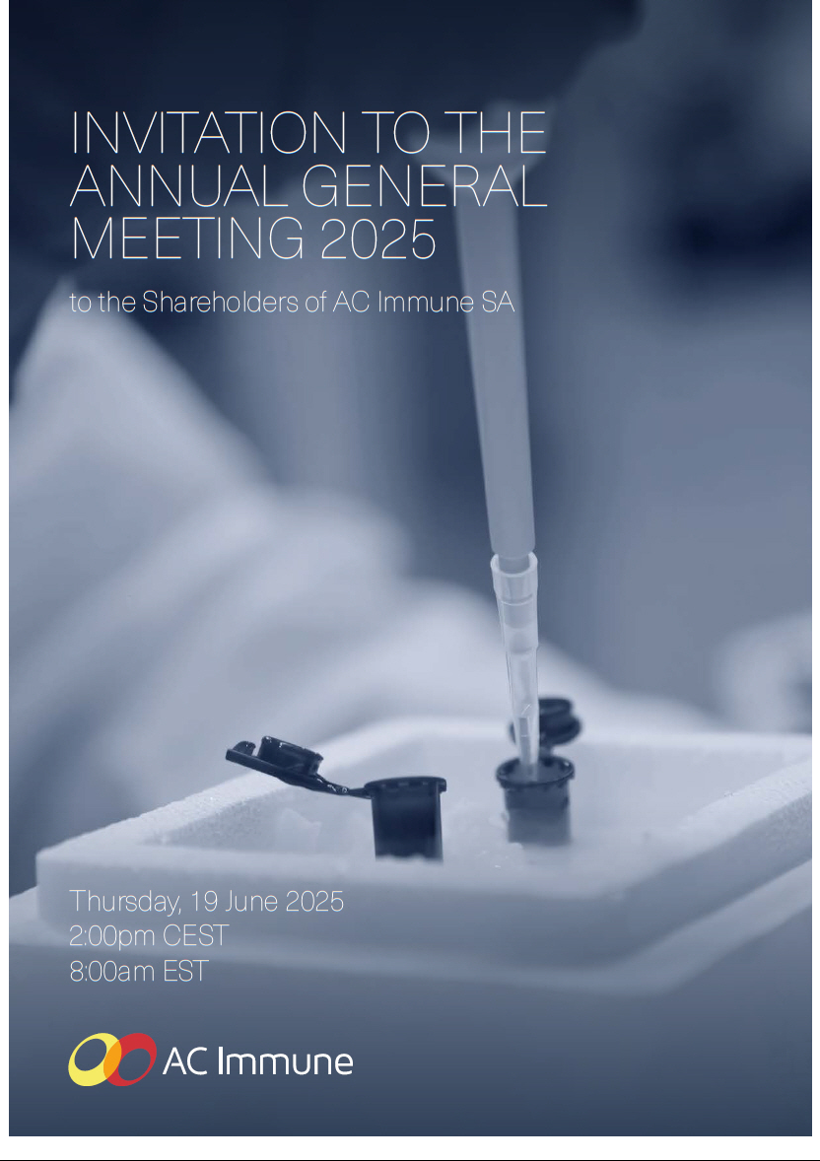

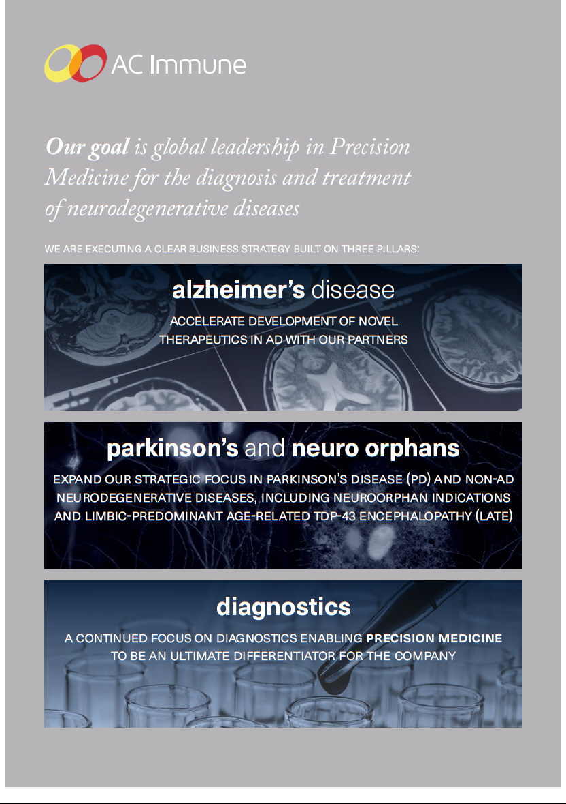

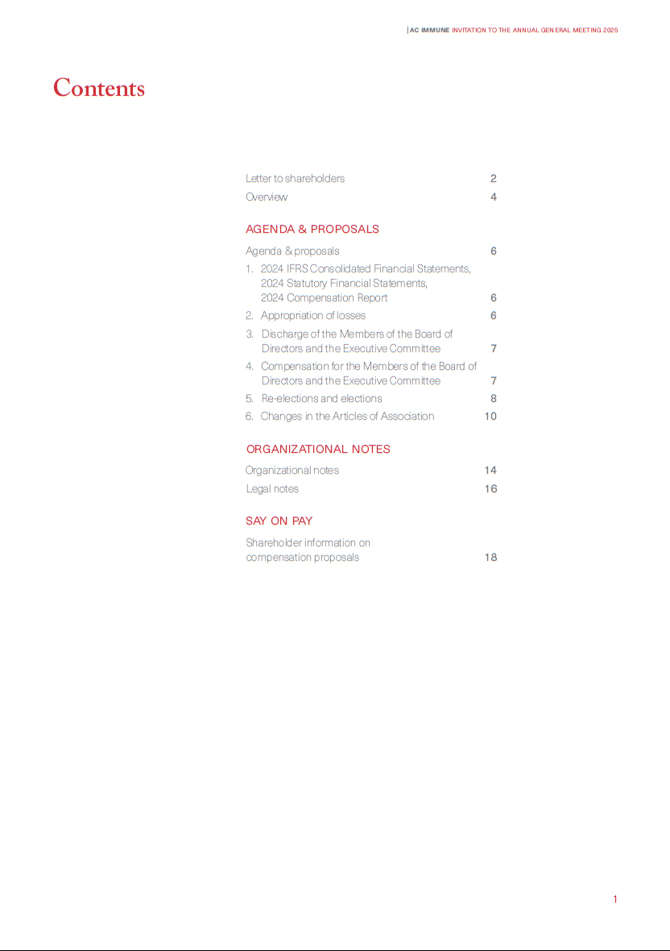

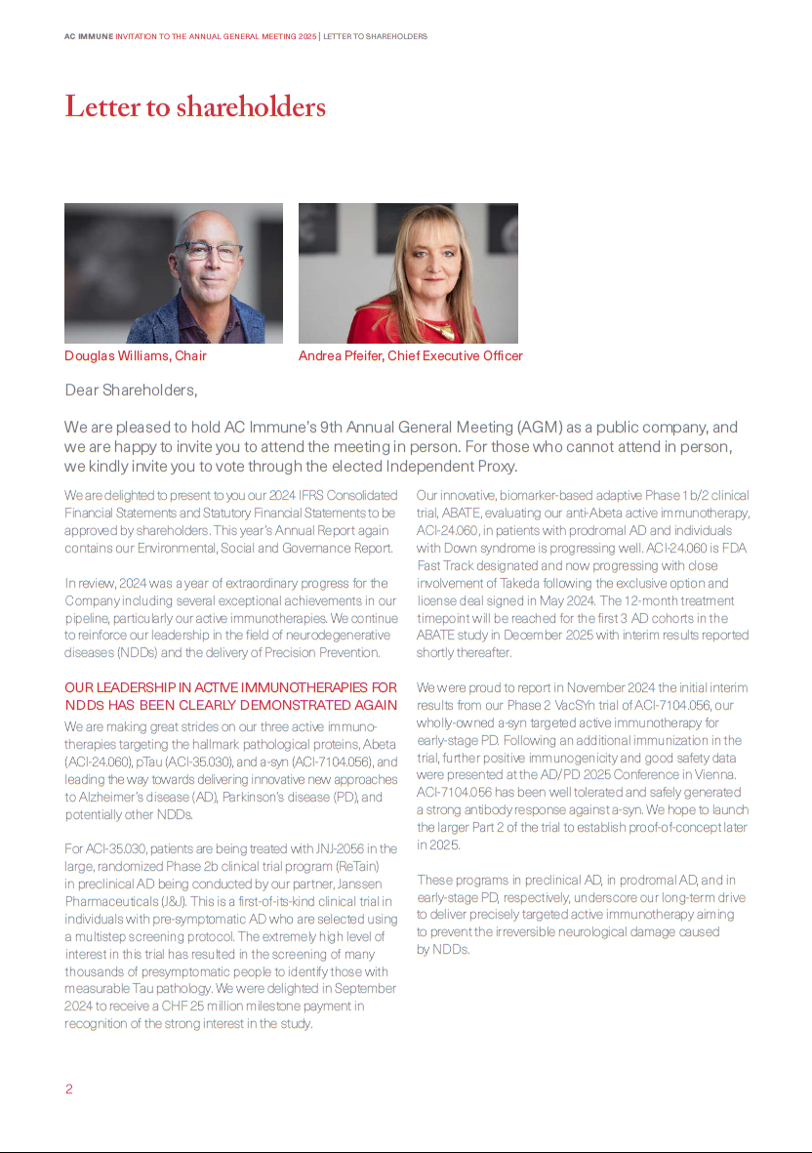

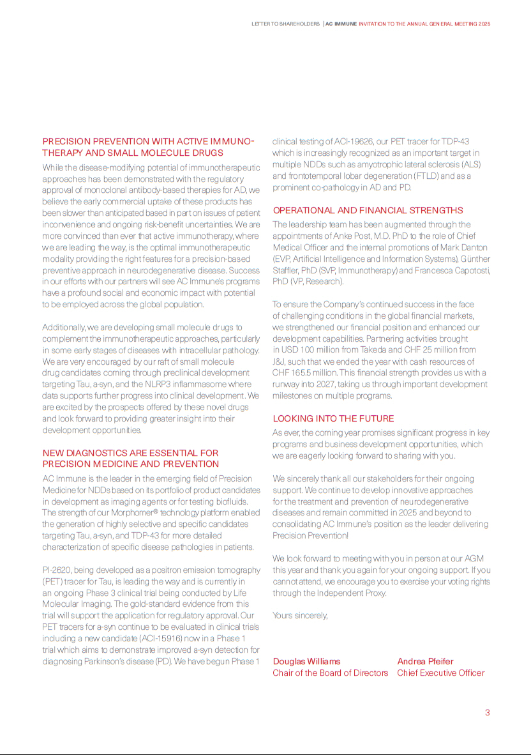

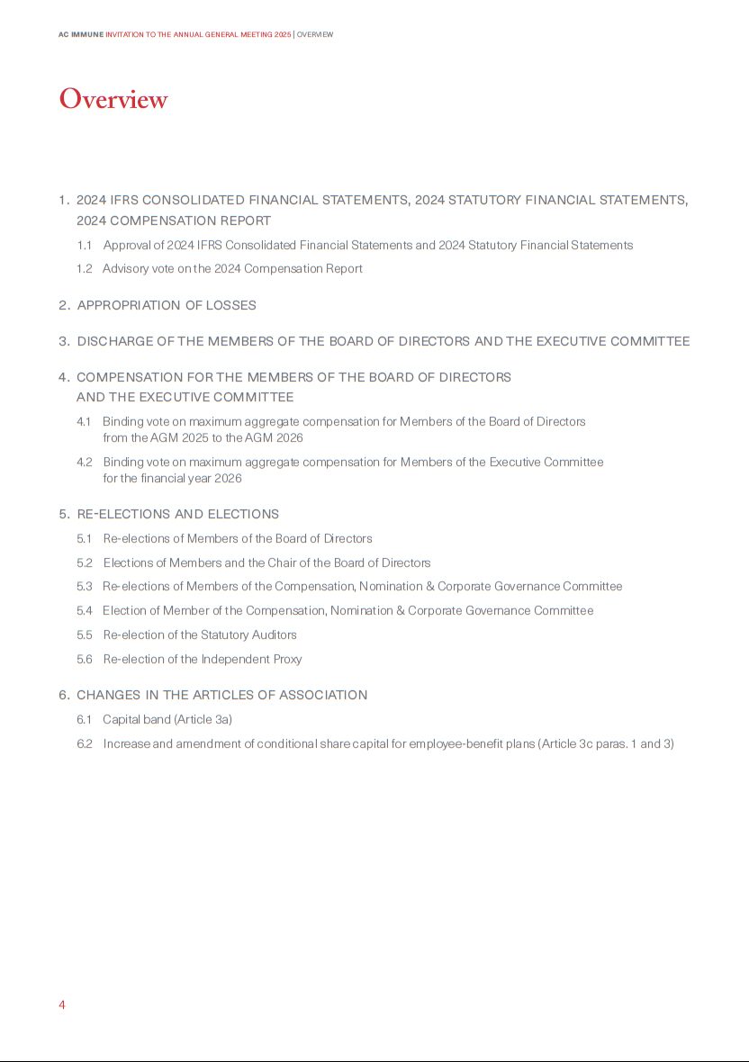



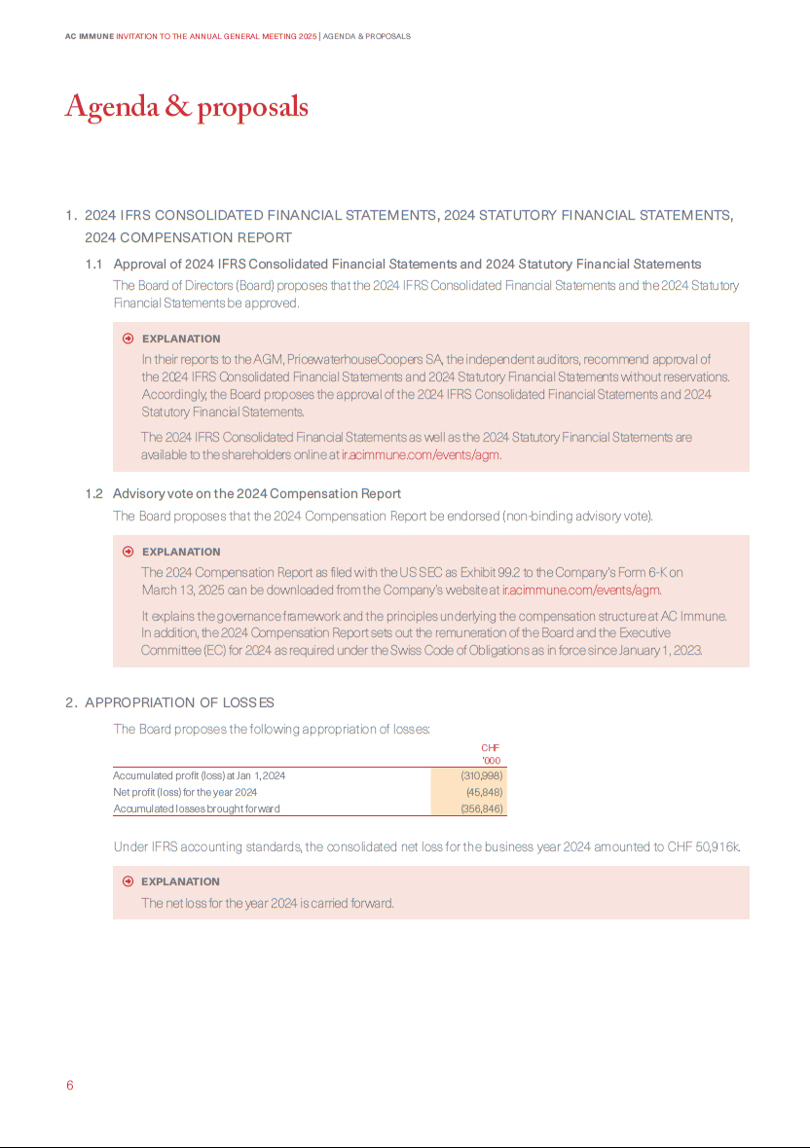

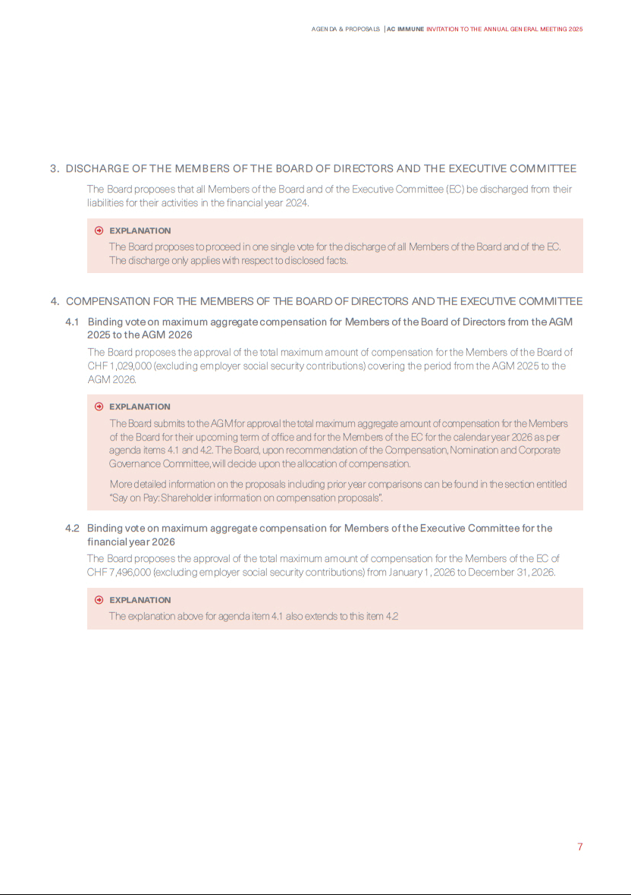

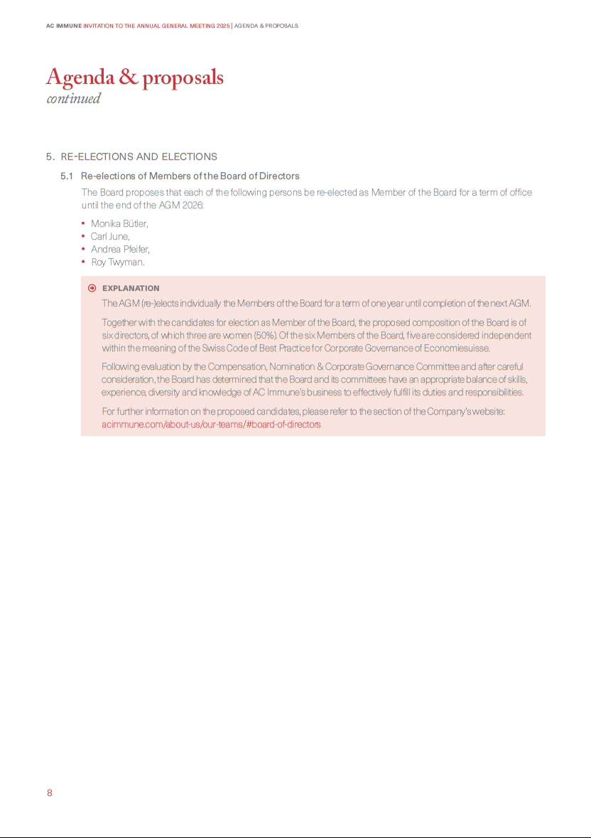

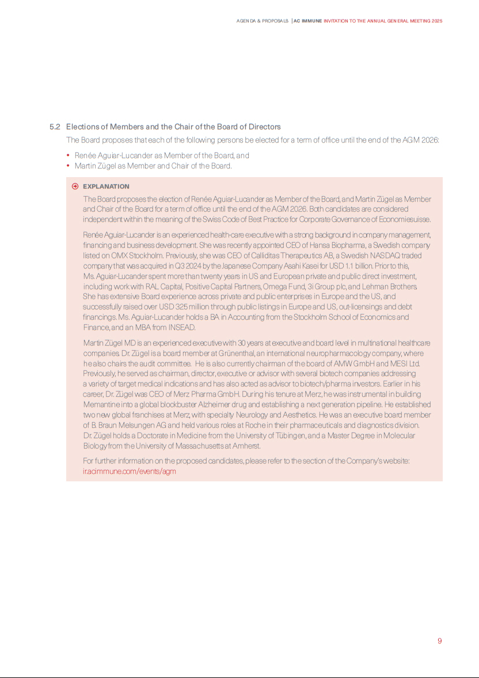

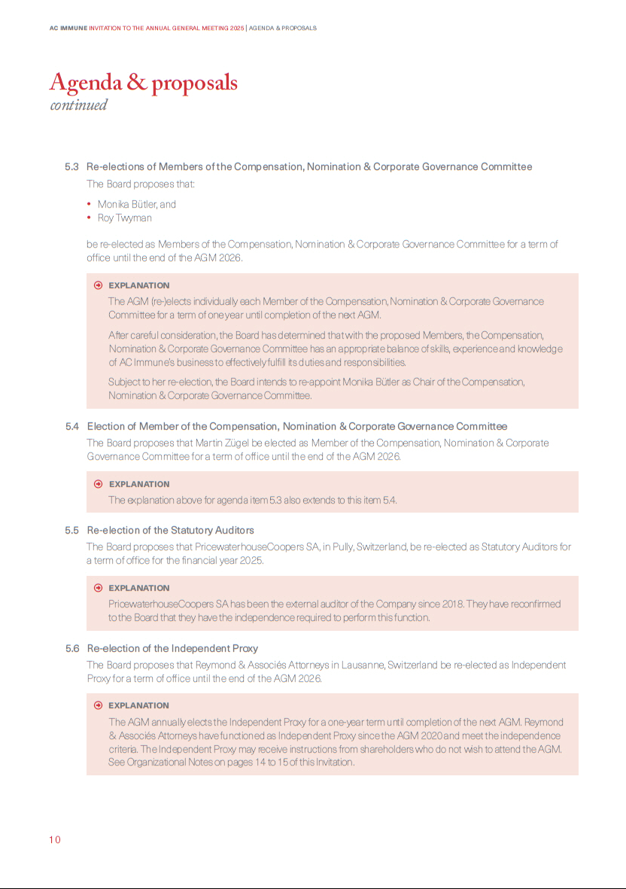

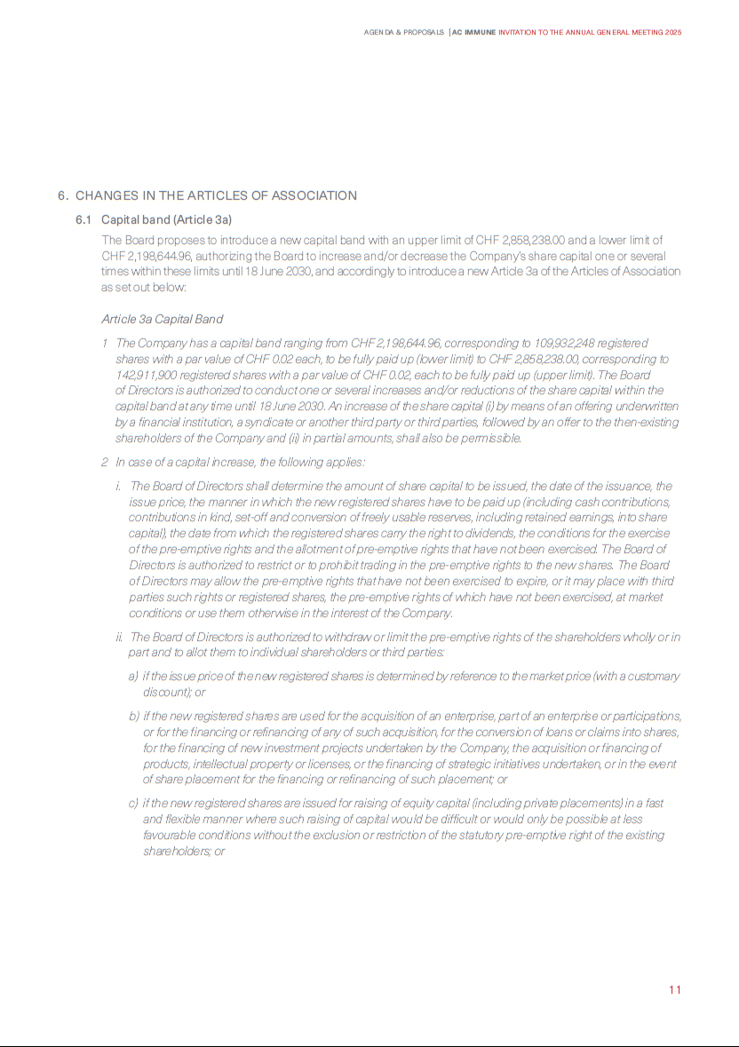

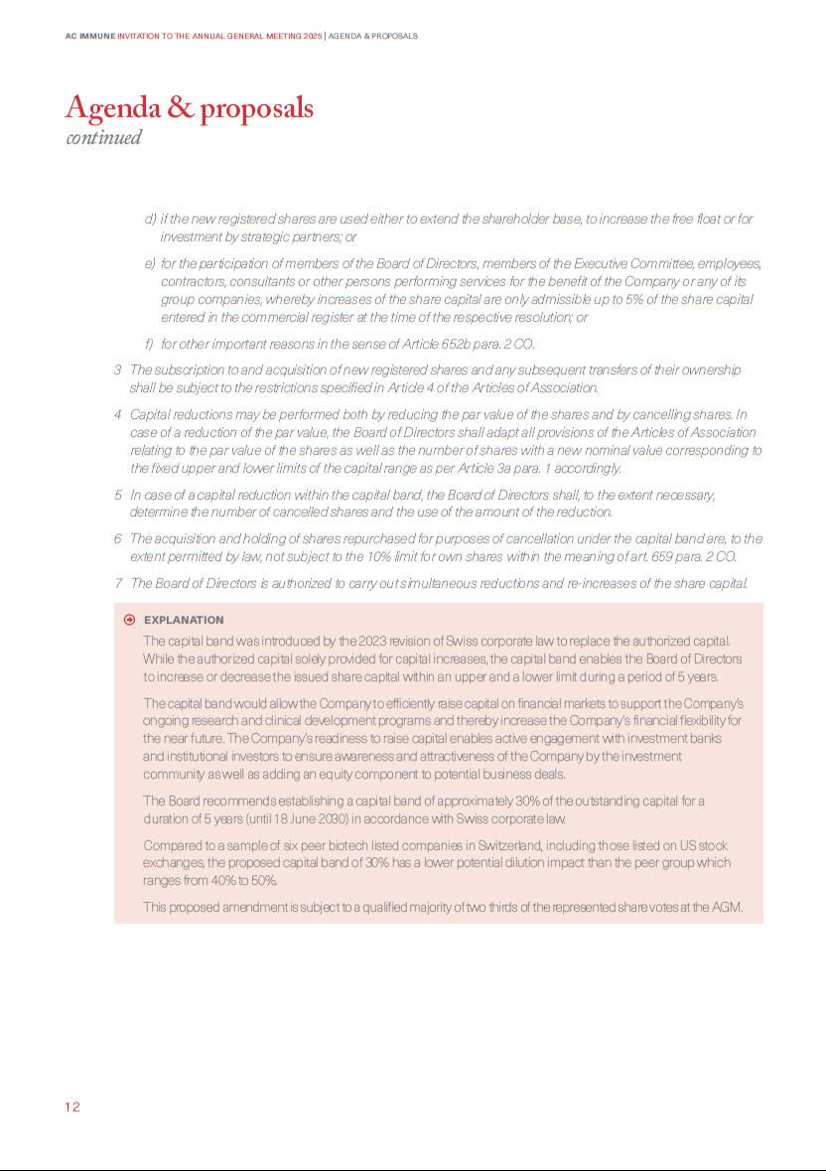

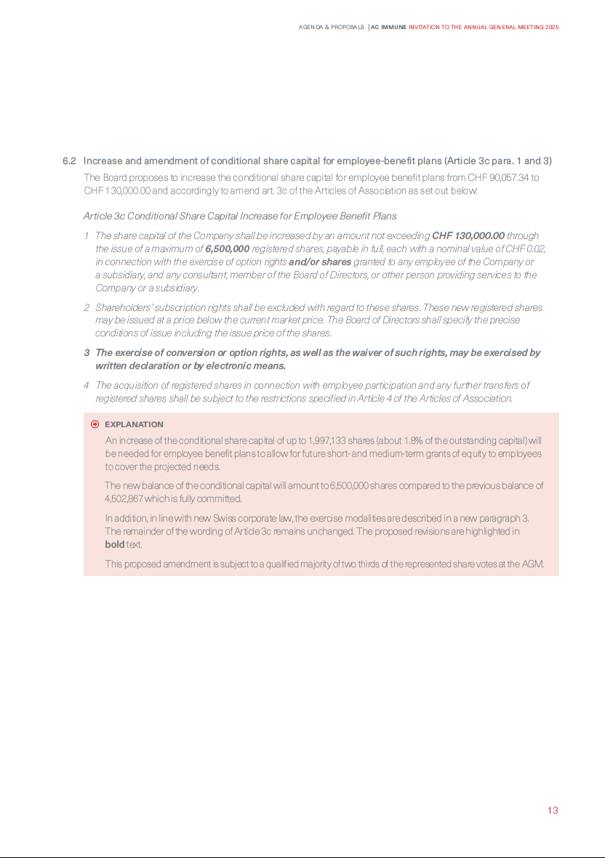

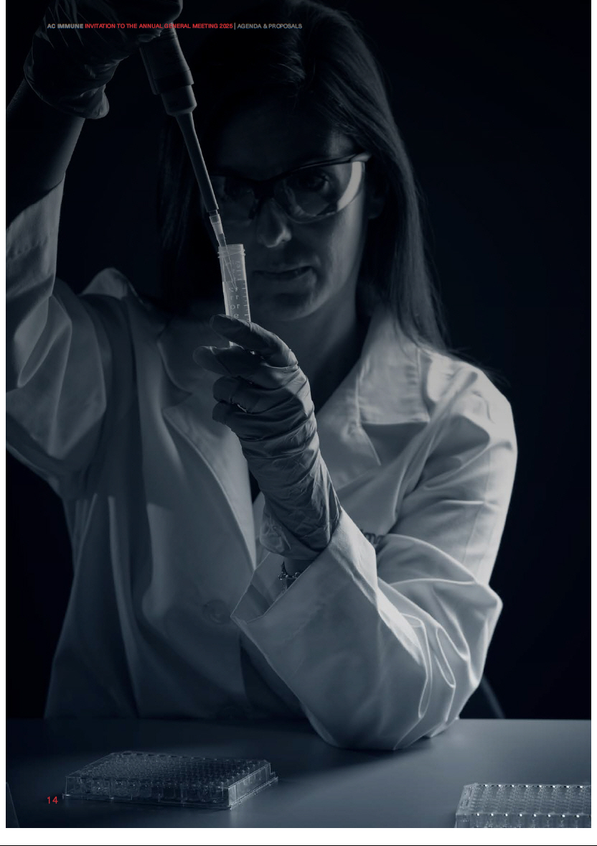



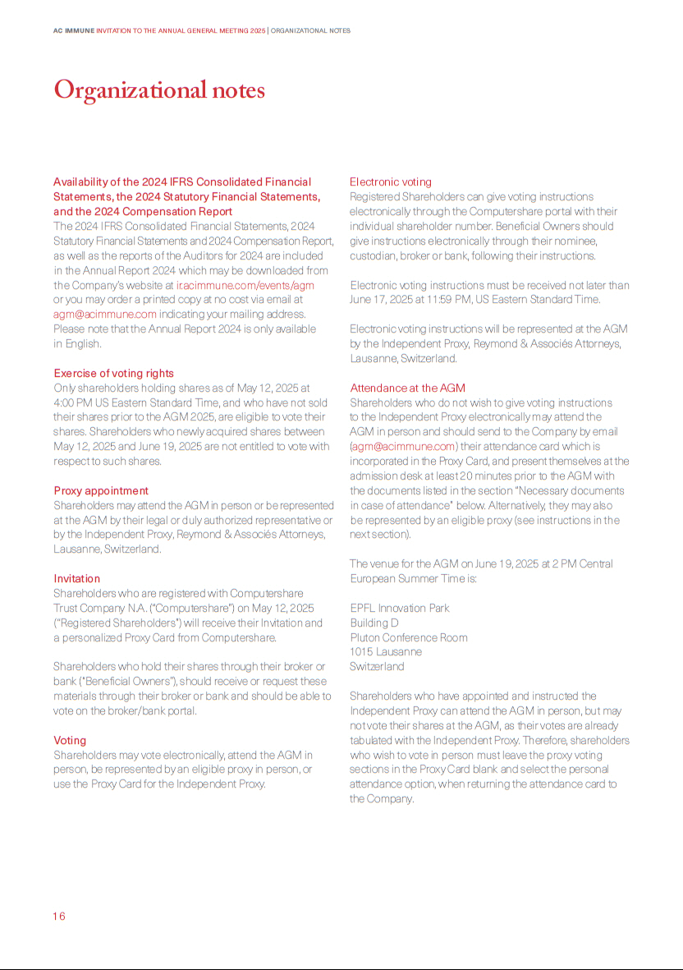

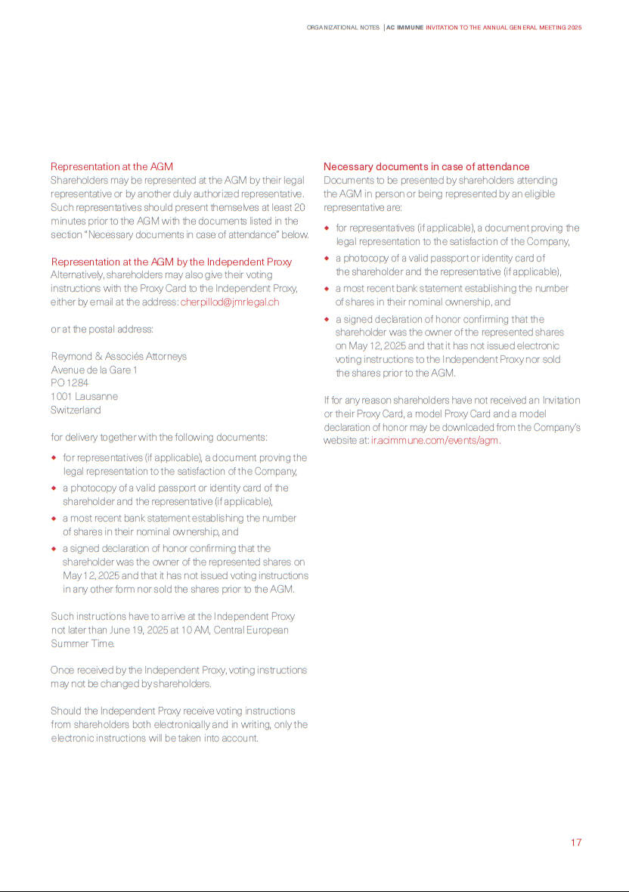

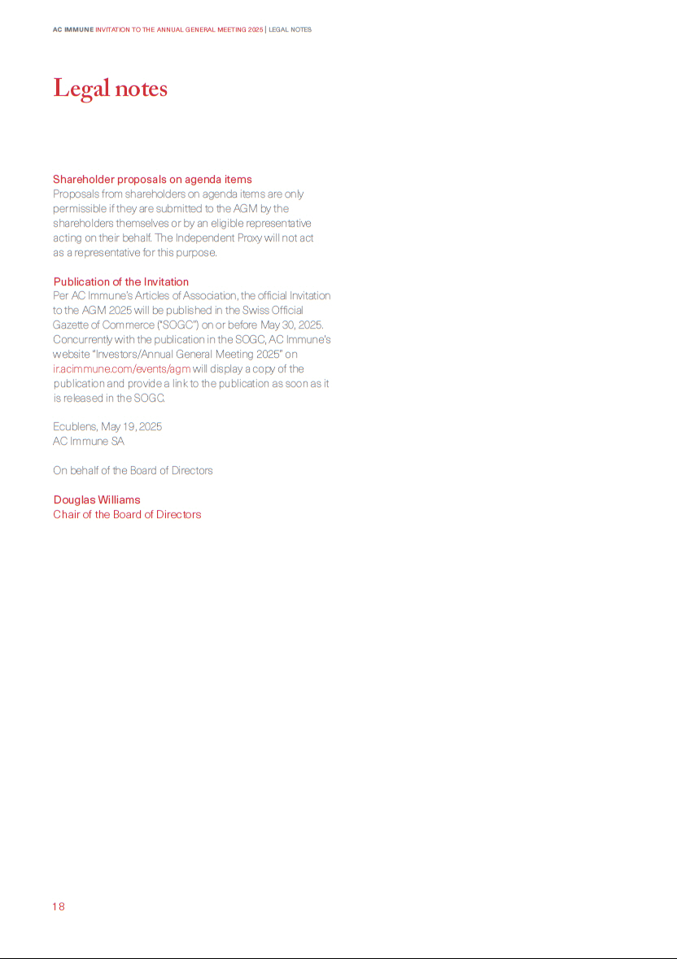

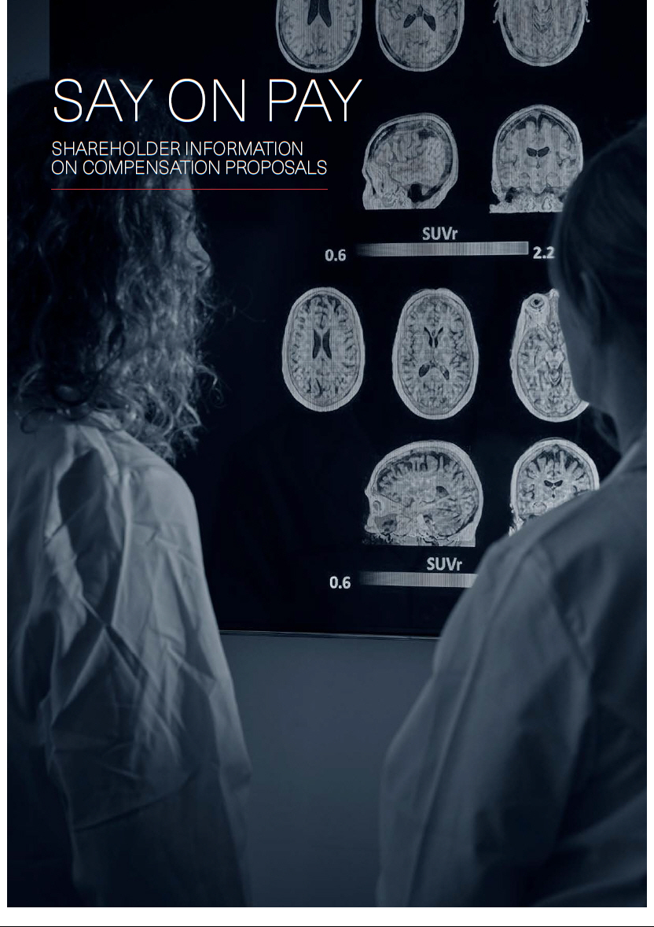

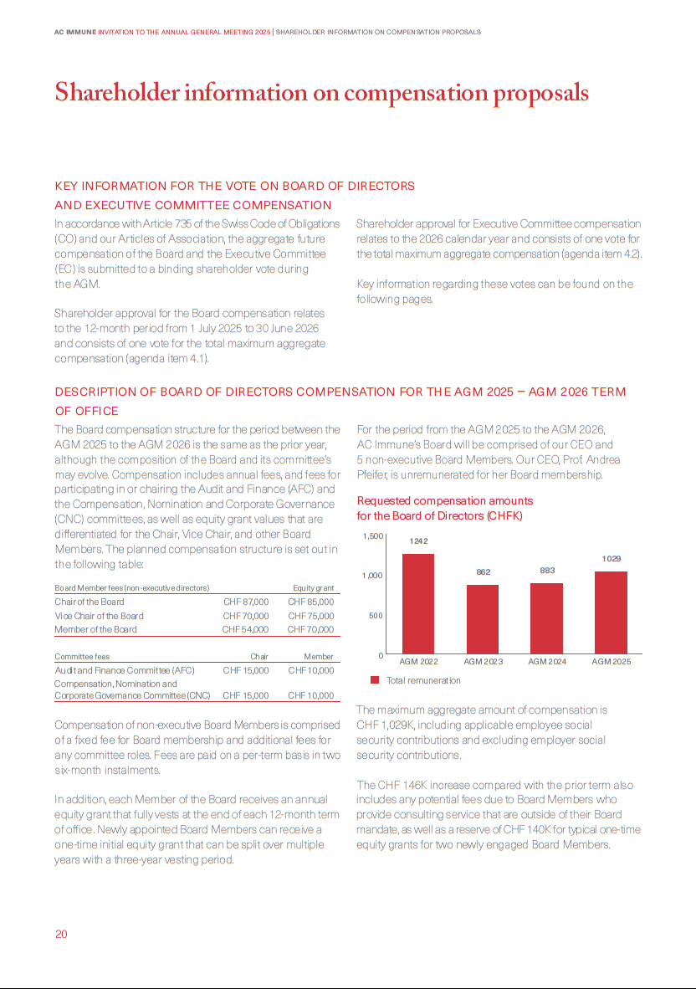

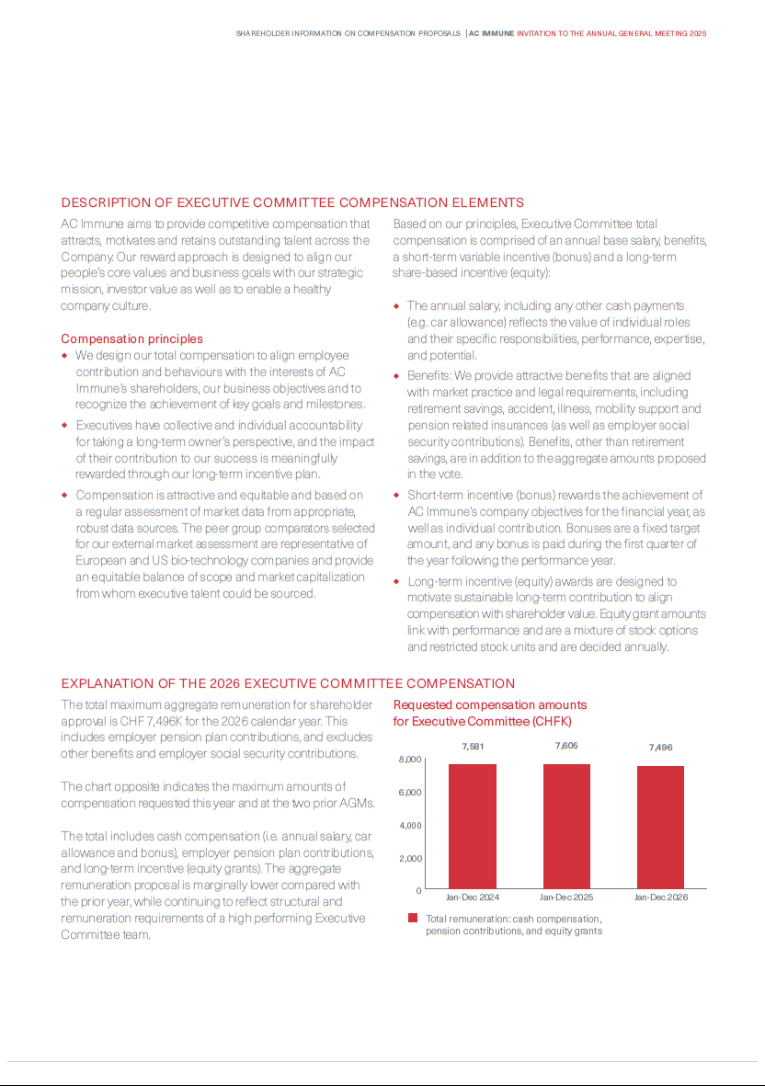

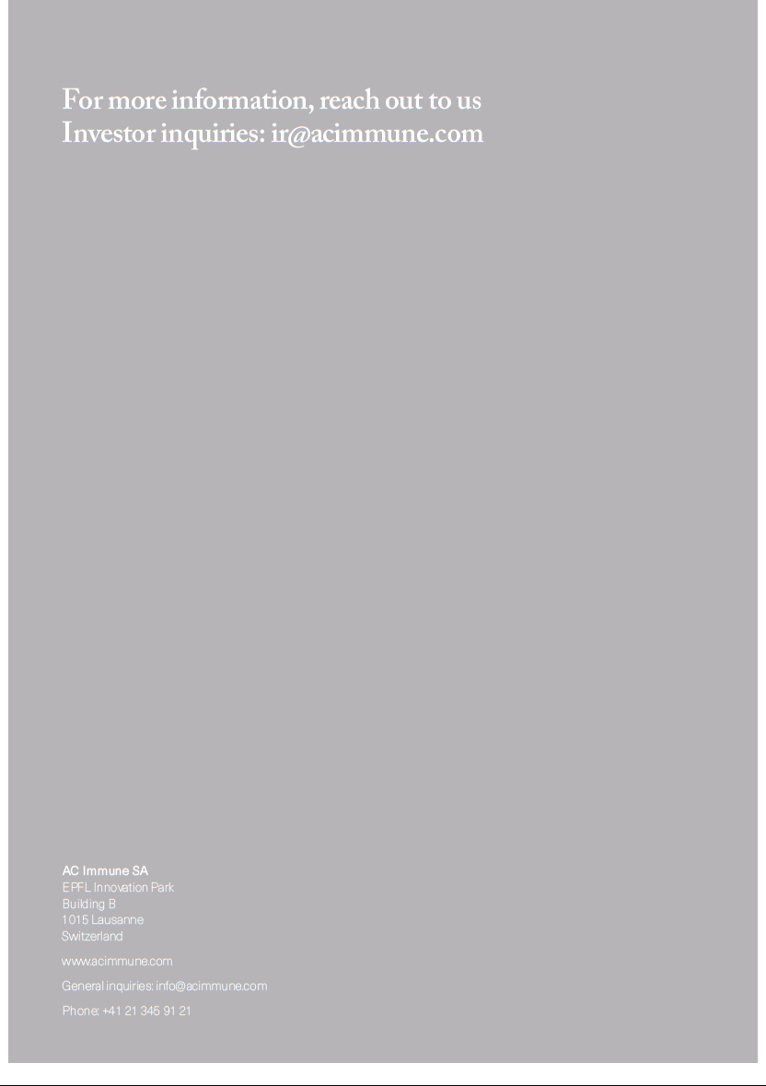

Exhibit 99.2
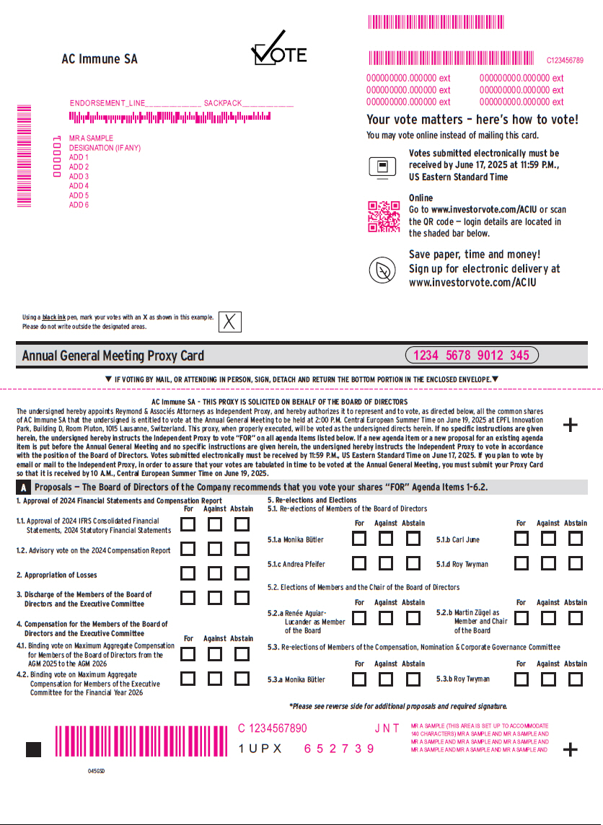

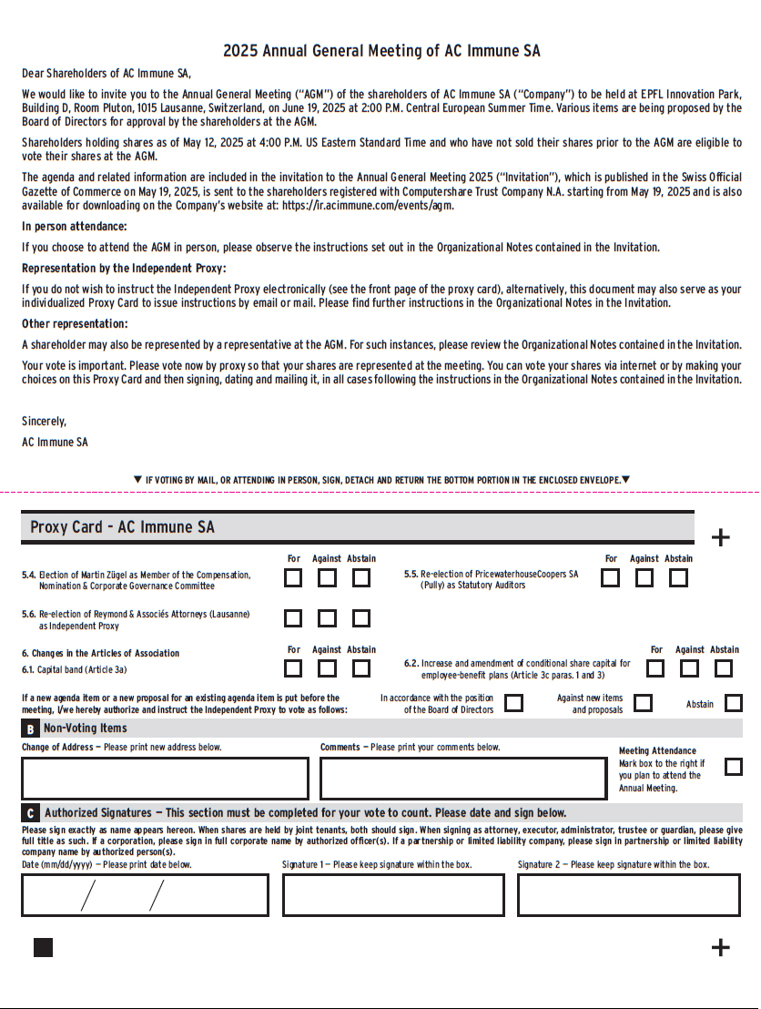

Exhibit 99.3


