UNITED STATES

SECURITIES AND EXCHANGE COMMISSION

Washington, D.C. 20549

FORM 6-K

REPORT OF FOREIGN PRIVATE ISSUER PURSUANT TO RULE 13a-16 OR 15d-16 UNDER THE SECURITIES EXCHANGE ACT OF 1934

For the month of June, 2020

Commission File Number: 001-37891

AC IMMUNE SA

(Exact name of registrant as specified in its charter)

EPFL Innovation Park

Building B
1015 Lausanne, Switzerland
(Address of principal executive office)

Indicate by check mark whether the registrant files or will file annual reports under cover of Form 20-F or Form 40-F:

Form 20-F X Form 40-F

Indicate by check mark if the registrant is submitting the Form 6-K in paper as permitted by Regulation S-T Rule 101(b)(1):

Yes No X

Indicate by check mark if the registrant is submitting the Form 6-K in paper as permitted by Regulation S-T Rule 101(b)(7):

Yes No X

Annual Ordinary Shareholders’ Meeting Results

On June 26, 2020, AC Immune SA (“AC Immune”) held its annual Ordinary Shareholders’ Meeting. The presentation that was given at the Ordinary Shareholders’ Meeting is attached hereto as Exhibit 99.1 and the press release relating to the results of the Ordinary Shareholders’ Meeting is attached hereto as Exhibit 99.2. The final results of each of the agenda items submitted to a vote of the shareholders are as follows:

Agenda Item 1: Approval of the Annual Report, Annual Statutory Financial Statements and Financial Statements under IFRS of AC Immune SA for the year 2019

AC Immune shareholders approved the Annual Report, the Annual Statutory Financial Statements and the Financial Statements under IFRS of AC Immune SA for the year 2019, and took note of the Reports of the Auditors.

Agenda Item 2: Appropriation of Profit

AC Immune shareholders approved that the profit for the year 2019 in the amount of KCHF 45,169 reduces the “accumulated losses brought forward” of KCHF 107,320, resulting in a new balance of “accumulated losses brought forward” of KCHF 62,151.

Agenda Item 3: Discharge of the Members of the Board of Directors and the Executive Committee

AC Immune shareholders approved the discharge of the Board and the Executive Committee of their liabilities for their activities in the financial year 2019.

Agenda Item 4: Compensation for the Members of the Board of Directors and the Executive Committee

AC Immune shareholders approved:

- The total maximum amount of non-performance-related compensation for the members of the Board of Directors covering the period from 1 July 2020 to 30 June 2021, i.e., CHF 565,000 (cash based compensation plus pensionable social security costs);

- The maximum grant of equity or equity linked instruments for the members of the Board of Directors from 1 July 2020 to 30 June 2021 with maximum value of CHF 635,000 (equity or equity linked instruments at grant value plus pensionable social security costs);

- The total maximum amount of non-performance-related cash compensation for the members of the Executive Committee from 1 July 2020 to 30 June 2021, i.e., CHF 2,778,000 (cash based compensation plus pensionable social security costs);

- The total maximum amount of variable compensation for the members of the Executive Committee for the current year 2020, i.e., CHF 1,133,000 (cash based compensation plus pensionable social security costs);

- The maximum grant of equity or equity linked instruments for the members of the Executive Committee from 1 July 2020 to 30 June 2021 with maximum value of CHF 3,496,000 (equity or equity linked instruments at grant value plus pensionable social security costs); and

- The 2019 Remuneration Report as filed with the US Securities and Exchange Commission as Annex 99.3 to the Company’s March 30, 2020 Form 6-K filing.

Agenda Item 5: Re-elections

Agenda Item 5.1: Re-elections of the Members of the Board

AC Immune shareholders approved the re-election of Douglas Williams as member and as Chairman of the Board, the re-election of Martin Velasco as member and as Vice-Chairman of the Board, the re-election of Peter Bollmann, Andrea Pfeifer, Tom Graney, Werner Lanthaler and Roy Twyman as members of the Board of Directors, each until the end of the next Ordinary General Meeting.

Agenda Item 5.2: Re-elections to the Compensation, Nomination & Corporate Governance Committee

AC Immune shareholders approved the re-election of Martin Velasco, Tom Graney and Douglas Williams as members of the Compensation, Nomination & Corporate Governance Committee, each until the end of the next Ordinary General Meeting.

Agenda Item 5.3: Re-elections of the Statutory Auditors

AC Immune shareholders approved the re-election of PricewaterhouseCoopers SA, in Pully, for a term of office of one year.

Agenda Item 5.4: Re-election of the Independent Proxy

AC Immune shareholders approved the re-election of Reymond & Associés, represented by Denis Cherpillod as AC Immune’s independent proxy until the end of the next Ordinary General Meeting.

Agenda Item 6: Amendments to the Articles of Association

Agenda Item 6.1: Authorized Share Capital

AC Immune shareholders approved an amendment to the existing first paragraph of article 3a (Authorized Capital Increase of Share Capital) of the articles of association pertaining to a proposed increase by the Board of Directors in AC Immune’s share capital, in one or several steps, until 27 June 2022, by a maximum amount of CHF 290,000 by issuing a maximum of 14,500,000 registered shares with a par value of CHF 0.02 each, to be fully paid up. An increase of the share capital (i) by means of an offering underwritten by a financial institution, a syndicate or another third party or third parties, followed by an offer to the then-existing shareholders of the Company and (ii) in partial amounts, shall also be permissible.

Agenda Item 6.2: Conditional Capital Increase for Bonds and Similar Debt Instruments

AC Immune shareholders approved an amendment to the existing first paragraph of article 3b (Conditional Capital Increase for Bonds and Similar Debt Instruments) of the articles of association pertaining to the increase of the share capital of the company by a maximum amount of CHF 91,560.94 through the issue of a maximum of 4,578,047 registered shares, payable in full, each with a nominal value of CHF 0.02, through the exercise of conversion and/or option or warrant rights granted in connection with bonds or similar instruments, issued or to be issued by the Company or by subsidiaries of the Company, including convertible debt instruments.

SIGNATURE

Pursuant to the requirements of the Securities Exchange Act of 1934, the registrant has duly caused this report to be signed on its behalf by the undersigned, thereunto duly authorized.

AC IMMUNE SA

By: /s/ Andrea Pfeifer
Name: Andrea Pfeifer

Title: Chief Executive Officer

By: /s/ Joerg Hornstein
Name: Joerg Hornstein

Title: Chief Financial Officer

Date: June 26, 2020

 | EXHIBIT INDEX
Exhibit | Description
Number
99.1 | Annual Ordinary Shareholders’ Meeting presentation
99.2 | Press Release dated June 26, 2020

EXHIBIT 99.1


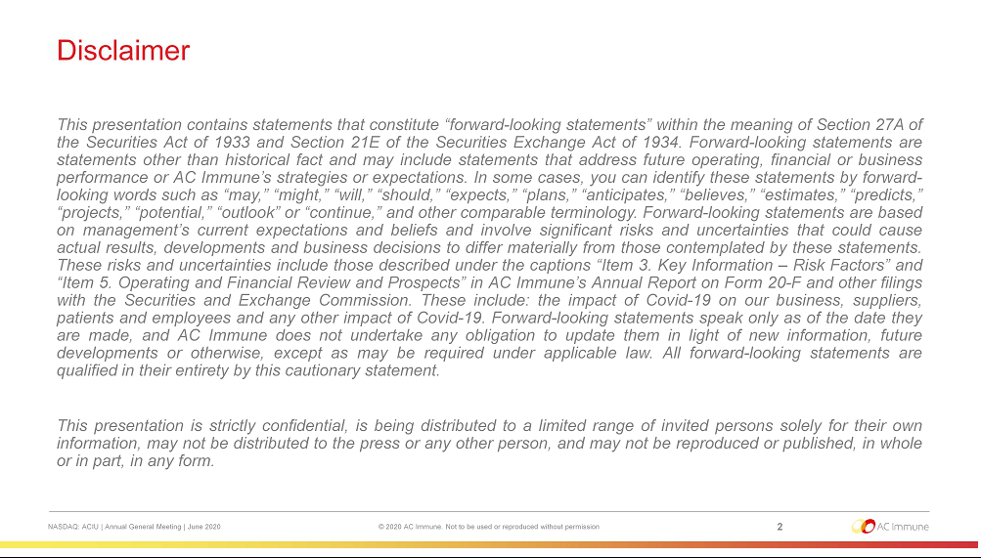

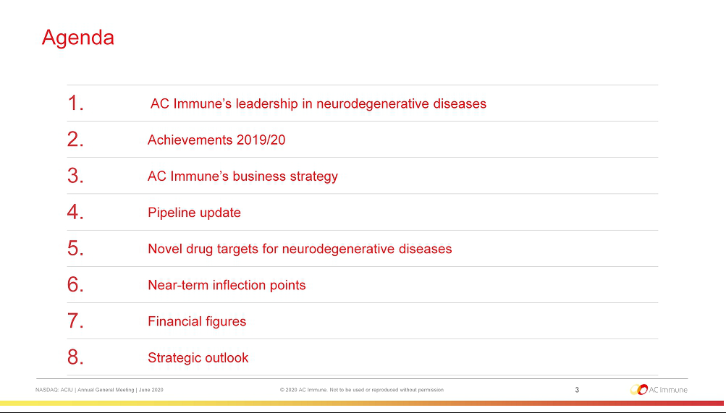

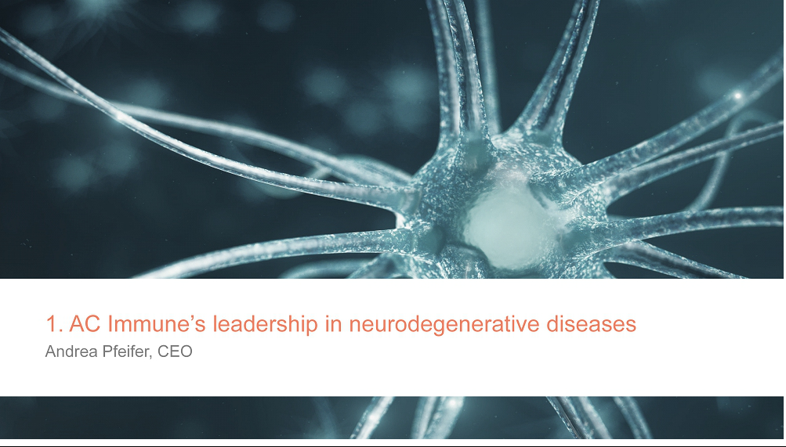

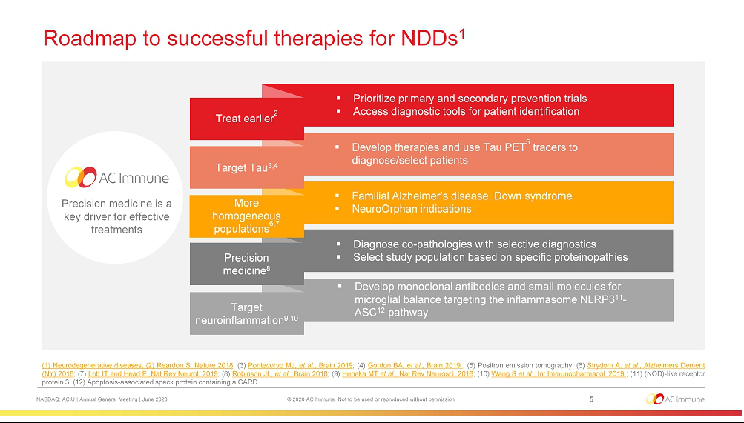

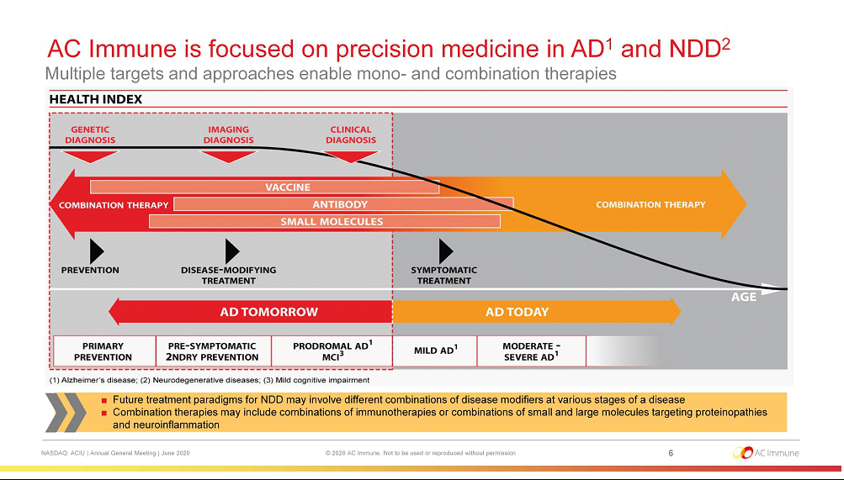

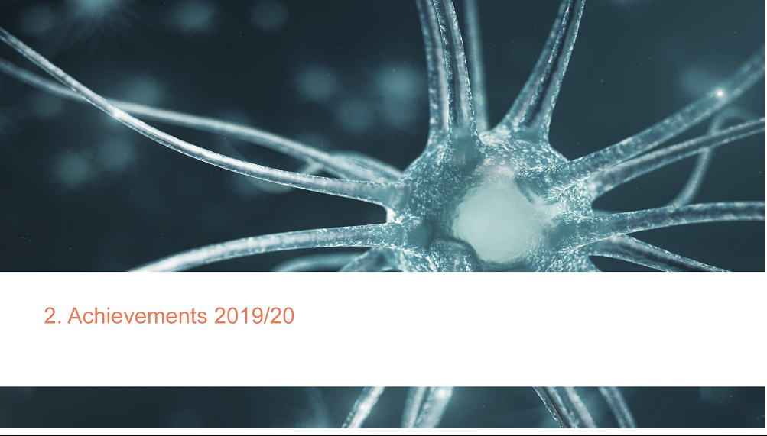

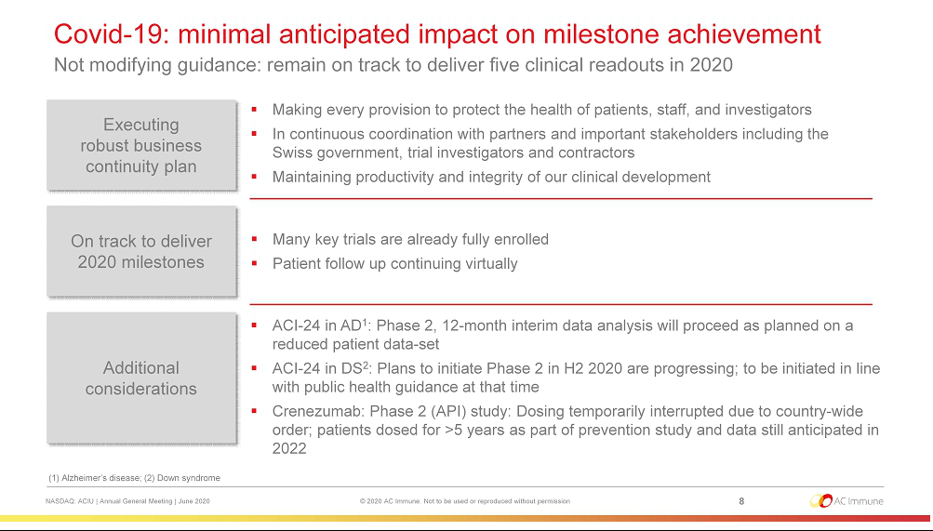

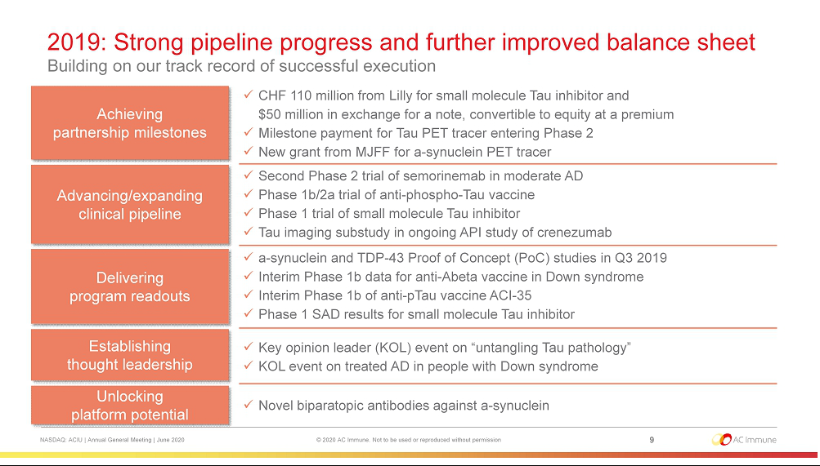

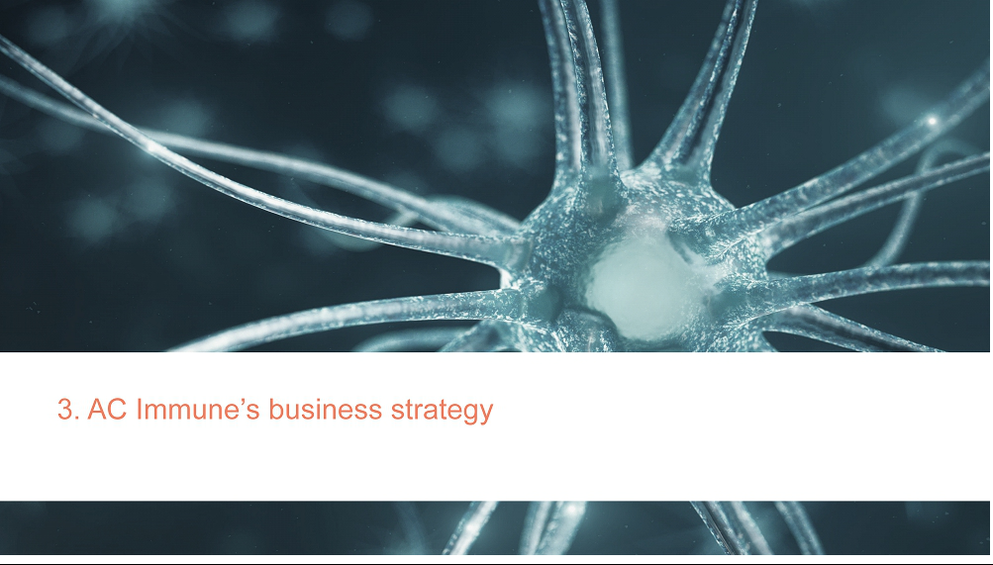

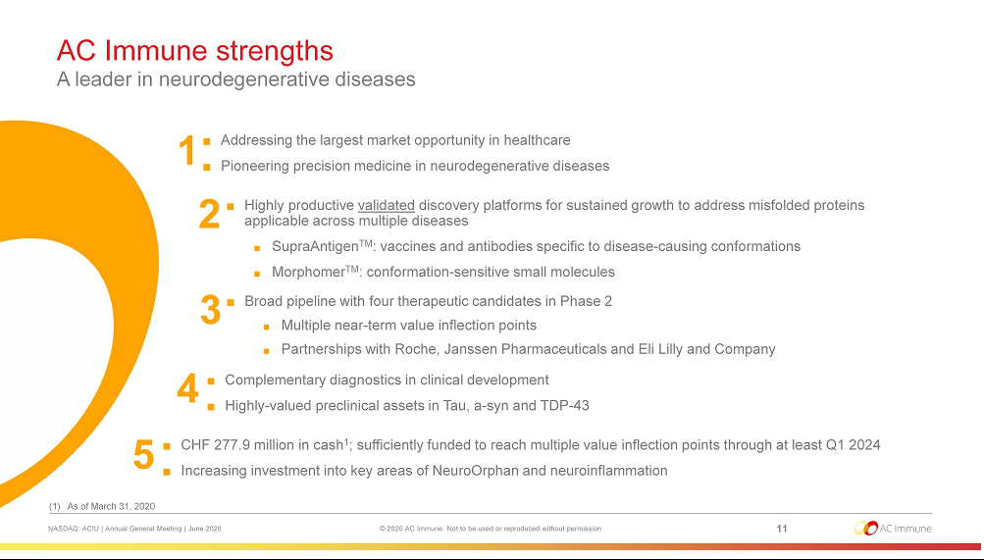

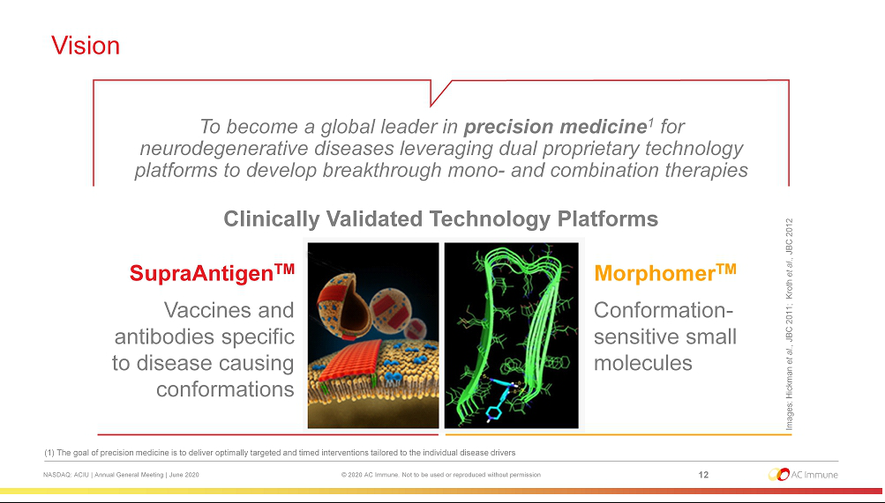

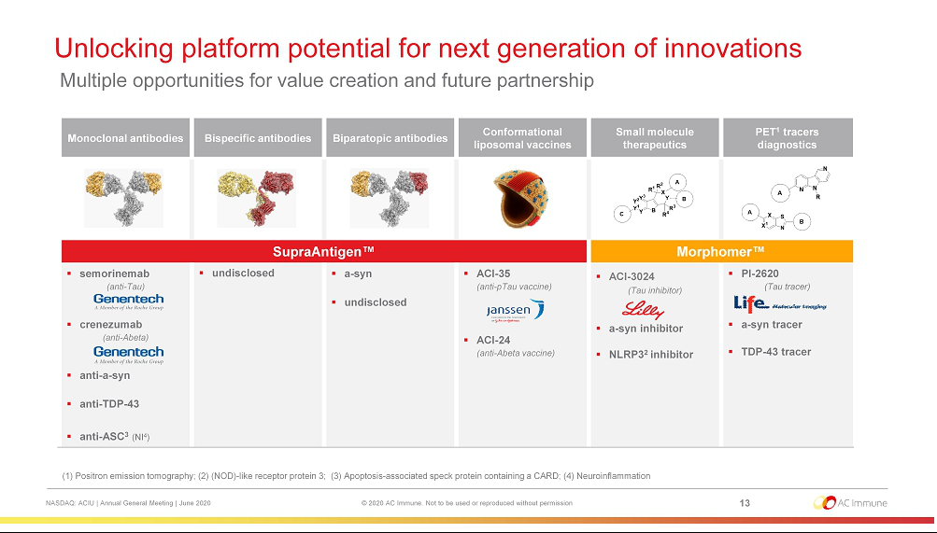

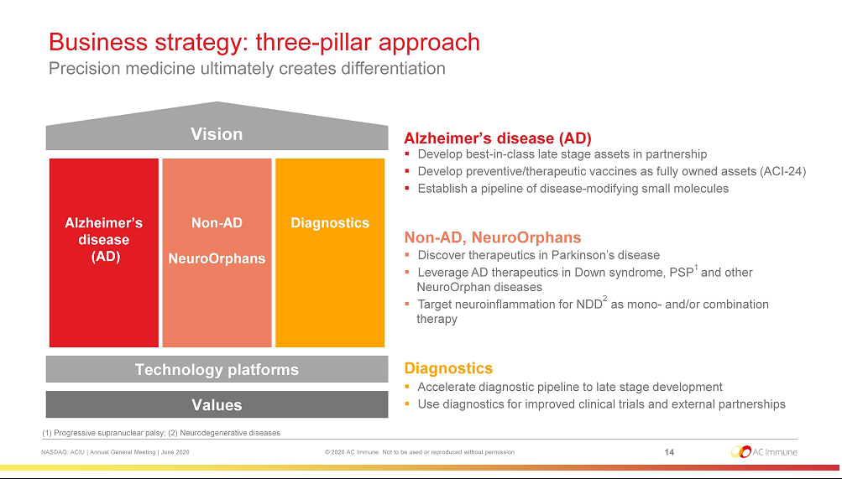



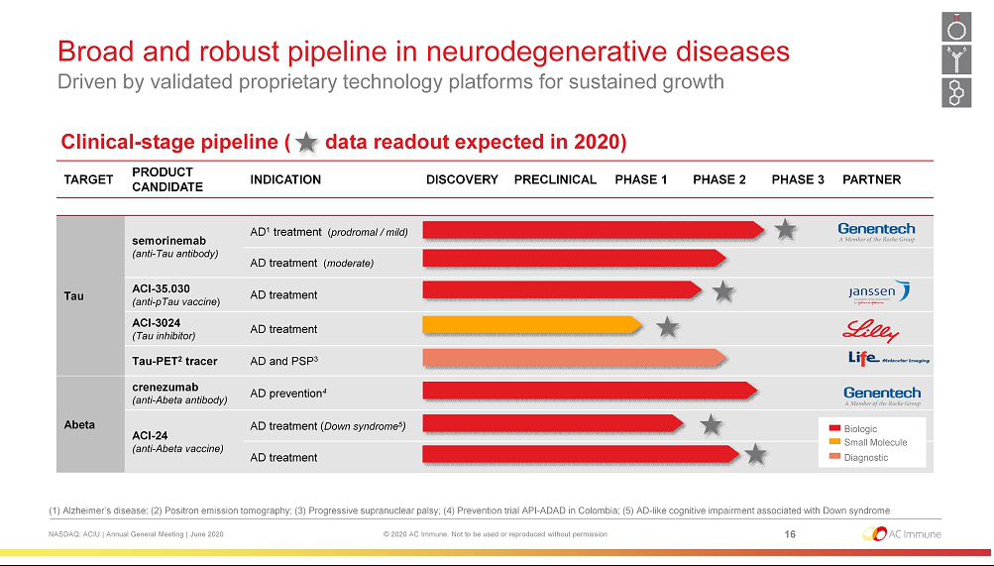

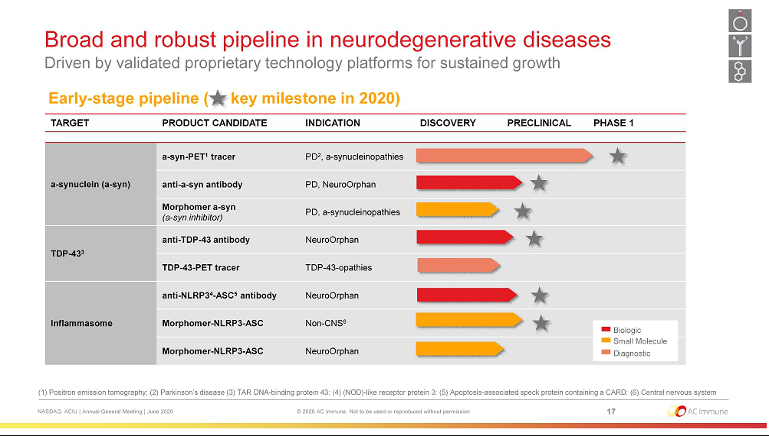

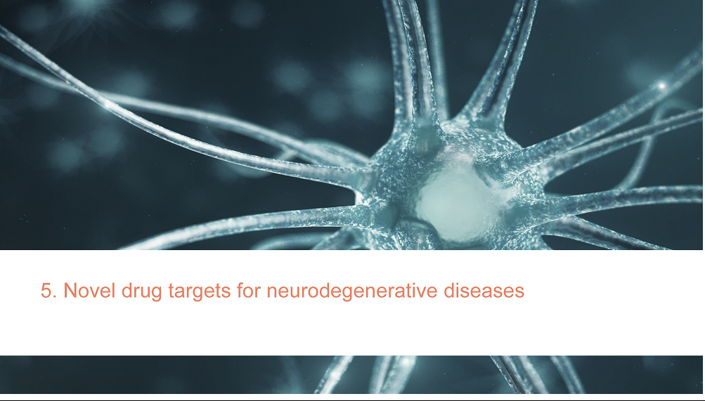

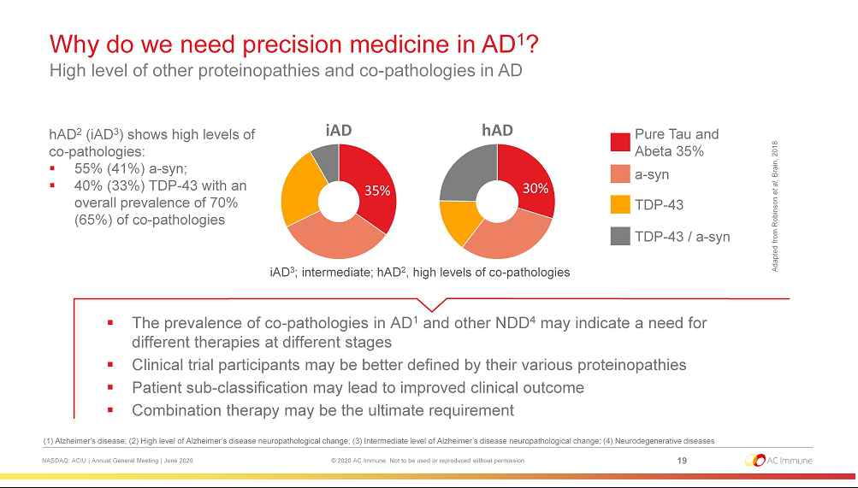

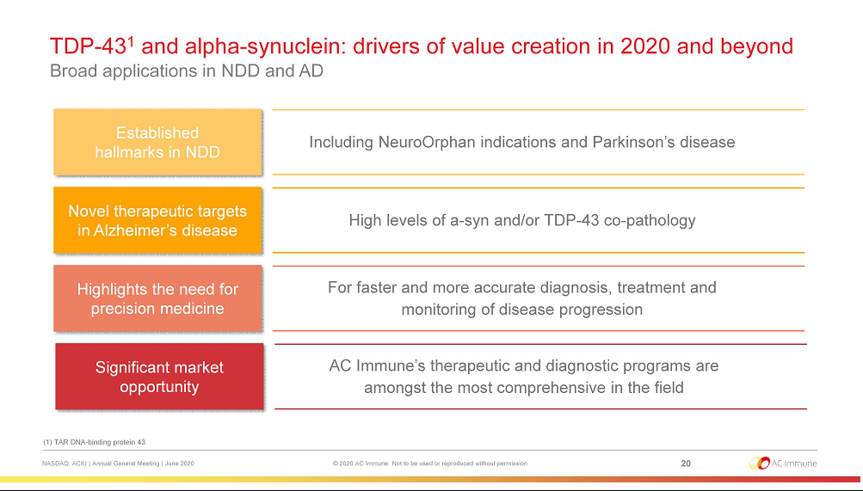

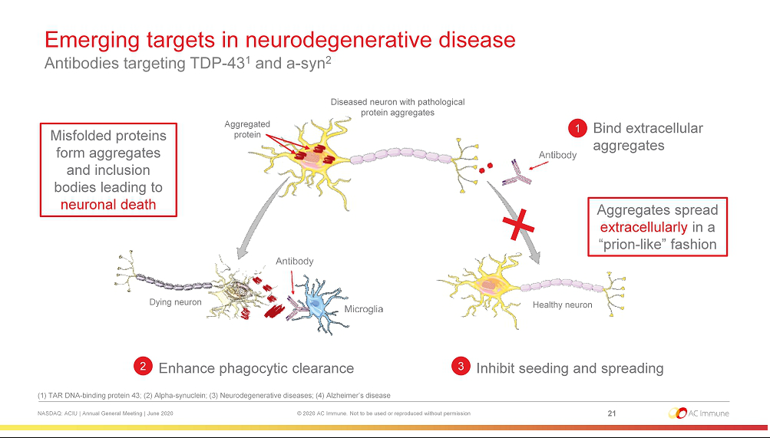

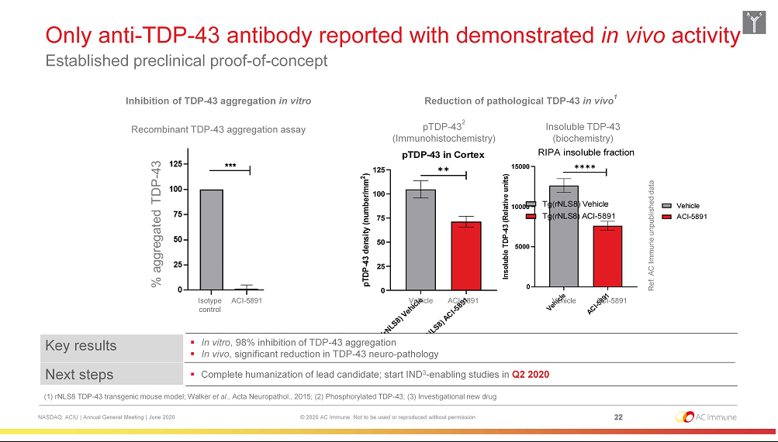

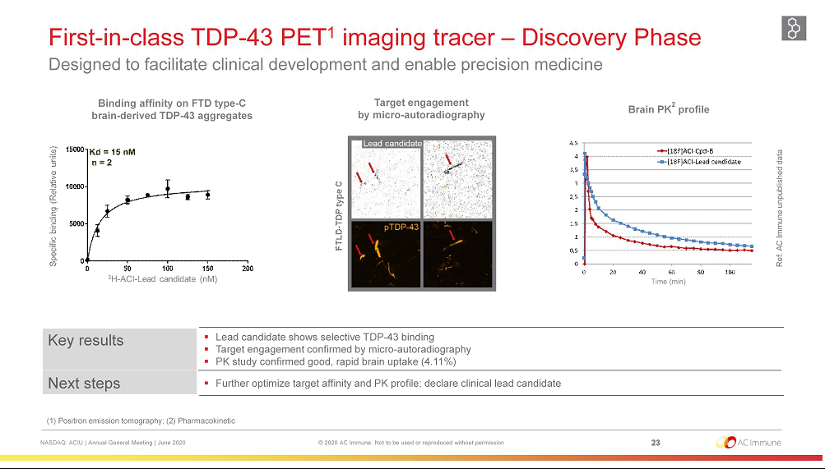

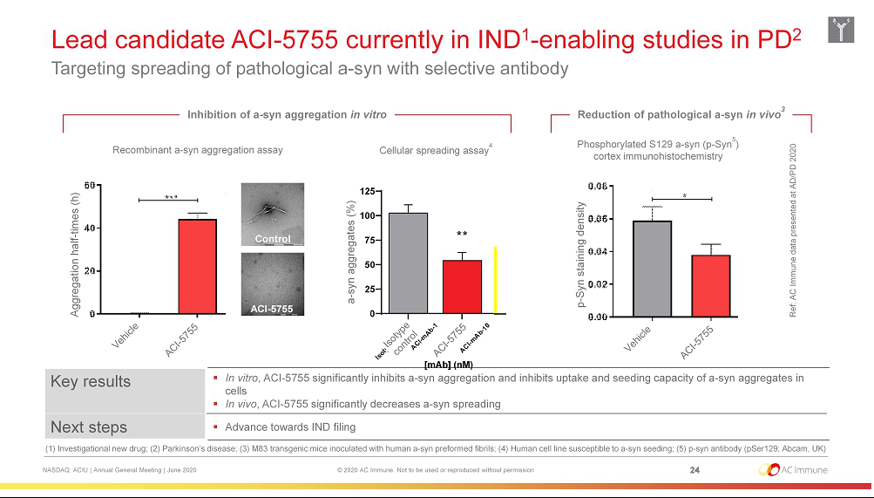

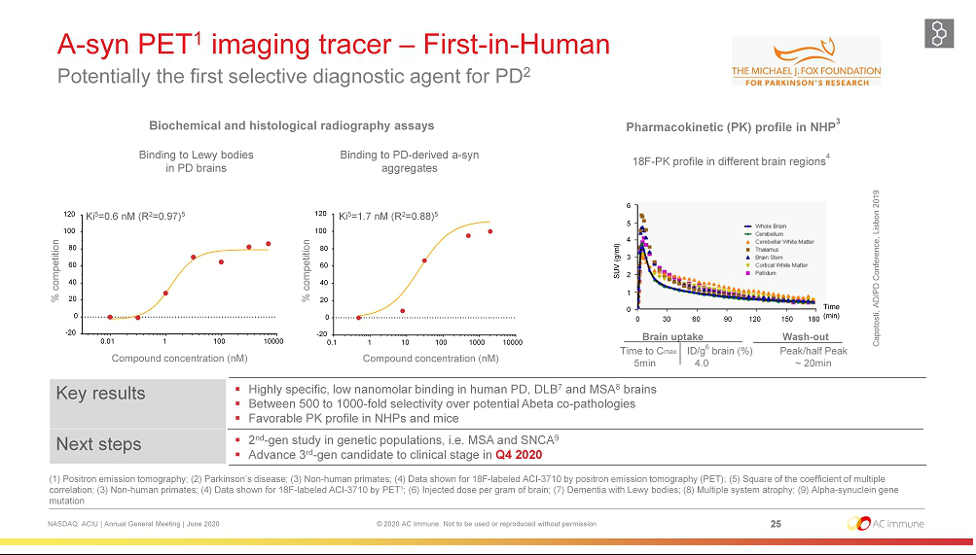

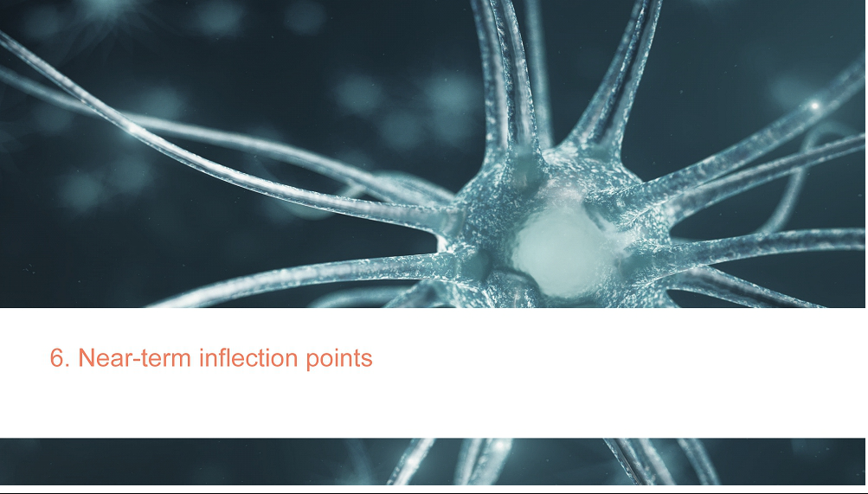

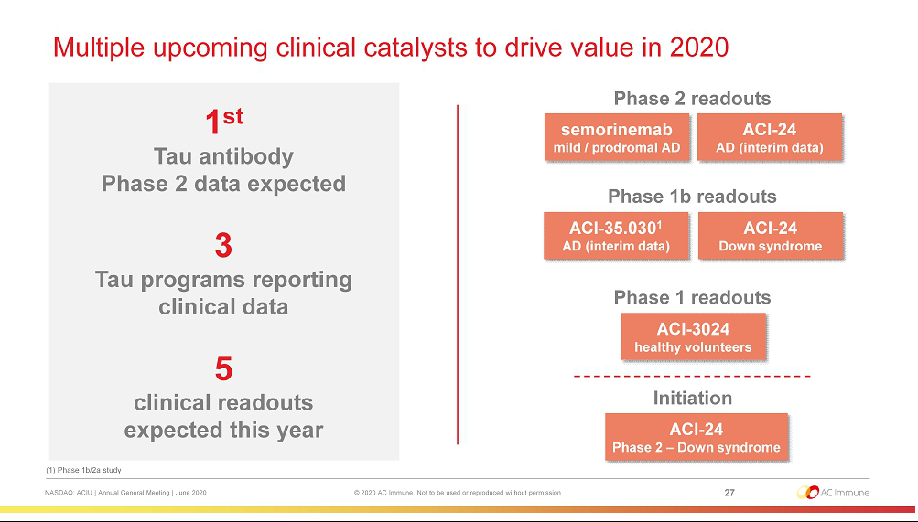

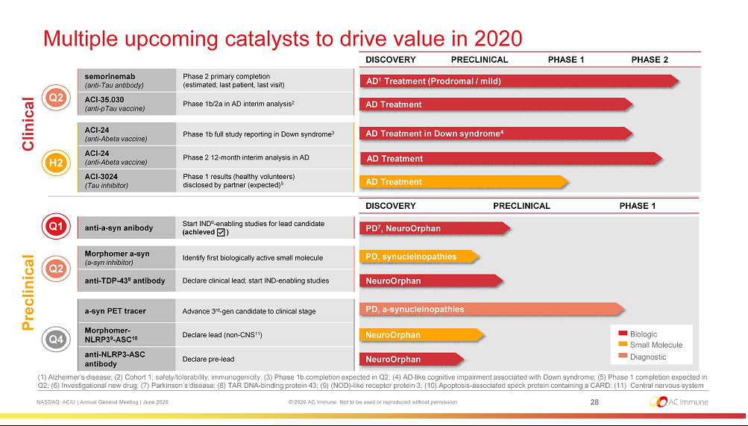



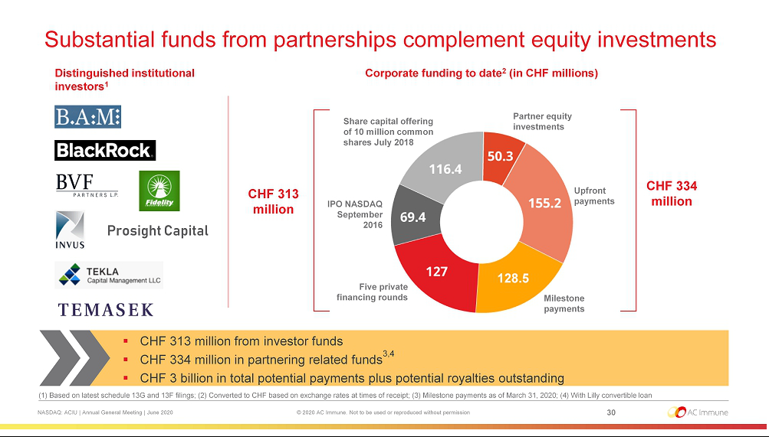

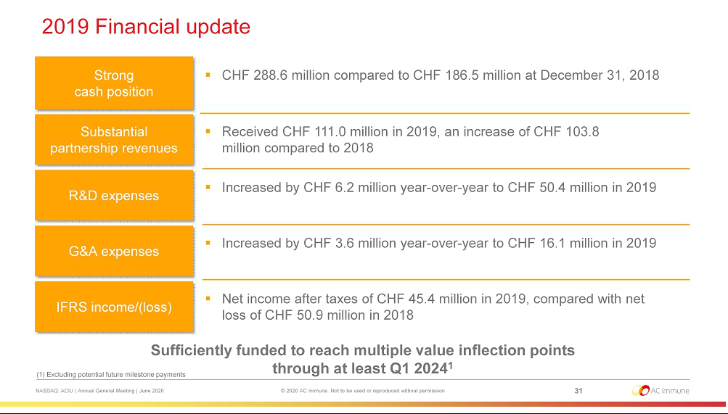



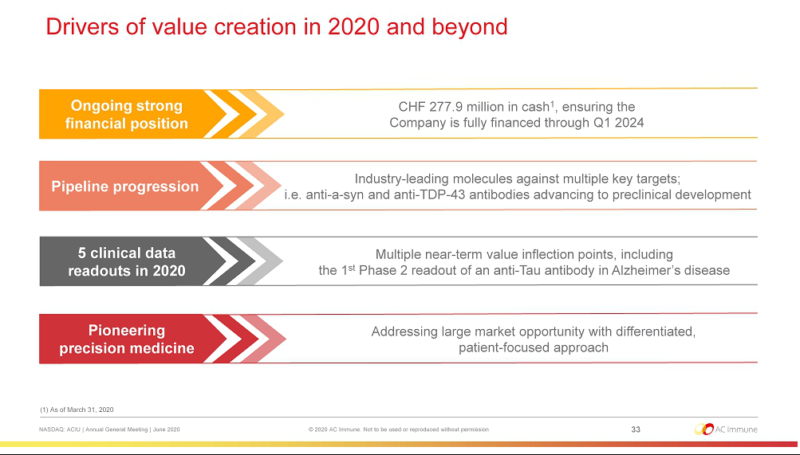

EXHIBIT 99.2


PRESS RELEASE

AC Immune Announces Results of Annual General Meeting

Lausanne, Switzerland, 26 June, 2020 – AC Immune SA (NASDAQ: ACIU), a Swiss-based, clinical-stage biopharmaceutical company with a broad pipeline focused on neurodegenerative diseases, announced AC Immune shareholders approved all of the resolutions as proposed by the Board of Directors at today's Annual General Meeting (AGM) in Lausanne.

At the AGM, shareholders re-elected Douglas Williams, Martin Velasco, Peter Bollmann, Andrea Pfeifer, Thomas Graney, Werner Lanthaler and Roy Twyman to their positions on the Board of Directors. Douglas Williams and Martin Velasco will continue to serve as Chairman and Vice-Chairman of the Board, respectively.

Douglas Williams, Chairman of the Board, said: “The Company is gathering momentum on the back of strong progress, and we remain on track to meet multiple value-creating milestones this year with five clinical readouts expected in 2020. We are especially excited about the Phase 2 trial evaluating our anti-Tau antibody semorinemab in Alzheimer’s disease. The primary completion of the trial is expected soon and we expect top line data in the second half of 2020. We are also extremely pleased to report AC Immune’s solid financial position, with operations fully funded through at least Q1 2024.”

AC Immune has always maintained a robust business continuity plan. During the Covid-19 outbreak, every provision has been made to protect the health of patients, staff and investigators, as well as the productivity and integrity of our clinical development. Importantly, we currently remain on track to deliver all clinical and preclinical readouts expected in 2020. The Swiss Government’s management of Covid-19 means that businesses have been able to return to near normal working practices with all AC Immune staff now back on site in Lausanne.

As part of its efforts to ensure stakeholder safety during the Covid-19 outbreak, AC Immune held only the mandatory part of the AGM as stipulated by Swiss law and by the Company’s Articles of Association. Voting took place via the independent proxy.

About AC Immune SA

AC Immune SA is a Nasdaq-listed clinical-stage biopharmaceutical company, which aims to become a global leader in precision medicine for neurodegenerative diseases. The Company utilizes two proprietary platforms, SupraAntigenTM and MorphomerTM, to design, discover and develop small molecule and biological therapeutics as well as diagnostic products intended to diagnose, prevent and modify neurodegenerative diseases caused by misfolding proteins. The Company's pipeline features nine therapeutic and three diagnostic product candidates, with six currently in clinical trials. It has collaborations with major pharmaceutical companies including Roche/Genentech, Eli Lilly and Company and Janssen Pharmaceuticals.

1 of 2

For further information, please contact:
Head of Investor Relations |  |  | US Media
Joshua Drumm, Ph.D. |  |  | Katie Gallagher
AC Immune |  |  | LaVoieHealthScience
Phone: +1 917 809 0814 |  |  | Phone: +1 617 792 3937
Email: joshua.drumm@acimmune.com |  |  | Email: kgallagher@lavoiehealthscience.com

Global Head of Communications |  |  | European Investors & Media
Judith Moore |  |  | Chris Maggos
AC Immune |  |  | LifeSci Advisors
Phone: +41 79 826 63 82 |  |  | Phone: +41 79 367 6254
Email: judith.moore@acimmune.com |  |  | Email: chris@lifesciadvisors.com
Forward looking statements

This press release contains statements that constitute “forward-looking statements” within the meaning of Section 27A of the Securities Act of 1933 and Section 21E of the Securities Exchange Act of 1934. Forward-looking statements are statements other than historical fact and may include statements that address future operating, financial or business performance or AC Immune’s strategies or expectations. In some cases, you can identify these statements by forward-looking words such as “may,” “might,” “will,” “should,” “expects,” “plans,” “anticipates,” “believes,” “estimates,” “predicts,” “projects,” “potential,” “outlook” or “continue,” and other comparable terminology. Forward-looking statements are based on management’s current expectations and beliefs and involve significant risks and uncertainties that could cause actual results, developments and business decisions to differ materially from those contemplated by these statements. These risks and uncertainties include those described under the captions “Item 3. Key Information – Risk Factors” and “Item 5. Operating and Financial Review and Prospects” in AC Immune’s Annual Report on Form 20-F and other filings with the Securities and Exchange Commission. These include: the impact of Covid-19 on our business, suppliers, patients and employees and any other impact of Covid-19. Forward-looking statements speak only as of the date they are made, and AC Immune does not undertake any obligation to update them in light of new information, future developments or otherwise, except as may be required under applicable law. All forward-looking statements are qualified in their entirety by this cautionary statement.

2 of 2

