UNITED STATES

SECURITIES AND EXCHANGE COMMISSION

Washington, D.C. 20549

FORM 6-K

REPORT OF FOREIGN PRIVATE ISSUER PURSUANT TO RULE 13a-16 OR 15d-16 UNDER THE SECURITIES EXCHANGE ACT OF 1934

For the month of June, 2019

Commission File Number: 001-37891

AC IMMUNE SA

(Exact name of registrant as specified in its charter)

EPFL Innovation Park

Building B

1015 Lausanne, Switzerland

(Address of principal executive office)

Indicate by check mark whether the registrant files or will file annual reports under cover of Form 20-F or Form 40-F:

Form 20-F X Form 40-F

Indicate by check mark if the registrant is submitting the Form 6-K in paper as permitted by Regulation S-T Rule 101(b)(1):

Yes No X

Indicate by check mark if the registrant is submitting the Form 6-K in paper as permitted by Regulation S-T Rule 101(b)(7):

Yes No X

Annual Ordinary Shareholders’ Meeting Results

On June 28, 2019, AC Immune SA (“AC Immune”) held its annual Ordinary Shareholders’ Meeting. The presentation that was given at the Ordinary Shareholders’ Meeting is attached hereto as Exhibit 99.1 and the press release relating to the results of the Ordinary Shareholders’ Meeting is attached hereto as Exhibit 99.2. Prior to the meeting, the Board withdrew agenda items 9 and 10. The final results of each of the agenda items submitted to a vote of the shareholders are as follows:

Agenda Item 1: Approval of the Annual Report, Annual Statutory Financial Statements and Financial Statements under IFRS of AC Immune SA for the year 2018

AC Immune shareholders approved the Annual Report, the Annual Statutory Financial Statements and the Financial Statements under IFRS of AC Immune SA for the year 2018, and took note of the Reports of the Auditors.

Agenda Item 2: Appropriation of Loss

AC Immune shareholders approved the addition of the net loss for the year 2018 in the amount of KCHF 48,894 to the loss brought forward of KCHF 58,426, resulting in a new balance of loss brought forward of KCHF 107,320.

Agenda Item 3: Discharge of the Members of the Board of Directors and the Executive Committee

AC Immune shareholders approved the discharge of the Board and the Executive Committee of their liabilities for their activities in the financial year 2018.

Agenda Item 4: Compensation for the Members of the Board of Directors and the Executive Committee

AC Immune shareholders approved:

- The total maximum amount of non-performance-related compensation for the members of the Board of Directors covering the period from 1 July 2019 to 30 June 2020, i.e., CHF 547,000 (cash base compensation plus social security costs);

- The maximum grant of equity or equity linked instruments for the members of the Board of Directors from 1 July 2019 to 30 June 2020 with maximum value of CHF 626,000 (equity or equity linked instruments value plus social security costs);

- The total maximum amount of non-performance-related cash compensation for the members of the Executive Committee from 1 July 2019 to 30 June 2020, i.e., CHF 2,407,000 (cash base compensation plus social security costs);

- The total maximum amount of variable compensation for the members of the Executive Committee for the current year 2019, i.e., CHF 1,195,000 (cash compensation plus social security costs); and

- The maximum grant of equity or equity linked instruments for the members of the Executive Committee from 1 July 2019 to 30 June 2020 with maximum value of CHF 3,126,000 (equity or equity linked instruments value plus social security costs).

Agenda Item 5: Election of the Members of the Board

AC Immune shareholders approved the re-election of Douglas Williams as member and as election as Chairman of the Board, the re-election of Martin Velasco as member and election as Vice-Chairman of the Board, the re-election of Peter Bollmann, Friedrich von Bohlen, Andrea Pfeifer, Tom Graney and Werner Lanthaler and the election of Roy Twyman as members of the Board of Directors, each until the end of the next Ordinary General Meeting.

Agenda Item 6: Election to the Compensation, Nomination & Corporate Governance Committee

AC Immune shareholders approved the re-election of Martin Velasco, Tom Graney and Douglas Williams as members of the Compensation, Nomination & Corporate Governance Committee, each until the end of the next Ordinary General Meeting.

Agenda Item 7: Election of the Independent Proxy

AC Immune shareholders approved the election of Reymond & Associés, represented by Denis Cherpillod as AC Immune’s independent proxy until the end of the next Ordinary General Meeting.

Agenda Item 8: Re-Election of the Auditors

AC Immune shareholders approved the re-election of PricewaterhouseCoopers SA, in Pully, for a term of office of one year.

Agenda Item 11: Conditional Capital Increase for Employee Benefit Plans

AC Immune shareholders approved an amendment to the existing first paragraph of article 3c (Conditional Capital Increase for Employee Benefit Plans) of the articles of association pertaining to the conditional capital increase for employees and individuals of comparable positions, to create conditional share capital for the same purpose in the maximum amount of CHF 70,460 by the issuance of 3,523,000 registered common shares of CHF 0.02 nominal value each and to amend article 3c, paragraph 1 of the articles of association thereby increasing the conditional capital in the amount of 27,069.90 representing 1,353,495 registered common shares of CHF 0.02 nominal value each.

SIGNATURE

Pursuant to the requirements of the Securities Exchange Act of 1934, the registrant has duly caused this report to be signed on its behalf by the undersigned, thereunto duly authorized.

AC IMMUNE SA

By: | /s/ Andrea Pfeifer
 | Name: | Andrea Pfeifer
 | Title: | Chief Executive Officer
By: | /s/ Joerg Hornstein
 | Name: | Joerg Hornstein
 | Title: | Chief Financial Officer

Date: June 28, 2019

 | EXHIBIT INDEX
Exhibit | Description
Number
99.1 | Annual Ordinary Shareholders’ Meeting presentation
99.2 | Press Release dated June 28, 2019

Exhibit 99.1


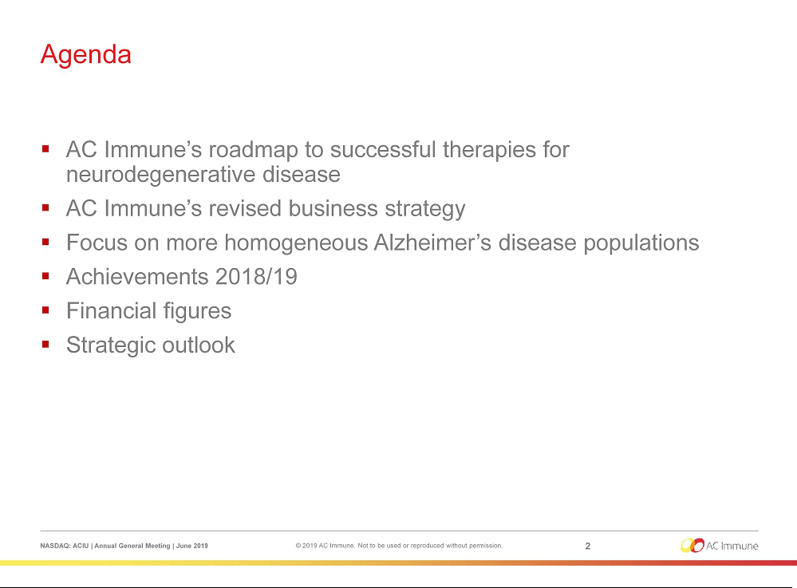

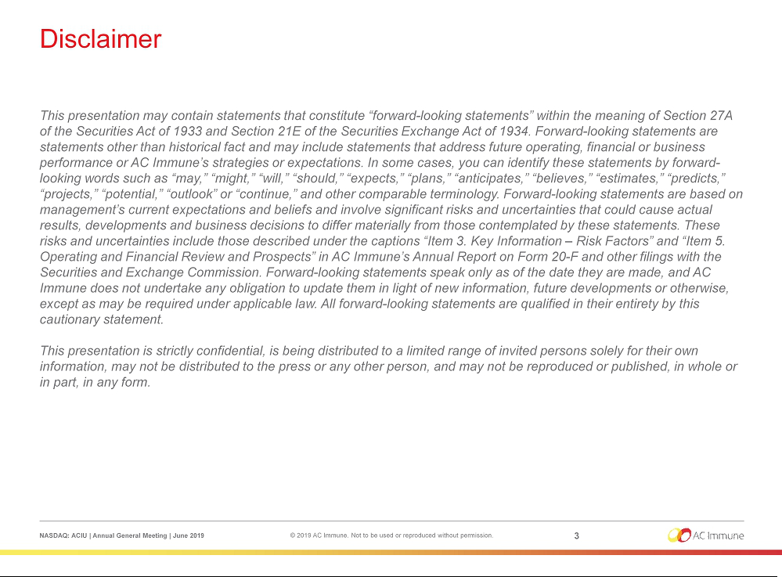



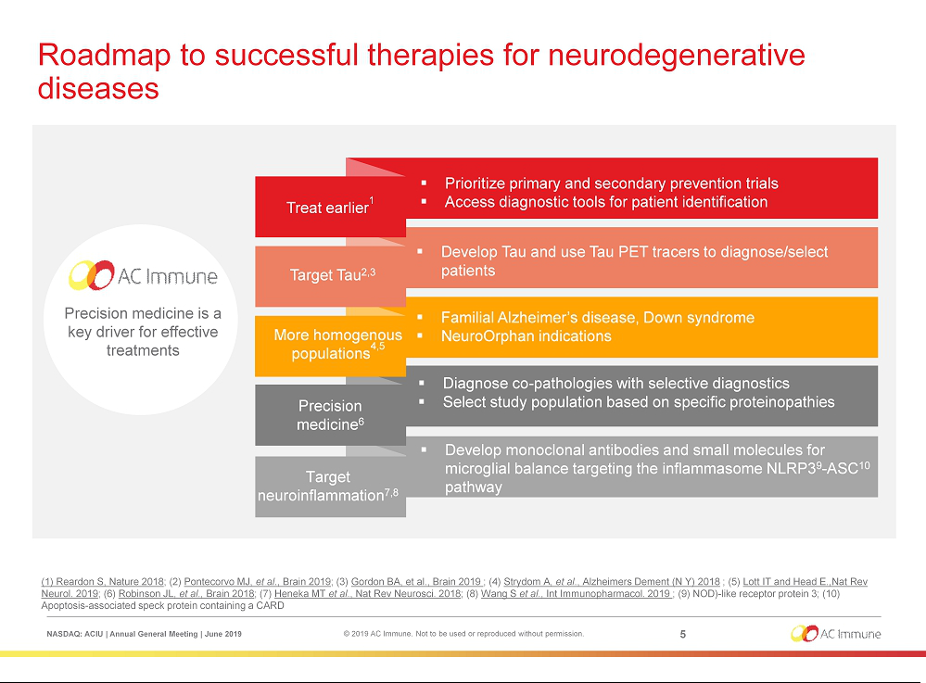



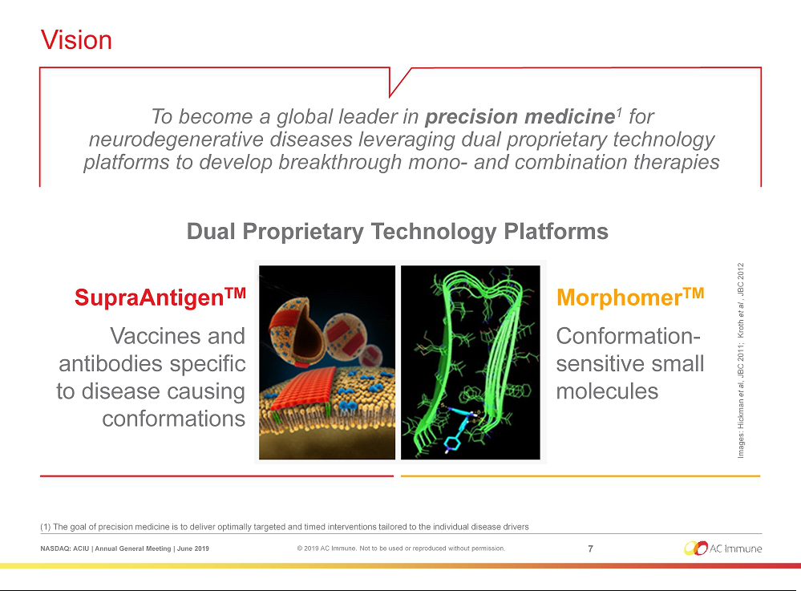

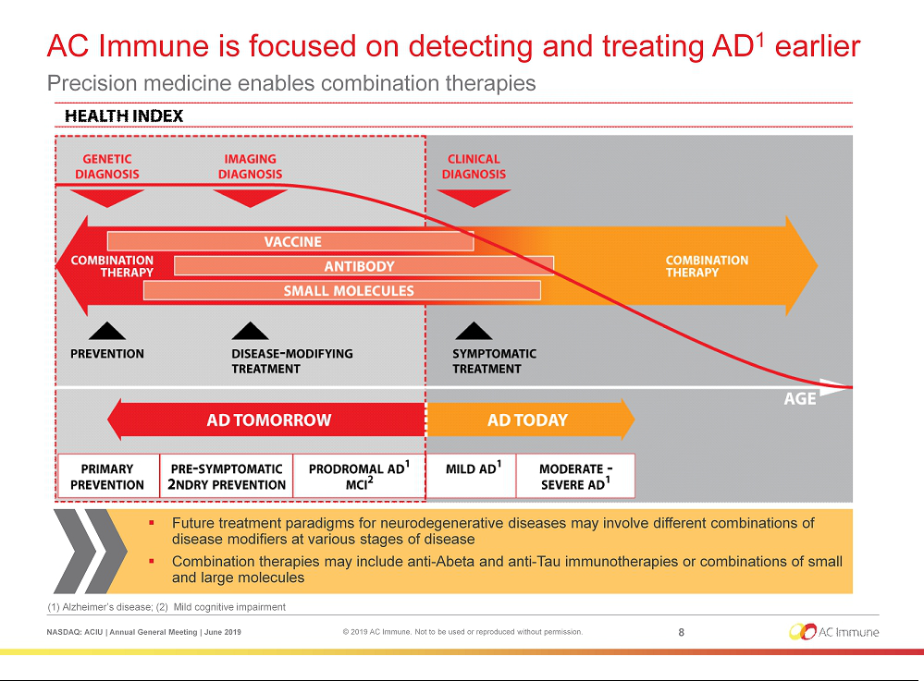

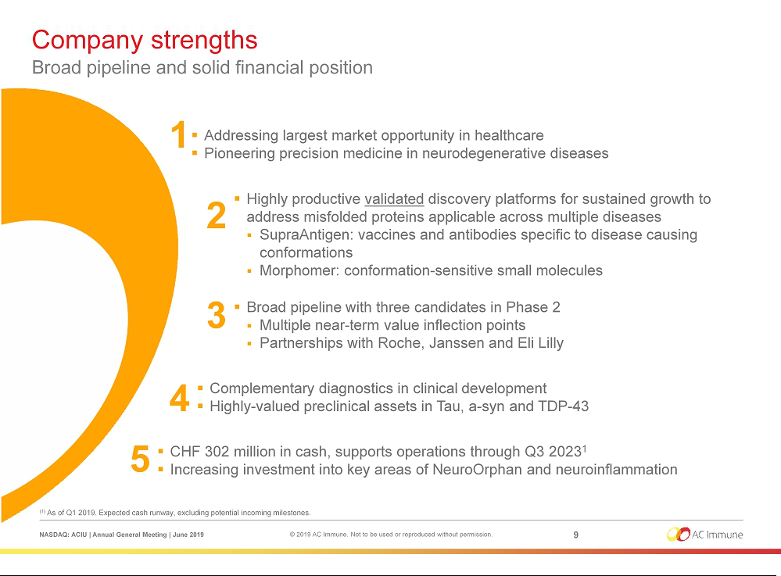

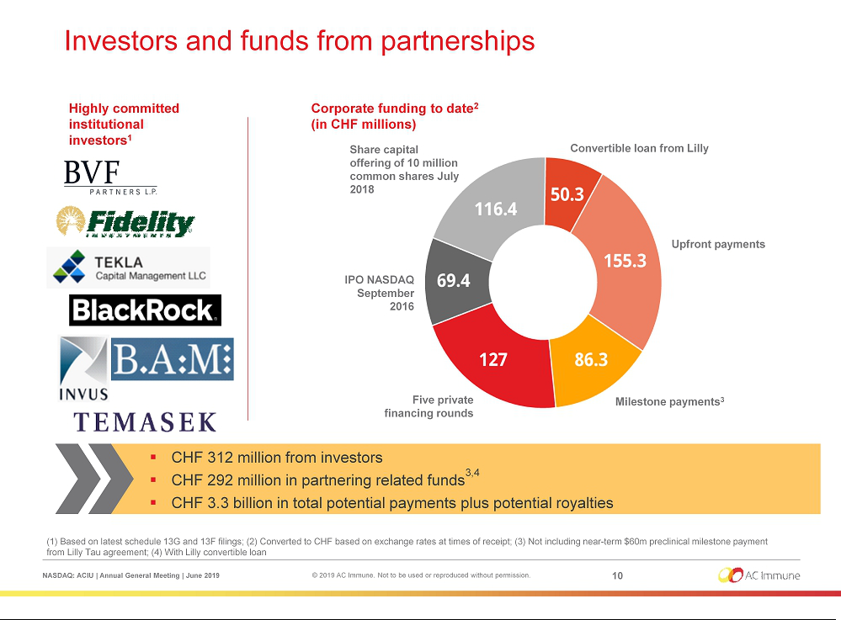

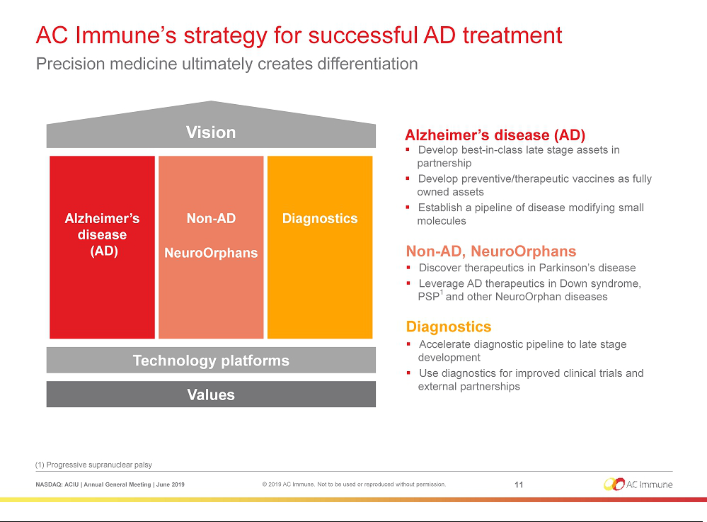

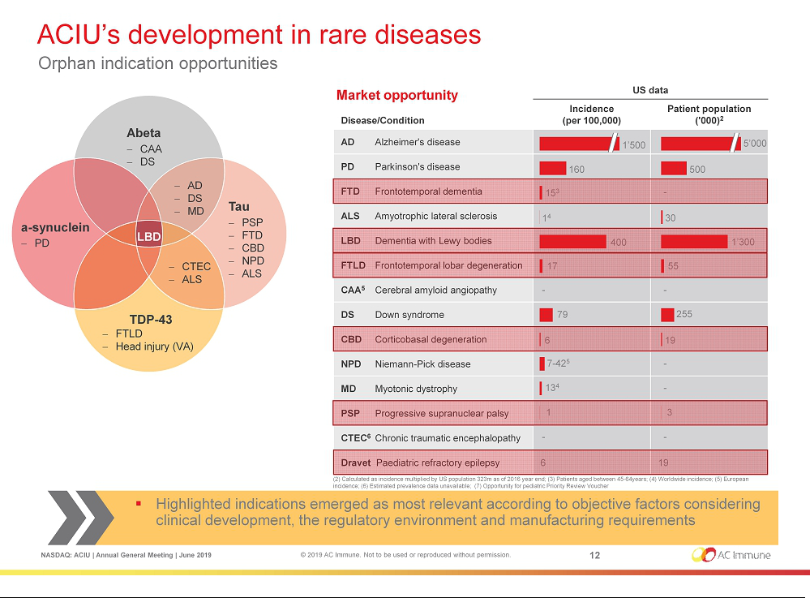

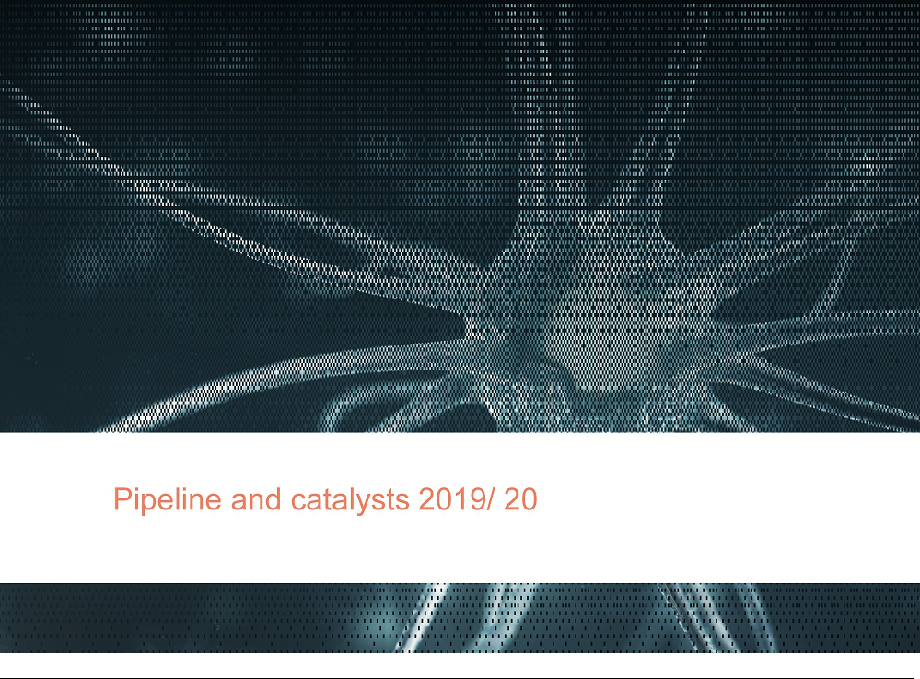

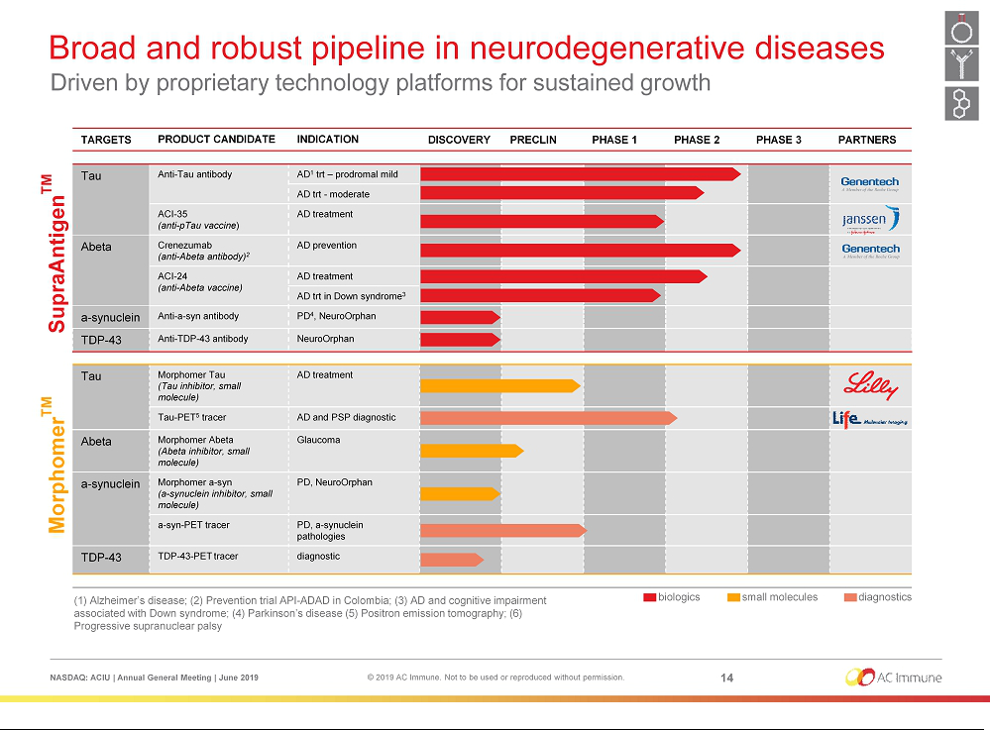

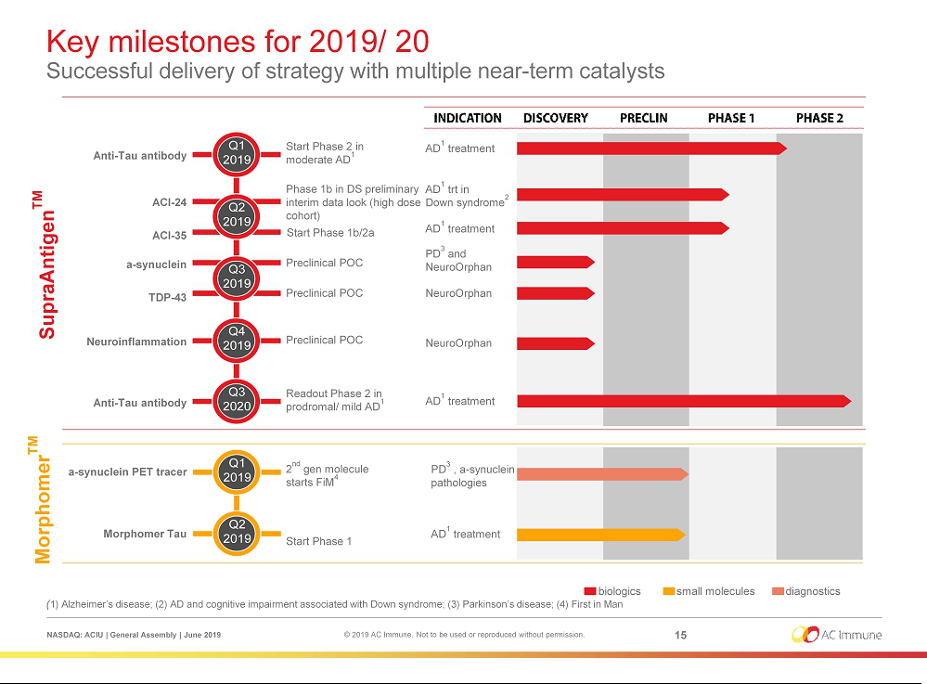



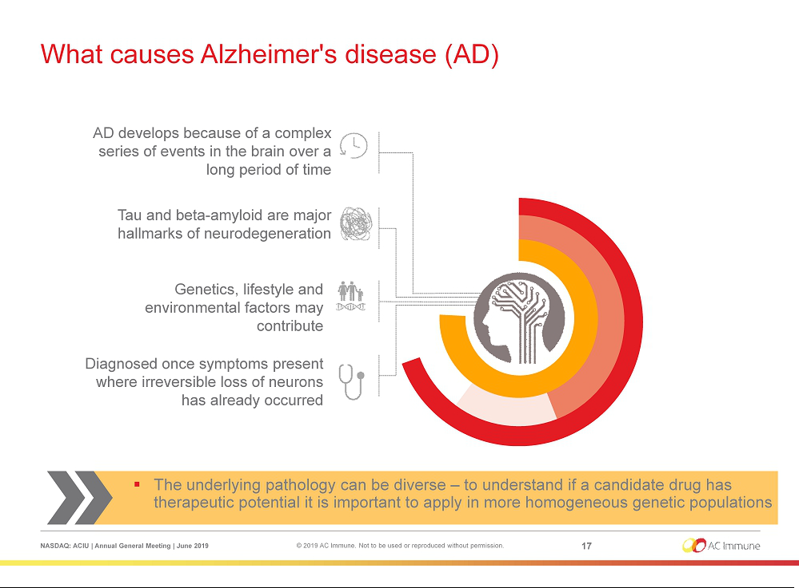

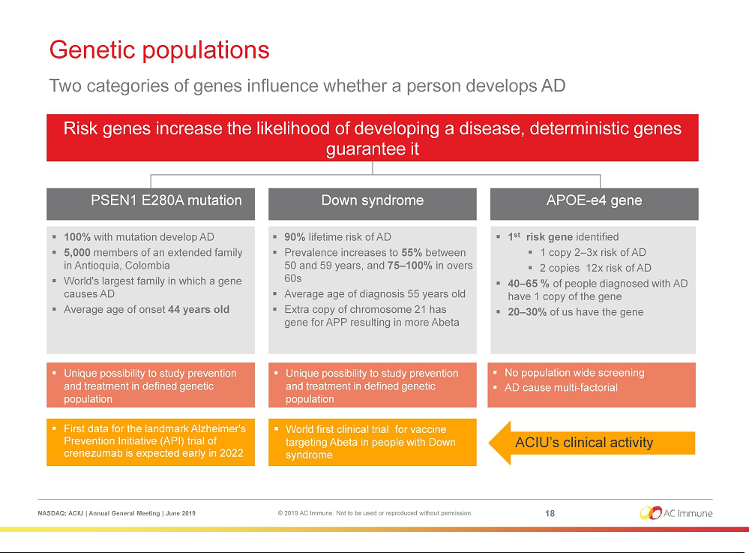

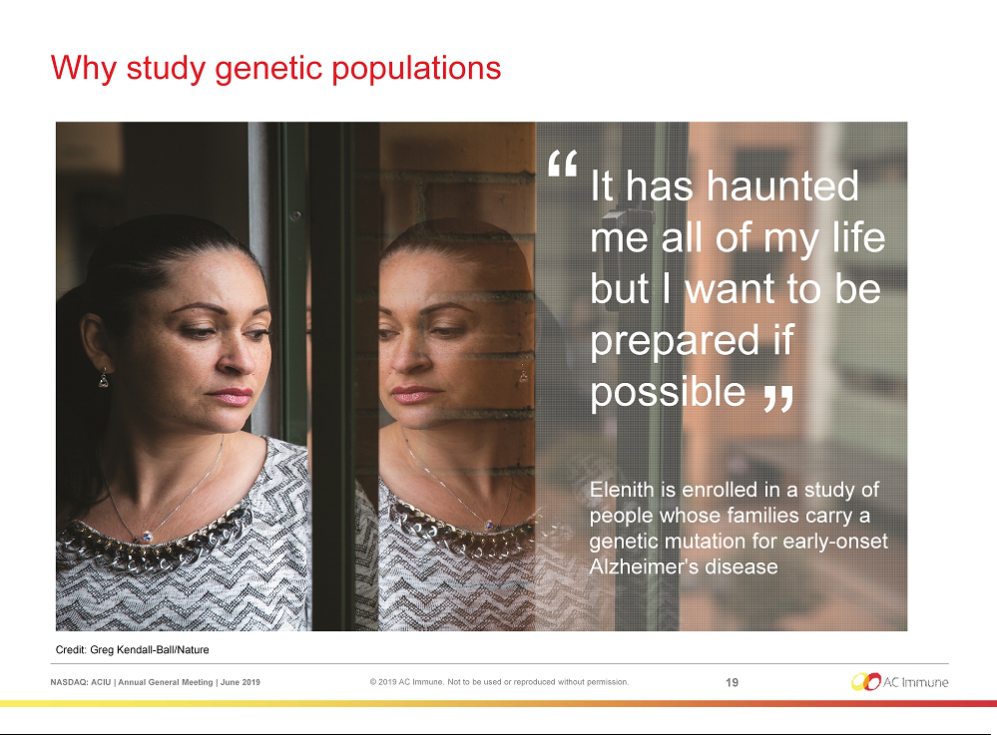

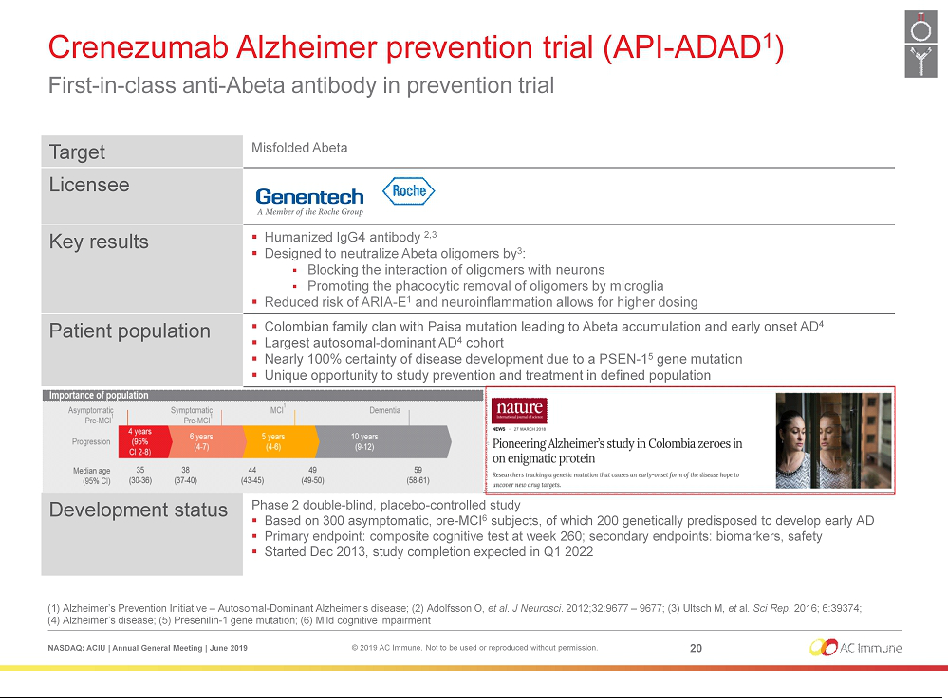

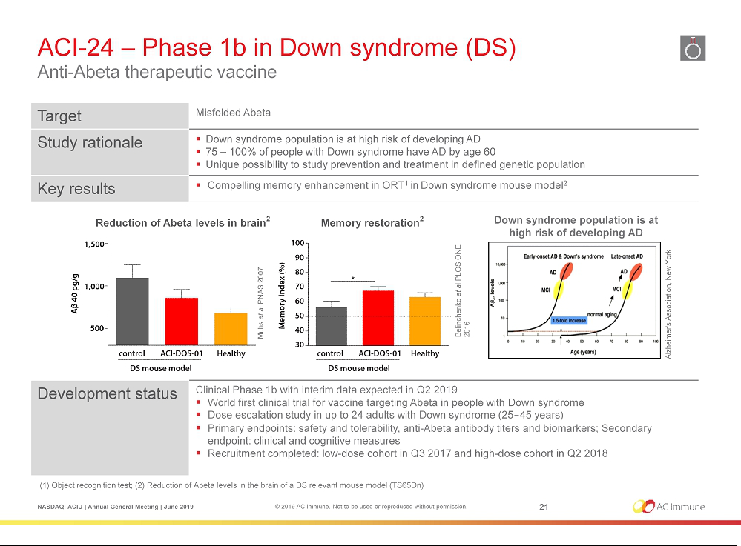



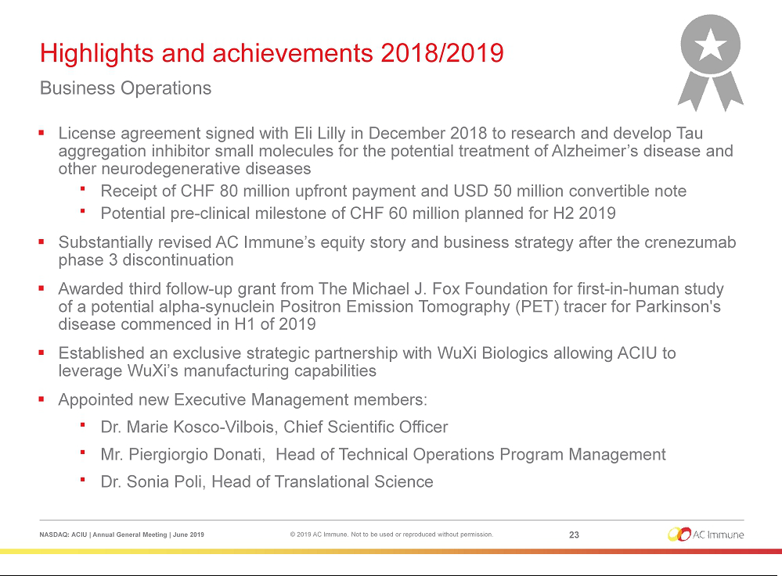

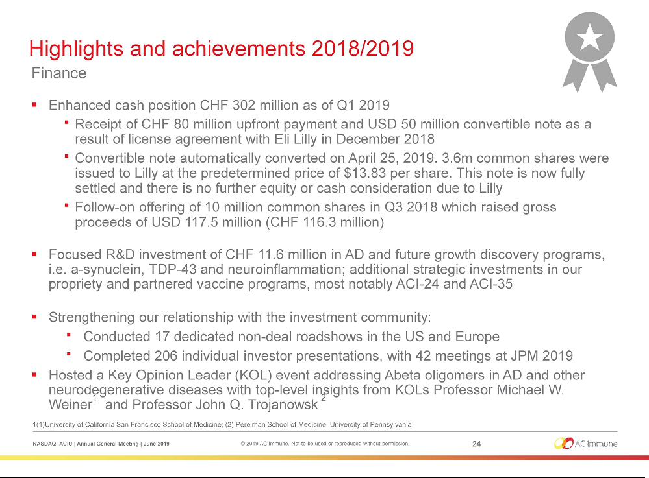

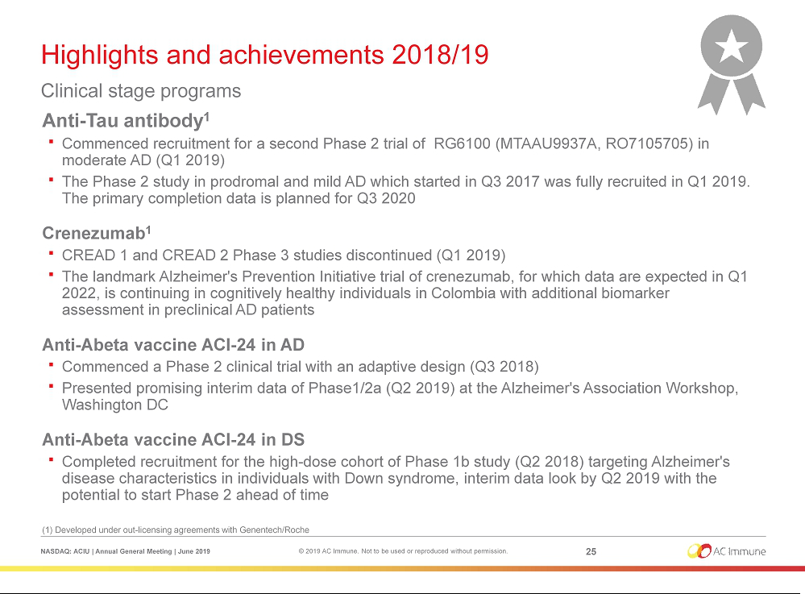

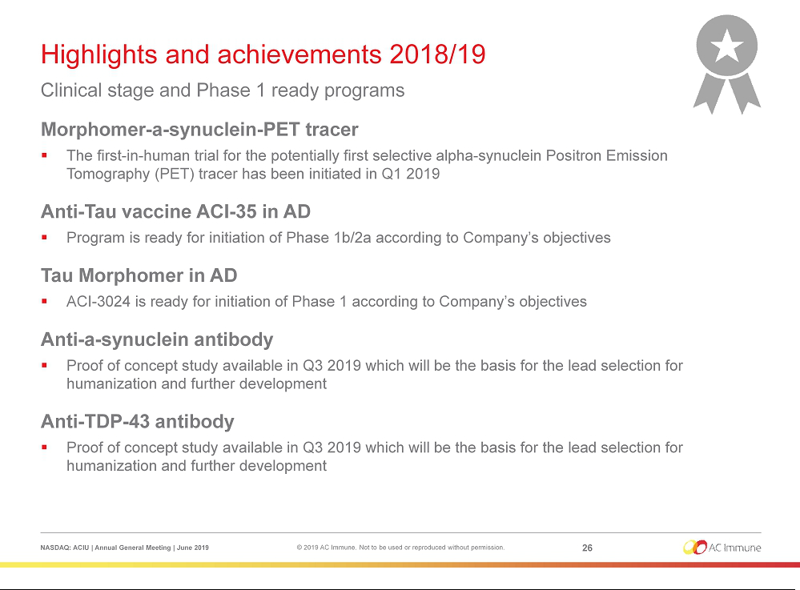

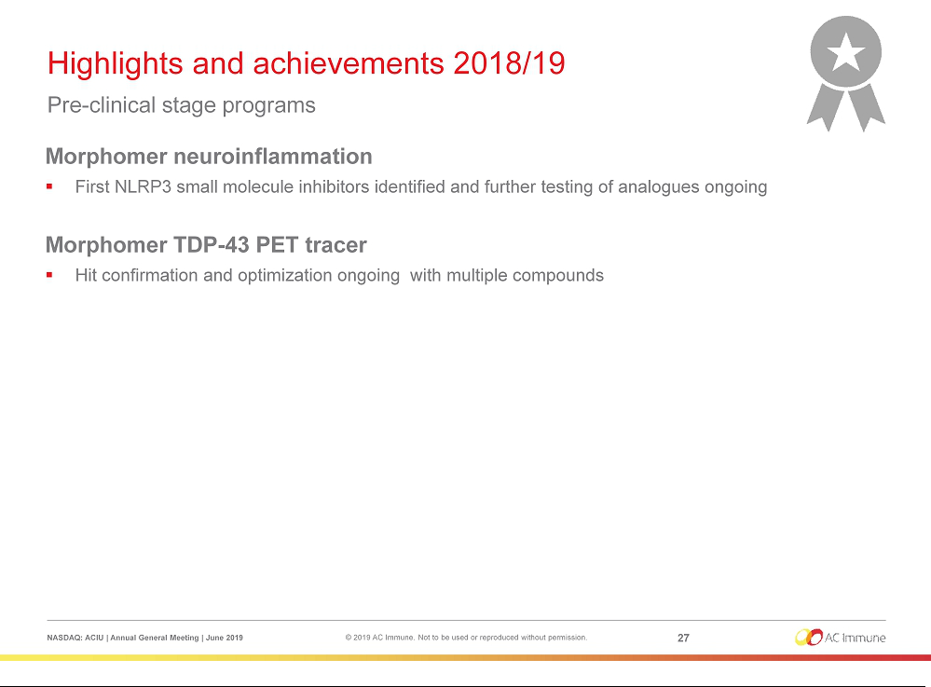

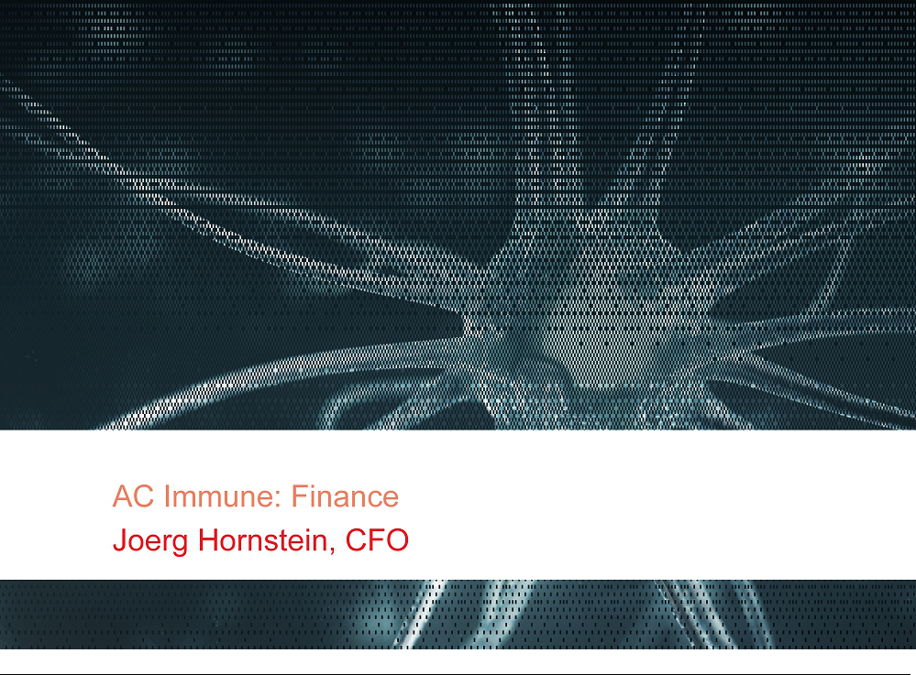

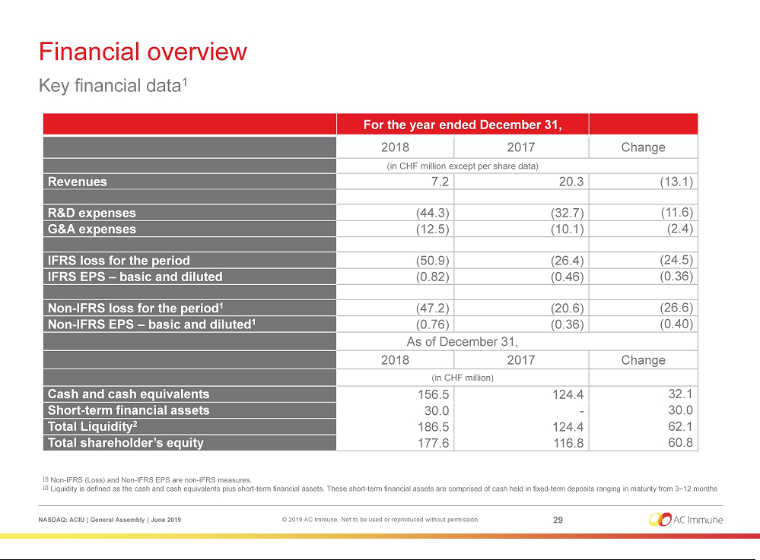



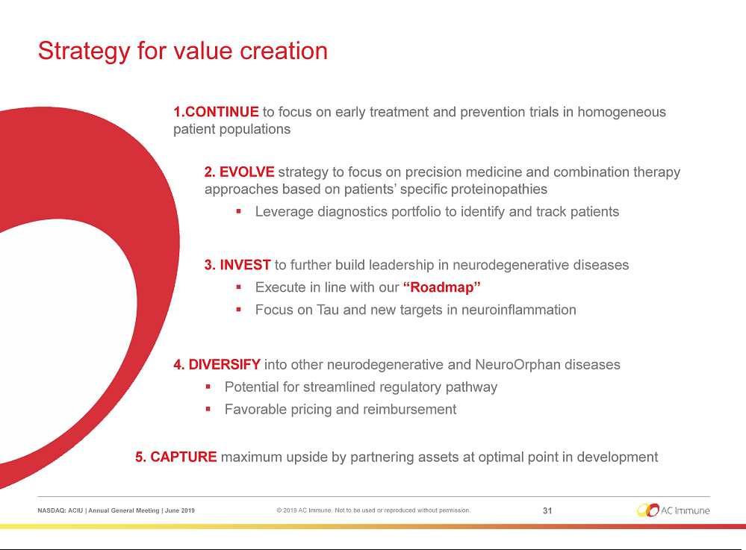

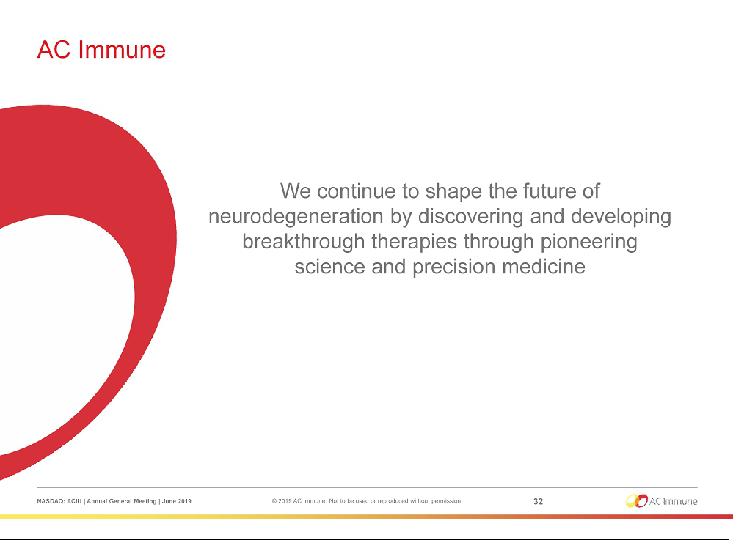

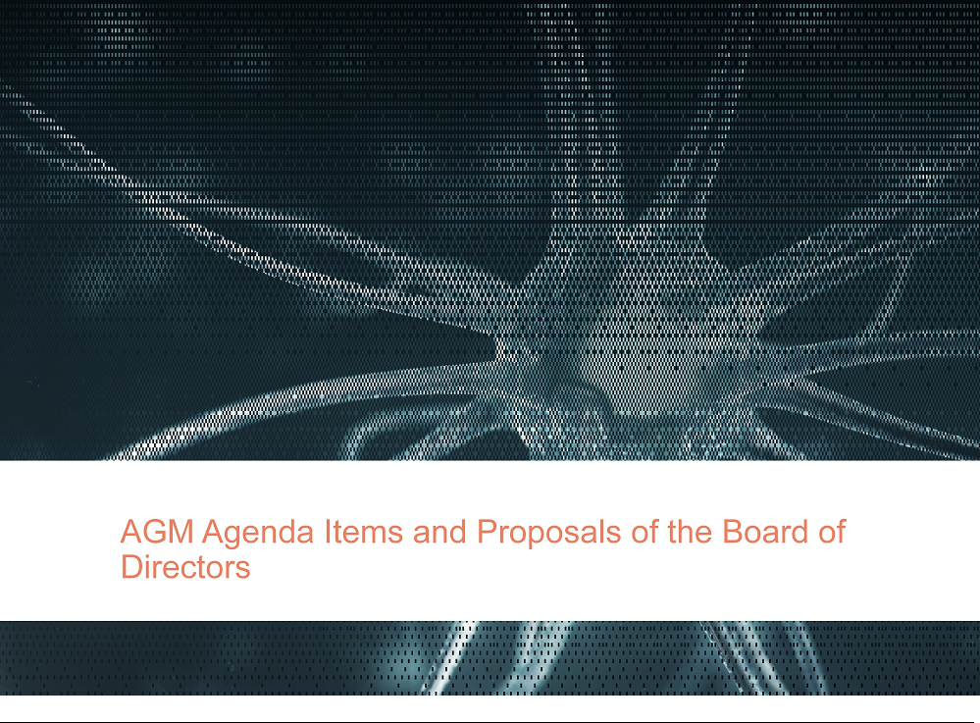

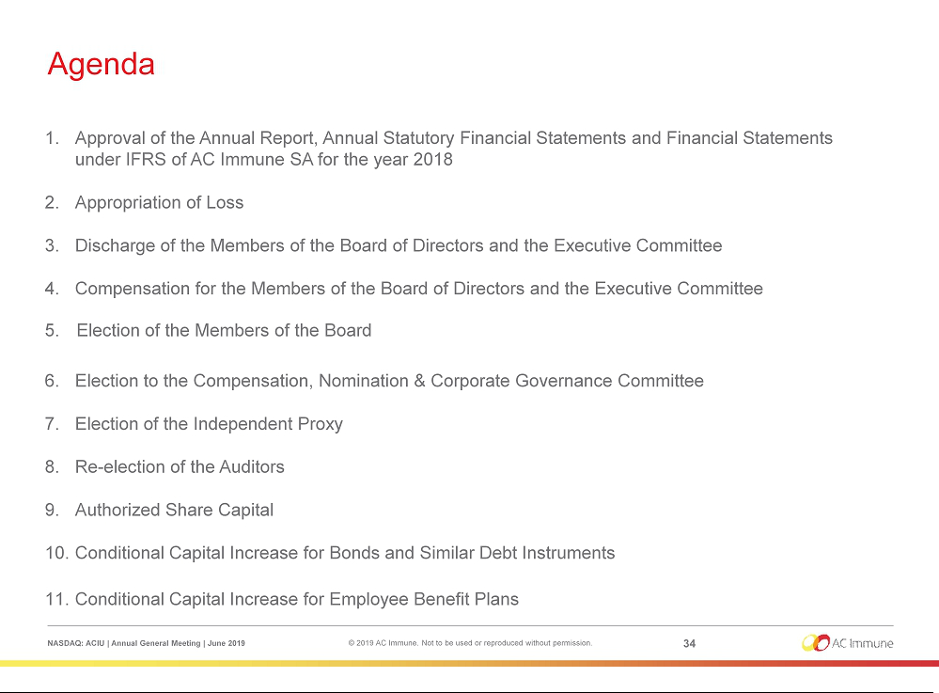

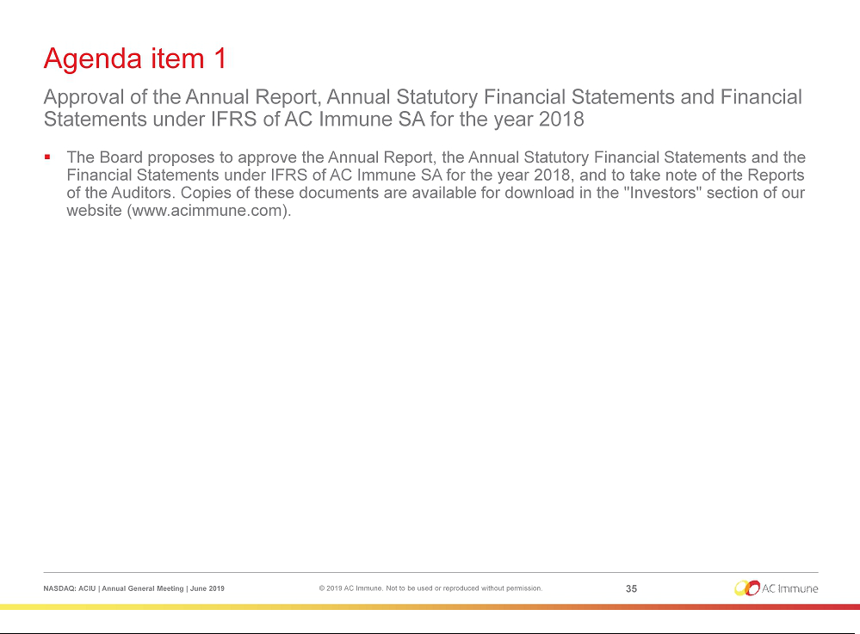

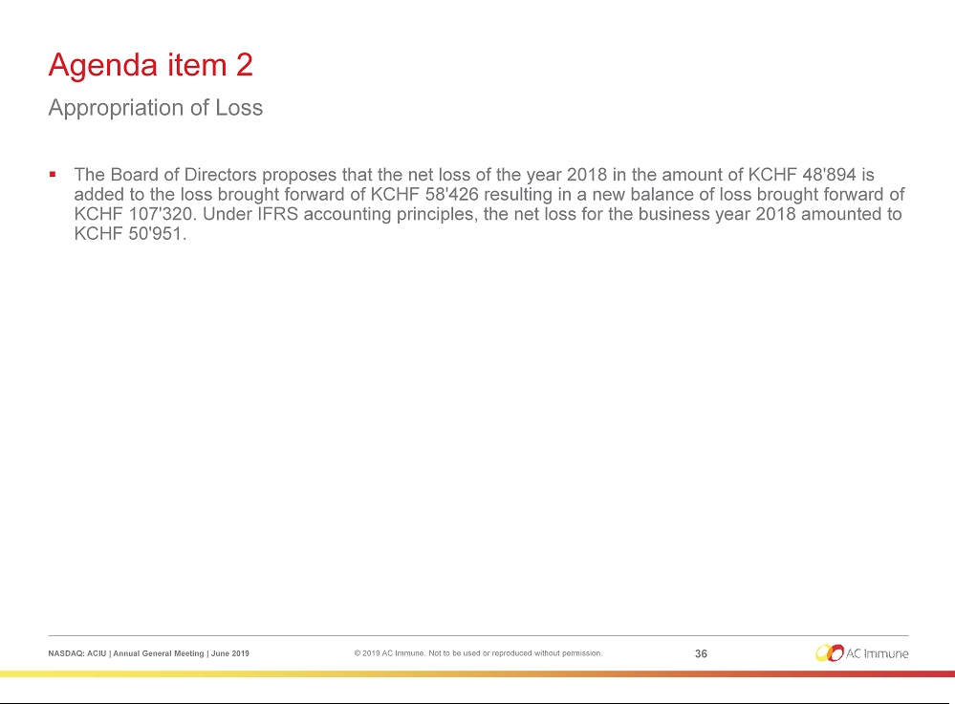

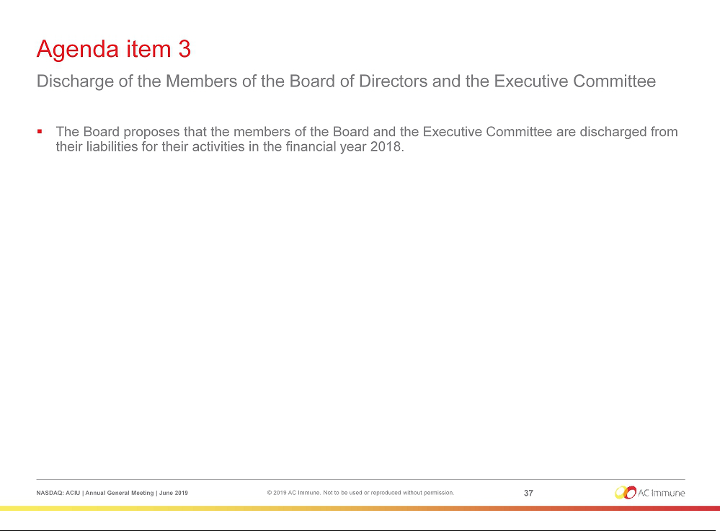

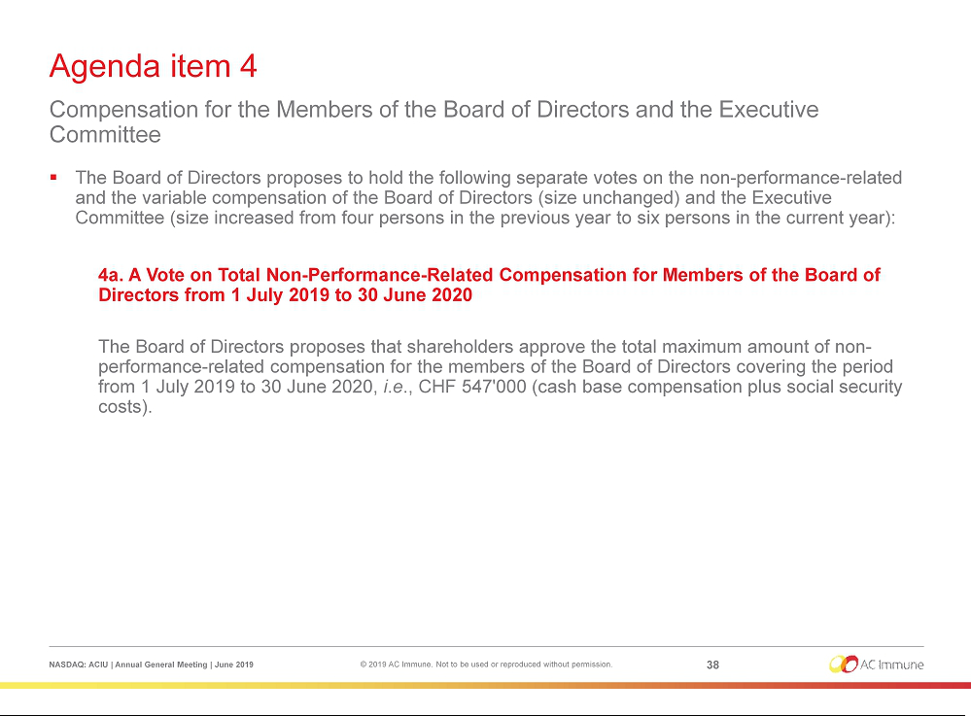

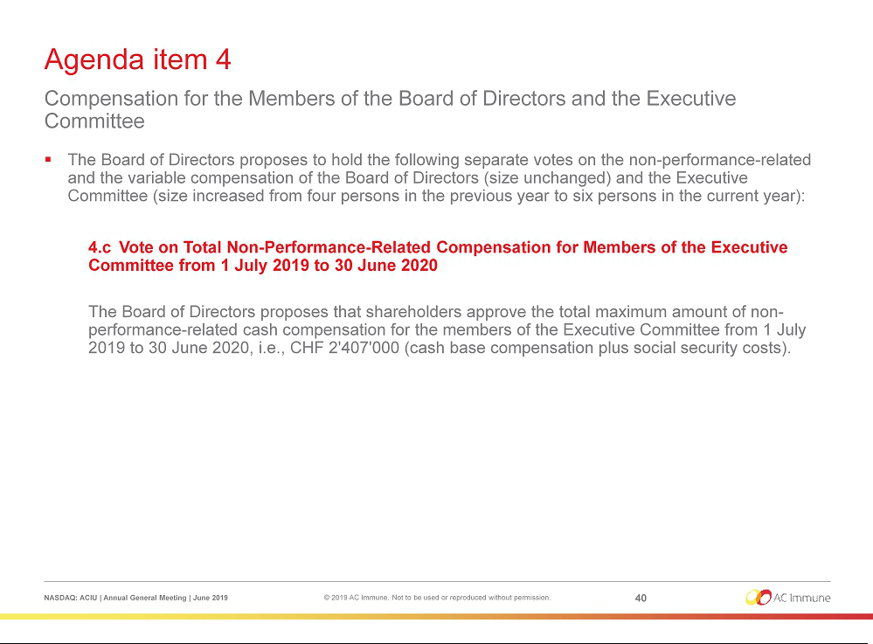

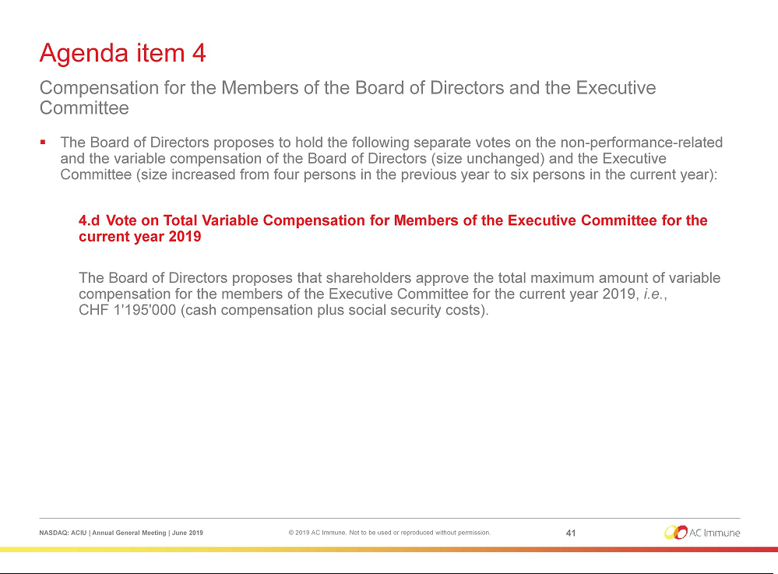

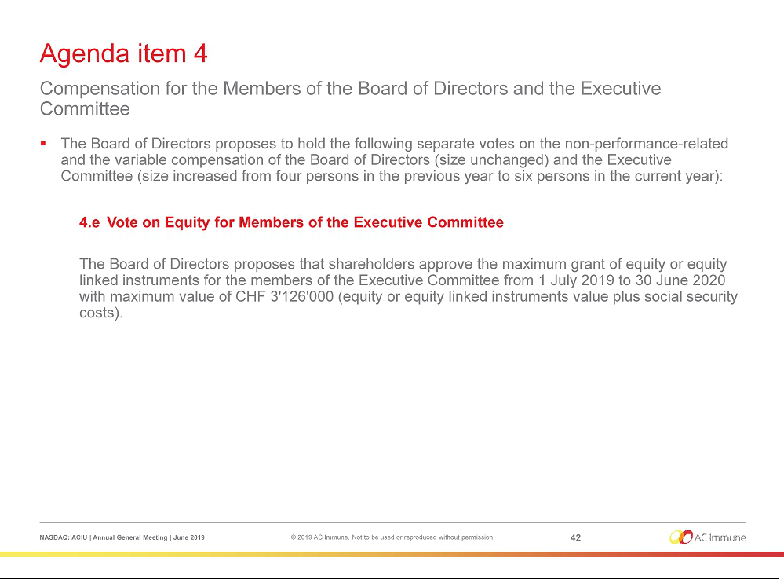

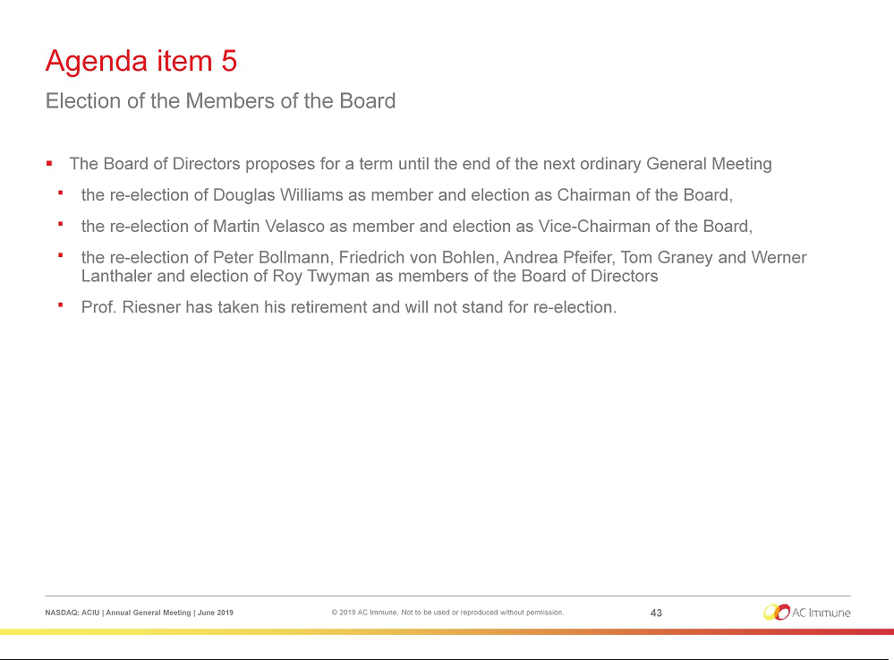

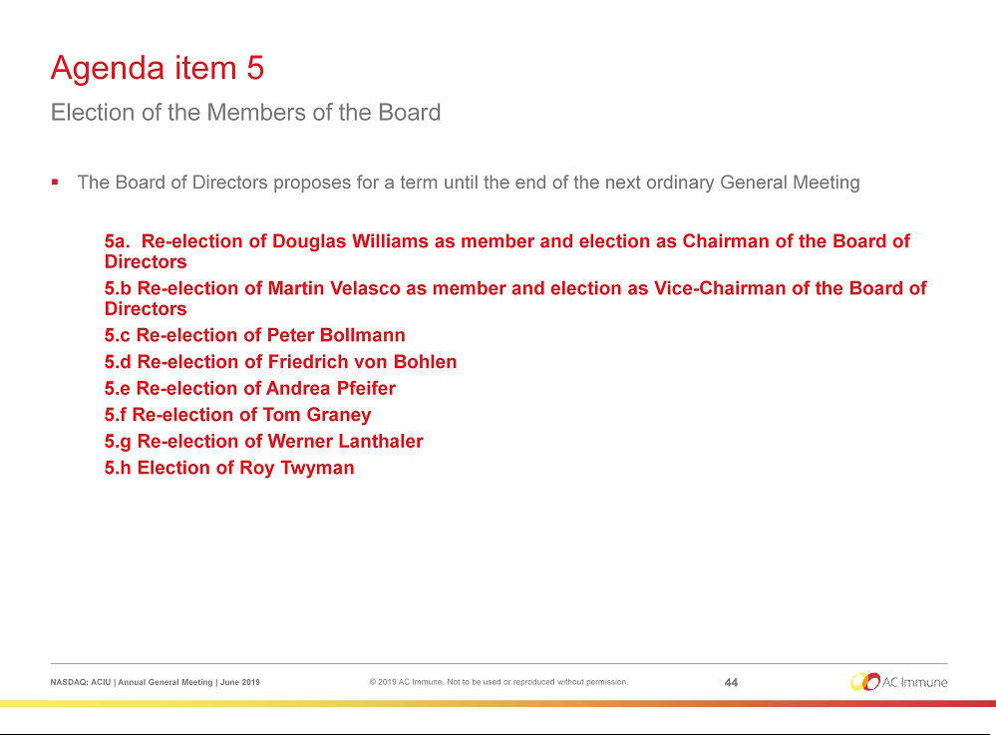

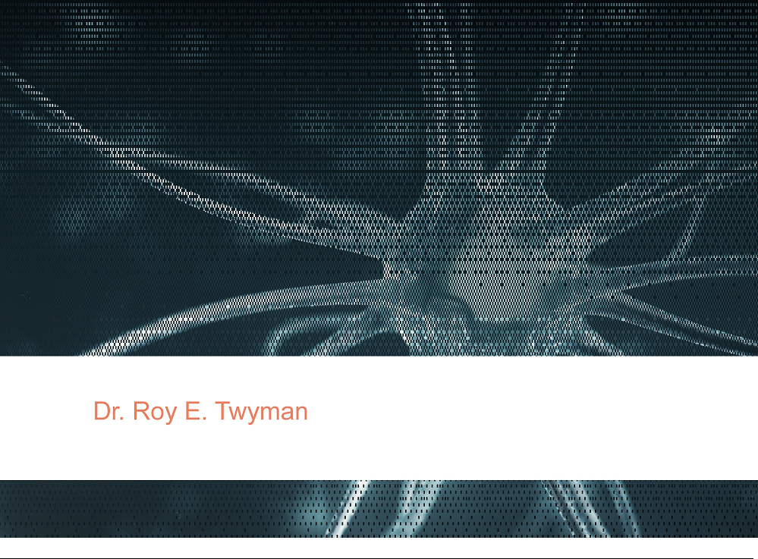

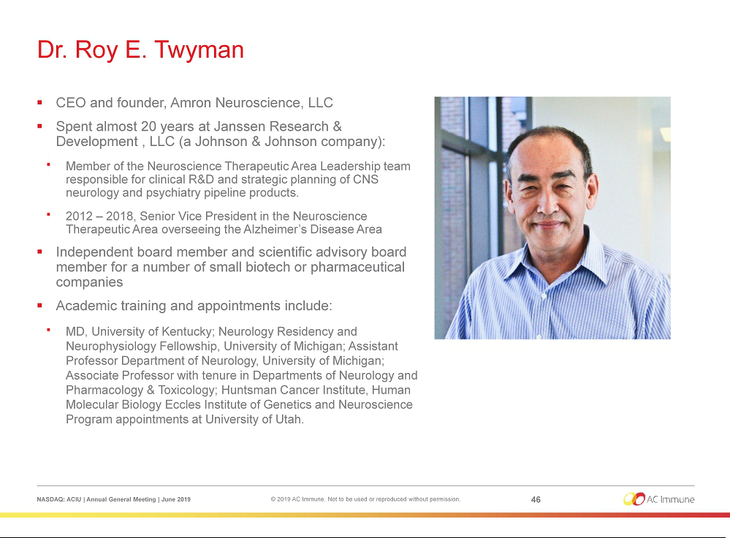

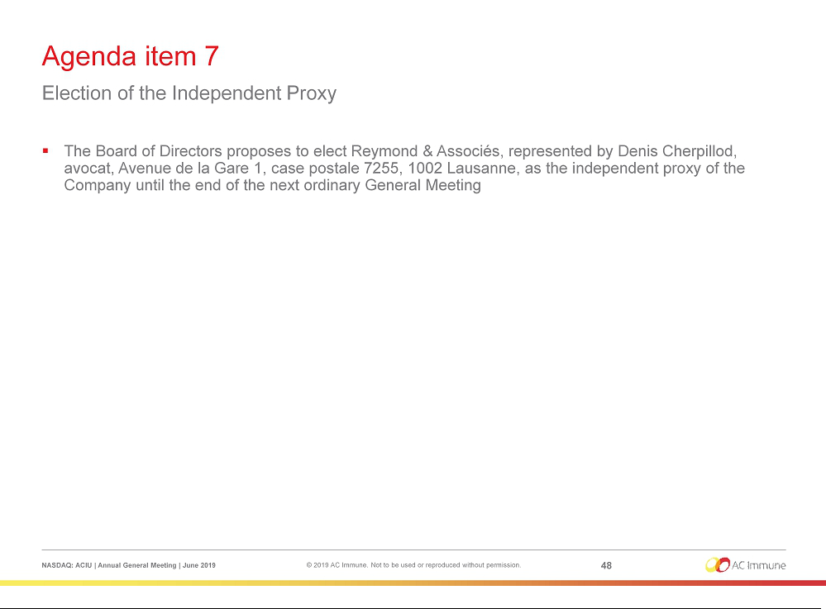

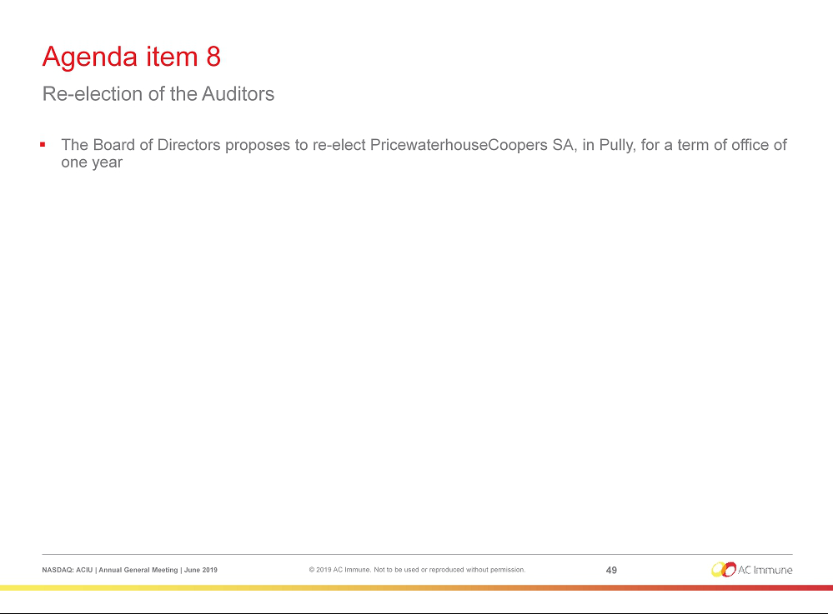

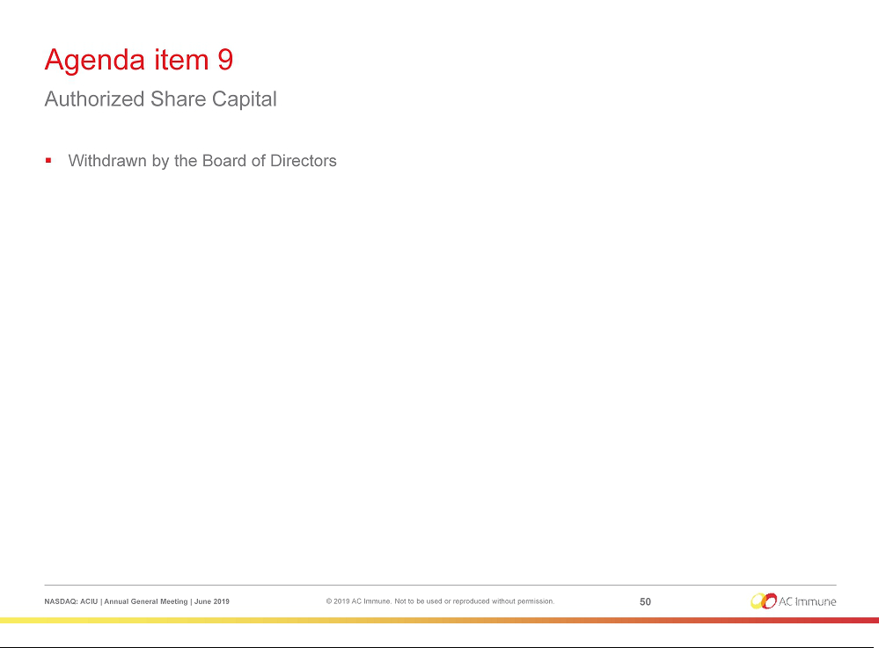

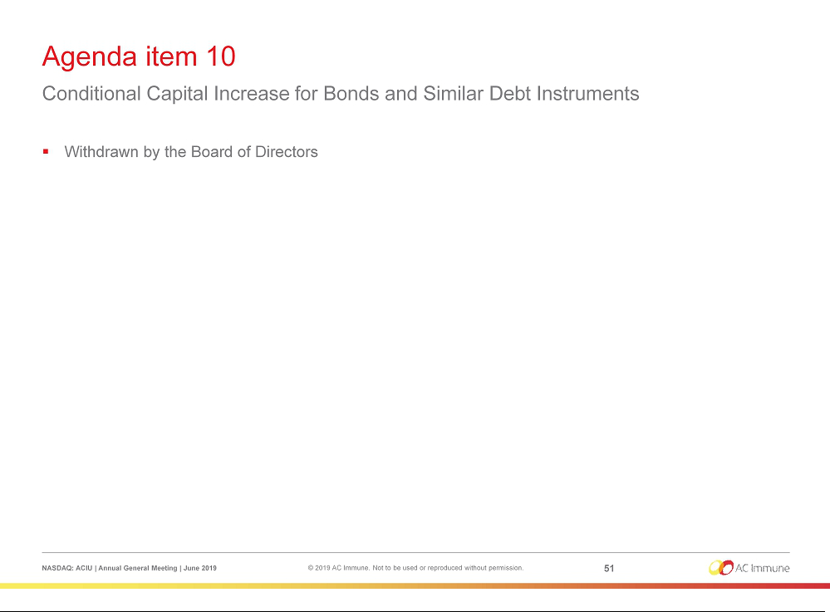

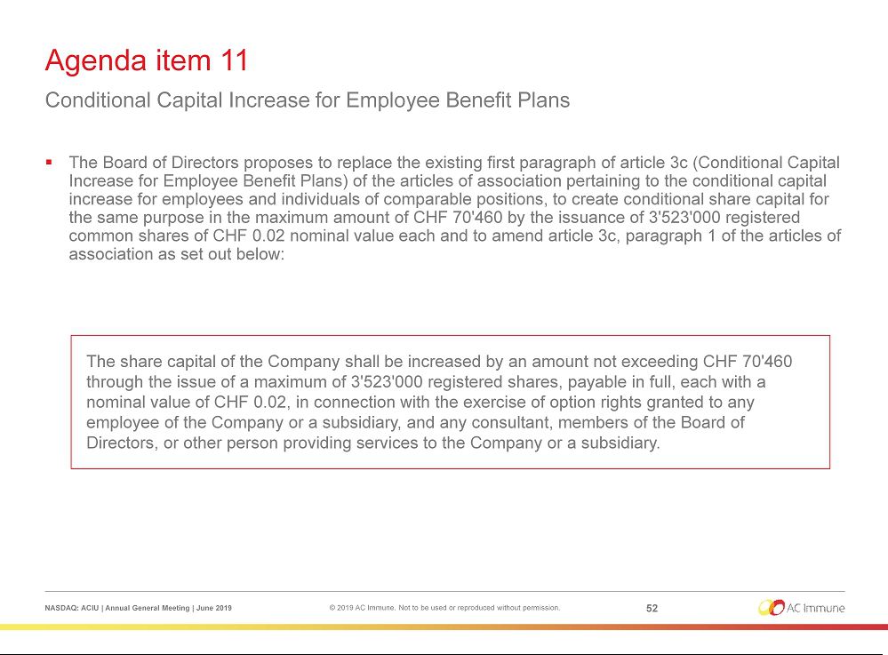

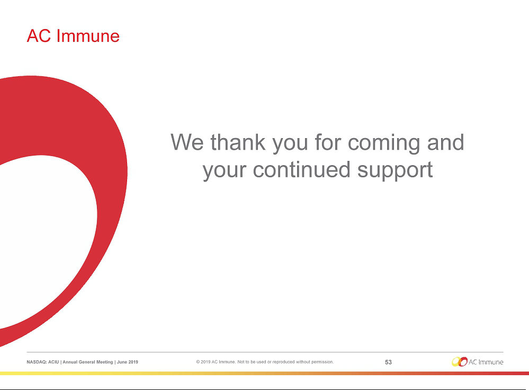

Exhibit 99.2


PRESS RELEASE

AC Immune Announces Election of New Chairman of the Board at Annual General Meeting

Lausanne, Switzerland, 28 June, 2019 – AC Immune SA (NASDAQ: ACIU), a Swiss-based, clinical-stage biopharmaceutical company with a broad pipeline focused on neurodegenerative diseases, announced that shareholders in the Company have elected Douglas Williams as Chairman of the Board at today’s Annual General Meeting (AGM).

At the AGM held in Lausanne, shareholders also elected Martin Velasco, previously Chairman, as Vice-Chairman of the Board. They re-elected Peter Bollmann, Friedrich von Bohlen, Andrea Pfeifer, Thomas Graney and Werner Lanthaler and elected Roy Twyman as members of the Board of Directors. Detlev Riesner has retired and did not stand for re-election.

Prof. Andrea Pfeifer, CEO of AC Immune, commented: “We are pleased to welcome Dr. Douglas Williams to the role of Chairman of the Board of AC Immune, to which he brings more than 30 years of experience and insight into the biotechnology industry. We’ve already benefitted from his leadership expertise as a member of our Board since 2018. In his career, Douglas has held senior executive roles at both pharmaceutical and biotechnology companies and played a role in the development of several novel drugs. The Board also welcomes Dr. Roy Twyman as a new member. Roy is an experienced neurologist who spent nearly 20 years at Janssen on its Neuroscience Therapeutic Area Leadership team where he oversaw clinical R&D and strategic planning for Alzheimer’s disease and other CNS disorders. Strengthening our Board of Directors with such accomplished industry leaders validates the strength and potential of our pipeline, and we believe their strategic guidance positions us for success as we continue to advance multiple clinical programs targeting neurodegenerative diseases.”

“We would also like to extend our deepest gratitude to Martin Velasco for his committed service as Chairman of the Board of AC Immune. We are honored by his dedication and delighted to continue benefitting from his knowledge and experience in his role as Vice-Chairman.”

Douglas E. Williams, Ph.D. Biography

Dr. Williams is currently the President, CEO and member of the Board of Directors of Codiak BioSciences. He was previously Biogen’s Executive Vice President, Research and Development. He joined Biogen from ZymoGenetics, where he was most recently CEO and member of the Board of Directors. Previously, he held leadership positions within the biotechnology industry, including Chief Scientific Officer and Executive Vice President of Research and Development at Seattle Genetics, and Senior Vice President and Washington Site Leader at Amgen. Dr. Williams served in a series of scientific and senior leadership positions over a decade at Immunex, including Executive Vice President and Chief Technology Officer and a member of the Board of Directors. During his 30+ year career in the biotechnology industry, he has played a role in the development of several novel drugs and has served on the board of numerous biotechnology companies.

Roy Twyman, M.D. Biography

Dr. Twyman is a neurologist and currently CEO and founder, Amron Neuroscience, LLC, a private consulting company focused on neuroscience drug development. Prior to this, Dr. Twyman spent almost 20 years at Janssen Research & Development, LLC (a Johnson & Johnson company) and was a member of the Neuroscience Therapeutic Area Leadership team responsible for clinical R&D and strategic planning of CNS neurology and psychiatry pipeline products. From 2012 to March 2018, he was a Senior Vice President in the Neuroscience Therapeutic Area overseeing the Alzheimer’s Disease Area. He currently participates as an independent board member or as a scientific advisory board member for a number of small biotech or pharmaceutical companies.

Shareholders also approved all resolutions at the AGM as proposed by the Board of Directors. Prior to the meeting, the Board withdrew agenda items 9 and 10.

About AC Immune SA

AC Immune SA is a Nasdaq-listed clinical-stage biopharmaceutical company, which aims to become a global leader in precision medicine for neurodegenerative diseases. The Company is utilizing two proprietary discovery platforms, SupraAntigenTM and MorphomerTM, to design, discover and develop small molecule and biological therapeutics as well as diagnostic products intended to diagnose, prevent and modify neurodegenerative diseases caused by misfolding proteins. The Company's pipeline features nine therapeutic and three diagnostic product candidates, with five currently in clinical trials. It has collaborations with major pharmaceutical companies including Roche/Genentech, Eli Lilly and Janssen.

For further information, please contact:
US Investors |  |  | US Media
Joshua Drumm, Ph.D. |  |  | Katie Gallagher or Sharon Correia
AC Immune Investor Relations |  |  | LaVoieHealthScience
Phone: +1 646 876 5538 |  |  | Phone: +1 617 792 3937
E-mail: joshua.drumm@acimmune.com |  |  | E-mail: kgallagher@lavoiehealthscience.com
 |  |  | scorreia@lavoiehealthscience.co

European Media |  |  | European Investors & Media
Judith Moore |  |  | Chris Maggos
AC Immune Global Communication Lead |  |  | LifeSci Advisors
Phone: +44 7932 053829 |  |  | Phone: +41 79 367 6254
E-mail: judith.moore@acimmune.com |  |  | E-mail: chris@lifesciadvisors.com

Forward looking statements

This press release contains statements that constitute “forward-looking statements” within the meaning of Section 27A of the Securities Act of 1933 and Section 21E of the Securities Exchange Act of 1934. Forward-looking statements are statements other than historical fact and may include statements that address future operating, financial or business performance or AC Immune’s strategies or expectations. In some cases, you can identify these statements by forward-looking words such as “may,” “might,” “will,” “should,” “expects,” “plans,” “anticipates,” “believes,” “estimates,” “predicts,” “projects,” “potential,” “outlook” or “continue,” and other comparable terminology. Forward-looking statements are based on management’s current expectations and beliefs and involve significant risks and uncertainties that could cause actual results, developments and business decisions to differ materially from those contemplated by these statements. These risks and uncertainties include those described under the captions “Item 3. Key Information – Risk Factors” and “Item 5. Operating and Financial Review and Prospects” in AC Immune’s Annual Report on Form 20-F and other filings with the Securities and Exchange Commission. Forward-looking statements speak only as of the date they are made, and AC Immune does not undertake any obligation to update them in light of new information, future developments or otherwise, except as may be required under applicable law. All forward-looking statements are qualified in their entirety by this cautionary statement.

