UNITED STATES

SECURITIES AND EXCHANGE COMMISSION

Washington, D.C. 20549

FORM 6-K

REPORT OF FOREIGN PRIVATE ISSUER PURSUANT TO RULE 13a-16 OR 15d-16 UNDER THE SECURITIES EXCHANGE ACT OF 1934

For the month of October, 2021

Commission File Number: 001-37891

AC IMMUNE SA

(Exact name of registrant as specified in its charter)

EPFL Innovation Park

Building B
1015 Lausanne, Switzerland
(Address of principal executive office)

Indicate by check mark whether the registrant files or will file annual reports under cover of Form 20-F or Form 40-F:

Form 20-F ☒ Form 40-F ☐

Indicate by check mark if the registrant is submitting the Form 6-K in paper as permitted by Regulation S-T Rule 101(b)(1):

Yes ☐ No ☒

Indicate by check mark if the registrant is submitting the Form 6-K in paper as permitted by Regulation S-T Rule 101(b)(7):

Yes ☐ No ☒

SIGNATURE

Pursuant to the requirements of the Securities Exchange Act of 1934, the registrant has duly caused this report to be signed on its behalf by the undersigned, thereunto duly authorized.

AC IMMUNE SA

By: /s/ Andrea Pfeifer
Name: Andrea Pfeifer

Title: Chief Executive Officer

By: /s/ Joerg Hornstein
Name: Joerg Hornstein

Title: Chief Financial Officer

Date: October 7, 2021

 | EXHIBIT INDEX
Exhibit | Description
Number
99.1 | Invitation to the Extraordinary General Meeting
99.2 | 2021 Extraordinary General Meeting Proxy Card

Exhibit 99.1
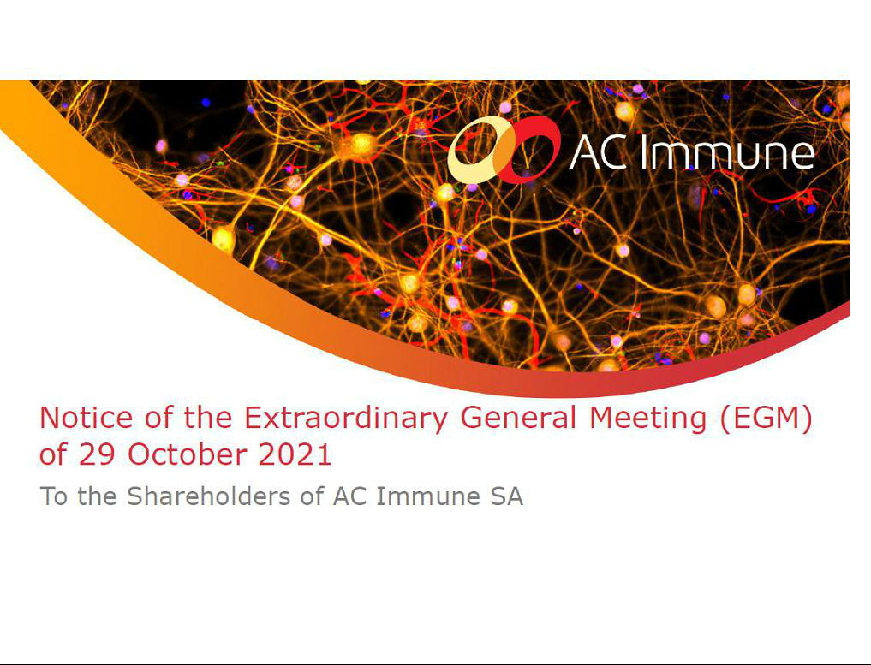

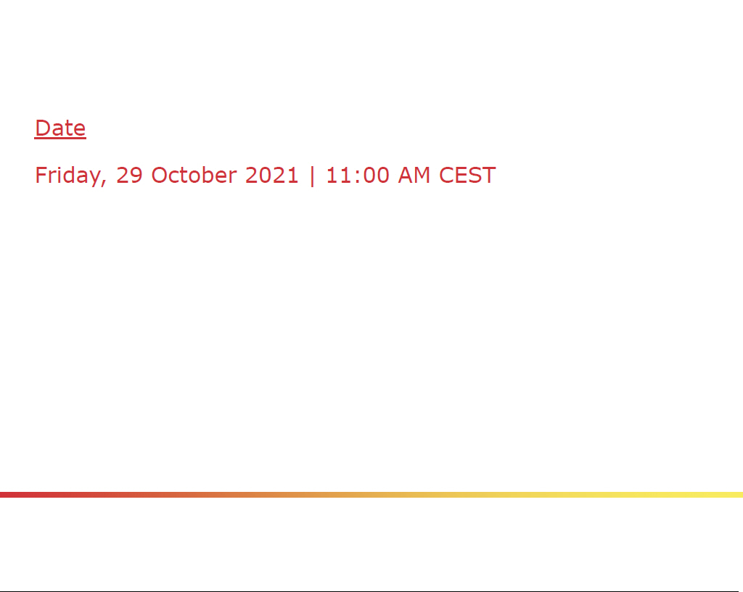

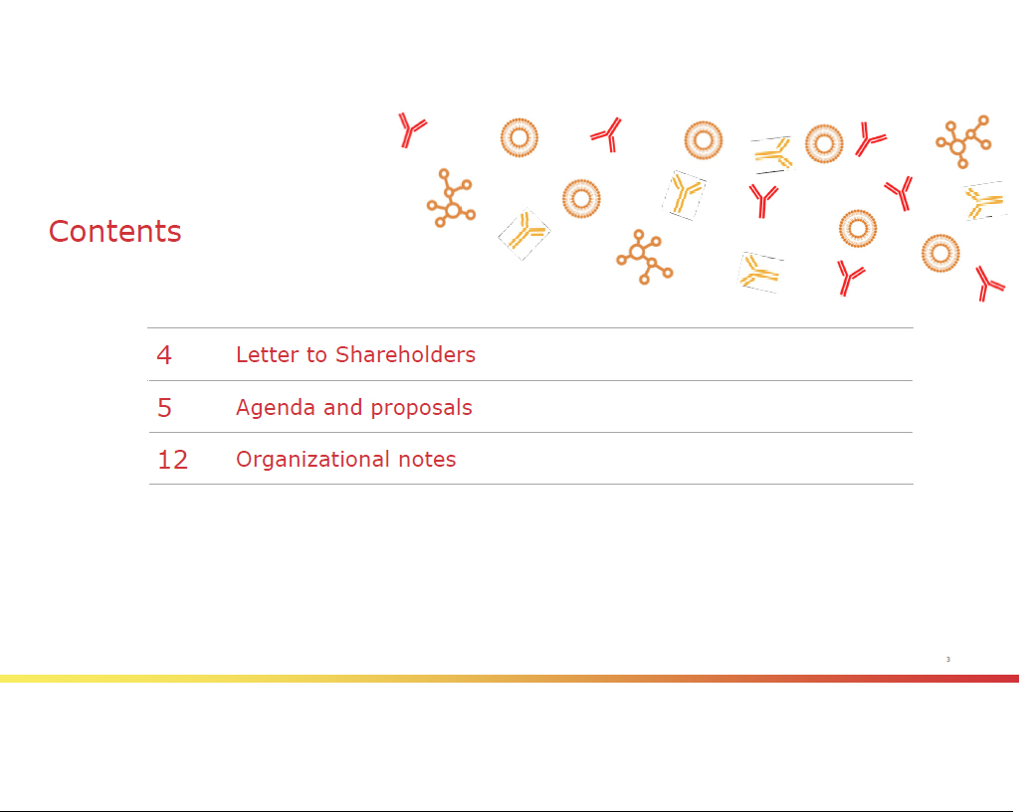

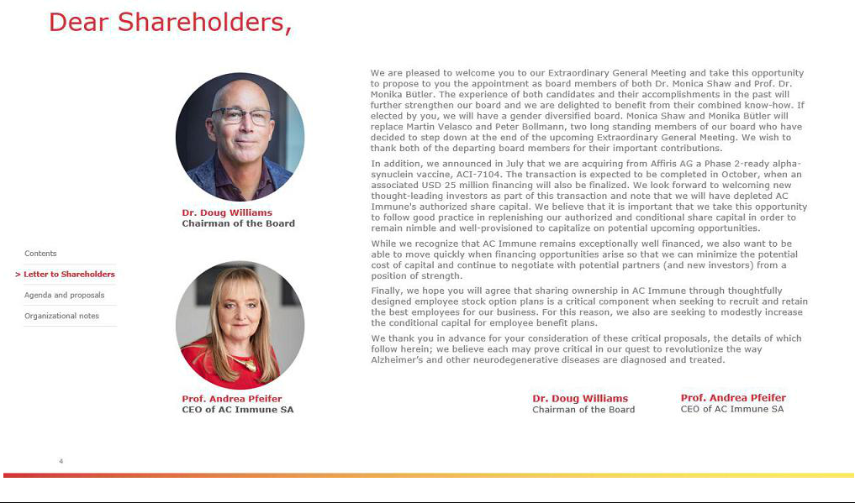



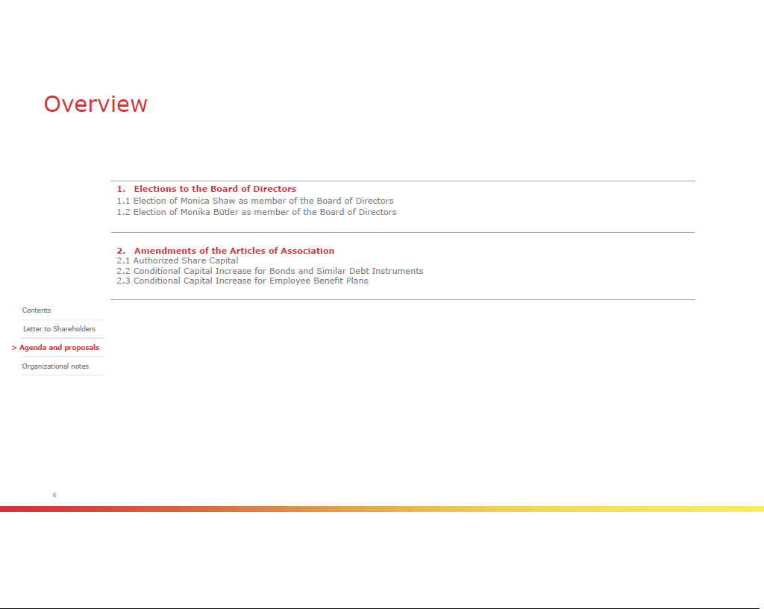

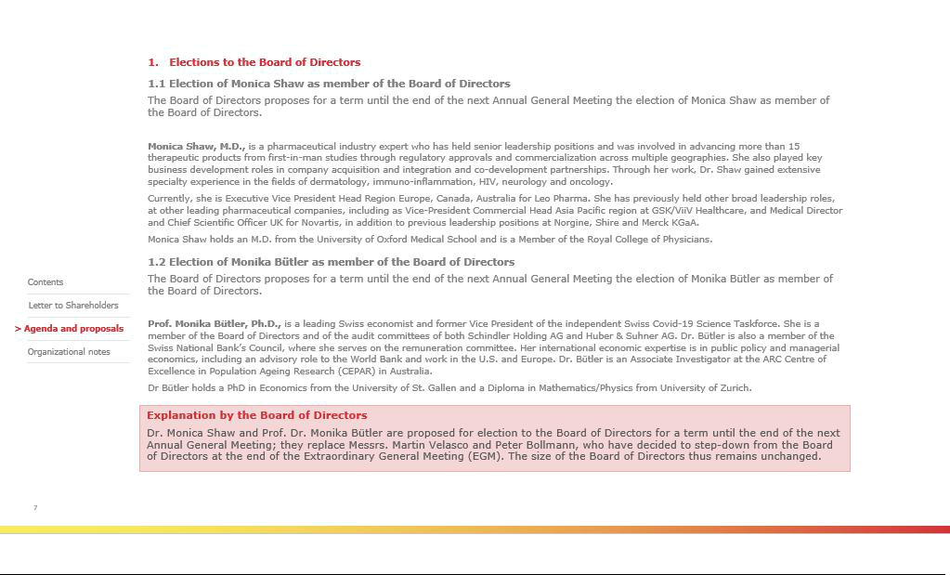

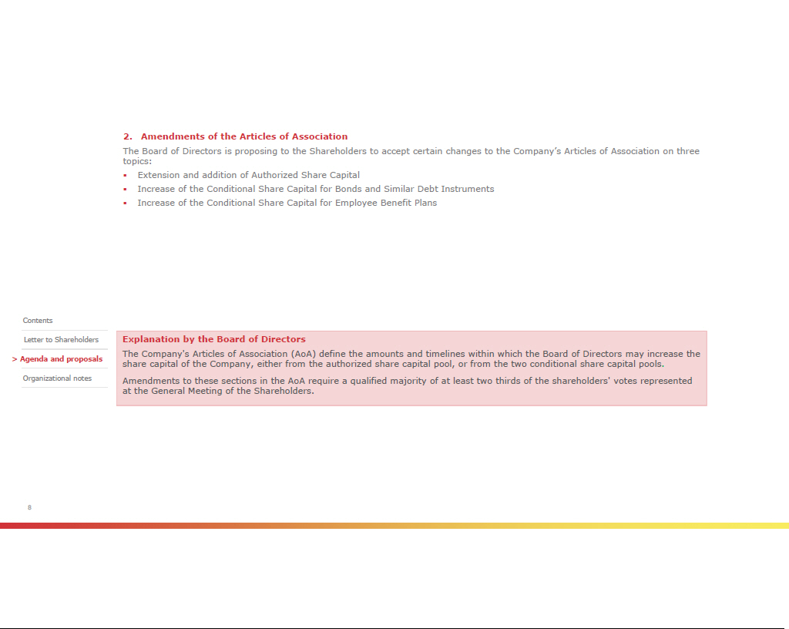

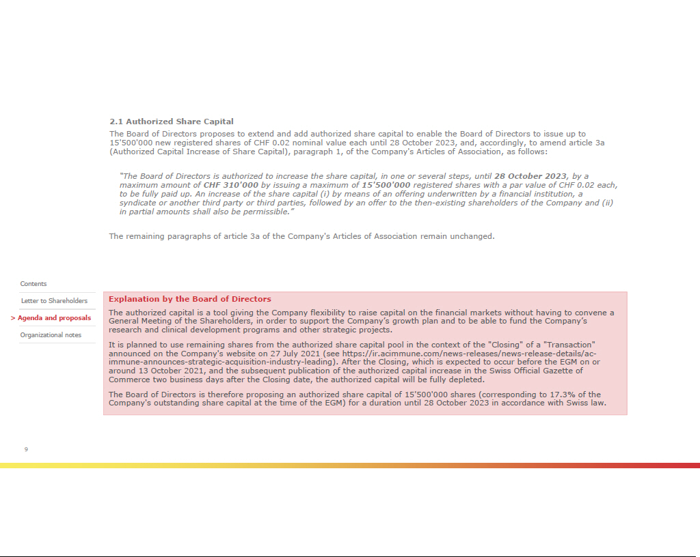

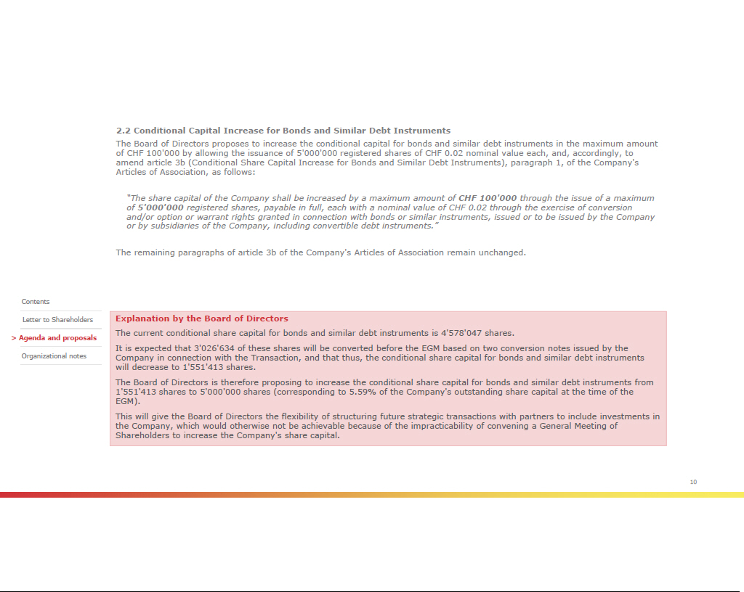

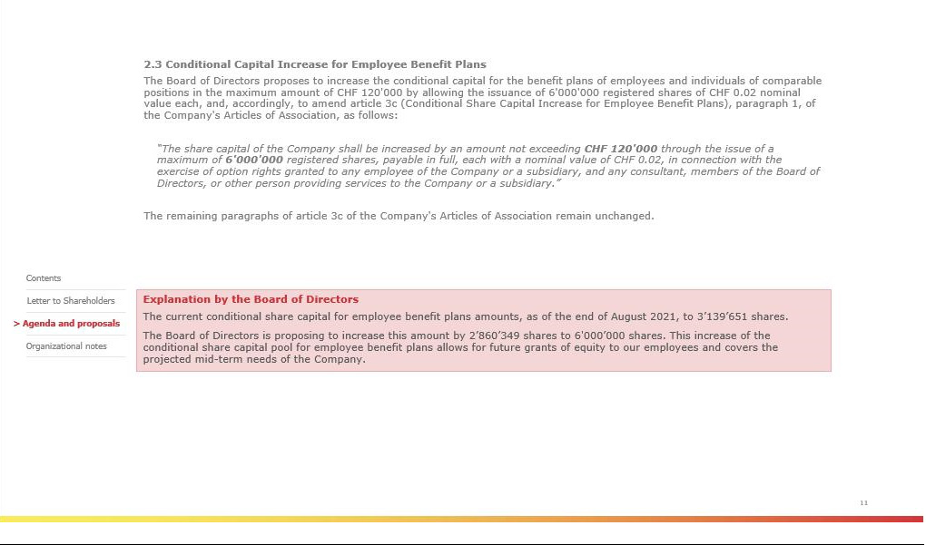

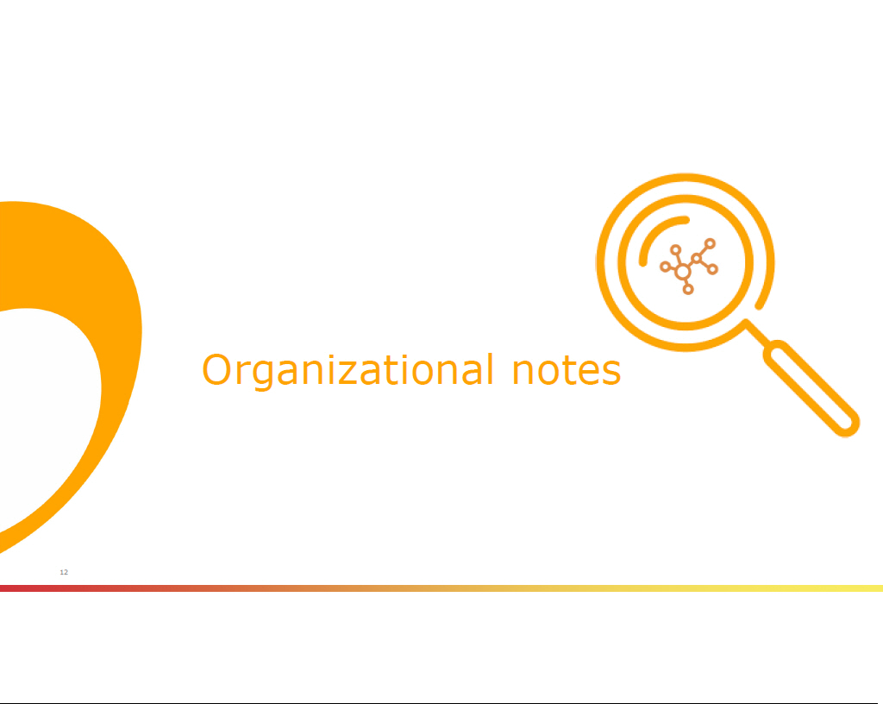

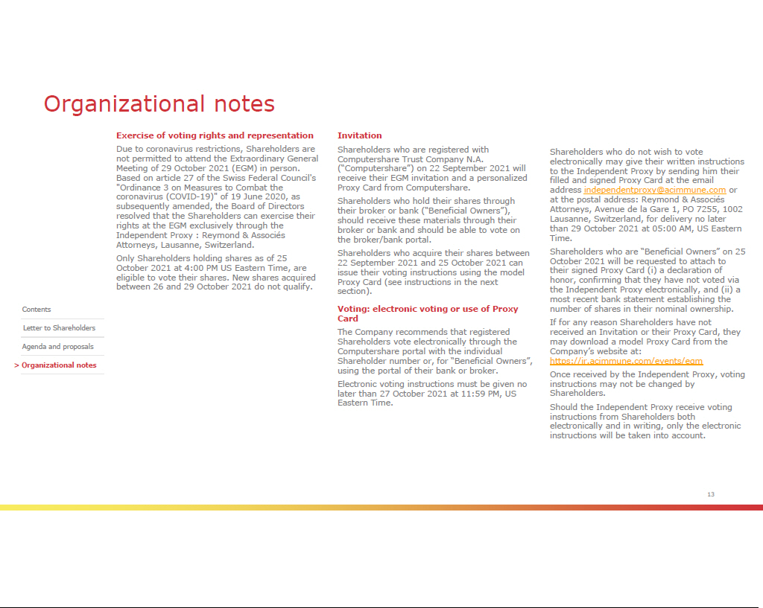

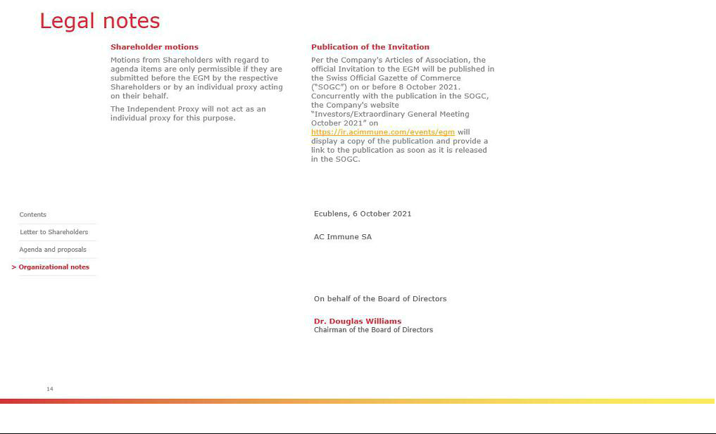



Exhibit 99.2


