UNITED STATES

SECURITIES AND EXCHANGE COMMISSION
Washington, D.C. 20549

FORM 6-K

REPORT OF FOREIGN PRIVATE ISSUER PURSUANT TO RULE 13a-16 OR 15d-16 UNDER THE SECURITIES EXCHANGE ACT OF 1934

For the month of December 2016

__________

Commission File Number: 001-37891

AC IMMUNE SA

(Exact name of registrant as specified in its charter)

EPFL Innovation Park

Building B

1015 Lausanne, Switzerland

Address of principal executive office)

Indicate by check mark whether the registrant files or will file annual reports under cover of Form 20-F or Form 40-F:

Form 20-F X Form 40-F

Indicate by check mark if the registrant is submitting the Form 6-K in paper as permitted by Regulation S-T Rule 101(b)(1):

Yes No X

Indicate by check mark if the registrant is submitting the Form 6-K in paper as permitted by Regulation S-T Rule 101(b)(7):

Yes No X

Item 7.01 Regulation FD Disclosure.

AC Immune SA (“AC Immune”) has updated its investor presentation with recent data presented by its partner Genentech, a member of the Roche group, at the 9th Clinical Trials on Alzheimer’s Disease Conference (CTAD) in San Diego. The updated investor presentation and informational poster that summarizes the data are attached hereto as Exhibit 99.1 and 99.2, respectively. From time to time, AC Immune will use this updated presentation and the informational poster in conversations with investors, analysts and others.

Item 9.01 Financial Statements and Exhibits.

(d) Exhibits

Exhibit Number | Description
99.1 | AC Immune SA Investor Presentation
99.2 | Informational Poster

SIGNATURE

Pursuant to the requirements of the Securities Exchange Act of 1934, the registrant has duly caused this report to be signed on its behalf by the undersigned, thereunto duly authorized.

AC IMMUNE SA
By: | /s/ Andrea Pfeifer
 | Name: | Andrea Pfeifer
 | Title: | Chief Executive Officer
By: | /s/ Martin Velasco
 | Name: | Martin Velasco
 | Title: | Chairman
Date: December 15, 2016

 | EXHIBIT INDEX
Exhibit Number | Description
99.1 | AC Immune SA Investor Presentation
99.2 | Informational Poster

Exhibit 99.1
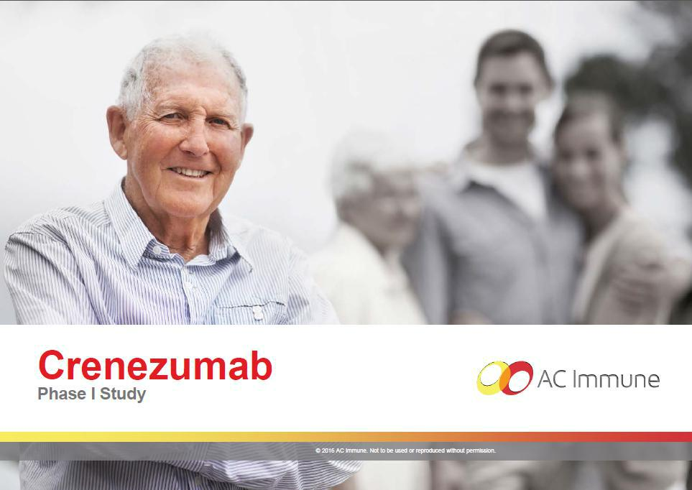

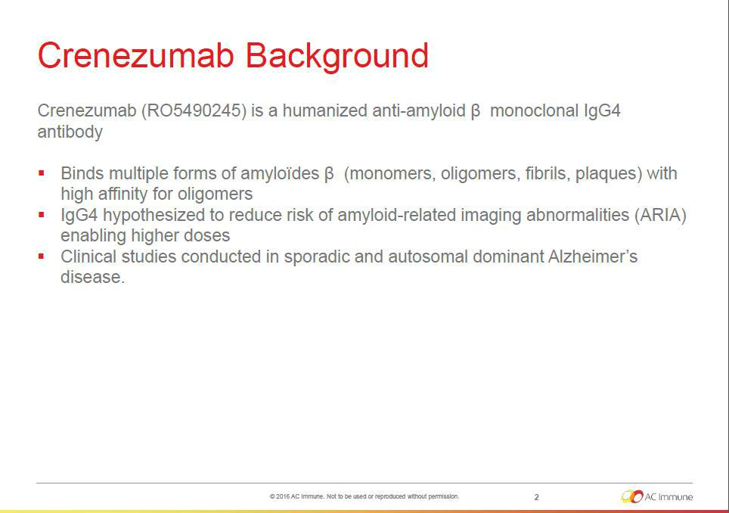

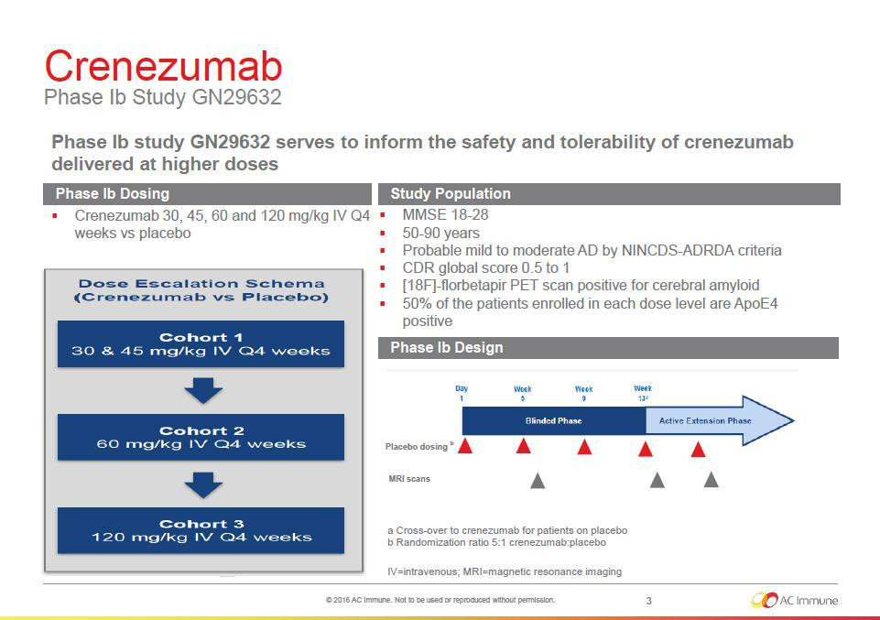

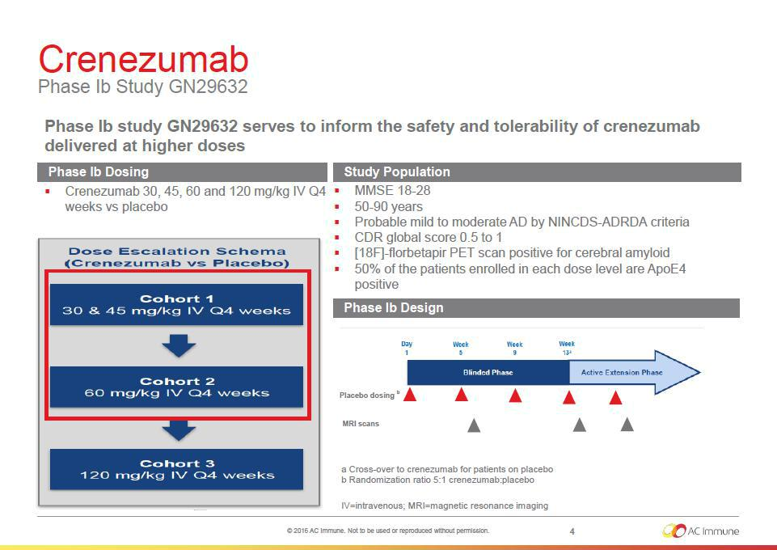

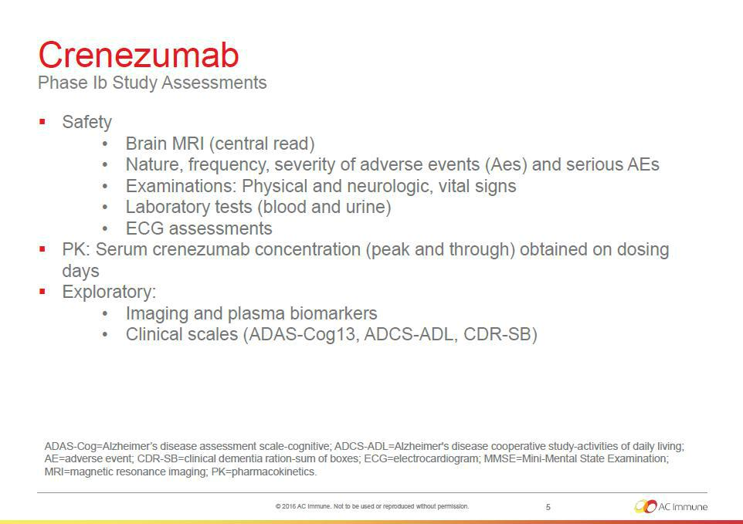

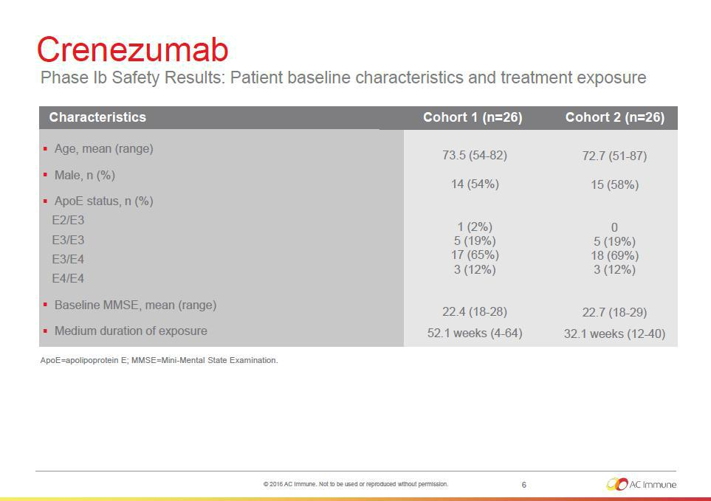

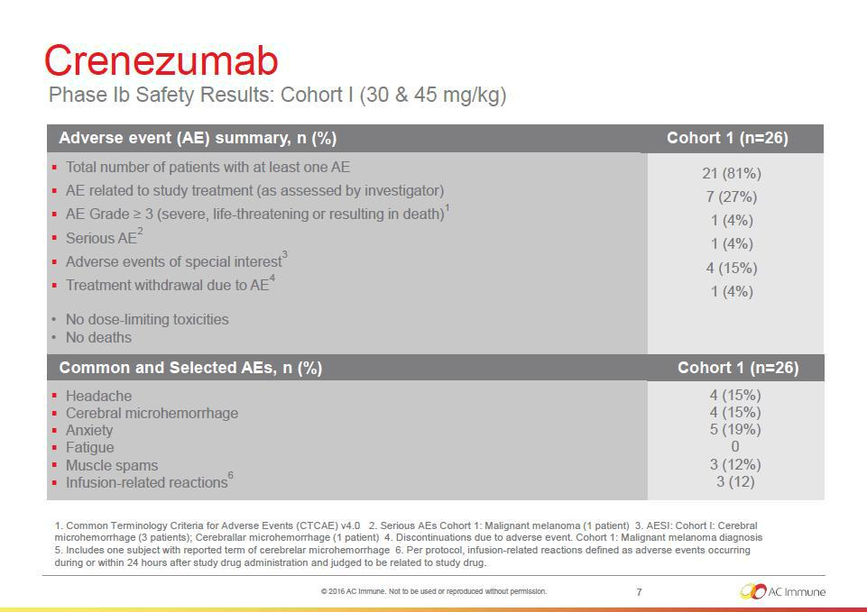

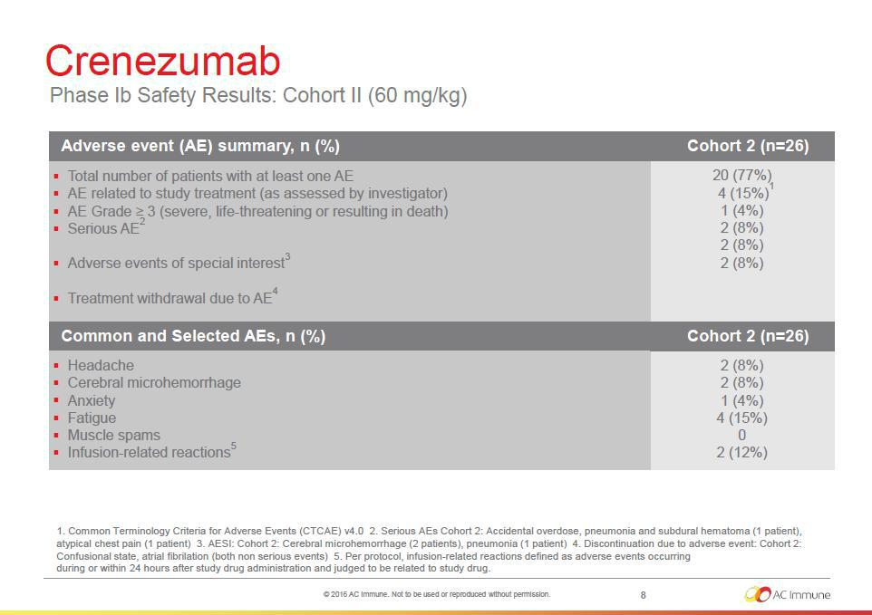

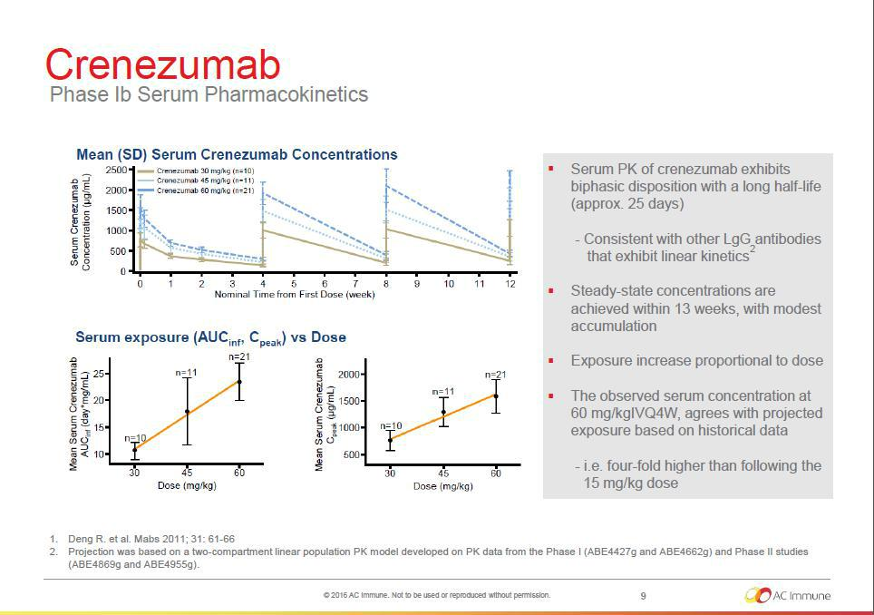

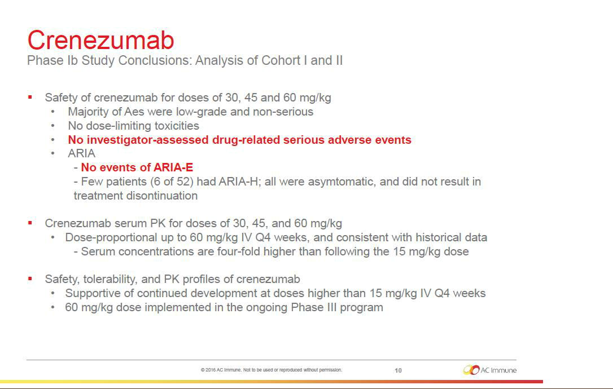

Exhibit 99.2

Crenezumab exposure-response across AD endpoints supports a higher dose for Phase 3

Dan Polhamus PhD¹, James Rogers PhD², Robert Paul MD², Smita Kshirsagar PhD², Srikumar Sahasranaman PhD², Jin Y Jin PhD², Angelica L Quartino PhD²
- Metrum Research Group, Tariffville, CT. USA

- Genentech, Inc., San Francisco, CA. USA


