UNITED STATES

SECURITIES AND EXCHANGE COMMISSION

Washington, D.C. 20549

FORM 6-K

REPORT OF FOREIGN PRIVATE ISSUER PURSUANT TO RULE 13a-16 OR 15d-16 UNDER THE SECURITIES EXCHANGE ACT OF 1934

For the month of May, 2023

Commission File Number: 001-37891

AC IMMUNE SA

(Exact name of registrant as specified in its charter)

EPFL Innovation Park

Building B

1015 Lausanne, Switzerland

(Address of principal executive office)

Indicate by check mark whether the registrant files or will file annual reports under cover of Form 20-F or Form 40-F:

Form 20-F ☒ Form 40-F ☐

SIGNATURE

Pursuant to the requirements of the Securities Exchange Act of 1934, the registrant has duly caused this report to be signed on its behalf by the undersigned, thereunto duly authorized.

AC IMMUNE SA

By: | /s/ Andrea Pfeifer
 | Name: | Andrea Pfeifer
 | Title: | Chief Executive Officer
By: | /s/ Christopher Roberts
 | Name: | Christopher Roberts
 | Title: | Vice President Finance and Interim Chief Financial Officer

Date: May 24, 2023

EXHIBIT INDEX

Exhibit Number Description

99.1*
99.2*
99.3

99.4

* Filed herewith.

Invitation to the Ordinary Shareholders’ Meeting

2023 Annual General Meeting Proxy Card

Consolidated Financial Statements (IFRS) as at and for the years ended December 31, 2022, 2021 and 2020 (incorporated by reference to Item 18 of Part III of AC Immune’s Annual Report on Form 20-F for the fiscal year ended December 31, 2022 filed on March 16, 2023)

2022 Annual Report (incorporated by reference to Exhibit 99.2 to the AC Immune Report of Foreign Private Issuer on Form 6-K filed on March 16, 2023)

Exhibit 99.1

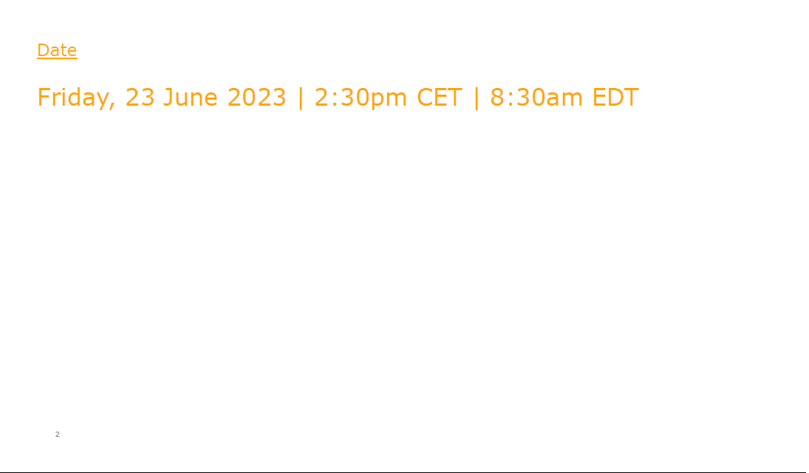

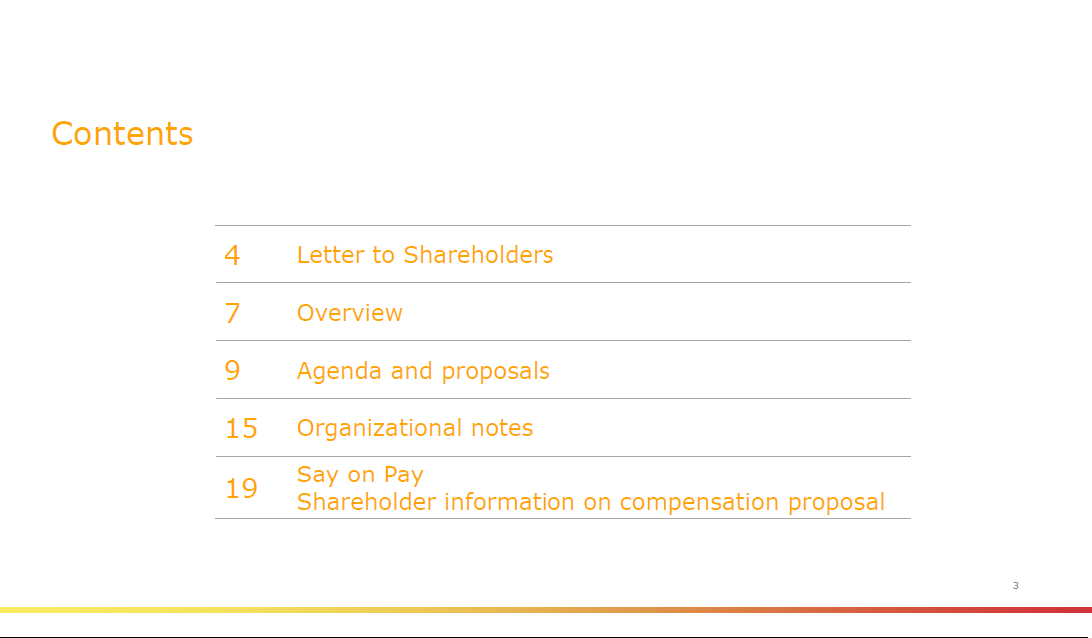

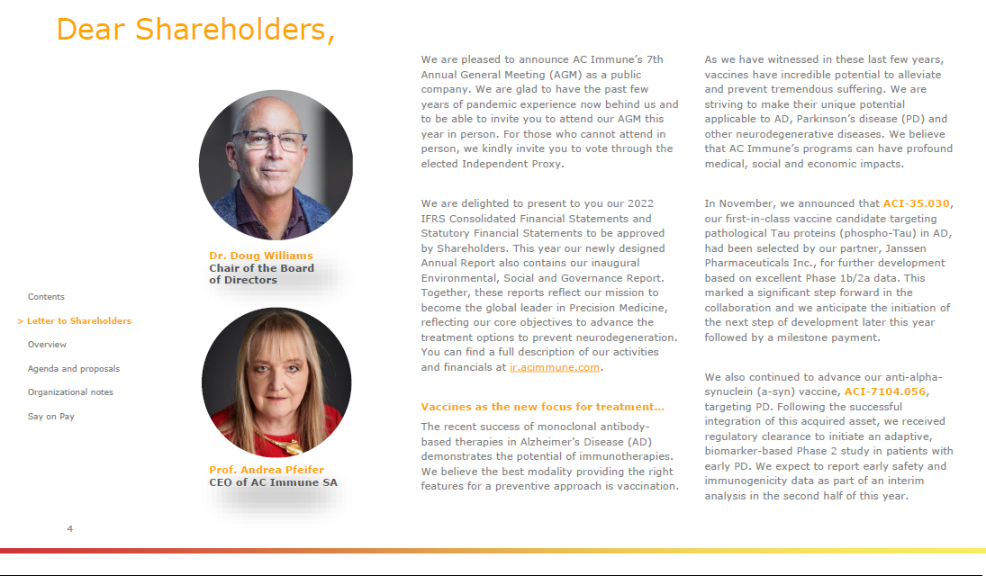

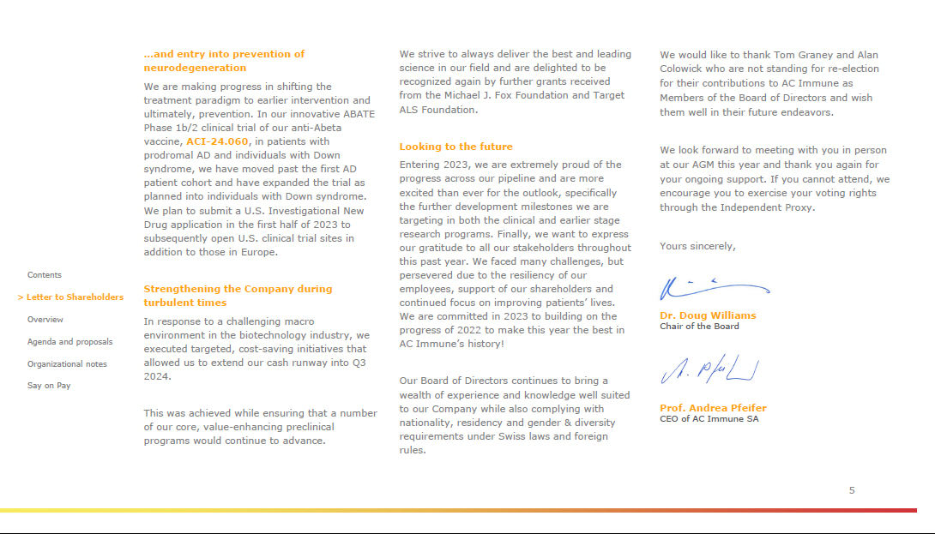



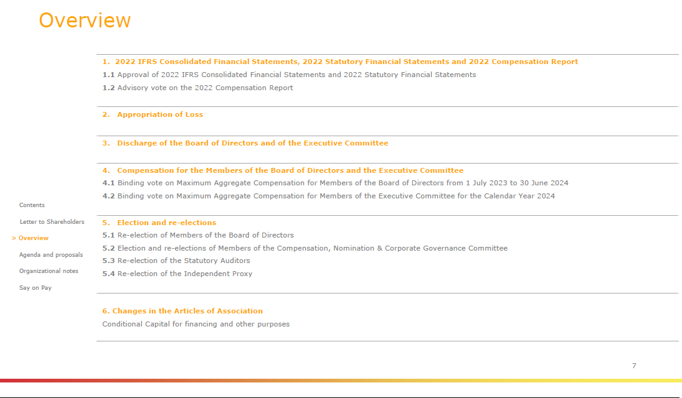





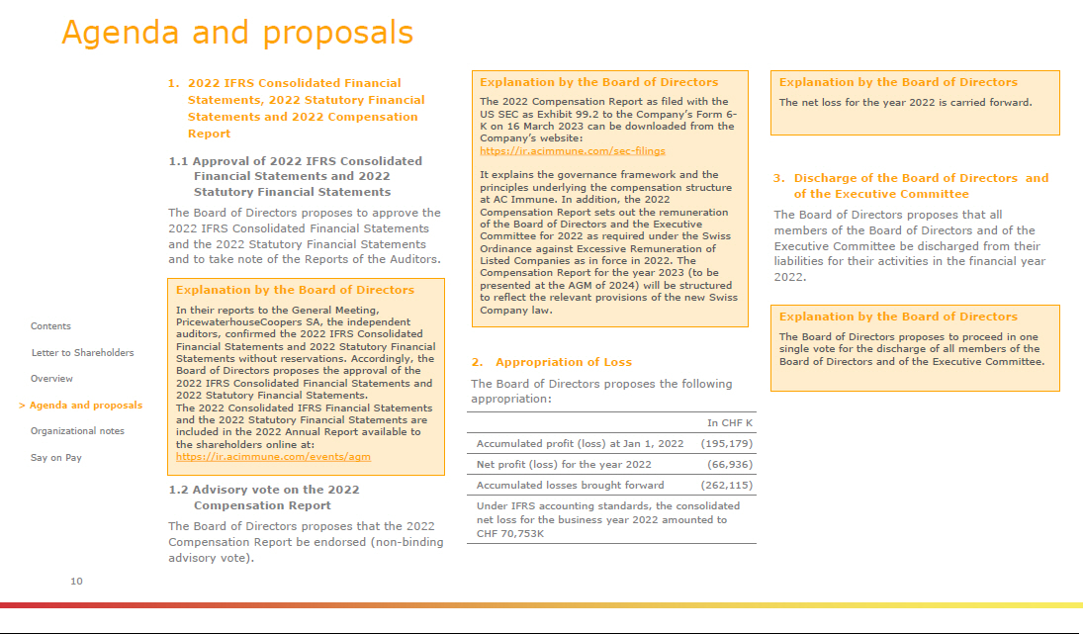

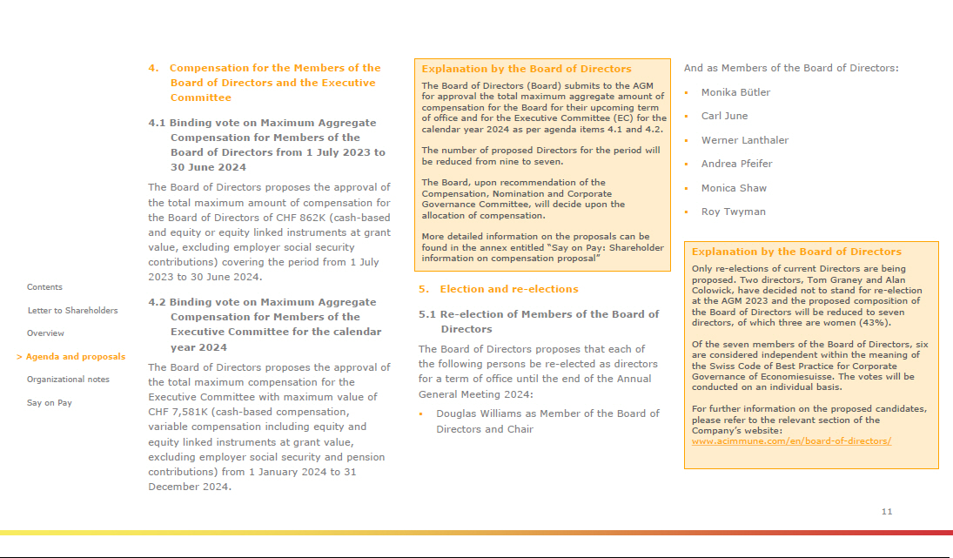

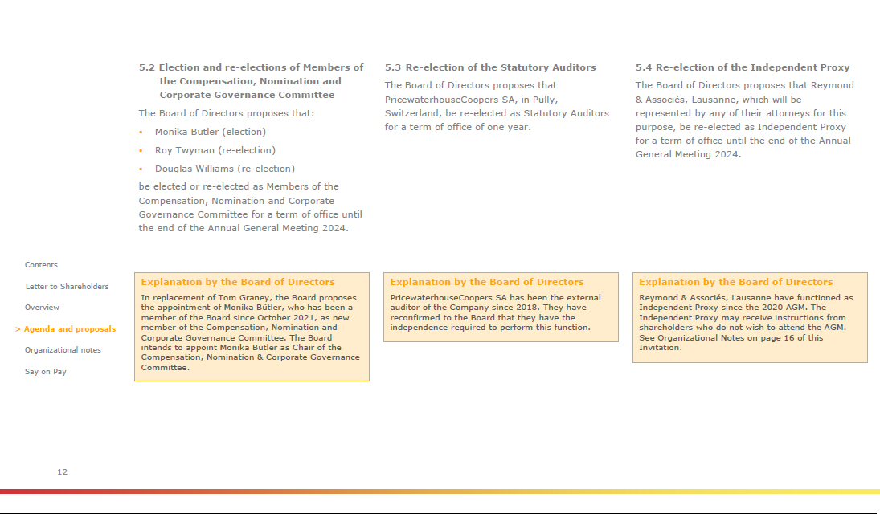

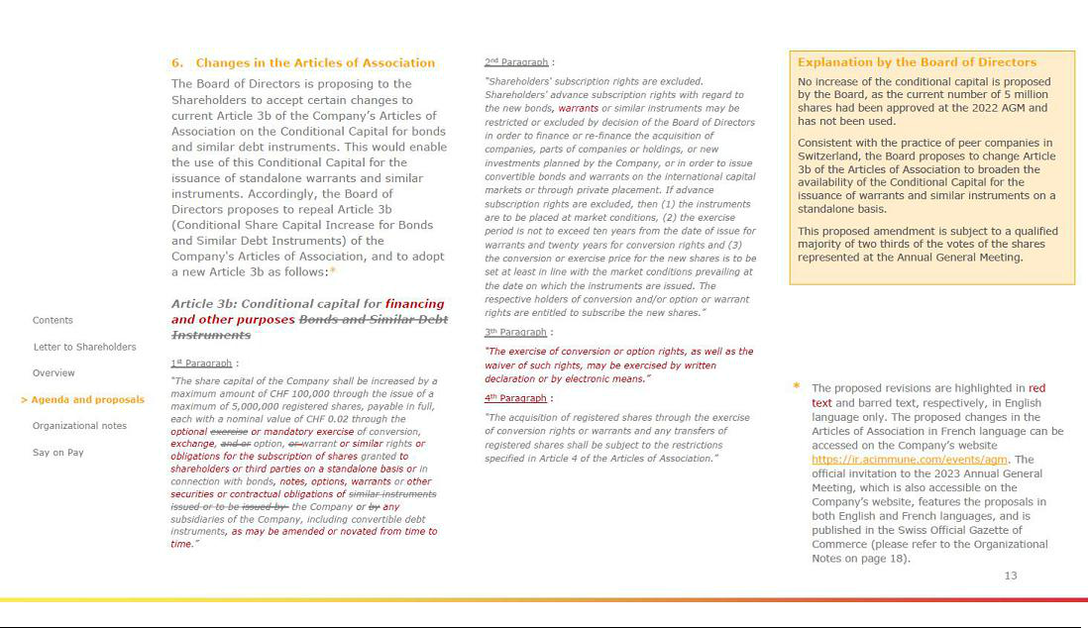

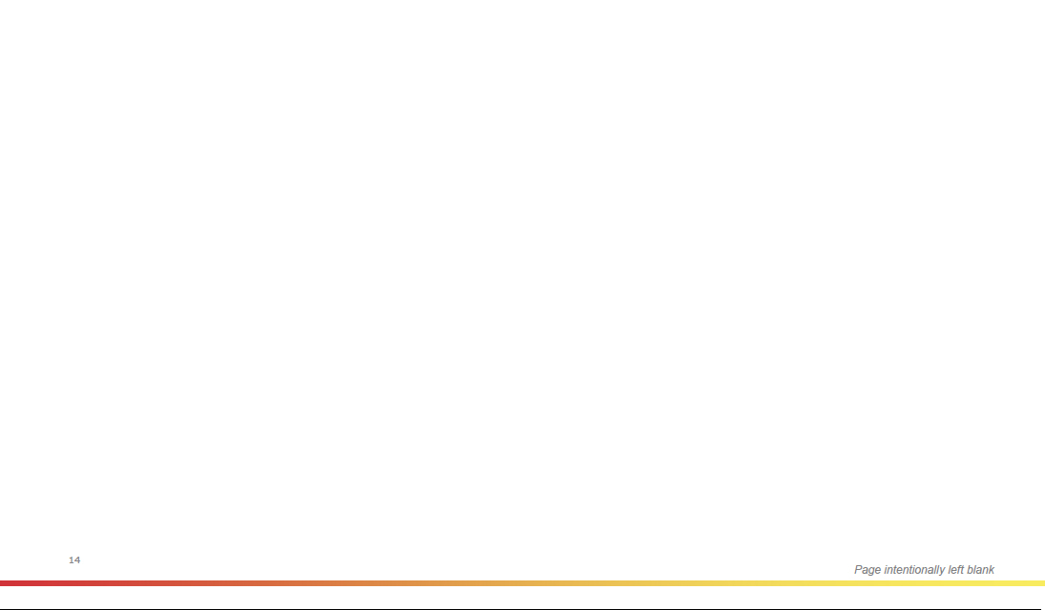



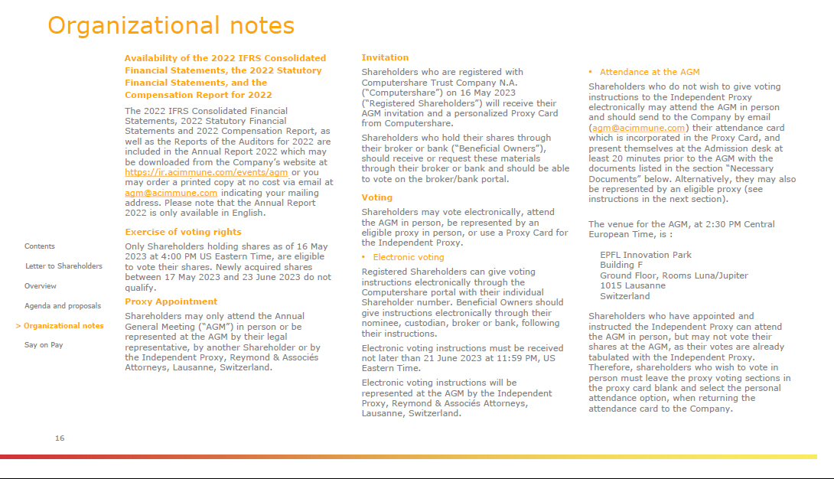

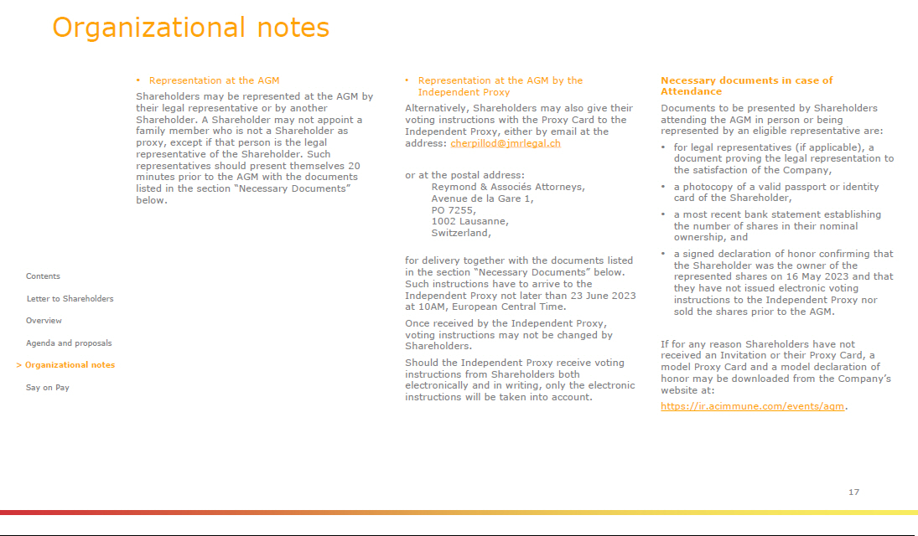

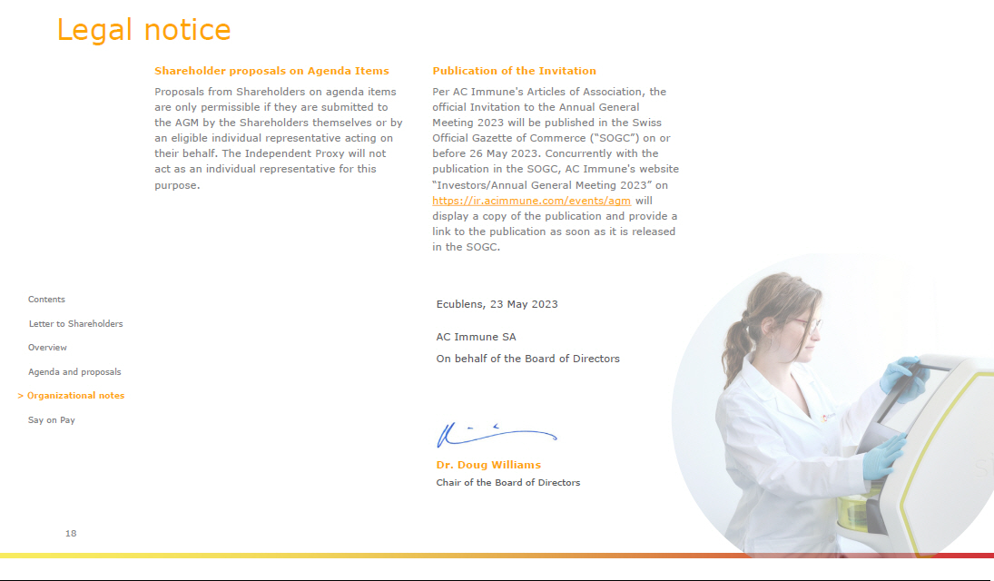



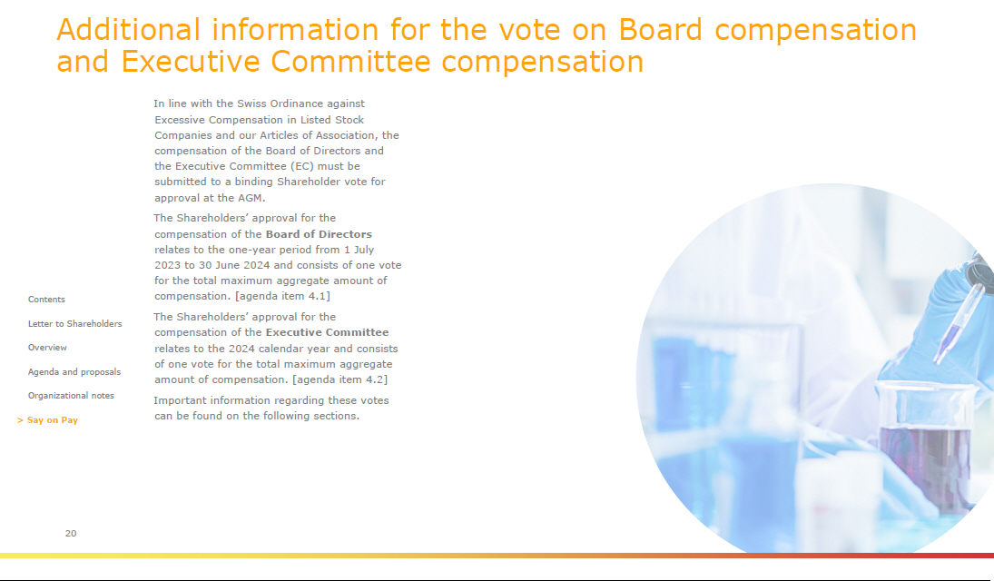

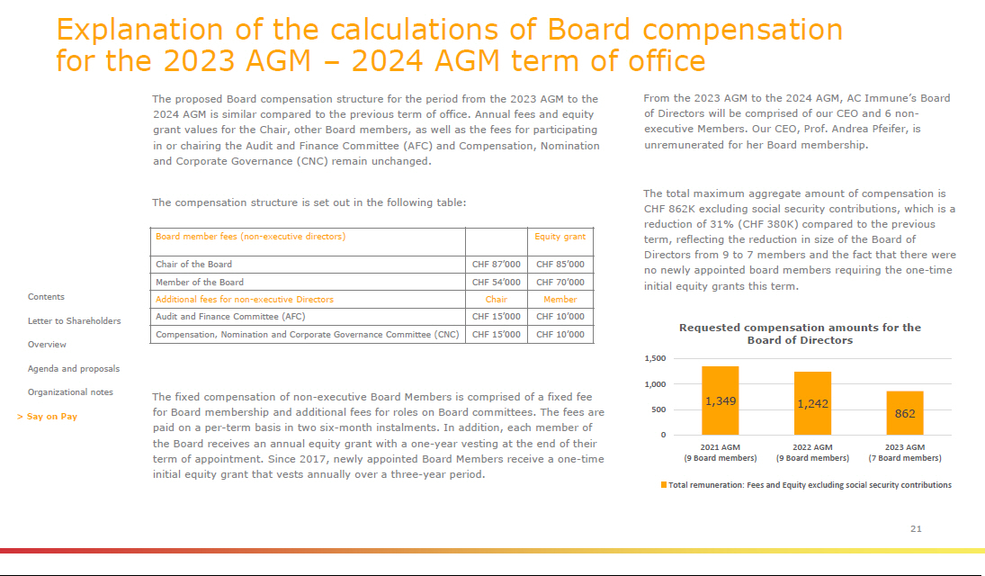

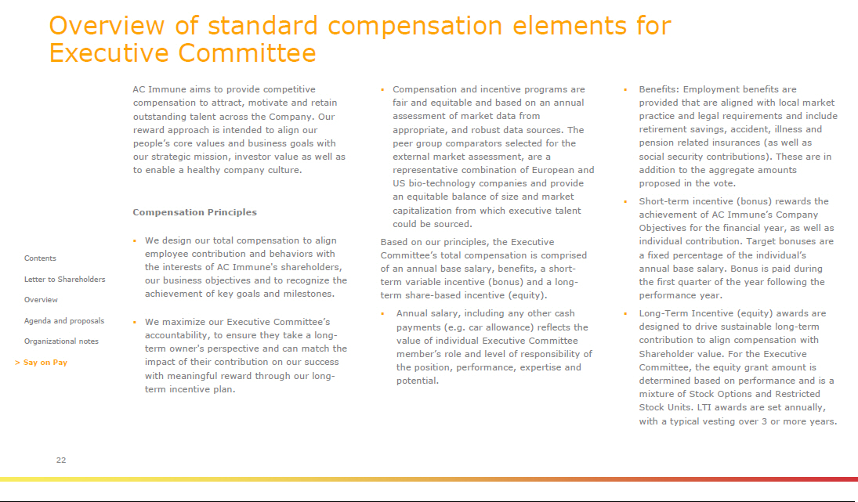

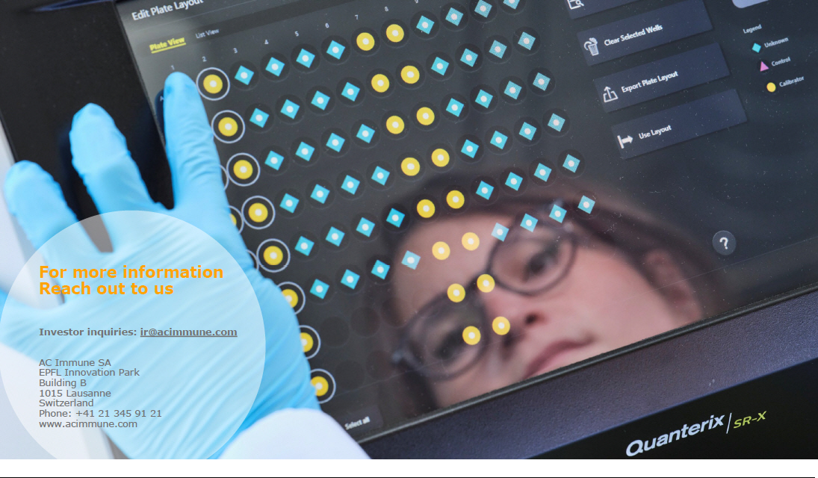

Exhibit 99.2


