UNITED STATES

SECURITIES AND EXCHANGE COMMISSION

Washington, D.C. 20549

FORM 6-K

REPORT OF FOREIGN PRIVATE ISSUER PURSUANT TO RULE 13a-16 OR 15d-16 UNDER THE SECURITIES EXCHANGE ACT OF 1934

For the month of September, 2020

Commission File Number: 001-37891

AC IMMUNE SA

(Exact name of registrant as specified in its charter)

EPFL Innovation Park

Building B
1015 Lausanne, Switzerland
(Address of principal executive office)

Indicate by check mark whether the registrant files or will file annual reports under cover of Form 20-F or Form 40-F:

Form 20-F ☒ Form 40-F ☐

Indicate by check mark if the registrant is submitting the Form 6-K in paper as permitted by Regulation S-T Rule 101(b)(1):

Yes ☐ No ☒

Indicate by check mark if the registrant is submitting the Form 6-K in paper as permitted by Regulation S-T Rule 101(b)(7):

Yes ☐ No ☒

SIGNATURE

Pursuant to the requirements of the Securities Exchange Act of 1934, the registrant has duly caused this report to be signed on its behalf by the undersigned, thereunto duly authorized.

AC IMMUNE SA

By: /s/ Andrea Pfeifer

Name: Andrea Pfeifer

Title: Chief Executive Officer

By: /s/ Joerg Hornstein

Name: Joerg Hornstein

Title: Chief Financial Officer

Date: September 23, 2020

EXHIBIT INDEX

Exhibit

Number Description

99.1 Press Release dated September 23, 2020

Exhibit 99.1

PRESS RELEASE

AC Immune Reports Top Line Results from TAURIEL Phase 2 Trial Evaluating Semorinemab in Early Alzheimer’s Disease

Genentech disclosed that the anti-Tau antibody did not meet the co-primary efficacy endpoint or two secondary endpoints in the TAURIEL study; the primary safety endpoint was met

Multiple other clinical stage programs progressing as planned

Investigational new drug (IND) enabling studies ongoing for first-in-class therapeutic candidates targeting TDP-43 and alpha-synuclein

Discovery on novel neuroinflammation target NLRP3-ASC inflammasome, including antibody and small molecule MorphomerTM inhibitors, advancing

AC Immune remains in a strong financial position with operations fully financed through Q1 2024

Lausanne, Switzerland, September 23, 2020 – AC Immune SA (NASDAQ: ACIU), a Swiss-based, clinical-stage biopharmaceutical company with a broad pipeline focused on neurodegenerative diseases, today announced that Genentech, a member of the Roche Group, has informed the Company of top line results from a Phase 2 trial of the anti-Tau antibody, semorinemab, in early (prodromal to mild) Alzheimer’s disease (AD) which show that semorinemab did not meet its primary efficacy endpoint of reducing decline on Clinical Dementia Rating-Sum of Boxes (CDR-SB) compared to placebo. Two secondary endpoints, Alzheimer’s Disease Assessment Scale-Cognitive Subscale 13 (ADAS-Cog13) and Alzheimer’s Disease Cooperative Study Group – Activities of Daily Living Inventory (ADCS-ADL) were also not met.

Additional data analyses are ongoing and Genentech plans to present the results from TAURIEL at an upcoming medical congress. The second Phase 2 (LAURIET) study of semorinemab in patients with moderate AD remains ongoing.

Prof. Andrea Pfeifer, CEO of AC Immune SA, commented: “Today’s news is surprising and disappointing, given what we as a field know about Tau and its strong spatiotemporal correlation with both symptoms and pathology in AD. We believe the full data analysis of this first-of-its-kind study will yield information about this promising target that will advance our understanding and inform future efforts to successfully develop effective therapeutics for neurodegenerative diseases (NDD). We would like to thank the patients, caregivers and investigators who participated in this important, ground-breaking trial and look forward to the final results from our partner, Genentech.”

Prof. Pfeifer continued, “Our proprietary technology platforms and proven business model of discovery, early development and partnering high-risk therapeutic candidates for AD have successfully generated CHF 334 million in non-dilutive funding and enabled us to accelerate clinical development of our product candidates in collaboration with world-leading partners. This strategy enables us to focus our resources on advancing the next generation of first-in-class or best-in-class assets. With current funding through Q1 2024, this robust risk-and-financial-sharing strategy will continue unaffected as we work diligently to mature our proprietary candidates and generate substantial future value for the Company.”

1 / 5

“One of AC Immune’s key strengths is our diversified approach and our broad pipeline of assets, fueled by our remarkably efficient SupraAntigen™ and Morphomer™ platforms and staff. This is evidenced by our novel therapeutic candidates targeting TDP-43 and alpha-synuclein, which have advanced rapidly from discovery into IND-enabling studies. Furthermore, we are particularly pleased with progress in our recently disclosed discovery program targeting the NLRP3-ASC inflammasome,” Prof. Pfeifer added.

Both TDP-43 and alpha-synuclein are major pathologies in NDD and are increasingly thought to be important co-pathologies in AD. AC Immune’s programs directed towards these targets are the most advanced and comprehensive in the field. AC Immune’s alpha-synuclein positron emission tomography (PET) tracer program for Parkinson’s disease (PD) diagnostics was recently recognized by the Michael J. Fox Foundation (MJFF) award. Activation of the NLRP3-ASC inflammasome leads to chronic and uncontrolled inflammation, which is understood to drive a number of neurodegenerative and inflammatory diseases. AC Immune’s approach has high potential for effective therapies, in NDD and non-NDD as mono- and/or combination therapy.

Broad Pipeline and Upcoming Milestones in 2020

AC Immune’s additional anti-Tau clinical assets are outlined below as well as additional milestone tables from the broader pipeline.

- ACI-35.030 (anti-Tau vaccine): ACI-35.030 is the first anti-phospho-Tau (pTau) vaccine to reach Phase 2 clinical development. The vaccine generates a polyclonal antibody response that targets epitopes that differ from the epitope targeted by the monoclonal semorinemab. Importantly, these epitopes include an epitope specific to pTau, which is the pathological form of Tau protein responsible for the formation of tangles in AD. Additionally, the antibodies generated by this active immunization approach have pharmacokinetic properties that differ from those of injected semorinemab

- ACI-3024 (anti-Tau inhibitor): ACI-3024 is a first-in-class small molecule that passes through cell membranes to allow for the inhibition of intracellular Tau aggregates, which is not easily achieved with a large antibody like semorinemab. Phase 1 results in healthy volunteers and data disclosure are expected by Eli Lilly and Company in 2020

- Tau- PET tracer: AC Immune’s Tau-PET tracer has the potential to work as a critical tool in the further development of anti-Tau approaches by facilitating the design of clinical trials that hit on two key aspects of AC Immune’s Roadmap to Successful Therapies for Neurodegenerative Diseases – treating earlier and targeting more homogeneous populations. PI-2620 is currently being evaluated in a longitudinal Phase 2 study in patients with AD and a Phase 1 study (test/retest) in patients with progressive supranuclear palsy (PSP).

2 / 5

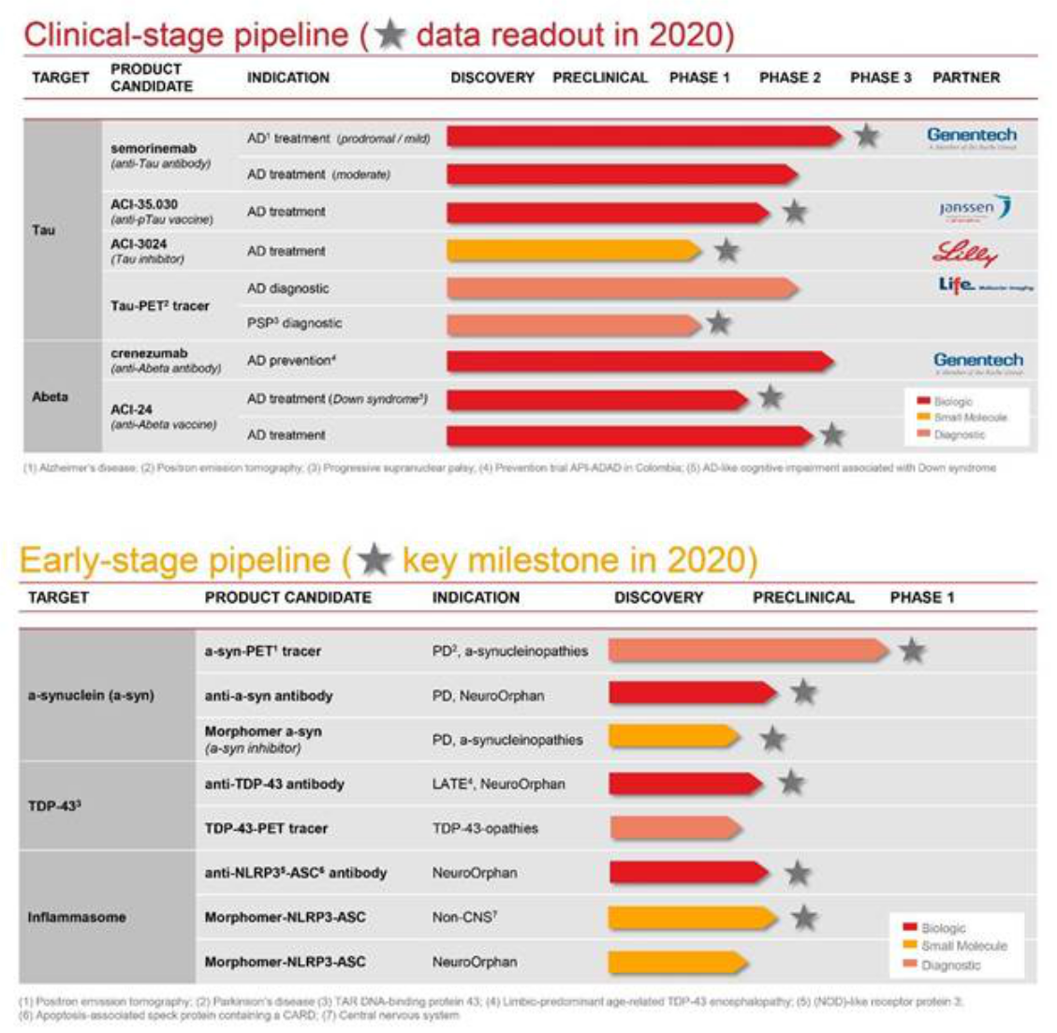

Details of the TAURIEL study

The Phase 2 TAURIEL study of semorinemab is a 73-week, double-blind, placebo-controlled trial to determine if it can slow the rate of clinical decline in early (prodromal to mild) AD. The study followed 457 participants across 97 study centers. The study did not meet the primary efficacy endpoint of reducing decline on Clinical Dementia Rating-Sum of Boxes (CDR-SB) compared to placebo, but did meet the primary safety endpoint. Overall, the incidence of adverse events was similar between semorinemab and placebo arms and further analysis of these safety data are currently underway. Two secondary endpoints, Alzheimer’s Disease Assessment Scale-Cognitive Subscale 13 (ADAS-Cog13) and Alzheimer’s Disease Cooperative Study Group – Activities of Daily Living Inventory (ADCS-ADL) also were not met. Analysis of additional data, including biomarkers such as Tau-PET, are ongoing and Genentech plans to present the results from the study at an upcoming medical congress. The second Phase 2 (LAURIET) study of semorinemab, in a different patient population, moderate AD, is ongoing.

3 / 5

About AC Immune SA

AC Immune SA is a Nasdaq-listed clinical-stage biopharmaceutical company, which aims to become a global leader in precision medicine for neurodegenerative diseases. The Company utilizes two proprietary platforms, SupraAntigenTM and MorphomerTM, to design, discover and develop small molecule and biological therapeutics as well as diagnostic products intended to diagnose, prevent, and modify neurodegenerative diseases caused by misfolding proteins. The Company's pipeline features nine therapeutic and three diagnostic product candidates, with six currently in clinical trials. It has collaborations with major pharmaceutical companies including Genentech, a member of the Roche Group, Eli Lilly and Company and Janssen Pharmaceuticals.

For further information, please contact:
Head of Investor Relations |  |  | US Media
Joshua Drumm, Ph.D. |  |  | Katie Gallagher
AC Immune |  |  | LaVoie Health Science
Phone: +1 917 809 0814 |  |  | Phone: +1 617 792 3937
Email: joshua.drumm@acimmune.com |  |  | Email: kgallagher@lavoiehealthscience.com

Global Head of Communications |  | European Investors & Media
Judith Moore |  | Chris Maggos
AC Immune |  | LifeSci Advisors
Phone: +41 79 826 63 82 |  | Phone: +41 79 367 6254
Email: judith.moore@acimmune.com |  | Email: chris@lifesciadvisors.com

4 / 5

Forward looking statements

This press release contains statements that constitute “forward-looking statements” within the meaning of Section 27A of the Securities Act of 1933 and Section 21E of the Securities Exchange Act of 1934. Forward-looking statements are statements other than historical fact and may include statements that address future operating, financial or business performance or AC Immune’s strategies or expectations. In some cases, you can identify these statements by forward-looking words such as “may,” “might,” “will,” “should,” “expects,” “plans,” “anticipates,” “believes,” “estimates,” “predicts,” “projects,” “potential,” “outlook” or “continue,” and other comparable terminology. Forward-looking statements are based on management’s current expectations and beliefs and involve significant risks and uncertainties that could cause actual results, developments, and business decisions to differ materially from those contemplated by these statements. These risks and uncertainties include those described under the captions “Item 3. Key Information – Risk Factors” and “Item 5. Operating and Financial Review and Prospects” in AC Immune’s Annual Report on Form 20-F and other filings with the Securities and Exchange Commission. These include: the impact of Covid-19 on our business, suppliers, patients and employees and any other impact of Covid-19. Forward-looking statements speak only as of the date they are made, and AC Immune does not undertake any obligation to update them in light of new information, future developments or otherwise, except as may be required under applicable law. All forward-looking statements are qualified in their entirety by this cautionary statement.

5 / 5

