UNITED STATES

SECURITIES AND EXCHANGE COMMISSION

Washington, D.C. 20549

FORM 6-K

REPORT OF FOREIGN PRIVATE ISSUER PURSUANT TO RULE 13a-16 OR 15d-16 UNDER THE SECURITIES EXCHANGE ACT OF 1934

For the month of April, 2018

Commission File Number: 001-37891

AC IMMUNE SA

(Exact name of registrant as specified in its charter)

EPFL Innovation Park

Building B

1015 Lausanne, Switzerland

(Address of principal executive office)

Indicate by check mark whether the registrant files or will file annual reports under cover of Form 20-F or Form 40-F:

Form 20-F X Form 40-F

Indicate by check mark if the registrant is submitting the Form 6-K in paper as permitted by Regulation S-T Rule 101(b)(1):

Yes No X

Indicate by check mark if the registrant is submitting the Form 6-K in paper as permitted by Regulation S-T Rule 101(b)(7):

Yes No X

Extraordinary General Meeting Results

On April 27, 2018, AC Immune SA (“AC Immune”) held an Extraordinary General Meeting. The presentation that was given at the Extraordinary General Meeting is attached hereto as Exhibit 99.1. The final results of each of the agenda items submitted to a vote of the shareholders are as follows:

Agenda Item 1: Election of Member to the Board of Directors

AC Immune shareholders approved the election of Douglas Williams as a new member of the Board of Directors, until the end of the next ordinary General Meeting.

Agenda Item 2: Election to the Compensation, Nomination & Corporate Governance Committee

AC Immune shareholders approved the election of Douglas Williams as a new member of the Compensation, Nomination & Corporate Governance Committee, until the end of the next ordinary General Meeting.

Agenda Item 3: Compensation for the newly elected Member of the Board of Directors

AC Immune shareholders approved:

- An additional maximum amount of non-performance-related compensation for the new member of the Board of Directors covering the period from 27 April 2018 to 30 June 2018, i.e., CHF 11,800 (cash base compensation plus social security costs); and

- An additional maximum grant of equity or equity linked instruments for the new member of the Board of Directors from 27 April 2018 to 30 June 2018 with maximum value of CHF 76,000 (equity or equity linked instruments value plus social security costs).

Agenda Item 4: Share Capital Increase

AC Immune shareholders approved:

- An ordinary share capital increase for institutional investors as follows:

  - the share capital of the Company is increased by way of an ordinary increase by up to CHF 170,000 by issuing up to 8,500,000 registered shares with a nominal value of CHF 0.02 each;

  - the pre-emptive rights of the shareholders for the newly issued registered shares shall be preserved; the Board of Directors shall be entitled to publish the subscription price by electronic media including press release

and e-mail and to limit the subscription period to one business day; any new shares not subscribed shall be allocated by the Board of Directors at its discretion;

  - the technical issuance of price of the new shares to be paid in cash shall be determined by the Board of Directors;

  - the new shares are entitled to dividends for the business year starting 1 January 2018;

  - the new shares are subject to the transfer restrictions as outlined in article 4 of the Articles of Association;

  - the stamp duty shall be paid by the Company; and

  - the Board of Directors is authorized and instructed to implement and register this capital increase with the competent commercial register. B. An ordinary share capital increase for current shareholders at identical terms as offered in the preceding ordinary share capital increase as follows:
  - the share capital of the Company is increased by way of an ordinary increase of up to CHF 30,000 by issuing up to 1,500,000 registered shares with a nominal value of CHF 0.02 each;

  - the pre-emptive rights of the shareholders for the newly issued registered shares shall be preserved; the Board of Directors shall credit each shareholder with a corresponding number of non-tradable subscription rights with identical terms as offered to institution investors in the ordinary share capital increase resolution resolved today. Such subscription rights may be exercised during a subscription period of at least six business days; any new shares not subscribed shall be allocated by the Board of Directors at its discretion in first priority to current shareholders;

  - the technical issuance price of the new shares to be paid in cash shall be determined by the Board of Directors;

  - the new shares are entitled to dividends for the business year starting 1 January 2018;

  - the new shares are subject to the transfer restrictions as outlined in article 4 of the Articles of Association;

  - the stamp duty shall be paid by the Company; and

  - the Board of Directors is authorized and instructed to implement and register this capital increase with the competent commercial register.

SIGNATURE

Pursuant to the requirements of the Securities Exchange Act of 1934, the registrant has duly caused this report to be signed on its behalf by the undersigned, thereunto duly authorized.

AC IMMUNE SA
By: | /s/ Andrea Pfeifer
 | Name: | Andrea Pfeifer
 | Title: | Chief Executive Officer
By: | /s/ Joerg Hornstein
 | Name: | Joerg Hornstein
 | Title: | Chief Financial Officer

Date: April 27, 2018

 | EXHIBIT INDEX
Exhibit Number | Description
99.1 | Extraordinary General Meeting presentation
99.2 | AC Immune SA Articles of Association dated March 26, 2018

Exhibit 99.1


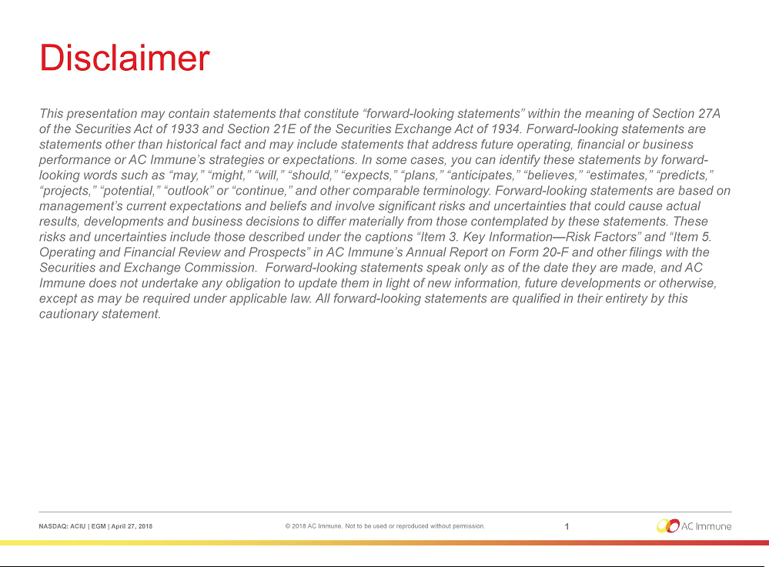

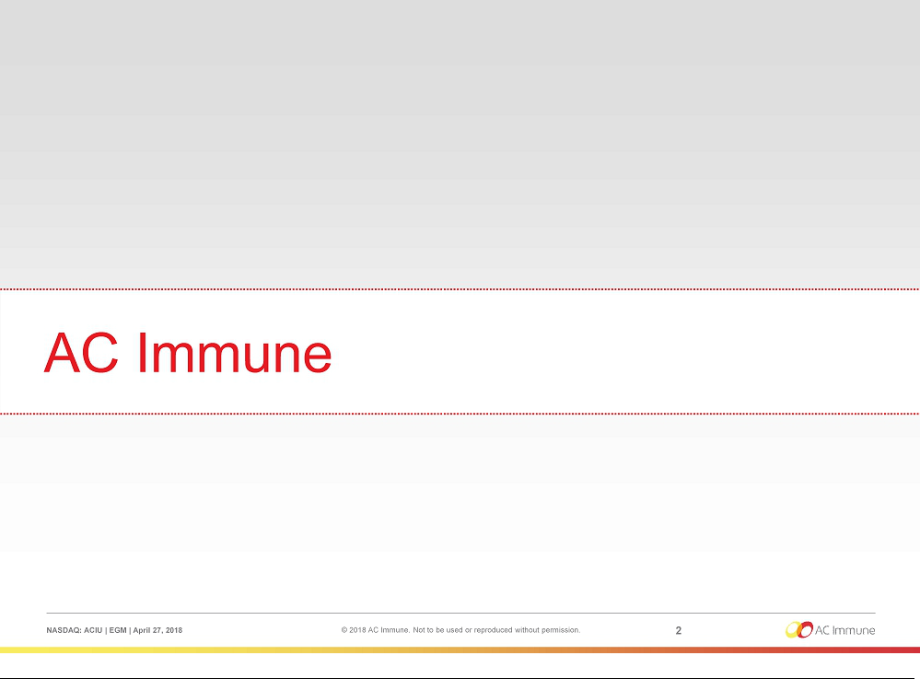

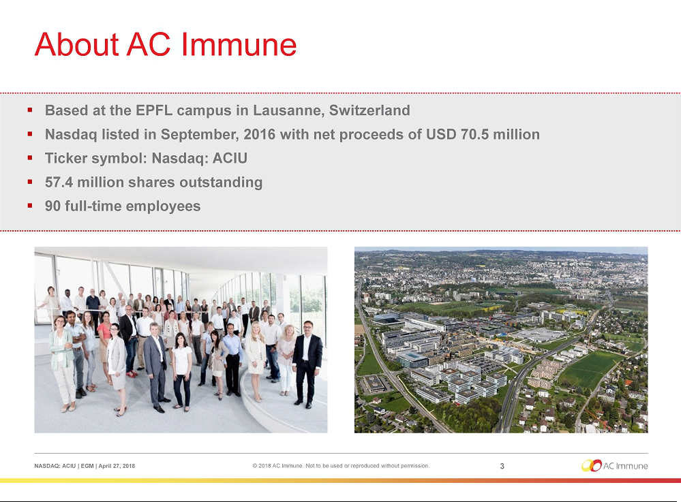

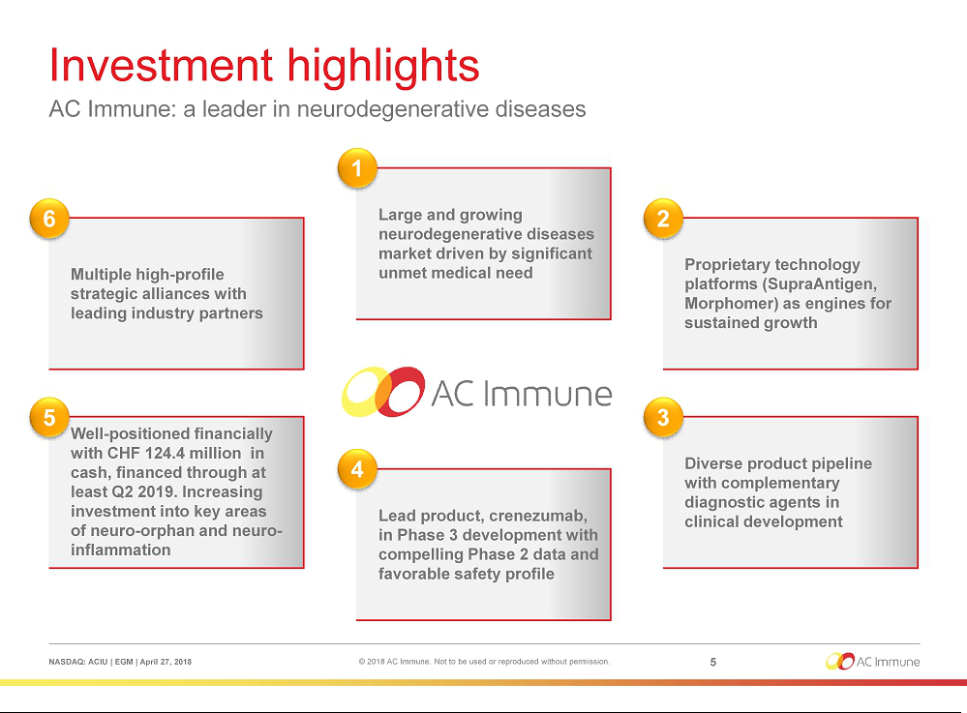

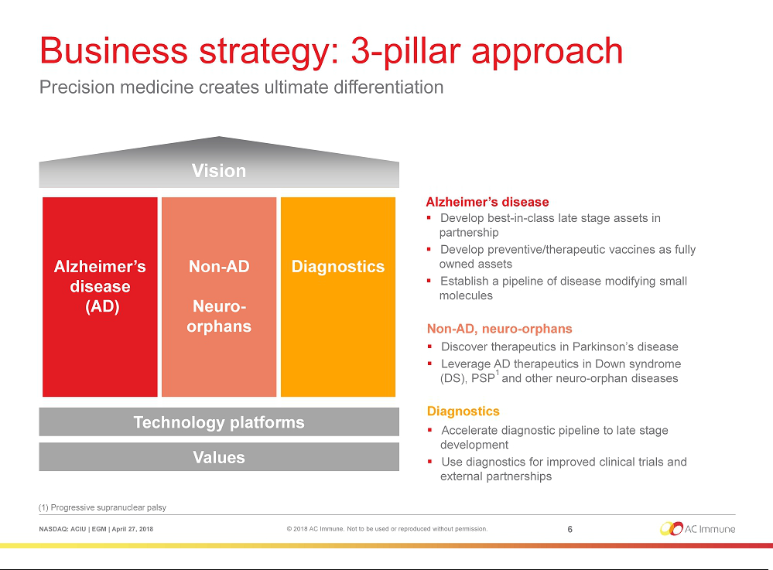

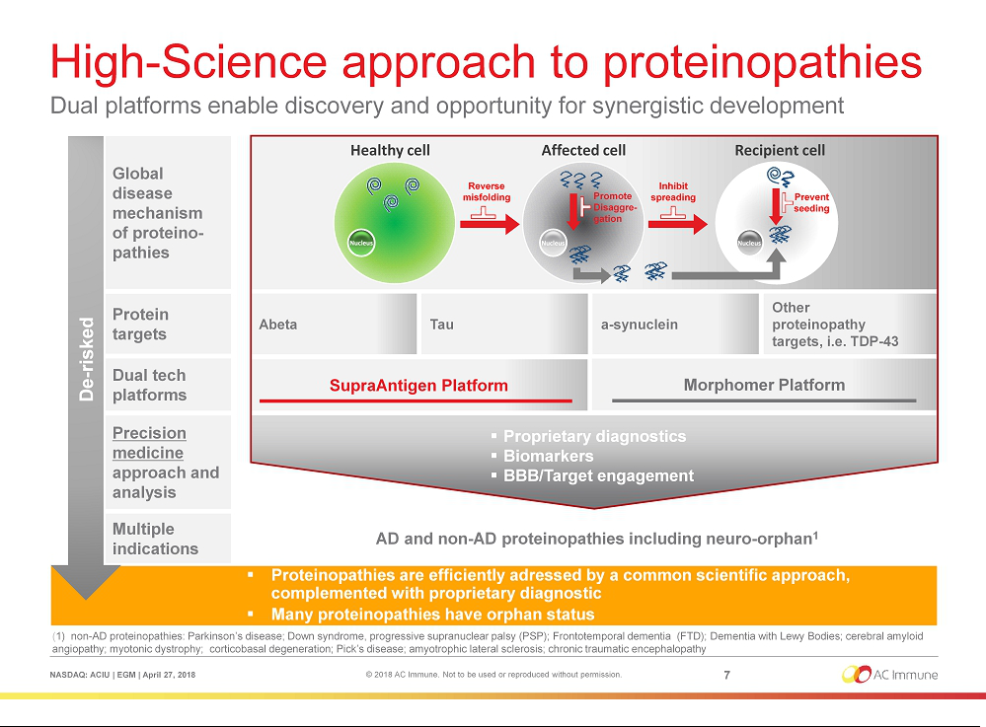

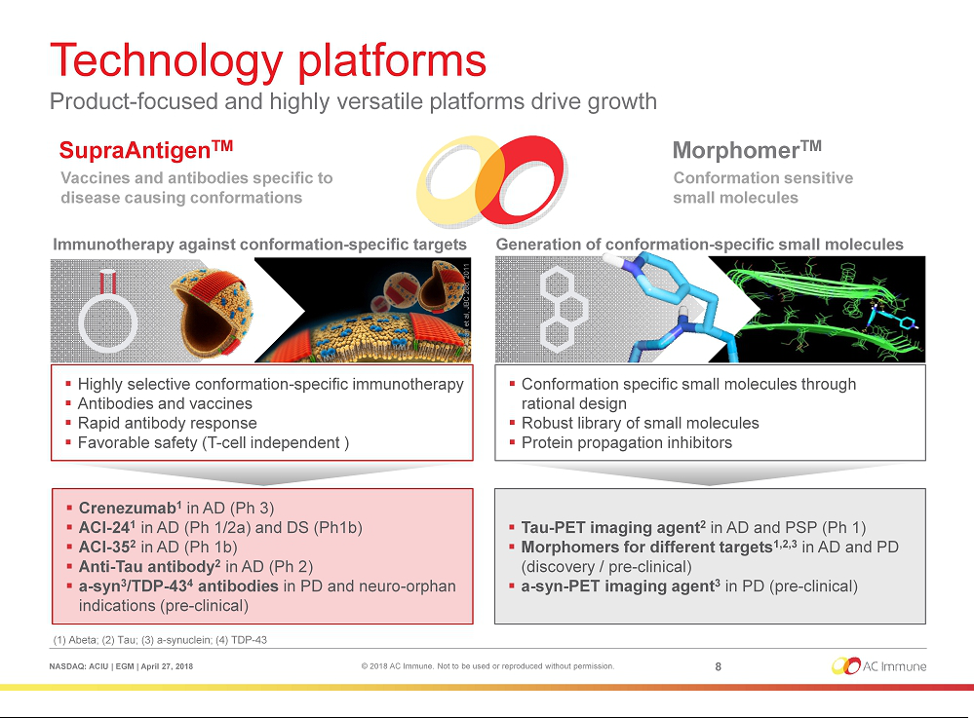

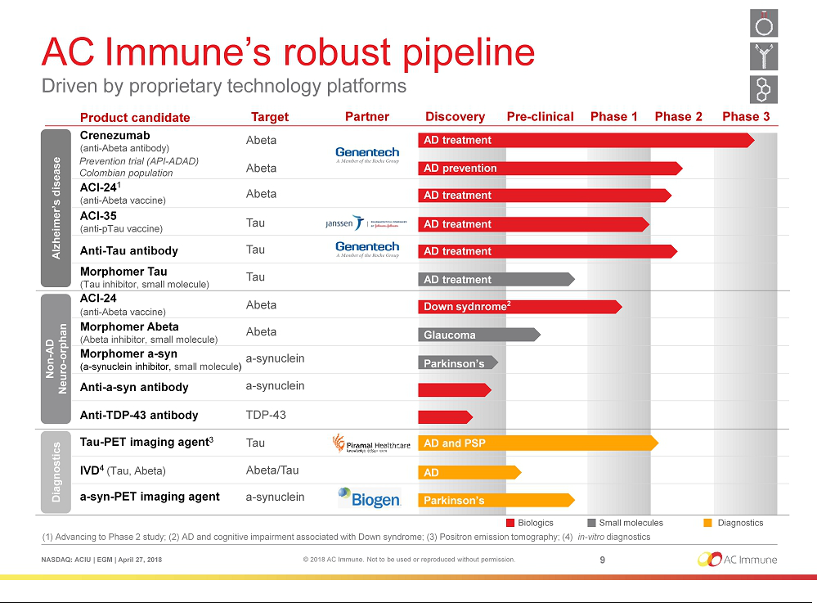

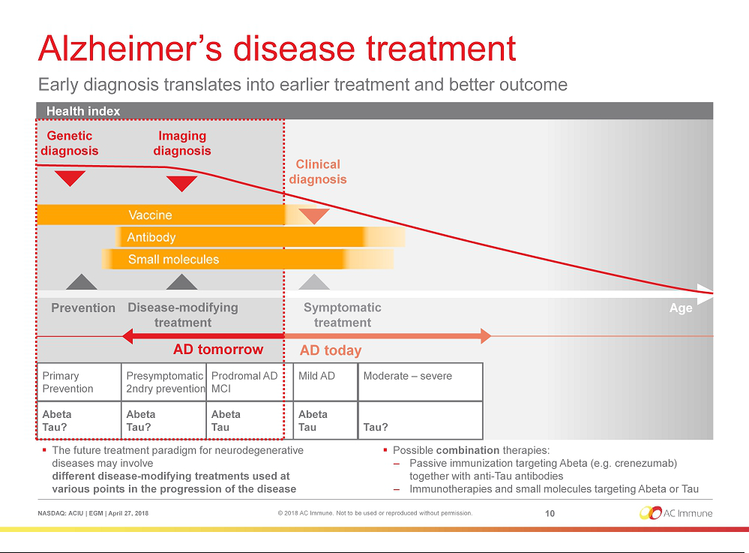

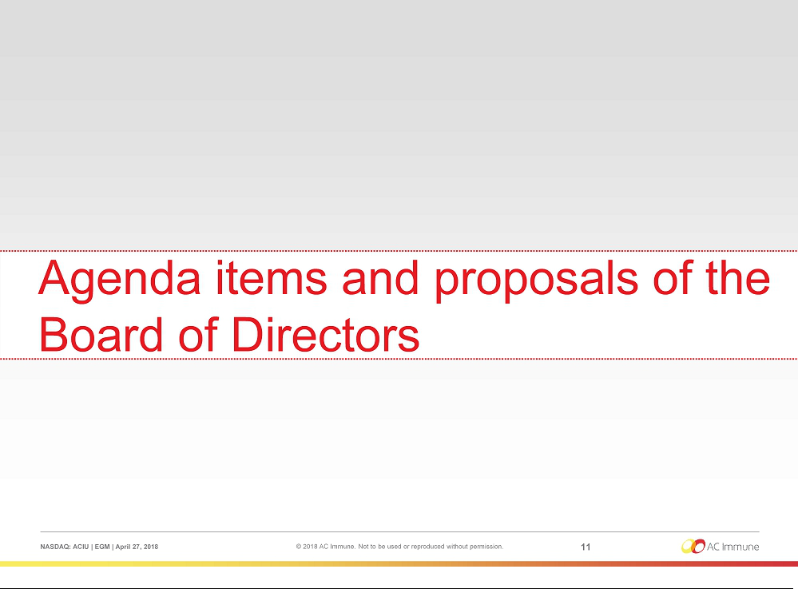

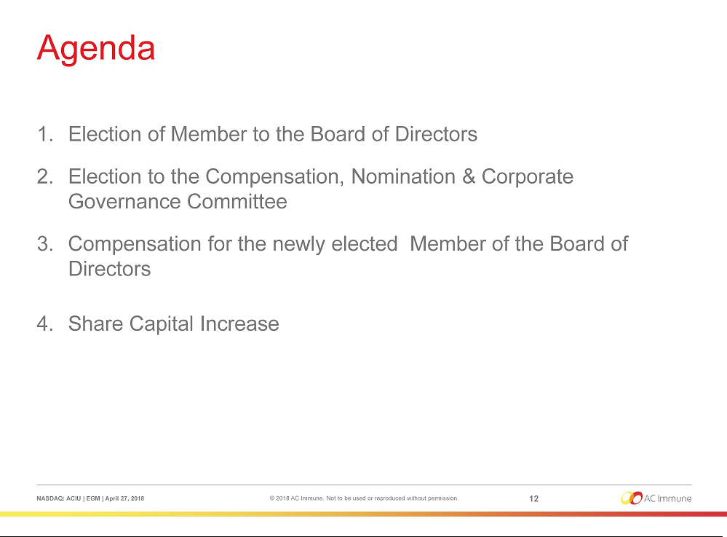

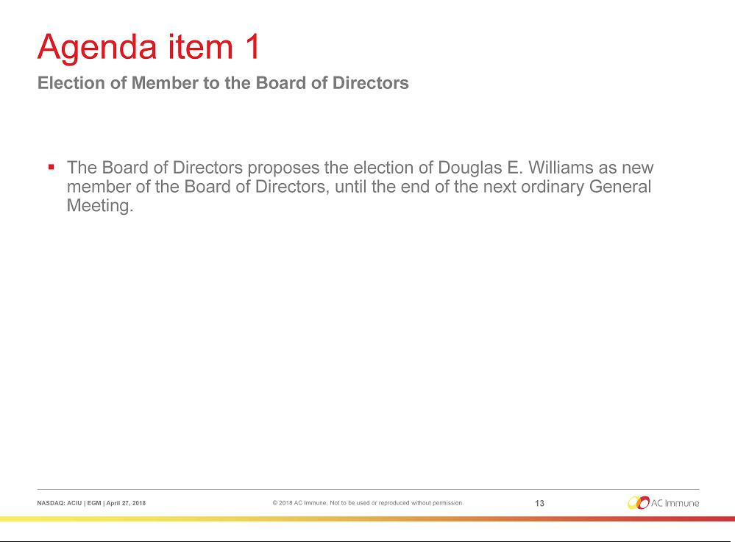

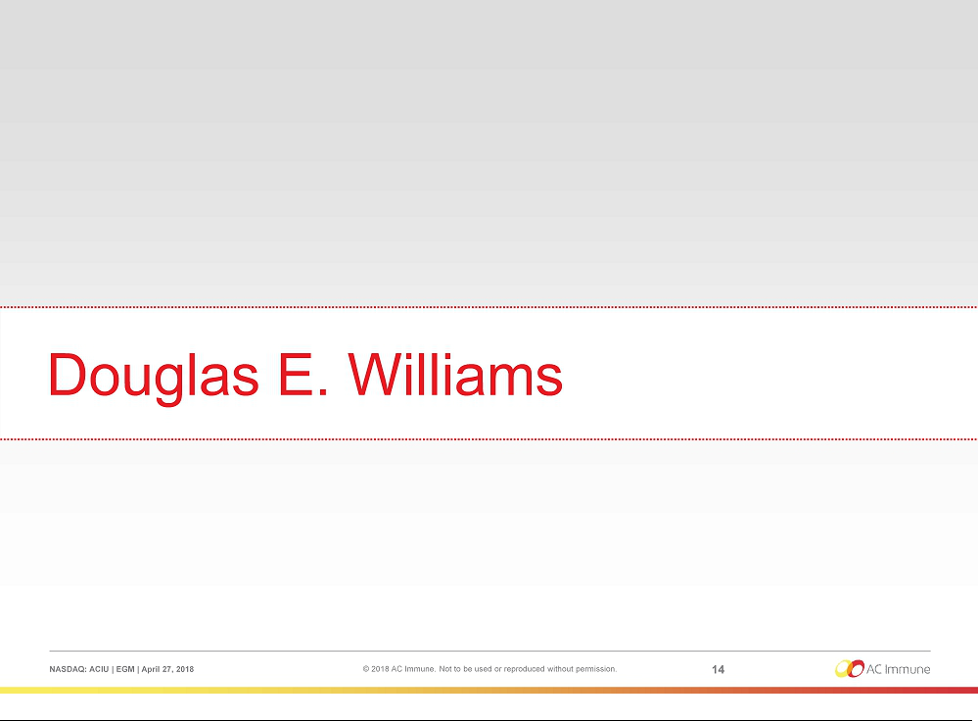

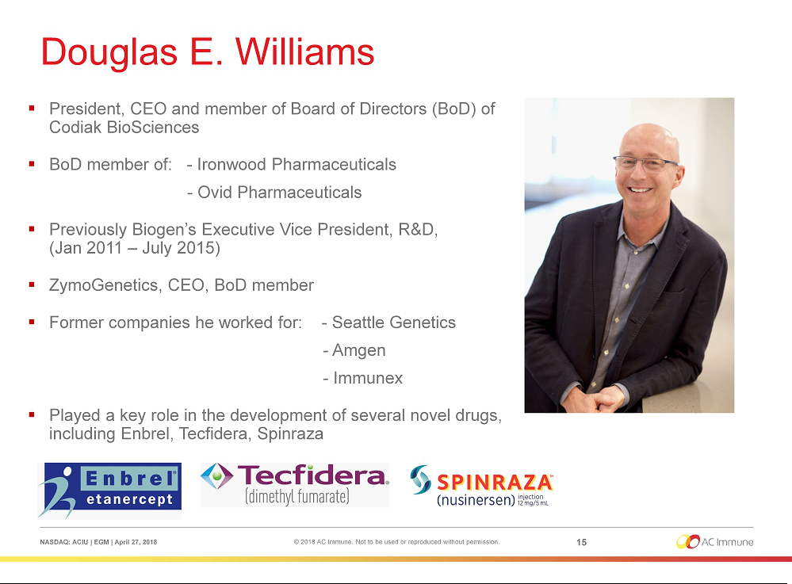

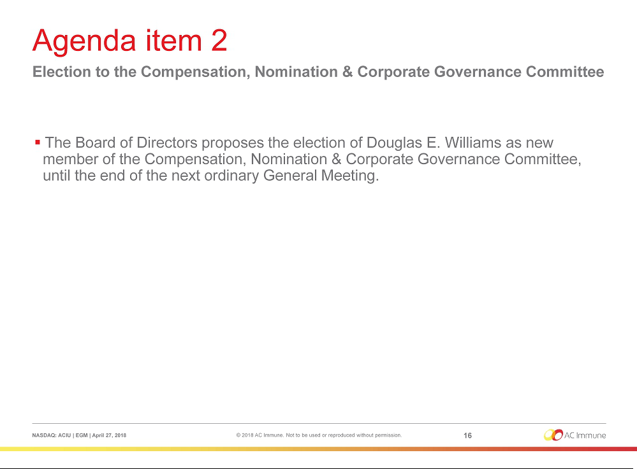

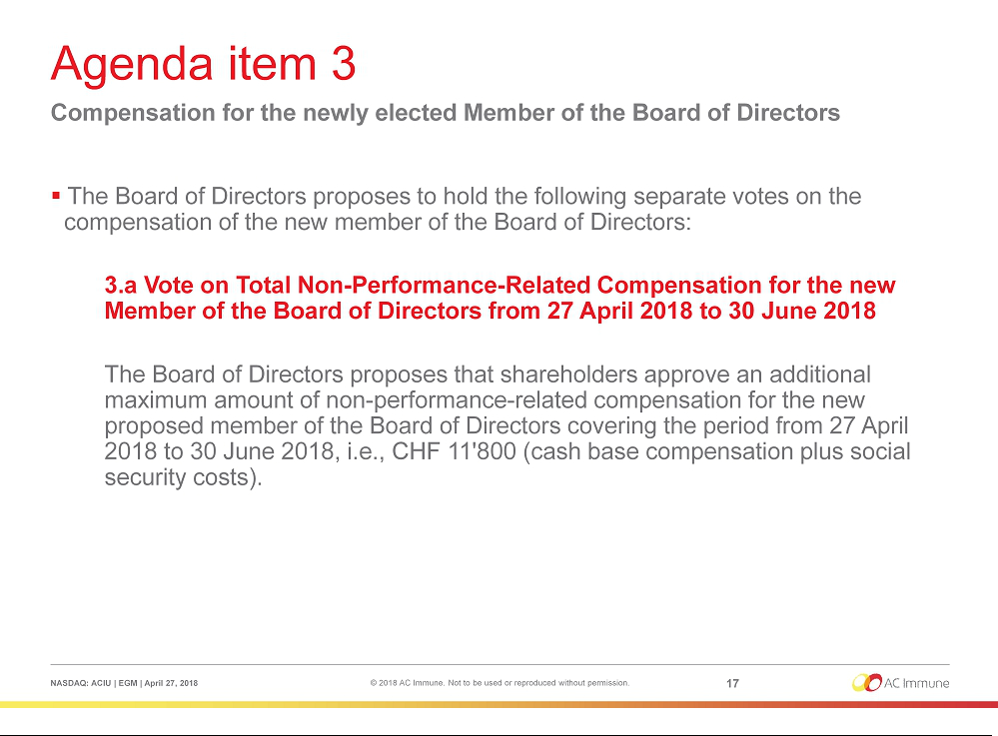

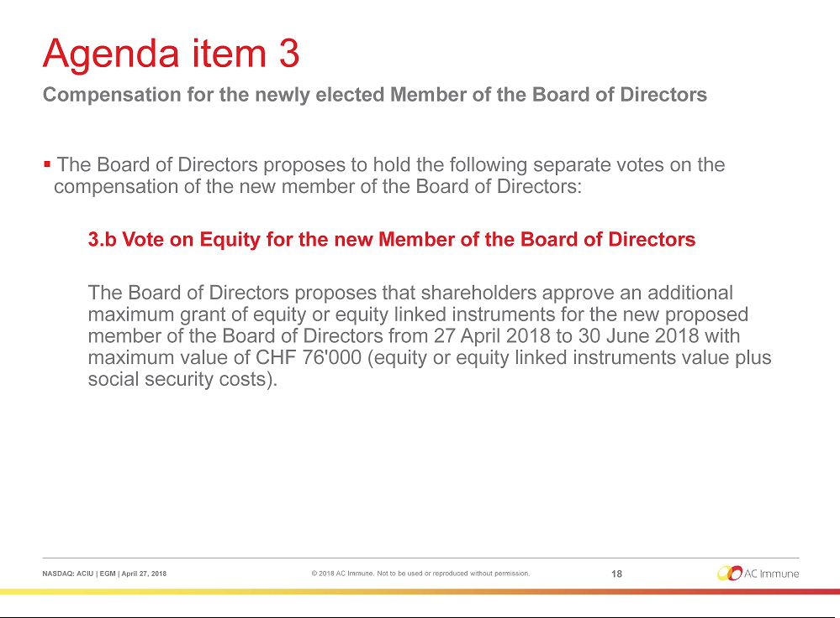

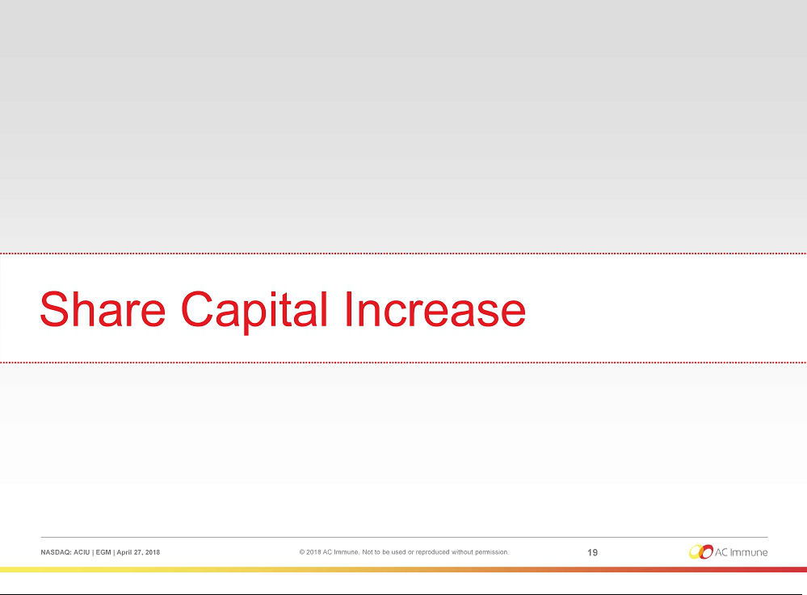

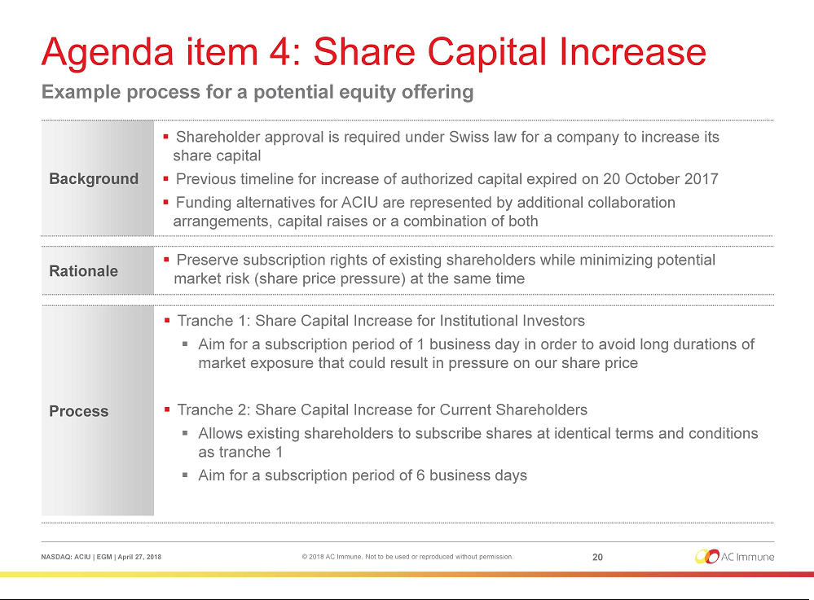

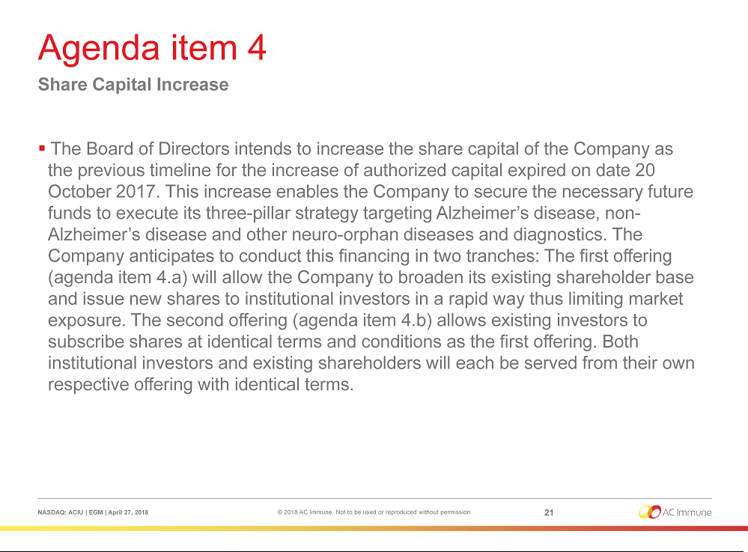

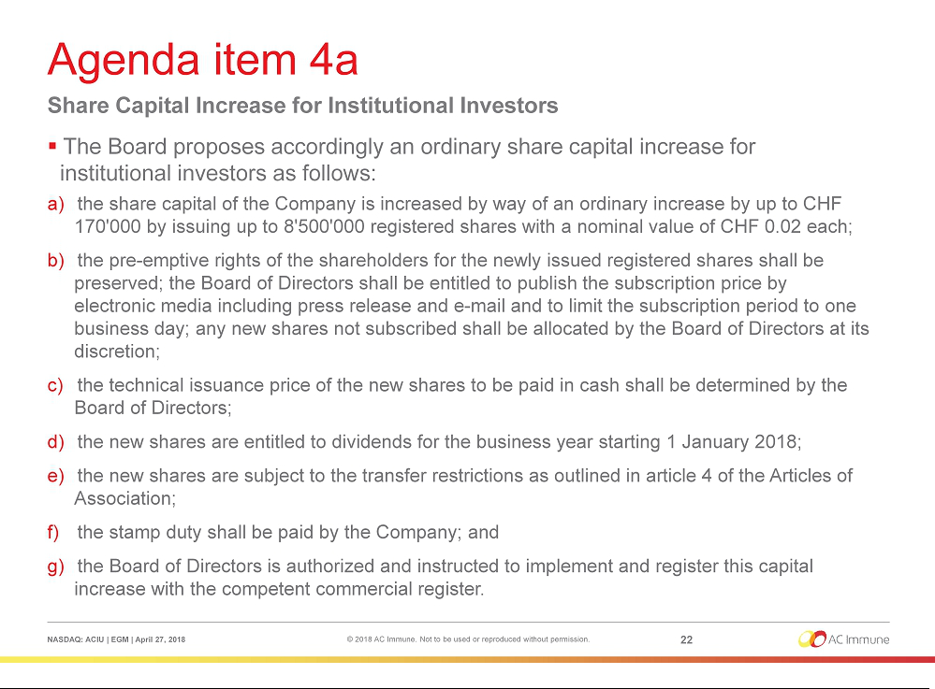

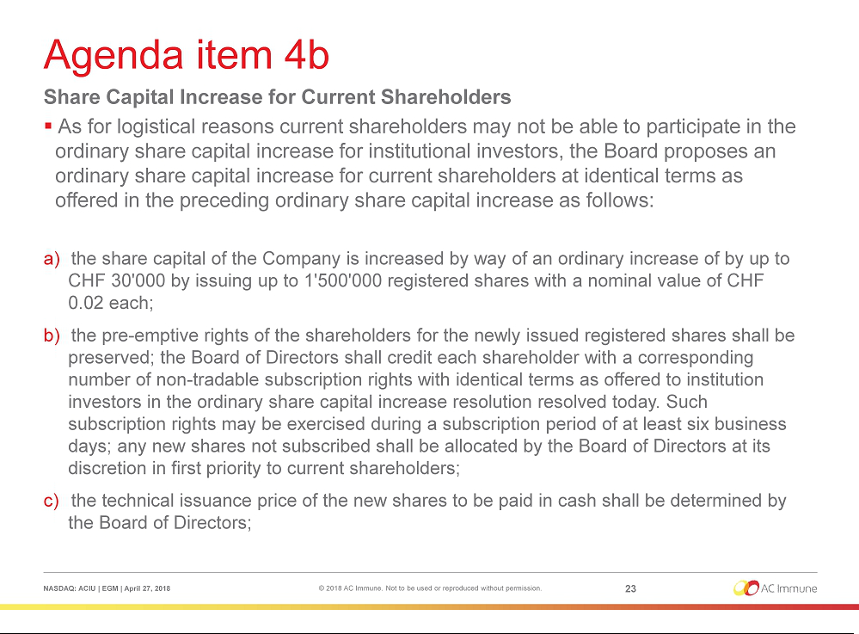

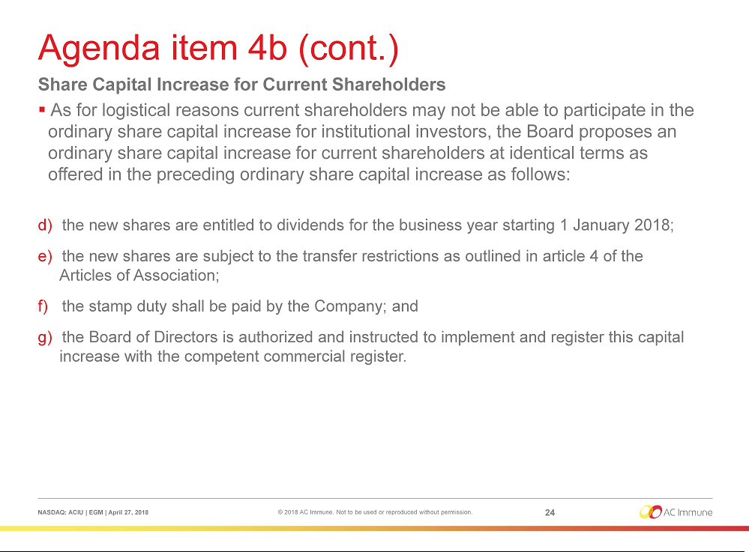

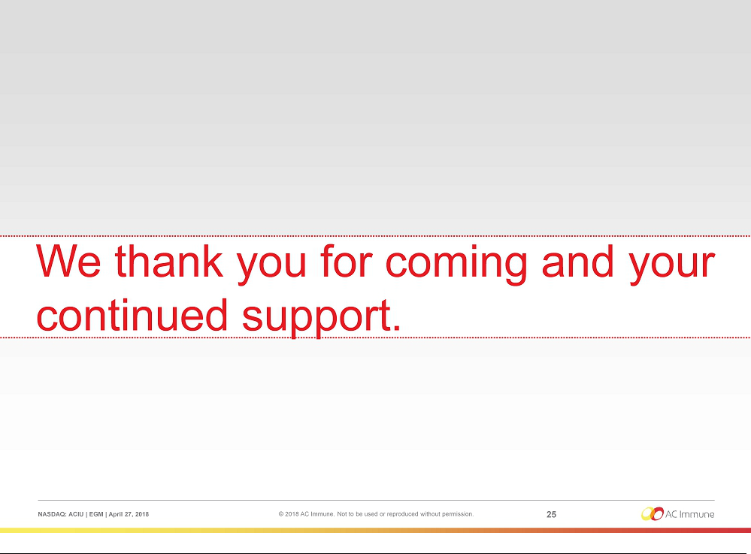

Exhibit 99.2

 | ARTICLES OF ASSOCIATION |  |  | STATUTS
 | of |  |  | de
 | AC Immune SA |  |  | AC Immune SA
 | (AC Immune AG) |  |  | (AC Immune AG)
 | (AC Immune Ltd) |  |  | (AC Immune Ltd)
 | with registered office in |  |  | avec siège à
 | Ecublens (VD) |  |  | Ecublens (VD)
 | The French version of these articles of association shall prevail. |  |  | La version française de ces statuts fait foi.
I. | CORPORATE NAME, PRINCIPAL OFFICE, DURATION AND PURPOSE |  | I. | RAISON SOCIALE, SIÈGE,
 | OF THE COMPANY |  |  | DURÉE ET BUT DE LA SOCIÉTÉ
Art. 1 Corporate Name and Duration |  |  | Art. 1 Raison sociale et durée
Under the name |  |  | Sous la raison sociale
 | AC Immune SA |  |  | AC Immune SA
 | (AC Immune AG) |  |  | (AC Immune AG)
 | (AC Immune Ltd) |  |  | (AC Immune Ltd)
there exists a Company pursuant to the provisions of Articles 620 et seq. of the |  |  | il existe une société conformément aux articles 620 ss. du Code des Obligations
Swiss Code of Obligations (CO) with registered office in Ecublens (VD). The |  |  | suisse (CO) ayant son siège à Ecublens (VD). La durée de la société est
duration of the Company is unlimited. |  |  | illimitée.
Art. 2 | Purpose |  | Art. 2 | But
The purpose of the Company is the research, study, development, manufacture, |  |  | Le but de la société est la recherche, les études, le développement, la
promotion, sale and marketing of products and substances within the |  |  | fabrication, la promotion, la vente et le marketing des produits et des substances
pharmaceutical and nutrition industry as well as the purchase, sale and |  |  | au sein de l'industrie pharmaceutique et de la nutrition ainsi que l'achat, la vente
exploitation of patents and licenses in this field. |  |  | et l'exploitation de brevets et de licences dans ce domaine.
The Company may engage in any activities which are apt to favor the purpose of |  |  | La société peut se livrer à des activités qui sont de nature à favoriser
the Company directly or indirectly. The Company may also acquire and sell real |  |  | directement ou indirectement le but de la société. La société peut également
estate. |  |  | acquérir et vendre des biens immobiliers.
The Company may open branch offices in Switzerland and abroad and may also |  |  | La société peut ouvrir des succursales en Suisse et à l'étranger et peut
acquire participations in other companies. |  |  | également acquérir des participations dans d'autres sociétés.

 |  |  |  | 2
The Company may provide securities to its subsidiaries and supply guarantees. |  |  | La société peut fournir des titres à ses filiales et des garanties
 |  |  | d'approvisionnement.
II. | SHARE CAPITAL AND SHARES |  | II. | CAPITAL-ACTIONS ET ACTIONS
Art. 3 Share Capital and Shares |  |  | Art. 3 Capital-actions et actions
The Share Capital of the Company is CHF 1'147'253.80. It is divided into |  |  | Le capital-actions de la société se monte à CHF 1'147'253.80. Il est divisé en
57'362'690 registered shares with a nominal value of CHF 0.02 each, fully paid- |  |  | 57'362'690 actions nominatives d'une valeur nominale de CHF 0.02 chacune,
in. |  |  | entièrement libérées.
Art. 3a Authorized Capital Increase of Share Capital |  |  | Art. 3a Augmentation autorisée du capital-actions
The Board of Directors is authorized to increase the share capital, in one or |  |  | Le conseil d'administration est autorisé à augmenter le capital-actions, en une ou
several steps until 20 October 2017, by a maximum amount of CHF 288'950 by |  |  | plusieurs étapes jusqu'au 20 octobre 2017, d'un montant maximum de CHF
issuing a maximum of 14'447'500 registered shares with a par value of CHF 0.02 |  |  | 288'950 par l'émission d'un montant maximum de 14'447'500 actions
each, to be fully paid up. An increase of the share capital (i) by means of an |  |  | nominatives d'une valeur nominale de CHF 0.02 chacune, à libérer entièrement.
offering underwritten by a financial institution, a syndicate or another third party |  |  | Une augmentation de capital (i) par souscription d'actions par une institution
or third parties, followed by an offer to the then-existing shareholders of the |  |  | financière, un syndicat ou un tiers ou des tiers, suivie par une souscription
Company and (ii) in partial amounts shall also be permissible. |  |  | d'actions par les actionnaires de la société alors existants et (ii) par montants
 |  |  | partiels, est également autorisée.
The Board of Directors shall determine the time of the issuance, the issue price, |  |  | Le conseil d'administration fixe la date d'émission, le prix d'émission, la manière
the manner in which the new registered shares have to be paid up, the date from |  |  | de libérer les nouvelles actions nominatives, la date à partir de laquelle les
which the registered shares carry the right to dividends, the conditions for the |  |  | actions nominatives donnent droit à un dividende, les conditions pour l'exercice
exercise of the preemptive rights and the allotment of preemptive rights that have |  |  | des droits de souscription préférentiels et l'attribution des droits de souscription
not been exercised. The Board of Directors may allow the preemptive rights that |  |  | préférentiels qui n'ont pas été exercés. Le conseil d'administration peut autoriser
have not been exercised to expire, or it may place with third parties such rights or |  |  | que des droits de souscription préférentiels qui n'ont pas été exercés expirent ou
registered shares, the preemptive rights of which have not been exercised, at |  |  | attribuer à des tiers ces droits ou actions nominatives, dont les droits de
market conditions or use them otherwise in the interest of the Company. |  |  | souscription préférentiels n'ont pas été exercés, aux conditions du marché ou les
 |  |  | utiliser autrement dans l'intérêt de la société.

3


The Board of Directors is authorized to withdraw or limit the preemptive rights of the shareholders and to allot them to third parties:

- if the issue price of the new registered shares is determined by reference to the market price; or

- for the acquisition of an enterprise, part of an enterprise or participations, or for the financing or refinancing of any of such acquisition, or in the event of share placement for the financing or refinancing of such placement; or

- for purposes of broadening the shareholder constituency of the Company in certain financial or investor markets, for purposes of the participation of strategic partners, or in connection with the listing or registration of new registered shares on domestic or foreign stock exchanges; or

- for purposes of granting an over-allotment option (Greenshoe) of up to 20% of the total number of registered shares in a placement or sale of registered shares to the respective initial purchaser(s) or underwriter(s); or

- for raising of capital (including private placements) in a fast and flexible which probably could not be reached without the exclusion of the statutory pre-emptive right of the existing shareholders; or

- for other valid grounds in the sense of Article 652b para. 2 CO; or

- following a shareholder or a group of shareholders acting in concert having accumulated shareholdings in excess of 33 ¹/₃ % of the share capital registered in the commercial register without having submitted to the other shareholders a takeover offer recommended by the Board of Directors,

Le conseil d'administration est autorisé à retirer ou de limiter les droits de souscription préférentiels des actionnaires et de les attribuer à des tiers:

- si le prix d'émission des nouvelles actions nominatives est déterminé avec une référence au prix de marché; ou

- pour l'acquisition d'une entreprise, part d'entreprise ou participation, ou pour le financement ou le refinancement de ladite acquisition, ou en cas de placement d'actions pour le financement ou le refinancement dudit placement; ou

- pour l'élargissement de la base des actionnaires de la société dans certains marchés financiers ou d'investissement, afin de permettre une participation de partenaires stratégiques, ou dans le cas de cotation ou d'enregistrement de nouvelles actions nominatives aux bourses nationales ou étrangères; ou

- pour octroyer une option de surallocation (Greenshoe) d'un maximum de 20% du nombre total d'actions nominatives dans un placement ou une vente d'actions nominatives à l'/des acheteur(s) initial(s) ou du/des souscripteur(s) respectif(s); ou

- pour lever des capitaux (y compris des placements privés) dans un délai rapide et flexible, ce qui ne pourrait probablement pas être réalisé sans l'exclusion du droit préférentiel de souscription statuaire des actionnaires existants; ou

- pour d'autres motifs valables au sens de l'article 652b al. 2 CO; ou

- suite à l'accumulation par un actionnaire ou un groupe d'actionnaires agissant de concert de participations supérieures à 33 ¹/₃ % du capital-actions inscrit au registre du commerce sans avoir soumis aux autres actionnaires une offre publique d'achat recommandée par le conseil d'administration, ou pour la

 |  | 4
or for the defense of an actual, threatened or potential takeover bid, in |  | défense d'une offre publique d'achat réelle, imminente ou potentielle, pour
relation to which the Board of Directors, upon consultation with an |  | laquelle le conseil d'administration, après consultation avec un conseiller
independent financial adviser retained by it, has not recommended to the |  | financier indépendant retenu par lui, n'a pas recommandé l'acceptation aux
shareholders acceptance on the basis that the Board of Directors has not |  | actionnaires car il a estimé que l'offre publique d'achat n'était pas
found the takeover bid to be financially fair to the shareholders. |  | financièrement équitable pour les actionnaires.
The acquisition of registered shares out of authorized capital increase of share |  | L'acquisition d'actions nominatives dans le cadre d'une augmentation autorisée
capital for general purposes and any transfers of registered shares shall be |  | du capital-actions à des fins générales et les transferts d'actions nominatives
subject to the restrictions specified in Article 4 of the Articles of Association. |  | sont soumis aux restrictions prévues à l'article 4 des statuts.
Art. 3b Conditional Capital Increase for Bonds and Similar Debt |  | Art. 3b Augmentation conditionnelle du capital-actions pour les obligations
Instruments |  | et instruments de dettes similaire
The share capital of the Company shall be increased by a maximum amount of |  | Le capital-actions de la société peut être augmenté d'un montant maximum de
CHF 91'867.50 through the issue of a maximum of 4'593'375 registered shares, |  | CHF 91'867.50 par l'émission d'un maximum de 4'593'375 actions nominatives,
payable in full, each with a nominal value of CHF 0.02 through the exercise of |  | d'une valeur nominale de CHF 0.02 chacune, à libérer entièrement, suite à
conversion and/or option or warrant rights granted in connection with bonds or |  | l'exercice de droits de conversion et/ou d'option ou de bons de souscription
similar instruments, issued or to be issued by the Company or by subsidiaries of |  | accordés en relation avec des obligations ou d'instruments similaires, émis ou
the Company, including convertible debt instruments. |  | devant être émis par la société ou par des filiales de la société, y compris les
 |  | instruments d'emprunt convertibles.
Shareholders' subscription rights are excluded. Shareholders' advance |  | Le droit de souscription préférentiel des actionnaires est exclu. Les droits de
subscription rights with regard to the new bonds or similar instruments may be |  | souscription préférentiels préalables des actionnaires à l'égard des nouvelles
restricted or excluded by decision of the Board of Directors in order to finance or |  | obligations ou instruments similaires peuvent être limités ou exclus par décision
re-finance the acquisition of companies, parts of companies or holdings, or new |  | du conseil d'administration afin de financer ou de refinancer l'acquisition
investments planned by the Company, or in order to issue convertible bonds and |  | d'entreprises, parts d'entreprises ou de holdings, ou de nouveaux
warrants on the international capital markets or through private placement. If |  | investissements prévus par la société, ou en vue d'émettre des obligations
advance subscription rights are excluded, then (1) the instruments are to be |  | convertibles et des bons de souscription sur les marchés internationaux de
placed at market |  | capitaux ou par placement privé. Si les droits de

 |  | 5
conditions, (2) the exercise period is not to exceed ten years from the date of |  | souscription préférentiels préalables sont exclus, (1) les instruments doivent être
issue for warrants and twenty years for conversion rights and (3) the conversion |  | attribués aux conditions du marché, (2) la période d'exercice ne doit pas
or exercise price for the new shares is to be set at least in line with the market |  | dépasser dix ans à partir de la date d'émission des bons de souscription et vingt
conditions prevailing at the date on which the instruments are issued. The |  | ans pour les droits de conversion et (3) le prix de conversion ou d'exercice des
respective holders of conversion and/or option or warrant rights are entitled to |  | actions nouvelles doit être fixé au moins aux conditions du marché prévalant à la
subscribe the new shares. |  | date à laquelle les instruments sont émis. Les détenteurs respectifs de droits de
 |  | conversion et/ou option ou de bons de souscription ont le droit de souscrire les
 |  | nouvelles actions.
The acquisition of registered shares through the exercise of conversion rights or |  | L'acquisition d'actions nominatives par l'exercice de droits ou de bons de
warrants and any transfers of registered shares shall be subject to the |  | conversion et les transferts d'actions nominatives sont assujetties aux
restrictions specified in Article 4 of the Articles of Association. |  | restrictions prévues par l'article 4 des statuts.
Art. 3c Conditional Share Capital Increase for Employee Benefit Plans |  | Art. 3c Augmentation conditionnelle du capital-actions pour les plans
 |  | d'avantages sociaux
The share capital of the Company shall be increased by an amount not |  | Le capital social de la société sera augmenté d'un montant ne dépassant pas
exceeding CHF 57'073.04 through the issue of a maximum of 2'853'652 |  | CHF 57'073.04 par l'émission d'un maximum de 2'853'652 actions nominatives,
registered shares, payable in full, each with a nominal value of CHF 0.02, in |  | entièrement libérées, chacune avec une valeur nominale de CHF 0.02, dans le
connection with the exercise of option rights granted to any employee of the |  | cadre de l'exercice de droits d'option accordés à tout employé de la Société ou
Company or a subsidiary, and any consultant, members of the Board of |  | d'une succursale, et à tout consultant, aux membres du conseil d'administration,
Directors, or other person providing services to the Company or a subsidiary. |  | ou à autres personnes fournissant des services en faveur de la société ou d'une
 |  | filiale.
Shareholders' subscription rights shall be excluded with regard to these shares. |  | Le droit de souscription préférentiel des actionnaires est exclu à l'égard de ces
These new registered shares may be issued at a price below the current market |  | actions. Ces nouvelles actions nominatives peuvent être émises à un prix
price. The Board of Directors shall specify the precise conditions of issue |  | inférieur au prix du marché actuel. Le conseil d'administration doit préciser les
including the issue price of the shares. |  | conditions précises d'émission, y compris le prix d'émission des actions.
The acquisition of registered shares in connection with employee participation |  | L'acquisition d'actions nominatives dans le cadre de la participation des
and any |  | employés et

 |  | 6
further transfers of registered shares shall be subject to the restrictions specified |  | d'autres transferts d'actions nominatives sont soumis aux restrictions prévues à
in Article 4 of the Articles of Association. |  | l'article 4 des statuts.
Art. 4 Share Register |  | Art. 4 Registre des actions
The Company shall maintain a share register in which it shall register the name, |  | La société tient un registre des actions nominatives, dans lequel sont inscrits le
first name and place of residence (in case of legal persons the place of |  | nom, le prénom et l'adresse (dans le cas d'une personne morale, le siège) des
incorporation) of the owners and usufructuaries of its registered shares. Natural |  | propriétaires et des usufruitiers des actions. Les personnes physiques et
and legal persons as well as legal representatives of minors etc. entitled by law |  | morales ainsi que les représentants légaux des mineurs etc. autorisés par la loi à
to the voting rights of a share which they do not own will be noted in the share |  | voter alors qu'ils ne sont pas propriétaires des actions seront, sur demande,
register upon request. |  | inscrits dans le registre des actions.
Upon request, acquirers of shares will be registered in the share register without |  | Sur demande, les acquéreurs d'actions seront inscrits dans le registre des
limitation as shareholders if they expressly certify that they acquired the shares |  | actions sans limitation comme actionnaires s'ils attestent expressément qu'ils ont
in their own name and for their own account. |  | acquis les actions en leur propre nom et pour leur propre compte.
Persons who do not expressly declare in the registration application that they are |  | Les personnes qui ne déclarent pas expressément dans la demande
holding the shares on their own account (thereafter: nominees) shall forthwith be |  | d'inscription qu'ils détiennent les actions pour leur propre compte (par la suite:
entered on the share register as shareholders with voting rights up to a maximum |  | les candidats) doivent immédiatement être inscrits dans le registre des actions
of 3 percent of the share capital. Beyond that limit, registered shares of |  | comme actionnaires avec droit de vote pour un maximum de 3 pour cent du
nominees shall only be entered as voting if the nominees in question confirm in |  | capital-actions. Au-delà de cette limite, les actions nominatives des candidats ne
writing that they are willing to disclose the names, addresses and shareholdings |  | sont inscrites avec droit de vote que si les candidats en question confirment par
of the persons on whose account they hold 0.5 percent or more of the share |  | écrit qu'ils sont prêts à divulguer les noms, adresses et participations des
capital. The Board of Directors concludes agreements with nominees that among |  | personnes pour le compte desquelles ils détiennent 0,5 pour cent ou plus du
other things govern the representation of shareholders and the voting rights. |  | capital-actions. Le conseil d'administration conclut des accords avec les
 |  | candidats qui, entre autres choses, régissent la représentation des actionnaires
 |  | et des droits de vote.
After hearing the registered shareholder or nominee, the Board of Directors may |  | Après avoir entendu l'actionnaire enregistré ou le candidat, le conseil
remove entries in the share register with retroactive effect as per the date of |  | d'administration peut supprimer des inscriptions dans le registre des actions
entry, if such entry was based on false information. The party affected must be |  | avec effet rétroactif à la date d'inscription, si cette inscription était basée sur de
informed of such removal |  | fausses informations. La partie

 |  | 7
immediately. |  | touchée doit être immédiatement informée de cette suppression.
No individual or legal entity may, directly or indirectly, formally, constructively or |  | Aucune personne physique ou morale ne peut, directement ou indirectement,
beneficially own (as defined in the next paragraph below) or otherwise control |  | formellement ou implicitement détenir à son profit (comme défini dans le
voting rights ("Controlled Shares") with respect to 33 ¹/₃ % or more of the |  | paragraphe ci-dessous) ou, d'une autre manière, contrôler le droit de vote (les
registered share capital recorded in the Commercial Register except if such |  | "Actions Contrôlées") de 33 ¹/ % ou plus du capital-actions nominatif tel
 |  | 3
individual or legal entity has submitted prior to the acquisition of such Controlled |  | qu'inscrit au registre du commerce sauf si cette personne physique ou morale a
Shares an orderly tender offer to all shareholders with a minimum price of the |  | présenté avant l'acquisition de ces Actions Contrôlée une offre publique d'achat
higher of (i) the volume weighted average price of the last 60 trading days prior |  | en bonne et due forme à tous les actionnaires à un prix minimum équivalent au
to the publication of the tender offer or (ii) the highest price paid by such |  | montant le plus élevé entre (i) le cours moyen pondéré en fonction du volume
individual or legal entity in the 12 months preceding to the publication of the |  | des 60 derniers jours de bourse précédant la publication de l'offre publique
tender offer. Those associated through capital, voting power, joint management |  | d'achat et (ii) le plus haut prix payé par cette personne physique ou morale dans
or in any other way, or joining for the acquisition of shares, shall be regarded as |  | les 12 mois précédant la publication de l'offre publique d'achat. Les personnes
one person. The registered shares exceeding the limit of 33 ¹/₃ % and not |  | associées par le capital, les droits de vote, une gestion commune ou de toute
benefiting from the exemption regarding a tender offer shall be entered in the |  | autre manière, ou qui se joignent pour une acquisition d'actions, sont
 |  | considérées comme une personne. Les actions nominatives dépassant la limite
share register as shares without voting rights.
share register as shares without voting rights. |  | de 33 ¹/₃ % et ne bénéficiant pas de l'exemption relative à une offre publique
 |  | d'achat sont inscrites dans le registre des actions comme des actions sans droit
 |  | de vote.
For the purposes of this Article 4, "Controlled Shares" in reference to any |  | Aux fins du présent article 4, Actions Contrôlées signifie en référence à toute
individual or entity means: |  | personne physique ou morale:
 |  | (a) toutes actions directement, indirectement ou implicitement détenues par
(a) all shares of the Company directly, indirectly or constructively owned by |  | cette personne physique ou morale, à condition que
such individual or entity; provided that |  | (i) les actions détenues, directement ou indirectement, par ou pour un
(i) shares owned, directly or indirectly, by or for a partnership, or trust or |  | partenariat, une fiducie ou une communauté d'héritiers sont
estate will be considered as being owned proportionately by its |  | considérées comme étant détenues proportionnellement par leurs
partners, or beneficiaries; and |  | partenaires ou bénéficiaires; et
(ii) shares owned, directly or indirectly, |  | (ii) les actions détenues, directement ou

8


by or for a corporation will be considered as being owned proportionately by any shareholder owning 50% or more of the outstanding voting shares of such corporation; and

  - shares subject to options, warrants or other similar rights shall be deemed to be owned; and

- all shares of the Company directly, indirectly beneficially owned by such individual or entity; provided that

  - a beneficial owner of a security includes any person who, directly or indirectly, through any contract, arrangement, understanding, relationship, or otherwise alone or together with other such persons has or shares:

    - voting power which includes the power to vote, or to direct the voting of, such security; and/or

    - investment power which includes the power to dispose, or to direct the disposition of, such security.

- Any person who, directly or indirectly, creates or uses a trust, proxy, power of attorney, pooling arrangement or any other contract, arrangement, or device with the purpose or effect of divesting such person of beneficial ownership of shares of the Company or preventing the vesting of such beneficial ownership as part of a plan or scheme to evade the provisions of these articles of association shall be deemed to be the beneficial owner of such shares.

- A person shall be deemed to be the beneficial owner of shares if that person has the right to acquire

indirectement, par ou pour une société seront considérées comme étant détenues proportionnellement par tout actionnaire détenant 50% ou plus des actions avec droit de vote en circulation de cette société; et

  - les actions sujettes à des options, des bons de souscription ou autres droits semblables sont réputées être détenues; et

- toutes actions de la société détenues directement, indirectement ou à son profit par cette personne physique ou morale, à condition que

  - un bénéficiaire effectif d'un titre comprend toute personne qui, directement ou indirectement, par le biais d'un contrat, d'un accord, d'une entente, d'une relation, ou autrement, seul ou avec d'autres personnes a ou partage:

    - le pouvoir de voter, y compris le pouvoir de voter ou de diriger le vote d'un tel titre; et/ou

    - le pouvoir d'investir, y compris le pouvoir de disposer ou de diriger la disposition d'un tel titre.

- Toute personne qui, directement ou indirectement, crée ou utilise une fiducie, une procuration, un pooling ou tout autre contrat, accord, ou un dispositif ayant pour objet ou pour effet de priver cette personne de la propriété effective des actions de la société ou d'en empêcher l'acquisition effective au moyen d'un plan ou programme visant à se soustraire aux dispositions de ces statuts est réputée être le propriétaire effectif de ces actions.

- Une personne est réputée être propriétaire effective d'actions si cette personne a le droit d'acquérir

 |  |  |  | 9
 | beneficial ownership of such shares within 60 days, including but not |  |  | la propriété effective de ces actions dans les 60 jours, y compris, mais
 | limited to any right acquired: (A) through the exercise of any option, |  |  | pas limité à un droit acquis: (A) au moyen de l'exercice d'une option,
 | warrant or right; (B) through the conversion of a security; (C) pursuant |  |  | d'un bon ou d'un droit de souscription; (B) par la conversion d'un titre;
 | to the power to revoke a trust, discretionary account, or similar |  |  | (C) en vertu du pouvoir de révoquer une fiducie, compte
 | arrangement; or (D) pursuant to the automatic termination of a trust, |  |  | discrétionnaire ou accord semblable; ou (D) conformément à la
 | discretionary account or similar arrangement. |  |  | résiliation automatique d'une fiducie, compte discrétionnaire ou accord
 | of 33 ¹/ % of the registered share capital also applies to the |  |  | semblable.
The limit
 | 3 |  | La limite de 33 ¹/₃ % du capital-actions nominatif s'applique également à la
subscription for, or acquisition of, registered shares by exercising option or
convertible rights arising from registered or bearer securities or any other |  |  | souscription ou l'acquisition d'actions nominatives par l'exercice d'options ou de
securities issued by the Company or third parties, as well as by means of |  |  | droits convertibles découlant de titres nominatifs ou au porteur ou d'autres titres
exercising purchased preemptive rights arising from either registered or bearer |  |  | émis par la société ou par des tiers, ainsi que par le biais de l'exercice de droits
shares. The registered shares exceeding the limit of 33 ¹/₃ % shall be entered in |  |  | de souscription préférentiels achetés découlant d'actions nominatives ou au
the share register as shares without voting rights. |  |  | porteur. Les actions nominatives dépassant la limite de 33 ¹/ % sont inscrites
 |  |  |  | 3
The Board of Directors may in special cases approve exceptions to the above |  |  | dans le registre des actions comme des actions sans droit de vote.
regulations. The Board of Directors is in addition authorized, after due |  |  | Le conseil d'administration peut dans des cas particuliers approuver des
consultation with the person concerned, to delete with retroactive effect entries in |  |  | exceptions aux règles précitées. Il est en outre autorisé, après consultation avec
the share register which were effected on the basis of false information. |  |  | la personne concernée, de supprimer avec effet rétroactif des inscriptions du
 |  |  | registre des actions qui ont été effectuées sur la base de fausses informations.
Art. 5 | Share Certificates and Intermediated Securities |  | Art. 5 | Certificats d'actions et titres intermédiés
The Company may issue registered shares in the form of single certificates, |  |  | La société peut émettre des actions nominatives sous forme de certificats
global certificates and uncertificated securities. Under the conditions set forth by |  |  | individuels, de certificats globaux et de titres dématérialisés. Dans les conditions
statutory law, the Company may convert its registered shares from one form into |  |  | prévues par la loi, la société peut convertir ses actions nominatives d'une forme
another form at any time and without the approval of the shareholders. |  |  | en une autre forme, à tout moment et sans l'approbation des actionnaires.
The shareholder has no right to demand a conversion of the registered shares. |  |  | L'actionnaire n'a pas le droit d'exiger une conversion d'actions nominatives.
Each shareholder may, however, at any time |  |  | Chaque actionnaire peut toutefois, à tout moment,

 |  |  |  | 10
request a written confirmation from the Company of the registered shares held by |  |  | demander une confirmation écrite de la société du nombres d'actions
such shareholder, as reflected in the share register. |  |  | nominatives détenues par cet actionnaire telles qu'inscrites au registre du
 |  |  | commerce.
The transfer of intermediated securities and the pledging of these intermediated |  |  | Le transfert des titres intermédiés et la mise en gage de ces titres intermédiés
securities shall be based on the provisions of the Swiss Federal Intermediated |  |  | suivent les dispositions de la Loi fédérale sur les titres intermédiés. Le transfert
Securities Act. Transfer of propriety as collateral by means of written assignment |  |  | de propriété à titre de sûreté par cession écrite n'est pas autorisé.
are not permitted.
Art. 6 Exercise of Shareholders Rights |  |  | Art. 6 | Exercice des droits des actionnaires
The shares are indivisible and the Company recognizes only one single |  |  | Les actions sont indivisibles et la société ne reconnaît qu'un seul représentant
representative per share. |  |  | par action.
The right to vote and the other rights pertaining to a registered share may only be |  |  | Le droit de vote et les autres droits relatifs à une action nominative ne peut être
exercised by a shareholder, a usufructuary or a nominee who is registered with |  |  | exercé que par un actionnaire, un usufruitier ou un candidat qui est inscrit avec
the right to vote in the share register and by persons who are entitled by law to |  |  | le droit de vote dans le registre des actions et par des personnes autorisées par
the voting rights of a share. |  |  | la loi à exercer les droits de vote d'une action.
III. | CORPORATE STRUCTURE |  | III. | STRUCTURE DE LA SOCIÉTÉ
Art. 7 | Organization |  | Art. 7 | Organisation
The corporate bodies are: |  |  | Les organes de la société sont:
A. | the General Meeting; |  | A. | L'assemblé générale;
B. | the Board of Directors; |  | B. | Le conseil d'administration;
C. | the Auditors. |  | C. | l'organe de révision.
IV. THE GENERAL MEETING |  |  | IV. | L'ASSEMBLÉE GÉNÉRALE
Art. 8 Powers |  |  | Art. 8 | Pouvoirs
The General Meeting is the supreme body of the Company. It has the following |  |  | L'assemblée générale des actionnaires est le pouvoir suprême de la société. Elle
non delegable powers: |  |  | a les droits intransmissibles suivants:
a) to adopt and amend the Articles of Association (Articles 651a, 652g, 653g |  |  | a) | adapter et modifier les statuts (articles 651a, 652g, 653g et 653i CO sont
und 653i CO remain reserved); |  |  | réservés);

 |  |  |  |  |  | 11
b) to elect and remove the members of the Board of Directors, the Chairman of |  |  |  | b) | nommer et révoquer les membres du conseil d'administration, le président
 | the Board of Directors, the members of the Compensation Committee, the |  |  |  | du conseil d'administration, les membres du comité de rémunération,
 | Auditors and the Independent Proxy; |  |  |  | l'organe de révision et le mandataire indépendant;
c) to approve the management report and the annual accounts and to determine |  |  |  | c) |  | approuver le rapport de gestion et les comptes annuels et déterminer la
 | the allocation of profits, in particular with regard to dividends and bonus |  |  |  | répartition des bénéfices, en particulier en ce qui concerne les dividendes
 | payments; |  |  |  | et les bonus;
d) | to discharge the members of the Board of Directors and of the Executive |  |  | d) |  | donner décharge aux membres du conseil d'administration et au comité
 | Committee; |  |  |  | exécutif;
e) | to approve the total compensation paid to the Board of Directors and the |  |  | e) |  | approuver la rémunération totale versée au conseil d'administration et au
 | Executive Committee as per Articles 32 and 33 below; |  |  |  | comité exécutif conformément aux l'articles 32 et 33 ci-dessous;
f) to pass resolutions concerning all matters which are reserved to the authority |  |  |  | f) |  | prendre les décisions sur toutes les affaires qui sont attribuées à
 | of the General Meeting by law or by the Articles of Association. |  |  |  | l'assemblée générale par la loi ou les statuts.
Art. 9 |  | Ordinary General Meeting |  | Art. 9 |  | Assemblée générale ordinaire
The Ordinary General Meeting shall be held annually within six months after the |  |  |  | L'assemblée générale ordinaire aura lieu chaque année dans les six mois qui
close of the business year at such time and at such location, which may be within |  |  |  | suivent la clôture de l'exercice à la date et à l'endroit, qui peut être en ou hors de
or outside Switzerland, as determined by the Board of Directors. |  |  |  | la Suisse, tel que déterminé par le conseil d'administration.
Art. 10 Extraordinary General Meeting |  |  |  | Art. 10 Assemblée générale extraordinaire
Extraordinary General Meetings may be called by resolution of the General |  |  |  | Les assemblées générales extraordinaires peuvent être convoquées par
Meeting, the Auditors or the Board of Directors, or by shareholders with voting |  |  |  | décision de l'assemblée générale, l'organe de révision ou le conseil
powers, provided they represent at least 10% of the share capital and who |  |  |  | d'administration, ou par des actionnaires avec droit de vote, à condition qu'ils
submit (a)(1) a request signed by such shareholder(s) that specifies the item(s) |  |  |  | représentent au moins 10% du capital-actions et qu'ils soumettent (a) (1) une
to be included on the agenda, (2) the respective proposals of the shareholders |  |  |  | demande signée par le(s)dit(s) actionnaire(s) qui spécifie les objets à faire figurer
and (3) evidence of the required shareholdings recorded in the share register |  |  |  | sur l'ordre du jour, (2) les propositions respectives de ces actionnaires et (3) la
and (b) such other information as would be required to be included in a proxy |  |  |  | preuve des participations requises inscrites dans le registre des actions et (b)

 |  | 12
statement pursuant to the rules of the country where the Company's shares are |  | les autres informations qui doivent être mentionnées dans une déclaration (proxy
primarily listed. |  | statement) conformément aux règles du pays où les actions de la société sont
 |  | principalement cotées.
Art. 11 Notice and Agenda of Shareholders' Meetings |  | Art. 11 Convocations et ordres du jour des assemblées générales
Notice of a General Meeting of Shareholders shall be given by the Board of |  | L'assemblée générale est convoquée par le conseil d'administration ou, si
Directors or, if necessary, by the Auditor, not later than twenty calendar days |  | nécessaire, par l'organe de révision, au moins 20 jours avant la tenue de
prior to the date of the General Meeting of Shareholders. Notice of the General |  | l'assemblée générale des actionnaires. La convocation à l'assemblée générale
Meeting of Shareholders shall be given by way of a one-time announcement in |  | des actionnaires doit être faite au moyen d'une seule publication conformément
the official means of publication of the Company pursuant to Article 46 of these |  | à l'article 46 de ces statuts. La période de préavis sera réputée avoir été
Articles of Association. The notice period shall be deemed to have been |  | respectée si la convocation à l'assemblée générale des actionnaires est publiée
observed if notice of the General Meeting of Shareholders is published in such |  | conformément à l'article 46 de ces statuts, étant entendu que la date de
official means of publication, it being understood that the date of publication shall |  | publication ne doit pas être calculée dans la période de préavis. Les actionnaires
not be computed in the notice period. Shareholders of record may in addition be |  | inscrits peuvent en outre être informés de l'assemblée générale des actionnaires
informed of the General Meeting of Shareholders by ordinary mail or e-mail. |  | par courrier ordinaire ou par e-mail.
The notice of a General Meeting of Shareholders shall specify the items on the |  | La convocation à l'assemblée générale des actionnaires doit préciser les objets
agenda and the proposals of the Board of Directors and the shareholder(s) who |  | de l'ordre du jour et les propositions du conseil d'administration et l'/les
requested that a General Meeting of Shareholders be held or an item be included |  | actionnaire(s) qui a/ont demandé que l'assemblée générale des actionnaires ait
on the agenda, and, in the event of elections, the name(s) of the candidate(s) |  | lieu ou qu'un objet soit inscrit à l'ordre du jour, et, dans le cas d'élections, le/les
that has or have been put on the ballot for election. |  | nom(s) du/des candidat(s) qui a ou ont été mis sur le bulletin de vote pour
 |  | l'élection.
The Board of Directors shall state the matters on the agenda. |  | Le conseil d'administration doit indiquer les objets de l'ordre du jour.
Shareholders who represent an aggregate of at least 10 percent of the share |  | Les actionnaires qui représentent un total d'au moins 10 pour cent du capital-
capital or together representing shares with a nominal value of 1 million Swiss |  | actions ou qui représentent ensemble une valeur nominale de CHF 1 million
francs may demand that an item be placed on the agenda of a General Meeting |  | d'actions peuvent exiger qu'un objet soit inscrit à l'ordre du jour d'une assemblée
of Shareholders. A request for inclusion of an item on the agenda must be |  | générale des actionnaires. Une demande d'inscription d'un objet à l'ordre du jour
requested in writing delivered to or |  | doit être faite par écrit

 |  | 13
mailed and received at the registered office of the Company at least 120 |  | et remise ou envoyée et reçue au siège de la société au moins 120 jours avant
calendar days before the first anniversary of the date that the Company's proxy |  | le premier anniversaire de la date à laquelle la déclaration (proxy statement) de
statement was released to shareholders in connection with the previous year's |  | la Société a été communiquée aux actionnaires lors de l'assemblée générale
ordinary General Meeting of Shareholders. However, if no ordinary General |  | ordinaire des actionnaires de l'année précédente. Toutefois, si aucune
Meeting of Shareholders was held in the previous year or if the date of the |  | assemblée générale ordinaire des actionnaires n'a eu lieu l'année précédente ou
ordinary General Meeting of Shareholders has been changed by more than 30 |  | si la date de l'assemblée générale ordinaire des actionnaires a été modifiée de
calendar days from the date contemplated at the time of the previous year's |  | plus de 30 jours calendaires à compter de la date prévue au moment de la
proxy statement, request for inclusion of an item on the agenda must be |  | déclaration (proxy statement) de l'année précédente, une demande d'inscription
requested not fewer than the later of (i) 150 calendar days prior to the date of the |  | d'un objet à l'ordre du jour doit être demandée au moins à la date la plus tardive
contemplated annual General Meeting or (ii) the date which is ten calendar days |  | entre (i) 150 jours calendaires avant la date de l'assemblée générale ordinaire
after the date of the first public announcement or other notification to the |  | envisagée ou (ii) la date qui est dix jours calendaires plus tard que la date de la
shareholders of the date of the contemplated annual General Meeting. To be |  | première annonce publique ou autre notification aux actionnaires de la date
timely for an extraordinary General Meeting, a shareholder's notice to the |  | envisagée de l'assemblée générale ordinaire. Pour être dans les délais pour une
Secretary must be delivered to or mailed and received at the registered office of |  | assemblée générale extraordinaire, l'avis d'un actionnaire au secrétaire doit être
the Company not fewer than the later of (i) 120 calendar days before the date of |  | livré ou envoyé et reçu au siège de la société au moins à la date la plus tardive
the extraordinary General Meeting of Shareholders or (ii) the date which is ten |  | entre (i) 120 jours calendaires avant la date de l'assemblée générale
calendar days after the date of the first public announcement or other notification |  | extraordinaire des actionnaires ou (ii) la date qui est dix jours calendaires plus
to the shareholders of the date of the contemplated extraordinary General |  | tard que la date de la première annonce publique ou autre notification aux
Meeting of Shareholders. |  | actionnaires de la date envisagée de l'assemblée générale extraordinaire des
 |  | actionnaires.
Each request for inclusion of an item on the agenda must include (i) a brief |  | Chaque demande d'inscription d'un objet à l'ordre du jour doit inclure (i) une
description of the business desired to be brought before the meeting and the |  | brève description de l'affaire qui sera soumise à l'assemblée et les raisons pour
reasons for conducting such business at the meeting; (ii) the name and address, |  | lesquelles cette affaire est soumise à l'assemblée; (ii) le nom et l'adresse, tels
as they appear on the Company's register of shareholders, of the shareholder |  | qu'ils apparaissent dans le registre des actionnaires de la société, de l'/des
proposing such business; (iii) the number of shares of the Company which are |  | actionnaire(s) proposant un tel objet; (iii) le nombre d'actions de la société
beneficially owned by such shareholder; (iv) the dates upon which the |  | effectivement détenues par (un) tel(s) actionnaire(s); (iv) les dates auxquelles
shareholder acquired such shares; (v) documentary support for any claim of |  | l'/les actionnaire(s) a/ont acquis ces actions; (v) l'appui documentaire pour
beneficial

 |  | 14
ownership; (vi) any material interest of such shareholder in such business; and |  | toute revendication de propriété effective; (vi) un intérêt important de cet/ces
(vii) a statement in support of the matter and, for proposals sought to be included |  | actionnaire(s) par rapport à cet objet; et (vii) une déclaration à l'appui de cet
in the Company's proxy statement, any other information required by Securities |  | objet et, pour les propositions devant être incluses dans la déclaration (proxy
and Exchange Commission Rule "14a-8". |  | statement) de la société, toute autre information requise par la Securities and
 |  | Exchange Commission règle "14a-8".
In addition, if the shareholder intends to solicit proxies from the shareholders of |  | En outre, si un actionnaire a l'intention de solliciter des procurations des
the Company, such shareholder shall notify the Company of this intent in |  | actionnaires de la société, cet actionnaire doit en informer la société
accordance with Securities and Exchange Commission Rule "14a-4" and/or Rule |  | conformément aux dispositions de la Securities and Exchange Commission règle
"14a-8". |  | "14a-4" et "14a-8".
No resolution may be passed at a General Meeting of Shareholders concerning |  | Aucune décision ne peut être adoptée lors d'une assemblée générale des
an item in relation to which due notice was not given. Proposals made during a |  | actionnaires si un objet n'a pas été inscrit à l'ordre du jour dans le délai de
General Meeting of Shareholders to (i) convene a extraordinary General Meeting |  | préavis. Les propositions faites au cours d'une assemblée générale des
or (ii) initiate a special investigation in accordance with article 697a of the Swiss |  | actionnaires pour (i) convoquer une assemblée générale extraordinaire ou (ii)
Code of Obligations are not subject to the due notice requirement set forth |  | instituer un contrôle spécial au sens de l'article 697a CO ne sont pas soumises à
herein. |  | l'obligation d'inscription prévue dans ces statuts.
No advance notice is required to propose motions on duly notified agenda items |  | Aucun préavis n'est nécessaire pour proposer des motions sur les objets inscrits
and to debate items without passing resolutions. |  | à l'ordre du jour ou débattre desdits objets sans prendre de décisions.
Art. 12 Documentation |  | Art. 12 Documents
The annual business report, the compensation report and the Auditor's report |  | Le rapport de gestion annuel, le rapport de rémunération et le rapport du
must be submitted for examination by the shareholders at the registered office of |  | réviseur doivent être présentés aux actionnaires pour examen au siège de la
the Company at least 20 days prior to the date of the Ordinary General Meeting. |  | société au moins 20 jours avant la date de l'assemblée générale ordinaire.
Each shareholder may request that a copy of this documentation be sent to him |  | Chaque actionnaire peut demander une copie de ces documents qui doivent lui
promptly by e-mail. Such right shall be included in the invitation to the General |  | être envoyés promptement par e-mail. Ce droit doit être mentionné dans
Meeting. |  | l'invitation à l'assemblée générale.

 |  |  | 15
Art. 13 Meeting of All Shareholders |  | Art. 13 | Assemblée universelle
Shareholders or their proxies representing all shares issued may hold a General |  | Les propriétaires ou les représentants de la totalité des actions peuvent, s'il n'y a
Meeting without observing the formalities required for calling a meeting, unless |  | pas d'opposition, tenir une assemblée générale sans observer les formes
objection is raised. At such a meeting, discussions may be held and resolutions |  | prévues pour sa convocation. Aussi longtemps que les propriétaires ou les
passed on all matters within the scope of the powers of a General Meeting for so |  | représentants de la totalité des actions sont présents, cette assemblée a le droit
long as the shareholders or proxies representing all shares issued are present. |  | de délibérer et de statuer valablement sur tous les objets qui sont du ressort de
 |  | l'assemblée générale.
Art. 14 Chairman and Scrutineers |  | Art. 14 Président et scrutateurs
The Chairman of the Board of Directors shall preside over the General Meeting. |  | L'assemblée générale est présidée par le président du conseil d'administration.
In his absence, a member of the Board of Directors or another Chairman of the |  | En cas d'empêchement, un autre membre du conseil d'administration ou un
Meeting designated by the General Meeting shall preside. |  | président ad hoc nommé par l'assemblée générale préside celle-ci.
The Chairman of the Meeting shall designate a Secretary and the scrutineers |  | Le président de l'assemblée générale désigne un secrétaire et les scrutateurs
who need not be shareholders. |  | qui ne doivent pas nécessairement être actionnaires.
Art. 15 Minutes |  | Art. 15 | Procès-verbal
The Board of Directors is responsible for the keeping of the minutes of the |  | Le conseil d'administration est responsable de la tenue du procès-verbal de
Meeting, which shall state the number, kind, nominal value of shares represented |  | l'assemblée, qui doit indiquer le nombre, le type, la valeur nominale des actions
by the shareholders, by the corporate bodies and by the independent proxy and |  | représentées par les actionnaires, par les organes sociaux et par le représentant
gives information on resolutions passed, elections, requests for information and |  | indépendant et donne des informations sur les décisions adoptées, les élections,
information as well as declarations given by the shareholders. The minutes shall |  | les demandes de renseignements et les informations ainsi que les déclarations
be signed by the Chairman and the Secretary. |  | faites par les actionnaires. Le procès-verbal est signé par le président et le
 |  | secrétaire.
The shareholders are entitled to inspect the minutes. |  | Les actionnaires ont le droit d'examiner le procès-verbal.
Art. 16 Right to Vote |  | Art. 16 Droit de vote
Each share entitles to one vote. |  | Chaque action donne droit à une voix.

 |  |  | 16
Each shareholder may be represented at a General Meeting by any person who |  | Chaque actionnaire peut se faire représenter à l'assemblée générale par toute
is so authorized by a written proxy. A proxy need not be a shareholder. |  | personne qui est autorisée par une procuration écrite. Le représentant ne doit
 |  | pas nécessairement être un actionnaire.
Each shareholder may be represented by the Independent Proxy. The |  | Chaque actionnaire peut se faire représenter par le représentant indépendant.
requirements regarding proxies and instructions are determined by the Board of |  | Les exigences en matière de procurations et les instructions sont déterminées
Directors. |  | par le conseil d'administration.
Art. 17 Resolutions and Elections |  | Art. 17 Décisions and élections
All voting and elections are held openly or electronically. A written voting or |  | Tous votes et élections sont tenus ouvertement ou par voie électronique. Sur
election shall be held if instructed so by the Chairman or if decided by the |  | instruction du président ou de l'assemblée générale, un vote ou une élection doit
General Meeting. |  | être tenu par écrit.
The General Meeting shall pass its resolutions and carry out its elections with the |  | Sous réserve des dispositions impératives de la loi ou des statuts, l'assemblée
simple majority of the votes cast regardless of abstentions and empty or invalid |  | générale prend ses décisions et procède aux élections à la majorité simple des
votes, unless statutory law or articles of association state otherwise. In the event |  | voix émises. En cas de partage égal des voix, la requête sera refusée. Le
of tie votes, the request shall be refused. The Chairman shall not have a casting |  | président n'a pas voix prépondérante.
vote.
A resolution of the General Meeting passed by at least two thirds of the |  | Une décision de l'assemblée générale recueillant au moins les deux tiers des
represented share votes and the absolute majority of the represented shares par |  | voix attribuées aux actions représentées et la majorité absolue des valeurs
value is required for: |  | nominales représentées est nécessaire pour:
a) The cases listed in art. 704 para. 1 CO, i.e.: |  | a) les cas énumérés dans l'art. 704 al. 1 CO, i.e.:
(i) the change of the company purpose; |  | (i) | la modification du but social;
(ii) the creation of shares with privileged voting rights; |  | (ii) | l'introduction d'actions à droit de vote privilégié;
(iii) the restriction of the transferability of registered shares; |  | (iii) la restriction de la transmissibilité des actions nominatives;
(iv) an increase of capital, authorized or subject to a condition; |  | (iv) l'augmentation autorisée ou conditionnelle du capital-actions;

 |  |  |  | 17
 | (v) an increase of capital out of equity, against contribution in kind, or for |  |  | (v) l'augmentation du capital-actions au moyen des fonds propres, contre
 | the purpose of acquisition of assets and the granting of special |  |  | apport en nature ou en vue d'une reprise de biens et l'octroi
 | benefits; |  |  | d'avantages particuliers;
 | (vi) the limitation or withdrawal of subscription rights; |  |  | (vi) la limitation ou la suppression du droit de souscription préférentiel;
 | (vii) the change of the domicile of the Company; and |  |  | (vii) le transfert du siège de la société; et
 | (viii) the liquidation of the Company; |  |  | (viii) la dissolution de la société;
b) the merger, de-merger or conversion of the Company (subject to mandatory |  |  | b) | la fusion, la scission ou la conversion de la société (sous réserve des
 | law); |  |  | dispositions impératives);
c) the alleviating or withdrawal of restrictions upon the transfer of registered |  |  | c) | l'atténuation ou la suppression des restrictions sur le transfert des actions
 | shares; |  |  | nominatives;
d) the conversion of registered shares into bearer shares and vice versa; and |  |  | d) | la conversion d'actions nominatives en actions au porteur et vice versa; et
e) the amendment or elimination of the provisions of Article 4 and 29 of the |  |  | e) | la modification ou la suppression des dispositions des articles 4 et 29 des
 | Articles of Association as well as those contained in this Article 17. |  |  | statuts ainsi que ceux contenues dans le présent article 17.
Art. 18 Votes on Compensation |  |  | Art. 18 Votes sur la rémunération
Each year, the General Meeting separately approves the total maximum amounts |  |  | Chaque année, l'assemblée générale approuve séparément les montants totaux
proposed by the Board of Directors pursuant to Articles 32 and 33 of the Articles |  |  | maximaux proposés par le conseil d'administration conformément aux articles 32
of Association for: |  |  | et 33 des statuts pour:
a) the non-performance-related compensation of the Board of Directors for the |  |  | a) | la rémunération non liée à la performance du conseil d'administration pour
 | next term of office; |  |  | le prochain mandat;
b) | a possible additional compensation of the Board of Directors for the |  | b) | une éventuelle rémunération supplémentaire du conseil d'administration
 | preceding business year; |  |  | pour l'exercice précédent;
 |  |  | c) | la rémunération non liée à la performance du comité exécutif pour la
c) the non-performance-related compensation of the Executive Committee for |  |  |  | période de 12 mois commençant le 1er juillet après chaque assemblée
 | the 12-month period starting on 1 July following the Ordinary General |  |  | générale ordinaire;
 | Meeting;

 |  | 18
d) the variable compensation for the Executive Committee for the current year; |  | d) la rémunération variable pour le comité exécutif pour l'année en cours;
e) the grant of options or shares in the Company to the Board of Directors and |  | e) l'octroi d'options ou d'actions de la société au conseil d'administration et au
the Executive Committee. |  | comité exécutif.
The respective total compensation amounts include social security and |  | Les montants totaux de rémunération respectifs comprennent la sécurité sociale
occupational pension contributions for the benefit of the members of the Board of |  | et les cotisations de retraite professionnelle au profit des membres du conseil
Directors, the Executive Committee and the Company. |  | d'administration, du comité exécutif et de la société.
If the General Meeting refuses to approve a respective motion by the Board of |  | Si l'assemblée générale refuse d'approuver une motion soumise par le conseil
Directors, the Board of Directors may either submit a new motion at the same |  | d'administration, le conseil d'administration peut, soit présenter une nouvelle
meeting or determine a maximum total remuneration or several maximum partial |  | motion à la même séance ou déterminer une rémunération maximale totale ou
remunerations, subject to the relevant principles of the compensation, or submit |  | plusieurs rémunérations maximales partielles, sous réserve des principes
a new motion to the next General Meeting for approval. The Company may pay |  | concernant la rémunération, soit soumettre une nouvelle motion à la prochaine
remunerations within the framework of the maximum total or partial remuneration |  | assemblée générale pour approbation. La société peut verser des rémunérations
and subject to the approval by the General Meeting. |  | dans le cadre de la rémunération maximale totale ou partielle et sous réserve de
 |  | l'approbation par l'assemblée générale.
Art. 19 Independent Proxy |  | Art. 19 Représentant indépendant
The Independent Proxy shall be elected by the Ordinary General Meeting for a |  | Le représentant indépendant est élu par l'assemblée générale ordinaire pour une
term of one year until the end of the next Ordinary General Meeting. Re-election |  | durée d'un an jusqu'à la fin de la prochaine assemblée générale ordinaire. Une
is permitted. The Independent Proxy informs the Company about number, type, |  | réélection est possible. Le représentant indépendant informe la société sur le
par value and category of the represented shares. The Chairman of the Board |  | nombre, le type, la valeur nominale et la catégorie des actions représentées. Le
discloses the information to the General Meeting. The other duties of the |  | président du conseil d'administration communique ces informations à
Independent Proxy are determined by the applicable statutory provisions. |  | l'assemblée générale. Les autres fonctions du représentant indépendant sont
 |  | déterminées par les dispositions statutaires applicables.

 |  |  |  | 19
V. | BOARD OF DIRECTORS |  | V. | CONSEIL D'ADMINISTRATION
Art. 20 Number of Members, Term of Office |  |  | Art. 20 Nombre de membres, durée de la fonction
The Board of Directors shall consist of at least 3 and not more than 9 members. |  |  | Le conseil d'administration se compose d'au minimum 3 et au maximum 9
The chairman and the members of the Board of Directors are individually elected |  |  | membres. Le président et les membres du conseil d'administration sont élus
by the General Meeting for a term of one year until the end of the next Ordinary |  |  | individuellement par l'assemblée générale pour un mandat d'un an jusqu'à la fin
General Meeting, provided that he/she does not resign or is not replaced during |  |  | de la prochaine assemblée générale ordinaire, à condition qu'il/elle ne
his term. |  |  | démissionne pas ou ne soit pas remplacé(e) durant son mandat.
The members of the Board of Directors may be re-elected without limitation. The |  |  | Les membres du conseil d'administration peuvent être réélus sans limitation. La
maximum age limit of members of the Board shall be 75 years. When a member |  |  | limite d’âge des membres du conseil d'administration est fixée à 75 ans.
of the Board of Directors reaches this age limit during his term of office, such |  |  | Lorsqu'un membre du conseil d'administration atteint cette limite d'âge durant
term shall automatically extend to the next ordinary shareholders' meeting. The |  |  | son mandat, ledit mandat sera automatiquement prolongé jusqu'à la prochaine
shareholders' meeting may resolve to grant an exception to the age limit. |  |  | assemblée générale ordinaire. L'assemblée générale des actionnaires peut
 |  |  | décider d'accorder une dérogation à la limite d'âge.
Art. 21 | Constitution |  | Art. 21 | Constitution
Subject to the powers of the General Meeting, the Board of Directors determines |  |  | Sous réserve des pouvoirs de l'assemblée générale, le conseil d'administration
its own organization. It appoints a Secretary who needs not be a member of the |  |  | détermine sa propre organisation. Il nomme un secrétaire qui ne doit pas
Board of Directors. |  |  | nécessairement être un membre du conseil d'administration.
Art. 22 | Function, Organization |  | Art. 22 | Fonction, organisation
It is the Board of Director's duty to lead the Company and to supervise the |  |  | Le conseil d'administration exerce la direction de la société et en supervise la
management. The Board of Director represents the Company and may take |  |  | gestion. Le conseil d'administration représente la société et peut prendre les
decisions on all affairs which are not assigned to any other body of the Company |  |  | décisions sur toutes les affaires qui ne sont pas attribuées à un autre organe de
by law, the Articles of Association or the organizational regulations. |  |  | la société par la loi, les statuts ou le règlement d'organisation.
The Board of Directors shall enact the organizational regulations and arrange for |  |  | Le conseil d'administration édicte le règlement d'organisation et s'occupe des
the appropriate contractual relationships. |  |  | relations contractuelles appropriées.

 | 20
Art. 23 Powers | Art. 23 Pouvoirs
The Board of Directors has the following non-delegable and inalienable duties: | Le conseil d'administration a les attributions intransmissibles et inaliénables
 | suivantes:

- the overall management of the company and the issuing of all necessary

 | directives; | a) | exercer la haute direction de la société et établir les instructions nécessaires;
b) determination of the company's organisation; |  | b) | fixer l'organisation;
c) the organisation of the accounting, financial control and financial planning |  | c) | fixer les principes de la comptabilité et du contrôle financier ainsi que le plan
 | systems as required for management of the company; |  | financier pour autant que celui-ci soit nécessaire à la gestion de la société;
d) | the appointment and dismissal of persons entrusted with managing and | d) | nommer et révoquer les personnes chargées de la gestion et de la
 | representing the company; |  | représentation;

- overall supervision of the persons entrusted with managing the company, in

 | particular with regard to compliance with the law, articles of association, | e) exercer la haute surveillance sur les personnes chargées de la gestion pour
 | operational regulations and directives; | s'assurer notamment qu'elles observent la loi, les statuts, les règlements et
f) | compilation of the annual report, preparation for the general meeting and | les instructions données;
 | implementation of its resolutions; | f) établir le rapport de gestion, préparer l'assemblée générale et exécuter ses
g) the preparation of the compensation report and to request approval by the |  | décisions;
 | General Meeting regarding compensation of the Board of Directors and the
 | Executive Committee; and | g) la préparation du rapport de rémunération et de demander l'approbation par
 |  | l'assemblée générale en ce qui concerne la rémunération du conseil
h) notification of the court in the event that the company is overindebted. |  | d'administration et du comité exécutif; et
 |  | h) informer le juge en cas de surendettement.
The board of directors may assign responsibility for preparing and implementing |  | Le conseil d'administration peut déléguer à un ou plusieurs membres, regroupés
its resolutions or monitoring transactions to committees or individual members. It |  | en comités, la charge de préparer et d'exécuter ses décisions ou de surveiller
must ensure appropriate reporting to its members. |  | certaines affaires. Il veille à ce que ses membres soient convenablement
 |  | informés.
Art. 24 Representation of the Company |  | Art. 24 Représentation de la société
The Board of Directors shall assign the persons with signatory power for the |  | Le conseil d'administration nomme les personnes pouvant représenter la société
company and the kind of signatory power. |  | ainsi que le mode de signature.

 |  | 21
Art. 25 Delegation |  | Art. 25 Délégation
Moreover, the Board of Directors is authorized to delegate, in part or entirely, the |  | En outre, le conseil d'administration peut, dans les limites de la loi, déléguer, en
management and the representation of the Company, within the limits of the law, |  | partie ou entièrement, la gestion et la représentation de la société à un ou
to one or more individual directors (Delegates) or to third parties pursuant to |  | plusieurs administrateurs (délégués) ou à des tiers conformément au règlement
organizational regulations. |  | d'organisation.
Art. 26 Meetings, Resolutions and Minutes |  | Art. 26 Réunions, décisions et procès-verbal
The organization of the meetings, the presence quorum and the passing of |  | L'organisation des réunions, le quorum de présence et l'adoption de décisions du
resolutions of the Board of Directors is determined by the organizational |  | conseil d'administration sont prévus dans le règlement d'organisation. Aucun
regulations. No presence quorum is required for the approval of the capital |  | quorum de présence n'est nécessaire pour l'approbation d'un rapport
increase. |  | d'augmentation de capital.
Resolutions may be passed via telephone or videoconference. Resolutions may |  | Les décisions peuvent être prises par téléphone ou par vidéoconférence. Les
also be passed by way of circulation, provided that no member requests oral |  | décisions peuvent également être prises par voie de circulation, à condition
deliberation. |  | qu'aucun membre ne demande une délibération orale.
Minutes are kept of the board's discussions and resolutions and signed by the |  | Les délibérations et les décisions du conseil d'administration sont consignées
chairman and the minute-taker. |  | dans un procès-verbal signé par le président et le rédacteur du procès-verbal.
Art. 27 Right to information and inspection |  | Art. 27 Droit aux renseignements et à la consultation
Any member of the board of directors may request information on any company |  | Chaque membre du conseil d'administration a le droit d'obtenir des
business. |  | renseignements sur toutes les affaires de la société.
Outside meetings, any member may request information from the persons |  | En dehors des séances, chaque membre du conseil d'administration peut exiger
entrusted with managing the company's business concerning the company's |  | des personnes chargées de la gestion des renseignements sur la marche de
business performance and, with the chairman's authorisation, specific |  | l'entreprise et, avec l'autorisation du président, sur des affaires déterminées.
transactions.
Where required for the performance of his duties, any member may request the |  | Dans la mesure où cela est nécessaire à l'accomplissement de ses tâches,
chairman to have books of account and documents made available to him for |  | chaque membre du conseil d'administration peut demander au président la
inspection. |  | production des livres ou des dossiers.

 |  |  | 22
If the chairman refuses a request for information, a request to be heard or an |  | Si le président rejette une demande de renseignement, d'audition ou de
application to inspect documents, the board of directors rules on the matter. |  | consultation, le conseil d'administration tranche.
Art. 28 Compensation Committee |  | Art. 28 Comité de rémunération
The Compensation Committee shall comprise at least 2 members. The members |  | Le comité de rémunération se compose d'au moins 2 membres. Les membres
of the Compensation Committee shall be individually elected by the Ordinary |  | du comité de rémunération sont élus par l'assemblée générale ordinaire parmi
General Meeting from among the members of the Board of Directors for a term of |  | les membres du conseil d'administration pour un mandat d'un an jusqu'à la
one year until the next Ordinary General Meeting. Re-election is permitted. The |  | prochaine assemblée générale ordinaire. Une réélection est possible. Le comité
Compensation Committee has the following duties: |  | de rémunération a les fonctions suivantes:
a) | to draw up principles for compensation of members of the Board of | a) | élaborer des principes de rémunération des membres du conseil
 | Directors and the Executive Committee and to submit them to the Board of |  | d'administration et du comité exécutif et de les soumettre au conseil
 | Directors for approval; |  | d'administration pour approbation;
b) | to propose to the Board of Directors the resolution to be submitted to the | b) proposer au conseil d'administration la décision sera soumise à l'assemblée
 | Ordinary General Meeting for the maximum total compensation of the Board |  | générale ordinaire pour la rémunération totale maximale du conseil
 | of Directors and Executive Committee; |  | d'administration et du comité exécutif;
c) subject to and within the bounds of the maximum compensation approved by |  | c) | sous réserve et dans les limites de la rémunération maximale approuvée
 | the Ordinary General Meeting, to request approval by the Board of Directors |  | par l'assemblée générale ordinaire, demander l'approbation du conseil
 | of the individual remuneration packages to be paid to members of the Board |  | d'administration quant aux paquets de rémunération individuels devant être
 | of Directors and members of the Executive Committee; |  | versés aux membres du conseil d'administration et aux membres du
 |  |  | comité exécutif;

- to request approval by the Board of Directors regarding the determination of

the compensation-related targets for the Executive Committee; | d) | requérir l'approbation du conseil d'administration sur la fixation d'objectifs
 |  | liés à la rémunération pour le comité exécutif;
- to request approval by the Board of Directors regarding the adjustments to

the Articles of Association relating to remuneration; and | e) | requérir l'approbation du conseil d'administration sur les adaptations des
 |  | statuts relatives à la rémunération; et
- to prepare the Compensation Report and submit it to the Board of Directors.

f) préparer le rapport de rémunération et de le soumettre au conseil

d'administration.

 |  | 23
The Board of Directors shall set out any further duties and responsibilities vested |  | Le conseil d'administration fixe toutes les autres fonctions et responsabilités
on the Compensation Committee in the Company's Organizational Rules. |  | dévolues au comité de rémunération dans le règlement d'organisation de la
 |  | société.
Art. 29 Indemnification |  | Art. 29 Indemnisation
As far as is permissible under applicable law, the Company shall indemnify any |  | Dans la mesure permise par la loi applicable, la société indemnisera tout
current or former member of the Board of Directors, former members of the |  | membre actuel ou ancien du conseil d'administration, les anciens membres du
Executive Committee, or any person who is serving or has served at the request |  | comité exécutif, ou toute personne qui sert ou a servi à la demande de la société
of the Company as a member of the Board of Directors or member of the |  | en tant que membre du conseil d'administration ou membre du comité exécutif
Executive Committee (each individually, a "Covered Person"), against any |  | (chacun individuellement, une "Personne Couverte"), pour toutes les dépenses,
expenses, including attorneys' fees, judgments, fines, and amounts paid in |  | y compris les honoraires d'avocat, jugements, amendes, et montants versés
settlement actually and reasonably incurred by him or her in connection with any |  | effectivement et raisonnablement à titre de règlement dans le cadre de toute
threatened, pending, or completed action, suit or proceeding, whether civil, |  | action, poursuite ou procédure imminente, pendante ou terminée, qu'elle soit
criminal or administrative, to which he or she was, is, or is threatened to be made |  | civile, pénale ou administrative, à laquelle il ou elle a été, est, ou est menacé
a party, or is otherwise involved (a "Proceeding"). This provision shall not |  | d'être partie, ou est impliqué de toute autre manière (une "Procédure"). Cette
indemnify any Covered Person against any liability arising out of (a) any fraud or |  | disposition ne doit pas indemniser une Personne Couverte contre une
dishonesty in the performance of such Covered Person's duty to the Company, |  | responsabilité découlant de (a) une fraude ou une malhonnêteté de cette
or (b) such Covered Party's conscious, intentional or willful or grossly negligent |  | Personne Couverte dans l'exercice de ses fonctions vis-à-vis de la société, ou
breach of the obligation to act honestly and in good faith with a view to the best |  | (b) une violation consciente, intentionnelle ou volontaire ou gravement
interests of the Company. Notwithstanding the preceding sentence, this section |  | négligente de l'obligation de cette Personne Couverte d'agir avec honnêteté en
shall not extend to any person holding the office of auditor or special auditor of |  | tenant compte du meilleur intérêt de la société. Nonobstant ce qui précède, cette
the Company. |  | disposition ne s'étend pas aux personnes qui occupent le poste de réviseur ou
 |  | de réviseur spécial de la société.
In the case of any Proceeding by or in the name of the Company, the Company |  | Dans le cas de toute Procédure intentée par ou au nom de la société, la société
shall indemnify each Covered Person against expenses, including attorneys' |  | doit indemniser chaque Personne Couverte pour les dépenses, y compris les
fees, actually and reasonably incurred in connection with the defense or |  | honoraires d'avocat, effectivement et raisonnablement encourus dans le cadre
settlement thereof, except no indemnification shall be made in respect of any |  | de la défense ou du règlement dans le cadre de la Procédure. Aucune
claim, issue or matter as to which a Covered Person shall have been adjudged to |  | indemnisation ne sera octroyée pour une réclamation, problème ou affaire pour
be liable for fraud or dishonesty in the |  | laquelle une Personne Couverte est tenue

 |  | 24
performance of his or her duty to the Company, or for conscious, intentional or |  | responsable à la suite de fraude ou de malhonnêteté dans l'exercice de ses
willful or grossly negligent breach of his or her obligation to act honestly and in |  | fonctions vis-à-vis de la société, ou à cause d'une violation consciente,
good faith with a view to the best interests of the Company, unless and only to |  | intentionnelle ou volontaire ou gravement négligente de l'obligation de la
the extent that a court in which such action or suit was brought shall determine |  | Personne Couverte d'agir avec honnêteté en tenant compte du meilleur intérêt
upon application that despite the adjudication of liability, but in view of all the |  | de la société, sauf et uniquement si un tribunal auquel une telle action ou
circumstances of the case, such Covered Person is fairly and reasonably entitled |  | poursuite a été porté détermine que, malgré la reconnaissance de la
to indemnity for such expenses as the court shall deem proper. Notwithstanding |  | responsabilité, mais compte tenu de toutes les circonstances du cas d'espèce,
the preceding sentence, this section shall not extend to any person holding the |  | cette Personne Couverte a équitablement et raisonnablement droit à une
office of auditor or special auditor of the Company. |  | indemnisation de ces dépenses, mais uniquement à hauteur du montant que le
 |  | tribunal jugera convenable. Nonobstant la phrase précédente, cette disposition
 |  | ne s'étend pas aux personnes qui occupent le poste de réviseur ou de réviseur
 |  | spécial de la société.
Any indemnification under this Article 29 (unless ordered by a court) shall be |  | Toute indemnisation en vertu du présent article 29 (sauf si ordonnée par un
made by the Company only as authorized in the specific case upon a |  | tribunal) doit être octroyée par la société dans chaque cas dans les limites de
determination that indemnification of the Covered Person is proper in the |  | l'autorisation sur la base d'une détermination que l'indemnisation de la Personne
circumstances because such person has met the applicable Standard of conduct |  | Couverte est appropriée dans les circonstances parce que cette personne a
set forth in this Article 29. Such determination shall be made, with respect to a |  | satisfait au standard de conduite applicable énoncé dans le présent article 29.
Covered Person (a) by a majority vote of the members of the Board of Directors |  | Une telle décision concernant une Personne Couverte doit être prise (a) par la
who are not parties to such proceeding, even though less than a quorum; (b) by |  | majorité des votes des membres du conseil d'administration qui ne sont pas
a committee of such members of the Board of Directors designated by a majority |  | parties à cette procédure, même si le quorum requis n'est pas réuni; (b) par un
vote of such the Board of Directors, even though less than a quorum; (c) if there |  | comité de membres du conseil d'administration désignés par une majorité des
are no such member of the Board of Directors, or if such member of the Board of |  | votes du conseil d'administration, même si le quorum requis n'est pas réuni; (c)
Directors so direct, by independent legal counsel in a written opinion; or (d) by |  | s'il n'y a pas de tel membre du conseil d'administration, ou si ce membre du
the General Meeting of Shareholders. Such determination shall be made, with |  | conseil d'administration l'ordonne, par un conseiller juridique indépendant dans
respect to any other Covered Person, by any person or persons having the |  | un avis écrit; ou (d) par l'assemblée générale des actionnaires. Une telle
authority to act on the matter on behalf of the Company. To the extent, however, |  | décision concernant une Personne Couverte doit être prise par une personne ou
that any Covered Person has been successful on the merits or otherwise in |  | des personnes ayant le pouvoir d'agir dans cet affaire au nom de la société.
defense of any |  | Dans la

 |  | 25
proceeding, or in defense of any claim, issue or matter therein, such Covered |  | mesure, cependant, où une Personne Couverte a gagné sur le fond ou
Person shall be indemnified against expenses (including attorneys' fees) actually |  | autrement dans la défense d'une procédure, ou dans la défense de toute
and reasonably incurred by such person in connection therewith, without the |  | réclamation, problème ou affaire dans cette procédure, cette Personne Couverte
necessity of authorization in the specific case. |  | doit être indemnisée pour les dépenses (y compris les honoraires d'avocat)
 |  | effectivement et raisonnablement encourus dans le cadre de l'affaire en question
 |  | sans qu'il soit nécessaire d'avoir une autorisation dans le cas spécifique.
As far as is permissible under applicable law, expenses, including attorneys' |  | Dans la mesure permise par la loi applicable, les dépenses, y compris les
fees, incurred in defending any proceeding for which indemnification is permitted |  | honoraires d'avocats, encourus dans la défense de toute procédure pour
pursuant to this Article 29 shall be paid by the Company in advance of the final |  | laquelle l'indemnisation est permise en vertu du présent article 29, doivent être
disposition of such proceeding upon receipt by the Board of Directors of an |  | payées par la société avant la décision finale dans cette procédure à réception
undertaking by or on behalf of the Covered Person to repay such amount if it |  | par le conseil d'administration d'une promesse faite par ou au nom de la
shall ultimately be determined that he or she is not entitled to be indemnified by |  | Personne Couverte de rembourser ce montant s'il s'avère finalement que cette
the Company under these Articles of Association. |  | Personne Couverte n'a pas droit à l'indemnisation par la société en vertu de ces
 |  | statuts.
It being the policy of the Company that indemnification of the persons specified in |  | La politique de la société prévoit que l'indemnisation des personnes visées au
this Article 29 shall be made to the fullest extent permitted by law and the |  | présent article 29 doit être payée dans toute la mesure autorisée par la loi et
indemnification provided by this Article 29 shall not be deemed exclusive (a) of |  | l'indemnisation prévue par cet article 29 ne sera pas considérée comme
any other rights to which those seeking indemnification or advancement of |  | exclusive (a) d'autres droits auxquels les personnes demandant une
expenses may be entitled under these Articles of Association, any agreement, |  | indemnisation ou une avance des dépenses ont droit en vertu de ces statuts,
any insurance purchased by the Company, vote of shareholders or disinterested |  | d'un accord, d'une assurance souscrite par la société, d'un vote d'actionnaires
members of the Board of Directors, or pursuant to the decision of any court of |  | ou de membres du conseil d'administration n'ayant pas d'intérêt direct, ou en
competent jurisdiction, or otherwise, both as to action in his or her official |  | vertu d'une décision d'un tribunal compétent, ou autrement, soit à l'égard
capacity and as to action in another capacity while holding such office, or (b) of |  | d'actions faites en sa capacité officielle, soit à l'égard d'actions faites à un autre
the power of the Company to indemnify any person who is or was an employee |  | titre tout en ayant une telle fonction, ou (b) du pouvoir de la société d'indemniser
or agent of the Company or of another corporation, joint venture, trust or other |  | toute personne qui est ou était un employé ou un mandataire de la société ou
enterprise which he or she is serving or has served at the request of the |  | d'une autre société, d'une joint venture, d'une fiducie ou d'une autre entreprise
 |  | pour laquelle il ou elle

 |  |  |  | 26
Company, to the same extent and in the same situations and subject to the same |  |  | travaille ou a travaillé à la demande de la société, dans la même mesure et dans
determinations as are hereinabove set forth with respect to a Covered Person. |  |  | les mêmes situations et sous réserve des mêmes principes concernant une
As used in this Article 29, references to the "Company" include all constituent |  |  | Personne Couverte évoquées ci-dessus.
corporations in a consolidation or merger in which the Company or a |  |  | Tel qu'utilisé dans le présent article 29, les références à la "société" comprennent
predecessor to the Company by consolidation or merger was involved. |  |  | toutes les sociétés ayant fait l'objet d'un regroupement ou d'une fusion dans
The indemnification provided by this Article 29 shall continue as to a person who |  |  | laquelle la société ou un prédécesseur à la société a été impliqué.
has ceased to be a member of the Board of Directors or the Executive |  |  | L'indemnisation prévue par cet article 29 est maintenue à l'égard d'une personne
Committee and shall inure to the benefit of their heirs, executors, and |  |  | qui a cessé d'être un membre du conseil d'administration ou le comité exécutif et
administrators. |  |  | sera en vigueur au bénéfice de ses héritiers, exécuteurs et administrateurs.
VI. | AUDITORS |  | VI. | ORGANE DE RÉVISION
Art. 30 | Election, Term |  | Art. 30 | Élection, durée
The General Meeting shall elect one or more accountants as its Auditors in terms |  |  | L'assemblée générale nomme chaque année un ou plusieurs réviseurs comme
of Articles 727 et seq. CO every year with the rights and duties determined by |  |  | organe de révision selon les articles 727 ss. CO avec les droits et les devoirs
law. |  |  | déterminés par la loi.
The General Meeting may appoint Special Auditors for a term of up to three |  |  | L'assemblée générale peut nommer des réviseurs spéciaux pour une durée de
years who provide the attestations required for capital increases. |  |  | trois ans au maximum qui fournissent les attestations requises pour les
 |  |  | augmentations de capital.
Art. 31 | Duties |  | Art. 31 | Fonctions
The Auditors shall perform their duties to audit and report whether the |  |  | L'organe de révision vérifie et rapporte si la comptabilité, les comptes annuels et
accounting, the annual accounts and the proposal regarding allocation of profits |  |  | la proposition relative à la répartition des bénéfices sont en conformité avec la loi
are in accordance with law and the Articles of Association. |  |  | et les statuts.
VII. | COMPENSATION AND RELATED PROVISIONS |  | VII. | RÉMUNÉRATION ET DISPOSITIONS ANALOGUES
Art. 32 Principles of the Compensation of the Board of Directors |  |  | Art. 32 Principes de rémunération du conseil d'administration
The compensation payable to the members of the Board of Directors comprises, |  |  | La rémunération des membres du conseil d'administration comprend, sous
subject to and within the bounds of the approval by the General Meeting of the |  |  | réserve et dans les limites de l'approbation de la rémunération totale par
total |  |  | l'assemblée

 |  |  |  | 27
compensation, the following elements: |  |  | générale, les éléments suivants:
a) a fixed basic remuneration; |  |  | a) | une rémunération fixe de base;
b) a fixed committee fee for work in a committee of the Board of Directors; |  |  | b) | des frais de commission fixes pour le travail dans un comité du conseil
c) a lump sum compensation for expenses; |  |  |  | d'administration;
 |  |  | c) une compensation forfaitaire pour les dépenses;
d) | a number of options or shares in the Company, as further outlined in Art.
 | 41. |  | d) | un nombre d'actions ou d'options dans la société, comme détaillée à l'art.
 |  |  |  | 41.
The compensation is paid in cash and in form of options or shares in the |  |  | La rémunération est versée en espèces et sous forme d'options ou d'actions de
Company. The board of directors or, to the extent delegated to it, the |  |  | la société. Le conseil d'administration ou, en cas de délégation des fonctions, le
compensation committee shall determine grant, exercise and forfeiture |  |  | comité de rémunération doit fixer les conditions de l'octroi, de l'exercice et de la
conditions. In particular, they may provide for continuation, acceleration or |  |  | péremption. En particulier, il peut prévoir la poursuite, l'accélération ou la
removal of vesting, exercise and forfeiture conditions, for payment or grant of |  |  | suppression des conditions d'acquisition, d'exercice et de péremption, pour le
compensation based upon assumed target achievement, or for forfeiture, in each |  |  | paiement ou l'octroi d'une rémunération basée sur la réalisation des objectifs
case in the event of pre-determined events such as a change-of-control or |  |  | supposés, ou pour la péremption, dans chaque cas, dans le cas d'événements
termination of an employment or mandate agreement. The Company may |  |  | prédéterminés tels qu'un changement de contrôle ou la résiliation d'un contrat de
procure the required shares through purchases in the market, from treasury |  |  | travail ou d'un mandat. La société peut fournir les actions nécessaires par des
shares or by using contingent or authorized share capital. |  |  | achats sur le marché, par ses actions propres ou en utilisant du capital
 |  |  | conditionnel ou autorisé.
Subject to the approval by the General Meeting, the members of the Board of |  |  | Sous réserve de l'approbation par l'assemblée générale, les membres du conseil
Directors may receive remuneration in cash at customary conditions for advisory |  |  | d'administration peuvent recevoir une rémunération en espèces dans les
services rendered outside their capacity as Board member for the benefit of the |  |  | conditions habituelles pour des services consultatifs rendus en-dehors de leur
Company or companies under its control. The General Meeting may approve an |  |  | qualité de membre du conseil pour le bénéfice de la société ou des sociétés
additional bonus for the members of the Board of Directors in exceptional cases. |  |  | sous son contrôle. L'assemblée générale peut approuver un bonus
 |  |  | supplémentaire pour les membres du conseil d'administration dans des cas
 |  |  | exceptionnels.
The compensation may also be paid for activities in companies that are directly |  |  | La rémunération peut également être accordée pour des activités dans des
or indirectly controlled by the Company and may be paid by the Company or by a |  |  | entreprises qui sont contrôlées directement ou indirectement par la société et
 |  |  | peuvent

 |  |  |  | 28
company controlled by it. |  |  | être versées par la société ou par une société contrôlée par elle.
Art. 33 Principles of the Compensation of the Executive Committee |  |  | Art. 33 Principe de rémunération du comité exécutif
The compensation payable to the members of the Executive Committee is |  |  | La rémunération des membres du comité exécutif est soumis à l'approbation
subject to the approval by the General Meeting and comprises the following |  |  | l'assemblée générale et comprend les éléments suivants
elements: |  |  | a) une rémunération fixe payable en espèces;
a) a fixed remuneration payable in cash;
 |  |  | b) une rémunération liée à la performance payable en espèces (variable);
b) a performance-related remuneration payable in cash (variable);
 |  |  | c) | un nombre d'actions ou d'options dans la société, comme détaillée à l'art.
c) | a number of options or shares in the Company, as further outlined in Art. |  |  | 41.
 | 41.
The performance-related remuneration depends on the Company's business |  |  | La rémunération liée à la performance dépend de la réussite économique de la
success and the individual performance of the member of the Executive |  |  | société et de la performance individuelle du membre du comité exécutif sur la
Committee based on the achievement of pre-determined targets during a |  |  | base de la réalisation des objectifs prédéterminés au cours d'une année
business year. The Board of Directors determines annually at the beginning of |  |  | d'activité. Le conseil d'administration détermine au début de chaque exercice les
each relevant business year the decisive targets and their weighting upon |  |  | objectifs décisifs et leur pondération sur proposition du comité de rémunération.
proposal by the Compensation Committee. The amount of the performance- |  |  | Le montant de la rémunération liée à la performance pour chaque membre du
related remuneration for each member of the Executive Committee is determined |  |  | comité exécutif est déterminé par le conseil d'administration et ne peut dépasser
by the Board of Directors and may not exceed 100 percent of the respective |  |  | 100 pour cent de la rémunération fixe individuelle respective pour la même
individual fixed remuneration for the same year. |  |  | année.
The compensation may also be paid for activities in companies that are directly |  |  | La rémunération peut également être versée pour activités dans des entreprises
or indirectly controlled by the Company and may be paid by the Company or by a |  |  | qui sont contrôlées directement ou indirectement par la société et peut être
company controlled by it. |  |  | versée par la société ou par une société contrôlée par elle.
Art. 34 Compensation for new Members of the Executive Committee |  |  | Art. 34 Rémunération pour les nouveaux membres du comité exécutif
If new members of the Executive Committee are appointed and take up their |  |  | Si de nouveaux membres du comité exécutif sont nommés et prennent leur
position in the Company after the General Meeting has approved the maximum |  |  | position dans la société après que l'assemblée générale a approuvé la
total compensation for members of the Executive Committee for the year in |  |  | rémunération totale maximale pour les membres du comité exécutif pour l'année
question, the new members may |  |  | en question, les nouveaux membres

 |  |  | 29
 | be paid an additional amount for the period until the next Ordinary |  | peuvent être payés au moyen d'un montant additionnel pour la période
 | Meeting of Shareholder. The additional amount payable to all new |  | allant jusqu'à la prochaine assemblée ordinaire des actionnaires. Le
 | members of the Executive Committee may not exceed 50 percent of the |  | montant additionnel payable à tous les nouveaux membres du comité
 | respective total compensation already approved by the General |  | exécutif ne peut pas dépasser 50 pour cent de la rémunération totale
 | Meeting. The additional compensation may only be paid if the total |  | respective déjà approuvé par l'assemblée générale. La rémunération
 | compensation amount that has been approved by the General Meeting |  | additionnelle ne peut être versée que si le montant total de la
 | for the compensation of the members of the Executive Committee is |  | rémunération qui a été approuvé par l'assemblée générale pour la
 | insufficient to compensate the newly appointed members. The General |  | rémunération des membres du comité exécutif est insuffisant pour
 | Meeting is not required to vote on this additional amount. |  | rémunérer les membres nouvellement nommés. L'assemblée générale
 |  |  | n'a pas à se prononcer sur ce montant supplémentaire.
This additional overall compensation is understood to include any settlements for |  |  | Cette rémunération additionnelle globale est sensée comprendre toutes les
any disadvantage suffered as a result of the change of job. |  |  | règlements pour tout inconvénient subi à la suite du changement de travail.
Art. 35 | Expenses |  | Art. 35 Dépenses
Expenses which are not covered by the lump sum compensation pursuant to the |  |  | Les dépenses qui ne sont pas couvertes par l'indemnité forfaitaire conformément
Company's expense regulations shall be reimbursed following presentation of the |  |  | aux règlements de frais de la société sont remboursées à la suite de la
supporting receipts. This additional remuneration is not subject to a separate |  |  | présentation des reçus correspondants. Cette rémunération additionnelle n'est
vote by the General Meeting. |  |  | pas soumise à un vote séparé par l'assemblée générale.
Art. 36 | Compensation Agreements |  | Art. 36 Accords sur la rémunération
Agreements on compensation with members of the Board of Directors may not |  |  | Les accords sur la rémunération des membres du conseil d'administration ne
exceed the term of maximal one year. |  |  | peuvent pas excéder la durée maximale d'une année.
Employment agreements of the members of the Executive Committee are |  |  | Les contrats de travail des membres du comité exécutif sont principalement
principally concluded for an indefinite period of time whereas a notice period may |  |  | conclus pour une durée indéterminée. Un délai de préavis ne peut pas excéder
not exceed 12 months. If an employment agreement is concluded for a fixed term |  |  | 12 mois. Si un accord de travail est conclu pour une durée déterminée, telle
such term may not exceed one year. |  |  | durée ne peut pas excéder un an.

 |  |  |  | 30
Art. 37 Mandates of a Member of the Board of Directors outside the |  |  | Art. 37 Mandats d'un membre du conseil d'administration de la société
 | Company |  | Un membre du conseil d'administration ne peut pas cumuler plus que le nombre
A member of the Board of Directors may cumulatively assume not more than the |  |  | suivant de mandats dans un conseil d'administration, une direction supérieure ou
following number of mandates in the board of directors, the superior |  |  | un organisme administratif d'une personne morale qui est obligée d'être inscrite
management or an administrative body of a legal entity which is obliged to be |  |  | au registre du commerce suisse ou un registre étranger équivalent:
registered in the Swiss commercial register or an equivalent foreign register: |  |  | a) | 7 mandats pour les entreprises cotées en bourse selon l'art. 727 al. 1
a) | 7 mandates for publicly traded companies pursuant to art. 727 para. 1 |  |  | chiffre 1 CO; et
 | number 1 CO; and |  | b) 8 mandats pour des entreprises selon l'art. 727 al. 1 chiffre 2 CO; et
b) 8 mandates for companies pursuant to art. 727 para. 1 number 2 CO; and
 |  |  | c) | 5 mandats pour les entreprises qui ne remplissent pas les critères sous a)
c) 5 mandates for companies which do not fulfil the criteria under a) and b) |  |  |  | et b) ci-dessus.
 | above.
Mandates held in several legal entities each operating under the same |  |  | Les mandats exercés dans plusieurs entités juridiques opérant chacune sous la
management or same beneficial owner (group) are deemed to be a single |  |  | même direction ou le même bénéficiaire effectif (groupe) sont réputés être un
mandate. |  |  | seul mandat.
If a legal entity fulfills several of the above mentioned criteria, it can be freely |  |  | Si une entité juridique remplit plusieurs des critères mentionnés ci-dessus, elle
counted towards any category. The following mandates are excepted from these |  |  | peut être librement placée dans une catégorie. Les mandats suivants sont
restrictions: |  |  | exceptés de ces restrictions:
a) mandates in legal entities which are controlled by the Company or which |  |  | a) | les mandats dans des entités juridiques qui sont contrôlées par la société
 | control the Company; |  |  | ou qui contrôlent la société;
b) honorary mandates in charitable legal entities. |  |  | b) des mandats d'honneur à des personnes morales de bienfaisance.
Art. 38 Mandates of a Member of the Executive Committee outside the |  |  | Art. 38 Mandats d'un membre du comité exécutif en-dehors de la société
 | Company
Each member of the Executive Committee may, with approval of the Board of |  |  | Chaque membre du comité exécutif peut, avec l'approbation du conseil
Directors, cumulatively assume not more than the following number of mandates |  |  | d'administration, cumuler pas plus que le nombre suivant de mandats dans un
in the board of directors, the superior management or an administrative body of a |  |  | conseil d'administration, une direction supérieure ou un organisme administratif
legal entity which is obliged to be registered in the Swiss |  |  | d'une personne morale qui est obligée d'être inscrite dans le

 |  |  | 31
commercial register or an equivalent foreign register: |  | registre du commerce suisse ou un registre étranger équivalent:
a) | 2 mandates for publicly traded companies pursuant to Art. 727 para. 1 | a) | 2 mandats pour les entreprises cotées en bourse selon l'art. 727 al. 1
 | number 1 CO; and |  | chiffre 1 CO; et
b) 3 mandates for companies pursuant to Art. 727 para. 1 number 2 CO; and |  | b) | 3 mandats pour des entreprises selon l'art. 727 al. 1 chiffre 2 CO; et
c) 5 mandates for companies which do not fulfil the criteria under litera a) and |  | c) | 5 mandats pour les entreprises qui ne remplissent pas les critères sous a)
 | b) above. |  | et b) ci-dessus.
Mandates held in several legal entities each operating under the same |  | Les mandats exercés dans plusieurs entités juridiques opérant chacun sous la
management or same beneficial owner (group) are deemed to be a single |  | même direction ou même bénéficiaire effectif (groupe) sont réputés être un seul
mandate. |  | mandat.
If a legal entity fulfills several of the above mentioned criteria, it can be freely |  | Si une entité juridique remplit plusieurs des critères mentionnés ci-dessus, elle
counted towards any category. The following mandates are excepted from this |  | peut être librement placée dans une catégorie. Les mandats suivants sont
restrictions: |  | exceptés de ces restrictions:
a) | mandates in legal entities which are controlled by the Company or which | a) | les mandats dans des entités juridiques qui sont contrôlées par la société
 | control the Company; |  | ou qui contrôlent la société;
 |  | b) | mandats d'honneur dans des entités juridiques de bienfaisance.

- honorary mandates in charitable legal entities.

Art. 39 Loans and Credits | Art. 39 Prêts et crédits
The members of the Board of Directors and the Executive Committee may not be | Les membres du conseil d'administration et du comité exécutif ne peuvent pas
granted any loans, credits or securities. Excepted from the above are advances | souscrire des prêts, des crédits ou des titres. Sont exceptées les avances d'un
in the maximum amount of CHF 500'000 per person for attorneys' fees, court and | montant maximum de CHF 500'000 par personne pour les frais d'avocat, des
other similar costs required for the defence of third-party liability claims permitted | coûts de tribunaux et d'autres coûts similaires nécessaires à la défense contre
by Article 29. | des actions en responsabilité civile autorisés par l'article 29.

Art. 40 Pension Funds | Art. 40 Fonds de pension
The Company shall remunerate members of the Board of Directors only in | La société ne doit rémunérer les membres du conseil d'administration que du
respect of the employer's mandatory contributions to social insurance. Above | montant dû au titre de contributions obligatoire de l'employeur à l'assurance
and beyond this, the Company shall not make any contributions to pension funds | sociale. Au-delà de ce montant, la société ne doit pas verser de cotisations à des
or other such pension plans. In exceptional cases, contributions such as these | institutions de prévoyance ou à d'autres régimes de retraite. Dans des cas
may be made subject to a | exceptionnels, des contributions comme

 |  | 32
request by the Compensation Committee and the approval of the General |  | celles-ci peuvent être faites sur demande au comité de rémunération et sous
Meeting. |  | réserve de l'approbation de l'assemblée générale.
Members of the Executive Committee participate in the Company's pension |  | Les membres du comité exécutif participent aux régimes de retraite de la société
plans (the Company's pension fund and the management pension plan). The |  | (le fond de pension de la société et le régime de retraite du management). Les
pension plans conform to the legal requirements. For members of the Executive |  | régimes de retraite sont conformes aux exigences légales (LPP). Pour les
Committee, the insured income is defined as the fixed remuneration plus 50 |  | membres du comité exécutif, le revenu assuré est défini comme la rémunération
percent of the target performance-related remuneration, up to the legal |  | fixe plus les 50 pour cent de la rémunération liée à la performance, jusqu'au
maximum. Equity-linked income components are not included. |  | maximum légal. Les composantes du revenu liées au capital propre ne sont pas
 |  | inclus.
Within the overall compensation approved by the General Meeting, the Company |  | Dans la rémunération globale approuvée par l'assemblée générale, la société
may make additional payments into the Company's pension funds for the benefit |  | pourra effectuer des paiements supplémentaires dans les caisses de retraite de
of members of the Executive Committee in order to cover any disadvantage |  | la société pour le bénéfice des membres du comité exécutif afin de couvrir tout
suffered as a result of the change of jobs or to purchase additional pension |  | désavantage subi par suite de la modification de l'emploi ou pour acheter des
entitlements. In this context the Company may conclude life insurance policies |  | droits de pension supplémentaires. Dans ce contexte, la société peut conclure
on behalf of members of the Executive Committee and pay the insurance |  | des contrats d'assurance-vie au nom des membres du comité exécutif et payer
premiums either fully or in part. |  | en totalité ou en partie les primes d'assurance.
Upon retirement, the Company may also grant members of the Executive |  | À la retraite, la société peut également accorder aux membres du comité
Committee a bridging pension to cover the period between early retirement at 62 |  | exécutif, une pension de transition pour couvrir la période entre la retraite
and the ordinary age of retirement, if such bridging pension does not exceed 100 |  | anticipée à 62 ans et l'âge ordinaire de la retraite, si cette rente transitoire ne
percent of the total annual compensation of the respective member last paid. |  | dépasse pas 100 pour cent du dernier montant de la rémunération annuelle
 |  | totale payée au membre respectif.
Art. 41 Option and Share Plans |  | Art. 41 Options et plan d'actions
Under the Company's Option Plan, the Board of Directors, upon proposal of the |  | En vertu du régime d'options de la société, le conseil d'administration, sur
Compensation Committee, allocates the participating members of the Executive |  | proposition du comité de rémunération, attribue aux membres participants du
Committee and the Board of Directors a fixed number of options or shares with a |  | comité exécutif et du conseil d'administration un nombre fixe d'options ou
vesting for a period of at least three years (the vesting period). At the end of the |  | d'actions avec une période de blocage d'une période d'au moins trois ans (la
vesting period, participants in the Option |  | "Période de Blocage"). À la fin de la Période de Blocage, les participants au

33


Plan are entitled to exercise the options granted against payment of the strike price. These options to acquire shares in the Company or allocated shares are subject to the basic principles set out in the following:

- it is the sole discretion of the Board of Directors to decide whether to allocate options or shares and to whom;

- each year, the Board of Directors, upon proposal of the Compensation Committee, stipulates the number of options and shares to be allocated, the date of allocation and the strike price;

- each option incorporates a non-transferable, pre-emptive, and contingent right to acquire a certain number of Company's shares;

- in the case of a change of control (as defined in the Option Plan) or delisting of the Company's shares, the vesting period shall end (accelerated vesting) and the participant shall be entitled to exercise the options on a pro rata basis on the day the transaction that led to the change of control or delisting was executed. It is at the sole discretion of the Board of Directors to decide upon proposal of the Compensation Committee whether the financial objectives have been met;

- the individual members of the Executive Committee or the Board of Directors participating in the Option Plan are responsible for paying any taxes or social security contributions and for declaring income correctly to the authorities;

- it is at the sole discretion of the Board of Directors to decide whether to supplement the Option Plan within the bounds of the principles set out above or to discontinue it.

régime d'options sont habilités à exercer les options attribuées contre paiement du prix d'exercice. Ces options d'achat d'actions de la société ou d'actions attribuées sont soumises aux principes de base suivants:

- il relève de la libre appréciation du conseil d'administration de décider si des options ou actions sont attribuées et à qui;

- chaque année, le conseil d'administration, sur proposition du comité de rémunération, fixe le nombre d'options et d'actions à attribuer, la date d'attribution et le prix d'exercice;

- chaque option comporte un droit non transférable, de souscription préférentielle et optionnel d'acquérir un certain nombre d'actions de la société;

- dans le cas d'un changement de contrôle (tel que défini dans le régime d'options) ou la radiation des actions de la société, la Période de Blocage prend fin (acquisition accélérée) et le participant est en droit d'exercer les options sur une base pro rata le jour de la transaction qui a conduit à un changement de contrôle ou le jour où la radiation a été exécutée. Il relève de la libre appréciation du conseil d'administration de décider, sur proposition du comité de rémunération, si les objectifs financiers ont été atteints;

- les membres individuels du comité exécutif ou du conseil d'administration qui participent au régime d'options sont responsables du paiement de tous les impôts ou cotisations de sécurité sociale et de déclarer correctement le revenu aux autorités;

- il relève de la libre appréciation du conseil d'administration de décider si le régime d'options est complété dans les limites des principes énoncés ci-dessus ou de l'interrompre.

 |  |  |  | 34
The Company may periodically offer shares in the Company to important and |  |  | La société peut périodiquement offrir des actions de la société aux salariés
long-term employees for a price being at maximum ten percent below the |  |  | importants et à long terme pour un prix étant au maximum dix pour cent au-
average volume-weighted price of the last 30 trading days at the stock exchange. |  |  | dessous du prix moyen pondéré par les volumes des 30 derniers jours à la
Members of the Board of Directors and the Executive Committee may be |  |  | bourse. Les membres du conseil d'administration et du comité exécutif peuvent
included in this program. The shares acquired thereby shall be blocked for a |  |  | être inclus dans ce programme. Les actions ainsi acquises seront bloquées pour
period of at least 3 years. |  |  | une période d'au moins 3 ans.
VIII. | BUSINESS YEAR, ACCOUNTING, ALLOCATION OF PROFITS |  | VIII. | EXERCICE, COMPTABILITÉ, RÉPARTITION DES BÉNÉFICES
Art. 42 | Business Year |  | Art. 42 | Exercice
The Board of Directors shall determine the start and the end of the Company's |  |  | Le conseil d'administration détermine le début et la fin de l'exercice de la société.
business year.
Art. 43 | Accounting |  | Art. 43 | Comptabilité
The annual accounts consist of the profit and loss statement, the balance sheet, |  |  | Les comptes annuels se composent du compte de profits et pertes, du bilan, du
the cash flow statement, the annex and the management report, and shall be |  |  | tableau des flux de trésorerie, de l'annexe et du rapport de gestion, et sont
drawn up pursuant to the provisions of the CO, particularly of Articles 958 et seq. |  |  | établis conformément aux dispositions du CO, en particulier des articles 958 ss.
CO, and the generally accepted commercial principles and customary rules in |  |  | CO, et aux principes commerciaux généralement reconnus et aux règles
that business area. |  |  | coutumières dans ce secteur d'activité.
If required by law, the consolidated financial statements shall be drawn in |  |  | Si requis par la loi, les états financiers consolidés sont établis en conformité avec
accordance with the provisions of Article 962 CO. |  |  | les dispositions de l'article 962 CO.
Art. 44 Allocation of Profits |  |  | Art. 44 Répartition des bénéfices
Subject to the legal provisions regarding distribution of profits, the profit as |  |  | Sous réserve des dispositions légales en matière de répartition des bénéfices, le
shown on the balance sheet shall be allocated by the General Meeting at its |  |  | bénéfice comme indiqué sur le bilan doit être alloué à la libre appréciation de
discretion after receipt of the proposals of the Board of Directors and the |  |  | l'assemblée générale après réception des propositions du conseil
Auditors. |  |  | d'administration et de l'organe de révision.
In addition to the legal reserves, the General Meeting may create supplemental |  |  | En plus des réserves légales, l'assemblée générale peut créer des réserves
reserves. |  |  | supplémentaires.

 |  |  |  | 35
Dividends not claimed within five years after the due date shall remain with the |  |  | Les dividendes non réclamés dans les cinq ans après la date d'échéance restent
Company and be allocated to the general reserves. |  |  | avec la société et sont attribués aux réserves générales.
IX. | DISSOLUTION AND LIQUIDATION |  | IX. | DISSOLUTION ET LIQUIDATION
Art. 45 Dissolution and Liquidation |  |  | Art. 45 Dissolution et Liquidation
The dissolution and liquidation of the Company shall take place in accordance |  |  | La dissolution et la liquidation de la société ont lieu en conformité avec les
with the provisions of the CO. |  |  | dispositions du CO.
X. | NOTICES AND PUBLICATIONS |  | X. | AVIS ET PUBLICATIONS
Art. 46 Notices and Publications |  |  | Art. 46 Avis et Publications
The Swiss Official Gazette of Commerce is the official publication medium. |  |  | L'organe de publication légal est la Feuille officielle suisse du commerce.
Shareholder communications and notices to the shareholders shall be made by |  |  | Les communications et avis aux actionnaires sont effectués par publication dans
publication in the Swiss Official Gazette of Commerce or sent by mail or e-mail to |  |  | la Feuille officielle suisse du commerce ou envoyés par courrier ou e-mail aux
the addresses registered in the share register. |  |  | adresses enregistrées dans le registre des actions.
Unless the law provides otherwise, notices shall be given to creditors by |  |  | Sauf si la loi en dispose autrement, les avis seront envoyés aux créanciers par
publication in the Swiss Official Gazette of Commerce. The Board of Directors |  |  | publication dans la Feuille officielle suisse du commerce. Le conseil
may assign further means of communication. |  |  | d'administration peut prévoir d'autres moyens de communication.

Bâle, le 26 mars 2018

