UNITED STATES
SECURITIES AND EXCHANGE COMMISSION
Washington, D.C. 20549

FORM 6-K

REPORT OF FOREIGN PRIVATE ISSUER PURSUANT TO RULE 13a-16 OR
15d-16 UNDER THE SECURITIES EXCHANGE ACT OF 1934

For the month of June, 2025

Commission file number: 001-37891

AC IMMUNE SA
(Exact Name of Registrant as Specified in Its Charter)

EPFL Innovation Park
Building B
1015 Lausanne, Switzerland
(Address of Principal Executive Offices)

Indicate by check mark whether the registrant files or will file annual reports under cover of Form 20-F or
Form 40-F.

Form 20-F ☒ Form 40-F ☐

On June 19, 2025, AC Immune SA (“AC Immune”) held its Annual General Meeting of Shareholders. The final results of the voting on the agenda items are given below. The Management presentation to shareholders is attached hereto as Exhibit 99.1. Prior to the meeting, the board of directors of AC Immune withdrew agenda items 6.1 and 6.2. The final results of the remaining agenda items submitted to a vote of the shareholders are as below and the detailed results will be provided in the minutes which will be published on AC Immune’s website (https://ir.acimmune.com/governance) within 15 days:

Annual General Meeting Results

Agenda Item 1: 2024 IFRS Consolidated Financial Statements, 2024 Statutory Financial Statements, 2024 Compensation Report

Agenda Item 1.1: Approval of 2024 IFRS Consolidated Financial Statements and 2024 Statutory Financial Statements

AC Immune shareholders approved the 2024 IFRS Consolidated Financial Statements and the 2024 Statutory Financial Statements.

Agenda Item 1.2: Advisory Vote on the 2024 Compensation Report

AC Immune shareholders endorsed the 2024 Compensation Report.

Agenda Item 2: Appropriation of Losses

AC Immune shareholders approved that the net loss for the year 2024 in the amount of CHF 45,848K increases the “accumulated losses brought forward” of CHF 310,998K, resulting in a new balance of “accumulated losses brought forward” of CHF 356,846K.

Agenda Item 3: Discharge of the Members of the Board of Directors and the Executive Committee

AC Immune shareholders approved the discharge of the Members of the Board of Directors and the Executive Committee for the financial year 2024.

Agenda Item 4: Compensation for the Members of the Board of Directors and the Executive Committee

Agenda Item 4.1: Binding vote on Maximum Aggregate Compensation for Members of the Board of Directors from the AGM 2025 to the AGM 2026

AC Immune shareholders approved the total maximum amount of compensation for the Board of Directors of CHF 1,029K (excluding employer social security contributions) covering the period from the AGM 2025 to the AGM 2026.

Agenda Item 4.2: Binding vote on Maximum Aggregate Compensation for Members of the Executive Committee for the financial year 2026

AC Immune shareholders approved the total maximum compensation for the members of the Executive Committee of CHF 7,496K (excluding employer social security contributions) from 1 January 2026 to 31 December 2026.

Agenda Item 5: Re-elections and Elections

Agenda Item 5.1: Re-elections of Members of the Board of Directors

AC Immune shareholders approved the re-election of Monika Bütler, Carl June, Andrea Pfeifer, and Roy Twyman as Members of the Board of Directors, each until the end of the Annual General Meeting 2026.

Agenda Item 5.2: Elections of Members and Chair of the Board of Directors

AC Immune shareholders approved the election of Renée Aguiar-Lucander as Member of the Board and of Martin Zügel as Member and Chair of the Board.

Agenda Item 5.3: Re-election of Members of the Compensation, Nomination and Corporate Governance Committee

AC Immune shareholders approved the re-election of Monika Bütler and Roy Twyman as Members of the Compensation, Nomination and Corporate Governance Committee, each until the end of the Annual General Meeting 2026.

Agenda Item 5.4: Election of Member of the Compensation, Nomination and Corporate Governance Committee

AC Immune shareholders approved the election of Martin Zügel as Member of the Compensation, Nomination and Corporate Governance Committee until the end of the Annual General Meeting 2026.

Agenda Item 5.5: Re-election of the Statutory Auditors

AC Immune shareholders approved the re-election of PricewaterhouseCoopers SA, in Lausanne, Switzerland, as AC Immune’s statutory auditors for the financial year 2025.

Agenda Item 5.6: Re-election of the Independent Proxy

AC Immune shareholders approved the re-election of Reymond & Associés Attorneys, Lausanne, as AC Immune’s Independent proxy until the end of the Annual General Meeting 2026.

This Report on Form 6-K shall be deemed to be incorporated by reference into the registration statements on Form F-3 (File Nos. 333-227016, 333-249655 and 333-277940) and Form S-8 (File Nos. 333-213865, 333-216539 and 333-233019) of AC Immune SA and to be a part thereof from the date on which this report is filed, to the extent not superseded by documents or reports subsequently filed or furnished.

SIGNATURE

Pursuant to the requirements of the Securities Exchange Act of 1934, the registrant has duly caused this report to be signed on its behalf by the undersigned, thereunto duly authorized.

 | AC IMMUNE SA
 | By: | /s/ Andrea Pfeifer
 |  | Name: | Andrea Pfeifer
 |  | Title: | Chief Executive Officer
 | By: | /s/ Christopher Roberts
 |  | Name: | Christopher Roberts
 |  | Title: | Chief Financial Officer

Date: June 20, 2025

EXHIBIT INDEX

Exhibit Number | Description
99.1 | Annual General Meeting Presentation

Exhibit 99.1


NASDAQ: ACIU | AGM Presentation, June 2025 © 2025 AC Immune. Not to be used or reproduced without permission Investor Update NASDAQ: ACIU | Annual General Meeting – June 19, 2025 PIONEERING PRECISION MEDICINE TARGETED THERAPEUTICS FOR NEURODEGENERATIVE DISEASES
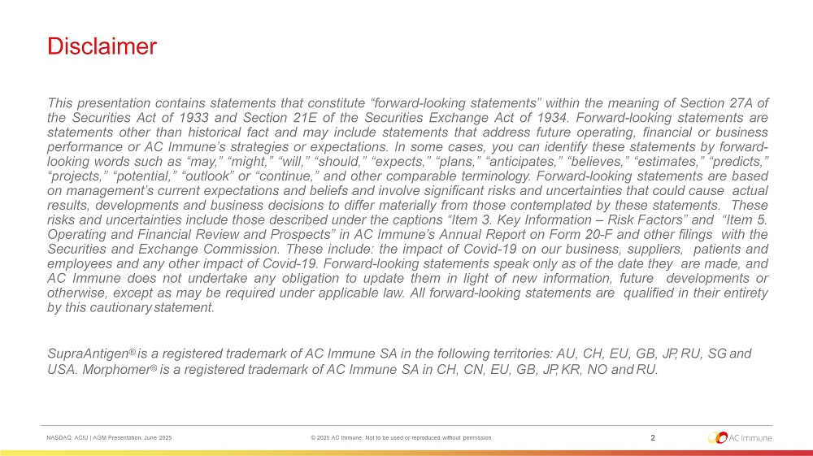
Disclaimer 2 NASDAQ: ACIU | AGM Presentation, June 2025 © 2025 AC Immune. Not to be used or reproduced without permission This presentation contains statements that constitute “forward - looking statements” within the meaning of Section 27 A of the Securities Act of 1933 and Section 21 E of the Securities Exchange Act of 1934 . Forward - looking statements are statements other than historical fact and may include statements that address future operating, financial or business performance or AC Immune’s strategies or expectations . In some cases, you can identify these statements by forward - looking words such as “may,” “might,” “will,” “should,” “expects,” “plans,” “anticipates,” “believes,” “estimates,” “predicts,” “projects,” “potential,” “outlook” or “continue,” and other comparable terminology . Forward - looking statements are based on management’s current expectations and beliefs and involve significant risks and uncertainties that could cause actual results, developments and business decisions to differ materially from those contemplated by these statements . These risks and uncertainties include those described under the captions “Item 3 . Key Information – Risk Factors” and “Item 5 . Operating and Financial Review and Prospects” in AC Immune’s Annual Report on Form 20 - F and other filings with the Securities and Exchange Commission . These include : the impact of Covid - 19 on our business, suppliers, patients and employees and any other impact of Covid - 19 . Forward - looking statements speak only as of the date they are made, and AC Immune does not undertake any obligation to update them in light of new information, future developments or otherwise, except as may be required under applicable law . All forward - looking statements are qualified in their entirety by this cautionary statement . SupraAntigen ® is a registered trademark of AC Immune SA in the following territories : AU, CH, EU, GB, JP, RU, SG and USA . Morphomer ® is a registered trademark of AC Immune SA in CH, CN, EU, GB, JP, KR, NO and RU .
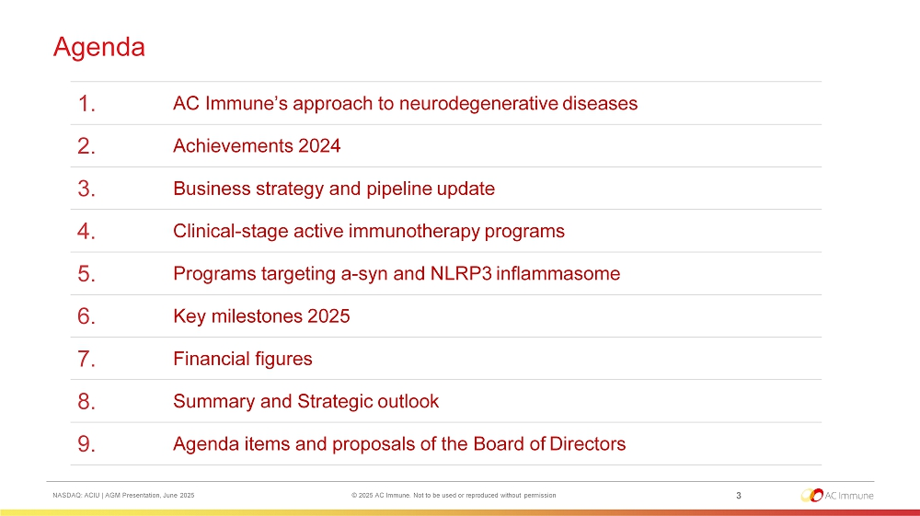
Agenda 3 NASDAQ: ACIU | AGM Presentation, June 2025 © 2025 AC Immune. Not to be used or reproduced without permission AC Immune’s approach to neurodegenerative diseases 1. Achievements 2024 2. Business strategy and pipeline update 3. Clinical - stage active immunotherapy programs 4. Programs targeting a - syn and NLRP3 inflammasome 5. Key milestones 2025 6. Financial figures 7. Summary and Strategic outlook 8. Agenda items and proposals of the Board of Directors 9.
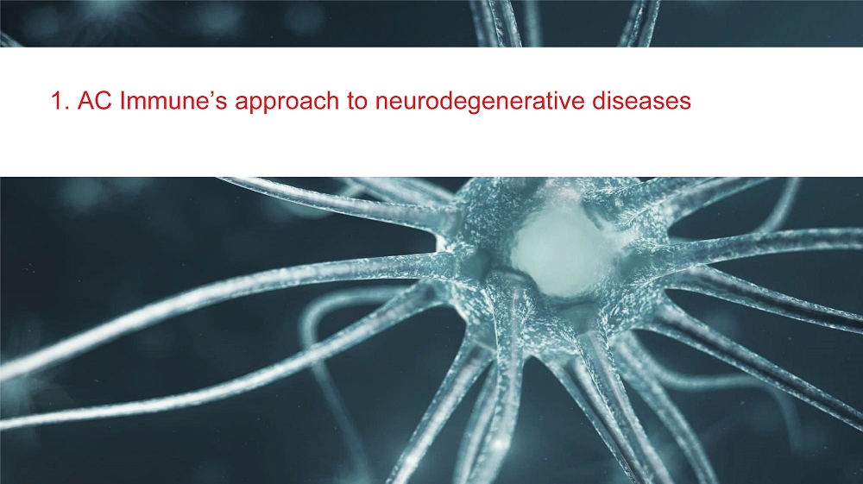
1. AC Immune’s approach to neurodegenerative diseases
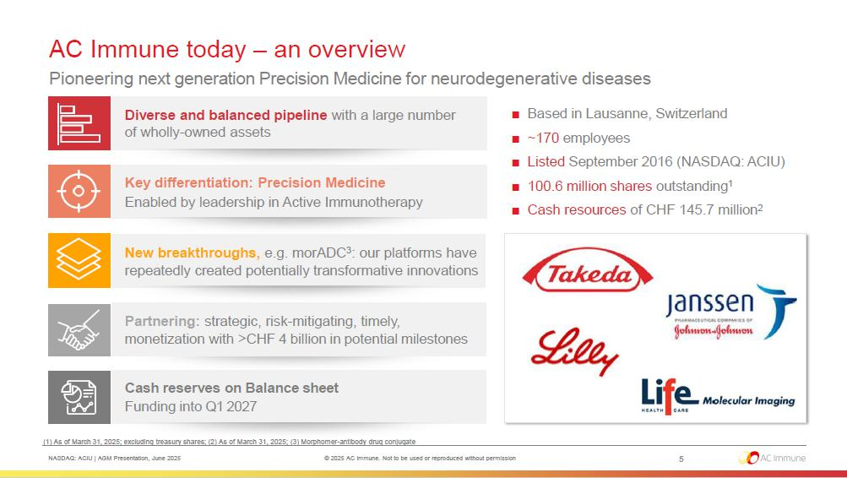
AC Immune today – an overview Pioneering next generation Precision Medicine for neurodegenerative diseases ■ Based in Lausanne, Switzerland ■ ~170 employees ■ Listed September 2016 (NASDAQ: ACIU) ■ 100.6 million shares outstanding 1 ■ Cash resources of CHF 145.7 million 2 Diverse and balanced pipeline with a large number of wholly - owned assets Key differentiation: Precision Medicine Enabled by leadership in Active Immunotherapy New breakthroughs, e.g. morADC 3 : our platforms have repeatedly created potentially transformative innovations Partnering: strategic, risk - mitigating, timely, monetization with >CHF 4 billion in potential milestones Cash reserves on Balance sheet Funding into Q1 2027 (1) As of March 31, 2025; excluding treasury shares; (2) As of March 31, 2025; (3) Morphomer - antibody drug conjugate 5 NASDAQ: ACIU | AGM Presentation, June 2025 © 2025 AC Immune. Not to be used or reproduced without permission
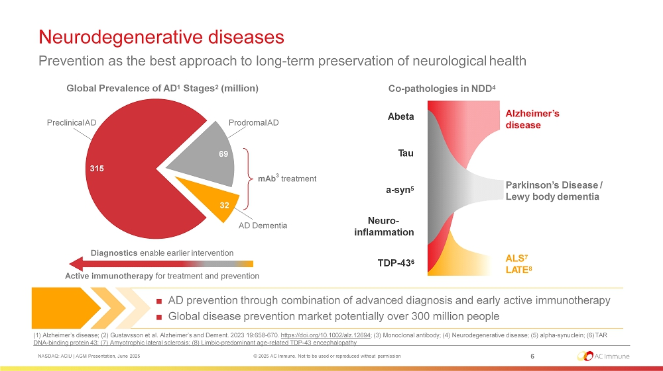
Neurodegenerative diseases mAb 3 treatment 315 69 32 Active immunotherapy for treatment and prevention Diagnostics enable earlier intervention Preclinical AD Prodromal AD AD Dementia A beta T au a - syn 5 TDP - 43 6 Neuro - i n fl ammat io n ALS 7 L A T E 8 Parkinson’s Disease / Lewy body dementia Alzheimer’s disease ■ AD prevention through combination of advanced diagnosis and early active immunotherapy ■ Global disease prevention market potentially over 300 million people (1) Alzheimer’s disease; (2) Gustavsson et al. Alzheimer’s and Dement. 2023 19:658 - 670. https://doi.org/10.1002/alz.12694 ; (3) Monoclonal antibody; (4) Neurodegenerative disease; (5) alpha - synuclein; (6) TAR DNA - binding protein 43; (7) Amyotrophic lateral sclerosis; (8) Limbic - predominant age - related TDP - 43 encephalopathy 6 NASDAQ: ACIU | AGM Presentation, June 2025 © 2025 AC Immune. Not to be used or reproduced without permission Prevention as the best approach to long - term preservation of neurological health Global Prevalence of AD 1 Stages 2 (million) Co - pathologies in NDD 4

2. Achievements 2024
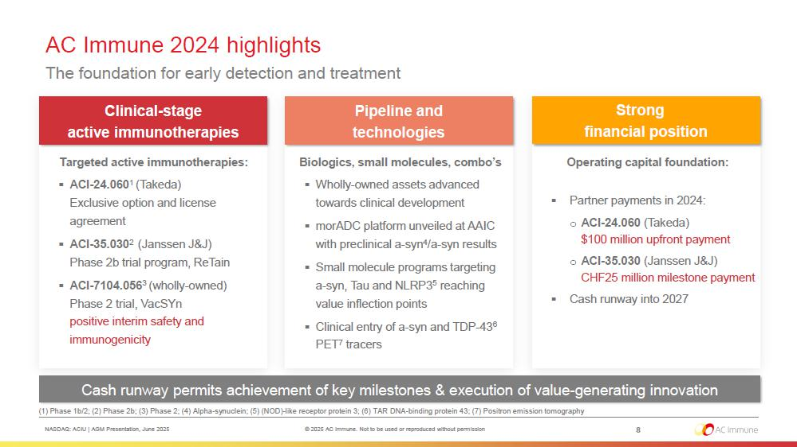
AC Immune 2024 highlights The foundation for early detection and treatment 8 Cash runway permits achievement of key milestones & execution of value - generating innovation Strong financial position (1) Phase 1b/2; (2) Phase 2b; (3) Phase 2; (4) Alpha - synuclein; (5) (NOD) - like receptor protein 3; (6) TAR DNA - binding protein 43; (7) Positron emission tomography NASDAQ: ACIU | AGM Presentation, June 2025 © 2025 AC Immune. Not to be used or reproduced without permission Targeted active immunotherapies: ▪ ACI - 24.060 1 (Takeda) Exclusive option and license agreement ▪ ACI - 35.030 2 (Janssen J&J) Phase 2b trial program, ReTain ▪ ACI - 7104.056 3 (wholly - owned) Phase 2 trial, VacSYn positive interim safety and immunogenicity Operating capital foundation: ▪ Partner payments in 2024: o ACI - 24.060 (Takeda) $100 million upfront payment o ACI - 35.030 (Janssen J&J) CHF25 million milestone payment ▪ Cash runway into 2027 Biologics, small molecules, combo’s ▪ Wholly - owned assets advanced towards clinical development ▪ morADC platform unveiled at AAIC with preclinical a - syn 4 /a - syn results ▪ Small molecule programs targeting a - syn, Tau and NLRP3 5 reaching value inflection points ▪ Clinical entry of a - syn and TDP - 43 6 PET 7 tracers Clinical - stage active immunotherapies Pipeline and te c h n o l o g ies

3. Business strategy and pipeline update
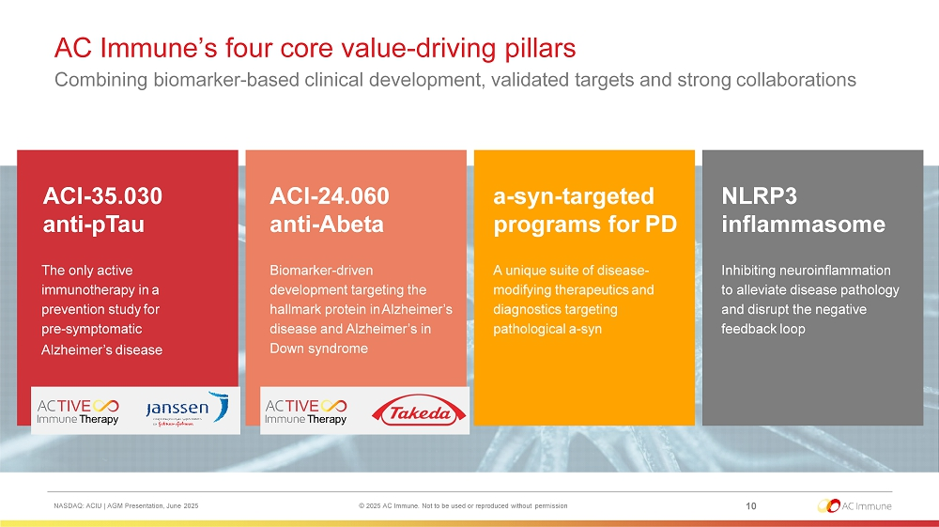
AC Immune’s four core value - driving pillars Combining biomarker - based clinical development, validated targets and strong collaborations The only active immunotherapy in a prevention study for pre - symptomatic Alzheimer’s disease ACI - 35.030 anti - pTau Biomarker - driven development targeting the hallmark protein in Alzheimer’s disease and Alzheimer’s in Down syndrome ACI - 24.060 anti - Abeta A unique suite of disease - modifying therapeutics and diagnostics targeting pathological a - syn a - syn - targeted programs for PD Inhibiting neuroinflammation to alleviate disease pathology and disrupt the negative feedback loop NLRP3 in f lammasome 10 NASDAQ: ACIU | AGM Presentation, June 2025 © 2025 AC Immune. Not to be used or reproduced without permission
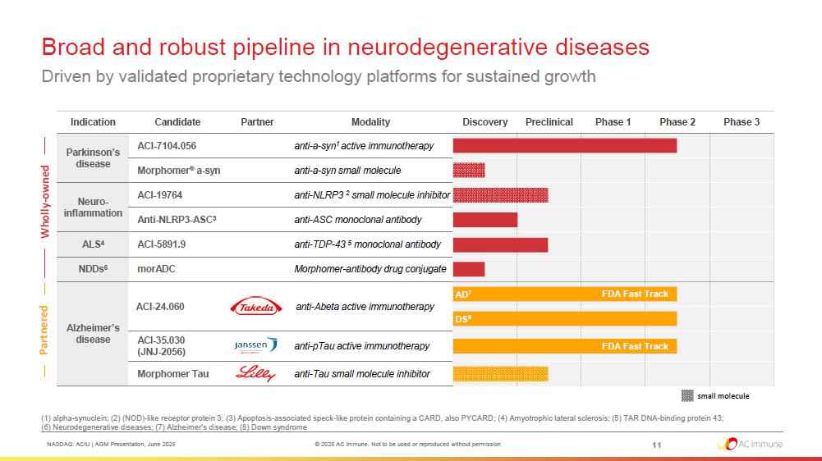
Indication Candidate Partner Mo d al i ty Discovery Prec linical Phase 1 Phase 2 Phase 3 Parkinson’s disease A C I - 7104 . 05 6 anti - a - syn 1 active immunotherapy Morphomer ® a - syn anti - a - syn small molecule Neuro - inflammation ACI - 19764 anti - NLRP3 2 small molecule inhibitor Anti - NLRP3 - ASC 3 anti - ASC monoclonal antibody ALS 4 A C I - 5891 .9 anti - TDP - 43 5 monoclonal antibody NDDs 6 mor A D C Morphomer - antibody drug conjugate A lzh e i mer ’ s disease A CI - 24 . 06 0 anti - Abeta active immunotherapy A C I - 35 . 03 0 ( J N J - 2056) anti - pTau active immunotherapy Morphomer Tau anti - Tau small molecule inhibitor Broad and robust pipeline in neurodegenerative diseases Driven by validated proprietary technology platforms for sustained growth Who lly - owned P a r tner e d DS 8 FDA Fast Track AD 7 FDA Fast Track small molecule (1) alpha - synuclein; (2) (NOD) - like receptor protein 3; (3) Apoptosis - associated speck - like protein containing a CARD, also PYCARD; (4) Amyotrophic lateral sclerosis; (5) TAR DNA - binding protein 43; (6) Neurodegenerative diseases; (7) Alzheimer’s disease; (8) Down syndrome 11 NASDAQ: ACIU | AGM Presentation, June 2025 © 2025 AC Immune. Not to be used or reproduced without permission
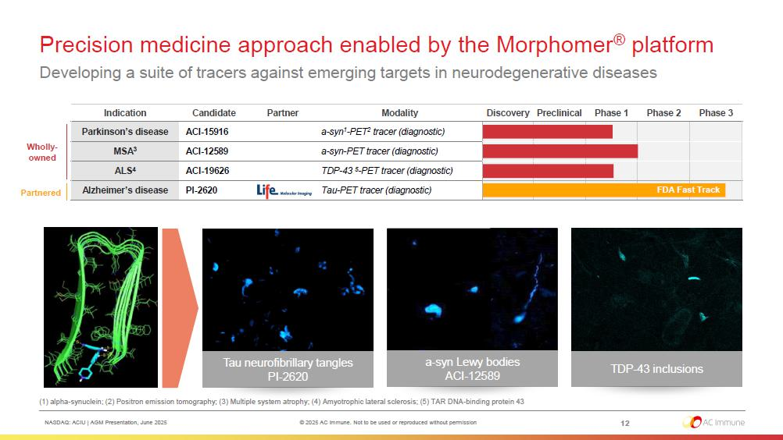
Precision medicine approach enabled by the Morphomer ® platform Developing a suite of tracers against emerging targets in neurodegenerative diseases (1) alpha - synuclein; (2) Positron emission tomography; (3) Multiple system atrophy; (4) Amyotrophic lateral sclerosis; (5) TAR DNA - binding protein 43 Who ll y - o w n ed P ar t ne red TDP - 43 inclusions a - syn Lewy bodies ACI - 12589 Tau neurofibrillary tangles PI - 2620 Phase 3 Phase 2 Phase 1 Preclinical Discovery Modality Partner Candidate Indication a - syn 1 - PET 2 tracer (diagnostic) ACI - 15916 Parkinson’s disease a - syn - PET tracer (diagnostic) ACI - 12589 MSA 3 TDP - 43 5 - PET tracer (diagnostic) ACI - 19626 ALS 4 Track FDA Fast Tau - PET tracer (diagnostic) PI - 2620 Alzheimer’s disease 12 NASDAQ: ACIU | AGM Presentation, June 2025 © 2025 AC Immune. Not to be used or reproduced without permission
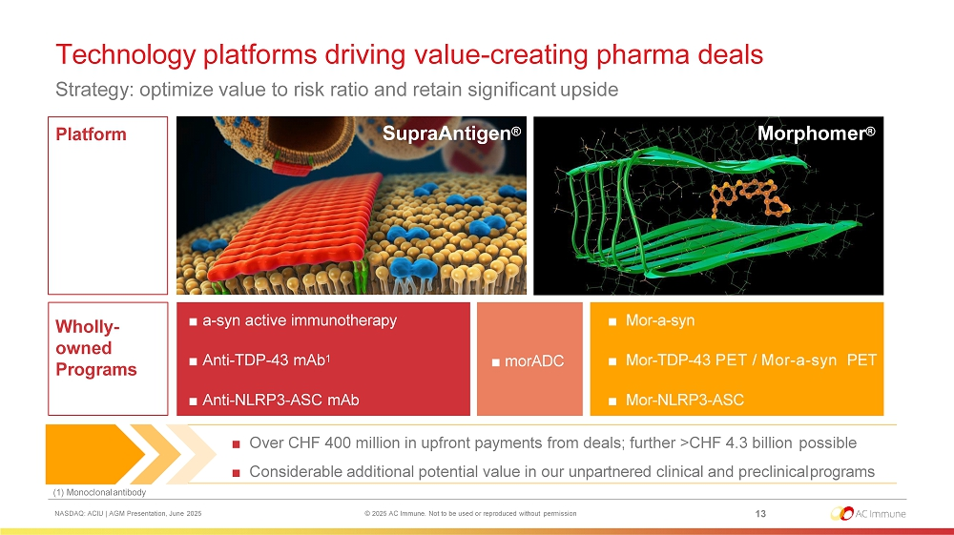
Technology platforms driving value - creating pharma deals Strategy: optimize value to risk ratio and retain significant upside ■ Over CHF 400 million in upfront payments from deals; further >CHF 4.3 billion possible ■ Considerable additional potential value in our unpartnered clinical and preclinical programs (1) Monoclonal antibody 13 NASDAQ: ACIU | AGM Presentation, June 2025 © 2025 AC Immune. Not to be used or reproduced without permission Platform Wholly - owned P r og ram s SupraAntigen ® Morphomer ® ■ a - syn active immunotherapy ■ Anti - TDP - 43 mAb 1 ■ Anti - NLRP3 - ASC mAb ■ Mor - a - syn ■ Mor - TDP - 43 PET / Mor - a - syn PET ■ Mor - NLRP3 - ASC ■ morADC
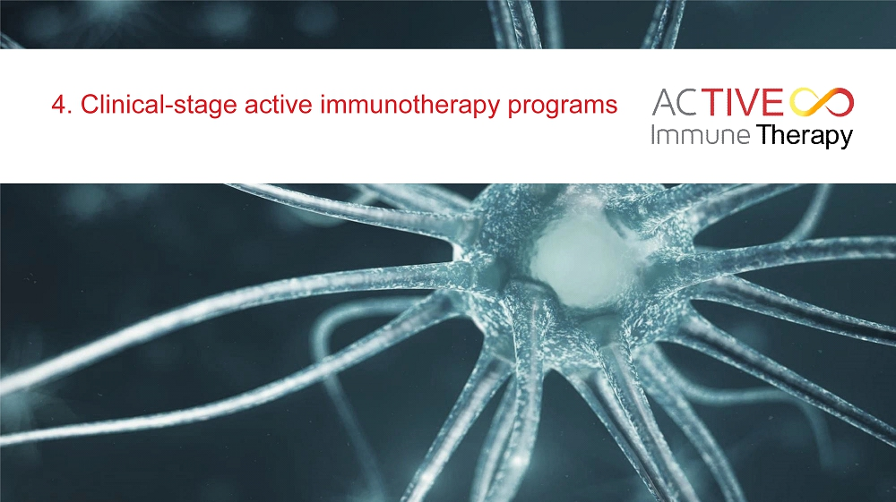
4. Clinical - stage active immunotherapy programs
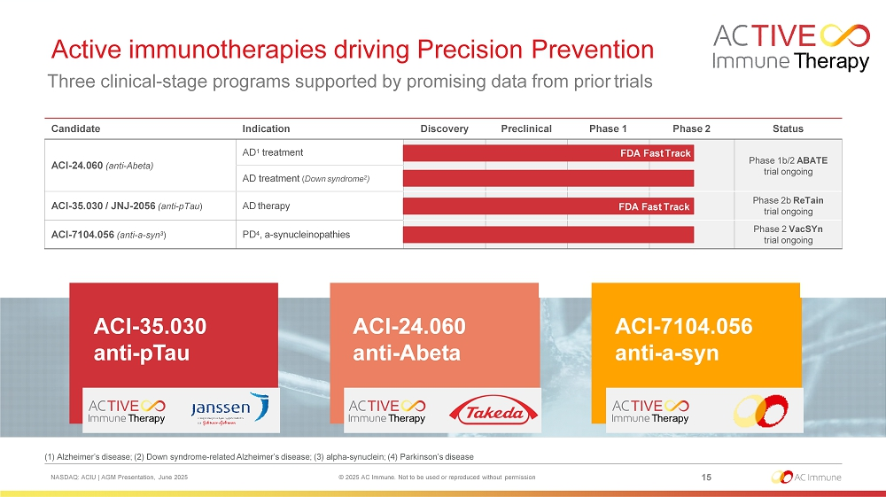
(1) Alzheimer’s disease; (2) Down syndrome - related Alzheimer’s disease; (3) alpha - synuclein; (4) Parkinson’s disease NASDAQ: ACIU | AGM Presentation, June 2025 © 2025 AC Immune. Not to be used or reproduced without permission 15 Active immunotherapies driving Precision Prevention Three clinical - stage programs supported by promising data from prior trials ACI - 35.030 anti - pTau ACI - 24.060 anti - Abeta ACI - 7104.056 anti - a - syn Candidate Indication Discovery Prec linical Status ACI - 24.060 (anti - Abeta) AD 1 treatment Phase 1b/2 ABATE trial ongoing AD treatment ( Down syndrome 2 ) ACI - 35.030 / JNJ - 2056 (anti - pTau ) AD therapy Phase 2b ReTain trial ongoing ACI - 7104.056 (anti - a - syn 3 ) PD 4 , a - synucleinopathies Phase 2 VacSYn trial ongoing Phase 1 Phase 2 FDA Fast Track FDA Fast Track
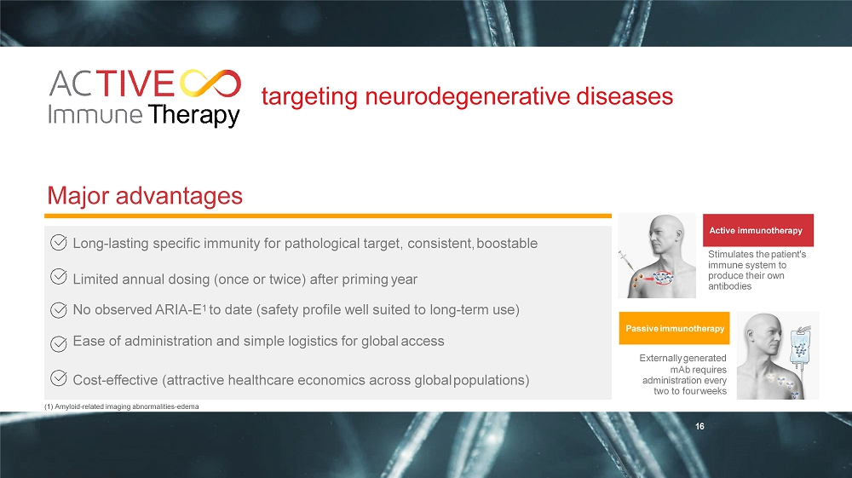
targeting neurodegenerative diseases Long - lasting specific immunity for pathological target, consistent, boostable Limited annual dosing (once or twice) after priming year No observed ARIA - E 1 to date (safety profile well suited to long - term use) Ease of administration and simple logistics for global access Cost - effective (attractive healthcare economics across global populations) Active immunotherapy Stimulates the patient's immune system to produce their own antibodies Passive immunotherapy Externally generated mAb requires administration every two to four weeks Major advantages (1) Amyloid - related imaging abnormalities - edema 16
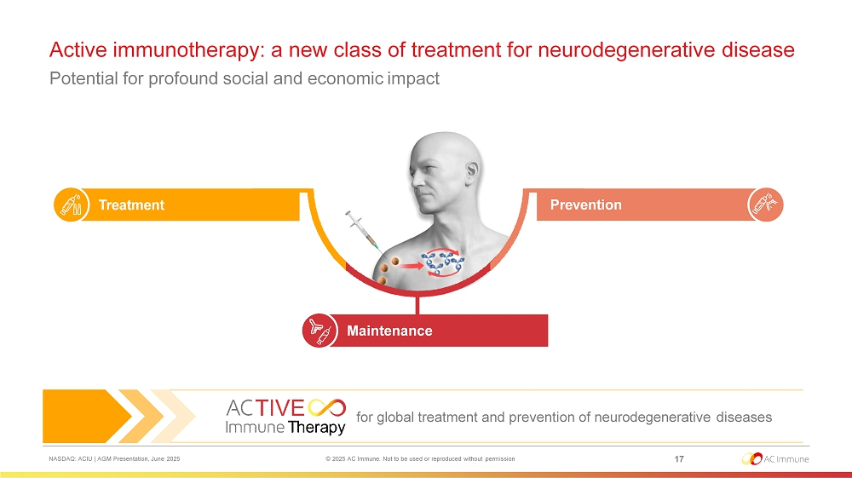
NASDAQ: ACIU | AGM Presentation, June 2025 © 2025 AC Immune. Not to be used or reproduced without permission 17 Active immunotherapy: a new class of treatment for neurodegenerative disease Potential for profound social and economic impact Treatment Maintenance Prevention for global treatment and prevention of neurodegenerative diseases
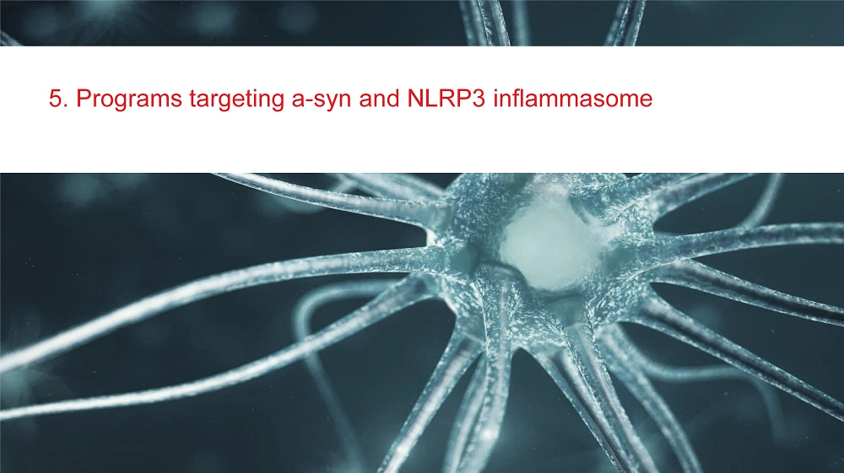
5. Programs targeting a - syn and NLRP3 inflammasome
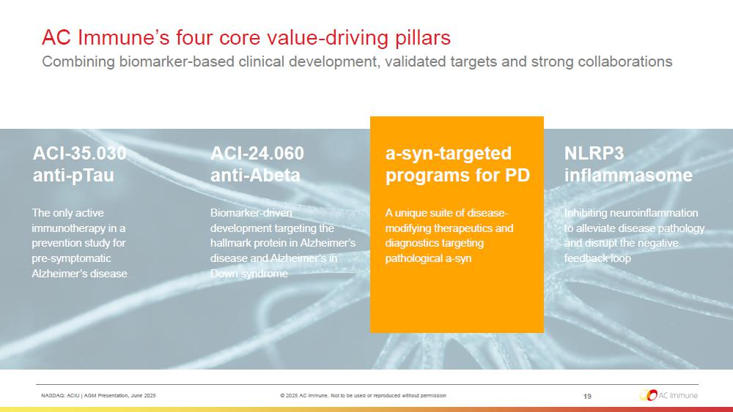
AC Immune’s four core value - driving pillars Combining biomarker - based clinical development, validated targets and strong collaborations The only active immunotherapy in a prevention study for pre - symptomatic Alzheimer’s disease 19 NASDAQ: ACIU | AGM Presentation, June 2025 © 2025 AC Immune. Not to be used or reproduced without permission ACI - 35.030 anti - pTau Biomarker - driven development targeting the hallmark protein in Alzheimer’s disease and Alzheimer’s in Down syndrome ACI - 24.060 anti - Abeta A unique suite of disease - modifying therapeutics and diagnostics targeting pathological a - syn a - syn - targeted programs for PD Inhibiting neuroinflammation to alleviate disease pathology and disrupt the negative feedback loop NLRP3 in f lammasome
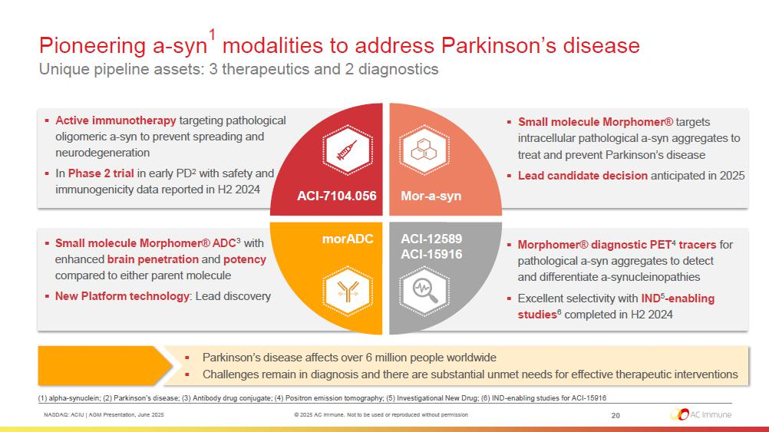
▪ Active immunotherapy targeting pathological oligomeric a - syn to prevent spreading and neurodegeneration ▪ In Phase 2 trial in early PD 2 with safety and immunogenicity data reported in H2 2024 ▪ Morphomer® diagnostic PET 4 tracers for pathological a - syn aggregates to detect and differentiate a - synucleinopathies ▪ Excellent selectivity with IND 5 - enabling studies 6 completed in H2 2024 Pioneering a - syn 1 modalities to address Parkinson’s disease Unique pipeline assets: 3 therapeutics and 2 diagnostics ▪ Small molecule Morphomer® ADC 3 with enhanced brain penetration and potency compared to either parent molecule ▪ New Platform technology : Lead discovery ACI - 7104.056 ▪ Small molecule Morphomer® targets intracellular pathological a - syn aggregates to treat and prevent Parkinson’s disease ▪ Lead candidate decision anticipated in 2025 Mor - a - syn A CI - 12589 A CI - 15916 morADC ▪ Parkinson’s disease affects over 6 million people worldwide ▪ Challenges remain in diagnosis and there are substantial unmet needs for effective therapeutic interventions (1) alpha - synuclein; (2) Parkinson’s disease; (3) Antibody drug conjugate; (4) Positron emission tomography; (5) Investigational New Drug; (6) IND - enabling studies for ACI - 15916 20 NASDAQ: ACIU | AGM Presentation, June 2025 © 2025 AC Immune. Not to be used or reproduced without permission
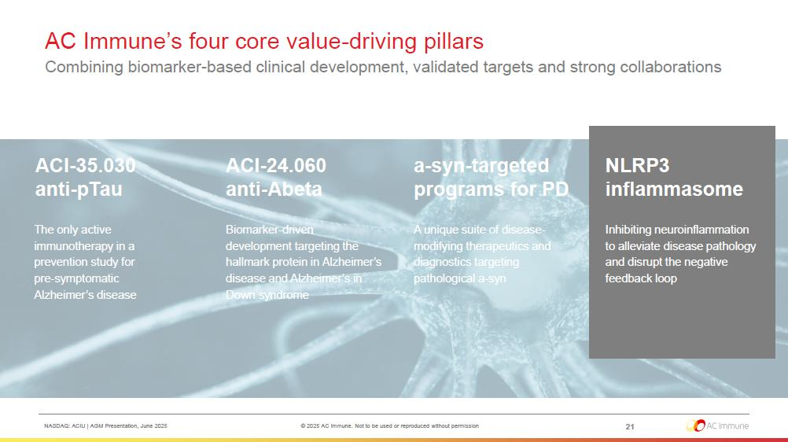
AC Immune’s four core value - driving pillars Combining biomarker - based clinical development, validated targets and strong collaborations The only active immunotherapy in a prevention study for pre - symptomatic Alzheimer’s disease 21 NASDAQ: ACIU | AGM Presentation, June 2025 © 2025 AC Immune. Not to be used or reproduced without permission ACI - 35.030 anti - pTau Biomarker - driven development targeting the hallmark protein in Alzheimer’s disease and Alzheimer’s in Down syndrome ACI - 24.060 anti - Abeta A unique suite of disease - modifying therapeutics and diagnostics targeting pathological a - syn a - syn - targeted programs for PD Inhibiting neuroinflammation to alleviate disease pathology and disrupt the negative feedback loop NLRP3 in f lammasome
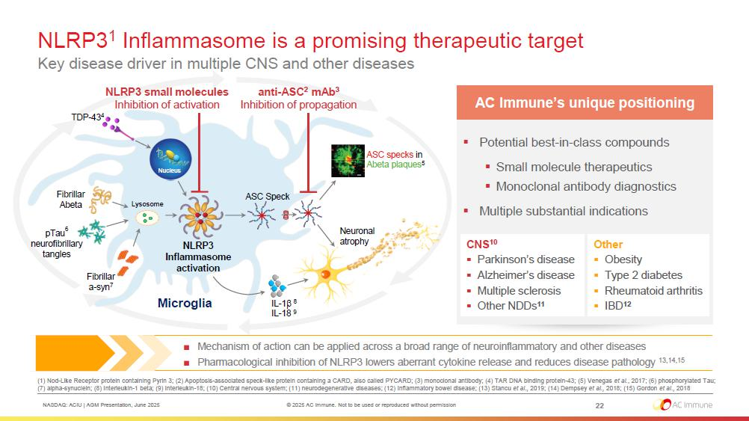
NLRP3 1 Inflammasome is a promising therapeutic target Key disease driver in multiple CNS and other diseases ■ Mechanism of action can be applied across a broad range of neuroinflammatory and other diseases ■ Pharmacological inhibition of NLRP3 lowers aberrant cytokine release and reduces disease pathology 13,14,15 (1) Nod - Like Receptor protein containing Pyrin 3; (2) Apoptosis - associated speck - like protein containing a CARD, also called PYCARD; (3) monoclonal antibody; (4) TAR DNA binding protein - 43; (5) Venegas et al. , 2017; (6) phosphorylated Tau; (7) alpha - synuclein; (8) Interleukin - 1 beta; (9) Interleukin - 18; (10) Central nervous system; (11) neurodegenerative diseases; (12) Inflammatory bowel disease; (13) Stancu et al., 2019; (14) Dempsey et al., 2018; (15) Gordon et al., 2018 TDP - 43 4 F i bri ll ar Abeta pTau 6 neu r o f i bri ll ary tangles Neuronal atrophy F i bri ll ar a - syn 7 Nucleus ASC Speck Micro g lia NLRP3 Inflammasome activation anti - ASC 2 mAb 3 Inhibition of propagation NLRP3 small molecules Inhibition of activation ASC specks in Abeta plaques 5 L y s o s o m e IL - 1  8 IL - 18 9 ▪ Potential best - in - class compounds ▪ Small molecule therapeutics ▪ Monoclonal antibody diagnostics ▪ Multiple substantial indications 22 NASDAQ: ACIU | AGM Presentation, June 2025 © 2025 AC Immune. Not to be used or reproduced without permission AC Immune’s unique positioning CNS 10 ▪ Parkinson’s disease ▪ Alzheimer’s disease ▪ Multiple sclerosis ▪ Other NDDs 11 Other ▪ Obesity ▪ Type 2 diabetes ▪ Rheumatoid arthritis ▪ IBD 12
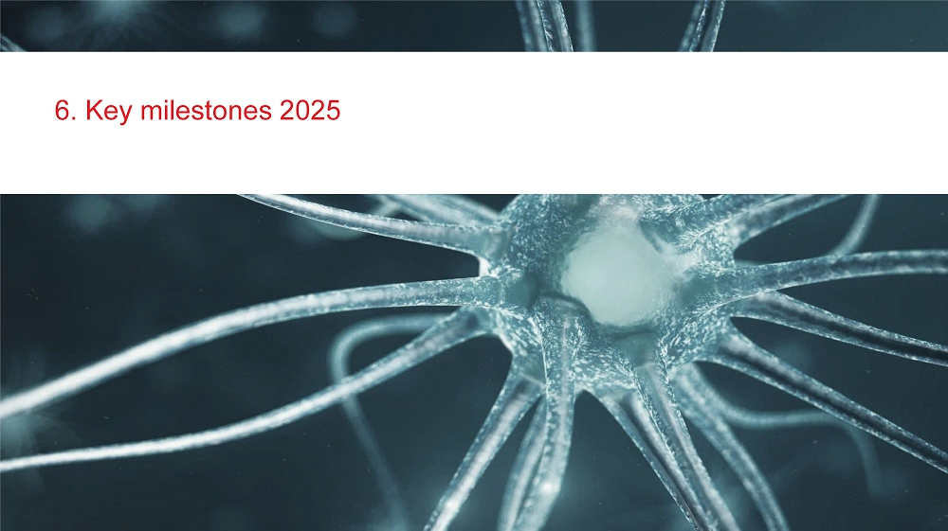
6. Key milestones 2025
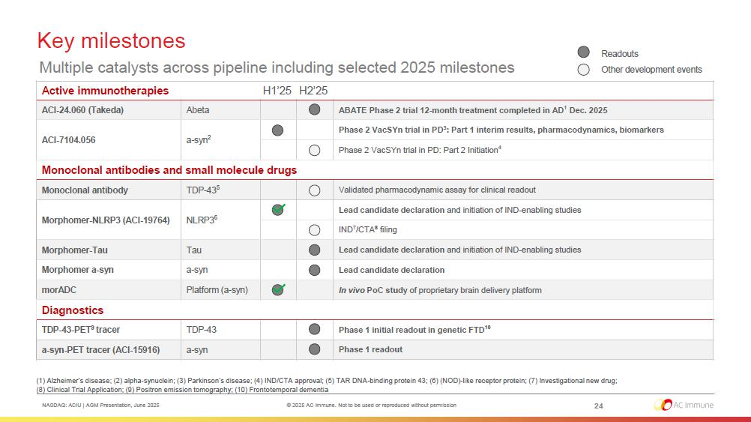
NASDAQ: ACIU | AGM Presentation, June 2025 © 2025 AC Immune. Not to be used or reproduced without permission H2’25 H1’25 Active immunotherapies ABATE Phase 2 trial 12 - month treatment completed in AD 1 Dec. 2025 Abeta ACI - 24.060 (Takeda) Phase 2 VacSYn trial in PD 3 : Part 1 interim results, pharmacodynamics, biomarkers a - syn 2 ACI - 7104.056 Phase 2 VacSYn trial in PD: Part 2 Initiation 4 Monoclonal antibodies and small molecule drugs Validated pharmacodynamic assay for clinical readout TDP - 43 5 Monoclonal antibody Lead candidate declaration and initiation of IND - enabling studies NLRP3 6 Morphomer - NLRP3 (ACI - 19764) IND 7 /CTA 8 filing Lead candidate declaration and initiation of IND - enabling studies Tau Morphomer - Tau Lead candidate declaration a - syn Morphomer a - syn In vivo PoC study of proprietary brain delivery platform Platform (a - syn) morADC Diagnostics Phase 1 initial readout in genetic FTD 10 TDP - 43 TDP - 43 - PET 9 tracer Phase 1 readout a - syn a - syn - PET tracer (ACI - 15916) Key milestones Multiple catalysts across pipeline including selected 2025 milestones (1) Alzheimer’s disease; (2) alpha - synuclein; (3) Parkinson’s disease; (4) IND/CTA approval; (5) TAR DNA - binding protein 43; (6) (NOD) - like receptor protein; (7) Investigational new drug; (8) Clinical Trial Application; (9) Positron emission tomography; (10) Frontotemporal dementia 24 Readouts Other development events

7. Financial figures
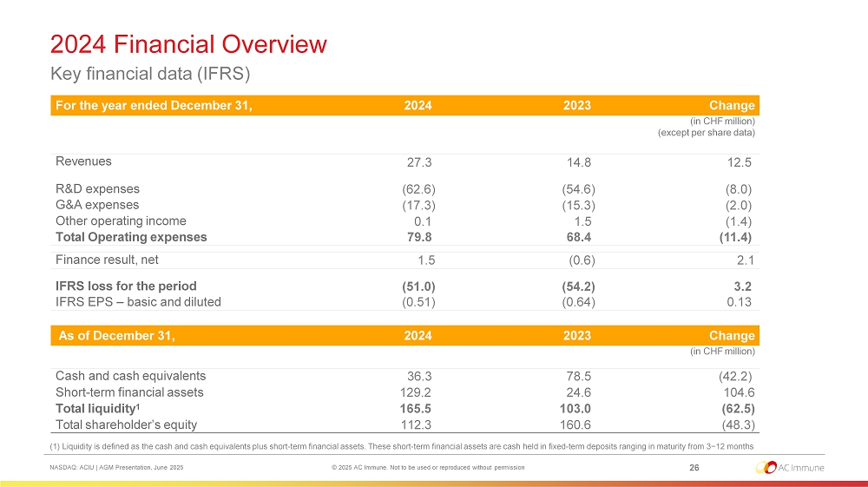
2024 Financial Overview Key financial data (IFRS) 26 NASDAQ: ACIU | AGM Presentation, June 2025 © 2025 AC Immune. Not to be used or reproduced without permission Ch a ng e 2023 2024 For the year ended December 31, (in CHF million) (except per share data) 12 .5 14.8 27 .3 Revenues (8. 0) (54. 6) ( 62 .6) R&D expenses (2. 0) (15. 3) ( 17 .3) G&A expenses (1. 4) 1 .5 0 .1 Other operating income ( 1 1 . 4) 68.4 79 .8 Total Operating expenses 2 .1 (0. 6) 1 .5 Finance result, net 3 .2 (54. 2) ( 51 .0) IFRS loss for the period 0 . 13 (0. 64) (0. 51) IFRS EPS – basic and diluted Ch a ng e 2023 2024 As of December 31, (in CHF million) (42. 2) 78.5 36 .3 Cash and cash equivalents 104.6 24.6 129.2 Short - term financial assets ( 62 .5) 103.0 165.5 Total liquidity 1 ( 48 .3) 160.6 112.3 Total shareholder’s equity (1) Liquidity is defined as the cash and cash equivalents plus short - term financial assets. These short - term financial assets are cash held in fixed - term deposits ranging in maturity from 3−12 months
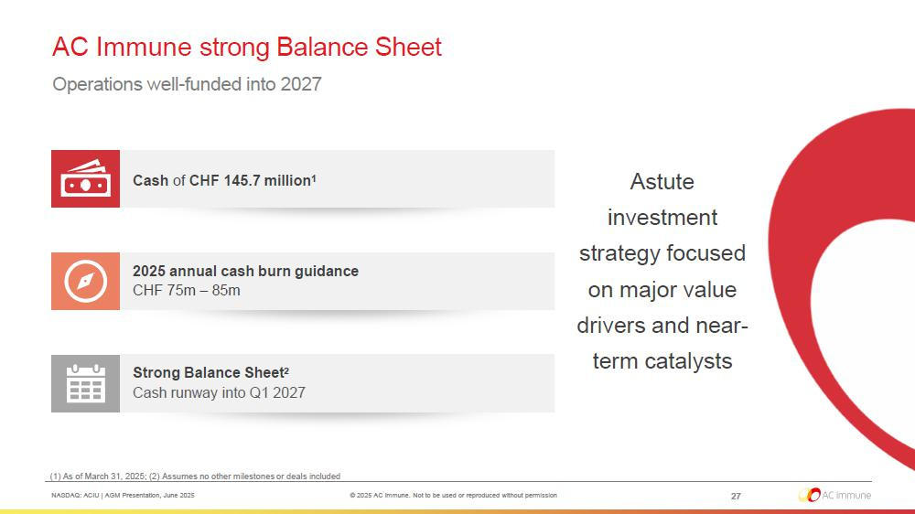
AC Immune strong Balance Sheet Operations well - funded into 2027 Astute investment strategy focused on major value drivers and near - term catalysts Strong Balance Sheet 2 Cash runway into Q1 2027 2025 annual cash burn guidance CHF 75m – 85m Cash of CHF 145.7 million 1 (1) As of March 31, 2025; (2) Assumes no other milestones or deals included 27 NASDAQ: ACIU | AGM Presentation, June 2025 © 2025 AC Immune. Not to be used or reproduced without permission
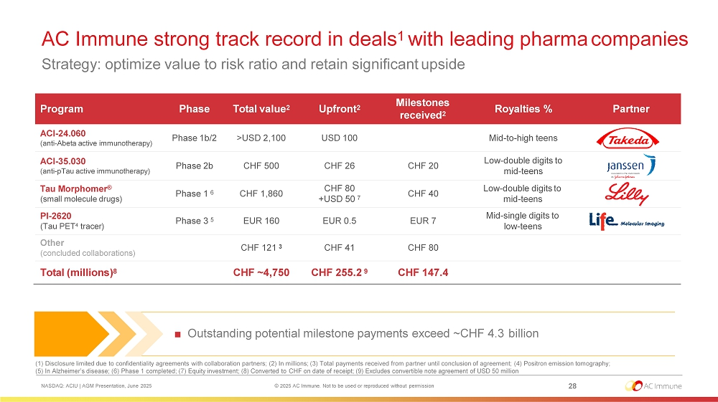
AC Immune strong track record in deals 1 with leading pharma companies Strategy: optimize value to risk ratio and retain significant upside (1) Disclosure limited due to confidentiality agreements with collaboration partners; (2) In millions; (3) Total payments received from partner until conclusion of agreement; (4) Positron emission tomography; (5) In Alzheimer’s disease; (6) Phase 1 completed; (7) Equity investment; (8) Converted to CHF on date of receipt; (9) Excludes convertible note agreement of USD 50 million Partner Royalties % Milestones received 2 Upfront 2 Total value 2 Phase Program Mid - to - high teens USD 100 >USD 2,100 Phase 1b/2 ACI - 24.060 (anti - Abeta active immunotherapy) Low - double digits to mid - teens CHF 20 CHF 26 CHF 500 Phase 2b ACI - 35.030 (anti - pTau active immunotherapy) Low - double digits to mid - teens CHF 40 CHF 80 +USD 50 7 CHF 1,860 Phase 1 6 Tau Morphomer ® (small molecule drugs) Mid - single digits to low - teens EUR 7 EUR 0.5 EUR 160 Phase 3 5 PI - 2620 (Tau PET 4 tracer) CHF 80 CHF 41 CHF 121 3 Other (concluded collaborations) CHF 147.4 CHF 255.2 9 CHF ~4,750 Total (millions) 8 ■ Outstanding potential milestone payments exceed ~CHF 4.3 billion 28 NASDAQ: ACIU | AGM Presentation, June 2025 © 2025 AC Immune. Not to be used or reproduced without permission
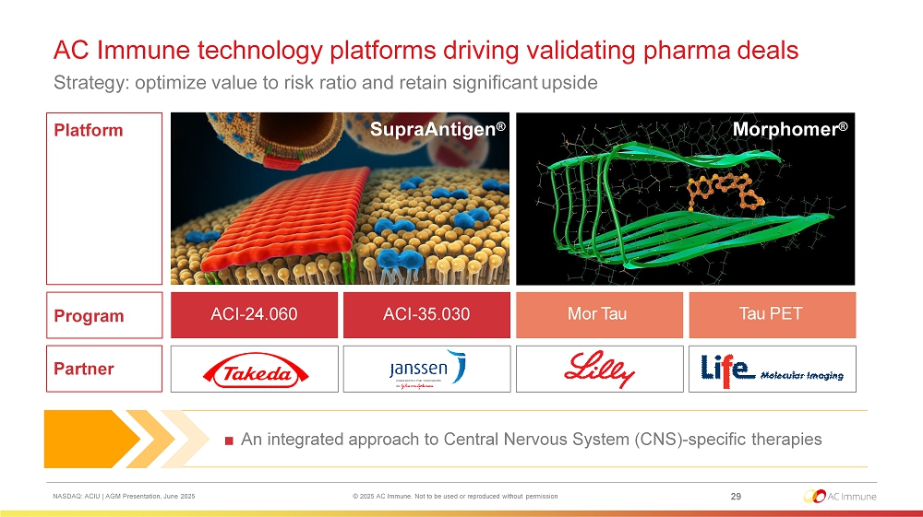
AC Immune technology platforms driving validating pharma deals Strategy: optimize value to risk ratio and retain significant upside ■ An integrated approach to Central Nervous System (CNS) - specific therapies Platform Program Partner A C I - 24 .0 6 0 A C I - 35 .0 3 0 Mor Tau Tau PET SupraAntigen ® Morphomer ® 29 NASDAQ: ACIU | AGM Presentation, June 2025 © 2025 AC Immune. Not to be used or reproduced without permission

8. Summary and Strategic outlook
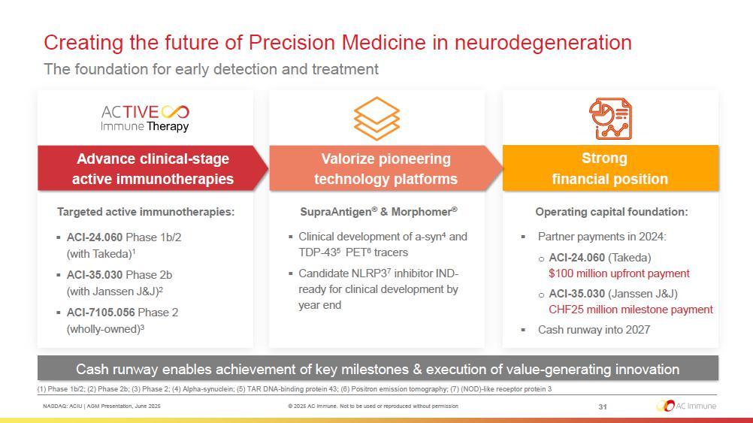
Creating the future of Precision Medicine in neurodegeneration The foundation for early detection and treatment Cash runway enables achievement of key milestones & execution of value - generating innovation Advance clinical - stage active immunotherapies Strong financial position (1) Phase 1b/2; (2) Phase 2b; (3) Phase 2; (4) Alpha - synuclein; (5) TAR DNA - binding protein 43; (6) Positron emission tomography; (7) (NOD) - like receptor protein 3 Targeted active immunotherapies: ▪ ACI - 24.060 Phase 1b/2 (with Takeda) 1 ▪ ACI - 35.030 Phase 2b (with Janssen J&J) 2 ▪ ACI - 7105.056 Phase 2 (wholly - owned) 3 Valorize pioneering technology platforms Operating capital foundation: ▪ Partner payments in 2024: o ACI - 24.060 (Takeda) $100 million upfront payment o ACI - 35.030 (Janssen J&J) CHF25 million milestone payment ▪ Cash runway into 2027 31 NASDAQ: ACIU | AGM Presentation, June 2025 © 2025 AC Immune. Not to be used or reproduced without permission SupraAntigen ® & Morphomer ® ▪ Clinical development of a - syn 4 and TDP - 43 5 PET 6 tracers ▪ Candidate NLRP 3 7 inhibitor IND - ready for clinical development by year end

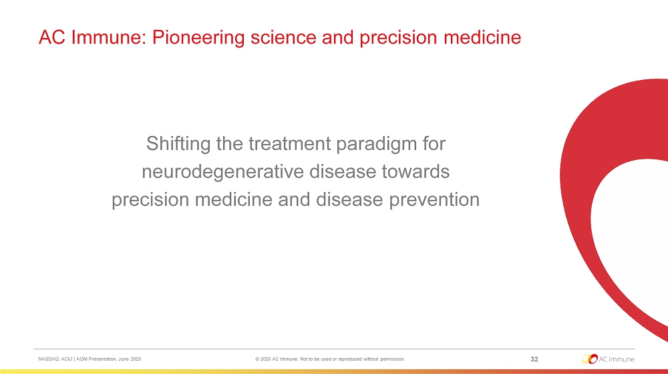
Shifting the treatment paradigm for neurodegenerative disease towards precision medicine and disease prevention 32 NASDAQ: ACIU | AGM Presentation, June 2025 © 2025 AC Immune. Not to be used or reproduced without permission AC Immune: Pioneering science and precision medicine

9. Agenda items and proposals of the Board of Directors
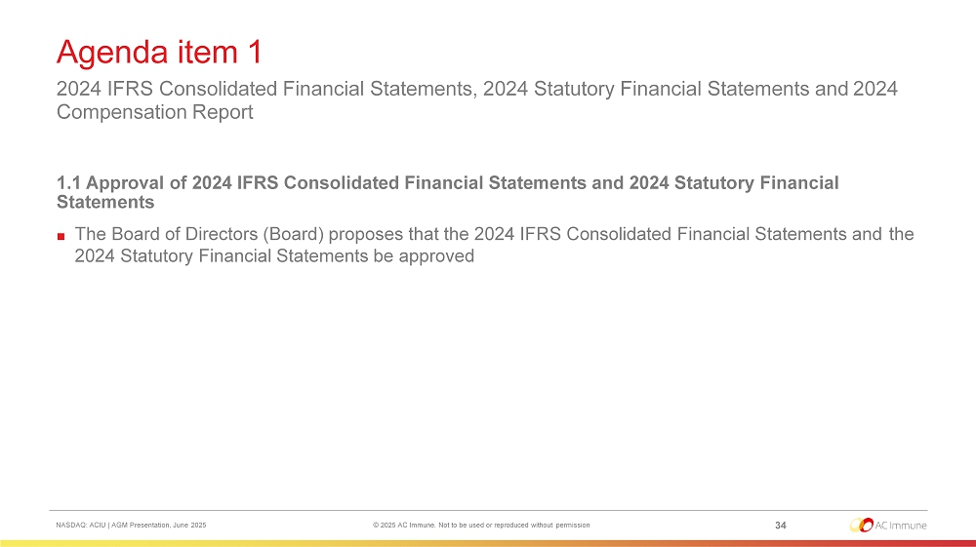
Agenda item 1 34 NASDAQ: ACIU | AGM Presentation, June 2025 © 2025 AC Immune. Not to be used or reproduced without permission 2024 IFRS Consolidated Financial Statements, 2024 Statutory Financial Statements and 2024 Compensation Report 1.1 Approval of 2024 IFRS Consolidated Financial Statements and 2024 Statutory Financial Statements ■ The Board of Directors (Board) proposes that the 2024 IFRS Consolidated Financial Statements and the 2024 Statutory Financial Statements be approved
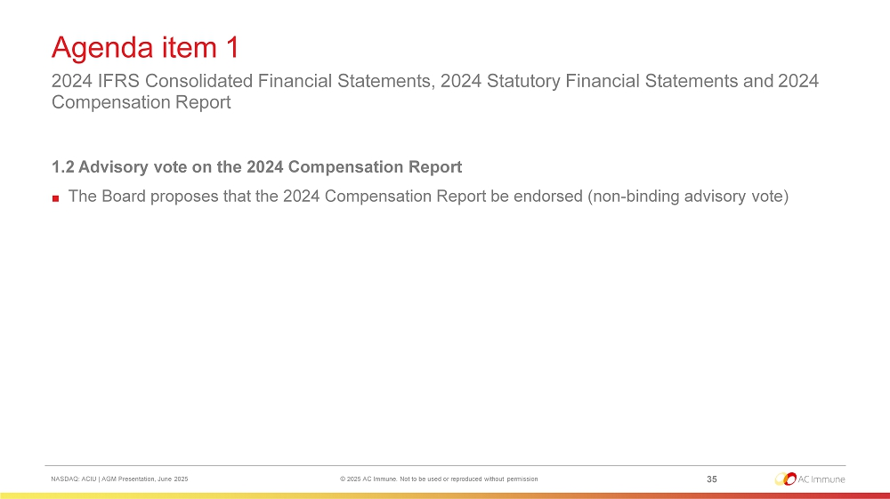
Agenda item 1 35 NASDAQ: ACIU | AGM Presentation, June 2025 © 2025 AC Immune. Not to be used or reproduced without permission 2024 IFRS Consolidated Financial Statements, 2024 Statutory Financial Statements and 2024 Compensation Report 1.2 Advisory vote on the 2024 Compensation Report ■ The Board proposes that the 2024 Compensation Report be endorsed (non - binding advisory vote)
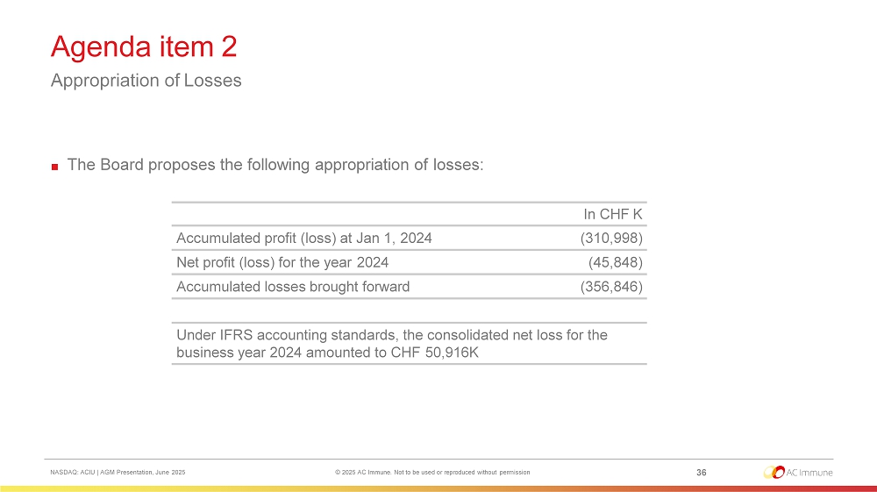
Agenda item 2 Appropriation of Losses 36 NASDAQ: ACIU | AGM Presentation, June 2025 © 2025 AC Immune. Not to be used or reproduced without permission ■ The Board proposes the following appropriation of losses: In CHF K (310,998) Accumulated profit (loss) at Jan 1, 2024 (45,848) Net profit (loss) for the year 2024 (356,846) Accumulated losses brought forward Under IFRS accounting standards, the consolidated net loss for the business year 2024 amounted to CHF 50,916K
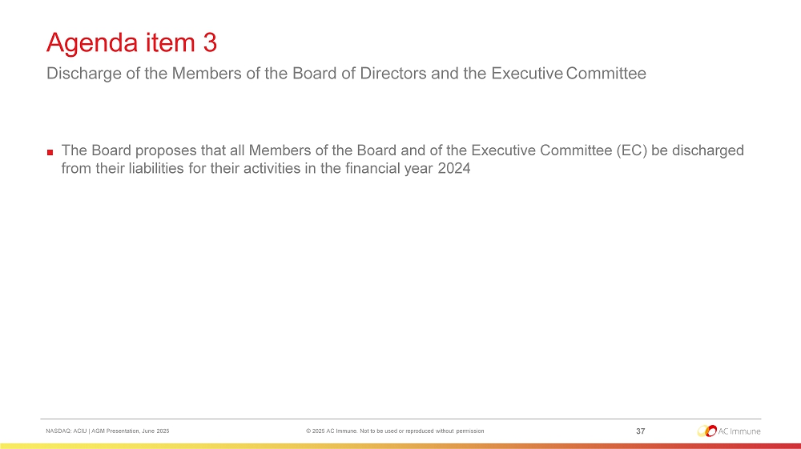
Agenda item 3 Discharge of the Members of the Board of Directors and the Executive Committee 37 NASDAQ: ACIU | AGM Presentation, June 2025 © 2025 AC Immune. Not to be used or reproduced without permission ■ The Board proposes that all Members of the Board and of the Executive Committee (EC) be discharged from their liabilities for their activities in the financial year 2024
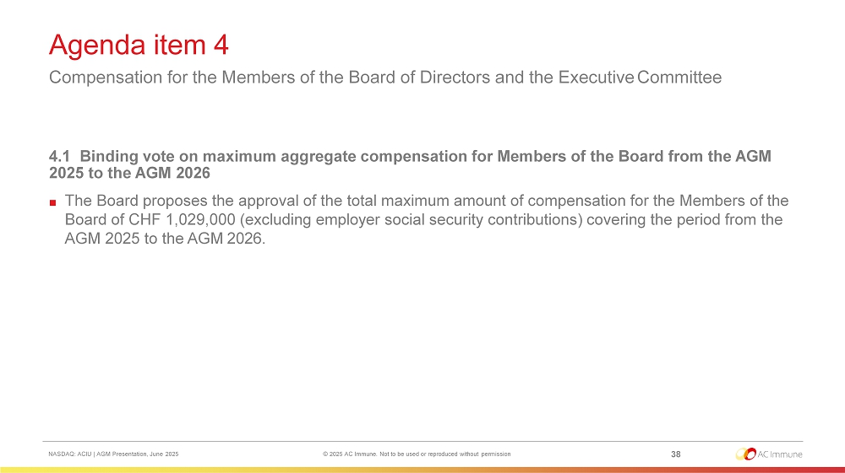
Agenda item 4 Compensation for the Members of the Board of Directors and the Executive Committee 38 NASDAQ: ACIU | AGM Presentation, June 2025 © 2025 AC Immune. Not to be used or reproduced without permission 4.1 Binding vote on maximum aggregate compensation for Members of the Board from the AGM 2025 to the AGM 2026 ■ The Board proposes the approval of the total maximum amount of compensation for the Members of the Board of CHF 1,029,000 (excluding employer social security contributions) covering the period from the AGM 2025 to the AGM 2026.
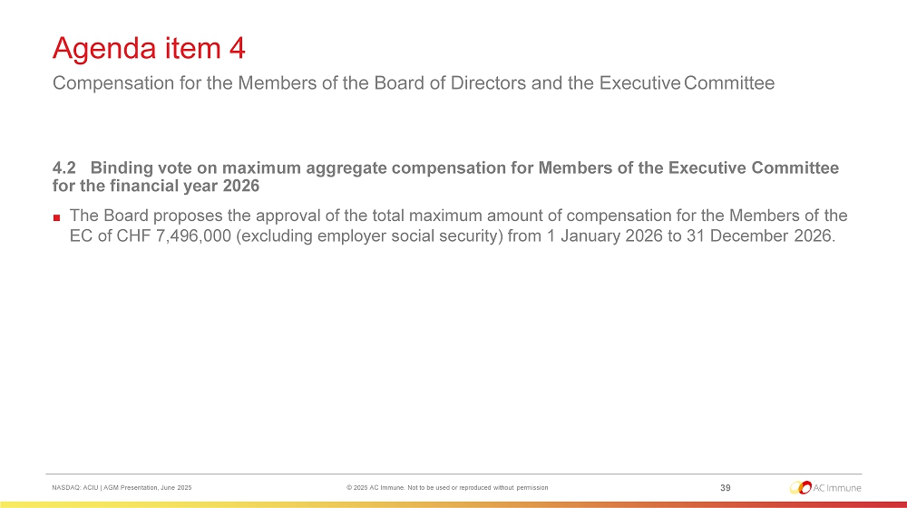
Agenda item 4 Compensation for the Members of the Board of Directors and the Executive Committee 39 NASDAQ: ACIU | AGM Presentation, June 2025 © 2025 AC Immune. Not to be used or reproduced without permission 4.2 Binding vote on maximum aggregate compensation for Members of the Executive Committee for the financial year 2026 ■ The Board proposes the approval of the total maximum amount of compensation for the Members of the EC of CHF 7,496,000 (excluding employer social security) from 1 January 2026 to 31 December 2026.
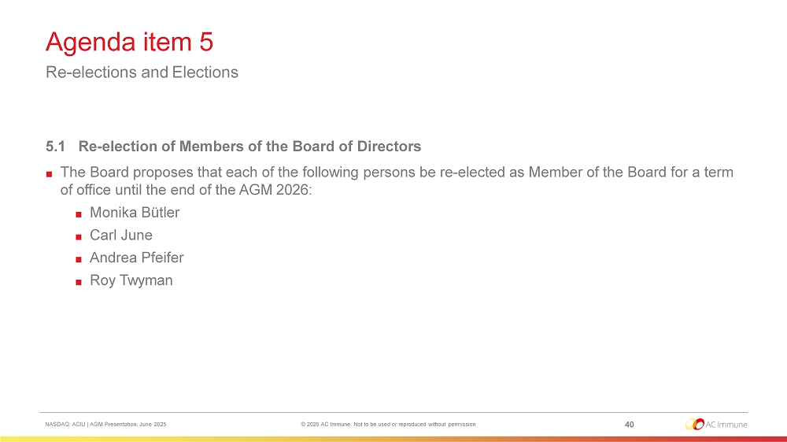
Agenda item 5 Re - elections and Elections 40 NASDAQ: ACIU | AGM Presentation, June 2025 © 2025 AC Immune. Not to be used or reproduced without permission 5.1 Re - election of Members of the Board of Directors ■ The Board proposes that each of the following persons be re - elected as Member of the Board for a term of office until the end of the AGM 2026: ■ Monika Bütler ■ Carl June ■ Andrea Pfeifer ■ Roy Twyman
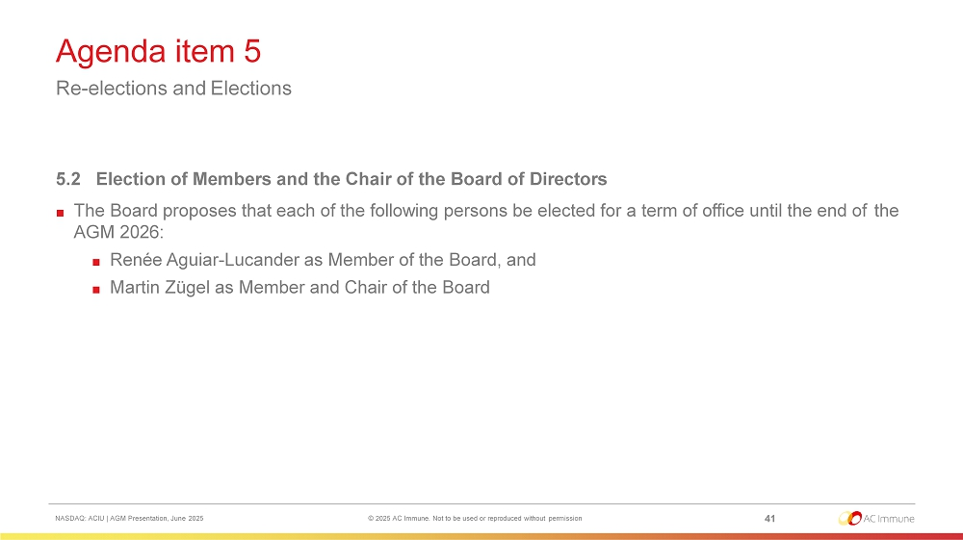
Agenda item 5 Re - elections and Elections 41 NASDAQ: ACIU | AGM Presentation, June 2025 © 2025 AC Immune. Not to be used or reproduced without permission 5.2 Election of Members and the Chair of the Board of Directors ■ The Board proposes that each of the following persons be elected for a term of office until the end of the AGM 2026: ■ Renée Aguiar - Lucander as Member of the Board, and ■ Martin Zügel as Member and Chair of the Board
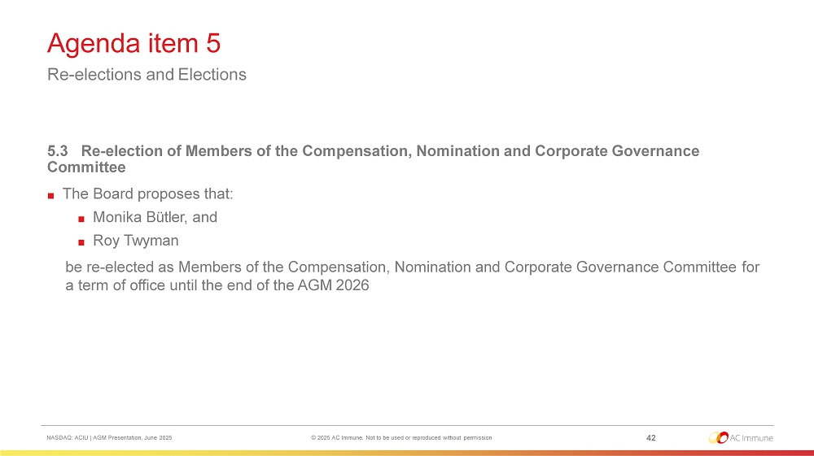
Agenda item 5 Re - elections and Elections 42 NASDAQ: ACIU | AGM Presentation, June 2025 © 2025 AC Immune. Not to be used or reproduced without permission 5.3 Re - election of Members of the Compensation, Nomination and Corporate Governance Committee ■ The Board proposes that: ■ Monika Bütler, and ■ Roy Twyman be re - elected as Members of the Compensation, Nomination and Corporate Governance Committee for a term of office until the end of the AGM 2026
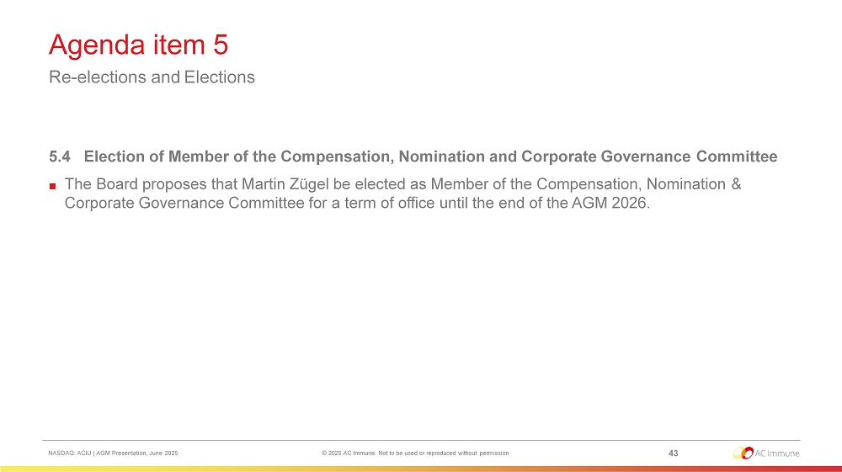
Agenda item 5 Re - elections and Elections 43 NASDAQ: ACIU | AGM Presentation, June 2025 © 2025 AC Immune. Not to be used or reproduced without permission 5.4 Election of Member of the Compensation, Nomination and Corporate Governance Committee ■ The Board proposes that Martin Zügel be elected as Member of the Compensation, Nomination & Corporate Governance Committee for a term of office until the end of the AGM 2026.
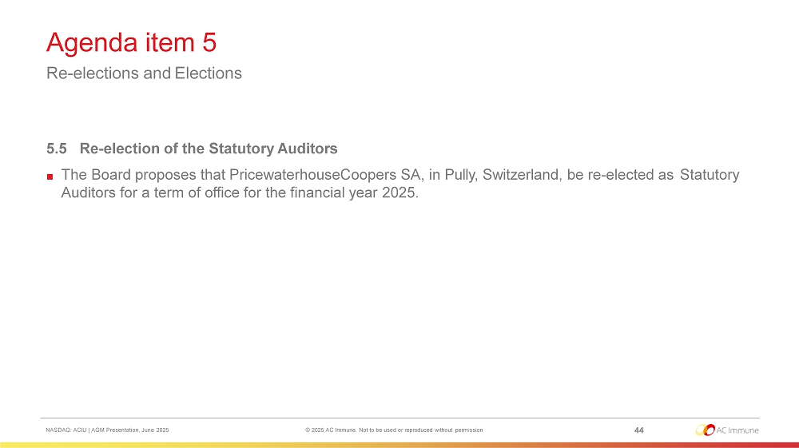
Agenda item 5 Re - elections and Elections 44 NASDAQ: ACIU | AGM Presentation, June 2025 © 2025 AC Immune. Not to be used or reproduced without permission 5.5 Re - election of the Statutory Auditors ■ The Board proposes that PricewaterhouseCoopers SA, in Pully, Switzerland, be re - elected as Statutory Auditors for a term of office for the financial year 2025.
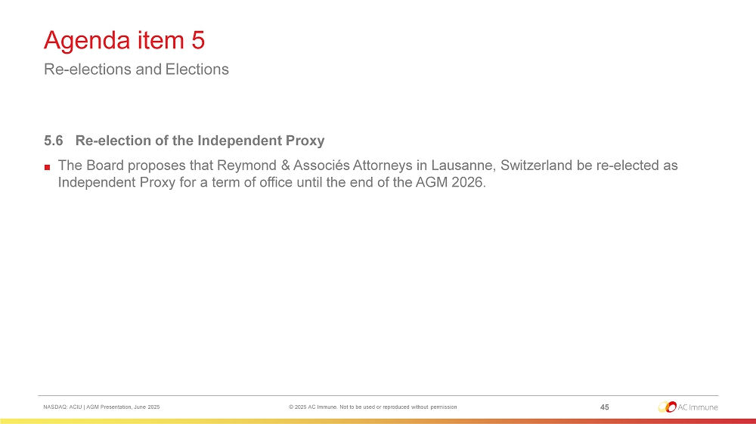
Agenda item 5 Re - elections and Elections 45 NASDAQ: ACIU | AGM Presentation, June 2025 © 2025 AC Immune. Not to be used or reproduced without permission 5.6 Re - election of the Independent Proxy ■ The Board proposes that Reymond & Associés Attorneys in Lausanne, Switzerland be re - elected as Independent Proxy for a term of office until the end of the AGM 2026.
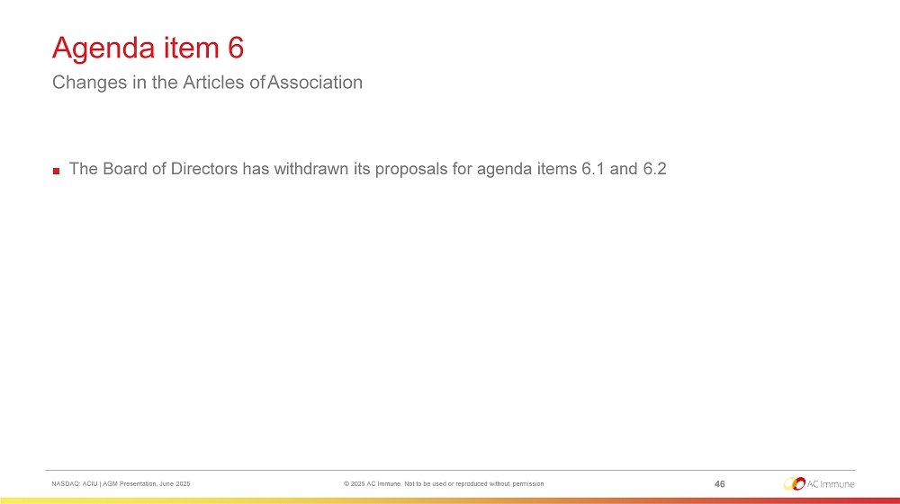
Agenda item 6 Changes in the Articles of Association 46 NASDAQ: ACIU | AGM Presentation, June 2025 © 2025 AC Immune. Not to be used or reproduced without permission ■ The Board of Directors has withdrawn its proposals for agenda items 6.1 and 6.2

We thank you for your attendance and your continued support. 47 NASDAQ: ACIU | AGM Presentation, June 2025 © 2025 AC Immune. Not to be used or reproduced without permission

