UNITED STATES

SECURITIES AND EXCHANGE COMMISSION

Washington, D.C. 20549

FORM 6-K

REPORT OF FOREIGN PRIVATE ISSUER PURSUANT TO RULE 13a-16 OR 15d-16 UNDER THE SECURITIES EXCHANGE ACT OF 1934

For the month of June, 2019

Commission File Number: 001-37891

AC IMMUNE SA

(Exact name of registrant as specified in its charter)

EPFL Innovation Park

Building B
1015 Lausanne, Switzerland

(Address of principal executive office)

Indicate by check mark whether the registrant files or will file annual reports under cover of Form 20-F or Form 40-F:

Form 20-F X Form 40-F

Indicate by check mark if the registrant is submitting the Form 6-K in paper as permitted by Regulation S-T Rule 101(b)(1):

Yes No X

Indicate by check mark if the registrant is submitting the Form 6-K in paper as permitted by Regulation S-T Rule 101(b)(7):

Yes No X

SIGNATURE

Pursuant to the requirements of the Securities Exchange Act of 1934, the registrant has duly caused this report to be signed on its behalf by the undersigned, thereunto duly authorized.

AC IMMUNE SA
By: | /s/ Andrea Pfeifer
 | Name: | Andrea Pfeifer
 | Title: | Chief Executive Officer
By: | /s/ Joerg Hornstein
 | Name: | Joerg Hornstein
 | Title: | Chief Financial Officer

Date: June 4, 2019

 | EXHIBIT INDEX
Exhibit | Description
Number
99.1* | Invitation to the Ordinary Shareholders’ Meeting
99.2* | 2019 Annual General Meeting Proxy Card
99.3 | 2018 Statutory Annual Report (incorporated by reference to Exhibit 99.2 to the AC Immune Report of Foreign Private Issuer on Form 6-K
 | filed on March 21, 2019)
99.4 | Financial Statements (IFRS) as at and for the years ended December 31, 2018, 2017 and 2016 (incorporated by reference to Item 18 of
 | Part III of AC Immune’s Annual Report on Form 20-F for the fiscal year ended December 31, 2018 filed on March 21, 2019)
99.5 | 2018 Compensation Report (incorporated by reference to Exhibit 99.3 to the AC Immune Report of Foreign Private Issuer on Form 6-K
 | filed on March 21, 2019)
99.6* | Instructions on How to Become a Holder of Record
* Filed herewith.

Exhibit 99.1


Lausanne, 31 May 2019
Invitation to the Ordinary Shareholders' Meeting

Date: 28 June 2019, at 11:30 am Swiss time

Place: Rosa Parks Learning Center, ACI offices, EPFL Innovation Park, Building G, South, 1st Floor, 1015 Lausanne

Dear Shareholder,

In 2018, AC Immune continued to shape the future by discovering and developing breakthrough therapies to treat neurodegenerative diseases, one of the most important societal challenges of our day, through pioneering science and precision medicine. Specifically, our two validated proprietary discovery platforms, SupraAntigen™ and Morphomer™, already have and are continuing to produce value-creating innovative potential therapeutics and diagnostics for neurodegenerative diseases.

AC Immune’s partnerships with global leaders in neurodegeneration, Eli Lilly, Genentech (a Roche company) and Janssen, have generated close to CHF300 million in funds and are a testament to our approach. Our cash position, CHF300 million as of 31 March 2019, funds the company through Q3 2023, allowing us to achieve multiple potentially transformative goals, even as we accelerate implementation of our strategy to new high value therapeutic targets, like neuroinflammation.

We are glad to report that our strategy and ongoing development programs closely match the evolving views of key opinion leaders. The recent setbacks in Abeta development, including the discontinuation by our partner Roche of the Phase 3 crenezumab program, were very disappointing. Viewed positively and taken together with other recent scientific findings, these events served to further elucidate the roadmap for developing effective therapies and diagnostics to treat Alzheimer’s disease (AD) and other neurodegenerative diseases.

We are already implementing the new strategies recommended by KOLs going forward: 1) pursue Abeta in earlier-stage patients to prevent rather than treating AD and; 2) target Tau, which has been shown to correlate with disease progression; 3) run trials of Abeta therapeutics in

more homogeneous populations (e.g. in our case, Down syndrome¹ and familial AD²; 4) pursue combination therapies; 5) pursue neuroinflammation. To succeed with the above, it is necessary to develop/access and utilize novel diagnostics allowing earlier treatment and more specific identification of patients’ pathologies applying Precision Medicine to neurodegenerative diseases

In the short- to medium-term, we and others in the industry are increasingly focused on clinical trials of Tau therapies to treat early and late stage AD based on emerging clinical evidence that Tau pathology drives disease progression^{3,4}. We are also actively pursuing other strategies, such as targeting neuroinflammation^{5,6}, and look forward to communicating specifics on this soon.

In addition, we are targeting earlier therapeutic intervention and prevention, for example by testing new diagnostic tools in the clinic that will allow us to identify and track patients earlier and throughout the course of the disease. Effective diagnostics will allow us to detect and track specific pathologies, making possible the study of combination therapies and prevention studies in pre-symptomatic patients, who could not otherwise have been diagnosed.

Discovery platforms underpin pipeline progress

The AC Immune pipeline, all of which originated from the SupraAntigenTM and MorphomerTM platforms, is broad and robust. It includes nine therapeutic and three diagnostic product

1.Strydom A, et al., Alzheimers Dement (N Y) 2018;

2.Lott IT and Head E.,Nat Rev Neurol. 2019

3. Pontecorvo MJ, et al., Brain 2019;

4. Gordon BA, et al., Brain 2019

5.Heneka MT et al., Nat Rev Neurosci. 2018;

6.Wang S et al., Int Immunopharmacol. 2019

1

candidates, with three product candidates currently in four Phase 2 trials, as well as highly-valued preclinical assets targeting Tau, a-syn and TDP-43.

In December 2018, we initiated a transformative license agreement with Lilly to research and develop small molecule Tau Morphomer™ aggregation inhibitors to treat AD and other neurodegenerative diseases. The terms include upfront payment of CHF 80 million, USD 50 million convertible equity note, CHF 60 million in potential near-term milestones, as well as additional potential milestones of approximately CHF 1.68 billion, plus tiered royalty payments in the low double digits.

Genentech commenced recruitment for a second Phase 2 trial of AC Immune's anti-Tau monoclonal antibody in moderate AD, supplementing a separate Phase 2 trial to evaluate its efficacy and safety in participants with prodromal to mild AD. We expect data readout from the latter in 2020.

Crenezumab continues to be studied in a landmark trial of cognitively healthy individuals in Colombia with an autosomal dominant mutation who are at risk of developing familial AD, under the Alzheimer's Prevention Initiative (API). The goal is to show that crenezumab will prevent or delay disease onset and progression of AD, and continuing this study has been encouraged by KOLs since amyloid is still considered a critical genetic and molecular pathology leading to the emergence of AD. The current prevailing view is that Abeta treatment was tested too late in the course of the disease to have an impact and that Abeta monotherapy should be applied in primary or secondary prevention studies as tested in the API study.

We initiated a Phase 2 clinical trial with an adaptive design for evaluation of ACI-24 (anti-Abeta vaccine) in patients with mild AD, and completed recruitment of the ACI-24 Phase 1b study for the treatment of AD-like characteristics in adults with Down syndrome. We expect interim data in 2019 and a potential decision to start Phase 2 ahead of plan.

There are several other milestones approaching in 2019, including lead selection of a-synuclein and TDP-43 antibodies and proof-of-concept of the first candidate targeting neuroinflammation. The Morphomer™ Tau Phase 1 study by Lilly is expected to start in Q2 2019, and Phase 2 testing of ACI-35 is anticipated to start in H1 2019.

Management Appointments

On the personnel front, we strengthened the executive management team with the appointments of Dr. Marie Kosco-Vilbois, as Chief Scientific Officer, with a strong background in immunology and inflammation. We also appointed Piergiorgio Donati as Head of Technical Operations and Program Management and Dr. Sonia Poli as Head of Translational Science.

Conclusion

The achievements of AC Immune – not just in 2018 but looking back to the foundation of the company more than 15 years ago – have been enabled by the commitment and support of you, our highly valued shareholders. We would like to take this opportunity to extend our gratitude for your continued interest and engagement in our work in such an exciting and challenging field, which is one of the greatest unmet medical needs as well as one of the biggest opportunities in healthcare. We always appreciate your different and sometimes challenging insights and feedback, all of which contribute to our growth and success, and we look forward to keeping you up to date on the exciting developments ahead of us in 2019.

Together, we can look forward to taking AC Immune forward to developing innovative treatments and diagnostics that shape how we address neurodegenerative diseases.

Martin Velasco

Prof. Andrea Pfeifer

Chairman of the Board

CEO

2

Kindly find hereafter the agenda items and proposals of the Board of Directors in connection with the third ordinary annual meeting of AC Immune SA as a public company:

Agenda Items and Proposals of the Board of Directors

- Approval of the Annual Report, Annual Statutory Financial Statements and Financial Statements under IFRS of AC Immune SA for the year 2018

The Board proposes to approve the Annual Report, the Annual Statutory Financial Statements and the Financial Statements under IFRS of AC Immune SA for the year 2018, and to take note of the Reports of the Auditors. Copies of these documents are available for download in the "Investors" section of our website (www.acimmune.com).

- Appropriation of Loss

The Board of Directors proposes that the net loss of the year 2018 in the amount of KCHF 48'894 is added to the loss brought forward of KCHF 58'426 resulting in a new balance of loss brought forward of KCHF 107'320. Under IFRS accounting principles, the net loss for the business year 2018 amounted to KCHF 50'951.

- Discharge of the Members of the Board of Directors and the Executive Committee

The Board proposes that the members of the Board and the Executive Committee are discharged from their liabilities for their activities in the financial year 2018.

- Compensation for the Members of the Board of Directors and the Executive Committee

The Board of Directors proposes to hold the following separate votes on the non-performance-related and the variable compensation of the Board of Directors (size unchanged) and the Executive Committee (size increased from four persons in the previous year to six persons in the current year):

4.a Vote on Total Non-Performance-Related Compensation for Members of the Board of Directors from 1 July 2019 to 30 June

2020

The Board of Directors proposes that shareholders approve the total maximum amount of non-performance-related compensation for the members of the Board of Directors covering the period from 1 July 2019 to 30 June 2020, i.e., CHF 547'000 (cash base compensation plus social security costs).

4.b Vote on Equity for Members of the Board of Directors

The Board of Directors proposes that shareholders approve the maximum grant of equity or equity linked instruments for the members of the Board of Directors from 1 July 2019 to 30 June 2020 with maximum value of CHF 626'000 (equity or equity linked instruments value plus social security costs).

3

4.c Vote on Total Non-Performance-Related Compensation for Members of the Executive Committee from 1 July 2019 to 30 June 2020

The Board of Directors proposes that shareholders approve the total maximum amount of non-performance-related cash compensation for the members of the Executive Committee from 1 July 2019 to 30 June 2020, i.e., CHF 2'407'000 (cash base compensation plus social security costs).

4.d Vote on Total Variable Compensation for Members of the Executive Committee for the current year 2019

The Board of Directors proposes that shareholders approve the total maximum amount of variable compensation for the members of the Executive Committee for the current year 2019, i.e., CHF 1'195'000 (cash compensation plus social security costs).

4.e Vote on Equity for Members of the Executive Committee

The Board of Directors proposes that shareholders approve the maximum grant of equity or equity linked instruments for the members of the Executive Committee from 1 July 2019 to 30 June 2020 with maximum value of CHF 3'126'000 (equity or equity linked instruments value plus social security costs).

- Election of the Members of the Board

The Board of Directors proposes for a term until the end of the next ordinary General Meeting

  - the re-election of Douglas Williams as member and election as Chairman of the Board,

  - the re-election of Martin Velasco as member and election as Vice-Chairman of the Board,

  - the re-election Peter Bollmann, Friedrich von Bohlen, Andrea Pfeifer, Tom Graney and Werner Lanthaler and election of Roy Twyman as members of the Board of Directors

Prof. Riesner has taken his retirement and will not stand for re-election.

- Dr. Roy E. Twyman: Dr. Roy Twyman is a neurologist and currently CEO and founder, Amron Neuroscience, LLC, a private consulting company focused on neuroscience drug development. Prior to this, Dr. Twyman spent almost 20 years at Janssen Research & Development, LLC (a Johnson & Johnson company) and was a member of the Neuroscience Therapeutic Area Leadership team responsible for clinical R&D and strategic planning of CNS neurology and psychiatry pipeline products. Since 2012 until March 2018 he was a Senior Vice President in the Neuroscience Therapeutic Area overseeing the Alzheimer’s Disease Area. He currently participates as an independent board member or as a scientific advisory board member for a number of small biotech or pharmaceutical companies. Academic training and appointments include MD at University of Kentucky; Neurology Residency and Neurophysiology Fellowship at University of Michigan; Assistant Professor Department of Neurology at University of Michigan; Associate Professor with tenure in Departments of Neurology and Pharmacology & Toxicology; and Huntsman Cancer Institute, Human Molecular Biology Eccles Institute of Genetics and Neuroscience Program appointments at University of Utah.

4

5.a Re-election of Douglas Williams as member and election as Chairman of the Board of Directors

5.b Re-election of Martin Velasco as member and election as Vice-Chairman of the Board of Directors

5.c Re-election of Peter Bollmann

5.d Re-election of Friedrich von Bohlen

5.e Re-election of Andrea Pfeifer

5.f Re-election of Tom Graney

5.g Re-election of Werner Lanthaler

5.h Election of Roy Twyman

- Election to the Compensation, Nomination & Corporate Governance Committee

The Board of Directors proposes the re-election of Martin Velasco, Tom Graney and Douglas Williams as members of the Compensation, Nomination & Corporate Governance Committee, each until the end of the next ordinary General Meeting.

6.a Re-election of Tom Graney

6.b Re-election of Martin Velasco

6.c Re-election of Douglas Williams

- Election of the independent proxy

The Board of Directors proposes to elect Reymond & Associés, represented by Denis Cherpillod, avocat, Avenue de la Gare 1, case postale 7255, 1002 Lausanne, as the independent proxy of the Company until the end of the next ordinary General Meeting.

- Re-election of the Auditors

The Board of Directors proposes to re-elect PricewaterhouseCoopers SA, in Pully, for a term of office of one year.

- Authorized Share Capital

As the previous timeline for the increase of authorized capital expired on 20 October 2017, the Board of Directors proposes to replace the existing first paragraph of article 3a (Authorized Capital Increase of Share Capital) of the articles of association pertaining to the authorized share capital to authorize the Board of Directors to issue up to 13'500'000 registered common shares of CHF 0.02 nominal value each until 27 June 2021 and to amend article 3a, paragraph 1 of the articles of association as set out below:

5

The Board of Directors is authorized to increase the share capital, in |  | Le conseil d'administration est autorisé à augmenter le capital-
one or several steps until 27 June 2021, by a maximum amount of |  | actions, en une ou plusieurs étapes jusqu'au 27 juin 2021, d'un
CHF 270'000 by issuing a maximum of 13'500'000 registered shares |  | montant maximum de CHF 270'000 par l'émission d'un nombre
with a par value of CHF 0.02 each, to be fully paid up. An increase of |  | maximum de 13'500'000 actions nominatives d'une valeur
the share capital (i) by means of an offering underwritten by a financial |  | nominale de CHF 0.02 chacune, à libérer entièrement. Une
institution, a syndicate or another third party or third parties, followed |  | augmentation de capital (i) par souscription d'actions par une
by an offer to the then-existing shareholders of the Company and (ii) in |  | institution financière, un syndicat ou un tiers ou des tiers, suivie par
partial amounts shall also be permissible. |  | une souscription d'actions par les actionnaires de la société alors
 |  | existants et (ii) par montants partiels, est également autorisée.

- Conditional Capital Increase for Bonds and Similar Debt Instruments

With a view of resetting the Company's conditional share capital subsequent to the equity issuance related to the license and collaboration agreement entered into with Eli Lilly in December 2018, the Board of Directors proposes to replace the existing first paragraph of article 3b (Conditional Capital Increase for Bonds and Similar Debt Instruments) of the articles of association pertaining to the conditional capital increase for bonds and similar debt instruments to create conditional share capital for the same purpose in the maximum amount of CHF 91'560.94 by the issuance of 4'578'047 registered common shares of CHF 0.02 nominal value each and to amend article 3b, paragraph 1 of the articles of association as set out below:

The share capital of the Company shall be increased by a maximum |  | Le capital-actions de la société peut être augmenté d'un montant
amount of CHF 91'560.94 through the issue of a maximum of |  | maximum de CHF 91'560.94 par l'émission d'un maximum de
4'578'047 registered shares, payable in full, each with a nominal value |  | 4'578'047 actions nominatives, d'une valeur nominale de CHF 0.02
of CHF 0.02 through the exercise of conversion and/or option or |  | chacune, à libérer entièrement, suite à l'exercice de droits de
warrant rights granted in connection with bonds or similar instruments, |  | conversion et/ou d'option ou de bons de souscription accordés en
issued or to be issued by the Company or by subsidiaries of the |  | relation avec des obligations ou d'instruments similaires, émis ou
Company, including convertible debt instruments. |  | devant être émis par la société ou par des filiales de la société, y
 |  | compris les instruments d'emprunt convertibles.
 |  | 6

- Conditional Capital Increase for Employee Benefit Plans

The Board of Directors proposes to replace the existing first paragraph of article 3c (Conditional Capital Increase for Employee Benefit Plans) of the articles of association pertaining to the conditional capital increase for employees and individuals of comparable positions, to create conditional share capital for the same purpose in the maximum amount of CHF 70'460 by the issuance of 3'523'000 registered common shares of CHF 0.02 nominal value each and to amend article 3c, paragraph 1 of the articles of association as set out below:

The share capital of the Company shall be increased by an amount |  | Le capital social de la société sera augmenté d'un montant ne
not exceeding CHF 70'460 through the issue of a maximum of |  | dépassant pas CHF 70'460 par l'émission d'un maximum de
3'523'000 registered shares, payable in full, each with a nominal value |  | 3'523'000 actions nominatives, entièrement libérées, chacune avec
of CHF 0.02, in connection with the exercise of option rights granted to |  | une valeur nominale de CHF 0.02, dans le cadre de l'exercice de
any employee of the Company or a subsidiary, and any consultant, |  | droits d'option accordés à tout employé de la Société ou d'une
members of the Board of Directors, or other person providing services |  | succursale, et à tout consultant, aux membres du conseil
to the Company or a subsidiary. |  | d'administration, ou à autres personnes fournissant des services en
 |  | faveur de la société ou d'une filiale.

Please participate electronically or mail as per the Organizational Matters section at the end of this invitation to vote in this Shareholders' Meeting.

For the Board of Directors:
/s/ Martin Velasco |  |  | /s/ Andrea Pfeifer
 | Martin Velasco, Chairman |  | Andrea Pfeifer, CEO

7

Organizational Matters

1 Financial Statements

The Annual Statutory Financial Statements and the Financial Statements under IFRS of AC Immune SA for the year 2018 as well as the corresponding Auditor's reports are available for download in the "Investors" section of our website (www.acimmune.com).

2 Invitation and Attendance

Shareholders registered in the share register maintained by our transfer agent, Computershare Trust Company N.A. at 5:00 pm Eastern Standard Time ("EST") / 11:00 pm Swiss time on 23 May 2019 are entitled to participate in and vote at the Annual General Meeting. On 31 May 2019, the invitation and proxy form will be mailed to all holders of record as at 23 May 2019 at 5:00 pm EST / 11:00 pm Swiss time. The invitation is available for download in the "Investors" section of our website (www.acimmune.com).

If you wish to attend the Annual General Meeting in person, you will be required to present the enclosed proxy form and a valid government issued proof of identification and present yourself at the admission desk at the latest 20 minutes prior to the beginning of the Annual General Meeting.

3 Representation

Shareholders of record, who do not attend the Annual General Meeting in person, may:

- grant a proxy to the current independent proxy of the Company for the Annual General Meeting, Bugnion Ballansat Ehrler, represented by Gérald Virieux, avocat, rue de Rive 6, case postale 3143, CH-1211 Geneva 3 in writing or electronically as described below; or

- grant a proxy in writing to another shareholder or other third party who must present him- or herself at the admission desk at the latest 20 minutes prior to the beginning of the Annual General Meeting.

Proxies to the independent proxy must be mailed to and received by our transfer agent, Computershare Trust Company N.A. by 12:00 pm EST
- 6:00 pm Swiss time on 25 June 2019. Proxies received after such time will not be considered. Please do not send your proxy card directly to the independent proxy.

The login information for electronic instructions is set forth on the proxy form. Electronic instructions must be received no later than 11:59 pm EST on 25 June 2019 / 5:59 am Swiss time on 26 June 2019.

Shareholders that have granted a proxy to the independent proxy, in writing or electronically, may not vote their shares at the Annual General Meeting.

4 Registration as Shareholder with Voting Rights

Instructions on how a "street name" holder may become a holder of record are available in the "Investors" section of our website (www.acimmune.com). Between 5:00 pm EST / 11:00 pm Swiss time on 23 May 2019 and 12:00 pm EST / 6:00 pm Swiss time on 28 June 2019, no new shareholder will be registered for voting purposes. Computershare Trust Company N.A. will continue to register transfers of shares in the share register in its capacity as transfer agent.

8

5 Trading Restrictions

The registration of shareholders for voting purposes does not impact trading of AC Immune shares held by registered shareholders before, during or after the Annual General Meeting. Shareholders selling their shares in AC Immune prior to the meeting are excluded from voting.

* * *

9

Exhibit 99.2
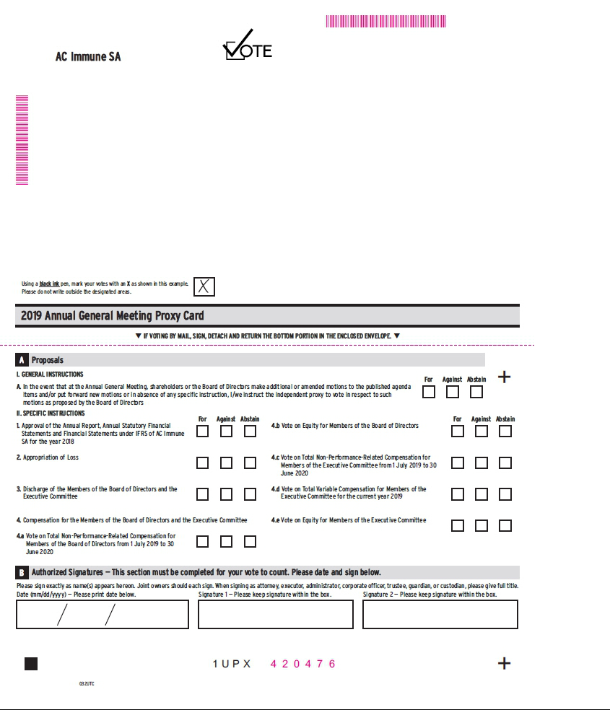

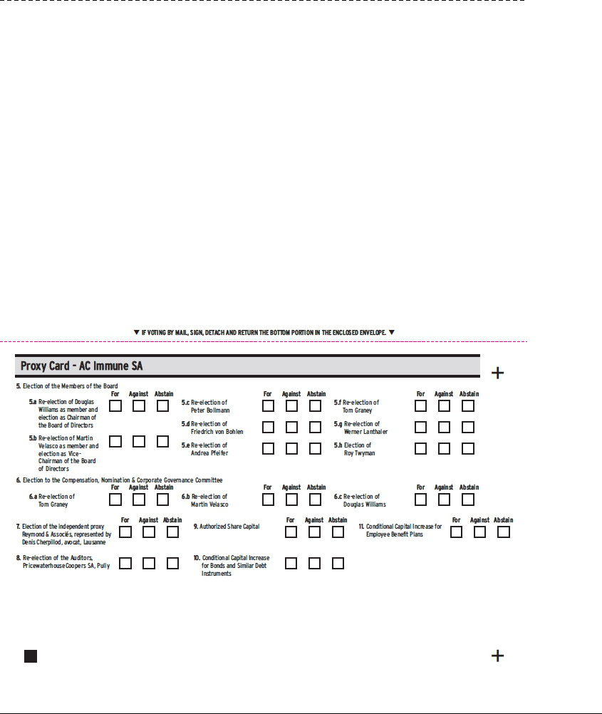

Exhibit 99.6

Lausanne, 3 June 2019

Instructions on how to become a holder of record

These instructions do not apply to existing holders of record as of 23 May 2019

You already qualify as a holder of record as of 23 May 2019 with respect to all your shareholding in AC Immune SA if:

- you were shareholder of AC Immune SA prior to our initial public offering; and

- you did not purchase any additional shares in AC Immune SA during our initial public offering or subsequently.

If you purchased shares in AC Immune SA during our initial public offering or subsequently and that you have already become a registered holder as at the record date of 23 May 2019 with respect to such shares, these instructions do not apply to you.

As an individual holder of record, you may attend and vote at our annual general meeting in person or by proxy.

As a corporate holder of record (corporations or other entities), you may have your duly authorized representatives attend and vote at our annual general meeting in person or by proxy.

For additional information, please review the "Invitation to the Ordinary Shareholders' meeting" and the "Annual General Meeting Proxy Card". Instructions for shareholders who want to become holders of record
If you purchased shares in AC Immune SA during our initial public offering or subsequently, your shares are currently registered in the name of a bank or brokerage firm (acting as your record holder). You will receive instructions from your record holder in order for your record holder to vote your shares per your instructions.

We encourage you to contact your record holder to commence the process to become a registered holder as at the record date of 23 May 2019. Alternatively, you may directly contact AC Immune SA to request a guest card to attend our annual general meeting. You will need to provide us with evidence of ownership of your shares in AC Immune SA to be entitled to vote your shares at our annual general meeting.

Please send your written request along with evidence of ownership of your shares in AC Immune SA by regular mail or email at the following address:

AC Immune SA
Attn. Jean-Fabien Monin, Chief Administrative Officer
EPFL Innovation Park
Building B
CH-1015 Lausanne
Switzerland
E-mail: jean-fabien.monin@acimmune.com

1

