UNITED STATES

SECURITIES AND EXCHANGE COMMISSION

Washington, D.C. 20549

FORM 6-K

REPORT OF FOREIGN PRIVATE ISSUER PURSUANT TO RULE 13a-16 OR 15d-16

UNDER THE SECURITIES EXCHANGE ACT OF 1934

For the month of March, 2018

Commission File Number: 001-37891

AC IMMUNE SA

(Exact name of registrant as specified in its charter)

EPFL Innovation Park

Building B

1015 Lausanne, Switzerland

(Address of principal executive office)

Indicate by check mark whether the registrant files or will file annual reports under cover of Form 20-F or Form 40-F:

Form 20-F X Form 40-F

Indicate by check mark if the registrant is submitting the Form 6-K in paper as permitted by Regulation S-T Rule 101(b)(1):

Yes No X

Indicate by check mark if the registrant is submitting the Form 6-K in paper as permitted by Regulation S-T Rule 101(b)(7):

Yes No X

SIGNATURE

Pursuant to the requirements of the Securities Exchange Act of 1934, the registrant has duly caused this report to be signed on its behalf by the undersigned, thereunto duly authorized.

AC IMMUNE SA
By: | /s/ Andrea Pfeifer
 | Name: | Andrea Pfeifer
 | Title: | Chief Executive Officer
By: | /s/ Joerg Hornstein
 | Name: | Joerg Hornstein
 | Title: | Chief Financial Officer

Date: March 22, 2018

 | EXHIBIT INDEX
Exhibit | Description
Number
99.1 | Invitation to the Extraordinary Shareholders’ Meeting
99.2 | 2018 Extraordinary Shareholders’ Meeting Proxy Card
99.3 | Instructions on How to Become a Holder of Record

Exhibit 99.1

Lausanne, 22 March 2018

Invitation to the Extraordinary Shareholders' Meeting

Date: 27 April 2018, at 15.00 pm Swiss time

Place: EPFL Innovation Park Building D, ground floor, Uranus Meeting room, 1015 Lausanne

Dear Shareholder,

We have the pleasure of informing you that the following industry expert has recently confirmed his interest in joining our team as member of the Board of

Directors of AC Immune SA:

- Dr. Douglas Williams: Dr. Williams has been President and Chief Executive Officer of Codiak Biosciences since 2015. Before joining Codiak Biosciences, Dr. Williams was actively engaged in leading functions of several biotech companies, such as Biogen Idec from 2011 until 2015 (Executive Vice President, Research and Development) and Zymogenetics from 2004 until 2011 (initially as Chief Scientific Officer and Executive Vice President and, from 2009 until 2011, as Chief Executive Officer). Dr. Williams's extensive insight in the biotech field is furthermore supported by his holding of various board memberships since 1995; Dr. Williams currently sits on the boards of Ovid Therapeutics, Codiak Biosciences and Ironwood Pharmaceuticals. Dr. Williams holds a PhD in Physiology of the State University of New York, Buffalo and a B.S. in Biological Sciences of the University of Massachusetts, Lowell.

We propose to elect Dr. Williams as new member of our Board of Directors and as new member of our Compensation, Nomination & Corporate Governance Committee.

Furthermore, we propose to increase the Company's share capital, thereby providing AC Immune SA with additional funds to support its continued efforts in becoming a global leader in personalized treatment of neurodegenerative diseases.

Agenda Items and Proposals of the Board of Directors

- Election of Member to the Board of Directors

The Board of Directors proposes the election of Douglas Williams as new member of the Board of Directors, until the end of the next ordinary General Meeting.

- Election to the Compensation, Nomination & Corporate Governance Committee

The Board of Directors proposes the election of Douglas Williams as new member of the Compensation, Nomination & Corporate Governance Committee, until the end of the next ordinary General Meeting.

- Compensation for the newly elected Member of the Board of Directors

The Board of Directors proposes to hold the following separate votes on the compensation of the new member of the Board of Directors:

3.a Vote on Total Non-Performance-Related Compensation for the new Member of the Board of Directors from 27 April 2018 to 30 June

2018

The Board of Directors proposes that shareholders approve an additional maximum amount of non-performance-related compensation for the new proposed member of the Board of Directors covering the period from 27 April 2018 to 30 June 2018, i.e., CHF 11'800 (cash base compensation plus social security costs).

3.b Vote on Equity for the new Member of the Board of Directors

The Board of Directors proposes that shareholders approve an additional maximum grant of equity or equity linked instruments for the new proposed member of the Board of Directors from 27 April 2018 to 30 June 2018 with maximum value of CHF 76'000 (equity or equity linked instruments value plus social security costs).

- Share Capital Increase

The Board of Directors intends to increase the share capital of the Company as the previous timeline for the increase of authorized capital expired on date 20 October 2017. This increase enables the Company to secure the necessary future funds to execute its three-pillar strategy targeting Alzheimer’s disease, non-Alzheimer’s disease and other neuro-orphan diseases and diagnostics. The Company anticipates to conduct this financing in two tranches: The first offering (agenda item 4.a) will allow the Company to broaden its existing shareholder base and issue new shares to institutional investors in a rapid way thus limiting market exposure. The second offering (agenda item 4.b) allows existing investors to subscribe shares at identical terms and conditions as the first offering. Both institutional investors and existing shareholders will each be served from their own respective offering with identical terms.

4.a Share Capital Increase for Institutional Investors

The Board proposes accordingly an ordinary share capital increase for institutional investors as follows:

- the share capital of the Company is increased by way of an ordinary increase by up to CHF 170'000 by issuing up to 8'500'000 registered shares with a nominal value of CHF 0.02 each;

- the pre-emptive rights of the shareholders for the newly issued registered shares shall be preserved; the Board of Directors shall be entitled to publish the subscription price by electronic media including press release and e-mail and to limit the subscription period to one business day; any new shares not subscribed shall be allocated by the Board of Directors at its discretion;

- the technical issuance price of the new shares to be paid in cash shall be determined by the Board of Directors;

- the new shares are entitled to dividends for the business year starting 1 January 2018;

- the new shares are subject to the transfer restrictions as outlined in article 4 of the Articles of Association;

- the stamp duty shall be paid by the Company; and

- the Board of Directors is authorized and instructed to implement and register this capital increase with the competent commercial register.

4.b Share Capital Increase for Current Shareholders

As for logistical reasons current shareholders may not be able to participate in the ordinary share capital increase for institutional investors, the Board proposes an ordinary share capital increase for current shareholders at identical terms as offered in the preceding ordinary share capital increase as follows:

- the share capital of the Company is increased by way of an ordinary increase of by up to CHF 30'000 by issuing up to 1'500'000 registered shares with a nominal value of CHF 0.02 each;

- the pre-emptive rights of the shareholders for the newly issued registered shares shall be preserved; the Board of Directors shall credit each shareholder with a corresponding number of non-tradable subscription rights with identical terms as offered to institution investors in the ordinary share capital increase resolution resolved today. Such subscription rights may be exercised during a subscription period of at least six business days; any new shares not subscribed shall be allocated by the Board of Directors at its discretion in first priority to current shareholders;

- the technical issuance price of the new shares to be paid in cash shall be determined by the Board of Directors;

- the new shares are entitled to dividends for the business year starting 1 January 2018;

- the new shares are subject to the transfer restrictions as outlined in article 4 of the Articles of Association;

- the stamp duty shall be paid by the Company; and

- the Board of Directors is authorized and instructed to implement and register this capital increase with the competent commercial register.

Please participate electronically or mail as per the Organizational Matters section at the end of this invitation to vote in this Shareholders' Meeting.

Kind regards

/s/ Martin Velasco | /s/ Andrea Pfeifer
Martin Velasco | Prof. Andrea Pfeifer
Chairman of the Board | CEO

Organizational Matters

1 Invitation and Attendance

Shareholders registered in the share register maintained by our transfer agent, Computershare Trust Company N.A. at 5:00 pm Eastern Standard Time ("EST") / 11:00 pm Swiss time on 13 March 2018 are entitled to participate in and vote at the Extraordinary General Meeting. On 21 March 2018, the invitation and proxy form will be mailed to all holders of record as at 13 March 2018 at 5:00 pm EST / 11:00 pm Swiss time. The invitation is available for download in the "Investors" section of our website (www.acimmune.com).

If you wish to attend the Extraordinary General Meeting in person, you will be required to present the enclosed proxy form and a valid government issued proof of identification.

2 Representation

Shareholders of record, who do not attend the Extraordinary General Meeting in person, may:

- grant a proxy to the independent proxy, Bugnion Ballansat Ehrler, represented by Gérald Virieux, avocat, rue de Rive 6, case postale 3143, CH-1211 Geneva 3 in writing or electronically as described below; or

- grant a proxy in writing to another shareholder or other third party.

Proxies to the independent proxy must be mailed to and received by our transfer agent, Computershare Trust Company N.A. by 12:00 pm EST / 6:00 pm Swiss time on 23 April 2018. Proxies received after such time will not be considered. Please do not send your proxy card directly to the independent proxy.

The login information for electronic instructions is set forth on the proxy form. Electronic instructions must be received no later than 11:59 pm EST on 23 April 2018 / 5:59 am Swiss time on 24 April 2018.

Shareholders that have granted a proxy to the independent proxy, in writing or electronically, may not vote their shares at the Extraordinary General Meeting.

3 Registration as Shareholder with Voting Rights

Instructions on how a "street name" holder may become a holder of record are available in the "Investors" section of our website (www.acimmune.com). Between 5:00 pm EST / 11:00 pm Swiss time on 13 March 2018 and 12:00 pm EST / 6:00 pm Swiss time on 27 April 2018, no new shareholder will be registered for voting purposes. Computershare Trust Company N.A. will continue to register transfers of shares in the share register in its capacity as transfer agent.

4 Trading Restrictions

The registration of shareholders for voting purposes does not impact trading of AC Immune shares held by registered shareholders before, during or after the Extraordinary General Meeting. Shareholders selling their shares in AC Immune prior to the meeting are excluded from voting.

Exhibit 99.2
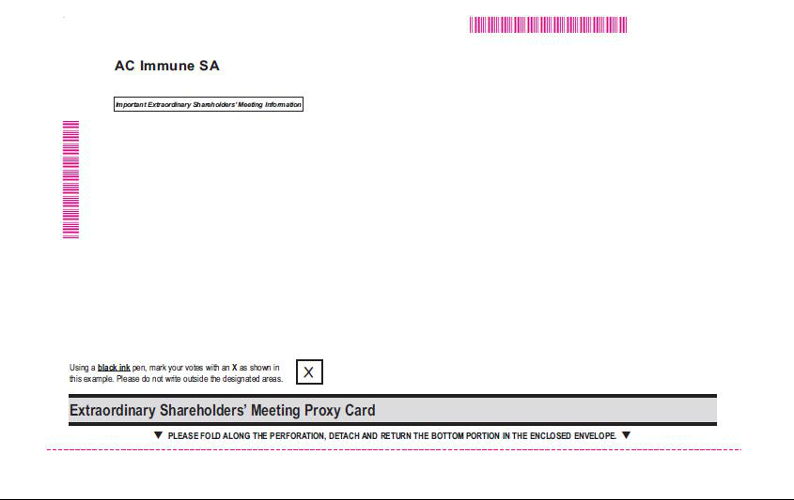

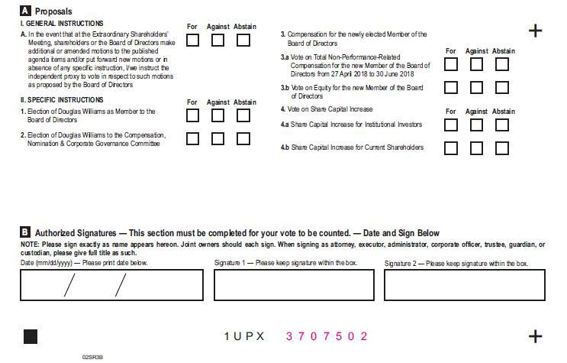
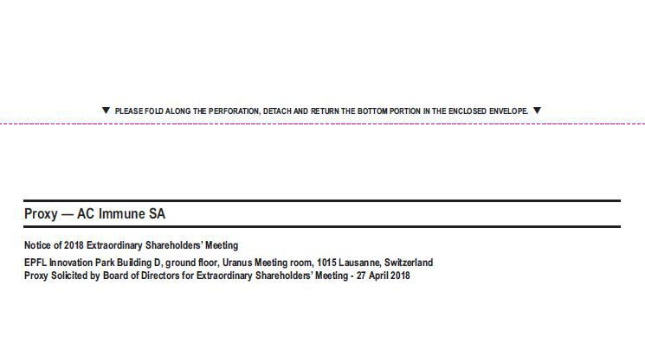

Exhibit 99.3


Lausanne, 22 March 2018

Instructions on how to become a holder of record

These instructions do not apply to existing holders of record as of 13 March 2018

You already qualify as a holder of record as of 13 March 2018 with respect to all your shareholding in AC Immune SA if:

- you were shareholder of AC Immune SA prior to our initial public offering; and

- you did not purchase any additional shares in AC Immune SA during our initial public offering or subsequently.

If you purchased shares in AC Immune SA during our initial public offering or subsequently and that you have already become a registered holder as at the record date of 13 March 2018 with respect to such shares, these instructions do not apply to you.

As an individual holder of record, you may attend and vote at our extraordinary shareholders' meeting in person or by proxy.

As a corporate holder of record (corporations or other entities), you may have your duly authorized representatives attend and vote at our extraordinary shareholders' meeting in person or by proxy.

For additional information, please review the "Invitation to the extraordinary shareholders' meeting" and the "Extraordinary Shareholders' Meeting Proxy Card".

Instructions for shareholders who want to become holders of record

If you purchased shares in AC Immune SA during our initial public offering or subsequently, your shares are currently registered in the name of a bank or brokerage firm (acting as your record holder). You will receive instructions from your record holder in order for your record holder to vote your shares per your instructions.

We encourage you to contact your record holder to commence the process to become a registered holder as at the record date of 13 March 2018. Alternatively, you may directly contact AC Immune SA to request a guest card to attend our extraordinary shareholders' meeting. You will need to provide us with evidence of ownership of your shares in AC Immune SA to be entitled to vote your shares at our extraordinary shareholders' meeting.

Please send your written request along with evidence of ownership of your shares in AC Immune SA by regular mail or email at the following address:

AC Immune SA

Attn. Jean-Fabien Monin, Chief Administrative Officer
EPFL Innovation Park
Building B
CH-1015 Lausanne
Switzerland
E-mail: jean-fabien.monin@acimmune.com

