UNITED STATES
SECURITIES AND EXCHANGE COMMISSION
Washington, D.C. 20549

FORM 6-K

REPORT OF FOREIGN PRIVATE ISSUER PURSUANT TO RULE 13a-16
OR 15d-16 UNDER THE SECURITIES EXCHANGE ACT OF 1934

For the month of May, 2022

Commission File Number: 001-37891

AC IMMUNE SA
(Exact name of registrant as specified in its charter)

EPFL Innovation Park
Building B
1015 Lausanne, Switzerland
(Address of principal executive office)

Indicate by check mark whether the registrant files or will file annual reports under cover of Form 20-F or Form 40-F:

Form 20-F | ☒ |  | Form 40-F | ☐

Indicate by check mark if the registrant is submitting the Form 6-K in paper as permitted by Regulation S-T Rule 101(b)(1):

Yes | ☐ |  | No | ☒

Indicate by check mark if the registrant is submitting the Form 6-K in paper as permitted by Regulation S-T Rule 101(b)(7):

Yes | ☐ |  | No | ☒

SIGNATURE

Pursuant to the requirements of the Securities Exchange Act of 1934, the registrant has duly caused this report to be signed on its behalf by the undersigned, thereunto duly authorized.

 | AC IMMUNE SA
 | By: | /s/ Andrea Pfeifer
 |  | Name: | Andrea Pfeifer
 |  | Title: | Chief Executive Officer

 | By: | /s/ Joerg Hornstein
 |  | Name: | Joerg Hornstein
 |  | Title: | Chief Financial Officer

Date: May 25, 2022

EXHIBIT INDEX

Exhibit Number | Description
99.1* | Invitation to the Ordinary Shareholders’ Meeting
99.2* | 2022 Annual General Meeting Proxy Card
99.3 | Consolidated Financial Statements (IFRS) as at and for the years ended December 31, 2021, 2020 and 2019 (incorporated by reference to Item 18 of Part III of AC Immune’s Annual Report on Form 20-F for the fiscal year ended December 31, 2021 filed on March 22, 2022)
99.4 | 2021 IFRS Consolidated Financial Statements (incorporated by reference to Exhibit 99.2 to the AC Immune Report of Foreign Private Issuer on Form 6-K filed on March 22, 2022)
99.5 | 2021 Statutory Annual Report (incorporated by reference to Exhibit 99.3 to the AC Immune Report of Foreign Private Issuer on Form 6-K filed on March 22, 2022)
99.6 | 2021 Compensation Report (incorporated by reference to Exhibit 99.4 to the AC Immune Report of Foreign Private Issuer on Form 6-K filed on March 22, 2022)

* Filed herewith.

Exhibit 99.1

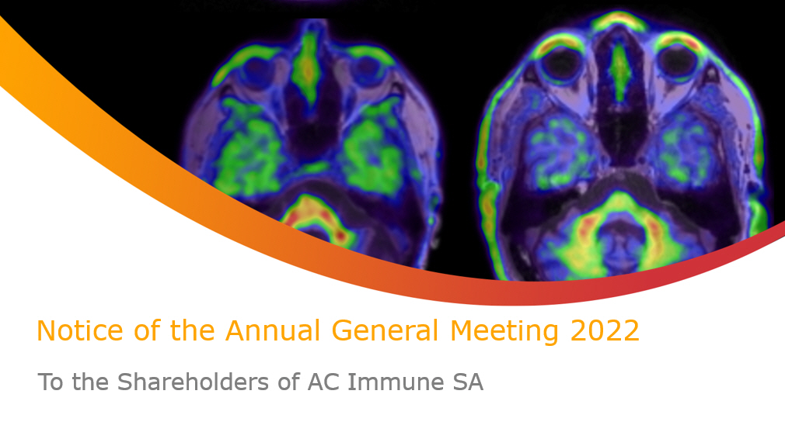
Notice of the Annual General Meeting 2022 To the Shareholders of AC Immune SA

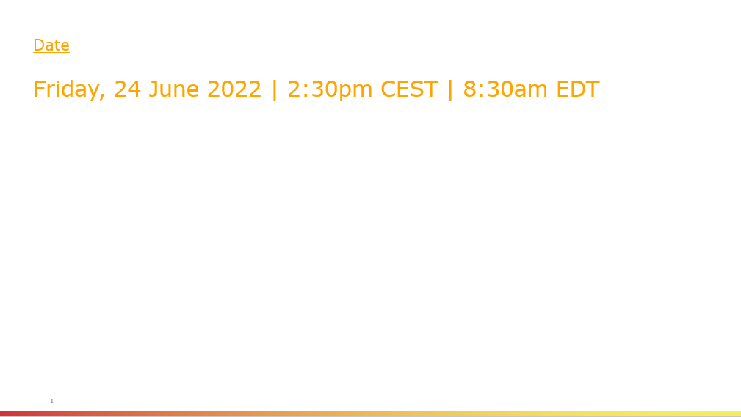
Date Friday, 24 June 2022 | 2 :30pm CEST | 8:30am EDT 1

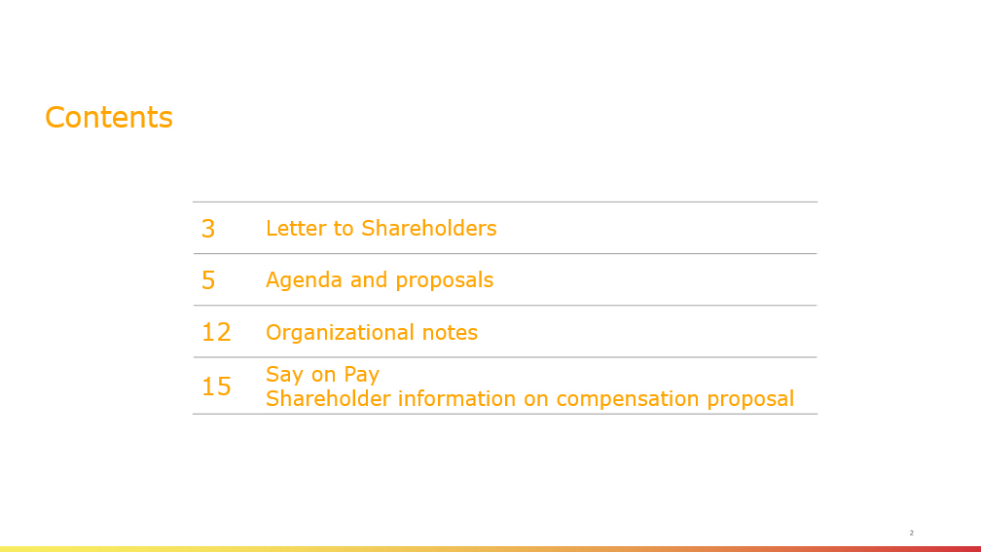
Contents 3 Letter to Shareholders 5 Agenda and proposals 12 Organizational notes 15 Say on Pay Shareholder information on compensation proposal 2

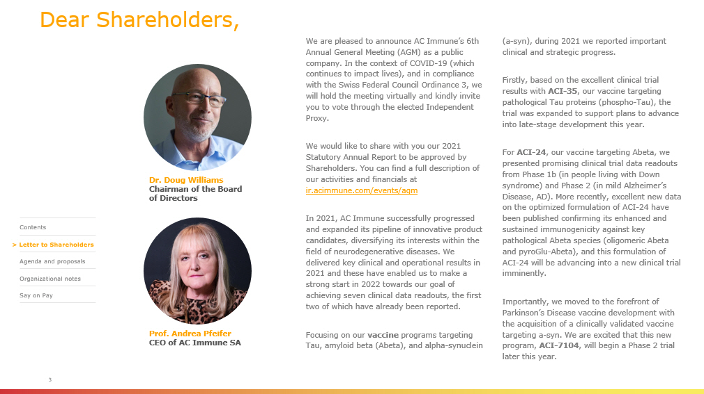
Dear Shareholders, We are pleased to announce AC Immune’s 6th Annual General Meeting (AGM) as a public company. In the context of COVID - 19 (which continues to impact lives), and in compliance with the Swiss Federal Council Ordinance 3, we will hold the meeting virtually and kindly invite you to vote through the elected Independent Proxy. We would like to share with you our 2021 Statutory Annual Report to be approved by Shareholders. You can find a full description of our activities and financials at ir.acimmune.com/events/ agm In 2021, AC Immune successfully progressed and expanded its pipeline of innovative product candidates, diversifying its interests within the field of neurodegenerative diseases. We delivered key clinical and operational results in 2021 and these have enabled us to make a strong start in 2022 towards our goal of achieving seven clinical data readouts, the first two of which have already been reported. Focusing on our vaccine programs targeting Tau, amyloid beta ( Abeta ), and alpha - synuclein (a - syn), during 2021 we reported important clinical and strategic progress. Firstly, based on the excellent clinical trial results with ACI - 35 , our vaccine targeting pathological Tau proteins (phospho - Tau), the trial was expanded to support plans to advance into late - stage development this year. For ACI - 24 , our vaccine targeting Abeta, we presented promising clinical trial data readouts from Phase 1b (in people living with Down syndrome) and Phase 2 (in mild Alzheimer’s Disease, AD). More recently, excellent new data on the optimized formulation of ACI - 24 have been published confirming its enhanced and sustained immunogenicity against key pathological Abeta species (oligomeric Abeta and pyroGlu - Abeta), and this formulation of ACI - 24 will be advancing into a new clinical trial imminently. Importantly, we moved to the forefront of Parkinson’s Disease vaccine development with the acquisition of a clinically validated vaccine targeting a - syn. We are excited that this new program, ACI - 7104 , will begin a Phase 2 trial later this year. Dr. Doug Williams Chairman of the Board of Directors Prof. Andrea Pfeifer CEO of AC Immune SA 3 > Contents > Letter to Shareholders Agenda and proposals > Organizational notes > Say on Pay

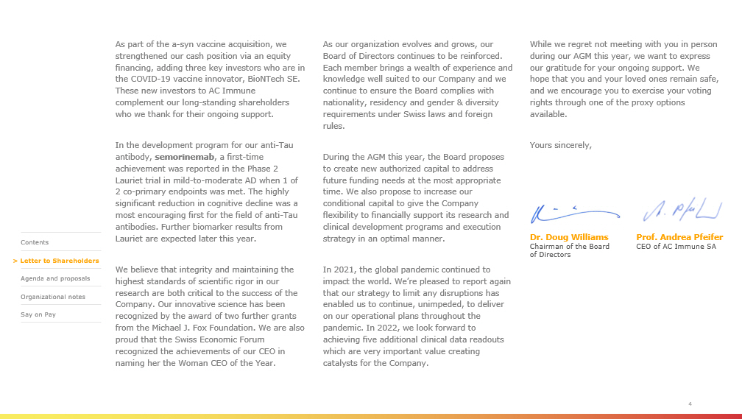
Dr. Doug Williams Chairman of the Board of Directors Prof. Andrea Pfeifer CEO of AC Immune SA 4 As part of the a - syn vaccine acquisition, we strengthened our cash position via an equity financing, adding three key investors who are in the COVID - 19 vaccine innovator, BioNTech SE. These new investors to AC Immune complement our long - standing shareholders who we thank for their ongoing support. In the development program for our anti - Tau antibody, semorinemab , a first - time achievement was reported in the Phase 2 Lauriet trial in mild - to - moderate AD when 1 of 2 co - primary endpoints was met. The highly significant reduction in cognitive decline was a most encouraging first for the field of anti - Tau antibodies. Further biomarker results from Lauriet are expected later this year. We believe that integrity and maintaining the highest standards of scientific rigor in our research are both critical to the success of the Company. Our innovative science has been recognized by the award of two further grants from the Michael J. Fox Foundation. We are also proud that the Swiss Economic Forum recognized the achievements of our CEO in naming her the Woman CEO of the Year. As our organization evolves and grows, our Board of Directors continues to be reinforced. Each member brings a wealth of experience and knowledge well suited to our Company and we continue to ensure the Board complies with nationality, residency and gender & diversity requirements under Swiss laws and foreign rules. During the AGM this year, the Board proposes to create new authorized capital to address future funding needs at the most appropriate time. We also propose to increase our conditional capital to give the Company flexibility to financially support its research and clinical development programs and execution strategy in an optimal manner. In 2021, the global pandemic continued to impact the world. We’re pleased to report again that our strategy to limit any disruptions has enabled us to continue, unimpeded, to deliver on our operational plans throughout the pandemic. In 2022, we look forward to achieving five additional clinical data readouts which are very important value creating catalysts for the Company. While we regret not meeting with you in person during our AGM this year, we want to express our gratitude for your ongoing support. We hope that you and your loved ones remain safe, and we encourage you to exercise your voting rights through one of the proxy options available. Yours sincerely, > Contents > Letter to Shareholders Agenda and proposals > Organizational notes > Say on Pay


Agenda & proposals

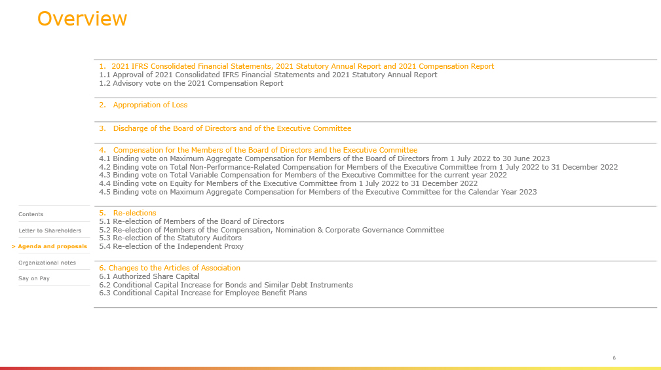
Overview 1. 2021 IFRS Consolidated Financial Statements, 2021 Statutory Annual Report and 2021 Compensation Report 1.1 Approval of 2021 Consolidated IFRS Financial Statements and 2021 Statutory Annual Report 1.2 Advisory vote on the 2021 Compensation Report 2. Appropriation of Loss 3. Discharge of the Board of Directors and of the Executive Committee 4. Compensation for the Members of the Board of Directors and the Executive Committee 4.1 Binding vote on Maximum Aggregate Compensation for Members of the Board of Directors from 1 July 2022 to 30 June 2023 4.2 Binding vote on Total Non - Performance - Related Compensation for Members of the Executive Committee from 1 July 2022 to 31 Dec ember 2022 4.3 Binding vote on Total Variable Compensation for Members of the Executive Committee for the current year 2022 4.4 Binding vote on Equity for Members of the Executive Committee from 1 July 2022 to 31 December 2022 4.5 Binding vote on Maximum Aggregate Compensation for Members of the Executive Committee for the Calendar Year 2023 5. Re - elections 5.1 Re - election of Members of the Board of Directors 5.2 Re - election of Members of the Compensation, Nomination & Corporate Governance Committee 5.3 Re - election of the Statutory Auditors 5.4 Re - election of the Independent Proxy 6. Changes to the Articles of Association 6.1 Authorized Share Capital 6.2 Conditional Capital Increase for Bonds and Similar Debt Instruments 6.3 Conditional Capital Increase for Employee Benefit Plans 6 > Contents Letter to Shareholders > Agenda and proposals > Organizational notes > Say on Pay

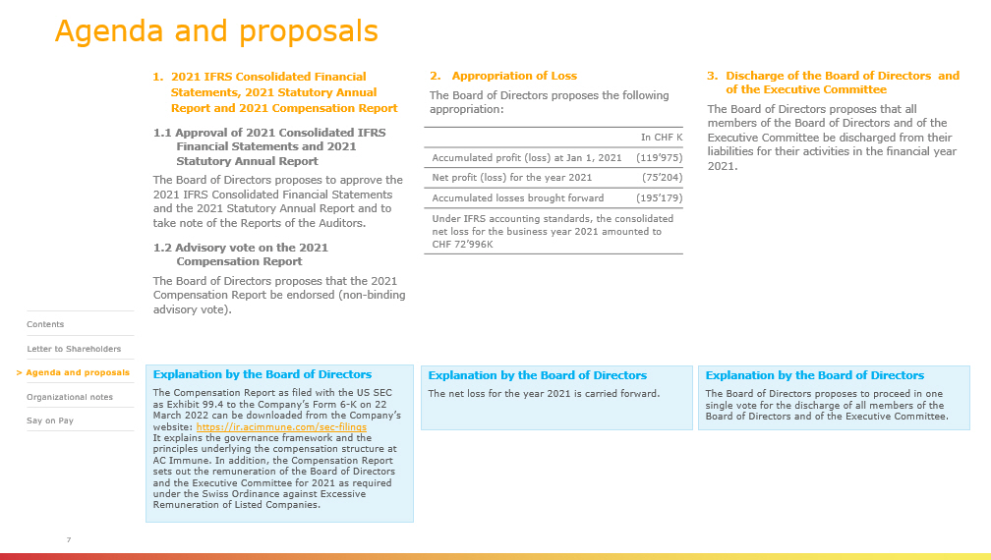
7 1. 2021 IFRS Consolidated Financial Statements, 2021 Statutory Annual Report and 2021 Compensation Report 1.1 Approval of 2021 Consolidated IFRS Financial Statements and 2021 Statutory Annual Report The Board of Directors proposes to approve the 2021 IFRS Consolidated Financial Statements and the 2021 Statutory Annual Report and to take note of the Reports of the Auditors. 1.2 Advisory vote on the 2021 Compensation Report The Board of Directors proposes that the 2021 Compensation Report be endorsed (non - binding advisory vote). 3. Discharge of the Board of Directors and of the Executive Committee The Board of Directors proposes that all members of the Board of Directors and of the Executive Committee be discharged from their liabilities for their activities in the financial year 2021. Explanation by the Board of Directors The Compensation Report as filed with the US SEC as Exhibit 99.4 to the Company’s Form 6 - K on 22 March 2022 can be downloaded from the Company’s website: https://ir.acimmune.com/sec - filings It explains the governance framework and the principles underlying the compensation structure at AC Immune. In addition, the Compensation Report sets out the remuneration of the Board of Directors and the Executive Committee for 2021 as required under the Swiss Ordinance against Excessive Remuneration of Listed Companies. 2. Appropriation of Loss The Board of Directors proposes the following appropriation: In CHF K Accumulated profit (loss) at Jan 1, 2021 (119’975) Net profit (loss) for the year 2021 (75’204) Accumulated losses brought forward (195’179) Under IFRS accounting standards, the consolidated net loss for the business year 2021 amounted to CHF 72’996K Agenda and proposals Explanation by the Board of Directors The Board of Directors proposes to proceed in one single vote for the discharge of all members of the Board of Directors and of the Executive Committee . Explanation by the Board of Directors The net loss for the year 2021 is carried forward. > Contents Letter to Shareholders > Agenda and proposals > Organizational notes > Say on Pay

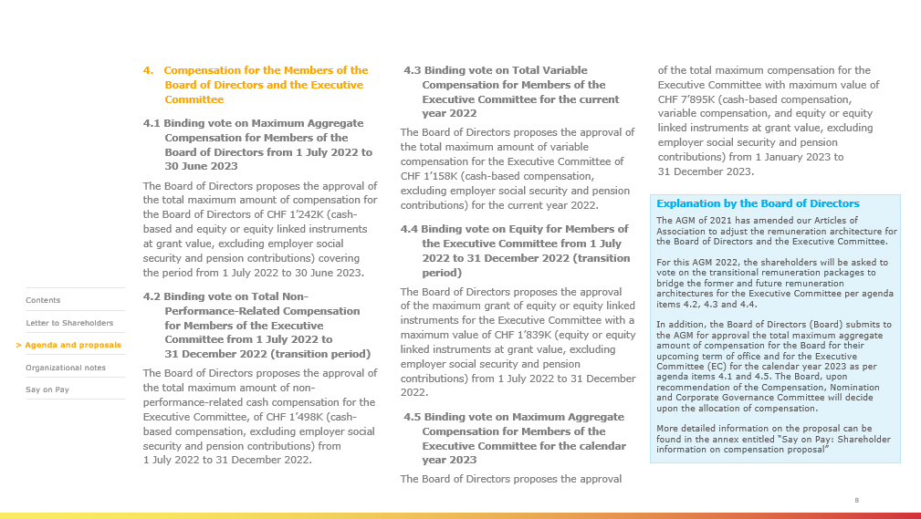
KC H 8 4. Compensation for the Members of the Board of Directors and the Executive Committee 4.1 Binding vote on Maximum Aggregate Compensation for Members of the Board of Directors from 1 July 2022 to 30 June 2023 The Board of Directors proposes the approval of the total maximum amount of compensation for the Board of Directors of CHF 1’242K (cash - based and equity or equity linked instruments at grant value, excluding employer social security and pension contributions) covering the period from 1 July 2022 to 30 June 2023. 4.2 Binding vote on Total Non - Performance - Related Compensation for Members of the Executive Committee from 1 July 2022 to 31 December 2022 (transition period) The Board of Directors proposes the approval of the total maximum amount of non - performance - related cash compensation for the Executive Committee, of CHF 1’498K (cash - based compensation, excluding employer social security and pension contributions) from 1 July 2022 to 31 December 2022. 4.3 Binding vote on Total Variable Compensation for Members of the Executive Committee for the current year 2022 The Board of Directors proposes the approval of the total maximum amount of variable compensation for the Executive Committee of CHF 1’158K (cash - based compensation, excluding employer social security and pension contributions) for the current year 2022. 4.4 Binding vote on Equity for Members of the Executive Committee from 1 July 2022 to 31 December 2022 (transition period) The Board of Directors proposes the approval of the maximum grant of equity or equity linked instruments for the Executive Committee with a maximum value of CHF 1’839K (equity or equity linked instruments at grant value, excluding employer social security and pension contributions) from 1 July 2022 to 31 December 2022. 4.5 Binding vote on Maximum Aggregate Compensation for Members of the Executive Committee for the calendar year 2023 The Board of Directors proposes the approval of the total maximum compensation for the Executive Committee with maximum value of CHF 7’895K (cash - based compensation, variable compensation, and equity or equity linked instruments at grant value, excluding employer social security and pension contributions) from 1 January 2023 to 31 December 2023. Explanation by the Board of Directors The AGM of 2021 has amended our Articles of Association to adjust the remuneration architecture for the Board of Directors and the Executive Committee. For this AGM 2022, the shareholders will be asked to vote on the transitional remuneration packages to bridge the former and future remuneration architectures for the Executive Committee per agenda items 4.2, 4.3 and 4.4. In addition, t he Board of Directors (Board) submits to the AGM for approval the total maximum aggregate amount of compensation for the Board for their upcoming term of office and for the Executive Committee (EC) for the calendar year 2023 as per agenda items 4.1 and 4.5. The Board, upon recommendation of the Compensation, Nomination and Corporate Governance Committee will decide upon the allocation of compensation. More detailed information on the proposal can be found in the annex entitled “Say on Pay: Shareholder information on compensation p roposal ” > Contents Letter to Shareholders > Agenda and proposals > Organizational notes > Say on Pay

9 5. Re - elections 5.1 Re - election of Members of the Board of Directors The Board of Directors proposes that each of the following persons be re - elected as directors for a term of office until the end of the Annual General Meeting 2023: ▪ Douglas Williams as Member of the Board of Directors and Chairman And as Members of the Board of Directors: ▪ Monika Bütler ▪ Alan Colowick ▪ Tom Graney ▪ Carl June ▪ Werner Lanthaler ▪ Andrea Pfeifer ▪ Monica Shaw ▪ Roy Twyman 5.2 Re - election of Members of the Compensation, Nomination & Corporate Governance Committee The Board of Directors proposes that: ▪ Tom Graney ▪ Roy Twyman ▪ Douglas Williams be re - elected as Members of the Compensation, Nomination & Corporate Governance Committee for a term of office until the end of the Annual General Meeting 2023. 5.3 Re - election of the Statutory Auditors The Board of Directors proposes that PricewaterhouseCoopers SA, in Pully, Switzerland, be re - elected as Statutory Auditors for a term of office of one year. 5.4 Re - election of the Independent Proxy The Board of Directors proposes that Reymond & Associés , Lausanne, which will be represented by any of their attorneys for this purpose, be re - elected as Independent Proxy for a term of office until the end of the Annual General Meeting 2023. Explanation by the Board of Directors Only re - elections of current Directors are being proposed. The votes will be conducted on an individual basis. For further information on the proposed candidates, please refer to the section of the Company’s website: www.acimmune.com / en /board - of - directors/ > Contents Letter to Shareholders > Agenda and proposals > Organizational notes > Say on Pay

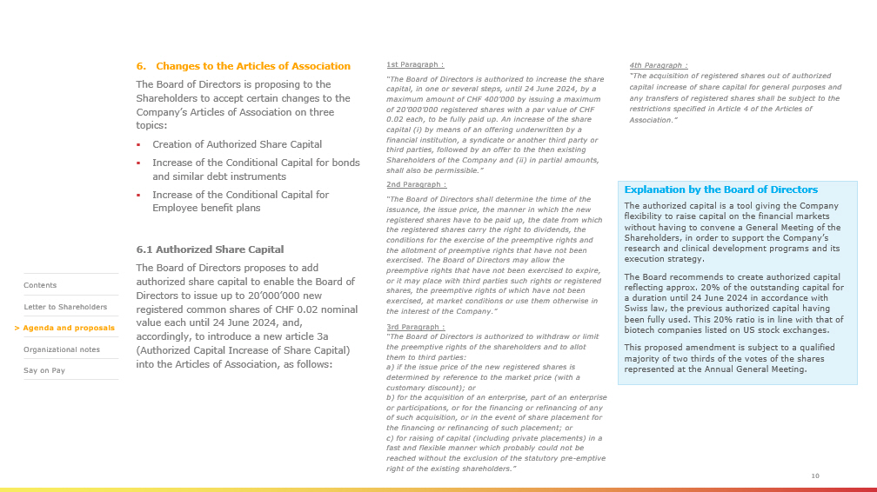
1st Paragraph : “The Board of Directors is authorized to increase the share capital, in one or several steps, until 24 June 2024, by a maximum amount of CHF 400’000 by issuing a maximum of 20’000’000 registered shares with a par value of CHF 0.02 each, to be fully paid up. An increase of the share capital (i) by means of an offering underwritten by a financial institution, a syndicate or another third party or third parties, followed by an offer to the then existing Shareholders of the Company and (ii) in partial amounts, shall also be permissible.” 2nd Paragraph : “The Board of Directors shall determine the time of the issuance, the issue price, the manner in which the new registered shares have to be paid up, the date from which the registered shares carry the right to dividends, the conditions for the exercise of the preemptive rights and the allotment of preemptive rights that have not been exercised. The Board of Directors may allow the preemptive rights that have not been exercised to expire, or it may place with third parties such rights or registered shares, the preemptive rights of which have not been exercised, at market conditions or use them otherwise in the interest of the Company.” 3rd Paragraph : “The Board of Directors is authorized to withdraw or limit the preemptive rights of the shareholders and to allot them to third parties: a) if the issue price of the new registered shares is determined by reference to the market price (with a customary discount); or b) for the acquisition of an enterprise, part of an enterprise or participations, or for the financing or refinancing of any of such acquisition, or in the event of share placement for the financing or refinancing of such placement; or c ) for raising of capital (including private placements) in a fast and flexible manner which probably could not be reached without the exclusion of the statutory pre - emptive right of the existing shareholders .” 10 6. Changes to the Articles of Association The Board of Directors is proposing to the Shareholders to accept certain changes to the Company’s Articles of Association on three topics: ▪ Creation of Authorized Share Capital ▪ Increase of the Conditional Capital for bonds and similar debt instruments ▪ Increase of the Conditional Capital for Employee benefit plans 6.1 Authorized Share Capital The Board of Directors proposes to add authorized share capital to enable the Board of Directors to issue up to 20’000’000 new registered common shares of CHF 0.02 nominal value each until 2 4 June 2024, and, accordingly, to introduce a new article 3a (Authorized Capital Increase of Share Capital) into the Articles of Association, as follows: Explanation by the Board of Directors The authorized capital is a tool giving the Company flexibility to raise capital on the financial markets without having to convene a General Meeting of the Shareholders, in order to support the Company’s research and clinical development programs and its execution strategy. The Board recommends to create authorized capital reflecting approx. 20% of the outstanding capital for a duration until 24 June 2024 in accordance with Swiss law, the previous authorized capital having been fully used. This 20% ratio is in line with that of biotech companies listed on US stock exchanges. This proposed amendment is subject to a qualified majority of two thirds of the votes of the shares represented at the Annual General Meeting. 4th Paragraph : “The acquisition of registered shares out of authorized capital increase of share capital for general purposes and any transfers of registered shares shall be subject to the restrictions specified in Article 4 of the Articles of Association.” > Contents Letter to Shareholders > Agenda and proposals > Organizational notes > Say on Pay

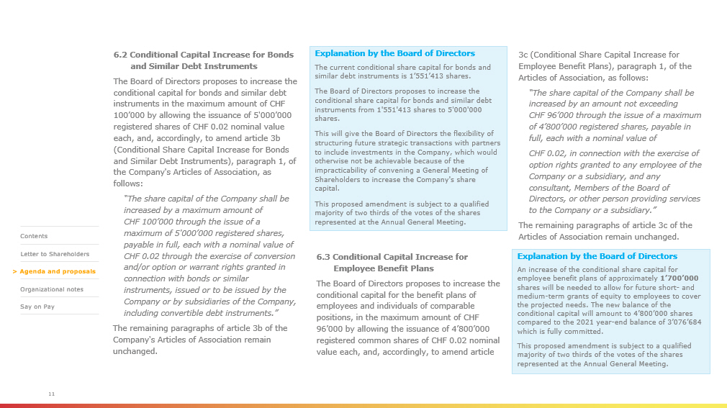
6.2 Conditional Capital Increase for Bonds and Similar Debt Instruments The Board of Directors proposes to increase the conditional capital for bonds and similar debt instruments in the maximum amount of CHF 100’000 by allowing the issuance of 5'000’000 registered shares of CHF 0.02 nominal value each, and, accordingly, to amend article 3b (Conditional Share Capital Increase for Bonds and Similar Debt Instruments), paragraph 1, of the Company's Articles of Association, as follows: “The share capital of the Company shall be increased by a maximum amount of CHF 100’000 through the issue of a maximum of 5'000’000 registered shares, payable in full, each with a nominal value of CHF 0.02 through the exercise of conversion and/or option or warrant rights granted in connection with bonds or similar instruments, issued or to be issued by the Company or by subsidiaries of the Company, including convertible debt instruments.” The remaining paragraphs of article 3b of the Company's Articles of Association remain unchanged. 11 Explanation by the Board of Directors The current conditional share capital for bonds and similar debt instruments is 1’551’413 shares. The Board of Directors proposes to increase the conditional share capital for bonds and similar debt instruments from 1'551'413 shares to 5'000'000 shares. This will give the Board of Directors the flexibility of structuring future strategic transactions with partners to include investments in the Company, which would otherwise not be achievable because of the impracticability of convening a General Meeting of Shareholders to increase the Company's share capital. This proposed amendment is subject to a qualified majority of two thirds of the votes of the shares represented at the Annual General Meeting. 3c (Conditional Share Capital Increase for Employee Benefit Plans), paragraph 1, of the Articles of Association, as follows: “The share capital of the Company shall be increased by an amount not exceeding CHF 96’000 through the issue of a maximum of 4’800’000 registered shares, payable in full, each with a nominal value of CHF 0.02, in connection with the exercise of option rights granted to any employee of the Company or a subsidiary, and any consultant, Members of the Board of Directors, or other person providing services to the Company or a subsidiary.” The remaining paragraphs of article 3c of the Articles of Association remain unchanged. Explanation by the Board of Directors An increase of the conditional share capital for employee benefit plans of approximately 1’700’000 shares will be needed to allow for future short - and medium - term grants of equity to employees to cover the projected needs. The new balance of the conditional capital will amount to 4’800’000 shares compared to the 2021 year - end balance of 3’076’684 which is fully committed. This proposed amendment is subject to a qualified majority of two thirds of the votes of the shares represented at the Annual General Meeting. 6.3 Conditional Capital Increase for Employee Benefit Plans The Board of Directors proposes to increase the conditional capital for the benefit plans of employees and individuals of comparable positions, in the maximum amount of CHF 96’000 by allowing the issuance of 4’800’000 registered common shares of CHF 0.02 nominal value each, and, accordingly, to amend article > Contents Letter to Shareholders > Agenda and proposals > Organizational notes > Say on Pay


Organizational notes

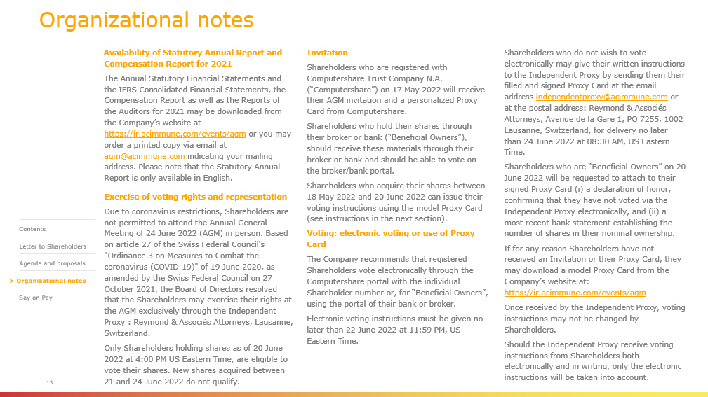
Organizational notes Availability of Statutory Annual Report and Compensation Report for 2021 The Annual Statutory Financial Statements and the IFRS Consolidated Financial Statements, the Compensation Report as well as the Reports of the Auditors for 2021 may be downloaded from the Company’s website at https://ir.acimmune.com/events/agm or you may order a printed copy via email at agm@acimmune.com indicating your mailing address. Please note that the Statutory Annual Report is only available in English. Exercise of voting rights and representation Due to coronavirus restrictions, Shareholders are not permitted to attend the Annual General Meeting of 24 June 2022 (AGM) in person. Based on article 27 of the Swiss Federal Council's "Ordinance 3 on Measures to Combat the coronavirus (COVID - 19)" of 19 June 2020, as amended by the Swiss Federal Council on 27 October 2021, the Board of Directors resolved that the Shareholders may exercise their rights at the AGM exclusively through the Independent Proxy : Reymond & Associés Attorneys, Lausanne, Switzerland. Only Shareholders holding shares as of 20 June 2022 at 4:00 PM US Eastern Time, are eligible to vote their shares. New shares acquired between 21 and 24 June 2022 do not qualify. Invitation Shareholders who are registered with Computershare Trust Company N.A. (“Computershare”) on 17 May 2022 will receive their AGM invitation and a personalized Proxy Card from Computershare. Shareholders who hold their shares through their broker or bank (“Beneficial Owners”), should receive these materials through their broker or bank and should be able to vote on the broker/bank portal. Shareholders who acquire their shares between 18 May 2022 and 20 June 2022 can issue their voting instructions using the model Proxy Card (see instructions in the next section). Voting: electronic voting or use of Proxy Card The Company recommends that registered Shareholders vote electronically through the Computershare portal with the individual Shareholder number or, for “Beneficial Owners”, using the portal of their bank or broker. Electronic voting instructions must be given no later than 22 June 2022 at 11:59 PM, US Eastern Time. Shareholders who do not wish to vote electronically may give their written instructions to the Independent Proxy by sending them their filled and signed Proxy Card at the email address independentproxy@acimmune.com or at the postal address: Reymond & Associés Attorneys, Avenue de la Gare 1, PO 7255, 1002 Lausanne, Switzerland, for delivery no later than 24 June 2022 at 08:30 AM, US Eastern Time. Shareholders who are “Beneficial Owners” on 20 June 2022 will be requested to attach to their signed Proxy Card ( i ) a declaration of honor, confirming that they have not voted via the Independent Proxy electronically, and (ii) a most recent bank statement establishing the number of shares in their nominal ownership. If for any reason Shareholders have not received an Invitation or their Proxy Card, they may download a model Proxy Card from the Company’s website at: https://ir.acimmune.com/events/agm Once received by the Independent Proxy, voting instructions may not be changed by Shareholders. Should the Independent Proxy receive voting instructions from Shareholders both electronically and in writing, only the electronic instructions will be taken into account. 13 > Contents Letter to Shareholders Agenda and proposals > Organizational notes > Say on Pay

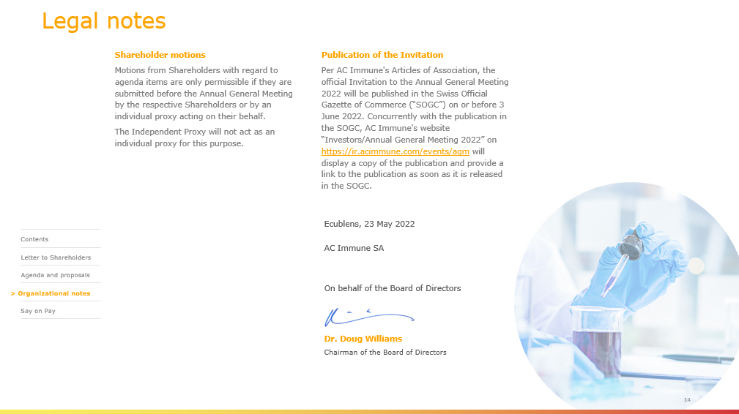
Legal notes Shareholder motions Motions from Shareholders with regard to agenda items are only permissible if they are submitted before the Annual General Meeting by the respective Shareholders or by an individual proxy acting on their behalf. The Independent Proxy will not act as an individual proxy for this purpose. Publication of the Invitation Per AC Immune's Articles of Association, the official Invitation to the Annual General Meeting 2022 will be published in the Swiss Official Gazette of Commerce (“SOGC”) on or before 3 June 2022. Concurrently with the publication in the SOGC, AC Immune's website “Investors/Annual General Meeting 2022” on https://ir.acimmune.com/events/agm will display a copy of the publication and provide a link to the publication as soon as it is released in the SOGC. 14 Ecublens , 23 May 2022 AC Immune SA On behalf of the Board of Directors Dr. Doug Williams Chairman of the Board of Directors > Contents Letter to Shareholders Agenda and proposals > Organizational notes > Say on Pay

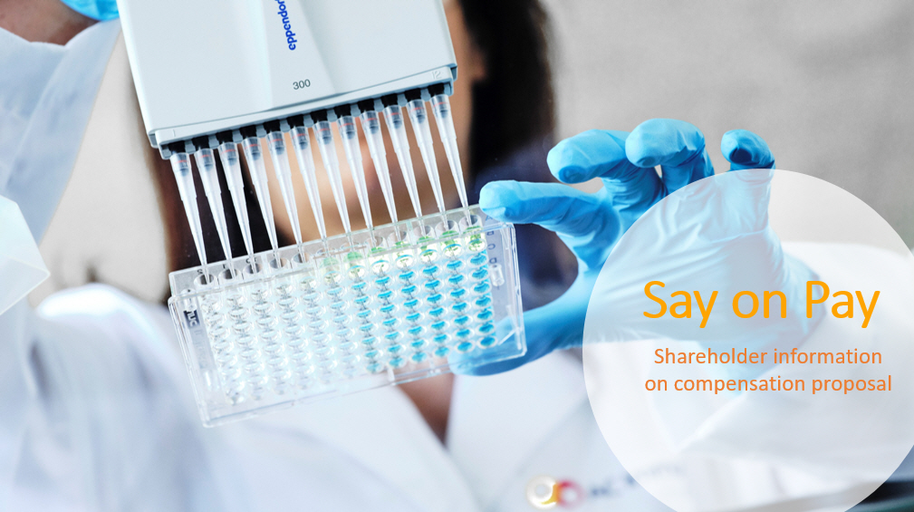
Say on Pay Shareholder information on compensation proposal

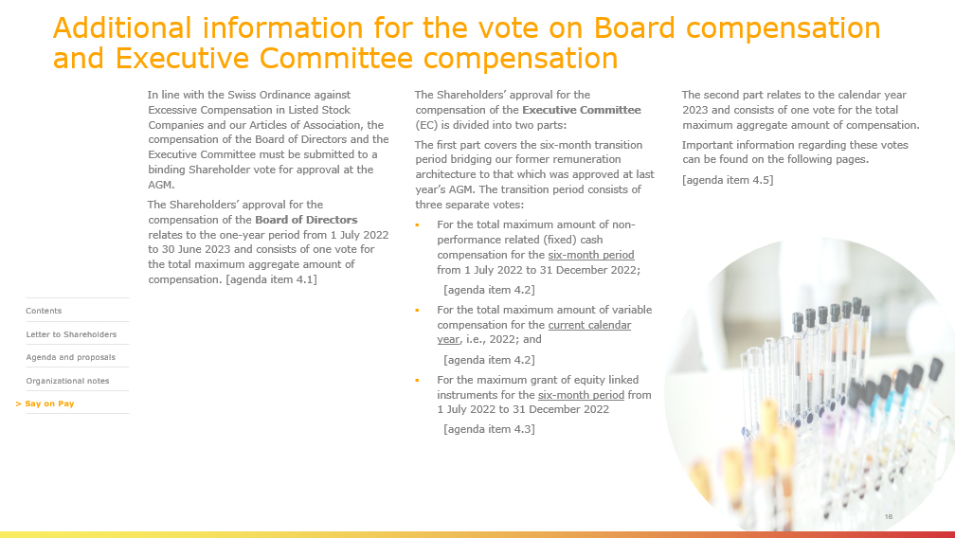
Additional information for the vote on Board compensation and Executive Committee compensation In line with the Swiss Ordinance against Excessive Compensation in Listed Stock Companies and our Articles of Association, the compensation of the Board of Directors and the Executive Committee must be submitted to a binding Shareholder vote for approval at the AGM. The Shareholders’ approval for the compensation of the Board of Directors relates to the one - year period from 1 July 2022 to 30 June 2023 and consists of one vote for the total maximum aggregate amount of compensation. [agenda item 4.1] 16 The Shareholders’ approval for the compensation of the Executive Committee (EC) is divided into two parts: The first part covers the six - month transition period bridging our former remuneration architecture to that which was approved at last year’s AGM. The transition period consists of three separate votes: ▪ For the total maximum amount of non - performance related (fixed) cash compensation for the six - month period from 1 July 2022 to 31 December 2022; [agenda item 4.2] ▪ For the total maximum amount of variable compensation for the current calendar year , i.e., 2022; and [agenda item 4.2] ▪ For the maximum grant of equity linked instruments for the six - month period from 1 July 2022 to 31 December 2022 [agenda item 4.3] The second part relates to the calendar year 2023 and consists of one vote for the total maximum aggregate amount of compensation. Important information regarding these votes can be found on the following pages. [agenda item 4.5] > Contents Letter to Shareholders Agenda and proposals Organizational notes > Say on Pay

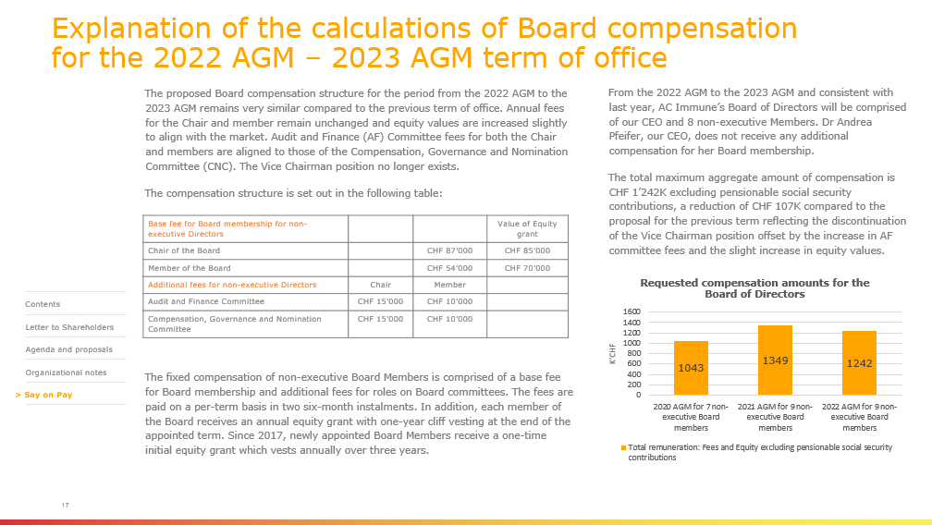
Explanation of the calculations of Board compensation for the 2022 AGM – 2023 AGM term of office The proposed Board compensation structure for the period from the 2022 AGM to the 2023 AGM remains very similar compared to the previous term of office. Annual fees for the Chair and member remain unchanged and equity values are increased slightly to align with the market. Audit and Finance (AF) Committee fees for both the Chair and members are aligned to those of the Compensation, Governance and Nomination Committee (CNC). The Vice Chairman position no longer exists. The compensation structure is set out in the following table: The fixed compensation of non - executive Board Members is comprised of a base fee for Board membership and additional fees for roles on Board committees. The fees are paid on a per - term basis in two six - month instalments. In addition, each member of the Board receives an annual equity grant with one - year cliff vesting at the end of the appointed term. Since 2017, newly appointed Board Members receive a one - time initial equity grant which vests annually over three years. 17 From the 2022 AGM to the 2023 AGM and consistent with last year, AC Immune’s Board of Directors will be comprised of our CEO and 8 non - executive Members. Dr Andrea Pfeifer, our CEO, does not receive any additional compensation for her Board membership. The total maximum aggregate amount of compensation is CHF 1’242K excluding pensionable social security contributions, a reduction of CHF 107K compared to the proposal for the previous term reflecting the discontinuation of the Vice Chairman position offset by the increase in AF committee fees and the slight increase in equity values. Base fee for Board membership for non - executive Directors Value of Equity grant Chair of the Board CHF 87’000 CHF 85’000 Member of the Board CHF 54’000 CHF 70’000 Additional fees for non - executive Directors Chair Member Audit and Finance Committee CHF 15’000 CHF 10’000 Compensation, Governance and Nomination Committee CHF 15’000 CHF 10’000 1043 1349 1242 0 200 400 600 800 1000 1200 1400 1600 2020 AGM for 7 non- executive Board members 2021 AGM for 9 non- executive Board members 2022 AGM for 9 non- executive Board members K’CHF Requested compensation amounts for the Board of Directors Total remuneration: Fees and Equity excluding pensionable social security contributions > Contents Letter to Shareholders Agenda and proposals Organizational notes > Say on Pay

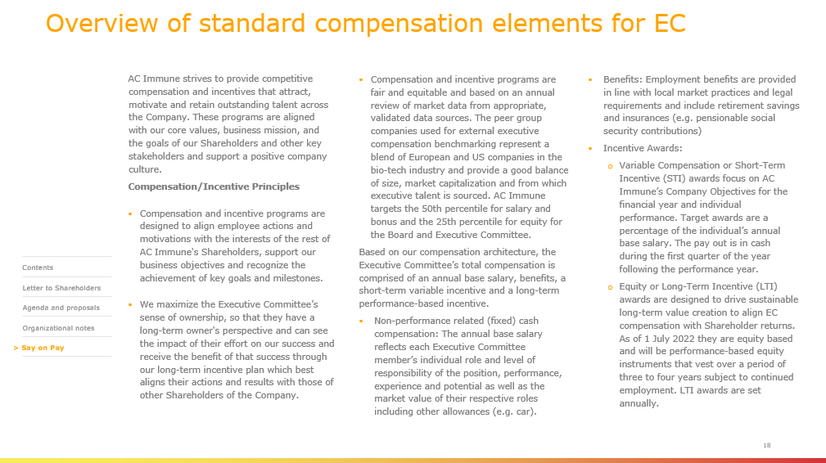
Overview of standard compensation elements for EC AC Immune strives to provide competitive compensation and incentives that attract, motivate and retain outstanding talent across the Company. These programs are aligned with our core values, business mission, and the goals of our Shareholders and other key stakeholders and support a positive company culture. Compensation/Incentive Principles ▪ Compensation and incentive programs are designed to align employee actions and motivations with the interests of the rest of AC Immune's Shareholders, support our business objectives and recognize the achievement of key goals and milestones. ▪ We maximize the Executive Committee’s sense of ownership, so that they have a long - term owner's perspective and can see the impact of their effort on our success and receive the benefit of that success through our long - term incentive plan which best aligns their actions and results with those of other Shareholders of the Company. 18 ▪ Benefits: Employment benefits are provided in line with local market practices and legal requirements and include retirement savings and insurances (e.g. pensionable social security contributions) ▪ Incentive Awards: o Variable Compensation or Short - Term Incentive (STI) awards focus on AC Immune’s Company Objectives for the financial year and individual performance. Target awards are a percentage of the individual’s annual base salary. The pay out is in cash during the first quarter of the year following the performance year. o Equity or Long - Term Incentive (LTI) awards are designed to drive sustainable long - term value creation to align EC compensation with Shareholder returns. As of 1 July 2022 they are equity based and will be performance - based equity instruments that vest over a period of three to four years subject to continued employment. LTI awards are set annually. ▪ Compensation and incentive programs are fair and equitable and based on an annual review of market data from appropriate, validated data sources. The peer group companies used for external executive compensation benchmarking represent a blend of European and US companies in the bio - tech industry and provide a good balance of size, market capitalization and from which executive talent is sourced. AC Immune targets the 50th percentile for salary and bonus and the 25th percentile for equity for the Board and Executive Committee. Based on our compensation architecture, the Executive Committee’s total compensation is comprised of an annual base salary, benefits, a short - term variable incentive and a long - term performance - based incentive. ▪ Non - performance related (fixed) cash compensation: The annual base salary reflects each Executive Committee member’s individual role and level of responsibility of the position, performance, experience and potential as well as the market value of their respective roles including other allowances (e.g. car). > Contents Letter to Shareholders Agenda and proposals Organizational notes > Say on Pay

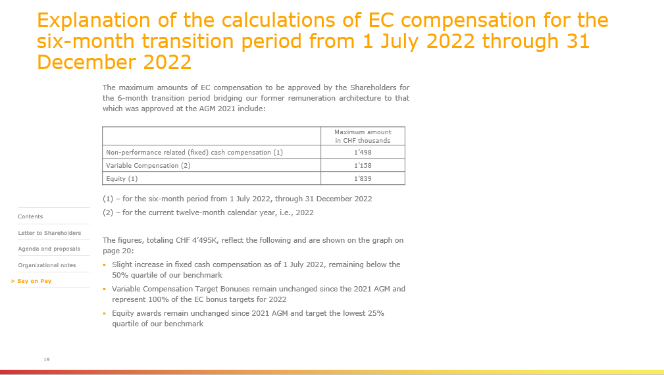
Explanation of the calculations of EC compensation for the six - month transition period from 1 July 2022 through 31 December 2022 19 The maximum amounts of EC compensation to be approved by the Shareholders for the 6 - month transition period bridging our former remuneration architecture to that which was approved at the AGM 2021 include : ( 1 ) – for the six - month period from 1 July 2022 , through 31 December 2022 ( 2 ) – for the current twelve - month calendar year, i . e . , 2022 The figures, totaling CHF 4’495K, reflect the following and are shown on the graph on page 20: ▪ Slight increase in fixed cash compensation as of 1 July 2022, remaining below the 50% quartile of our benchmark ▪ Variable Compensation Target Bonuses remain unchanged since the 2021 AGM and represent 100% of the EC bonus targets for 2022 ▪ Equity awards remain unchanged since 2021 AGM and target the lowest 25% quartile of our benchmark Maximum amount in CHF thousands Non - performance related (fixed) cash compensation (1) 1’498 Variable Compensation (2) 1’158 Equity (1) 1’839 > Contents Letter to Shareholders Agenda and proposals Organizational notes > Say on Pay

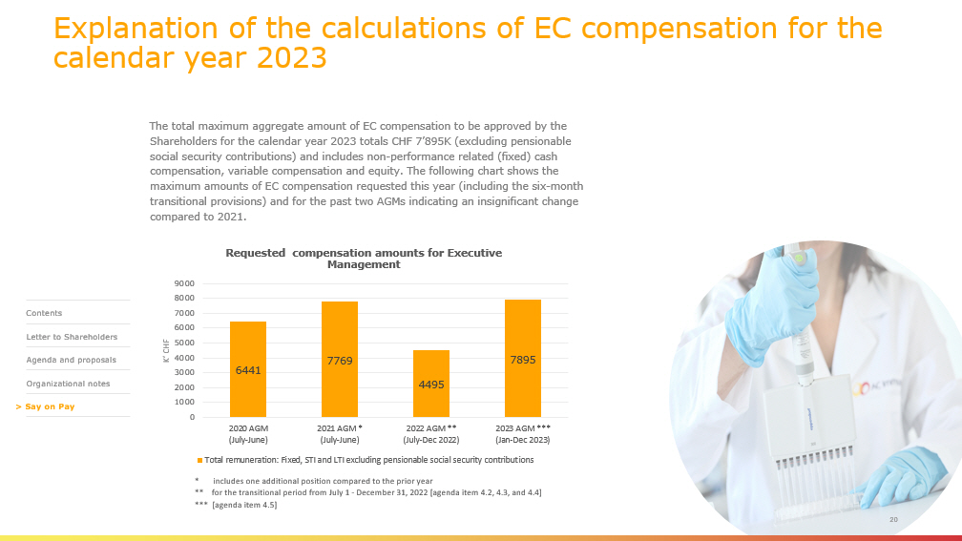
Explanation of the calculations of EC compensation for the calendar year 2023 The total maximum aggregate amount of EC compensation to be approved by the Shareholders for the calendar year 2023 totals CHF 7’895K (excluding pensionable social security contributions) and includes non - performance related (fixed) cash compensation, variable compensation and equity. The following chart shows the maximum amounts of EC compensation requested this year (including the six - month transitional provisions) and for the past two AGMs indicating an insignificant change compared to 2021. 20 * includes one additional position compared to the prior year ** for the transitional period from July 1 - December 31, 2022 [agenda item 4.2, 4.3, and 4.4] *** [agenda item 4.5] 6441 7769 4495 7895 0 1000 2000 3000 4000 5000 6000 7000 8000 9000 2020 AGM (July-June) 2021 AGM * (July-June) 2022 AGM ** (July-Dec 2022) 2023 AGM *** (Jan-Dec 2023) K’ CHF Requested compensation amounts for Executive Management Total remuneration: Fixed, STI and LTI excluding pensionable social security contributions > Contents Letter to Shareholders Agenda and proposals Organizational notes > Say on Pay


For more information Reach out to us Investor inquiries: ir@acimmune.com AC Immune SA EPFL Innovation Park Building B 1015 Lausanne Switzerland Phone: +41 21 345 91 21 www.acimmune.com

EXHIBIT 99.2
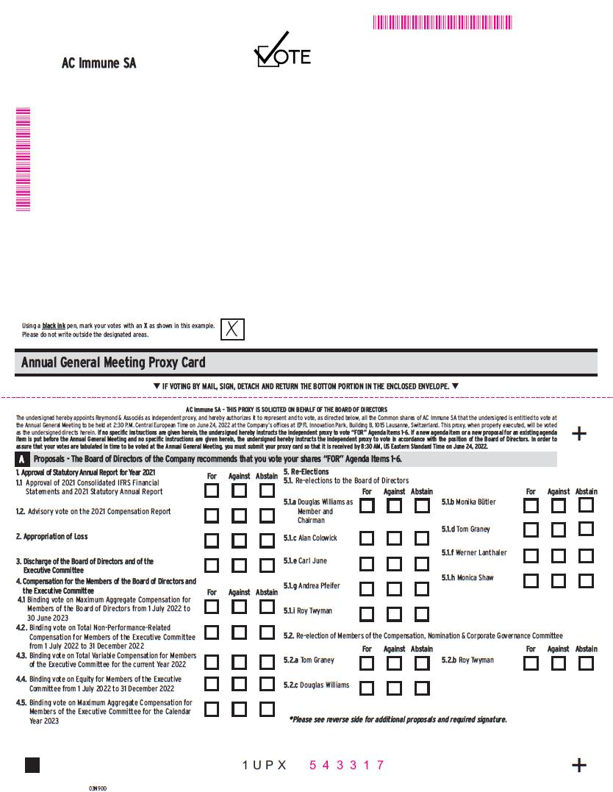
1 U P X AC Immune SA Using a black ink pen, mark your votes with an X as shown in this example. Please do not write outside the designated areas. 0 3N9OD + + q IF VOTING BY MAIL, SIGN, DETACH AND RETURN THE BOTTOM PORTION IN THE ENCLOSED ENVELOPE. q Annual General Meeting Proxy Card Proposals - The Board of Directors of the Company recommends that you vote your shares “FOR” Agenda Items 1 - 6. A *Please see reverse side for additional proposals and required signature. 1. Approval of Statutory Annual Report for Year 2021 1. Approval of 2021 Consolidated IFRS Financial Statements and 2021 Statutory Annual Report 1.2. Advisory vote on the 2021 Compensation Report 5.1. Re - elections to the Board of Directors For Against Abstain F or Against Abstain 5. Re - Elections 2. Appropriation of Loss 3. Discharge of the Board of Directors and of the Executive Committee 4. Compensation for the Members of the Board of Directors and the Executive Committee 1. Binding vote on Maximum Aggregate Compensation for Members of the Board of Directors from 1 July 2022 to 30 June 2023 2. Binding vote on Total Non - Performance - Related Compensation for Members of the Executive Committee from 1 July 2022 to 31 December 2022 3. Binding vote on Total Variable Compensation for Members of the Executive Committee for the current Year 2022 4. Binding vote on Equity for Members of the Executive Committee from 1 July 2022 to 31 December 2022 5. Binding vote on Maximum Aggregate Compensation for Members of the Executive Committee for the Calendar Year 2023 AC Immune SA - THIS PROXY IS SOLICITED ON BEHALF OF THE BOARD OF DIRECTORS The undersigned hereby appoints Reymond & Associés as independent proxy, and hereby authorizes it to represent and to vote, as directed below, all the Common shares of AC Immune SA that the undersigned is entitled to vote at the Annual General Meeting to be held at 2 : 30 P . M . Central European Time on June 24 , 2022 at the Company’s offices at EPFL Innovation Park, Building B, 1015 Lausanne, Switzerland . This proxy, when properly executed, will be voted as the undersigned directs herein . If no specific instructions are given herein, the undersigned hereby instructs the independent proxy to vote “FOR” Agenda Items 1 - 6 . If a new agenda item or a new proposal for an existing agenda item is put before the Annual General Meeting and no specific instructions are given herein, the undersigned hereby instructs the independent proxy to vote in accordance with the position of the Board of Directors . In order to assure that your votes are tabulated in time to be voted at the Annual General Meeting, you must submit your proxy card so that it is received by 8 : 30 AM, US Eastern Standard Time on June 24 , 2022 . 5.1.a Douglas Williams as Member and Chairman 5.1.c Alan Colowick 5.1.e Carl June For Against Abstain 5.1.b Monika Bütler 5.1.d Tom Graney 5.1.f Werner Lanthaler For Against Abstain 5.2. Re - election of Members of the Compensation, Nomination & Corporate Governance Committee For Against Abstain For Against Abstain 5.2.a Tom Graney 5.2.b Roy Twyman 5.2.c Douglas Williams 5.1.g Andrea Pfeifer 5.1.h Monica Shaw 5.1.i Roy Twyman MMMMMMMM M 5 4 3 3 1 7 MMMMMMMMMMMM

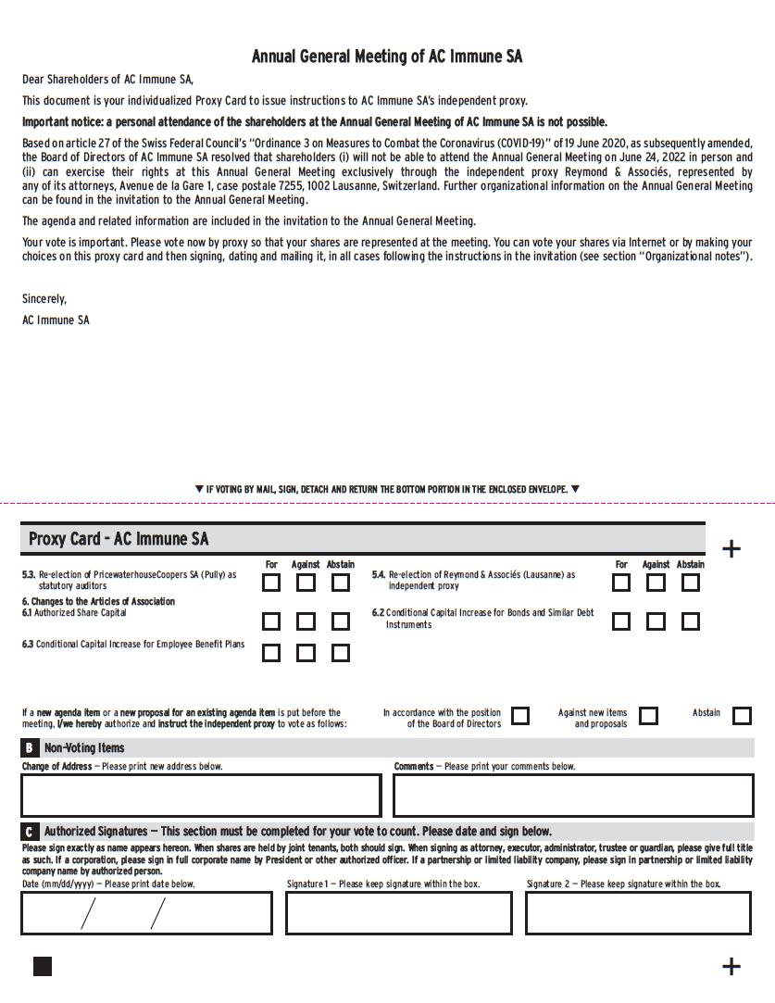
Proxy Card - AC Immune SA q IF VOTING BY MAIL, SIGN, DETACH AND RETURN THE BOTTOM PORTION IN THE ENCLOSED ENVELOPE. q + + Please sign exactly as name appears hereon . When shares are held by joint tenants, both should sign . When signing as attorney, executor, administrator, trustee or guardian, please give full title as such . If a corporation, please sign in full corporate name by President or other authorized officer . If a partnership or limited liability company, please sign in partnership or limited liability company name by authorized person . Date (mm/dd/yyyy) — Please print date below . Signature 1 — Please keep signature within the box . Signature 2 — Please keep signature within the box . Annual General Meeting of AC Immune SA Dear Shareholders of AC Immune SA, This document is your individualized Proxy Card to issue instructions to AC Immune SA’s independent proxy. Important notice: a personal attendance of the shareholders at the Annual General Meeting of AC Immune SA is not possible. Based on article 27 of the Swiss Federal Council’s “Ordinance 3 on Measures to Combat the Coronavirus (COVID - 19)” of 19 June 2020, as subsequently amended, the Board of Directors of AC Immune SA resolved that shareholders (i) will not be able to attend the Annual General Meeting on June 24, 2022 in person and (ii) can exercise their rights at this Annual General Meeting exclusively through the independent proxy Reymond & Associés, represented by any of its attorneys, Avenue de la Gare 1 , case postale 7255 , 1002 Lausanne, Switzerland . Further organizational information on the Annual General Meeting can be found in the invitation to the Annual General Meeting . The agenda and related information are included in the invitation to the Annual General Meeting . Your vote is important . Please vote now by proxy so that your shares are represented at the meeting . You can vote your shares via Internet or by making your choices on this proxy card and then signing, dating and mailing it, in all cases following the instructions in the invitation (see section “Organizational notes”) . Sincerely, AC Immune SA Non - Voting Items B Authorized Signatures — This section must be completed for your vote to count. Please date and sign below. C Change of Address — Please print new address below. Comments — Please print your comments below. If a new agenda item or a new proposal for an existing agenda item is put before the meeting, I/we hereby authorize and instruct the independent proxy to vote as follows: In accordance with the position of the Board of Directors Against new items and proposals A b s t ain 5.4. Re - election of Reymond & Associés (Lausanne) as independent proxy 5.3. Re - election of PricewaterhouseCoopers SA (Pully) as statutory auditors 6. Changes to the Articles of Association 1. Authorized Share Capital 6.2 Conditional Capital Increase for Bonds and Similar Debt Instruments 6.3 Conditional Capital Increase for Employee Benefit Plans For Against Abstain For Against Abstain

