UNITED STATES

SECURITIES AND EXCHANGE COMMISSION

Washington, D.C. 20549

FORM 6-K

REPORT OF FOREIGN PRIVATE ISSUER PURSUANT TO RULE 13a-16 OR 15d-16 UNDER THE SECURITIES EXCHANGE ACT OF 1934

For the month of July, 2019

Commission File Number: 001-37891

AC IMMUNE SA

(Exact name of registrant as specified in its charter)

EPFL Innovation Park

Building B

1015 Lausanne, Switzerland

(Address of principal executive office)

Indicate by check mark whether the registrant files or will file annual reports under cover of Form 20-F or Form 40-F:

Form 20-F X Form 40-F

Indicate by check mark if the registrant is submitting the Form 6-K in paper as permitted by Regulation S-T Rule 101(b)(1):

Yes No X

Indicate by check mark if the registrant is submitting the Form 6-K in paper as permitted by Regulation S-T Rule 101(b)(7):

Yes No X

AC IMMUNE SA

On July 11, 2019, representatives from AC Immune will present at its Key Opinion Leader (“KOL”) meeting held in New York City, using the presentation slides attached as Exhibit 99.1 hereto. A related press release describing certain of the information being presented at the KOL meeting is also attached as Exhibit 99.2 hereto.

This report on Form 6-K (including Exhibits 99.1 and 99.2 hereto) shall be deemed to be incorporated by reference into the registration on Form F-3 (Registration Number: 333-224694), the registration statement on Form F-3 (Registration Number: 333-227016) and the registration statement on Form S-8 (Registration Number: 333-216539) of AC Immune and to be a part thereof from the date on which this report is filed, to the extent not superseded by documents or reports subsequently filed or furnished.

SIGNATURE

Pursuant to the requirements of the Securities Exchange Act of 1934, the registrant has duly caused this report to be signed on its behalf by the undersigned, thereunto duly authorized.

AC IMMUNE SA

By: | /s/ Andrea Pfeifer
 | Name: | Andrea Pfeifer
 | Title: | Chief Executive Officer
By: | /s/ Joerg Hornstein
 | Name: | Joerg Hornstein
 | Title: | Chief Financial Officer

Date: July 11, 2019

 | EXHIBIT INDEX
Exhibit | Description
Number
99.1 | Presentation dated July 11, 2019
99.2 | Press Release dated July 11, 2019

Exhibit 99.1
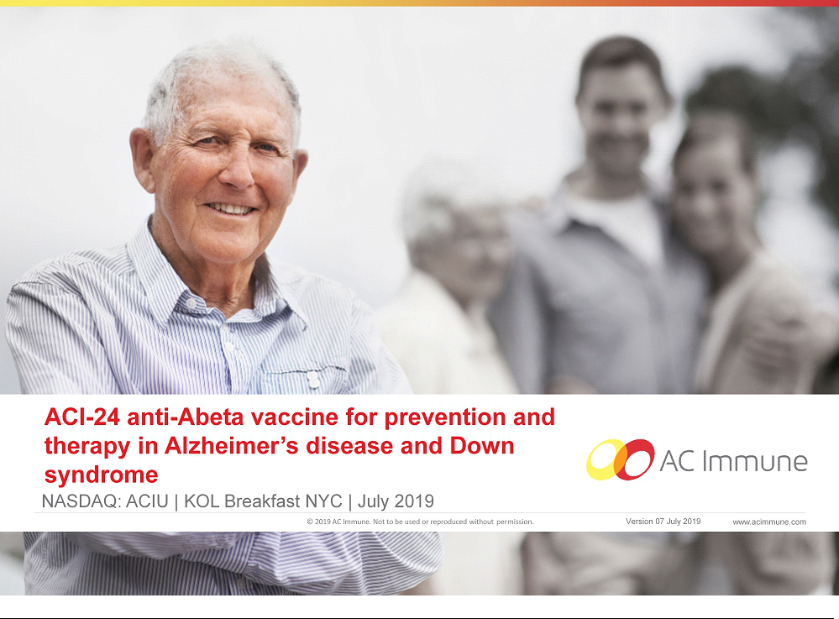

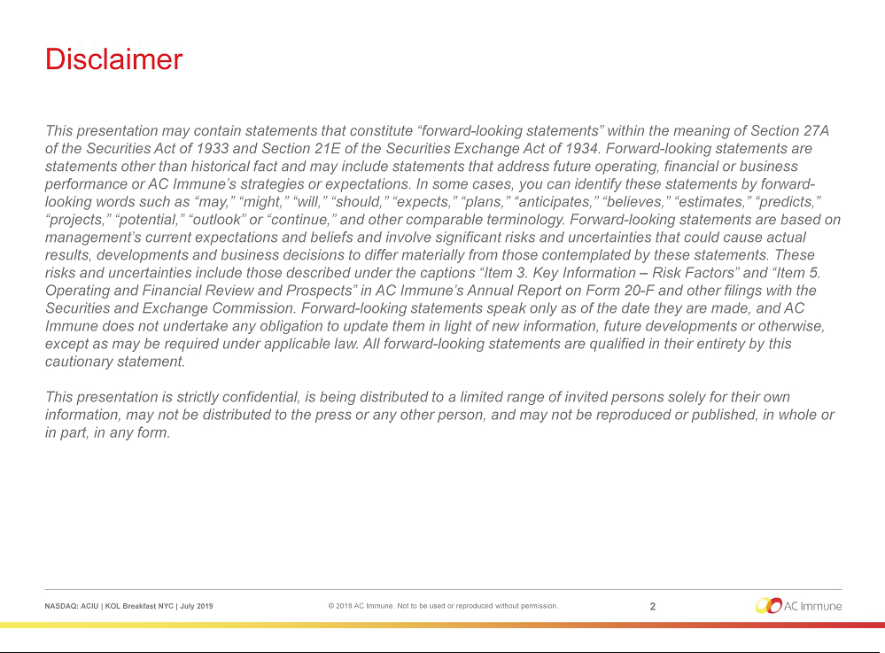

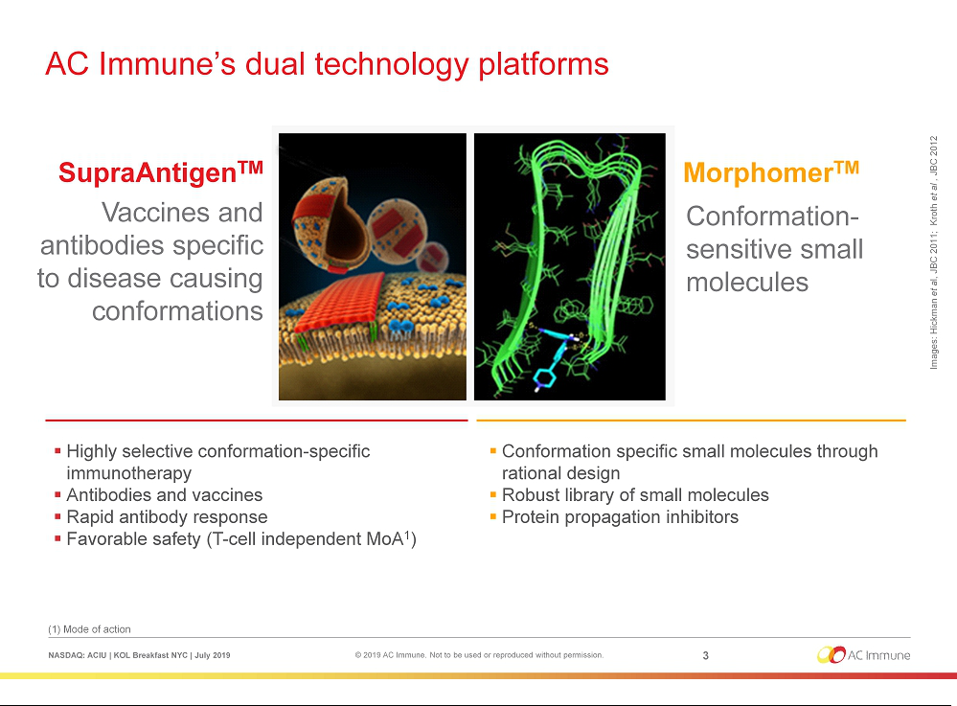

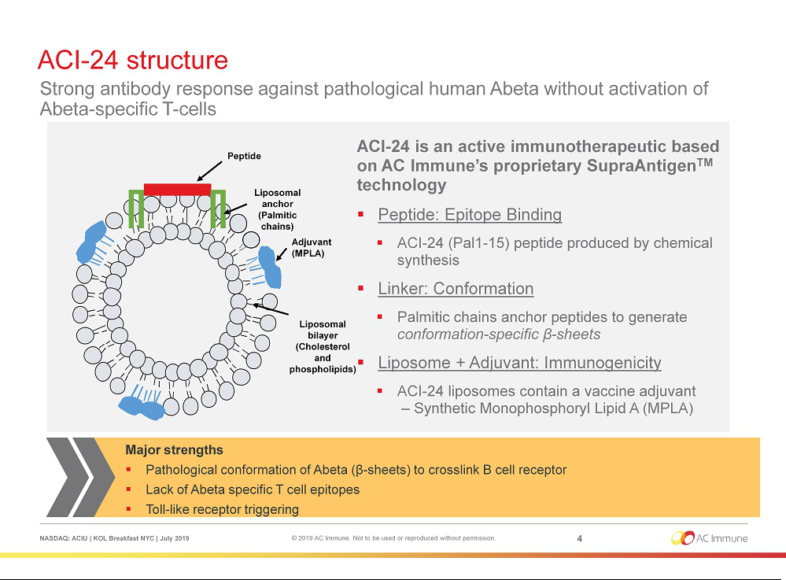

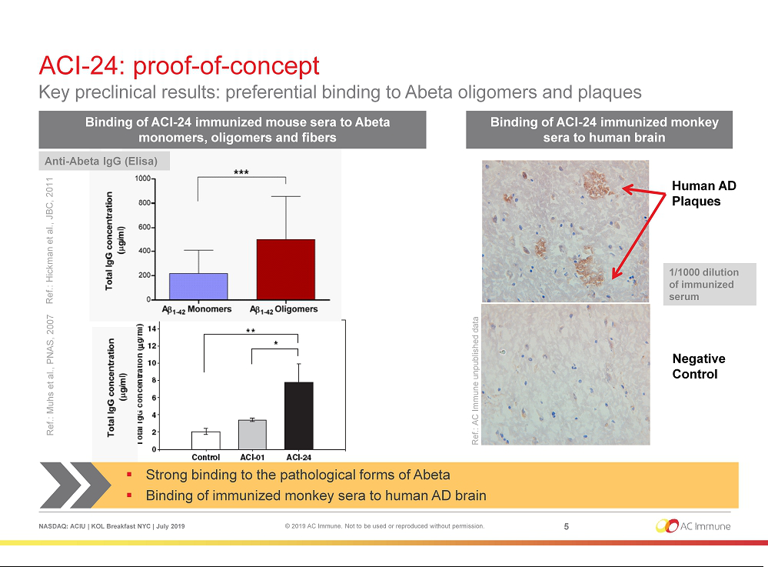

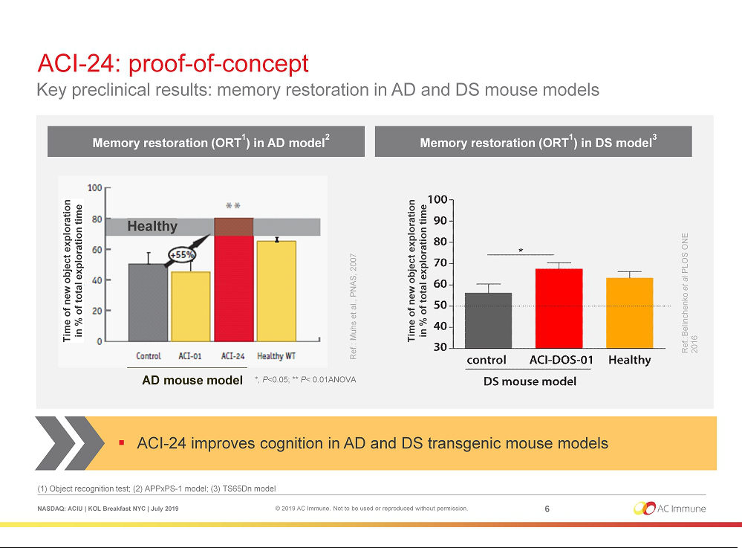

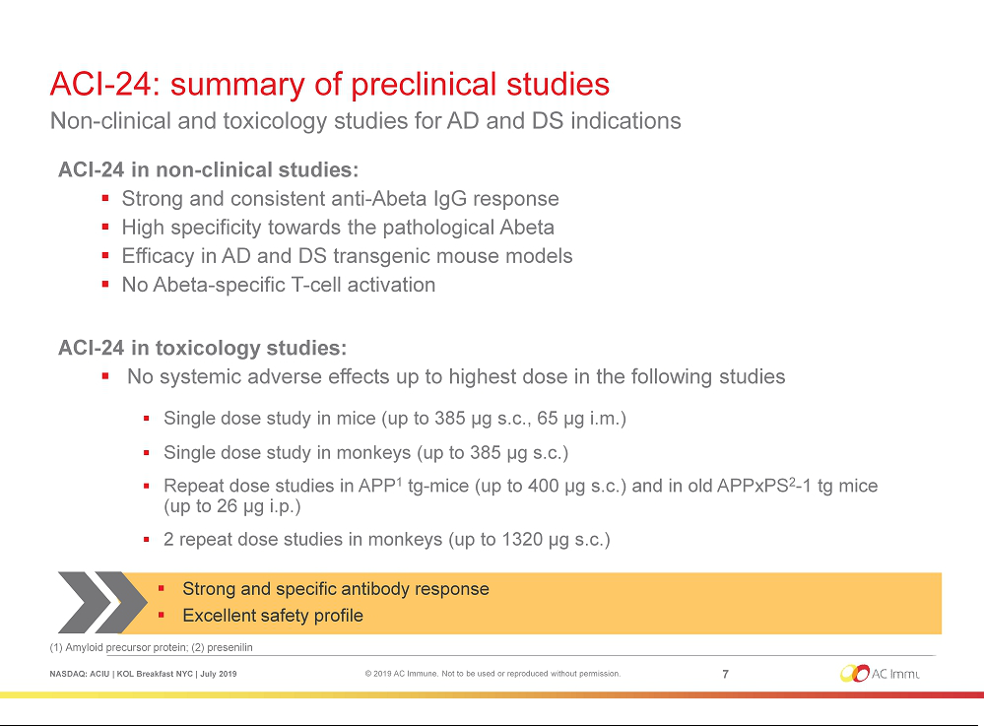

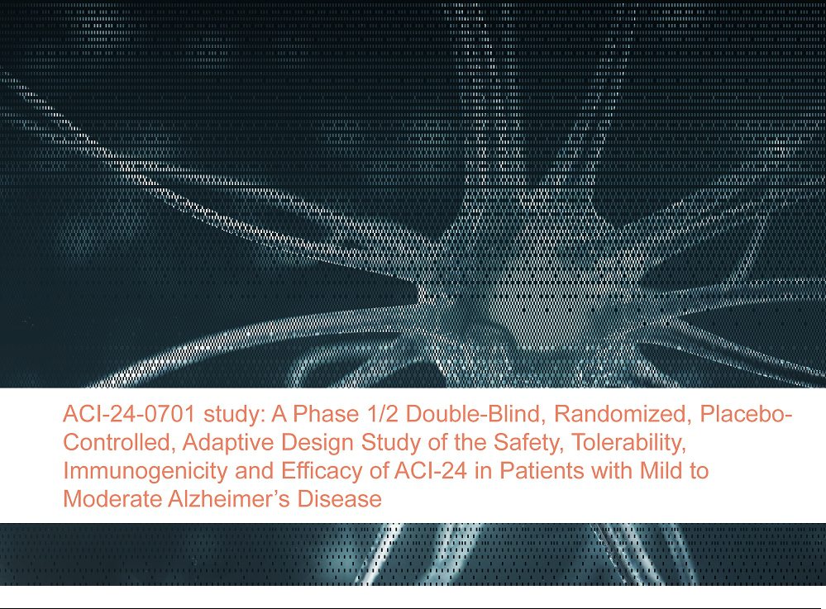

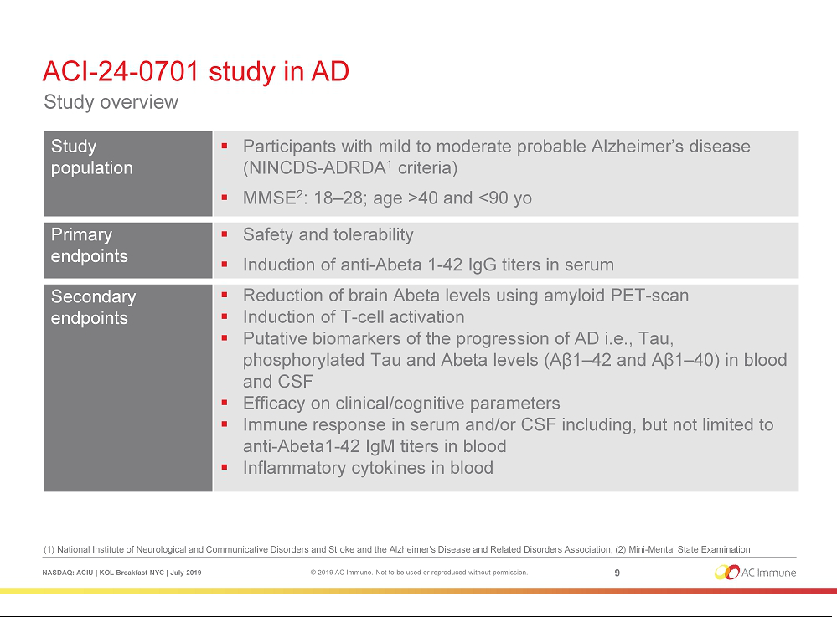

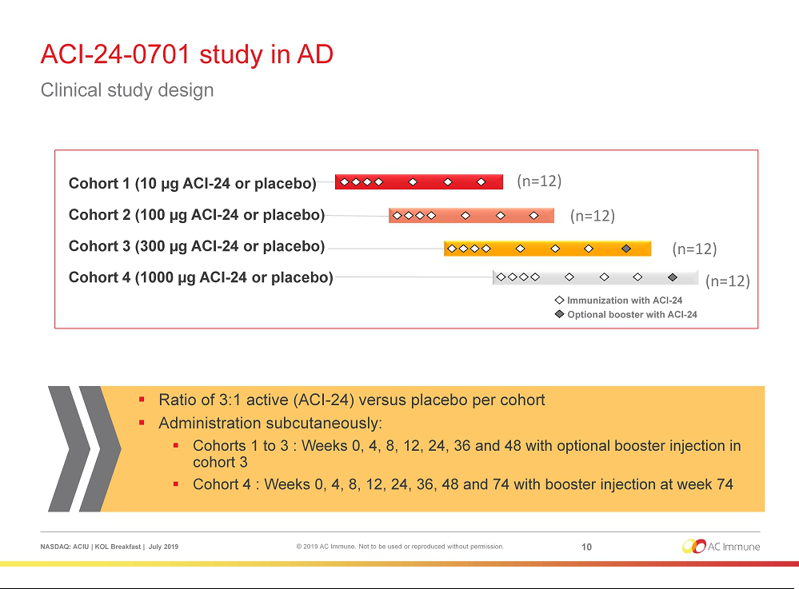

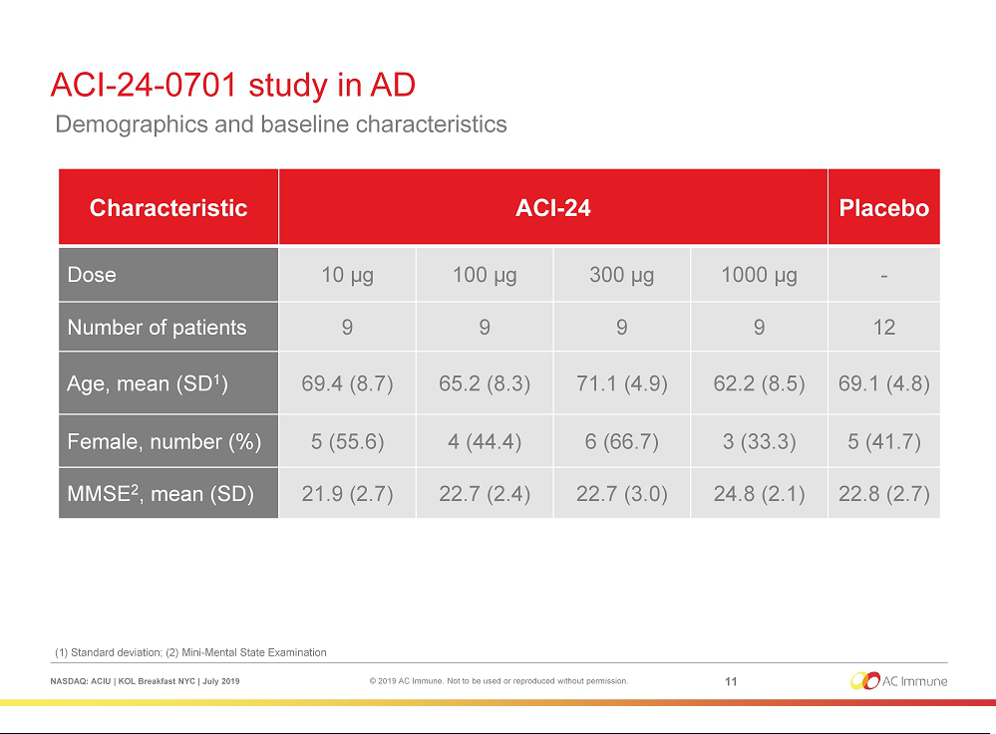

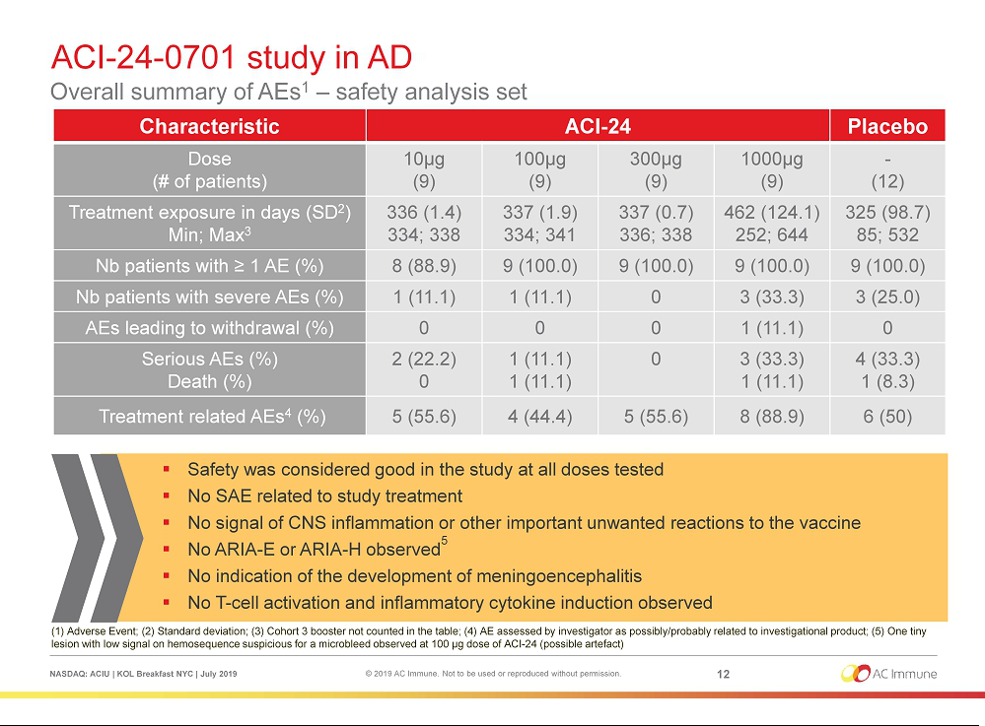

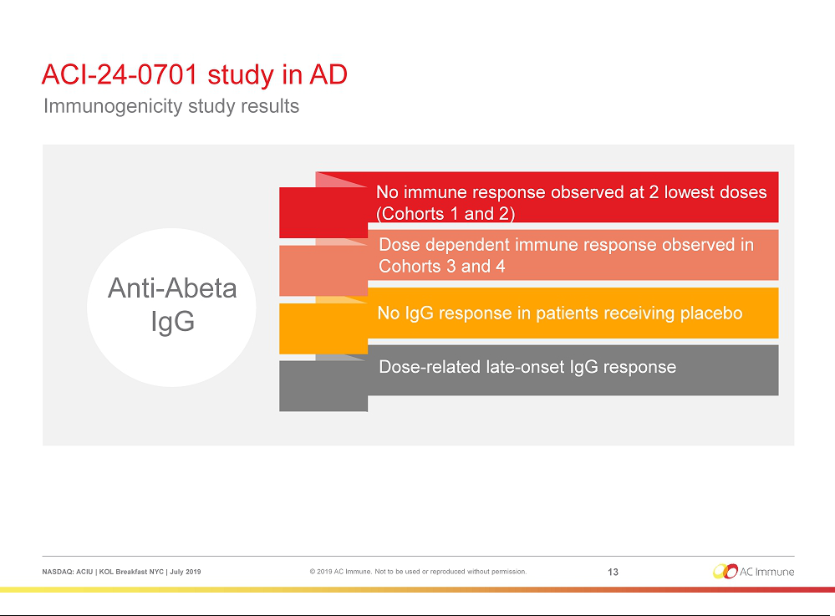

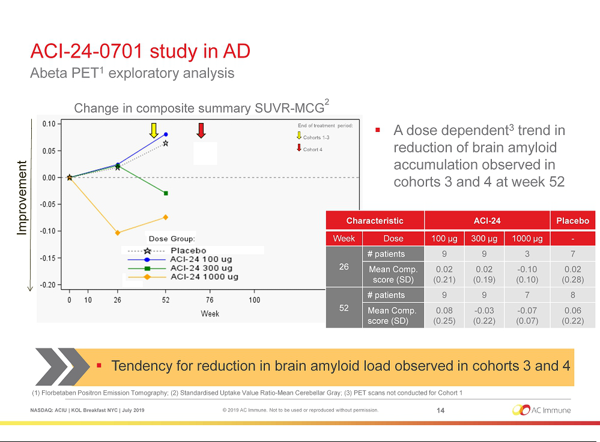

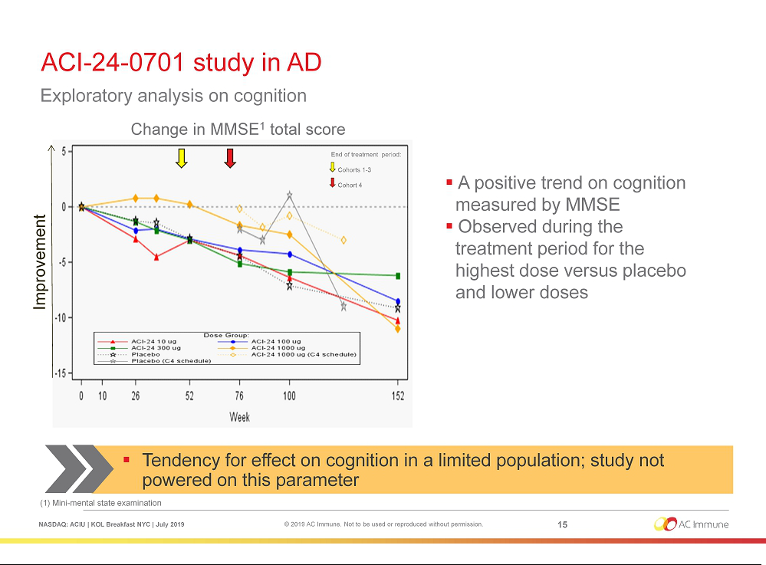

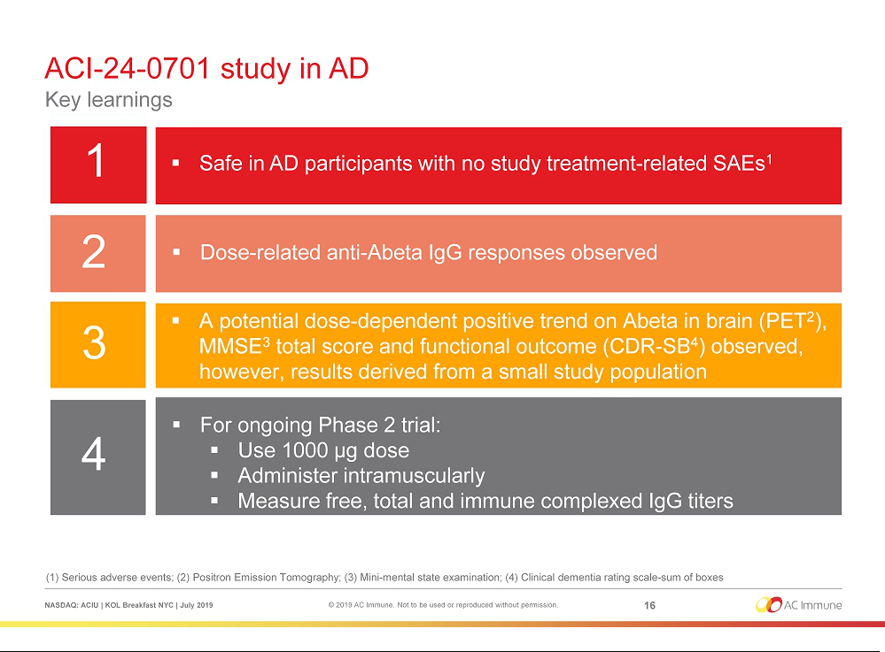

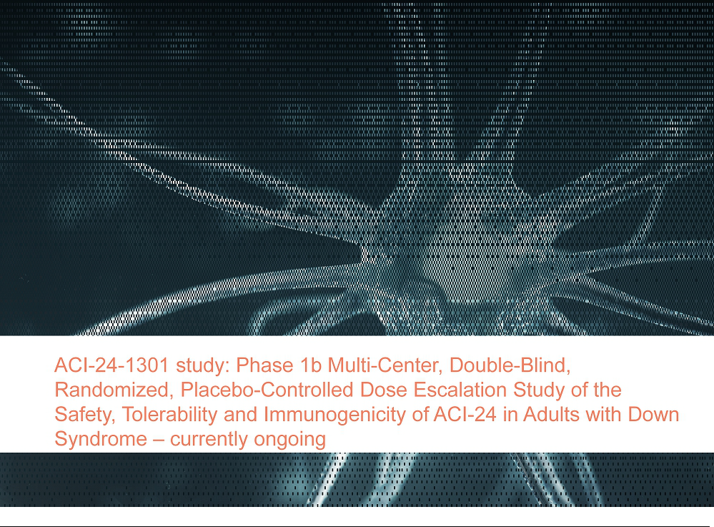

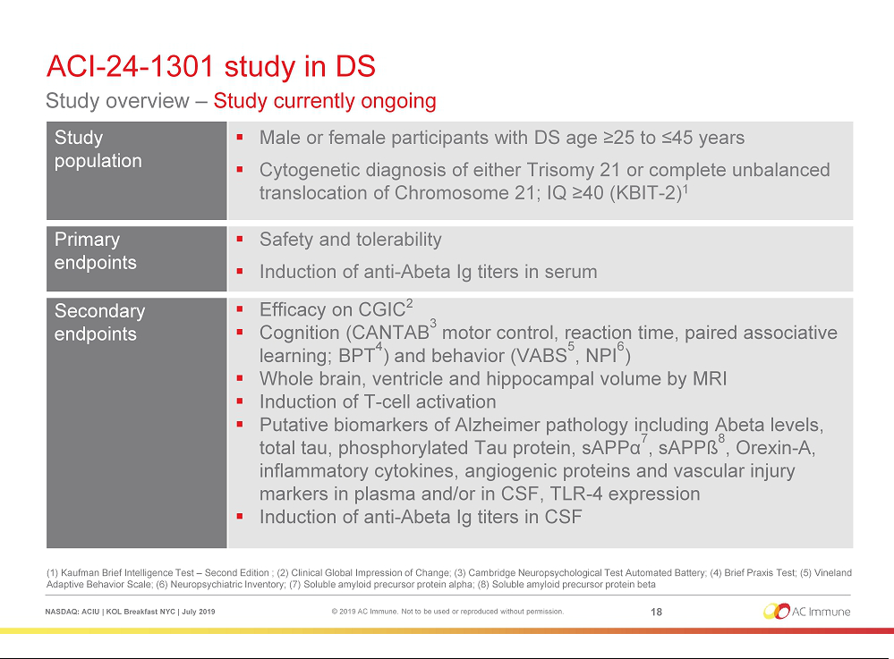

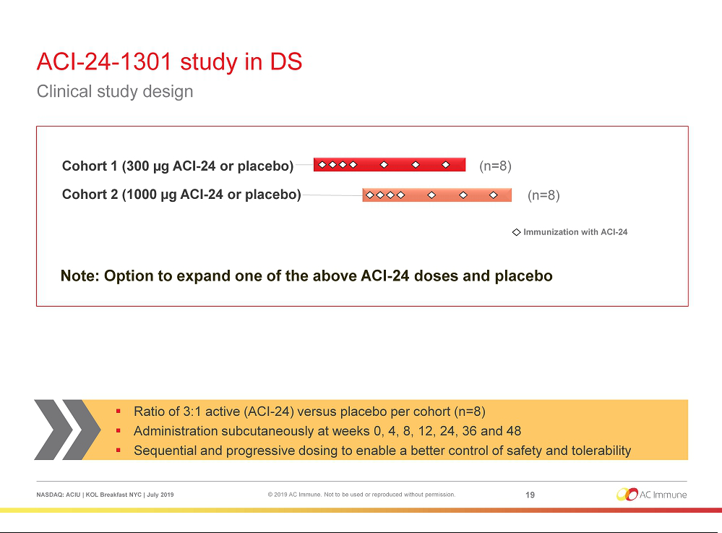

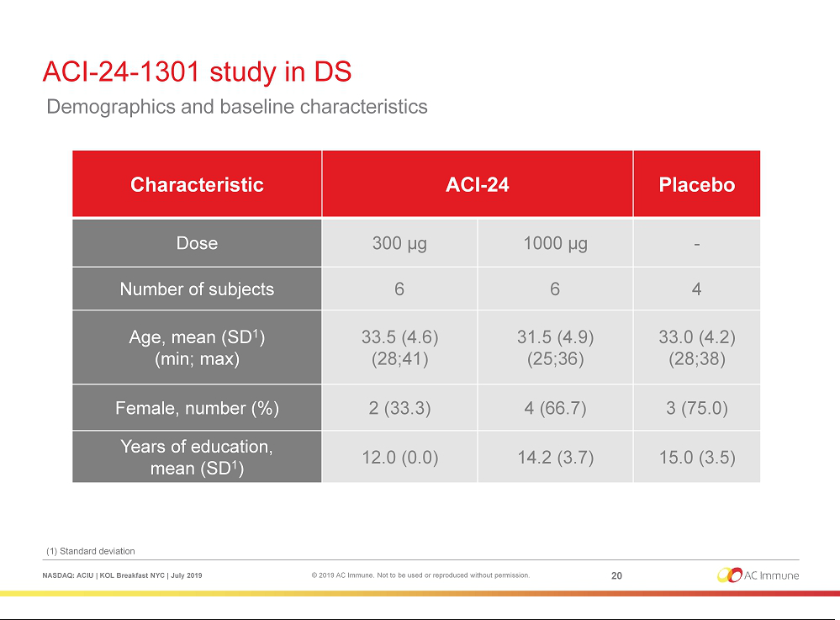

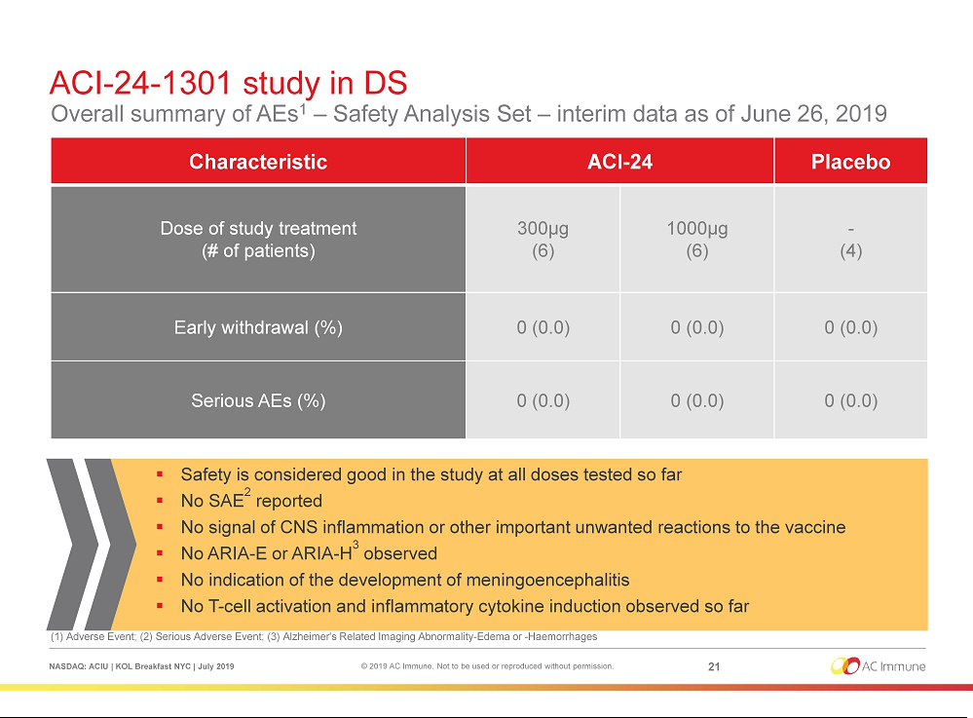

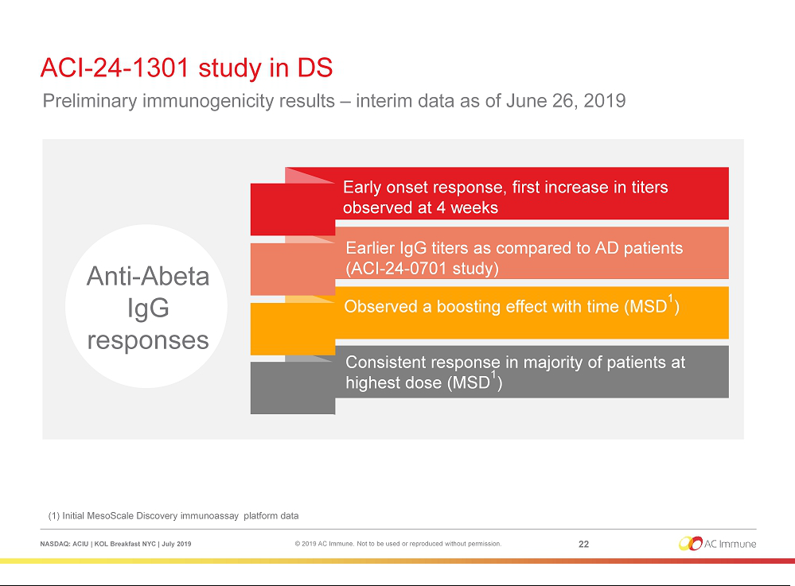

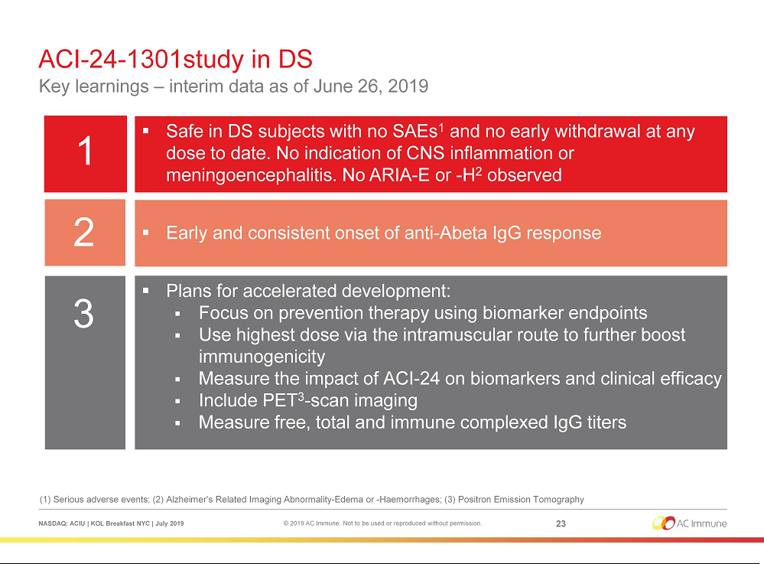

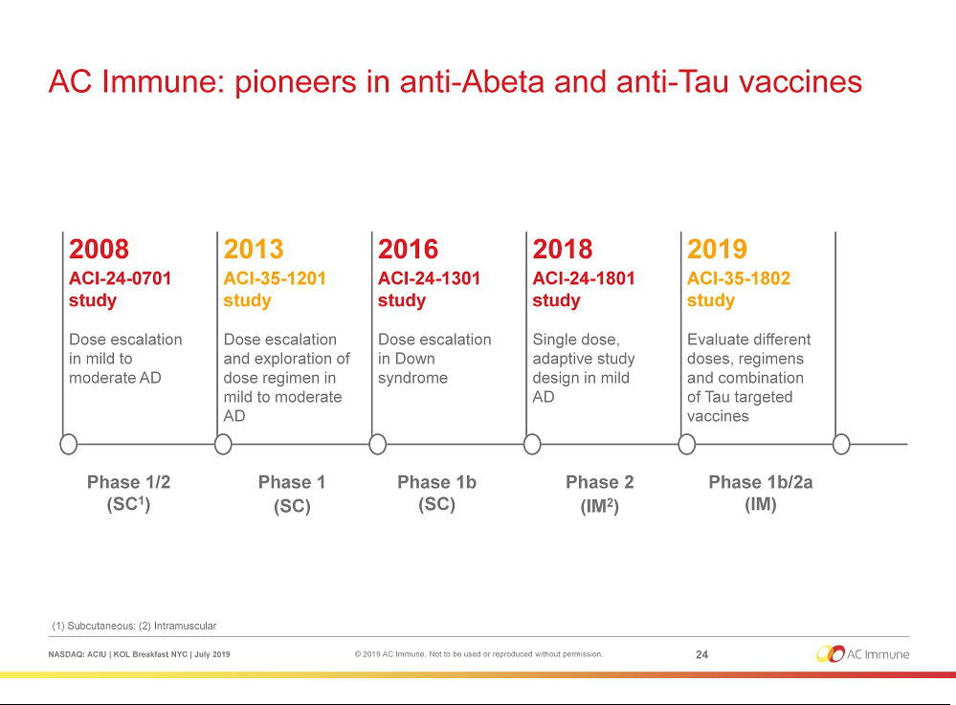

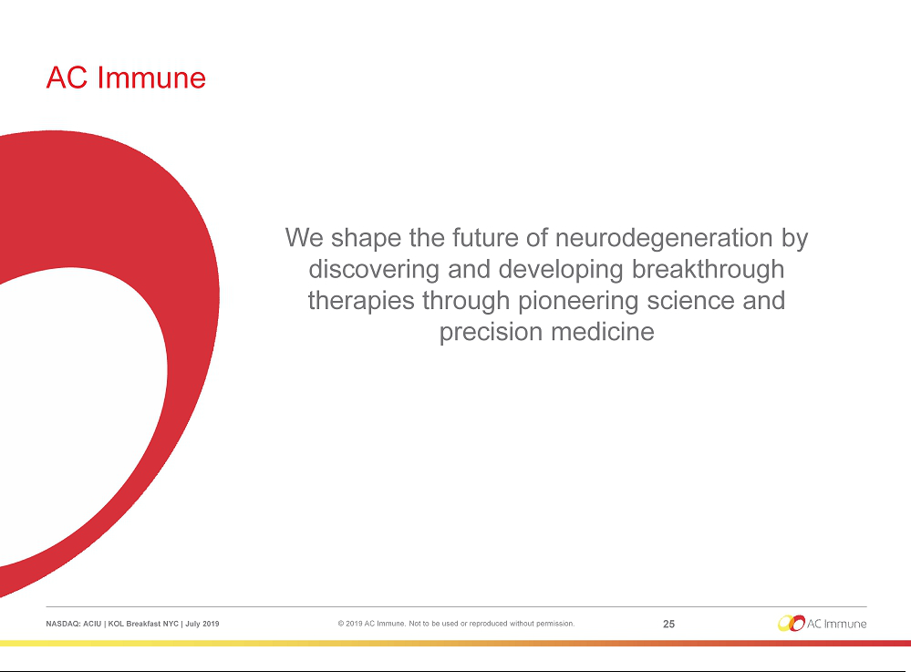

Exhibit 99.2


PRESS RELEASE

AC Immune Hosts KOL Event and Reports Initial Interim Clinical Data for ACI-24 Vaccine to Treat Alzheimer’s Disease-like Symptoms in Subjects with Down Syndrome

Anti-Abeta vaccine demonstrates strong safety and preliminary immunogenicity results in subjects with Down syndrome

Presentations underscore significant need and opportunity for studying Alzheimer’s disease-like symptoms in this high-risk and genetically homogeneous

population

Lausanne, Switzerland, 11, July 2019 – AC Immune SA (NASDAQ: ACIU), a Swiss-based, clinical-stage biopharmaceutical company with a broad pipeline focused on neurodegenerative diseases, today announced initial interim data from an ongoing Phase 1b trial of the ACI-24 anti-Abeta vaccine to treat Alzheimer’s disease (AD) like symptoms in subjects with Down syndrome (DS) as well as key takeaways from its Key Opinion Leader (KOL) meeting, held in New York City.

Professor Andrea Pfeifer, CEO of AC Immune, commented: “These initial interim Phase 1b data support the continued study of ACI-24 in this trial to treat AD-like symptoms in DS as well as in our ongoing Phase 2 trial in subjects with mild AD. We thank Dr. Skotko and Professor Mobley, leading Key Opinion Leaders, whose participation today highlights the unmet need and the significant opportunity that exists for studying AD-like symptoms in this more homogeneous population, which may yield critical information for the potential benefit of DS subjects as well as the broader AD community.”

The event, which will be recorded and can be viewed here, is being co-chaired by Professor Pfeifer and Professor William Mobley, Executive Director of the University of California San Diego’s Down Syndrome Center for Research and Treatment. It features presentations from Professor Mobley and Dr. Brian Skotko, Associate Professor at Harvard Medical School and the Emma Campbell Endowed Chair on Down Syndrome and Director of the Down Syndrome Program at Massachusetts General Hospital, as well as Professor Pfeifer and Dr. Marie Kosco-Vilbois, Chief Scientific Officer of AC Immune.

Highlights from Dr. Kosco-Vilbois’ presentation include:

- The trial is a fully enrolled, placebo-controlled, 16 subjects Phase 1b study of AC Immune’s ACI-24 anti-Abeta vaccine

- To date, ACI-24 was well tolerated by DS subjects, demonstrating a favourable safety profile at all doses tested, mirroring previous clinical trial results

- There were no subjects withdrawals from the study or serious adverse events (SAE) reported, no signals of CNS inflammation or other pro-inflammatory reactions, no amyloid-related imaging abnormalities (ARIA-E/ARIA-H) or indication of meningoencephalitis

- Preliminary immunogenicity data showed an anti-Abeta IgG response that was detectable at week 4

- Pending the final outcome, the Phase 2 study of ACI-24 in subjects with DS would likely focus on disease prevention and will include biomarkers and Positron Emission Tomography (PET) imaging to monitor disease progression, in addition to quantifying anti-Abeta IgG titers generated by the vaccine.

Dr. Kosco-Vilbois, CSO of AC Immune, commented: “We are pleased that to date in this study our proprietary, highly selective, conformation-specific anti-Abeta vaccine has been safe and was well tolerated and demonstrated preliminary signals of activity in DS subjects. These early immunogenicity data, showing an IgG response, are encouraging. Given the Abeta-driven nature of AD-like symptoms in DS subjects, we believe that ACI-24, which targets pathologic forms of Abeta, may reduce the appearance of amyloid burden and related brain lesions and potentially slow or halt progression of the disease.”

Highlights of Dr. Skotko’s presentation include:

- DS is caused by having a third copy (trisomy) of chromosome 21 and occurs in 1/~792 live births; ~5,000 children per year

- ~212,000 people living with DS in the US and ~359,000 in Europe

- Adults with DS are increasingly moving into semi-independent living situations and securing paid employment, are involved in romantic relationships and marry, participate in day habilitation services or are active participants in sports (Special Olympics)

- Initial symptoms are typically changes in behavior; seizures can also be an early warning sign, followed by memory loss

- Based on surveys, family members and people with DS say they are satisfied, even positive, about their lives despite acknowledging the challenges that accompany DS

Highlights from Professor Mobley’s presentation include:

- The neuropathological changes in DS subjects are very similar but not identical to typical AD. People with Down syndrome have an extra copy of chromosome 21, which houses the gene that codes for amyloid precursor protein (APP). APP is the parent protein of Abeta, a protein fragment that accumulates into amyloid plaques, a key feature of AD

- Studying AD-like symptoms in the DS population addresses many of the key dilemmas that hinder the discovery of new treatments: uncertain mechanisms and timing of disease-induced brain changes, difficulty offering treatment before disease onset, genetic and age-related variability, and the risk of including subjects with other forms of age-related dementia

- For AD in DS, the disease mechanism and approximate timing of onset are known; readily detectable pathological changes occur prior to AD-like symptoms, enabling treatment prior to disease onset; the DS population is far more homogeneous and carries minimal risk of having coexisting conditions causing dementia at such a young age

- In mouse models of DS, vaccination against Abeta by ACI-24 improved cognition and prevented neuronal atrophy

Professor Mobley commented: “DS is an underrepresented, overlooked population at increased risk for AD-like disease. It offers opportunities for exploring effective treatments for AD that will benefit both the DS and general populations. Homogeneity in pathogenesis, age-related disease onset and absence of other dementias powerfully enable prevention trials of AD-like symptoms in DS. I am encouraged by the body of evidence supporting this rationale and personally gratified to be conducting the first clinical trial of a vaccine against Abeta in individuals with DS.”

DS is characterized by the onset of AD-like symptoms by age 20, and nearly all DS subjects display AD-like symptoms by age 40. Treating AD-like symptoms in DS subjects is imperative and information from this patient population may also be pivotal for developing successful treatments for the broader AD population. Many KOLs – and AC Immune – believe that this approach may make it possible to more rapidly identify successful treatment strategies, including combination therapies for AD, to benefit DS subjects as well as the AD community. This was the theme of AC Immune’s KOL Breakfast today, which examined the Company’s Roadmap for developing innovative treatment paradigms for neurodegenerative diseases.

Key Opinion Leader Biographies:

Professor William C. Mobley, M.D., Ph.D., is an Executive Director of UCSD’s Down Syndrome Center for Research and Treatment and the Florence Riford Chair of Alzheimer’s Disease Research. Professor Mobley came to UCSD in 2009 from Stanford University where he served as the John E. Cahill Family Professor in the Department of Neurology and Neurological Sciences and was the founding director of the Neuroscience Institute. Professor Mobley earned his M.D. and Ph.D. in Neuro- & Behavioral Science, as well as an internship in pathology, all at Stanford University in Palo Alto, California. He then went on to complete a residency and fellowship in neurology and pediatric neurology at The Johns Hopkins University. While there, he was selected to serve as Chief Resident in Pediatric Neurology. He is certified by the American Board of Pediatrics and the American Board of Psychiatry and Neurology with Special Competence in Child Neurology.

Dr. Brian Skotko, M.D., M.P.P., is a Board-certified medical geneticist and the Emma Campbell Endowed Chair on Down Syndrome at Massachusetts General Hospital. As the Director of the hospital’s Down Syndrome Program, he has dedicated his professional energies toward children with cognitive and development disabilities. Dr. Skotko co-authored the national award-winning books, Common Threads: Celebrating Life with Down Syndrome and Fasten Your Seatbelt: A Crash Course on Down Syndrome for Brothers and Sisters. He is a graduate of Duke University, Harvard Medical School, and Harvard Kennedy School, and he is currently an Associate Professor at Harvard Medical School. Dr. Skotko is a leader on clinical and translational research in the field of Down syndrome. He has been featured in The Wall Street Journal, The New York Times, The Washington Post, The L.A. Times, NPR’s “On Point,” and ABC’s “Good Morning America.” Dr. Skotko serves on the Honorary Board of Directors for the Massachusetts Down Syndrome Congress. Dr. Skotko has a sister with Down syndrome.

About AC Immune SA

AC Immune SA is a Nasdaq-listed clinical-stage biopharmaceutical company, which aims to become a global leader in precision medicine for neurodegenerative diseases. The Company is utilizing two proprietary discovery platforms, SupraAntigenTM and MorphomerTM, to design, discover and develop small molecule and biological therapeutics as well as diagnostic products intended to diagnose, prevent and modify

neurodegenerative diseases caused by misfolding proteins. The Company's pipeline features nine therapeutic and three diagnostic product candidates, with five currently in clinical trials. It has collaborations with major pharmaceutical companies including Roche/Genentech, Eli Lilly and Janssen.

For further information, please contact:
US Investors |  |  | US Media
Joshua Drumm, Ph.D. |  |  | Katie Gallagher or Sharon Correia
AC Immune Investor Relations |  |  | LaVoieHealthScience
Phone: +1 646 876 5538 |  |  | Phone: +1 617 792 3937
E-mail: joshua.drumm@acimmune.com |  |  | E-mail: kgallagher@lavoiehealthscience.com
 |  |  | scorreia@lavoiehealthscience.co

European Media |  |  | European Investors
Judith Moore |  |  | Chris Maggos
AC Immune Global Communication Lead |  |  | LifeSci Advisors
Phone: +44 7932 053829 |  |  | Phone: +41 79 367 6254
E-mail: judith.moore@acimmune.com |  |  | E-mail: chris@lifesciadvisors.com

Forward looking statements

This press release contains statements that constitute “forward-looking statements” within the meaning of Section 27A of the Securities Act of 1933 and Section 21E of the Securities Exchange Act of 1934. Forward-looking statements are statements other than historical fact and may include statements that address future operating, financial or business performance or AC Immune’s strategies or expectations. In some cases, you can identify these statements by forward-looking words such as “may,” “might,” “will,” “should,” “expects,” “plans,” “anticipates,” “believes,” “estimates,” “predicts,” “projects,” “potential,” “outlook” or “continue,” and other comparable terminology. Forward-looking statements are based on management’s current expectations and beliefs and involve significant risks and uncertainties that could cause actual results, developments and business decisions to differ materially from those contemplated by these statements. These risks and uncertainties include those described under the captions “Item 3. Key Information – Risk Factors” and “Item 5. Operating and Financial Review and Prospects” in AC Immune’s Annual Report on Form 20-F and other filings with the Securities and Exchange Commission. Forward-looking statements speak only as of the date they are made, and AC Immune does not undertake any obligation to update them in light of new information, future developments or otherwise, except as may be required under applicable law. All forward-looking statements are qualified in their entirety by this cautionary statement.

